/content/drive/.shortcut-targets-by-id/1uxGDw2jrgN_sf996q3R-vwZjKIbVlgXL/differentiable-particle-filter/experiments

WARNING:tensorflow:From /tensorflow-1.15.2/python3.7/sonnet/python/modules/util.py:63: The name tf.GraphKeys is deprecated. Please use tf.compat.v1.GraphKeys instead.

WARNING:tensorflow:

The TensorFlow contrib module will not be included in TensorFlow 2.0.

For more information, please see:

* <https://github.com/tensorflow/community/blob/master/rfcs/20180907-contrib-sunset.md>

* <https://github.com/tensorflow/addons>

* <https://github.com/tensorflow/io> (for I/O related ops)

If you depend on functionality not listed there, please file an issue.

noisyfying data ...

WARNING:tensorflow:From /content/drive/MyDrive/differentiable-particle-filter/methods/dpf.py:43: The name tf.placeholder is deprecated. Please use tf.compat.v1.placeholder instead.

WARNING:tensorflow:From /content/drive/MyDrive/differentiable-particle-filter/methods/dpf.py:47: The name tf.placeholder_with_default is deprecated. Please use tf.compat.v1.placeholder_with_default instead.

WARNING:tensorflow:From /content/drive/MyDrive/differentiable-particle-filter/methods/dpf.py:50: to_int32 (from tensorflow.python.ops.math_ops) is deprecated and will be removed in a future version.

Instructions for updating:

Use `tf.cast` instead.

WARNING:tensorflow:From /tensorflow-1.15.2/python3.7/sonnet/python/modules/base.py:177: The name tf.make_template is deprecated. Please use tf.compat.v1.make_template instead.

WARNING:absl:normalize_final is not specified, so using the value of activate_final = True. Change your code to set this kwarg explicitly. In the future, normalize_final will default to True.

WARNING:tensorflow:From /tensorflow-1.15.2/python3.7/sonnet/python/modules/base.py:579: The name tf.variable_scope is deprecated. Please use tf.compat.v1.variable_scope instead.

WARNING:tensorflow:From /tensorflow-1.15.2/python3.7/sonnet/python/modules/base.py:579: The name tf.variable_scope is deprecated. Please use tf.compat.v1.variable_scope instead.

WARNING:tensorflow:From /tensorflow-1.15.2/python3.7/sonnet/python/modules/conv.py:134: The name tf.Dimension is deprecated. Please use tf.compat.v1.Dimension instead.

WARNING:tensorflow:From /tensorflow-1.15.2/python3.7/sonnet/python/modules/conv.py:134: The name tf.Dimension is deprecated. Please use tf.compat.v1.Dimension instead.

SPLIT (1000, 99, 3)

SPLIT --> train: 900

SPLIT --> val: 100

WARNING:tensorflow:From /tensorflow-1.15.2/python3.7/sonnet/python/modules/base.py:278: The name tf.get_default_graph is deprecated. Please use tf.compat.v1.get_default_graph instead.

WARNING:tensorflow:From /tensorflow-1.15.2/python3.7/sonnet/python/modules/base.py:278: The name tf.get_default_graph is deprecated. Please use tf.compat.v1.get_default_graph instead.

WARNING:tensorflow:From /tensorflow-1.15.2/python3.7/sonnet/python/modules/conv.py:299: calling TruncatedNormal.__init__ (from tensorflow.python.ops.init_ops) with dtype is deprecated and will be removed in a future version.

Instructions for updating:

Call initializer instance with the dtype argument instead of passing it to the constructor

WARNING:tensorflow:From /tensorflow-1.15.2/python3.7/sonnet/python/modules/conv.py:299: calling TruncatedNormal.__init__ (from tensorflow.python.ops.init_ops) with dtype is deprecated and will be removed in a future version.

Instructions for updating:

Call initializer instance with the dtype argument instead of passing it to the constructor

WARNING:tensorflow:From /tensorflow-1.15.2/python3.7/sonnet/python/modules/conv.py:665: The name tf.get_variable is deprecated. Please use tf.compat.v1.get_variable instead.

WARNING:tensorflow:From /tensorflow-1.15.2/python3.7/sonnet/python/modules/conv.py:665: The name tf.get_variable is deprecated. Please use tf.compat.v1.get_variable instead.

WARNING:tensorflow:From /tensorflow-1.15.2/python3.7/sonnet/python/modules/conv.py:304: calling Zeros.__init__ (from tensorflow.python.ops.init_ops) with dtype is deprecated and will be removed in a future version.

Instructions for updating:

Call initializer instance with the dtype argument instead of passing it to the constructor

WARNING:tensorflow:From /tensorflow-1.15.2/python3.7/sonnet/python/modules/conv.py:304: calling Zeros.__init__ (from tensorflow.python.ops.init_ops) with dtype is deprecated and will be removed in a future version.

Instructions for updating:

Call initializer instance with the dtype argument instead of passing it to the constructor

WARNING:tensorflow:From /content/drive/MyDrive/differentiable-particle-filter/methods/dpf.py:69: calling dropout (from tensorflow.python.ops.nn_ops) with keep_prob is deprecated and will be removed in a future version.

Instructions for updating:

Please use `rate` instead of `keep_prob`. Rate should be set to `rate = 1 - keep_prob`.

WARNING:tensorflow:From /content/drive/MyDrive/differentiable-particle-filter/methods/dpf.py:69: calling dropout (from tensorflow.python.ops.nn_ops) with keep_prob is deprecated and will be removed in a future version.

Instructions for updating:

Please use `rate` instead of `keep_prob`. Rate should be set to `rate = 1 - keep_prob`.

WARNING:tensorflow:Large dropout rate: 0.85 (>0.5). In TensorFlow 2.x, dropout() uses dropout rate instead of keep_prob. Please ensure that this is intended.

WARNING:tensorflow:Large dropout rate: 0.85 (>0.5). In TensorFlow 2.x, dropout() uses dropout rate instead of keep_prob. Please ensure that this is intended.

WARNING:tensorflow:From /content/drive/MyDrive/differentiable-particle-filter/utils/method_utils.py:29: where (from tensorflow.python.ops.array_ops) is deprecated and will be removed in a future version.

Instructions for updating:

Use tf.where in 2.0, which has the same broadcast rule as np.where

WARNING:tensorflow:From /content/drive/MyDrive/differentiable-particle-filter/utils/method_utils.py:29: where (from tensorflow.python.ops.array_ops) is deprecated and will be removed in a future version.

Instructions for updating:

Use tf.where in 2.0, which has the same broadcast rule as np.where

WARNING:tensorflow:From /content/drive/MyDrive/differentiable-particle-filter/methods/dpf.py:598: The name tf.random_uniform is deprecated. Please use tf.random.uniform instead.

WARNING:tensorflow:From /content/drive/MyDrive/differentiable-particle-filter/methods/dpf.py:598: The name tf.random_uniform is deprecated. Please use tf.random.uniform instead.

WARNING:tensorflow:From /content/drive/MyDrive/differentiable-particle-filter/methods/dpf.py:602: calling argmax (from tensorflow.python.ops.math_ops) with dimension is deprecated and will be removed in a future version.

Instructions for updating:

Use the `axis` argument instead

WARNING:tensorflow:From /content/drive/MyDrive/differentiable-particle-filter/methods/dpf.py:602: calling argmax (from tensorflow.python.ops.math_ops) with dimension is deprecated and will be removed in a future version.

Instructions for updating:

Use the `axis` argument instead

WARNING:tensorflow:From /content/drive/MyDrive/differentiable-particle-filter/methods/dpf.py:169: The name tf.random_normal is deprecated. Please use tf.random.normal instead.

WARNING:tensorflow:From /content/drive/MyDrive/differentiable-particle-filter/methods/dpf.py:169: The name tf.random_normal is deprecated. Please use tf.random.normal instead.

WARNING:tensorflow:Large dropout rate: 0.85 (>0.5). In TensorFlow 2.x, dropout() uses dropout rate instead of keep_prob. Please ensure that this is intended.

WARNING:tensorflow:Large dropout rate: 0.85 (>0.5). In TensorFlow 2.x, dropout() uses dropout rate instead of keep_prob. Please ensure that this is intended.

WARNING:tensorflow:From /content/drive/MyDrive/differentiable-particle-filter/methods/dpf.py:631: calling reduce_sum_v1 (from tensorflow.python.ops.math_ops) with keep_dims is deprecated and will be removed in a future version.

Instructions for updating:

keep_dims is deprecated, use keepdims instead

WARNING:tensorflow:From /content/drive/MyDrive/differentiable-particle-filter/methods/dpf.py:631: calling reduce_sum_v1 (from tensorflow.python.ops.math_ops) with keep_dims is deprecated and will be removed in a future version.

Instructions for updating:

keep_dims is deprecated, use keepdims instead

WARNING:tensorflow:From /content/drive/MyDrive/differentiable-particle-filter/methods/dpf.py:251: The name tf.log is deprecated. Please use tf.math.log instead.

WARNING:tensorflow:From /content/drive/MyDrive/differentiable-particle-filter/methods/dpf.py:251: The name tf.log is deprecated. Please use tf.math.log instead.

WARNING:tensorflow:From /content/drive/MyDrive/differentiable-particle-filter/methods/dpf.py:252: The name tf.train.AdamOptimizer is deprecated. Please use tf.compat.v1.train.AdamOptimizer instead.

WARNING:tensorflow:From /content/drive/MyDrive/differentiable-particle-filter/methods/dpf.py:252: The name tf.train.AdamOptimizer is deprecated. Please use tf.compat.v1.train.AdamOptimizer instead.

WARNING:tensorflow:From /content/drive/MyDrive/differentiable-particle-filter/methods/dpf.py:253: The name tf.get_collection is deprecated. Please use tf.compat.v1.get_collection instead.

WARNING:tensorflow:From /content/drive/MyDrive/differentiable-particle-filter/methods/dpf.py:253: The name tf.get_collection is deprecated. Please use tf.compat.v1.get_collection instead.

WARNING:tensorflow:From /content/drive/MyDrive/differentiable-particle-filter/methods/dpf.py:271: The name tf.diag_part is deprecated. Please use tf.linalg.tensor_diag_part instead.

WARNING:tensorflow:From /content/drive/MyDrive/differentiable-particle-filter/methods/dpf.py:271: The name tf.diag_part is deprecated. Please use tf.linalg.tensor_diag_part instead.

WARNING:tensorflow:From /content/drive/MyDrive/differentiable-particle-filter/methods/dpf.py:272: The name tf.diag is deprecated. Please use tf.linalg.tensor_diag instead.

WARNING:tensorflow:From /content/drive/MyDrive/differentiable-particle-filter/methods/dpf.py:272: The name tf.diag is deprecated. Please use tf.linalg.tensor_diag instead.

WARNING:tensorflow:Large dropout rate: 0.85 (>0.5). In TensorFlow 2.x, dropout() uses dropout rate instead of keep_prob. Please ensure that this is intended.

WARNING:tensorflow:Large dropout rate: 0.85 (>0.5). In TensorFlow 2.x, dropout() uses dropout rate instead of keep_prob. Please ensure that this is intended.

WARNING:tensorflow:From /content/drive/MyDrive/differentiable-particle-filter/methods/dpf.py:417: The name tf.global_variables_initializer is deprecated. Please use tf.compat.v1.global_variables_initializer instead.

WARNING:tensorflow:From /content/drive/MyDrive/differentiable-particle-filter/methods/dpf.py:417: The name tf.global_variables_initializer is deprecated. Please use tf.compat.v1.global_variables_initializer instead.

WARNING:tensorflow:From /content/drive/MyDrive/differentiable-particle-filter/methods/dpf.py:425: The name tf.train.Saver is deprecated. Please use tf.compat.v1.train.Saver instead.

WARNING:tensorflow:From /content/drive/MyDrive/differentiable-particle-filter/methods/dpf.py:425: The name tf.train.Saver is deprecated. Please use tf.compat.v1.train.Saver instead.

epoch 0 >> motion_mle: 25.62+-0.26 --

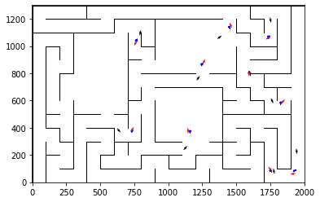

epoch 1 >> motion_mle: 26.11+-0.34/25.41+-0.27 --

epoch 2 >> motion_mle: 25.12+-0.30/25.11+-0.27 --

epoch 3 >> motion_mle: 24.85+-0.34/24.92+-0.27 --

epoch 4 >> motion_mle: 24.22+-0.38/24.57+-0.26 --

epoch 5 >> motion_mle: 24.87+-0.32/24.15+-0.27 --

epoch 6 >> motion_mle: 24.60+-0.41/23.81+-0.26 --

epoch 7 >> motion_mle: 23.18+-0.37/23.29+-0.26 --

epoch 8 >> motion_mle: 22.90+-0.40/22.80+-0.26 --

epoch 9 >> motion_mle: 22.91+-0.37/22.25+-0.26 --

epoch 10 >> motion_mle: 21.78+-0.38/21.87+-0.26 --

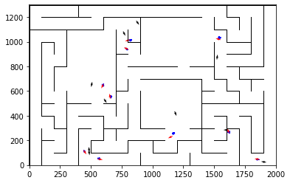

epoch 11 >> motion_mle: 22.38+-0.39/21.27+-0.25 --

epoch 12 >> motion_mle: 21.36+-0.35/20.78+-0.26 --

epoch 13 >> motion_mle: 20.40+-0.37/20.53+-0.24 --

epoch 14 >> motion_mle: 20.64+-0.35/19.79+-0.25 --

epoch 15 >> motion_mle: 19.73+-0.40/19.16+-0.25 --

epoch 16 >> motion_mle: 18.73+-0.40/18.74+-0.24 --

epoch 17 >> motion_mle: 18.36+-0.42/18.26+-0.23 --

epoch 18 >> motion_mle: 18.02+-0.38/17.98+-0.25 --

epoch 19 >> motion_mle: 18.40+-0.32/17.54+-0.24 --

epoch 20 >> motion_mle: 17.40+-0.34/17.33+-0.25 --

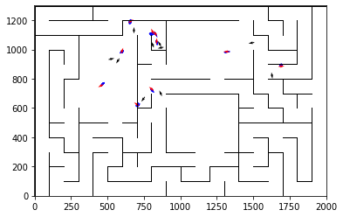

epoch 21 >> motion_mle: 17.62+-0.38/16.95+-0.24 --

epoch 22 >> motion_mle: 17.61+-0.37/16.87+-0.23 --

epoch 23 >> motion_mle: 16.85+-0.43/16.74+-0.22 --

epoch 24 >> motion_mle: 16.52+-0.35/16.37+-0.24 --

epoch 25 >> motion_mle: 16.39+-0.35/16.33+-0.24 --

epoch 26 >> motion_mle: 16.06+-0.31/16.08+-0.22 --

epoch 27 >> motion_mle: 16.24+-0.39/15.94+-0.23 --

epoch 28 >> motion_mle: 15.67+-0.34/15.71+-0.23 --

epoch 29 >> motion_mle: 15.67+-0.31/15.50+-0.22 --

epoch 30 >> motion_mle: 14.71+-0.33/15.29+-0.23 --

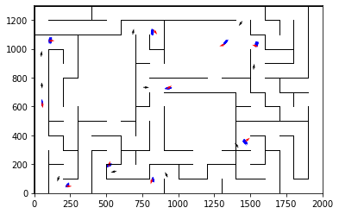

epoch 31 == motion_mle: 15.74+-0.32/15.49+-0.24 --

epoch 32 >> motion_mle: 15.22+-0.35/15.28+-0.23 --

epoch 33 >> motion_mle: 15.99+-0.37/15.07+-0.22 --

epoch 34 >> motion_mle: 15.14+-0.37/14.99+-0.23 --

epoch 35 >> motion_mle: 15.85+-0.37/14.84+-0.21 --

epoch 36 == motion_mle: 14.73+-0.34/14.89+-0.22 --

epoch 37 >> motion_mle: 14.45+-0.38/14.83+-0.23 --

epoch 38 >> motion_mle: 14.99+-0.31/14.77+-0.22 --

epoch 39 >> motion_mle: 14.85+-0.34/14.68+-0.23 --

epoch 40 >> motion_mle: 14.98+-0.36/14.55+-0.22 --

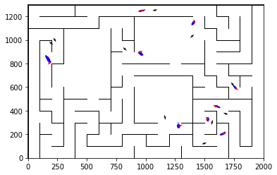

epoch 41 == motion_mle: 14.62+-0.30/14.74+-0.22 --

epoch 42 >> motion_mle: 14.52+-0.37/14.27+-0.23 --

epoch 43 == motion_mle: 14.47+-0.33/14.59+-0.22 --

epoch 44 == motion_mle: 14.82+-0.38/14.31+-0.22 --

epoch 45 == motion_mle: 14.26+-0.35/14.28+-0.20 --

epoch 46 >> motion_mle: 14.39+-0.37/14.19+-0.23 --

epoch 47 == motion_mle: 14.05+-0.32/14.52+-0.22 --

epoch 48 == motion_mle: 13.80+-0.27/14.65+-0.23 --

epoch 49 >> motion_mle: 14.67+-0.33/14.13+-0.23 --

epoch 50 == motion_mle: 14.25+-0.42/14.13+-0.23 --

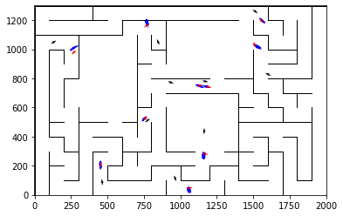

epoch 51 >> motion_mle: 14.06+-0.36/14.03+-0.22 --

epoch 52 == motion_mle: 14.49+-0.37/14.24+-0.20 --

epoch 53 >> motion_mle: 14.00+-0.29/13.97+-0.23 --

epoch 54 >> motion_mle: 13.88+-0.35/13.88+-0.23 --

epoch 55 == motion_mle: 13.95+-0.31/13.93+-0.22 --

epoch 56 == motion_mle: 13.92+-0.31/13.92+-0.22 --

epoch 57 == motion_mle: 13.72+-0.28/14.03+-0.22 --

epoch 58 >> motion_mle: 13.89+-0.31/13.70+-0.21 --

epoch 59 == motion_mle: 14.67+-0.36/14.04+-0.24 --

epoch 60 == motion_mle: 13.97+-0.33/13.86+-0.23 --

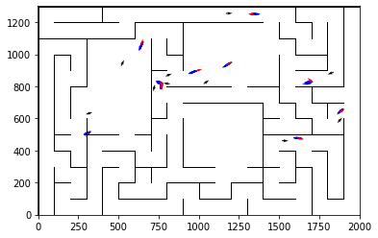

epoch 61 == motion_mle: 14.18+-0.35/13.84+-0.21 --

epoch 62 == motion_mle: 13.67+-0.33/13.93+-0.22 --

epoch 63 == motion_mle: 13.21+-0.30/13.75+-0.22 --

epoch 64 == motion_mle: 13.89+-0.30/13.75+-0.22 --

epoch 65 >> motion_mle: 13.93+-0.24/13.70+-0.22 --

epoch 66 == motion_mle: 13.72+-0.31/13.98+-0.22 --

epoch 67 == motion_mle: 13.77+-0.32/13.78+-0.22 --

epoch 68 == motion_mle: 14.23+-0.33/13.83+-0.21 --

epoch 69 == motion_mle: 13.93+-0.40/13.92+-0.21 --

epoch 70 == motion_mle: 13.77+-0.37/13.88+-0.22 --

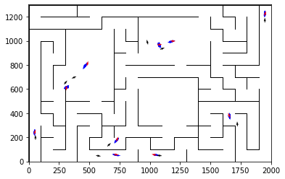

epoch 71 == motion_mle: 13.41+-0.26/13.87+-0.21 --

epoch 72 >> motion_mle: 14.18+-0.31/13.56+-0.20 --

epoch 73 == motion_mle: 14.25+-0.30/13.70+-0.21 --

epoch 74 >> motion_mle: 13.40+-0.35/13.45+-0.22 --

epoch 75 == motion_mle: 13.16+-0.33/13.51+-0.21 --

epoch 76 == motion_mle: 13.70+-0.32/13.63+-0.22 --

epoch 77 == motion_mle: 13.81+-0.34/13.56+-0.21 --

epoch 78 >> motion_mle: 13.64+-0.31/13.41+-0.22 --

epoch 79 == motion_mle: 13.43+-0.32/13.57+-0.21 --

epoch 80 == motion_mle: 13.66+-0.27/13.52+-0.21 --

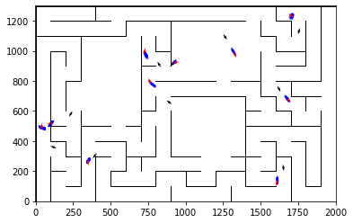

epoch 81 == motion_mle: 14.30+-0.34/13.44+-0.22 --

epoch 82 >> motion_mle: 13.99+-0.33/13.38+-0.21 --

epoch 83 >> motion_mle: 13.83+-0.29/13.31+-0.21 --

epoch 84 == motion_mle: 13.22+-0.28/13.39+-0.21 --

epoch 85 == motion_mle: 13.34+-0.41/13.33+-0.22 --

epoch 86 == motion_mle: 13.22+-0.39/13.38+-0.22 --

epoch 87 == motion_mle: 13.10+-0.33/13.32+-0.21 --

epoch 88 == motion_mle: 13.56+-0.32/13.58+-0.21 --

epoch 89 == motion_mle: 13.51+-0.36/13.45+-0.21 --

epoch 90 >> motion_mle: 13.34+-0.30/13.27+-0.23 --

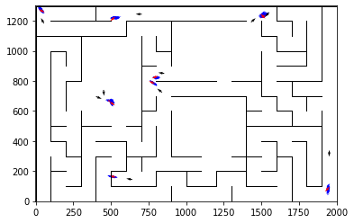

epoch 91 >> motion_mle: 14.05+-0.32/13.25+-0.21 --

epoch 92 >> motion_mle: 13.67+-0.37/13.12+-0.20 --

epoch 93 == motion_mle: 12.93+-0.29/13.53+-0.21 --

epoch 94 == motion_mle: 13.52+-0.33/13.64+-0.21 --

epoch 95 == motion_mle: 13.15+-0.32/13.28+-0.21 --

epoch 96 == motion_mle: 13.78+-0.30/13.34+-0.20 --

epoch 97 == motion_mle: 13.55+-0.31/13.17+-0.20 --

epoch 98 == motion_mle: 13.17+-0.31/13.53+-0.21 --

epoch 99 == motion_mle: 13.42+-0.37/13.41+-0.22 --

epoch 100 == motion_mle: 12.70+-0.29/13.17+-0.20 --

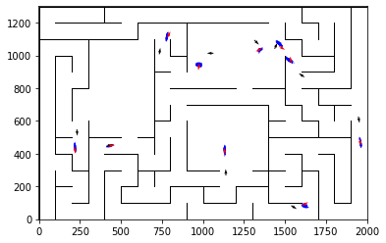

epoch 101 == motion_mle: 13.44+-0.30/13.25+-0.21 --

epoch 102 == motion_mle: 13.56+-0.31/13.14+-0.22 --

epoch 103 == motion_mle: 13.20+-0.29/13.14+-0.21 --

epoch 104 >> motion_mle: 12.82+-0.29/13.03+-0.21 --

epoch 105 == motion_mle: 13.23+-0.34/13.30+-0.21 --

epoch 106 == motion_mle: 13.39+-0.35/13.12+-0.23 --

epoch 107 == motion_mle: 13.58+-0.37/13.07+-0.22 --

epoch 108 == motion_mle: 13.13+-0.34/13.24+-0.22 --

epoch 109 == motion_mle: 13.52+-0.24/13.29+-0.21 --

epoch 110 >> motion_mle: 13.45+-0.30/12.98+-0.21 --

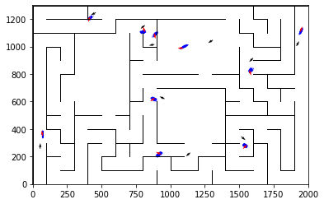

epoch 111 == motion_mle: 13.16+-0.31/13.02+-0.21 --

epoch 112 == motion_mle: 14.00+-0.34/13.01+-0.21 --

epoch 113 == motion_mle: 13.07+-0.33/13.20+-0.20 --

epoch 114 >> motion_mle: 12.50+-0.30/12.74+-0.21 --

epoch 115 == motion_mle: 13.81+-0.36/12.76+-0.21 --

epoch 116 == motion_mle: 13.13+-0.37/13.03+-0.19 --

epoch 117 == motion_mle: 12.67+-0.30/13.13+-0.20 --

epoch 118 == motion_mle: 12.89+-0.29/12.96+-0.20 --

epoch 119 == motion_mle: 13.34+-0.36/12.93+-0.21 --

epoch 120 == motion_mle: 12.80+-0.27/13.02+-0.21 --

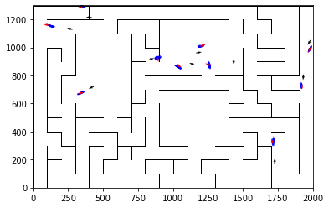

epoch 121 == motion_mle: 13.17+-0.35/12.93+-0.22 --

epoch 122 == motion_mle: 13.40+-0.29/13.18+-0.22 --

epoch 123 == motion_mle: 13.09+-0.31/12.81+-0.22 --

epoch 124 == motion_mle: 13.07+-0.33/12.80+-0.21 --

epoch 125 == motion_mle: 12.60+-0.30/12.78+-0.21 --

epoch 126 >> motion_mle: 12.78+-0.36/12.66+-0.22 --

epoch 127 == motion_mle: 12.55+-0.35/12.80+-0.20 --

epoch 128 == motion_mle: 13.41+-0.29/12.95+-0.20 --

epoch 129 == motion_mle: 12.43+-0.27/12.98+-0.21 --

epoch 130 == motion_mle: 12.67+-0.26/12.80+-0.21 --

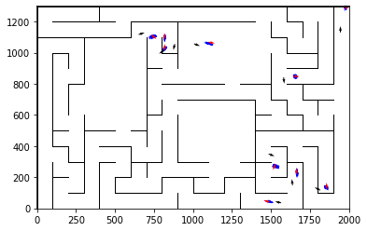

epoch 131 >> motion_mle: 13.24+-0.23/12.55+-0.22 --

epoch 132 >> motion_mle: 12.52+-0.28/12.53+-0.21 --

epoch 133 == motion_mle: 12.82+-0.33/12.76+-0.21 --

epoch 134 == motion_mle: 13.05+-0.38/12.66+-0.22 --

epoch 135 == motion_mle: 12.35+-0.25/12.65+-0.22 --

epoch 136 == motion_mle: 12.48+-0.30/12.68+-0.20 --

epoch 137 == motion_mle: 12.55+-0.28/12.60+-0.21 --

epoch 138 == motion_mle: 12.70+-0.34/12.72+-0.21 --

epoch 139 >> motion_mle: 12.41+-0.29/12.49+-0.22 --

epoch 140 == motion_mle: 12.84+-0.27/12.52+-0.20 --

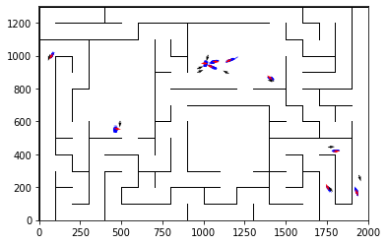

epoch 141 == motion_mle: 12.21+-0.27/12.53+-0.21 --

epoch 142 == motion_mle: 12.81+-0.31/12.54+-0.21 --

epoch 143 >> motion_mle: 12.76+-0.29/12.16+-0.22 --

epoch 144 == motion_mle: 12.88+-0.25/12.49+-0.20 --

epoch 145 == motion_mle: 12.71+-0.30/12.54+-0.23 --

epoch 146 == motion_mle: 12.85+-0.36/12.62+-0.20 --

epoch 147 == motion_mle: 12.57+-0.30/12.31+-0.21 --

epoch 148 == motion_mle: 12.76+-0.29/12.59+-0.19 --

epoch 149 == motion_mle: 12.84+-0.37/12.49+-0.19 --

epoch 150 == motion_mle: 13.19+-0.30/12.35+-0.21 --

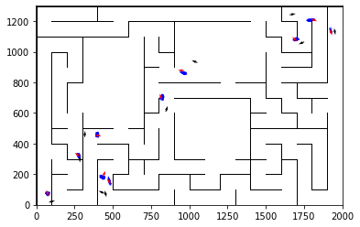

epoch 151 == motion_mle: 12.59+-0.31/12.45+-0.19 --

epoch 152 == motion_mle: 12.65+-0.25/12.29+-0.21 --

epoch 153 == motion_mle: 13.19+-0.28/12.49+-0.19 --

epoch 154 == motion_mle: 12.95+-0.27/12.37+-0.22 --

epoch 155 == motion_mle: 12.70+-0.35/12.43+-0.21 --

epoch 156 == motion_mle: 12.81+-0.25/12.44+-0.21 --

epoch 157 == motion_mle: 12.48+-0.32/12.46+-0.22 --

epoch 158 == motion_mle: 12.69+-0.30/12.38+-0.20 --

epoch 159 == motion_mle: 11.94+-0.31/12.47+-0.21 --

epoch 160 == motion_mle: 12.39+-0.33/12.27+-0.22 --

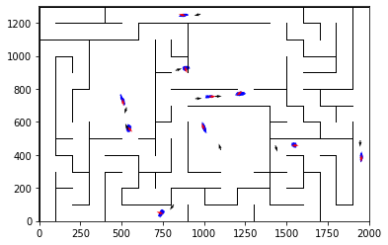

epoch 161 == motion_mle: 12.44+-0.30/12.50+-0.21 --

epoch 162 == motion_mle: 12.81+-0.36/12.24+-0.20 --

epoch 163 == motion_mle: 12.69+-0.34/12.36+-0.20 --

epoch 164 == motion_mle: 12.56+-0.28/12.59+-0.22 --

epoch 165 == motion_mle: 12.50+-0.30/12.33+-0.19 --

epoch 166 == motion_mle: 12.39+-0.27/12.19+-0.20 --

epoch 167 == motion_mle: 12.66+-0.34/12.32+-0.21 --

epoch 168 == motion_mle: 12.55+-0.31/12.25+-0.18 --

epoch 169 == motion_mle: 12.94+-0.31/12.52+-0.22 --

epoch 170 >> motion_mle: 12.59+-0.32/12.12+-0.20 --

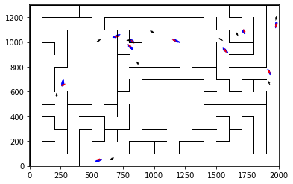

epoch 171 == motion_mle: 12.11+-0.31/12.41+-0.21 --

epoch 172 >> motion_mle: 12.45+-0.30/12.05+-0.20 --

epoch 173 == motion_mle: 12.15+-0.35/12.85+-0.20 --

epoch 174 == motion_mle: 12.37+-0.31/12.16+-0.21 --

epoch 175 == motion_mle: 12.10+-0.29/12.56+-0.22 --

epoch 176 == motion_mle: 12.80+-0.35/12.23+-0.21 --

epoch 177 == motion_mle: 12.89+-0.34/12.34+-0.21 --

epoch 178 == motion_mle: 12.48+-0.27/12.22+-0.21 --

epoch 179 == motion_mle: 12.11+-0.26/12.15+-0.21 --

epoch 180 == motion_mle: 12.16+-0.30/12.15+-0.21 --

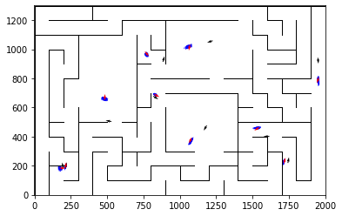

epoch 181 == motion_mle: 12.23+-0.30/12.23+-0.22 --

epoch 182 == motion_mle: 12.65+-0.25/12.11+-0.19 --

epoch 183 == motion_mle: 11.82+-0.31/12.46+-0.21 --

epoch 184 == motion_mle: 12.73+-0.30/12.49+-0.20 --

epoch 185 == motion_mle: 12.37+-0.35/12.35+-0.22 --

epoch 186 >> motion_mle: 12.69+-0.33/12.04+-0.20 --

epoch 187 == motion_mle: 12.75+-0.28/12.09+-0.22 --

epoch 188 == motion_mle: 12.11+-0.28/12.20+-0.20 --

epoch 189 == motion_mle: 11.99+-0.29/12.20+-0.20 --

epoch 190 == motion_mle: 12.42+-0.34/12.11+-0.20 --

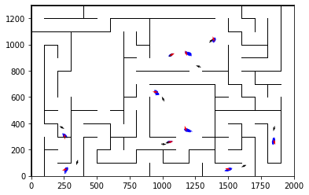

epoch 191 == motion_mle: 12.37+-0.29/12.07+-0.21 --

epoch 192 == motion_mle: 12.29+-0.34/12.16+-0.21 --

epoch 193 == motion_mle: 12.37+-0.38/12.12+-0.21 --

epoch 194 >> motion_mle: 12.38+-0.29/12.02+-0.22 --

epoch 195 == motion_mle: 12.23+-0.28/12.29+-0.21 --

epoch 196 == motion_mle: 12.24+-0.36/12.18+-0.21 --

epoch 197 == motion_mle: 12.27+-0.33/12.20+-0.22 --

epoch 198 == motion_mle: 12.22+-0.30/12.20+-0.21 --

epoch 199 == motion_mle: 12.83+-0.39/12.18+-0.20 --

epoch 200 == motion_mle: 12.04+-0.30/12.08+-0.22 --

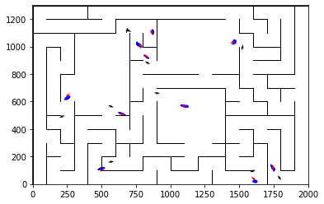

epoch 201 >> motion_mle: 12.51+-0.34/11.99+-0.20 --

epoch 202 == motion_mle: 11.79+-0.34/12.20+-0.20 --

epoch 203 == motion_mle: 12.32+-0.31/12.24+-0.19 --

epoch 204 == motion_mle: 12.03+-0.33/12.00+-0.21 --

epoch 205 == motion_mle: 12.45+-0.28/12.10+-0.20 --

epoch 206 == motion_mle: 12.83+-0.27/12.13+-0.23 --

epoch 207 >> motion_mle: 12.32+-0.27/11.96+-0.21 --

epoch 208 == motion_mle: 11.84+-0.31/12.04+-0.21 --

epoch 209 >> motion_mle: 12.15+-0.35/11.92+-0.20 --

epoch 210 == motion_mle: 12.85+-0.30/12.07+-0.20 --

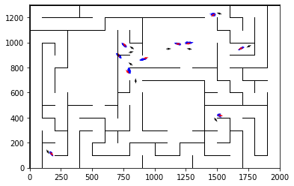

epoch 211 == motion_mle: 12.17+-0.35/12.02+-0.22 --

epoch 212 >> motion_mle: 11.67+-0.27/11.67+-0.21 --

epoch 213 == motion_mle: 12.22+-0.34/11.91+-0.21 --

epoch 214 == motion_mle: 12.42+-0.35/11.88+-0.21 --

epoch 215 == motion_mle: 11.62+-0.26/11.78+-0.19 --

epoch 216 == motion_mle: 11.88+-0.29/12.22+-0.20 --

epoch 217 == motion_mle: 12.40+-0.32/11.79+-0.21 --

epoch 218 == motion_mle: 12.15+-0.29/11.84+-0.23 --

epoch 219 == motion_mle: 11.37+-0.27/11.83+-0.20 --

epoch 220 == motion_mle: 12.06+-0.27/11.99+-0.21 --

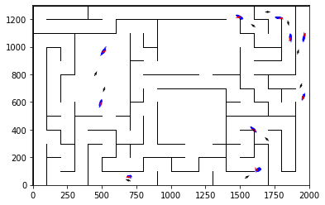

epoch 221 == motion_mle: 12.26+-0.29/12.23+-0.21 --

epoch 222 == motion_mle: 12.72+-0.31/11.80+-0.22 --

epoch 223 == motion_mle: 12.48+-0.29/11.97+-0.21 --

epoch 224 == motion_mle: 11.80+-0.31/12.93+-0.21 --

epoch 225 == motion_mle: 11.60+-0.38/11.97+-0.21 --

epoch 226 == motion_mle: 13.01+-0.29/11.74+-0.19 --

epoch 227 == motion_mle: 12.39+-0.35/11.97+-0.21 --

epoch 228 >> motion_mle: 12.61+-0.35/11.65+-0.20 --

epoch 229 == motion_mle: 12.03+-0.26/11.82+-0.21 --

epoch 230 == motion_mle: 12.01+-0.22/11.75+-0.21 --

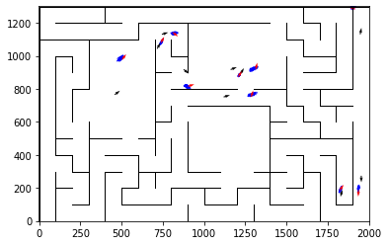

epoch 231 == motion_mle: 12.35+-0.30/11.78+-0.21 --

epoch 232 >> motion_mle: 11.51+-0.32/11.54+-0.20 --

epoch 233 == motion_mle: 11.84+-0.31/11.99+-0.21 --

epoch 234 == motion_mle: 12.05+-0.27/11.92+-0.21 --

epoch 235 == motion_mle: 12.13+-0.30/11.73+-0.20 --

epoch 236 == motion_mle: 11.78+-0.37/11.85+-0.22 --

epoch 237 == motion_mle: 11.21+-0.31/11.76+-0.19 --

epoch 238 == motion_mle: 11.63+-0.29/11.67+-0.18 --

epoch 239 == motion_mle: 11.52+-0.32/11.81+-0.21 --

epoch 240 == motion_mle: 12.42+-0.28/11.72+-0.21 --

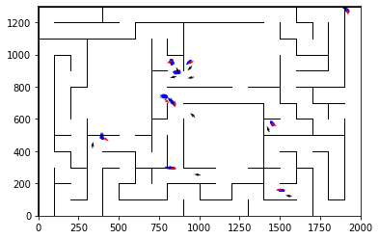

epoch 241 == motion_mle: 11.79+-0.28/11.59+-0.20 --

epoch 242 == motion_mle: 12.07+-0.29/11.69+-0.20 --

epoch 243 == motion_mle: 12.25+-0.32/11.89+-0.21 --

epoch 244 == motion_mle: 12.21+-0.35/11.75+-0.21 --

epoch 245 == motion_mle: 11.51+-0.33/11.71+-0.22 --

epoch 246 == motion_mle: 11.77+-0.25/11.75+-0.21 --

epoch 247 == motion_mle: 12.42+-0.34/11.81+-0.20 --

epoch 248 == motion_mle: 12.51+-0.32/11.76+-0.21 --

epoch 249 == motion_mle: 11.50+-0.34/12.03+-0.21 --

epoch 250 == motion_mle: 11.89+-0.32/11.73+-0.20 --

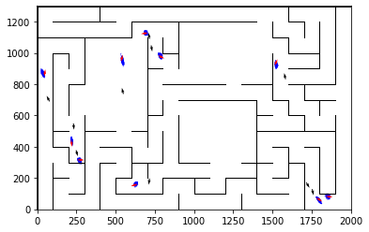

epoch 251 == motion_mle: 11.61+-0.24/11.68+-0.21 --

epoch 252 == motion_mle: 11.89+-0.29/11.82+-0.20 --

epoch 253 == motion_mle: 11.54+-0.26/11.67+-0.19 --

epoch 254 == motion_mle: 12.05+-0.28/11.84+-0.21 --

epoch 255 == motion_mle: 12.18+-0.30/11.70+-0.21 --

epoch 256 >> motion_mle: 10.78+-0.31/11.45+-0.20 --

epoch 257 == motion_mle: 11.35+-0.32/11.80+-0.21 --

epoch 258 == motion_mle: 12.05+-0.34/11.51+-0.22 --

epoch 259 == motion_mle: 11.94+-0.30/11.58+-0.21 --

epoch 260 >> motion_mle: 11.64+-0.30/11.44+-0.21 --

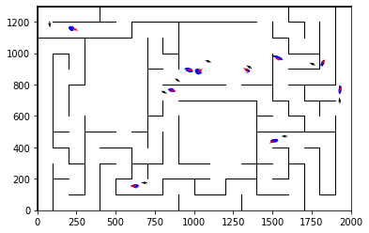

epoch 261 == motion_mle: 12.11+-0.29/11.72+-0.19 --

epoch 262 == motion_mle: 11.96+-0.33/11.61+-0.19 --

epoch 263 == motion_mle: 12.20+-0.33/11.63+-0.21 --

epoch 264 == motion_mle: 11.73+-0.29/11.68+-0.23 --

epoch 265 == motion_mle: 11.63+-0.27/11.70+-0.20 --

epoch 266 == motion_mle: 11.69+-0.28/11.73+-0.21 --

epoch 267 == motion_mle: 12.44+-0.33/11.70+-0.20 --

epoch 268 == motion_mle: 11.54+-0.28/11.61+-0.22 --

epoch 269 == motion_mle: 11.93+-0.35/11.61+-0.21 --

epoch 270 == motion_mle: 11.76+-0.24/11.74+-0.20 --

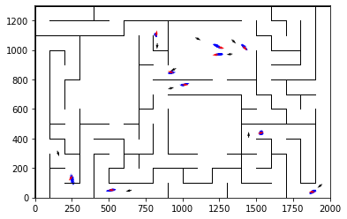

epoch 271 == motion_mle: 11.48+-0.26/11.56+-0.21 --

epoch 272 == motion_mle: 11.88+-0.27/11.56+-0.21 --

epoch 273 == motion_mle: 11.61+-0.32/11.51+-0.22 --

epoch 274 == motion_mle: 10.97+-0.23/11.69+-0.21 --

epoch 275 == motion_mle: 11.68+-0.34/11.68+-0.21 --

epoch 276 == motion_mle: 11.90+-0.25/11.67+-0.20 --

epoch 277 == motion_mle: 11.66+-0.28/11.79+-0.21 --

epoch 278 == motion_mle: 12.17+-0.30/11.48+-0.21 --

epoch 279 == motion_mle: 12.00+-0.30/11.56+-0.21 --

epoch 280 == motion_mle: 11.05+-0.31/11.81+-0.22 --

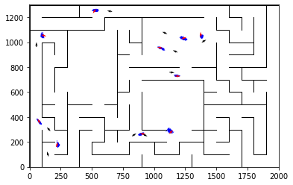

epoch 281 == motion_mle: 12.02+-0.27/11.54+-0.21 --

epoch 282 == motion_mle: 11.45+-0.32/11.62+-0.22 --

epoch 283 == motion_mle: 12.36+-0.34/11.60+-0.21 --

epoch 284 == motion_mle: 11.36+-0.30/11.52+-0.21 --

epoch 285 == motion_mle: 10.84+-0.30/11.56+-0.22 --

epoch 286 == motion_mle: 11.68+-0.32/11.54+-0.20 --

epoch 287 >> motion_mle: 11.70+-0.26/11.41+-0.20 --

epoch 288 == motion_mle: 12.32+-0.32/11.54+-0.20 --

epoch 289 == motion_mle: 11.88+-0.26/11.65+-0.21 --

epoch 290 >> motion_mle: 11.54+-0.26/11.36+-0.21 --

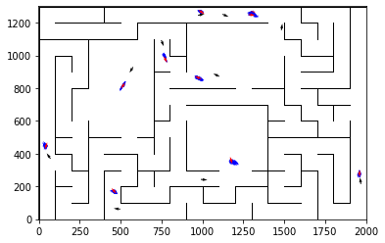

epoch 291 >> motion_mle: 11.04+-0.26/11.29+-0.20 --

epoch 292 == motion_mle: 11.67+-0.26/11.39+-0.20 --

epoch 293 == motion_mle: 12.04+-0.36/11.47+-0.22 --

epoch 294 == motion_mle: 10.99+-0.28/11.40+-0.21 --

epoch 295 == motion_mle: 12.16+-0.28/11.60+-0.21 --

epoch 296 == motion_mle: 11.41+-0.31/11.56+-0.22 --

epoch 297 == motion_mle: 11.85+-0.31/11.39+-0.20 --

epoch 298 == motion_mle: 11.72+-0.31/11.47+-0.22 --

epoch 299 == motion_mle: 11.55+-0.32/11.50+-0.23 --

epoch 300 == motion_mle: 11.48+-0.33/11.42+-0.19 --

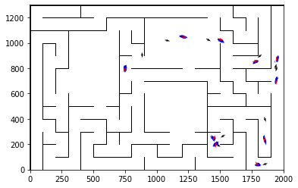

epoch 301 == motion_mle: 11.84+-0.31/11.45+-0.19 --

epoch 302 == motion_mle: 11.08+-0.27/11.54+-0.20 --

epoch 303 == motion_mle: 11.64+-0.30/11.53+-0.21 --

epoch 304 == motion_mle: 11.87+-0.28/11.41+-0.20 --

epoch 305 == motion_mle: 12.05+-0.29/11.61+-0.20 --

epoch 306 == motion_mle: 11.66+-0.33/11.90+-0.21 --

epoch 307 == motion_mle: 11.58+-0.30/11.50+-0.21 --

epoch 308 == motion_mle: 10.95+-0.26/11.34+-0.21 --

epoch 309 == motion_mle: 11.11+-0.31/11.32+-0.21 --

epoch 310 == motion_mle: 11.37+-0.34/11.63+-0.22 --

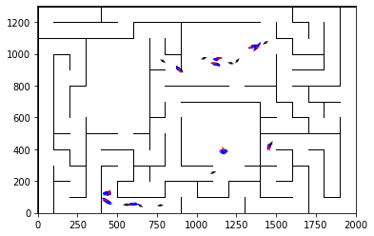

epoch 311 == motion_mle: 12.01+-0.30/11.52+-0.22 --

epoch 312 == motion_mle: 11.23+-0.31/11.33+-0.22 --

epoch 313 >> motion_mle: 11.62+-0.27/11.27+-0.20 --

epoch 314 == motion_mle: 11.08+-0.33/11.29+-0.19 --

epoch 315 >> motion_mle: 11.07+-0.29/11.26+-0.20 --

epoch 316 >> motion_mle: 11.54+-0.27/11.22+-0.20 --

epoch 317 == motion_mle: 11.37+-0.26/11.40+-0.20 --

epoch 318 == motion_mle: 11.30+-0.26/11.34+-0.21 --

epoch 319 == motion_mle: 11.35+-0.29/11.50+-0.20 --

epoch 320 == motion_mle: 11.27+-0.29/11.41+-0.21 --

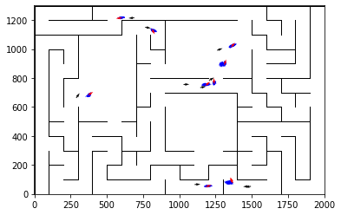

epoch 321 == motion_mle: 11.38+-0.31/11.39+-0.20 --

epoch 322 >> motion_mle: 11.82+-0.32/11.22+-0.19 --

epoch 323 >> motion_mle: 11.31+-0.29/11.21+-0.22 --

epoch 324 == motion_mle: 11.44+-0.31/11.44+-0.22 --

epoch 325 == motion_mle: 11.87+-0.34/11.27+-0.21 --

epoch 326 == motion_mle: 11.37+-0.30/11.30+-0.22 --

epoch 327 == motion_mle: 11.53+-0.32/11.38+-0.20 --

epoch 328 == motion_mle: 11.00+-0.31/11.46+-0.19 --

epoch 329 == motion_mle: 11.42+-0.28/11.22+-0.21 --

epoch 330 == motion_mle: 11.74+-0.28/11.40+-0.21 --

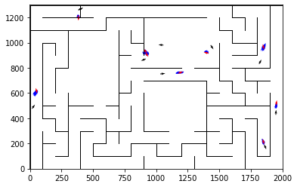

epoch 331 >> motion_mle: 11.84+-0.29/11.20+-0.21 --

epoch 332 == motion_mle: 11.75+-0.32/11.56+-0.21 --

epoch 333 == motion_mle: 11.53+-0.35/11.39+-0.21 --

epoch 334 == motion_mle: 11.46+-0.29/11.20+-0.22 --

epoch 335 == motion_mle: 11.41+-0.28/11.24+-0.20 --

epoch 336 >> motion_mle: 11.15+-0.31/11.18+-0.20 --

epoch 337 == motion_mle: 11.09+-0.29/11.22+-0.20 --

epoch 338 == motion_mle: 10.98+-0.33/11.25+-0.19 --

epoch 339 == motion_mle: 11.34+-0.32/11.25+-0.19 --

epoch 340 == motion_mle: 11.51+-0.28/11.24+-0.21 --

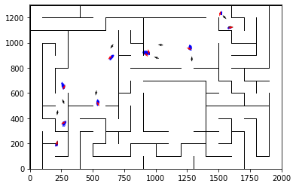

epoch 341 == motion_mle: 11.68+-0.31/11.32+-0.20 --

epoch 342 == motion_mle: 11.65+-0.29/11.29+-0.20 --

epoch 343 >> motion_mle: 11.31+-0.31/11.10+-0.21 --

epoch 344 == motion_mle: 10.92+-0.31/11.12+-0.20 --

epoch 345 == motion_mle: 11.29+-0.33/11.30+-0.21 --

epoch 346 == motion_mle: 11.14+-0.34/11.30+-0.21 --

epoch 347 == motion_mle: 11.67+-0.35/11.50+-0.20 --

epoch 348 == motion_mle: 10.88+-0.26/11.18+-0.22 --

epoch 349 == motion_mle: 11.28+-0.30/11.12+-0.20 --

epoch 350 == motion_mle: 11.31+-0.31/11.26+-0.21 --

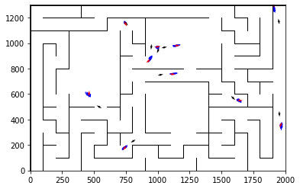

epoch 351 == motion_mle: 11.36+-0.26/11.15+-0.21 --

epoch 352 >> motion_mle: 10.66+-0.27/11.06+-0.20 --

epoch 353 >> motion_mle: 11.50+-0.35/11.02+-0.20 --

epoch 354 == motion_mle: 11.35+-0.35/11.29+-0.19 --

epoch 355 == motion_mle: 12.04+-0.30/11.15+-0.20 --

epoch 356 == motion_mle: 11.14+-0.28/11.36+-0.22 --

epoch 357 == motion_mle: 11.19+-0.35/11.37+-0.22 --

epoch 358 == motion_mle: 11.06+-0.31/11.21+-0.20 --

epoch 359 == motion_mle: 11.04+-0.31/11.15+-0.20 --

epoch 360 == motion_mle: 11.14+-0.32/11.11+-0.21 --

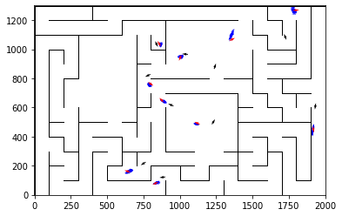

epoch 361 == motion_mle: 10.98+-0.31/11.25+-0.20 --

epoch 362 == motion_mle: 11.85+-0.31/11.31+-0.21 --

epoch 363 == motion_mle: 11.75+-0.31/11.09+-0.20 --

epoch 364 == motion_mle: 11.36+-0.34/11.15+-0.21 --

epoch 365 == motion_mle: 11.06+-0.22/11.11+-0.21 --

epoch 366 == motion_mle: 11.20+-0.26/11.39+-0.20 --

epoch 367 == motion_mle: 11.18+-0.25/11.09+-0.21 --

epoch 368 == motion_mle: 11.07+-0.29/11.29+-0.21 --

epoch 369 == motion_mle: 10.97+-0.25/11.02+-0.21 --

epoch 370 == motion_mle: 11.09+-0.32/11.04+-0.22 --

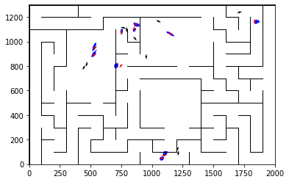

epoch 371 == motion_mle: 11.51+-0.29/11.22+-0.20 --

epoch 372 >> motion_mle: 11.16+-0.27/10.98+-0.20 --

epoch 373 == motion_mle: 11.00+-0.36/11.10+-0.20 --

epoch 374 == motion_mle: 10.82+-0.28/11.21+-0.22 --

epoch 375 == motion_mle: 11.42+-0.30/11.08+-0.21 --

epoch 376 == motion_mle: 11.32+-0.28/11.22+-0.21 --

epoch 377 == motion_mle: 11.26+-0.32/11.34+-0.20 --

epoch 378 == motion_mle: 10.95+-0.28/11.15+-0.20 --

epoch 379 == motion_mle: 11.81+-0.32/11.32+-0.22 --

epoch 380 == motion_mle: 11.04+-0.25/11.37+-0.20 --

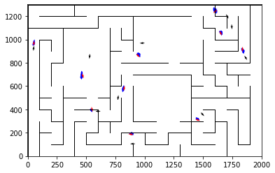

epoch 381 == motion_mle: 10.73+-0.29/11.18+-0.21 --

epoch 382 == motion_mle: 10.90+-0.30/11.05+-0.21 --

epoch 383 == motion_mle: 11.17+-0.26/11.22+-0.22 --

epoch 384 == motion_mle: 11.37+-0.31/11.00+-0.20 --

epoch 385 == motion_mle: 11.39+-0.30/11.11+-0.20 --

epoch 386 == motion_mle: 11.00+-0.29/11.11+-0.21 --

epoch 387 == motion_mle: 11.13+-0.28/11.25+-0.20 --

epoch 388 == motion_mle: 10.43+-0.28/11.19+-0.22 --

epoch 389 == motion_mle: 10.87+-0.30/11.06+-0.19 --

epoch 390 == motion_mle: 10.71+-0.26/11.04+-0.22 --

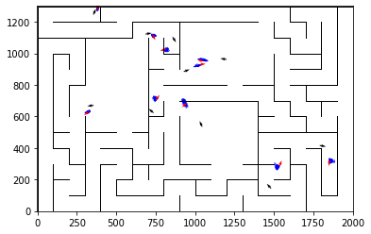

epoch 391 >> motion_mle: 10.80+-0.26/10.87+-0.20 --

epoch 392 == motion_mle: 11.39+-0.29/11.03+-0.21 --

epoch 393 == motion_mle: 11.30+-0.28/11.18+-0.20 --

epoch 394 == motion_mle: 11.10+-0.30/11.10+-0.22 --

epoch 395 == motion_mle: 11.38+-0.33/10.95+-0.20 --

epoch 396 == motion_mle: 11.05+-0.29/10.92+-0.21 --

epoch 397 == motion_mle: 11.11+-0.31/10.99+-0.19 --

epoch 398 == motion_mle: 11.29+-0.30/11.05+-0.20 --

epoch 399 == motion_mle: 11.13+-0.29/10.96+-0.19 --

epoch 400 == motion_mle: 11.69+-0.36/10.94+-0.20 --

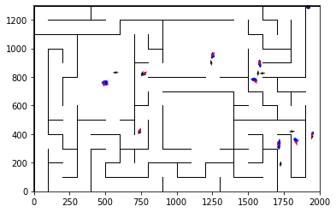

epoch 401 == motion_mle: 10.94+-0.31/11.13+-0.20 --

epoch 402 == motion_mle: 10.85+-0.30/10.92+-0.20 --

epoch 403 >> motion_mle: 10.84+-0.28/10.83+-0.21 --

epoch 404 == motion_mle: 11.14+-0.29/11.00+-0.21 --

epoch 405 == motion_mle: 10.61+-0.31/10.99+-0.22 --

epoch 406 == motion_mle: 11.71+-0.30/11.29+-0.22 --

epoch 407 == motion_mle: 11.60+-0.30/11.00+-0.21 --

epoch 408 == motion_mle: 11.11+-0.26/11.12+-0.21 --

epoch 409 == motion_mle: 11.35+-0.32/11.15+-0.20 --

epoch 410 == motion_mle: 10.88+-0.31/10.94+-0.21 --

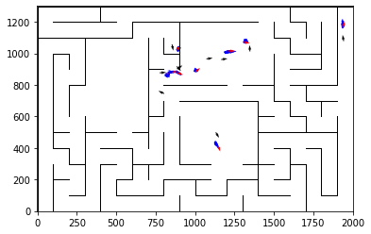

epoch 411 == motion_mle: 10.86+-0.28/11.06+-0.20 --

epoch 412 == motion_mle: 11.34+-0.31/11.08+-0.21 --

epoch 413 == motion_mle: 11.29+-0.30/10.88+-0.19 --

epoch 414 == motion_mle: 11.13+-0.31/10.94+-0.22 --

epoch 415 == motion_mle: 11.14+-0.31/11.03+-0.21 --

epoch 416 == motion_mle: 10.77+-0.35/10.97+-0.19 --

epoch 417 == motion_mle: 10.94+-0.25/10.90+-0.20 --

epoch 418 == motion_mle: 11.54+-0.29/10.97+-0.20 --

epoch 419 == motion_mle: 10.64+-0.24/11.18+-0.19 --

epoch 420 >> motion_mle: 10.78+-0.29/10.80+-0.22 --

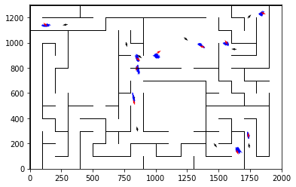

epoch 421 == motion_mle: 11.58+-0.30/10.92+-0.20 --

epoch 422 == motion_mle: 10.59+-0.26/10.92+-0.19 --

epoch 423 == motion_mle: 11.02+-0.32/11.16+-0.20 --

epoch 424 == motion_mle: 10.86+-0.32/10.90+-0.19 --

epoch 425 == motion_mle: 11.18+-0.34/11.05+-0.21 --

epoch 426 == motion_mle: 11.09+-0.33/10.99+-0.20 --

epoch 427 == motion_mle: 10.95+-0.30/11.20+-0.20 --

epoch 428 == motion_mle: 11.30+-0.24/11.04+-0.20 --

epoch 429 == motion_mle: 11.26+-0.27/10.81+-0.20 --

epoch 430 == motion_mle: 11.06+-0.30/11.00+-0.20 --

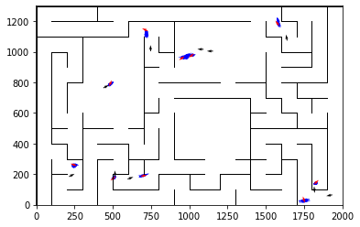

epoch 431 == motion_mle: 11.52+-0.34/10.89+-0.21 --

epoch 432 == motion_mle: 11.17+-0.29/10.98+-0.22 --

epoch 433 == motion_mle: 11.11+-0.26/10.92+-0.22 --

epoch 434 == motion_mle: 11.12+-0.34/10.83+-0.22 --

epoch 435 >> motion_mle: 11.10+-0.30/10.72+-0.19 --

epoch 436 == motion_mle: 11.14+-0.30/11.00+-0.20 --

epoch 437 == motion_mle: 11.10+-0.27/11.01+-0.20 --

epoch 438 == motion_mle: 11.01+-0.27/10.88+-0.21 --

epoch 439 == motion_mle: 10.79+-0.31/11.09+-0.20 --

epoch 440 == motion_mle: 10.47+-0.30/10.87+-0.20 --

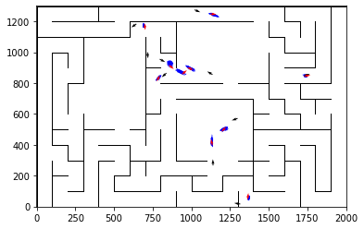

epoch 441 == motion_mle: 11.05+-0.32/10.75+-0.20 --

epoch 442 == motion_mle: 11.20+-0.37/10.76+-0.20 --

epoch 443 >> motion_mle: 10.44+-0.26/10.71+-0.21 --

epoch 444 == motion_mle: 11.06+-0.28/10.84+-0.20 --

epoch 445 == motion_mle: 10.79+-0.28/10.73+-0.20 --

epoch 446 == motion_mle: 10.86+-0.22/10.94+-0.21 --

epoch 447 == motion_mle: 10.81+-0.28/10.83+-0.20 --

epoch 448 == motion_mle: 11.24+-0.36/10.87+-0.21 --

epoch 449 == motion_mle: 10.39+-0.26/10.80+-0.21 --

epoch 450 == motion_mle: 10.84+-0.30/10.95+-0.20 --

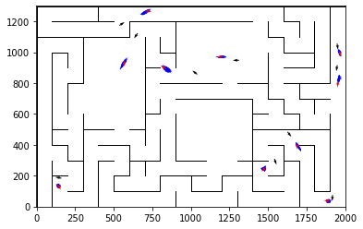

epoch 451 >> motion_mle: 11.04+-0.30/10.70+-0.19 --

epoch 452 == motion_mle: 11.14+-0.30/10.80+-0.21 --

epoch 453 >> motion_mle: 10.76+-0.29/10.65+-0.20 --

epoch 454 == motion_mle: 10.64+-0.26/11.11+-0.19 --

epoch 455 == motion_mle: 11.15+-0.28/10.76+-0.20 --

epoch 456 == motion_mle: 11.18+-0.29/10.70+-0.18 --

epoch 457 == motion_mle: 10.94+-0.26/10.92+-0.23 --

epoch 458 == motion_mle: 10.91+-0.25/10.79+-0.18 --

epoch 459 == motion_mle: 11.31+-0.29/10.92+-0.19 --

epoch 460 == motion_mle: 10.87+-0.30/10.78+-0.22 --

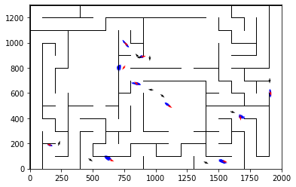

epoch 461 >> motion_mle: 10.40+-0.29/10.61+-0.21 --

epoch 462 == motion_mle: 10.98+-0.23/10.68+-0.20 --

epoch 463 == motion_mle: 11.24+-0.31/10.75+-0.20 --

epoch 464 == motion_mle: 11.36+-0.28/10.70+-0.21 --

epoch 465 == motion_mle: 10.93+-0.32/10.81+-0.21 --

epoch 466 == motion_mle: 10.77+-0.35/10.85+-0.21 --

epoch 467 == motion_mle: 10.65+-0.29/10.91+-0.20 --

epoch 468 == motion_mle: 10.78+-0.26/10.76+-0.19 --

epoch 469 == motion_mle: 11.04+-0.32/10.63+-0.19 --

epoch 470 == motion_mle: 10.26+-0.23/10.74+-0.19 --

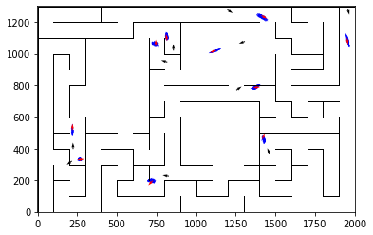

epoch 471 == motion_mle: 10.80+-0.27/10.91+-0.20 --

epoch 472 == motion_mle: 10.88+-0.30/10.90+-0.22 --

epoch 473 == motion_mle: 10.55+-0.36/10.95+-0.20 --

epoch 474 == motion_mle: 11.32+-0.33/11.07+-0.21 --

epoch 475 == motion_mle: 10.94+-0.25/10.66+-0.19 --

epoch 476 == motion_mle: 11.24+-0.31/10.72+-0.21 --

epoch 477 == motion_mle: 10.71+-0.27/10.85+-0.20 --

epoch 478 == motion_mle: 11.03+-0.26/10.67+-0.20 --

epoch 479 == motion_mle: 10.47+-0.24/10.85+-0.22 --

epoch 480 == motion_mle: 10.66+-0.29/10.89+-0.20 --

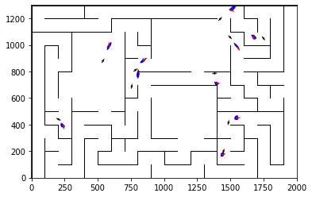

epoch 481 >> motion_mle: 11.01+-0.34/10.60+-0.21 --

epoch 482 == motion_mle: 10.81+-0.28/10.79+-0.22 --

epoch 483 == motion_mle: 10.48+-0.27/10.70+-0.20 --

epoch 484 == motion_mle: 10.85+-0.28/10.77+-0.18 --

epoch 485 == motion_mle: 10.99+-0.26/10.80+-0.19 --

epoch 486 == motion_mle: 10.67+-0.23/10.61+-0.20 --

epoch 487 == motion_mle: 11.02+-0.30/10.92+-0.19 --

epoch 488 == motion_mle: 10.85+-0.32/10.73+-0.21 --

epoch 489 == motion_mle: 10.88+-0.32/10.78+-0.21 --

epoch 490 == motion_mle: 10.34+-0.35/10.67+-0.22 --

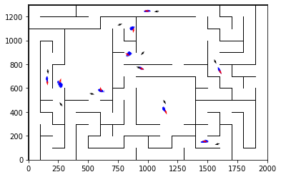

epoch 491 == motion_mle: 10.97+-0.32/10.63+-0.19 --

epoch 492 == motion_mle: 10.85+-0.30/10.65+-0.20 --

epoch 493 == motion_mle: 10.69+-0.27/10.83+-0.20 --

epoch 494 == motion_mle: 10.58+-0.29/10.87+-0.23 --

epoch 495 == motion_mle: 10.37+-0.27/11.02+-0.20 --

epoch 496 == motion_mle: 10.88+-0.30/10.98+-0.20 --

epoch 497 == motion_mle: 10.94+-0.31/10.77+-0.19 --

epoch 498 == motion_mle: 10.48+-0.30/10.75+-0.22 --

epoch 499 == motion_mle: 10.95+-0.29/10.95+-0.20 --

epoch 500 == motion_mle: 10.54+-0.28/10.62+-0.19 --

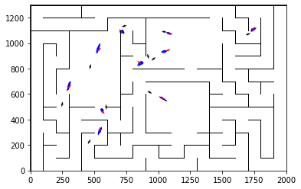

epoch 501 == motion_mle: 10.80+-0.31/10.74+-0.20 --

epoch 502 == motion_mle: 10.79+-0.29/10.74+-0.21 --

epoch 503 >> motion_mle: 10.73+-0.35/10.49+-0.19 --

epoch 504 == motion_mle: 10.73+-0.23/10.60+-0.20 --

epoch 505 == motion_mle: 10.72+-0.33/10.71+-0.19 --

epoch 506 == motion_mle: 10.37+-0.29/10.60+-0.20 --

epoch 507 == motion_mle: 10.19+-0.24/10.83+-0.19 --

epoch 508 == motion_mle: 10.48+-0.28/10.68+-0.20 --

epoch 509 == motion_mle: 10.74+-0.30/10.84+-0.19 --

epoch 510 == motion_mle: 10.80+-0.30/10.60+-0.21 --

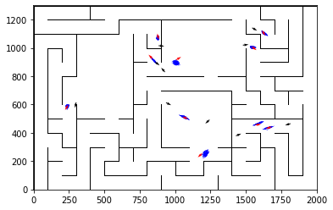

epoch 511 == motion_mle: 10.90+-0.27/10.63+-0.20 --

epoch 512 == motion_mle: 10.89+-0.26/10.99+-0.20 --

epoch 513 == motion_mle: 10.78+-0.25/10.74+-0.20 --

epoch 514 == motion_mle: 10.41+-0.27/10.56+-0.20 --

epoch 515 == motion_mle: 10.66+-0.28/10.96+-0.20 --

epoch 516 == motion_mle: 11.17+-0.35/10.68+-0.19 --

epoch 517 == motion_mle: 10.64+-0.26/10.57+-0.19 --

epoch 518 == motion_mle: 10.42+-0.27/10.65+-0.20 --

epoch 519 == motion_mle: 10.90+-0.31/10.70+-0.21 --

epoch 520 >> motion_mle: 10.74+-0.30/10.37+-0.21 --

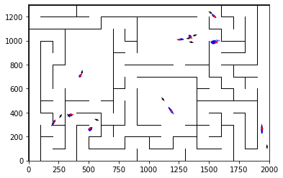

epoch 521 == motion_mle: 10.13+-0.21/10.62+-0.21 --

epoch 522 == motion_mle: 10.94+-0.24/10.62+-0.21 --

epoch 523 == motion_mle: 11.13+-0.30/10.74+-0.20 --

epoch 524 == motion_mle: 10.55+-0.24/10.62+-0.20 --

epoch 525 == motion_mle: 10.88+-0.29/10.73+-0.20 --

epoch 526 == motion_mle: 10.14+-0.26/10.94+-0.20 --

epoch 527 == motion_mle: 10.72+-0.25/10.70+-0.20 --

epoch 528 == motion_mle: 10.91+-0.34/10.60+-0.21 --

epoch 529 == motion_mle: 10.55+-0.31/10.61+-0.20 --

epoch 530 == motion_mle: 10.17+-0.28/10.49+-0.20 --

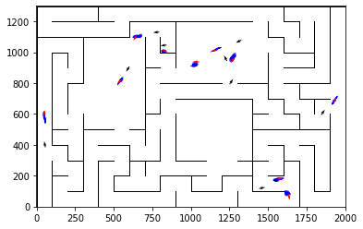

epoch 531 == motion_mle: 10.67+-0.35/10.81+-0.21 --

epoch 532 == motion_mle: 10.45+-0.30/10.70+-0.22 --

epoch 533 == motion_mle: 11.27+-0.34/10.49+-0.21 --

epoch 534 == motion_mle: 9.71+-0.24/10.70+-0.20 --

epoch 535 == motion_mle: 10.63+-0.31/10.65+-0.20 --

epoch 536 == motion_mle: 10.77+-0.28/10.81+-0.22 --

epoch 537 == motion_mle: 10.48+-0.28/10.64+-0.20 --

epoch 538 == motion_mle: 10.34+-0.27/10.67+-0.21 --

epoch 539 == motion_mle: 10.63+-0.31/10.63+-0.21 --

epoch 540 == motion_mle: 10.38+-0.32/10.59+-0.20 --

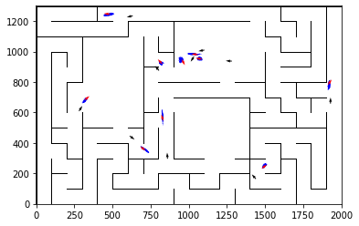

epoch 541 == motion_mle: 10.61+-0.26/10.58+-0.21 --

epoch 542 == motion_mle: 10.29+-0.28/10.91+-0.21 --

epoch 543 == motion_mle: 10.61+-0.27/10.63+-0.19 --

epoch 544 == motion_mle: 10.04+-0.27/10.69+-0.21 --

epoch 545 == motion_mle: 10.50+-0.28/10.57+-0.19 --

epoch 546 == motion_mle: 10.45+-0.29/10.76+-0.19 --

epoch 547 == motion_mle: 10.52+-0.26/10.50+-0.21 --

epoch 548 == motion_mle: 10.73+-0.28/10.53+-0.19 --

epoch 549 == motion_mle: 10.70+-0.26/10.79+-0.20 --

epoch 550 == motion_mle: 10.32+-0.31/10.64+-0.20 --

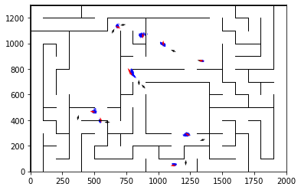

epoch 551 == motion_mle: 10.49+-0.29/10.61+-0.20 --

epoch 552 >> motion_mle: 10.20+-0.26/10.32+-0.22 --

epoch 553 == motion_mle: 10.37+-0.28/10.77+-0.20 --

epoch 554 == motion_mle: 10.82+-0.25/10.35+-0.20 --

epoch 555 == motion_mle: 9.95+-0.25/10.48+-0.21 --

epoch 556 == motion_mle: 10.70+-0.23/10.70+-0.21 --

epoch 557 == motion_mle: 10.23+-0.34/10.57+-0.22 --

epoch 558 == motion_mle: 11.12+-0.30/10.56+-0.19 --

epoch 559 == motion_mle: 10.74+-0.32/10.62+-0.20 --

epoch 560 == motion_mle: 10.61+-0.33/10.73+-0.20 --

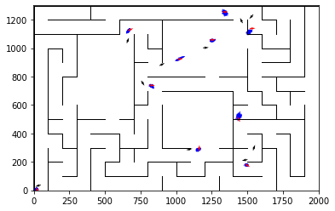

epoch 561 == motion_mle: 10.41+-0.32/10.59+-0.19 --

epoch 562 == motion_mle: 10.70+-0.25/10.72+-0.20 --

epoch 563 == motion_mle: 10.54+-0.28/10.67+-0.19 --

epoch 564 == motion_mle: 10.03+-0.31/10.54+-0.19 --

epoch 565 >> motion_mle: 10.05+-0.29/10.29+-0.19 --

epoch 566 == motion_mle: 10.67+-0.25/10.52+-0.18 --

epoch 567 == motion_mle: 10.36+-0.29/10.59+-0.21 --

epoch 568 == motion_mle: 10.38+-0.30/10.32+-0.20 --

epoch 569 == motion_mle: 10.33+-0.29/10.56+-0.22 --

epoch 570 == motion_mle: 10.70+-0.38/10.57+-0.21 --

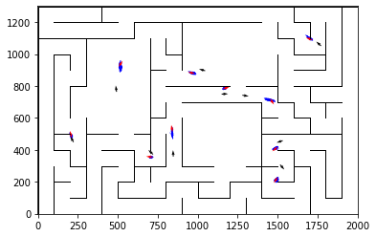

epoch 571 == motion_mle: 10.48+-0.29/10.34+-0.20 --

epoch 572 == motion_mle: 10.83+-0.34/10.46+-0.20 --

epoch 573 == motion_mle: 10.50+-0.32/10.41+-0.20 --

epoch 574 == motion_mle: 10.19+-0.33/10.48+-0.19 --

epoch 575 == motion_mle: 10.15+-0.26/10.49+-0.20 --

epoch 576 == motion_mle: 10.22+-0.21/10.89+-0.20 --

epoch 577 == motion_mle: 10.63+-0.27/10.39+-0.21 --

epoch 578 == motion_mle: 10.09+-0.26/10.60+-0.21 --

epoch 579 == motion_mle: 10.88+-0.26/10.49+-0.20 --

epoch 580 == motion_mle: 10.20+-0.30/10.40+-0.19 --

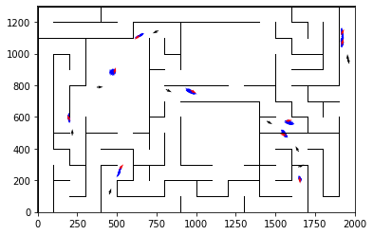

epoch 581 >> motion_mle: 10.09+-0.30/10.18+-0.20 --

epoch 582 == motion_mle: 10.77+-0.30/10.60+-0.22 --

epoch 583 == motion_mle: 10.31+-0.26/10.46+-0.22 --

epoch 584 == motion_mle: 10.85+-0.26/10.57+-0.21 --

epoch 585 == motion_mle: 10.37+-0.29/10.23+-0.19 --

epoch 586 == motion_mle: 10.37+-0.27/10.31+-0.20 --

epoch 587 == motion_mle: 10.37+-0.26/10.31+-0.20 --

epoch 588 == motion_mle: 10.77+-0.29/10.46+-0.20 --

epoch 589 == motion_mle: 10.04+-0.28/10.37+-0.19 --

epoch 590 == motion_mle: 10.08+-0.30/10.56+-0.22 --

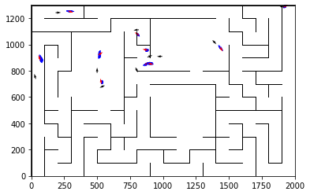

epoch 591 == motion_mle: 10.55+-0.30/10.37+-0.20 --

epoch 592 == motion_mle: 9.93+-0.29/10.38+-0.19 --

epoch 593 == motion_mle: 10.62+-0.31/10.34+-0.22 --

epoch 594 == motion_mle: 10.63+-0.30/10.47+-0.20 --

epoch 595 == motion_mle: 10.25+-0.32/10.58+-0.21 --

epoch 596 == motion_mle: 10.65+-0.24/10.41+-0.19 --

epoch 597 == motion_mle: 10.74+-0.32/10.36+-0.19 --

epoch 598 == motion_mle: 10.54+-0.27/10.56+-0.22 --

epoch 599 == motion_mle: 10.82+-0.31/10.41+-0.21 --

epoch 600 == motion_mle: 10.48+-0.29/10.37+-0.21 --

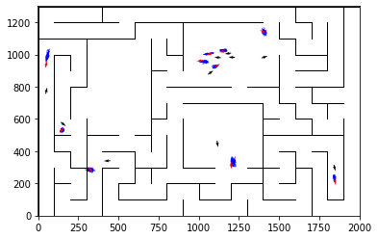

epoch 601 == motion_mle: 10.88+-0.27/10.39+-0.21 --

epoch 602 == motion_mle: 10.10+-0.24/10.37+-0.22 --

epoch 603 == motion_mle: 10.14+-0.32/10.24+-0.21 --

epoch 604 == motion_mle: 10.22+-0.30/10.26+-0.20 --

epoch 605 == motion_mle: 10.48+-0.31/10.63+-0.21 --

epoch 606 == motion_mle: 10.36+-0.27/10.34+-0.20 --

epoch 607 == motion_mle: 10.68+-0.30/10.23+-0.20 --

epoch 608 == motion_mle: 10.90+-0.27/10.28+-0.19 --

epoch 609 == motion_mle: 11.15+-0.27/10.40+-0.21 --

epoch 610 == motion_mle: 10.52+-0.25/10.42+-0.21 --

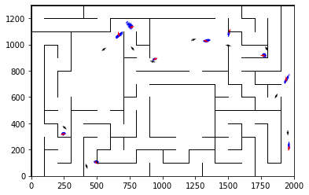

epoch 611 == motion_mle: 10.72+-0.25/10.47+-0.21 --

epoch 612 == motion_mle: 10.15+-0.27/10.33+-0.20 --

epoch 613 == motion_mle: 10.54+-0.26/10.54+-0.20 --

epoch 614 == motion_mle: 10.37+-0.32/10.36+-0.21 --

epoch 615 == motion_mle: 10.59+-0.26/10.44+-0.21 --

epoch 616 == motion_mle: 10.58+-0.29/10.55+-0.20 --

epoch 617 == motion_mle: 10.44+-0.23/10.34+-0.20 --

epoch 618 == motion_mle: 10.29+-0.27/10.53+-0.20 --

epoch 619 == motion_mle: 10.46+-0.27/10.28+-0.21 --

epoch 620 == motion_mle: 10.32+-0.26/10.34+-0.19 --

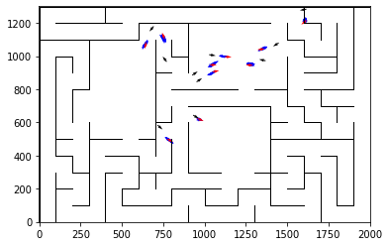

epoch 621 == motion_mle: 9.94+-0.32/10.45+-0.21 --

epoch 622 == motion_mle: 10.42+-0.24/10.33+-0.20 --

epoch 623 == motion_mle: 10.30+-0.22/10.34+-0.18 --

epoch 624 == motion_mle: 9.82+-0.30/10.23+-0.20 --

epoch 625 == motion_mle: 10.89+-0.28/10.29+-0.21 --

epoch 626 == motion_mle: 10.08+-0.31/10.38+-0.20 --

epoch 627 == motion_mle: 10.16+-0.28/10.43+-0.21 --

epoch 628 == motion_mle: 10.18+-0.32/10.47+-0.22 --

epoch 629 == motion_mle: 10.45+-0.28/10.43+-0.19 --

epoch 630 == motion_mle: 11.03+-0.26/10.43+-0.20 --

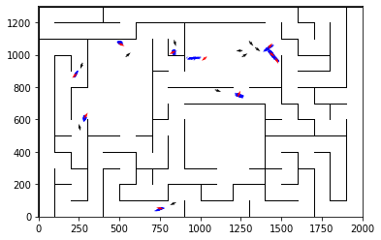

epoch 631 == motion_mle: 10.68+-0.28/10.47+-0.21 --

epoch 632 == motion_mle: 9.92+-0.32/10.38+-0.21 --

epoch 633 == motion_mle: 10.15+-0.27/10.37+-0.20 --

epoch 634 == motion_mle: 10.31+-0.27/10.41+-0.22 --

epoch 635 == motion_mle: 10.69+-0.29/10.34+-0.20 --

epoch 636 == motion_mle: 10.34+-0.32/10.26+-0.21 --

epoch 637 == motion_mle: 10.07+-0.29/10.22+-0.19 --

epoch 638 == motion_mle: 10.77+-0.30/10.25+-0.19 --

epoch 639 == motion_mle: 10.70+-0.28/10.32+-0.20 --

epoch 640 == motion_mle: 9.97+-0.31/10.44+-0.19 --

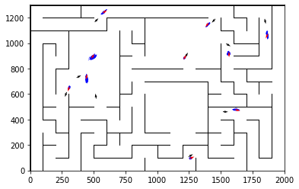

epoch 641 == motion_mle: 10.10+-0.26/10.55+-0.20 --

epoch 642 == motion_mle: 10.16+-0.28/10.33+-0.22 --

epoch 643 == motion_mle: 10.24+-0.26/10.28+-0.19 --

epoch 644 == motion_mle: 10.16+-0.29/10.51+-0.22 --

epoch 645 == motion_mle: 10.33+-0.30/10.44+-0.21 --

epoch 646 == motion_mle: 10.39+-0.32/10.40+-0.21 --

epoch 647 == motion_mle: 10.15+-0.24/10.44+-0.18 --

epoch 648 == motion_mle: 10.61+-0.26/10.38+-0.21 --

epoch 649 == motion_mle: 10.49+-0.28/10.42+-0.21 --

epoch 650 == motion_mle: 10.51+-0.30/10.19+-0.21 --

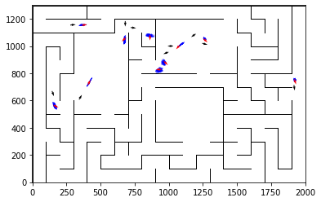

epoch 651 == motion_mle: 10.66+-0.29/10.29+-0.22 --

epoch 652 == motion_mle: 10.70+-0.33/10.38+-0.19 --

epoch 653 == motion_mle: 9.87+-0.30/10.35+-0.22 --

epoch 654 >> motion_mle: 11.03+-0.27/10.16+-0.19 --

epoch 655 == motion_mle: 10.33+-0.35/10.20+-0.19 --

epoch 656 == motion_mle: 11.09+-0.32/10.54+-0.22 --

epoch 657 == motion_mle: 10.25+-0.27/10.35+-0.21 --

epoch 658 == motion_mle: 10.83+-0.30/10.44+-0.20 --

epoch 659 == motion_mle: 10.73+-0.32/10.70+-0.21 --

epoch 660 == motion_mle: 10.47+-0.28/10.30+-0.22 --

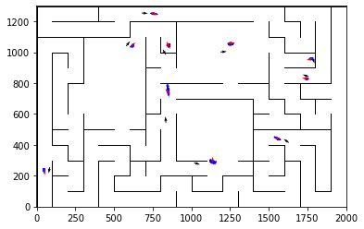

epoch 661 == motion_mle: 10.53+-0.28/10.37+-0.20 --

epoch 662 == motion_mle: 10.33+-0.28/10.31+-0.21 --

epoch 663 == motion_mle: 10.51+-0.29/10.58+-0.21 --

epoch 664 == motion_mle: 10.13+-0.28/10.22+-0.22 --

epoch 665 == motion_mle: 10.57+-0.27/10.48+-0.21 --

epoch 666 == motion_mle: 10.51+-0.31/10.29+-0.22 --

epoch 667 == motion_mle: 10.42+-0.23/10.32+-0.20 --

epoch 668 == motion_mle: 10.30+-0.27/10.32+-0.20 --

epoch 669 == motion_mle: 10.67+-0.20/10.29+-0.20 --

epoch 670 == motion_mle: 9.99+-0.24/10.22+-0.21 --

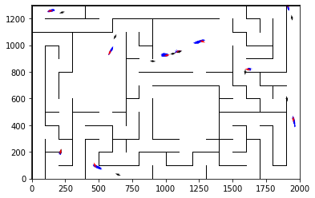

epoch 671 == motion_mle: 10.02+-0.31/10.29+-0.22 --

epoch 672 == motion_mle: 10.45+-0.30/10.41+-0.20 --

epoch 673 == motion_mle: 9.75+-0.26/10.27+-0.20 --

epoch 674 >> motion_mle: 10.06+-0.31/10.08+-0.19 --

epoch 675 == motion_mle: 10.44+-0.32/10.24+-0.20 --

epoch 676 == motion_mle: 10.59+-0.34/10.75+-0.21 --

epoch 677 == motion_mle: 10.21+-0.29/10.19+-0.21 --

epoch 678 == motion_mle: 9.81+-0.32/10.26+-0.20 --

epoch 679 == motion_mle: 10.00+-0.28/10.28+-0.21 --

epoch 680 == motion_mle: 10.75+-0.25/10.35+-0.21 --

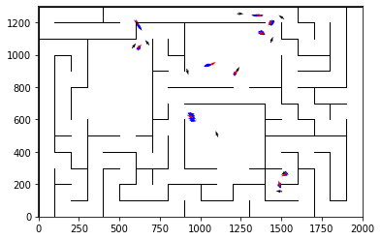

epoch 681 == motion_mle: 10.95+-0.28/10.42+-0.22 --

epoch 682 == motion_mle: 10.16+-0.31/10.39+-0.19 --

epoch 683 == motion_mle: 10.58+-0.25/10.37+-0.20 --

epoch 684 == motion_mle: 10.42+-0.27/10.32+-0.22 --

epoch 685 == motion_mle: 10.88+-0.32/10.19+-0.20 --

epoch 686 == motion_mle: 10.51+-0.30/10.48+-0.20 --

epoch 687 == motion_mle: 9.97+-0.31/10.19+-0.21 --

epoch 688 == motion_mle: 9.92+-0.27/10.28+-0.21 --

epoch 689 == motion_mle: 10.55+-0.33/10.42+-0.20 --

epoch 690 == motion_mle: 10.05+-0.28/10.25+-0.21 --

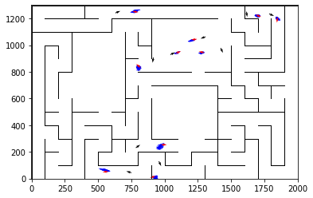

epoch 691 == motion_mle: 10.13+-0.32/10.38+-0.22 --

epoch 692 == motion_mle: 10.56+-0.28/10.34+-0.20 --

epoch 693 == motion_mle: 10.23+-0.27/10.34+-0.20 --

epoch 694 == motion_mle: 10.61+-0.31/10.20+-0.21 --

epoch 695 == motion_mle: 10.46+-0.27/10.33+-0.21 --

epoch 696 == motion_mle: 10.16+-0.32/10.31+-0.19 --

epoch 697 >> motion_mle: 10.68+-0.27/10.03+-0.19 --

epoch 698 == motion_mle: 10.48+-0.27/10.35+-0.21 --

epoch 699 == motion_mle: 10.76+-0.28/10.37+-0.20 --

epoch 700 == motion_mle: 10.69+-0.27/10.29+-0.21 --

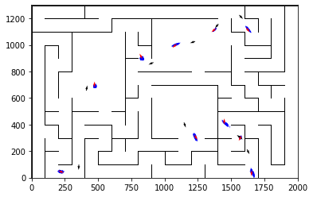

epoch 701 == motion_mle: 10.61+-0.29/10.26+-0.20 --

epoch 702 == motion_mle: 10.69+-0.28/10.19+-0.22 --

epoch 703 == motion_mle: 10.28+-0.26/10.25+-0.21 --

epoch 704 == motion_mle: 9.95+-0.28/10.13+-0.21 --

epoch 705 == motion_mle: 10.57+-0.31/10.38+-0.21 --

epoch 706 == motion_mle: 10.28+-0.29/10.22+-0.20 --

epoch 707 == motion_mle: 10.31+-0.29/10.33+-0.20 --

epoch 708 == motion_mle: 9.95+-0.31/10.47+-0.21 --

epoch 709 == motion_mle: 10.57+-0.36/10.17+-0.21 --

epoch 710 == motion_mle: 9.97+-0.29/10.20+-0.19 --

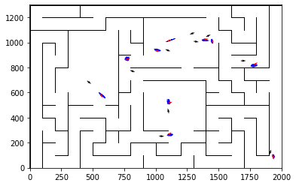

epoch 711 == motion_mle: 9.75+-0.33/10.36+-0.20 --

epoch 712 == motion_mle: 10.30+-0.33/10.18+-0.20 --

epoch 713 == motion_mle: 10.35+-0.28/10.75+-0.20 --

epoch 714 == motion_mle: 9.98+-0.32/10.34+-0.20 --

epoch 715 == motion_mle: 9.98+-0.27/10.23+-0.20 --

epoch 716 == motion_mle: 10.17+-0.26/10.27+-0.22 --

epoch 717 == motion_mle: 10.48+-0.31/10.09+-0.20 --

epoch 718 == motion_mle: 9.84+-0.30/10.27+-0.20 --

epoch 719 == motion_mle: 9.96+-0.29/10.22+-0.19 --

epoch 720 == motion_mle: 9.52+-0.25/10.29+-0.21 --

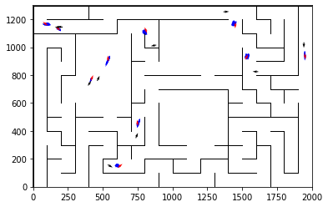

epoch 721 >> motion_mle: 9.77+-0.31/9.99+-0.19 --

epoch 722 == motion_mle: 10.83+-0.28/10.17+-0.21 --

epoch 723 == motion_mle: 10.63+-0.32/10.38+-0.20 --

epoch 724 == motion_mle: 10.24+-0.25/10.26+-0.21 --

epoch 725 == motion_mle: 10.28+-0.29/10.46+-0.20 --

epoch 726 == motion_mle: 10.13+-0.25/10.20+-0.20 --

epoch 727 == motion_mle: 10.58+-0.24/10.28+-0.21 --

epoch 728 == motion_mle: 10.29+-0.34/10.43+-0.21 --

epoch 729 == motion_mle: 10.02+-0.35/10.24+-0.20 --

epoch 730 == motion_mle: 10.23+-0.31/10.27+-0.22 --

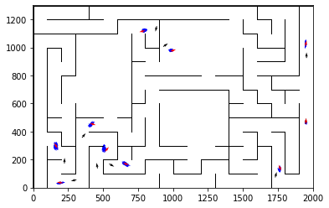

epoch 731 == motion_mle: 10.48+-0.31/10.33+-0.21 --

epoch 732 == motion_mle: 10.07+-0.32/10.28+-0.20 --

epoch 733 == motion_mle: 9.69+-0.28/10.25+-0.20 --

epoch 734 == motion_mle: 10.37+-0.26/10.23+-0.20 --

epoch 735 == motion_mle: 10.43+-0.27/10.15+-0.20 --

epoch 736 == motion_mle: 9.83+-0.27/10.42+-0.20 --

epoch 737 == motion_mle: 10.54+-0.23/10.28+-0.21 --

epoch 738 == motion_mle: 10.11+-0.29/10.23+-0.21 --

epoch 739 == motion_mle: 9.97+-0.33/10.26+-0.21 --

epoch 740 == motion_mle: 11.02+-0.31/10.41+-0.20 --

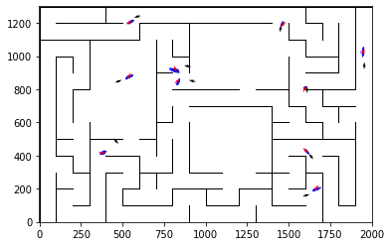

epoch 741 == motion_mle: 10.28+-0.30/10.16+-0.20 --

epoch 742 == motion_mle: 9.91+-0.29/10.24+-0.19 --

epoch 743 == motion_mle: 10.42+-0.26/10.09+-0.19 --

epoch 744 == motion_mle: 10.04+-0.27/10.24+-0.21 --

epoch 745 == motion_mle: 10.29+-0.31/10.17+-0.22 --

epoch 746 == motion_mle: 9.99+-0.31/10.04+-0.20 --

epoch 747 == motion_mle: 10.09+-0.27/10.22+-0.21 --

epoch 748 == motion_mle: 10.30+-0.23/10.40+-0.21 --

epoch 749 == motion_mle: 10.59+-0.26/10.35+-0.19 --

epoch 750 == motion_mle: 10.14+-0.26/10.18+-0.21 --

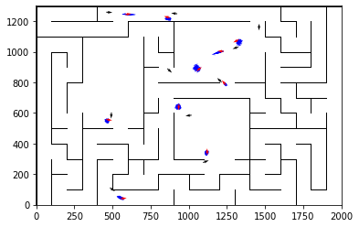

epoch 751 == motion_mle: 9.94+-0.25/10.32+-0.21 --

epoch 752 == motion_mle: 10.21+-0.26/10.21+-0.21 --

epoch 753 == motion_mle: 10.16+-0.28/10.33+-0.20 --

epoch 754 == motion_mle: 10.04+-0.27/10.20+-0.22 --

epoch 755 == motion_mle: 9.52+-0.29/10.22+-0.20 --

epoch 756 == motion_mle: 10.44+-0.26/10.25+-0.21 --

epoch 757 == motion_mle: 10.70+-0.26/10.20+-0.19 --

epoch 758 == motion_mle: 10.28+-0.30/10.21+-0.21 --

epoch 759 == motion_mle: 10.62+-0.32/10.38+-0.21 --

epoch 760 == motion_mle: 10.47+-0.29/10.35+-0.21 --

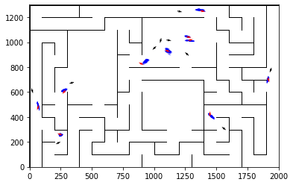

epoch 761 == motion_mle: 10.26+-0.30/10.18+-0.20 --

epoch 762 == motion_mle: 10.26+-0.26/10.31+-0.20 --

epoch 763 == motion_mle: 10.34+-0.33/10.29+-0.20 --

epoch 764 == motion_mle: 10.40+-0.27/10.20+-0.20 --

epoch 765 == motion_mle: 10.00+-0.32/10.28+-0.20 --

epoch 766 == motion_mle: 10.26+-0.30/10.12+-0.22 --

epoch 767 == motion_mle: 10.21+-0.32/10.21+-0.20 --

epoch 768 == motion_mle: 10.16+-0.28/10.25+-0.19 --

epoch 769 == motion_mle: 10.37+-0.29/10.08+-0.21 --

epoch 770 == motion_mle: 10.13+-0.27/10.24+-0.19 --

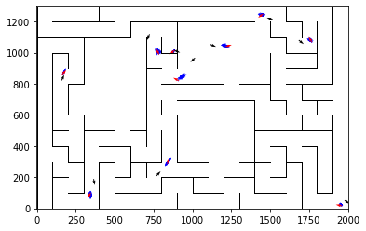

epoch 771 == motion_mle: 10.03+-0.30/10.12+-0.21 --

epoch 772 == motion_mle: 10.18+-0.23/10.10+-0.19 --

epoch 773 == motion_mle: 10.23+-0.29/10.29+-0.20 --

epoch 774 >> motion_mle: 10.54+-0.30/9.97+-0.19 --

epoch 775 == motion_mle: 10.07+-0.27/10.24+-0.21 --

epoch 776 == motion_mle: 10.27+-0.32/10.37+-0.20 --

epoch 777 == motion_mle: 10.51+-0.32/10.14+-0.21 --

epoch 778 == motion_mle: 10.04+-0.25/10.16+-0.20 --

epoch 779 == motion_mle: 10.38+-0.29/10.26+-0.20 --

epoch 780 == motion_mle: 10.16+-0.25/10.31+-0.20 --

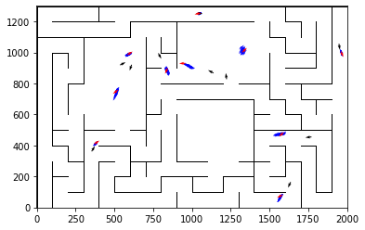

epoch 781 == motion_mle: 10.05+-0.27/10.31+-0.19 --

epoch 782 == motion_mle: 9.62+-0.22/10.28+-0.21 --

epoch 783 == motion_mle: 10.14+-0.26/10.33+-0.21 --

epoch 784 == motion_mle: 10.09+-0.31/10.14+-0.21 --

epoch 785 == motion_mle: 10.17+-0.26/10.22+-0.20 --

epoch 786 == motion_mle: 10.27+-0.24/10.15+-0.20 --

epoch 787 == motion_mle: 10.08+-0.29/10.12+-0.20 --

epoch 788 == motion_mle: 10.80+-0.33/10.37+-0.21 --

epoch 789 == motion_mle: 10.37+-0.25/10.34+-0.19 --

epoch 790 == motion_mle: 10.60+-0.32/10.18+-0.20 --

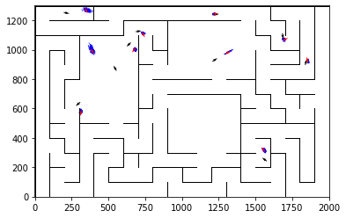

epoch 791 == motion_mle: 10.07+-0.27/10.02+-0.20 --

epoch 792 == motion_mle: 10.68+-0.24/10.40+-0.23 --

epoch 793 == motion_mle: 10.68+-0.29/10.32+-0.20 --

epoch 794 == motion_mle: 10.26+-0.27/10.08+-0.21 --

epoch 795 == motion_mle: 10.93+-0.28/10.15+-0.21 --

epoch 796 == motion_mle: 10.25+-0.30/10.12+-0.21 --

epoch 797 == motion_mle: 10.19+-0.34/10.05+-0.20 --

epoch 798 == motion_mle: 10.45+-0.28/10.29+-0.21 --

epoch 799 == motion_mle: 10.15+-0.35/9.99+-0.20 --

epoch 800 == motion_mle: 9.99+-0.32/10.08+-0.19 --

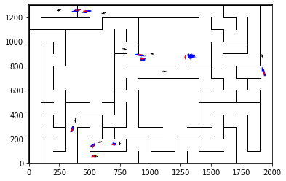

epoch 801 == motion_mle: 9.86+-0.27/10.25+-0.20 --

epoch 802 == motion_mle: 10.42+-0.30/10.10+-0.19 --

epoch 803 == motion_mle: 10.41+-0.26/10.13+-0.20 --

epoch 804 == motion_mle: 10.04+-0.24/10.15+-0.20 --

epoch 805 == motion_mle: 10.33+-0.32/10.10+-0.21 --

epoch 806 == motion_mle: 10.00+-0.28/10.31+-0.20 --

epoch 807 == motion_mle: 9.90+-0.30/10.03+-0.20 --

epoch 808 == motion_mle: 10.06+-0.26/10.35+-0.20 --

epoch 809 >> motion_mle: 10.07+-0.32/9.92+-0.20 --

epoch 810 == motion_mle: 10.62+-0.29/10.20+-0.21 --

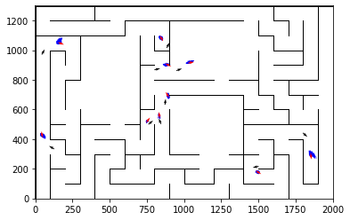

epoch 811 == motion_mle: 10.26+-0.28/10.27+-0.20 --

epoch 812 == motion_mle: 9.52+-0.27/10.16+-0.20 --

epoch 813 == motion_mle: 10.89+-0.28/10.06+-0.20 --

epoch 814 == motion_mle: 10.03+-0.28/10.26+-0.20 --

epoch 815 == motion_mle: 10.09+-0.26/10.18+-0.22 --

epoch 816 == motion_mle: 10.38+-0.30/10.15+-0.21 --

epoch 817 == motion_mle: 10.20+-0.27/10.25+-0.20 --

epoch 818 == motion_mle: 10.10+-0.30/10.31+-0.21 --

epoch 819 == motion_mle: 10.26+-0.31/10.18+-0.22 --

epoch 820 == motion_mle: 10.21+-0.28/10.25+-0.20 --

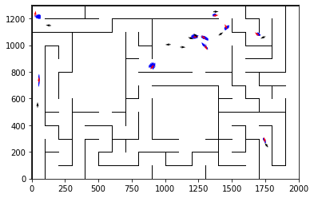

epoch 821 == motion_mle: 9.89+-0.29/10.09+-0.20 --

epoch 822 == motion_mle: 10.62+-0.33/10.26+-0.21 --

epoch 823 == motion_mle: 10.36+-0.29/10.28+-0.19 --

epoch 824 == motion_mle: 10.44+-0.26/10.06+-0.22 --

epoch 825 == motion_mle: 10.22+-0.25/10.19+-0.20 --

epoch 826 == motion_mle: 10.15+-0.29/10.28+-0.19 --

epoch 827 == motion_mle: 10.55+-0.26/10.19+-0.19 --

epoch 828 == motion_mle: 9.67+-0.31/10.17+-0.19 --

epoch 829 == motion_mle: 10.15+-0.29/10.12+-0.19 --

epoch 830 == motion_mle: 10.12+-0.26/10.15+-0.20 --

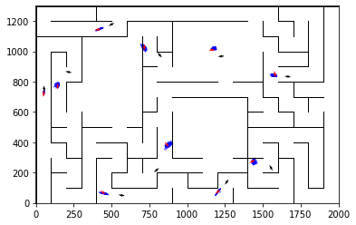

epoch 831 == motion_mle: 10.22+-0.29/10.20+-0.21 --

epoch 832 == motion_mle: 10.85+-0.29/9.96+-0.22 --

epoch 833 == motion_mle: 10.12+-0.26/10.11+-0.20 --

epoch 834 == motion_mle: 9.97+-0.36/10.37+-0.19 --

epoch 835 == motion_mle: 9.76+-0.32/10.16+-0.21 --

epoch 836 == motion_mle: 10.02+-0.23/10.07+-0.21 --

epoch 837 == motion_mle: 10.04+-0.33/10.25+-0.21 --

epoch 838 == motion_mle: 10.16+-0.31/10.10+-0.22 --

epoch 839 == motion_mle: 10.36+-0.32/10.16+-0.20 --

epoch 840 == motion_mle: 10.33+-0.27/10.15+-0.20 --

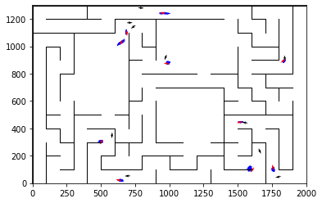

epoch 841 == motion_mle: 9.62+-0.29/10.24+-0.21 --

epoch 842 == motion_mle: 10.09+-0.30/10.05+-0.21 --

epoch 843 == motion_mle: 10.15+-0.26/10.16+-0.20 --

epoch 844 == motion_mle: 10.37+-0.27/10.07+-0.21 --

epoch 845 == motion_mle: 10.55+-0.26/10.20+-0.20 --

epoch 846 == motion_mle: 10.38+-0.32/10.34+-0.21 --

epoch 847 == motion_mle: 9.98+-0.31/10.12+-0.20 --

epoch 848 == motion_mle: 10.17+-0.26/10.34+-0.19 --

epoch 849 == motion_mle: 10.28+-0.30/10.19+-0.20 --

epoch 850 == motion_mle: 10.47+-0.25/10.20+-0.19 --

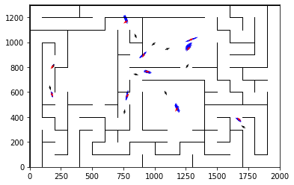

epoch 851 == motion_mle: 10.09+-0.29/10.21+-0.18 --

epoch 852 == motion_mle: 9.84+-0.26/9.96+-0.20 --

epoch 853 == motion_mle: 10.01+-0.26/10.36+-0.21 --

epoch 854 == motion_mle: 10.39+-0.31/10.05+-0.22 --

epoch 855 == motion_mle: 10.61+-0.28/10.19+-0.20 --

epoch 856 == motion_mle: 9.93+-0.28/10.21+-0.21 --

epoch 857 == motion_mle: 9.93+-0.29/10.20+-0.22 --

epoch 858 == motion_mle: 9.87+-0.27/10.11+-0.21 --

epoch 859 == motion_mle: 10.35+-0.27/10.14+-0.21 --

epoch 860 == motion_mle: 10.41+-0.29/10.29+-0.20 --

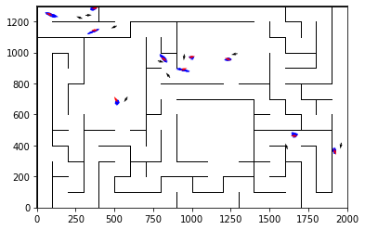

epoch 861 == motion_mle: 9.78+-0.24/10.11+-0.22 --

epoch 862 == motion_mle: 10.03+-0.29/10.24+-0.21 --

epoch 863 == motion_mle: 9.95+-0.31/10.23+-0.21 --

epoch 864 == motion_mle: 10.33+-0.27/10.20+-0.20 --

epoch 865 == motion_mle: 10.48+-0.31/10.18+-0.19 --

epoch 866 == motion_mle: 10.52+-0.26/10.07+-0.20 --

epoch 867 == motion_mle: 11.05+-0.32/10.17+-0.20 --

epoch 868 == motion_mle: 10.35+-0.29/10.17+-0.19 --

epoch 869 == motion_mle: 9.84+-0.23/10.10+-0.21 --

epoch 870 == motion_mle: 9.68+-0.31/10.27+-0.20 --

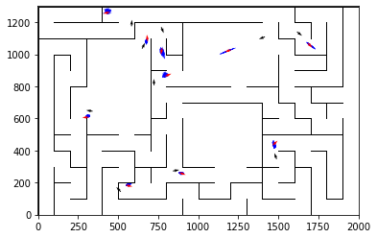

epoch 871 == motion_mle: 9.94+-0.21/10.13+-0.21 --

epoch 872 == motion_mle: 10.11+-0.31/10.19+-0.19 --

epoch 873 == motion_mle: 10.08+-0.27/10.09+-0.20 --

epoch 874 == motion_mle: 10.42+-0.30/10.16+-0.22 --

epoch 875 == motion_mle: 9.85+-0.32/10.17+-0.20 --

epoch 876 == motion_mle: 10.24+-0.32/10.10+-0.20 --

epoch 877 == motion_mle: 10.52+-0.27/10.15+-0.21 --

epoch 878 == motion_mle: 10.45+-0.33/10.40+-0.19 --

epoch 879 == motion_mle: 10.49+-0.31/9.98+-0.21 --

epoch 880 == motion_mle: 10.45+-0.28/10.04+-0.19 --

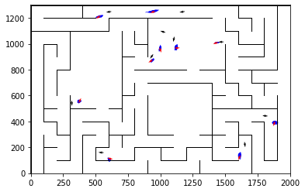

epoch 881 == motion_mle: 9.97+-0.29/10.25+-0.22 --

epoch 882 == motion_mle: 10.15+-0.30/10.00+-0.18 --

epoch 883 == motion_mle: 9.84+-0.30/10.19+-0.19 --

epoch 884 == motion_mle: 10.58+-0.25/10.13+-0.19 --

epoch 885 == motion_mle: 10.06+-0.31/10.21+-0.20 --

epoch 886 == motion_mle: 10.00+-0.34/10.06+-0.20 --

epoch 887 == motion_mle: 10.33+-0.31/10.20+-0.20 --

epoch 888 == motion_mle: 9.74+-0.33/10.04+-0.20 --

epoch 889 == motion_mle: 10.20+-0.28/10.12+-0.21 --

epoch 890 == motion_mle: 10.00+-0.31/10.24+-0.21 --

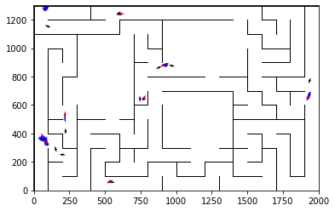

epoch 891 == motion_mle: 10.15+-0.28/10.17+-0.21 --

epoch 892 == motion_mle: 9.87+-0.28/10.04+-0.20 --

epoch 893 == motion_mle: 10.31+-0.27/9.94+-0.19 --

epoch 894 == motion_mle: 10.02+-0.30/9.94+-0.20 --

epoch 895 == motion_mle: 10.10+-0.25/10.08+-0.20 --

epoch 896 == motion_mle: 10.57+-0.37/10.00+-0.21 --

epoch 897 == motion_mle: 10.08+-0.30/10.14+-0.20 --

epoch 898 == motion_mle: 10.40+-0.33/9.94+-0.21 --

epoch 899 == motion_mle: 9.55+-0.27/10.23+-0.21 --

epoch 900 == motion_mle: 10.01+-0.26/10.16+-0.20 --

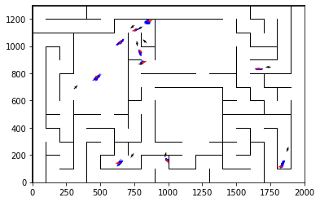

epoch 901 == motion_mle: 10.48+-0.30/9.96+-0.21 --

epoch 902 == motion_mle: 10.02+-0.33/10.10+-0.20 --

epoch 903 == motion_mle: 9.51+-0.28/10.21+-0.21 --

epoch 904 == motion_mle: 10.24+-0.29/10.31+-0.20 --

epoch 905 == motion_mle: 10.53+-0.31/10.00+-0.21 --

epoch 906 == motion_mle: 10.08+-0.34/10.02+-0.20 --

epoch 907 == motion_mle: 10.49+-0.31/10.10+-0.20 --

epoch 908 == motion_mle: 10.06+-0.30/10.20+-0.20 --

epoch 909 == motion_mle: 10.89+-0.31/10.21+-0.20 --

epoch 910 == motion_mle: 10.45+-0.30/10.07+-0.20 --

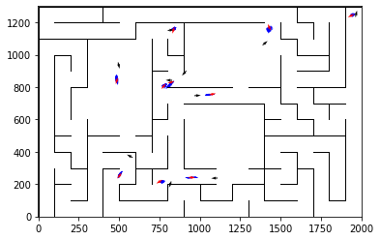

epoch 911 == motion_mle: 10.11+-0.29/10.22+-0.20 --

epoch 912 == motion_mle: 9.89+-0.30/10.16+-0.22 --

epoch 913 == motion_mle: 9.47+-0.27/9.97+-0.20 --

epoch 914 == motion_mle: 10.35+-0.27/10.02+-0.20 --

epoch 915 == motion_mle: 10.16+-0.30/10.08+-0.19 --

epoch 916 == motion_mle: 10.44+-0.28/10.06+-0.21 --

epoch 917 == motion_mle: 9.94+-0.22/10.02+-0.20 --

epoch 918 == motion_mle: 9.64+-0.27/10.20+-0.19 --

epoch 919 == motion_mle: 10.21+-0.32/10.27+-0.22 --

epoch 920 == motion_mle: 9.88+-0.30/10.10+-0.19 --

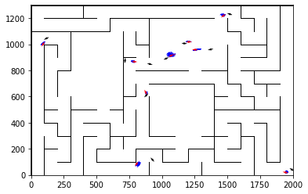

epoch 921 == motion_mle: 10.62+-0.32/10.19+-0.21 --

epoch 922 == motion_mle: 10.07+-0.30/9.93+-0.19 --

epoch 923 == motion_mle: 10.10+-0.27/10.05+-0.19 --

epoch 924 == motion_mle: 10.26+-0.27/10.13+-0.21 --

epoch 925 == motion_mle: 9.90+-0.29/9.97+-0.21 --

epoch 926 >> motion_mle: 9.91+-0.28/9.87+-0.20 --

epoch 927 == motion_mle: 9.99+-0.28/10.04+-0.21 --

epoch 928 == motion_mle: 9.78+-0.28/10.19+-0.21 --

epoch 929 == motion_mle: 9.77+-0.24/10.07+-0.19 --

epoch 930 == motion_mle: 10.27+-0.34/9.99+-0.20 --

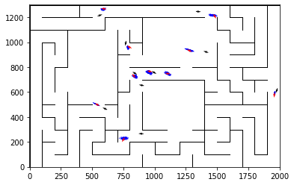

epoch 931 == motion_mle: 10.11+-0.29/10.14+-0.19 --

epoch 932 == motion_mle: 10.37+-0.31/10.25+-0.20 --

epoch 933 == motion_mle: 9.79+-0.27/10.32+-0.20 --

epoch 934 == motion_mle: 10.58+-0.28/10.30+-0.19 --

epoch 935 == motion_mle: 9.98+-0.26/10.25+-0.20 --

epoch 936 == motion_mle: 9.77+-0.25/10.23+-0.20 --

epoch 937 == motion_mle: 10.19+-0.24/10.14+-0.22 --

epoch 938 == motion_mle: 10.36+-0.28/9.94+-0.21 --

epoch 939 >> motion_mle: 9.78+-0.30/9.76+-0.19 --

epoch 940 == motion_mle: 9.65+-0.25/10.10+-0.20 --

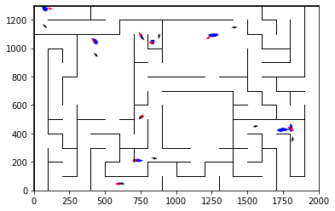

epoch 941 == motion_mle: 10.10+-0.27/10.18+-0.19 --

epoch 942 == motion_mle: 10.60+-0.29/10.18+-0.21 --

epoch 943 == motion_mle: 9.75+-0.34/10.26+-0.19 --

epoch 944 == motion_mle: 10.38+-0.27/10.19+-0.21 --

epoch 945 == motion_mle: 10.06+-0.27/10.24+-0.20 --

epoch 946 == motion_mle: 9.80+-0.29/10.08+-0.20 --

epoch 947 == motion_mle: 9.77+-0.28/10.20+-0.20 --

epoch 948 == motion_mle: 10.30+-0.31/10.21+-0.20 --

epoch 949 == motion_mle: 9.69+-0.28/10.05+-0.21 --

epoch 950 == motion_mle: 9.67+-0.27/9.93+-0.21 --

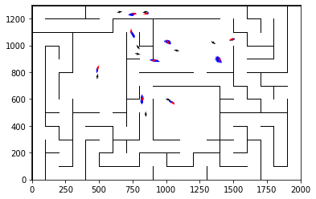

epoch 951 == motion_mle: 10.20+-0.27/10.12+-0.23 --

epoch 952 == motion_mle: 10.05+-0.29/10.11+-0.20 --

epoch 953 == motion_mle: 9.85+-0.30/10.16+-0.21 --

epoch 954 == motion_mle: 10.11+-0.30/10.31+-0.20 --

epoch 955 == motion_mle: 9.79+-0.31/9.98+-0.21 --

epoch 956 == motion_mle: 10.14+-0.27/10.10+-0.20 --

epoch 957 == motion_mle: 10.00+-0.27/10.19+-0.21 --

epoch 958 == motion_mle: 9.80+-0.26/9.97+-0.21 --

epoch 959 == motion_mle: 9.95+-0.30/10.25+-0.21 --

epoch 960 == motion_mle: 9.93+-0.29/10.22+-0.19 --

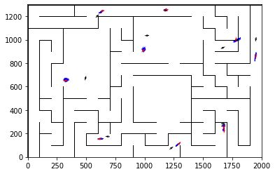

epoch 961 == motion_mle: 9.48+-0.27/10.03+-0.19 --

epoch 962 == motion_mle: 10.18+-0.27/10.11+-0.21 --

epoch 963 == motion_mle: 10.43+-0.33/10.05+-0.19 --

epoch 964 == motion_mle: 9.99+-0.32/9.98+-0.21 --

epoch 965 == motion_mle: 9.86+-0.28/10.08+-0.19 --

epoch 966 == motion_mle: 11.05+-0.27/9.94+-0.20 --

epoch 967 == motion_mle: 10.22+-0.28/10.12+-0.19 --

epoch 968 == motion_mle: 9.50+-0.32/10.22+-0.19 --

epoch 969 == motion_mle: 10.25+-0.30/10.15+-0.20 --

epoch 970 == motion_mle: 10.00+-0.28/9.94+-0.20 --

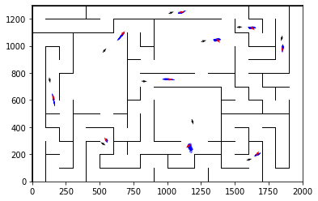

epoch 971 == motion_mle: 9.67+-0.29/9.94+-0.21 --

epoch 972 == motion_mle: 10.03+-0.27/10.11+-0.22 --

epoch 973 == motion_mle: 9.35+-0.28/10.17+-0.21 --

epoch 974 == motion_mle: 10.53+-0.26/10.07+-0.22 --

epoch 975 == motion_mle: 10.92+-0.28/10.16+-0.21 --

epoch 976 == motion_mle: 9.60+-0.31/10.34+-0.20 --

epoch 977 == motion_mle: 9.49+-0.24/10.28+-0.20 --

epoch 978 == motion_mle: 10.16+-0.27/9.98+-0.19 --

epoch 979 == motion_mle: 10.28+-0.29/10.07+-0.20 --

epoch 980 == motion_mle: 10.12+-0.28/10.18+-0.19 --

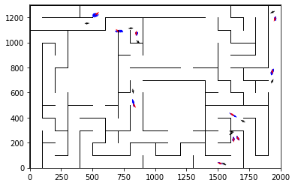

epoch 981 == motion_mle: 10.07+-0.29/10.12+-0.21 --

epoch 982 == motion_mle: 10.28+-0.28/10.15+-0.19 --

epoch 983 == motion_mle: 9.93+-0.28/9.96+-0.19 --

epoch 984 == motion_mle: 10.25+-0.35/10.08+-0.20 --

epoch 985 == motion_mle: 10.04+-0.33/10.07+-0.19 --

epoch 986 == motion_mle: 10.18+-0.29/10.08+-0.18 --

epoch 987 == motion_mle: 9.86+-0.36/10.08+-0.19 --

epoch 988 == motion_mle: 9.86+-0.34/10.11+-0.21 --

epoch 989 == motion_mle: 9.98+-0.31/10.09+-0.20 --

epoch 990 == motion_mle: 9.85+-0.27/10.18+-0.19 --

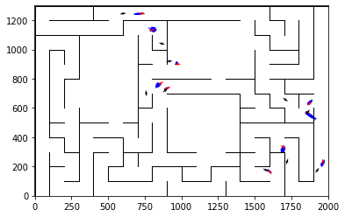

epoch 991 == motion_mle: 9.78+-0.25/10.01+-0.19 --

epoch 992 == motion_mle: 9.83+-0.28/10.04+-0.20 --

epoch 993 == motion_mle: 10.02+-0.24/9.93+-0.18 --

epoch 994 == motion_mle: 9.90+-0.26/10.30+-0.19 --

epoch 995 == motion_mle: 9.85+-0.28/10.13+-0.21 --

epoch 996 == motion_mle: 10.10+-0.25/10.01+-0.20 --

epoch 997 == motion_mle: 9.77+-0.23/10.10+-0.19 --

epoch 998 == motion_mle: 10.43+-0.26/10.19+-0.21 --

epoch 999 == motion_mle: 10.80+-0.33/10.04+-0.19 --

epoch 1000 == motion_mle: 9.57+-0.28/10.17+-0.21 --

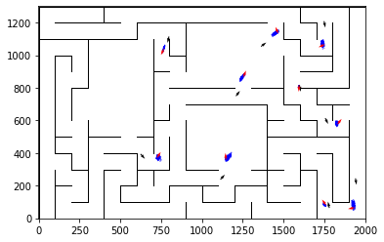

epoch 1001 == motion_mle: 10.02+-0.28/10.15+-0.22 --

epoch 1002 == motion_mle: 9.79+-0.31/10.05+-0.21 --

epoch 1003 == motion_mle: 9.86+-0.22/10.17+-0.21 --

epoch 1004 == motion_mle: 10.43+-0.34/10.03+-0.20 --

epoch 1005 == motion_mle: 9.96+-0.25/9.99+-0.21 --

epoch 1006 == motion_mle: 10.39+-0.27/9.96+-0.21 --

epoch 1007 == motion_mle: 10.12+-0.33/10.16+-0.21 --

epoch 1008 == motion_mle: 10.19+-0.29/10.13+-0.22 --

epoch 1009 == motion_mle: 10.14+-0.29/10.07+-0.21 --

epoch 1010 == motion_mle: 10.22+-0.27/9.78+-0.20 --

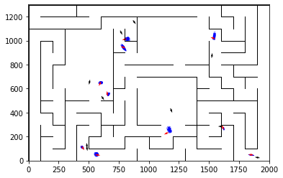

epoch 1011 == motion_mle: 10.74+-0.32/10.30+-0.22 --

epoch 1012 == motion_mle: 10.36+-0.33/10.13+-0.20 --

epoch 1013 == motion_mle: 9.98+-0.25/10.10+-0.21 --

epoch 1014 == motion_mle: 9.94+-0.31/10.10+-0.21 --

epoch 1015 == motion_mle: 10.41+-0.29/10.25+-0.20 --

epoch 1016 == motion_mle: 9.56+-0.25/10.20+-0.20 --

epoch 1017 == motion_mle: 9.49+-0.28/9.86+-0.19 --

epoch 1018 == motion_mle: 10.11+-0.33/10.27+-0.19 --

epoch 1019 == motion_mle: 10.11+-0.32/10.09+-0.20 --

epoch 1020 == motion_mle: 10.16+-0.26/10.04+-0.19 --

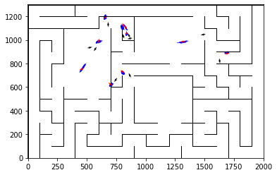

epoch 1021 == motion_mle: 10.34+-0.27/10.24+-0.19 --

epoch 1022 == motion_mle: 10.10+-0.28/10.06+-0.20 --

epoch 1023 == motion_mle: 9.72+-0.30/10.31+-0.18 --

epoch 1024 == motion_mle: 9.75+-0.25/9.92+-0.19 --

epoch 1025 == motion_mle: 9.86+-0.27/10.05+-0.21 --

epoch 1026 == motion_mle: 10.49+-0.30/9.95+-0.19 --

epoch 1027 == motion_mle: 10.52+-0.27/10.22+-0.22 --

epoch 1028 == motion_mle: 10.51+-0.27/10.08+-0.20 --

epoch 1029 == motion_mle: 10.53+-0.24/10.00+-0.21 --

epoch 1030 == motion_mle: 9.81+-0.29/10.06+-0.19 --

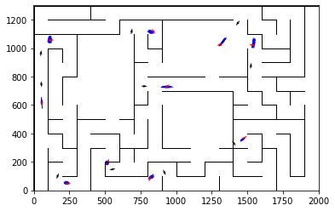

epoch 1031 == motion_mle: 9.56+-0.26/10.06+-0.20 --

epoch 1032 == motion_mle: 10.07+-0.24/10.02+-0.19 --

epoch 1033 == motion_mle: 9.97+-0.29/10.04+-0.22 --

epoch 1034 == motion_mle: 10.63+-0.29/10.27+-0.19 --

epoch 1035 == motion_mle: 10.25+-0.30/10.16+-0.22 --

epoch 1036 == motion_mle: 9.81+-0.32/10.17+-0.19 --

epoch 1037 == motion_mle: 10.23+-0.25/10.14+-0.20 --

epoch 1038 == motion_mle: 10.29+-0.24/10.21+-0.21 --

epoch 1039 == motion_mle: 10.19+-0.29/9.98+-0.19 --

epoch 1040 == motion_mle: 10.01+-0.24/10.01+-0.20 --

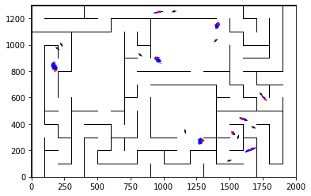

epoch 1041 == motion_mle: 10.25+-0.28/9.96+-0.22 --

epoch 1042 == motion_mle: 9.49+-0.24/10.08+-0.19 --

epoch 1043 == motion_mle: 9.60+-0.24/10.02+-0.18 --

epoch 1044 == motion_mle: 10.40+-0.28/10.03+-0.20 --

epoch 1045 == motion_mle: 10.10+-0.25/10.06+-0.21 --

epoch 1046 == motion_mle: 10.17+-0.25/9.95+-0.17 --

epoch 1047 == motion_mle: 10.15+-0.26/10.06+-0.21 --

epoch 1048 == motion_mle: 10.21+-0.32/9.93+-0.20 --

epoch 1049 == motion_mle: 10.21+-0.28/10.16+-0.19 --

epoch 1050 == motion_mle: 9.51+-0.30/10.34+-0.20 --

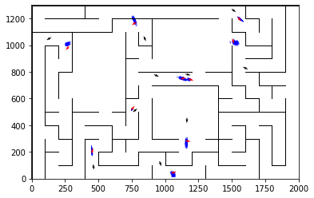

epoch 1051 == motion_mle: 9.80+-0.29/10.04+-0.21 --

epoch 1052 == motion_mle: 10.12+-0.36/9.85+-0.20 --

epoch 1053 == motion_mle: 9.98+-0.31/10.25+-0.21 --

epoch 1054 == motion_mle: 9.78+-0.32/10.05+-0.20 --

epoch 1055 == motion_mle: 10.14+-0.30/10.11+-0.19 --

epoch 1056 == motion_mle: 10.20+-0.30/9.91+-0.20 --

epoch 1057 == motion_mle: 9.65+-0.29/10.07+-0.19 --

epoch 1058 == motion_mle: 10.12+-0.26/9.95+-0.21 --

epoch 1059 == motion_mle: 10.26+-0.32/9.86+-0.19 --

epoch 1060 == motion_mle: 9.72+-0.25/10.05+-0.19 --

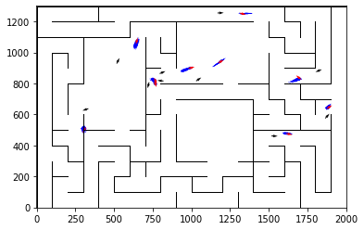

epoch 1061 == motion_mle: 9.97+-0.24/10.29+-0.20 --

epoch 1062 == motion_mle: 9.79+-0.30/9.81+-0.21 --

epoch 1063 == motion_mle: 10.29+-0.30/9.79+-0.20 --

epoch 1064 == motion_mle: 9.80+-0.27/9.97+-0.20 --

epoch 1065 == motion_mle: 9.98+-0.29/9.91+-0.19 --

epoch 1066 == motion_mle: 10.17+-0.30/10.08+-0.20 --

epoch 1067 == motion_mle: 10.11+-0.29/10.25+-0.22 --

epoch 1068 == motion_mle: 10.16+-0.30/9.90+-0.21 --

epoch 1069 == motion_mle: 10.82+-0.31/9.96+-0.19 --

epoch 1070 == motion_mle: 10.12+-0.30/9.95+-0.22 --

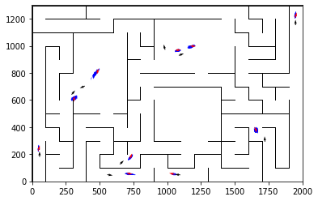

epoch 1071 == motion_mle: 9.95+-0.25/10.16+-0.20 --

epoch 1072 == motion_mle: 9.85+-0.32/10.00+-0.21 --

epoch 1073 == motion_mle: 10.34+-0.26/9.85+-0.20 --

epoch 1074 == motion_mle: 9.84+-0.29/9.91+-0.22 --

epoch 1075 == motion_mle: 9.98+-0.27/9.96+-0.19 --

epoch 1076 == motion_mle: 10.05+-0.26/9.97+-0.22 --

epoch 1077 == motion_mle: 10.76+-0.33/9.90+-0.21 --

epoch 1078 == motion_mle: 10.39+-0.32/9.91+-0.20 --

epoch 1079 == motion_mle: 10.16+-0.30/10.03+-0.19 --

epoch 1080 == motion_mle: 10.12+-0.30/9.87+-0.21 --

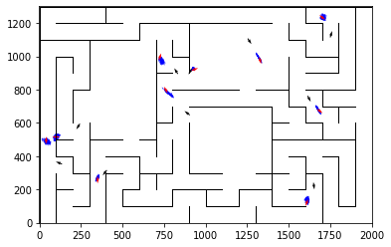

epoch 1081 == motion_mle: 9.97+-0.28/9.97+-0.20 --

epoch 1082 == motion_mle: 10.00+-0.24/10.17+-0.19 --

epoch 1083 == motion_mle: 9.97+-0.32/10.17+-0.21 --

epoch 1084 == motion_mle: 9.96+-0.32/9.99+-0.20 --

epoch 1085 == motion_mle: 9.88+-0.22/9.96+-0.20 --

epoch 1086 == motion_mle: 10.08+-0.29/10.12+-0.19 --

epoch 1087 == motion_mle: 9.60+-0.30/10.03+-0.19 --

epoch 1088 == motion_mle: 10.04+-0.31/9.93+-0.20 --

epoch 1089 == motion_mle: 10.34+-0.30/10.03+-0.20 --

epoch 1090 == motion_mle: 10.16+-0.31/9.96+-0.17 --

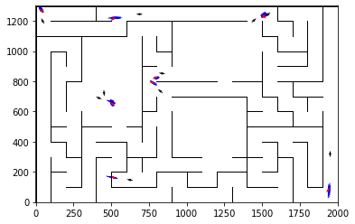

epoch 1091 == motion_mle: 10.46+-0.29/10.12+-0.20 --

epoch 1092 == motion_mle: 9.93+-0.27/10.02+-0.21 --

epoch 1093 == motion_mle: 10.27+-0.33/9.95+-0.20 --

epoch 1094 == motion_mle: 10.19+-0.26/9.88+-0.22 --

epoch 1095 == motion_mle: 10.20+-0.28/10.17+-0.21 --

epoch 1096 == motion_mle: 9.84+-0.30/9.98+-0.20 --

epoch 1097 == motion_mle: 9.65+-0.25/9.87+-0.22 --

epoch 1098 == motion_mle: 9.44+-0.22/10.00+-0.21 --

epoch 1099 == motion_mle: 10.04+-0.23/10.04+-0.20 --

epoch 1100 == motion_mle: 10.41+-0.29/10.33+-0.19 --

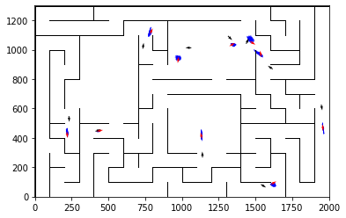

epoch 1101 == motion_mle: 9.54+-0.28/9.92+-0.20 --

epoch 1102 == motion_mle: 10.52+-0.25/10.12+-0.20 --

epoch 1103 == motion_mle: 10.06+-0.22/10.28+-0.22 --

epoch 1104 == motion_mle: 10.15+-0.30/10.11+-0.20 --

epoch 1105 == motion_mle: 10.14+-0.33/9.94+-0.21 --

epoch 1106 == motion_mle: 9.77+-0.29/9.95+-0.21 --

epoch 1107 == motion_mle: 9.85+-0.31/10.31+-0.21 --

epoch 1108 == motion_mle: 9.90+-0.30/9.93+-0.19 --

epoch 1109 == motion_mle: 10.39+-0.30/10.09+-0.20 --

epoch 1110 == motion_mle: 10.34+-0.32/10.15+-0.22 --

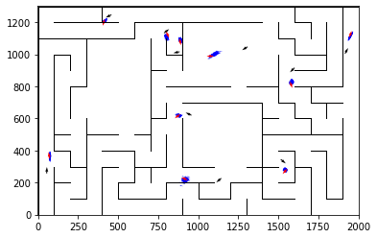

epoch 1111 == motion_mle: 9.47+-0.30/10.30+-0.20 --

epoch 1112 == motion_mle: 10.28+-0.26/9.96+-0.21 --

epoch 1113 == motion_mle: 10.08+-0.27/9.93+-0.22 --

epoch 1114 == motion_mle: 9.65+-0.27/9.86+-0.19 --

epoch 1115 == motion_mle: 9.99+-0.26/10.06+-0.20 --

epoch 1116 == motion_mle: 9.93+-0.25/10.01+-0.21 --

epoch 1117 == motion_mle: 10.17+-0.28/9.96+-0.19 --

epoch 1118 == motion_mle: 10.48+-0.29/9.80+-0.20 --

epoch 1119 == motion_mle: 9.82+-0.35/10.19+-0.20 --

epoch 1120 == motion_mle: 9.99+-0.27/10.11+-0.20 --

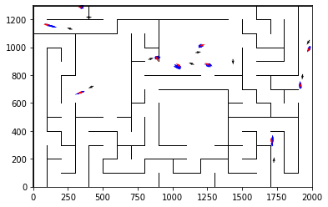

epoch 1121 == motion_mle: 9.72+-0.27/10.05+-0.19 --

epoch 1122 == motion_mle: 10.45+-0.31/10.30+-0.21 --

epoch 1123 == motion_mle: 10.33+-0.24/9.92+-0.21 --

epoch 1124 == motion_mle: 10.05+-0.33/10.22+-0.19 --

epoch 1125 == motion_mle: 10.00+-0.31/9.97+-0.20 --

epoch 1126 == motion_mle: 10.08+-0.24/10.00+-0.19 --

epoch 1127 == motion_mle: 9.80+-0.20/9.89+-0.20 --

epoch 1128 == motion_mle: 10.48+-0.25/10.21+-0.21 --

epoch 1129 == motion_mle: 9.91+-0.31/9.90+-0.21 --

epoch 1130 == motion_mle: 10.21+-0.24/10.04+-0.21 --

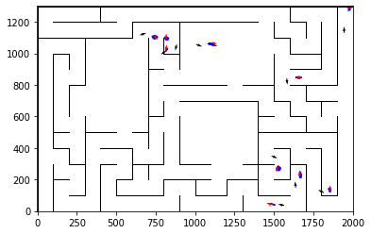

epoch 1131 == motion_mle: 10.02+-0.27/9.98+-0.21 --

epoch 1132 == motion_mle: 9.85+-0.31/10.23+-0.20 --

epoch 1133 == motion_mle: 9.62+-0.24/9.93+-0.21 --

epoch 1134 == motion_mle: 9.60+-0.30/10.18+-0.21 --

epoch 1135 == motion_mle: 10.48+-0.27/9.94+-0.23 --

epoch 1136 == motion_mle: 10.07+-0.26/10.09+-0.19 --

epoch 1137 == motion_mle: 10.23+-0.31/10.07+-0.19 --

epoch 1138 == motion_mle: 9.99+-0.28/9.88+-0.19 --

INFO:tensorflow:Restoring parameters from ../models/tmp/best_validation

INFO:tensorflow:Restoring parameters from ../models/tmp/best_validation

epoch 0 >> measurement_heuristic: 1.39+-0.00 --

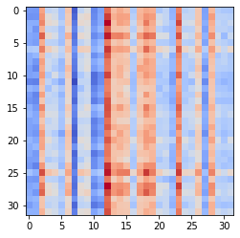

epoch 1 >> measurement_heuristic: 1.39+-0.00/1.38+-0.00 --

epoch 2 >> measurement_heuristic: 1.38+-0.00/1.37+-0.00 --

epoch 3 >> measurement_heuristic: 1.36+-0.00/1.35+-0.00 --

epoch 4 >> measurement_heuristic: 1.35+-0.00/1.33+-0.00 --

epoch 5 >> measurement_heuristic: 1.34+-0.00/1.32+-0.00 --

epoch 6 >> measurement_heuristic: 1.32+-0.00/1.31+-0.00 --

epoch 7 >> measurement_heuristic: 1.31+-0.00/1.29+-0.00 --

epoch 8 >> measurement_heuristic: 1.30+-0.01/1.28+-0.00 --

epoch 9 >> measurement_heuristic: 1.29+-0.00/1.27+-0.00 --

epoch 10 >> measurement_heuristic: 1.29+-0.01/1.26+-0.00 --

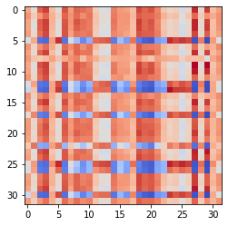

epoch 11 >> measurement_heuristic: 1.27+-0.01/1.24+-0.00 --

epoch 12 >> measurement_heuristic: 1.25+-0.01/1.24+-0.00 --

epoch 13 >> measurement_heuristic: 1.24+-0.00/1.23+-0.00 --

epoch 14 >> measurement_heuristic: 1.22+-0.01/1.21+-0.00 --

epoch 15 >> measurement_heuristic: 1.24+-0.01/1.21+-0.00 --

epoch 16 >> measurement_heuristic: 1.22+-0.01/1.20+-0.00 --

epoch 17 >> measurement_heuristic: 1.22+-0.01/1.19+-0.00 --

epoch 18 >> measurement_heuristic: 1.21+-0.01/1.19+-0.00 --

epoch 19 >> measurement_heuristic: 1.21+-0.01/1.18+-0.00 --

epoch 20 >> measurement_heuristic: 1.18+-0.01/1.17+-0.00 --

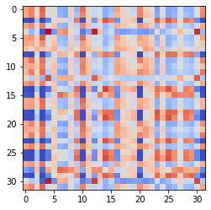

epoch 21 >> measurement_heuristic: 1.19+-0.01/1.17+-0.00 --

epoch 22 >> measurement_heuristic: 1.17+-0.01/1.17+-0.00 --

epoch 23 >> measurement_heuristic: 1.18+-0.01/1.15+-0.00 --

epoch 24 >> measurement_heuristic: 1.17+-0.01/1.15+-0.00 --

epoch 25 >> measurement_heuristic: 1.17+-0.01/1.14+-0.00 --

epoch 26 >> measurement_heuristic: 1.16+-0.01/1.14+-0.00 --

epoch 27 >> measurement_heuristic: 1.15+-0.01/1.14+-0.00 --

epoch 28 >> measurement_heuristic: 1.14+-0.01/1.13+-0.00 --

epoch 29 >> measurement_heuristic: 1.17+-0.01/1.13+-0.00 --

epoch 30 >> measurement_heuristic: 1.15+-0.01/1.12+-0.00 --

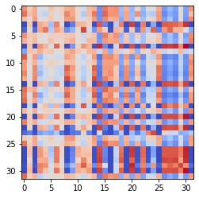

epoch 31 == measurement_heuristic: 1.14+-0.01/1.13+-0.00 --

epoch 32 >> measurement_heuristic: 1.13+-0.01/1.12+-0.01 --

epoch 33 >> measurement_heuristic: 1.14+-0.01/1.12+-0.00 --

epoch 34 >> measurement_heuristic: 1.15+-0.01/1.11+-0.00 --

epoch 35 >> measurement_heuristic: 1.13+-0.01/1.11+-0.01 --

epoch 36 >> measurement_heuristic: 1.13+-0.01/1.10+-0.01 --

epoch 37 >> measurement_heuristic: 1.12+-0.01/1.10+-0.01 --

epoch 38 >> measurement_heuristic: 1.11+-0.01/1.10+-0.01 --

epoch 39 >> measurement_heuristic: 1.13+-0.01/1.09+-0.01 --

epoch 40 >> measurement_heuristic: 1.12+-0.01/1.08+-0.01 --

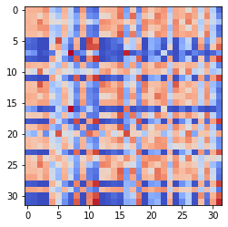

epoch 41 >> measurement_heuristic: 1.11+-0.01/1.08+-0.01 --

epoch 42 >> measurement_heuristic: 1.11+-0.01/1.07+-0.01 --

epoch 43 >> measurement_heuristic: 1.10+-0.01/1.07+-0.01 --

epoch 44 >> measurement_heuristic: 1.08+-0.01/1.07+-0.01 --

epoch 45 >> measurement_heuristic: 1.09+-0.01/1.07+-0.01 --

epoch 46 >> measurement_heuristic: 1.11+-0.01/1.06+-0.01 --

epoch 47 == measurement_heuristic: 1.10+-0.01/1.06+-0.01 --

epoch 48 >> measurement_heuristic: 1.08+-0.01/1.06+-0.01 --

epoch 49 >> measurement_heuristic: 1.07+-0.01/1.06+-0.01 --

epoch 50 >> measurement_heuristic: 1.08+-0.01/1.05+-0.01 --

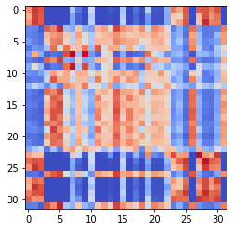

epoch 51 >> measurement_heuristic: 1.08+-0.01/1.04+-0.01 --

epoch 52 >> measurement_heuristic: 1.07+-0.01/1.04+-0.01 --

epoch 53 >> measurement_heuristic: 1.06+-0.01/1.04+-0.01 --

epoch 54 >> measurement_heuristic: 1.06+-0.01/1.04+-0.01 --

epoch 55 == measurement_heuristic: 1.07+-0.01/1.04+-0.01 --

epoch 56 >> measurement_heuristic: 1.06+-0.01/1.03+-0.01 --

epoch 57 == measurement_heuristic: 1.05+-0.01/1.03+-0.01 --

epoch 58 >> measurement_heuristic: 1.04+-0.01/1.02+-0.01 --

epoch 59 >> measurement_heuristic: 1.04+-0.01/1.02+-0.01 --

epoch 60 >> measurement_heuristic: 1.06+-0.01/1.02+-0.01 --

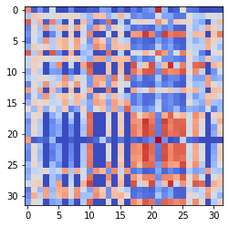

epoch 61 == measurement_heuristic: 1.05+-0.01/1.02+-0.01 --

epoch 62 >> measurement_heuristic: 1.05+-0.01/1.01+-0.01 --

epoch 63 == measurement_heuristic: 1.04+-0.01/1.02+-0.01 --

epoch 64 >> measurement_heuristic: 1.03+-0.01/1.01+-0.01 --

epoch 65 >> measurement_heuristic: 1.03+-0.01/1.00+-0.01 --

epoch 66 >> measurement_heuristic: 1.03+-0.01/1.00+-0.01 --

epoch 67 >> measurement_heuristic: 1.02+-0.01/0.99+-0.01 --

epoch 68 == measurement_heuristic: 1.03+-0.01/1.01+-0.01 --

epoch 69 >> measurement_heuristic: 1.04+-0.01/0.99+-0.01 --

epoch 70 >> measurement_heuristic: 1.03+-0.01/0.99+-0.01 --

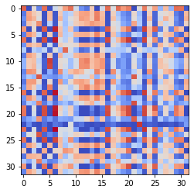

epoch 71 == measurement_heuristic: 1.03+-0.01/1.00+-0.01 --

epoch 72 >> measurement_heuristic: 1.00+-0.01/0.98+-0.01 --

epoch 73 == measurement_heuristic: 1.02+-0.01/0.99+-0.01 --

epoch 74 >> measurement_heuristic: 1.03+-0.01/0.98+-0.01 --

epoch 75 >> measurement_heuristic: 1.00+-0.01/0.98+-0.01 --

epoch 76 >> measurement_heuristic: 1.01+-0.01/0.98+-0.01 --

epoch 77 >> measurement_heuristic: 1.00+-0.01/0.97+-0.01 --

epoch 78 == measurement_heuristic: 1.00+-0.01/0.97+-0.01 --

epoch 79 == measurement_heuristic: 1.01+-0.01/0.98+-0.01 --

epoch 80 == measurement_heuristic: 1.00+-0.01/0.98+-0.01 --

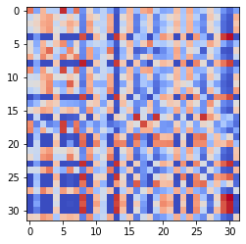

epoch 81 == measurement_heuristic: 1.00+-0.01/0.97+-0.01 --

epoch 82 >> measurement_heuristic: 1.00+-0.01/0.97+-0.01 --

epoch 83 >> measurement_heuristic: 1.00+-0.01/0.96+-0.01 --

epoch 84 == measurement_heuristic: 1.00+-0.01/0.97+-0.01 --

epoch 85 >> measurement_heuristic: 0.98+-0.01/0.95+-0.01 --

epoch 86 == measurement_heuristic: 0.98+-0.01/0.96+-0.01 --

epoch 87 == measurement_heuristic: 0.97+-0.01/0.96+-0.01 --

epoch 88 >> measurement_heuristic: 1.00+-0.01/0.95+-0.01 --

epoch 89 >> measurement_heuristic: 0.98+-0.01/0.95+-0.01 --

epoch 90 >> measurement_heuristic: 0.99+-0.01/0.94+-0.01 --

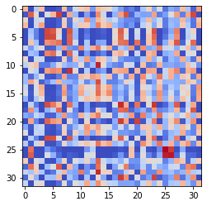

epoch 91 >> measurement_heuristic: 0.98+-0.01/0.94+-0.01 --

epoch 92 == measurement_heuristic: 0.99+-0.01/0.94+-0.01 --

epoch 93 == measurement_heuristic: 0.98+-0.01/0.95+-0.01 --

epoch 94 >> measurement_heuristic: 0.98+-0.01/0.93+-0.01 --

epoch 95 == measurement_heuristic: 0.98+-0.01/0.95+-0.01 --

epoch 96 >> measurement_heuristic: 0.99+-0.01/0.93+-0.01 --

epoch 97 == measurement_heuristic: 0.97+-0.01/0.94+-0.01 --

epoch 98 >> measurement_heuristic: 0.96+-0.01/0.93+-0.01 --

epoch 99 == measurement_heuristic: 0.96+-0.01/0.94+-0.01 --

epoch 100 >> measurement_heuristic: 0.97+-0.01/0.93+-0.01 --

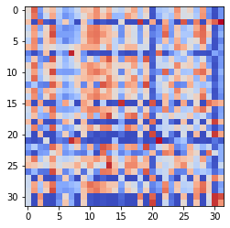

epoch 101 == measurement_heuristic: 0.95+-0.01/0.93+-0.01 --

epoch 102 >> measurement_heuristic: 0.97+-0.01/0.92+-0.01 --

epoch 103 >> measurement_heuristic: 0.95+-0.01/0.92+-0.01 --

epoch 104 >> measurement_heuristic: 0.95+-0.01/0.92+-0.01 --

epoch 105 == measurement_heuristic: 0.94+-0.01/0.93+-0.01 --

epoch 106 >> measurement_heuristic: 0.94+-0.01/0.91+-0.01 --

epoch 107 >> measurement_heuristic: 0.97+-0.01/0.91+-0.01 --

epoch 108 >> measurement_heuristic: 0.95+-0.01/0.91+-0.01 --

epoch 109 >> measurement_heuristic: 0.95+-0.01/0.90+-0.01 --

epoch 110 == measurement_heuristic: 0.95+-0.01/0.91+-0.01 --

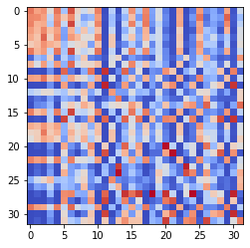

epoch 111 == measurement_heuristic: 0.95+-0.01/0.91+-0.01 --

epoch 112 == measurement_heuristic: 0.94+-0.01/0.91+-0.01 --

epoch 113 == measurement_heuristic: 0.92+-0.01/0.91+-0.01 --

epoch 114 >> measurement_heuristic: 0.94+-0.01/0.90+-0.01 --

epoch 115 >> measurement_heuristic: 0.93+-0.01/0.90+-0.01 --

epoch 116 == measurement_heuristic: 0.96+-0.01/0.91+-0.01 --

epoch 117 >> measurement_heuristic: 0.93+-0.01/0.89+-0.01 --

epoch 118 == measurement_heuristic: 0.93+-0.01/0.89+-0.01 --

epoch 119 >> measurement_heuristic: 0.95+-0.01/0.89+-0.01 --

epoch 120 >> measurement_heuristic: 0.93+-0.01/0.89+-0.01 --

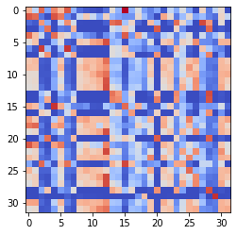

epoch 121 >> measurement_heuristic: 0.93+-0.01/0.89+-0.01 --

epoch 122 >> measurement_heuristic: 0.94+-0.01/0.88+-0.01 --

epoch 123 == measurement_heuristic: 0.94+-0.01/0.88+-0.01 --

epoch 124 >> measurement_heuristic: 0.90+-0.01/0.88+-0.01 --

epoch 125 == measurement_heuristic: 0.91+-0.01/0.88+-0.01 --

epoch 126 >> measurement_heuristic: 0.93+-0.01/0.88+-0.01 --

epoch 127 == measurement_heuristic: 0.92+-0.01/0.88+-0.01 --

epoch 128 >> measurement_heuristic: 0.93+-0.01/0.87+-0.01 --

epoch 129 >> measurement_heuristic: 0.92+-0.01/0.87+-0.01 --

epoch 130 == measurement_heuristic: 0.90+-0.01/0.87+-0.01 --

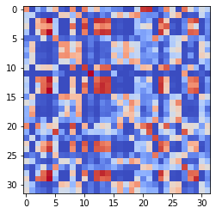

epoch 131 >> measurement_heuristic: 0.92+-0.01/0.87+-0.01 --

epoch 132 >> measurement_heuristic: 0.91+-0.01/0.87+-0.01 --

epoch 133 == measurement_heuristic: 0.91+-0.01/0.87+-0.01 --

epoch 134 >> measurement_heuristic: 0.89+-0.01/0.86+-0.01 --

epoch 135 >> measurement_heuristic: 0.90+-0.01/0.86+-0.01 --

epoch 136 == measurement_heuristic: 0.92+-0.01/0.86+-0.01 --

epoch 137 == measurement_heuristic: 0.93+-0.01/0.86+-0.01 --

epoch 138 == measurement_heuristic: 0.89+-0.01/0.86+-0.01 --

epoch 139 == measurement_heuristic: 0.91+-0.01/0.86+-0.01 --

epoch 140 >> measurement_heuristic: 0.90+-0.01/0.85+-0.01 --

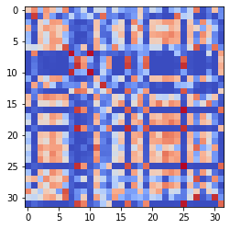

epoch 141 == measurement_heuristic: 0.90+-0.01/0.86+-0.01 --

epoch 142 == measurement_heuristic: 0.90+-0.01/0.86+-0.01 --

epoch 143 == measurement_heuristic: 0.90+-0.01/0.85+-0.01 --

epoch 144 == measurement_heuristic: 0.90+-0.01/0.85+-0.01 --

epoch 145 >> measurement_heuristic: 0.86+-0.01/0.84+-0.01 --

epoch 146 >> measurement_heuristic: 0.90+-0.01/0.84+-0.01 --

epoch 147 >> measurement_heuristic: 0.88+-0.01/0.84+-0.01 --

epoch 148 == measurement_heuristic: 0.89+-0.01/0.84+-0.01 --

epoch 149 >> measurement_heuristic: 0.89+-0.01/0.83+-0.01 --

epoch 150 == measurement_heuristic: 0.89+-0.01/0.83+-0.01 --

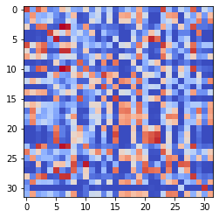

epoch 151 == measurement_heuristic: 0.89+-0.01/0.85+-0.01 --

epoch 152 == measurement_heuristic: 0.88+-0.01/0.85+-0.01 --

epoch 153 == measurement_heuristic: 0.87+-0.01/0.84+-0.01 --

epoch 154 == measurement_heuristic: 0.87+-0.01/0.85+-0.01 --

epoch 155 == measurement_heuristic: 0.89+-0.01/0.84+-0.01 --

epoch 156 >> measurement_heuristic: 0.88+-0.01/0.83+-0.01 --

epoch 157 == measurement_heuristic: 0.87+-0.01/0.83+-0.01 --

epoch 158 == measurement_heuristic: 0.86+-0.01/0.83+-0.01 --

epoch 159 >> measurement_heuristic: 0.88+-0.01/0.83+-0.01 --

epoch 160 >> measurement_heuristic: 0.87+-0.01/0.82+-0.01 --

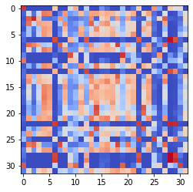

epoch 161 == measurement_heuristic: 0.87+-0.01/0.83+-0.01 --

epoch 162 >> measurement_heuristic: 0.85+-0.01/0.82+-0.01 --

epoch 163 >> measurement_heuristic: 0.86+-0.01/0.82+-0.01 --

epoch 164 == measurement_heuristic: 0.87+-0.01/0.82+-0.01 --

epoch 165 >> measurement_heuristic: 0.86+-0.01/0.81+-0.01 --

epoch 166 == measurement_heuristic: 0.87+-0.01/0.82+-0.01 --

epoch 167 >> measurement_heuristic: 0.86+-0.01/0.81+-0.01 --

epoch 168 == measurement_heuristic: 0.86+-0.01/0.81+-0.01 --

epoch 169 == measurement_heuristic: 0.87+-0.01/0.82+-0.01 --

epoch 170 == measurement_heuristic: 0.87+-0.01/0.82+-0.01 --

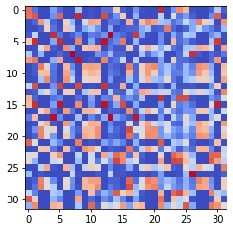

epoch 171 == measurement_heuristic: 0.87+-0.01/0.81+-0.01 --

epoch 172 == measurement_heuristic: 0.87+-0.01/0.81+-0.01 --

epoch 173 >> measurement_heuristic: 0.85+-0.01/0.81+-0.01 --

epoch 174 >> measurement_heuristic: 0.84+-0.01/0.80+-0.01 --

epoch 175 == measurement_heuristic: 0.86+-0.01/0.81+-0.01 --

epoch 176 >> measurement_heuristic: 0.84+-0.01/0.80+-0.01 --

epoch 177 == measurement_heuristic: 0.84+-0.01/0.80+-0.01 --

epoch 178 == measurement_heuristic: 0.86+-0.01/0.81+-0.01 --

epoch 179 == measurement_heuristic: 0.85+-0.01/0.80+-0.01 --

epoch 180 >> measurement_heuristic: 0.85+-0.01/0.80+-0.01 --

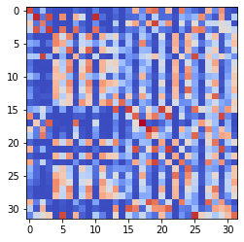

epoch 181 == measurement_heuristic: 0.84+-0.01/0.80+-0.01 --

epoch 182 == measurement_heuristic: 0.85+-0.01/0.81+-0.01 --

epoch 183 == measurement_heuristic: 0.86+-0.01/0.80+-0.01 --

epoch 184 >> measurement_heuristic: 0.85+-0.01/0.79+-0.01 --

epoch 185 >> measurement_heuristic: 0.83+-0.01/0.79+-0.01 --

epoch 186 == measurement_heuristic: 0.82+-0.01/0.79+-0.01 --

epoch 187 == measurement_heuristic: 0.84+-0.01/0.81+-0.01 --

epoch 188 == measurement_heuristic: 0.85+-0.01/0.80+-0.01 --

epoch 189 == measurement_heuristic: 0.84+-0.01/0.79+-0.01 --

epoch 190 >> measurement_heuristic: 0.83+-0.01/0.78+-0.01 --

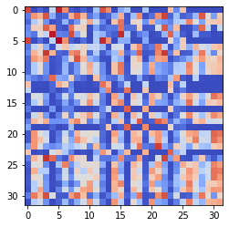

epoch 191 == measurement_heuristic: 0.85+-0.01/0.80+-0.01 --

epoch 192 == measurement_heuristic: 0.84+-0.01/0.79+-0.01 --

epoch 193 >> measurement_heuristic: 0.82+-0.01/0.78+-0.01 --

epoch 194 == measurement_heuristic: 0.85+-0.01/0.80+-0.01 --

epoch 195 == measurement_heuristic: 0.85+-0.01/0.79+-0.01 --

epoch 196 == measurement_heuristic: 0.83+-0.01/0.78+-0.01 --

epoch 197 == measurement_heuristic: 0.83+-0.01/0.79+-0.01 --

epoch 198 == measurement_heuristic: 0.82+-0.01/0.79+-0.01 --

epoch 199 >> measurement_heuristic: 0.83+-0.01/0.78+-0.01 --

epoch 200 == measurement_heuristic: 0.82+-0.01/0.79+-0.01 --

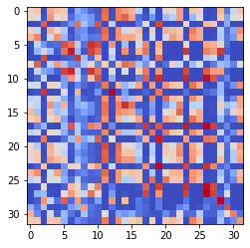

epoch 201 == measurement_heuristic: 0.83+-0.01/0.80+-0.01 --

epoch 202 >> measurement_heuristic: 0.82+-0.01/0.78+-0.01 --

epoch 203 == measurement_heuristic: 0.82+-0.01/0.78+-0.01 --

epoch 204 == measurement_heuristic: 0.83+-0.01/0.78+-0.01 --

epoch 205 == measurement_heuristic: 0.82+-0.01/0.79+-0.01 --

epoch 206 == measurement_heuristic: 0.82+-0.01/0.78+-0.01 --

epoch 207 == measurement_heuristic: 0.81+-0.01/0.78+-0.01 --

epoch 208 >> measurement_heuristic: 0.83+-0.01/0.77+-0.01 --

epoch 209 >> measurement_heuristic: 0.82+-0.01/0.76+-0.01 --

epoch 210 >> measurement_heuristic: 0.81+-0.01/0.76+-0.01 --

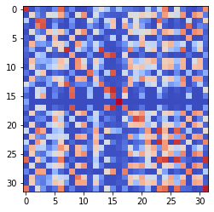

epoch 211 == measurement_heuristic: 0.82+-0.01/0.76+-0.01 --

epoch 212 == measurement_heuristic: 0.80+-0.01/0.76+-0.01 --

epoch 213 >> measurement_heuristic: 0.82+-0.01/0.76+-0.01 --

epoch 214 >> measurement_heuristic: 0.82+-0.01/0.76+-0.01 --

epoch 215 == measurement_heuristic: 0.82+-0.01/0.77+-0.01 --

epoch 216 == measurement_heuristic: 0.82+-0.01/0.77+-0.01 --

epoch 217 == measurement_heuristic: 0.80+-0.01/0.76+-0.01 --

epoch 218 == measurement_heuristic: 0.83+-0.02/0.76+-0.01 --

epoch 219 == measurement_heuristic: 0.80+-0.01/0.76+-0.01 --

epoch 220 >> measurement_heuristic: 0.82+-0.01/0.75+-0.01 --

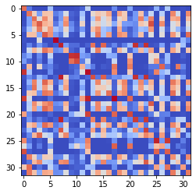

epoch 221 == measurement_heuristic: 0.81+-0.01/0.77+-0.01 --

epoch 222 == measurement_heuristic: 0.79+-0.01/0.76+-0.01 --

epoch 223 == measurement_heuristic: 0.80+-0.01/0.76+-0.01 --

epoch 224 == measurement_heuristic: 0.82+-0.01/0.76+-0.01 --

epoch 225 >> measurement_heuristic: 0.80+-0.01/0.75+-0.01 --

epoch 226 == measurement_heuristic: 0.79+-0.01/0.76+-0.01 --

epoch 227 == measurement_heuristic: 0.80+-0.01/0.76+-0.01 --

epoch 228 == measurement_heuristic: 0.81+-0.01/0.76+-0.01 --

epoch 229 >> measurement_heuristic: 0.79+-0.01/0.75+-0.01 --

epoch 230 == measurement_heuristic: 0.81+-0.01/0.76+-0.01 --

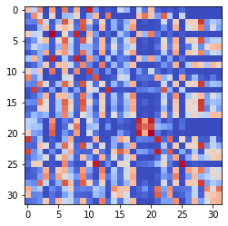

epoch 231 == measurement_heuristic: 0.80+-0.01/0.76+-0.01 --

epoch 232 == measurement_heuristic: 0.80+-0.01/0.75+-0.01 --

epoch 233 == measurement_heuristic: 0.80+-0.01/0.76+-0.01 --

epoch 234 >> measurement_heuristic: 0.81+-0.01/0.74+-0.01 --

epoch 235 >> measurement_heuristic: 0.82+-0.01/0.74+-0.01 --

epoch 236 == measurement_heuristic: 0.78+-0.01/0.74+-0.01 --

epoch 237 == measurement_heuristic: 0.79+-0.01/0.76+-0.01 --

epoch 238 >> measurement_heuristic: 0.81+-0.01/0.73+-0.01 --

epoch 239 == measurement_heuristic: 0.80+-0.01/0.74+-0.01 --

epoch 240 == measurement_heuristic: 0.79+-0.01/0.74+-0.01 --

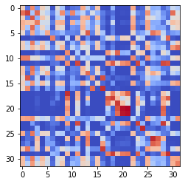

epoch 241 == measurement_heuristic: 0.77+-0.01/0.74+-0.01 --

epoch 242 == measurement_heuristic: 0.79+-0.01/0.74+-0.01 --

epoch 243 == measurement_heuristic: 0.78+-0.01/0.73+-0.01 --

epoch 244 >> measurement_heuristic: 0.79+-0.01/0.73+-0.01 --

epoch 245 == measurement_heuristic: 0.80+-0.01/0.74+-0.01 --

epoch 246 == measurement_heuristic: 0.79+-0.01/0.74+-0.01 --

epoch 247 >> measurement_heuristic: 0.78+-0.01/0.73+-0.01 --

epoch 248 == measurement_heuristic: 0.77+-0.01/0.74+-0.01 --

epoch 249 == measurement_heuristic: 0.78+-0.01/0.73+-0.01 --

epoch 250 == measurement_heuristic: 0.80+-0.01/0.74+-0.01 --

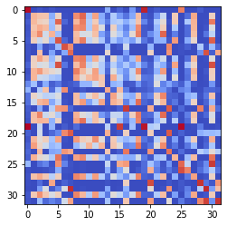

epoch 251 == measurement_heuristic: 0.76+-0.01/0.74+-0.01 --

epoch 252 >> measurement_heuristic: 0.80+-0.01/0.73+-0.01 --

epoch 253 == measurement_heuristic: 0.78+-0.01/0.73+-0.01 --

epoch 254 == measurement_heuristic: 0.78+-0.01/0.73+-0.01 --

epoch 255 == measurement_heuristic: 0.75+-0.01/0.74+-0.01 --

epoch 256 == measurement_heuristic: 0.80+-0.01/0.74+-0.01 --

epoch 257 >> measurement_heuristic: 0.77+-0.01/0.72+-0.01 --

epoch 258 == measurement_heuristic: 0.77+-0.01/0.72+-0.01 --

epoch 259 == measurement_heuristic: 0.76+-0.01/0.73+-0.01 --

epoch 260 >> measurement_heuristic: 0.79+-0.01/0.72+-0.01 --

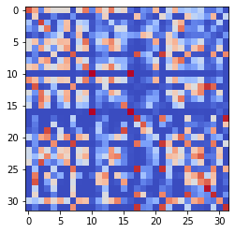

epoch 261 == measurement_heuristic: 0.76+-0.01/0.72+-0.01 --

epoch 262 >> measurement_heuristic: 0.78+-0.01/0.72+-0.01 --

epoch 263 == measurement_heuristic: 0.78+-0.01/0.72+-0.01 --

epoch 264 == measurement_heuristic: 0.78+-0.01/0.72+-0.01 --

epoch 265 >> measurement_heuristic: 0.77+-0.01/0.72+-0.01 --

epoch 266 == measurement_heuristic: 0.78+-0.02/0.73+-0.01 --

epoch 267 == measurement_heuristic: 0.75+-0.01/0.72+-0.01 --

epoch 268 == measurement_heuristic: 0.78+-0.01/0.73+-0.01 --

epoch 269 == measurement_heuristic: 0.77+-0.01/0.72+-0.01 --

epoch 270 == measurement_heuristic: 0.78+-0.01/0.72+-0.01 --

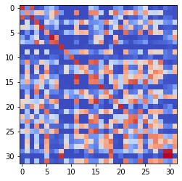

epoch 271 == measurement_heuristic: 0.80+-0.01/0.72+-0.01 --

epoch 272 == measurement_heuristic: 0.78+-0.01/0.72+-0.01 --

epoch 273 >> measurement_heuristic: 0.75+-0.01/0.71+-0.01 --

epoch 274 == measurement_heuristic: 0.76+-0.01/0.71+-0.01 --

epoch 275 == measurement_heuristic: 0.77+-0.01/0.72+-0.01 --

epoch 276 == measurement_heuristic: 0.76+-0.01/0.71+-0.01 --

epoch 277 == measurement_heuristic: 0.78+-0.01/0.71+-0.01 --

epoch 278 >> measurement_heuristic: 0.77+-0.02/0.71+-0.01 --

epoch 279 == measurement_heuristic: 0.76+-0.01/0.71+-0.01 --

epoch 280 == measurement_heuristic: 0.78+-0.01/0.72+-0.01 --

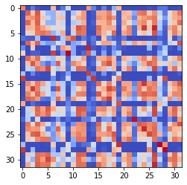

epoch 281 >> measurement_heuristic: 0.75+-0.01/0.71+-0.01 --

epoch 282 >> measurement_heuristic: 0.77+-0.01/0.71+-0.01 --

epoch 283 == measurement_heuristic: 0.77+-0.01/0.71+-0.01 --

epoch 284 == measurement_heuristic: 0.77+-0.01/0.71+-0.01 --

epoch 285 == measurement_heuristic: 0.77+-0.01/0.73+-0.01 --

epoch 286 >> measurement_heuristic: 0.76+-0.01/0.70+-0.01 --

epoch 287 >> measurement_heuristic: 0.74+-0.01/0.70+-0.01 --

epoch 288 >> measurement_heuristic: 0.76+-0.01/0.70+-0.01 --

epoch 289 == measurement_heuristic: 0.75+-0.01/0.71+-0.01 --

epoch 290 == measurement_heuristic: 0.78+-0.01/0.72+-0.01 --

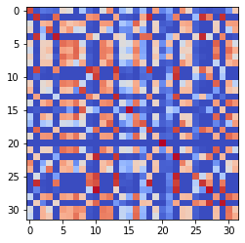

epoch 291 >> measurement_heuristic: 0.74+-0.01/0.70+-0.01 --

epoch 292 == measurement_heuristic: 0.76+-0.01/0.70+-0.01 --

epoch 293 == measurement_heuristic: 0.78+-0.02/0.70+-0.01 --

epoch 294 >> measurement_heuristic: 0.75+-0.01/0.70+-0.01 --

epoch 295 == measurement_heuristic: 0.76+-0.01/0.70+-0.01 --

epoch 296 == measurement_heuristic: 0.74+-0.01/0.70+-0.01 --

epoch 297 >> measurement_heuristic: 0.75+-0.01/0.69+-0.01 --

epoch 298 == measurement_heuristic: 0.75+-0.01/0.71+-0.01 --

epoch 299 == measurement_heuristic: 0.74+-0.01/0.70+-0.01 --

epoch 300 == measurement_heuristic: 0.75+-0.01/0.70+-0.01 --

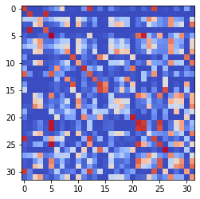

epoch 301 == measurement_heuristic: 0.73+-0.01/0.69+-0.01 --

epoch 302 == measurement_heuristic: 0.73+-0.01/0.70+-0.01 --

epoch 303 == measurement_heuristic: 0.74+-0.01/0.72+-0.01 --

epoch 304 == measurement_heuristic: 0.75+-0.01/0.71+-0.01 --

epoch 305 == measurement_heuristic: 0.75+-0.01/0.69+-0.01 --

epoch 306 == measurement_heuristic: 0.76+-0.01/0.70+-0.01 --

epoch 307 == measurement_heuristic: 0.74+-0.01/0.69+-0.01 --

epoch 308 >> measurement_heuristic: 0.76+-0.01/0.69+-0.01 --

epoch 309 == measurement_heuristic: 0.72+-0.01/0.70+-0.01 --

epoch 310 >> measurement_heuristic: 0.73+-0.01/0.69+-0.01 --

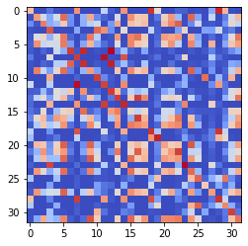

epoch 311 == measurement_heuristic: 0.76+-0.01/0.70+-0.01 --

epoch 312 == measurement_heuristic: 0.75+-0.01/0.71+-0.01 --

epoch 313 == measurement_heuristic: 0.73+-0.01/0.69+-0.01 --

epoch 314 >> measurement_heuristic: 0.76+-0.01/0.68+-0.01 --

epoch 315 == measurement_heuristic: 0.74+-0.01/0.69+-0.01 --

epoch 316 == measurement_heuristic: 0.76+-0.01/0.69+-0.01 --

epoch 317 == measurement_heuristic: 0.75+-0.01/0.69+-0.01 --

epoch 318 >> measurement_heuristic: 0.73+-0.01/0.67+-0.01 --

epoch 319 == measurement_heuristic: 0.72+-0.01/0.69+-0.01 --

epoch 320 == measurement_heuristic: 0.72+-0.01/0.68+-0.01 --

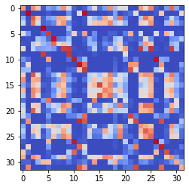

epoch 321 == measurement_heuristic: 0.74+-0.01/0.68+-0.01 --

epoch 322 == measurement_heuristic: 0.75+-0.01/0.69+-0.01 --

epoch 323 == measurement_heuristic: 0.75+-0.01/0.68+-0.01 --

epoch 324 == measurement_heuristic: 0.74+-0.01/0.69+-0.01 --

epoch 325 == measurement_heuristic: 0.73+-0.01/0.68+-0.01 --

epoch 326 == measurement_heuristic: 0.74+-0.01/0.70+-0.01 --

epoch 327 == measurement_heuristic: 0.72+-0.01/0.68+-0.01 --

epoch 328 == measurement_heuristic: 0.74+-0.01/0.68+-0.01 --

epoch 329 == measurement_heuristic: 0.70+-0.01/0.68+-0.01 --

epoch 330 == measurement_heuristic: 0.73+-0.01/0.68+-0.01 --

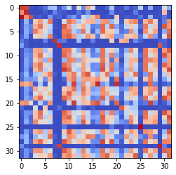

epoch 331 == measurement_heuristic: 0.71+-0.01/0.67+-0.01 --

epoch 332 >> measurement_heuristic: 0.73+-0.01/0.67+-0.01 --

epoch 333 == measurement_heuristic: 0.72+-0.01/0.68+-0.01 --

epoch 334 == measurement_heuristic: 0.72+-0.01/0.67+-0.01 --

epoch 335 == measurement_heuristic: 0.73+-0.01/0.68+-0.01 --

epoch 336 == measurement_heuristic: 0.73+-0.01/0.68+-0.01 --

epoch 337 == measurement_heuristic: 0.75+-0.01/0.70+-0.01 --

epoch 338 == measurement_heuristic: 0.73+-0.01/0.71+-0.01 --

epoch 339 == measurement_heuristic: 0.71+-0.01/0.67+-0.01 --

epoch 340 == measurement_heuristic: 0.73+-0.01/0.67+-0.01 --

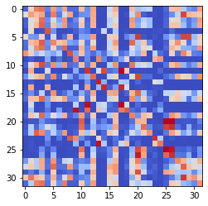

epoch 341 >> measurement_heuristic: 0.74+-0.01/0.66+-0.01 --

epoch 342 == measurement_heuristic: 0.70+-0.01/0.67+-0.01 --

epoch 343 == measurement_heuristic: 0.71+-0.01/0.67+-0.01 --

epoch 344 == measurement_heuristic: 0.73+-0.01/0.67+-0.01 --

epoch 345 == measurement_heuristic: 0.76+-0.01/0.68+-0.01 --

epoch 346 == measurement_heuristic: 0.71+-0.01/0.66+-0.01 --

epoch 347 >> measurement_heuristic: 0.72+-0.01/0.66+-0.01 --

epoch 348 == measurement_heuristic: 0.71+-0.01/0.67+-0.01 --

epoch 349 == measurement_heuristic: 0.73+-0.01/0.68+-0.01 --

epoch 350 == measurement_heuristic: 0.74+-0.01/0.66+-0.01 --

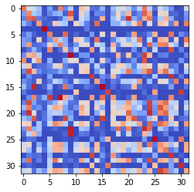

epoch 351 == measurement_heuristic: 0.73+-0.01/0.67+-0.01 --

epoch 352 == measurement_heuristic: 0.72+-0.01/0.67+-0.01 --

epoch 353 == measurement_heuristic: 0.73+-0.01/0.67+-0.01 --

epoch 354 == measurement_heuristic: 0.71+-0.01/0.67+-0.01 --

epoch 355 == measurement_heuristic: 0.72+-0.01/0.67+-0.01 --

epoch 356 >> measurement_heuristic: 0.70+-0.01/0.66+-0.01 --

epoch 357 == measurement_heuristic: 0.73+-0.01/0.67+-0.01 --

epoch 358 == measurement_heuristic: 0.70+-0.01/0.67+-0.01 --

epoch 359 == measurement_heuristic: 0.70+-0.01/0.66+-0.01 --

epoch 360 == measurement_heuristic: 0.73+-0.01/0.68+-0.01 --

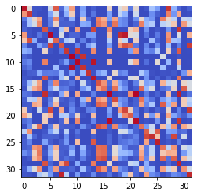

epoch 361 == measurement_heuristic: 0.70+-0.01/0.66+-0.01 --

epoch 362 >> measurement_heuristic: 0.70+-0.01/0.66+-0.01 --

epoch 363 == measurement_heuristic: 0.73+-0.01/0.67+-0.01 --

epoch 364 == measurement_heuristic: 0.71+-0.01/0.66+-0.01 --

epoch 365 >> measurement_heuristic: 0.71+-0.01/0.65+-0.01 --

epoch 366 >> measurement_heuristic: 0.69+-0.01/0.65+-0.01 --

epoch 367 == measurement_heuristic: 0.70+-0.01/0.65+-0.01 --

epoch 368 >> measurement_heuristic: 0.72+-0.01/0.65+-0.01 --

epoch 369 == measurement_heuristic: 0.71+-0.01/0.65+-0.01 --

epoch 370 == measurement_heuristic: 0.71+-0.01/0.67+-0.01 --

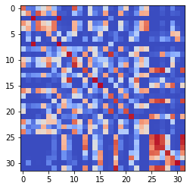

epoch 371 == measurement_heuristic: 0.72+-0.01/0.65+-0.01 --

epoch 372 == measurement_heuristic: 0.70+-0.01/0.65+-0.01 --

epoch 373 == measurement_heuristic: 0.68+-0.01/0.66+-0.01 --

epoch 374 == measurement_heuristic: 0.71+-0.01/0.66+-0.01 --

epoch 375 == measurement_heuristic: 0.68+-0.02/0.66+-0.01 --

epoch 376 == measurement_heuristic: 0.72+-0.01/0.65+-0.01 --

epoch 377 == measurement_heuristic: 0.70+-0.01/0.66+-0.01 --

epoch 378 == measurement_heuristic: 0.70+-0.01/0.65+-0.01 --

epoch 379 == measurement_heuristic: 0.72+-0.01/0.66+-0.01 --

epoch 380 == measurement_heuristic: 0.71+-0.01/0.65+-0.01 --

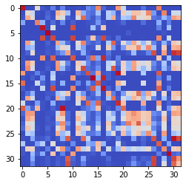

epoch 381 == measurement_heuristic: 0.72+-0.01/0.66+-0.01 --

epoch 382 >> measurement_heuristic: 0.68+-0.01/0.64+-0.01 --

epoch 383 == measurement_heuristic: 0.70+-0.01/0.65+-0.01 --

epoch 384 == measurement_heuristic: 0.69+-0.01/0.66+-0.01 --

epoch 385 == measurement_heuristic: 0.69+-0.01/0.65+-0.01 --

epoch 386 == measurement_heuristic: 0.70+-0.01/0.65+-0.01 --

epoch 387 == measurement_heuristic: 0.72+-0.01/0.65+-0.01 --

epoch 388 == measurement_heuristic: 0.72+-0.01/0.66+-0.01 --

epoch 389 == measurement_heuristic: 0.70+-0.01/0.66+-0.01 --

epoch 390 == measurement_heuristic: 0.71+-0.01/0.65+-0.01 --

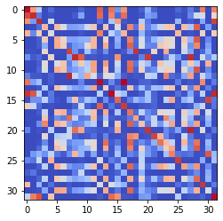

epoch 391 == measurement_heuristic: 0.68+-0.01/0.65+-0.01 --

epoch 392 >> measurement_heuristic: 0.71+-0.01/0.64+-0.01 --

epoch 393 >> measurement_heuristic: 0.68+-0.01/0.64+-0.01 --

epoch 394 == measurement_heuristic: 0.71+-0.01/0.65+-0.01 --

epoch 395 == measurement_heuristic: 0.69+-0.02/0.65+-0.01 --

epoch 396 == measurement_heuristic: 0.70+-0.01/0.64+-0.01 --

epoch 397 >> measurement_heuristic: 0.68+-0.01/0.63+-0.01 --

epoch 398 == measurement_heuristic: 0.70+-0.02/0.64+-0.01 --

epoch 399 == measurement_heuristic: 0.71+-0.01/0.64+-0.01 --

epoch 400 == measurement_heuristic: 0.68+-0.01/0.65+-0.01 --

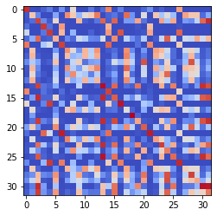

epoch 401 == measurement_heuristic: 0.71+-0.01/0.64+-0.01 --

epoch 402 == measurement_heuristic: 0.69+-0.01/0.64+-0.01 --

epoch 403 == measurement_heuristic: 0.68+-0.01/0.64+-0.01 --

epoch 404 == measurement_heuristic: 0.70+-0.01/0.63+-0.01 --

epoch 405 == measurement_heuristic: 0.68+-0.01/0.65+-0.01 --

epoch 406 == measurement_heuristic: 0.67+-0.01/0.64+-0.01 --

epoch 407 == measurement_heuristic: 0.70+-0.01/0.64+-0.01 --

epoch 408 >> measurement_heuristic: 0.69+-0.01/0.63+-0.01 --

epoch 409 == measurement_heuristic: 0.70+-0.01/0.63+-0.01 --

epoch 410 == measurement_heuristic: 0.68+-0.01/0.63+-0.01 --

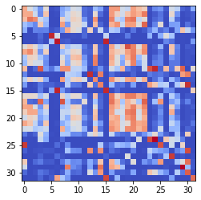

epoch 411 == measurement_heuristic: 0.69+-0.02/0.63+-0.01 --

epoch 412 == measurement_heuristic: 0.68+-0.01/0.66+-0.01 --

epoch 413 == measurement_heuristic: 0.69+-0.01/0.63+-0.01 --

epoch 414 >> measurement_heuristic: 0.70+-0.01/0.62+-0.01 --

epoch 415 == measurement_heuristic: 0.70+-0.01/0.63+-0.01 --

epoch 416 == measurement_heuristic: 0.70+-0.01/0.64+-0.01 --

epoch 417 == measurement_heuristic: 0.70+-0.01/0.63+-0.01 --

epoch 418 == measurement_heuristic: 0.69+-0.01/0.65+-0.01 --

epoch 419 == measurement_heuristic: 0.69+-0.02/0.63+-0.01 --

epoch 420 == measurement_heuristic: 0.67+-0.01/0.63+-0.01 --

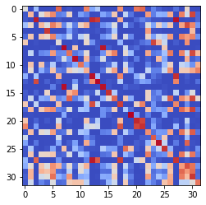

epoch 421 == measurement_heuristic: 0.71+-0.01/0.64+-0.01 --

epoch 422 == measurement_heuristic: 0.70+-0.02/0.63+-0.01 --

epoch 423 == measurement_heuristic: 0.69+-0.01/0.63+-0.01 --

epoch 424 == measurement_heuristic: 0.69+-0.01/0.64+-0.01 --

epoch 425 == measurement_heuristic: 0.69+-0.01/0.63+-0.01 --

epoch 426 >> measurement_heuristic: 0.70+-0.01/0.62+-0.01 --

epoch 427 == measurement_heuristic: 0.69+-0.01/0.63+-0.01 --

epoch 428 == measurement_heuristic: 0.70+-0.01/0.64+-0.01 --

epoch 429 == measurement_heuristic: 0.68+-0.01/0.63+-0.01 --

epoch 430 == measurement_heuristic: 0.68+-0.01/0.64+-0.01 --

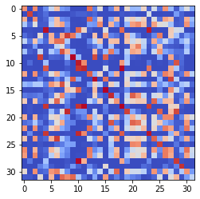

epoch 431 == measurement_heuristic: 0.68+-0.01/0.63+-0.01 --

epoch 432 == measurement_heuristic: 0.69+-0.02/0.64+-0.01 --

epoch 433 == measurement_heuristic: 0.70+-0.01/0.64+-0.01 --

epoch 434 == measurement_heuristic: 0.70+-0.01/0.64+-0.01 --

epoch 435 == measurement_heuristic: 0.68+-0.01/0.63+-0.01 --

epoch 436 == measurement_heuristic: 0.68+-0.01/0.63+-0.01 --

epoch 437 == measurement_heuristic: 0.68+-0.01/0.63+-0.01 --

epoch 438 == measurement_heuristic: 0.68+-0.01/0.64+-0.01 --

epoch 439 == measurement_heuristic: 0.66+-0.01/0.62+-0.01 --

epoch 440 == measurement_heuristic: 0.68+-0.01/0.63+-0.01 --

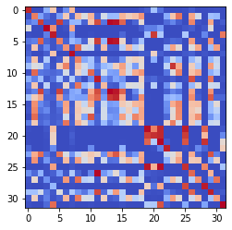

epoch 441 == measurement_heuristic: 0.69+-0.01/0.64+-0.01 --

epoch 442 == measurement_heuristic: 0.67+-0.01/0.62+-0.01 --

epoch 443 >> measurement_heuristic: 0.68+-0.01/0.62+-0.01 --

epoch 444 == measurement_heuristic: 0.67+-0.01/0.64+-0.01 --

epoch 445 >> measurement_heuristic: 0.67+-0.01/0.61+-0.01 --

epoch 446 >> measurement_heuristic: 0.69+-0.01/0.61+-0.01 --

epoch 447 == measurement_heuristic: 0.69+-0.01/0.63+-0.01 --

epoch 448 == measurement_heuristic: 0.67+-0.01/0.63+-0.01 --

epoch 449 == measurement_heuristic: 0.69+-0.01/0.61+-0.01 --

epoch 450 == measurement_heuristic: 0.68+-0.01/0.62+-0.01 --

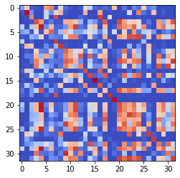

epoch 451 == measurement_heuristic: 0.66+-0.01/0.61+-0.01 --

epoch 452 == measurement_heuristic: 0.69+-0.01/0.62+-0.01 --

epoch 453 == measurement_heuristic: 0.66+-0.01/0.62+-0.01 --

epoch 454 == measurement_heuristic: 0.69+-0.01/0.62+-0.01 --

epoch 455 >> measurement_heuristic: 0.65+-0.01/0.61+-0.01 --

epoch 456 == measurement_heuristic: 0.66+-0.01/0.63+-0.01 --

epoch 457 == measurement_heuristic: 0.67+-0.01/0.63+-0.01 --

epoch 458 >> measurement_heuristic: 0.68+-0.01/0.61+-0.01 --

epoch 459 >> measurement_heuristic: 0.67+-0.01/0.61+-0.01 --

epoch 460 == measurement_heuristic: 0.66+-0.01/0.62+-0.01 --

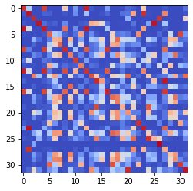

epoch 461 == measurement_heuristic: 0.69+-0.01/0.64+-0.01 --

epoch 462 == measurement_heuristic: 0.69+-0.01/0.62+-0.01 --

epoch 463 == measurement_heuristic: 0.69+-0.02/0.62+-0.01 --

epoch 464 == measurement_heuristic: 0.69+-0.02/0.62+-0.01 --

epoch 465 == measurement_heuristic: 0.65+-0.01/0.61+-0.01 --

epoch 466 == measurement_heuristic: 0.66+-0.01/0.61+-0.01 --

epoch 467 == measurement_heuristic: 0.65+-0.01/0.61+-0.01 --

epoch 468 == measurement_heuristic: 0.67+-0.02/0.62+-0.01 --

epoch 469 >> measurement_heuristic: 0.67+-0.01/0.61+-0.01 --

epoch 470 == measurement_heuristic: 0.66+-0.01/0.61+-0.01 --

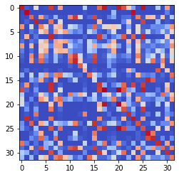

epoch 471 == measurement_heuristic: 0.67+-0.01/0.62+-0.01 --

epoch 472 >> measurement_heuristic: 0.65+-0.01/0.61+-0.01 --

epoch 473 == measurement_heuristic: 0.68+-0.01/0.61+-0.01 --

epoch 474 == measurement_heuristic: 0.66+-0.01/0.61+-0.01 --

epoch 475 == measurement_heuristic: 0.66+-0.01/0.61+-0.01 --

epoch 476 == measurement_heuristic: 0.66+-0.01/0.62+-0.01 --

epoch 477 == measurement_heuristic: 0.65+-0.01/0.61+-0.01 --

epoch 478 == measurement_heuristic: 0.67+-0.01/0.61+-0.01 --

epoch 479 == measurement_heuristic: 0.66+-0.01/0.62+-0.01 --

epoch 480 == measurement_heuristic: 0.68+-0.01/0.63+-0.01 --

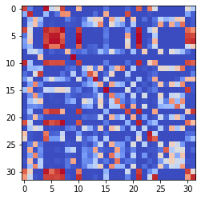

epoch 481 == measurement_heuristic: 0.68+-0.01/0.61+-0.01 --

epoch 482 >> measurement_heuristic: 0.68+-0.01/0.61+-0.01 --

epoch 483 == measurement_heuristic: 0.68+-0.01/0.61+-0.01 --

epoch 484 == measurement_heuristic: 0.66+-0.01/0.61+-0.01 --

epoch 485 >> measurement_heuristic: 0.65+-0.01/0.60+-0.01 --

epoch 486 == measurement_heuristic: 0.65+-0.01/0.60+-0.01 --

epoch 487 == measurement_heuristic: 0.65+-0.01/0.61+-0.01 --

epoch 488 == measurement_heuristic: 0.67+-0.01/0.61+-0.01 --

epoch 489 == measurement_heuristic: 0.69+-0.01/0.60+-0.01 --

epoch 490 == measurement_heuristic: 0.66+-0.01/0.60+-0.01 --

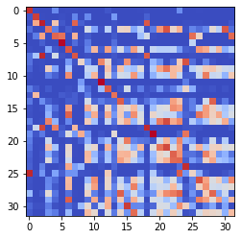

epoch 491 == measurement_heuristic: 0.68+-0.01/0.61+-0.01 --

epoch 492 == measurement_heuristic: 0.67+-0.01/0.61+-0.01 --

epoch 493 == measurement_heuristic: 0.65+-0.01/0.60+-0.01 --

epoch 494 == measurement_heuristic: 0.66+-0.01/0.61+-0.01 --

epoch 495 == measurement_heuristic: 0.66+-0.01/0.60+-0.01 --

epoch 496 == measurement_heuristic: 0.65+-0.01/0.62+-0.01 --

epoch 497 == measurement_heuristic: 0.66+-0.01/0.60+-0.01 --

epoch 498 == measurement_heuristic: 0.63+-0.01/0.60+-0.01 --

epoch 499 == measurement_heuristic: 0.65+-0.01/0.61+-0.01 --

epoch 500 >> measurement_heuristic: 0.65+-0.01/0.60+-0.01 --

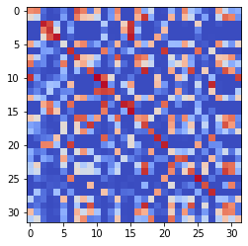

epoch 501 == measurement_heuristic: 0.67+-0.01/0.60+-0.01 --

epoch 502 == measurement_heuristic: 0.65+-0.02/0.62+-0.01 --

epoch 503 == measurement_heuristic: 0.67+-0.01/0.61+-0.01 --

epoch 504 == measurement_heuristic: 0.65+-0.01/0.60+-0.01 --

epoch 505 >> measurement_heuristic: 0.65+-0.01/0.60+-0.01 --

epoch 506 == measurement_heuristic: 0.65+-0.01/0.60+-0.01 --

epoch 507 == measurement_heuristic: 0.64+-0.01/0.61+-0.01 --

epoch 508 >> measurement_heuristic: 0.66+-0.01/0.60+-0.01 --

epoch 509 == measurement_heuristic: 0.66+-0.01/0.60+-0.01 --

epoch 510 == measurement_heuristic: 0.65+-0.01/0.61+-0.01 --

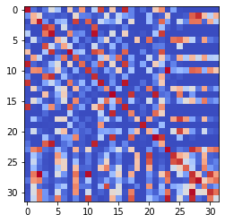

epoch 511 == measurement_heuristic: 0.64+-0.01/0.60+-0.01 --

epoch 512 == measurement_heuristic: 0.67+-0.01/0.60+-0.01 --

epoch 513 == measurement_heuristic: 0.63+-0.01/0.61+-0.01 --

epoch 514 >> measurement_heuristic: 0.65+-0.01/0.59+-0.01 --

epoch 515 == measurement_heuristic: 0.65+-0.01/0.59+-0.01 --

epoch 516 == measurement_heuristic: 0.65+-0.01/0.60+-0.01 --

epoch 517 == measurement_heuristic: 0.66+-0.01/0.60+-0.01 --

epoch 518 == measurement_heuristic: 0.66+-0.02/0.60+-0.01 --

epoch 519 == measurement_heuristic: 0.63+-0.01/0.59+-0.01 --

epoch 520 == measurement_heuristic: 0.66+-0.02/0.60+-0.01 --

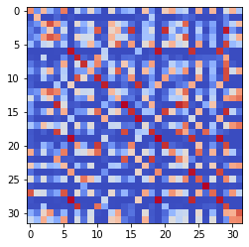

epoch 521 >> measurement_heuristic: 0.63+-0.01/0.59+-0.01 --

epoch 522 == measurement_heuristic: 0.66+-0.01/0.60+-0.01 --

epoch 523 >> measurement_heuristic: 0.66+-0.01/0.59+-0.01 --

epoch 524 == measurement_heuristic: 0.63+-0.01/0.59+-0.01 --

epoch 525 == measurement_heuristic: 0.66+-0.01/0.59+-0.01 --

epoch 526 == measurement_heuristic: 0.67+-0.01/0.59+-0.01 --

epoch 527 == measurement_heuristic: 0.65+-0.02/0.59+-0.01 --

epoch 528 == measurement_heuristic: 0.64+-0.01/0.59+-0.01 --

epoch 529 == measurement_heuristic: 0.66+-0.01/0.60+-0.01 --

epoch 530 == measurement_heuristic: 0.64+-0.01/0.60+-0.01 --

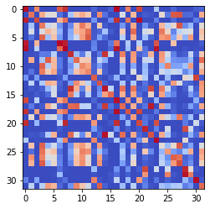

epoch 531 == measurement_heuristic: 0.63+-0.01/0.60+-0.01 --

epoch 532 == measurement_heuristic: 0.66+-0.01/0.59+-0.01 --

epoch 533 == measurement_heuristic: 0.65+-0.01/0.60+-0.01 --

epoch 534 == measurement_heuristic: 0.63+-0.01/0.60+-0.01 --

epoch 535 >> measurement_heuristic: 0.63+-0.01/0.58+-0.01 --

epoch 536 >> measurement_heuristic: 0.64+-0.01/0.58+-0.01 --

epoch 537 == measurement_heuristic: 0.65+-0.01/0.59+-0.01 --

epoch 538 == measurement_heuristic: 0.65+-0.01/0.59+-0.01 --

epoch 539 == measurement_heuristic: 0.66+-0.01/0.60+-0.01 --

epoch 540 == measurement_heuristic: 0.65+-0.01/0.59+-0.01 --

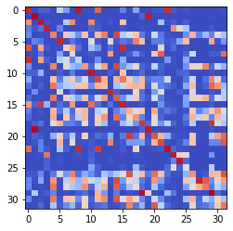

epoch 541 == measurement_heuristic: 0.64+-0.01/0.60+-0.01 --

epoch 542 >> measurement_heuristic: 0.64+-0.02/0.58+-0.01 --

epoch 543 == measurement_heuristic: 0.63+-0.01/0.60+-0.01 --

epoch 544 >> measurement_heuristic: 0.64+-0.01/0.58+-0.01 --

epoch 545 == measurement_heuristic: 0.65+-0.01/0.59+-0.01 --

epoch 546 == measurement_heuristic: 0.66+-0.01/0.60+-0.01 --

epoch 547 == measurement_heuristic: 0.64+-0.01/0.58+-0.01 --

epoch 548 >> measurement_heuristic: 0.62+-0.01/0.57+-0.01 --

epoch 549 == measurement_heuristic: 0.63+-0.01/0.60+-0.01 --

epoch 550 == measurement_heuristic: 0.62+-0.01/0.59+-0.01 --

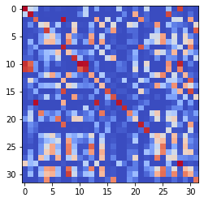

epoch 551 == measurement_heuristic: 0.63+-0.01/0.58+-0.01 --

epoch 552 == measurement_heuristic: 0.64+-0.01/0.58+-0.01 --

epoch 553 == measurement_heuristic: 0.65+-0.01/0.58+-0.01 --

epoch 554 == measurement_heuristic: 0.64+-0.01/0.58+-0.01 --

epoch 555 == measurement_heuristic: 0.64+-0.01/0.58+-0.01 --

epoch 556 == measurement_heuristic: 0.65+-0.01/0.58+-0.01 --

epoch 557 == measurement_heuristic: 0.61+-0.01/0.58+-0.01 --

epoch 558 == measurement_heuristic: 0.65+-0.01/0.59+-0.01 --

epoch 559 == measurement_heuristic: 0.64+-0.01/0.59+-0.01 --

epoch 560 == measurement_heuristic: 0.62+-0.01/0.59+-0.01 --

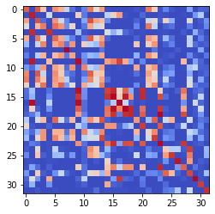

epoch 561 == measurement_heuristic: 0.63+-0.01/0.57+-0.01 --

epoch 562 == measurement_heuristic: 0.63+-0.01/0.58+-0.01 --

epoch 563 == measurement_heuristic: 0.66+-0.01/0.58+-0.01 --

epoch 564 == measurement_heuristic: 0.65+-0.02/0.58+-0.01 --

epoch 565 >> measurement_heuristic: 0.65+-0.01/0.57+-0.01 --

epoch 566 == measurement_heuristic: 0.63+-0.01/0.57+-0.01 --

epoch 567 == measurement_heuristic: 0.65+-0.01/0.60+-0.01 --

epoch 568 == measurement_heuristic: 0.65+-0.01/0.60+-0.01 --

epoch 569 == measurement_heuristic: 0.64+-0.01/0.58+-0.01 --

epoch 570 == measurement_heuristic: 0.64+-0.01/0.59+-0.01 --

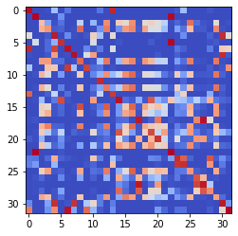

epoch 571 == measurement_heuristic: 0.65+-0.01/0.58+-0.01 --

epoch 572 == measurement_heuristic: 0.61+-0.01/0.59+-0.01 --

epoch 573 == measurement_heuristic: 0.61+-0.01/0.57+-0.01 --

epoch 574 == measurement_heuristic: 0.63+-0.01/0.58+-0.01 --

epoch 575 >> measurement_heuristic: 0.63+-0.01/0.56+-0.01 --

epoch 576 == measurement_heuristic: 0.63+-0.01/0.57+-0.01 --

epoch 577 == measurement_heuristic: 0.63+-0.01/0.57+-0.01 --

epoch 578 == measurement_heuristic: 0.65+-0.01/0.58+-0.01 --

epoch 579 >> measurement_heuristic: 0.61+-0.01/0.56+-0.01 --

epoch 580 == measurement_heuristic: 0.62+-0.01/0.57+-0.01 --

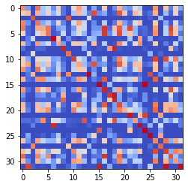

epoch 581 == measurement_heuristic: 0.65+-0.01/0.57+-0.01 --

epoch 582 == measurement_heuristic: 0.64+-0.02/0.56+-0.01 --

epoch 583 == measurement_heuristic: 0.61+-0.01/0.56+-0.01 --

epoch 584 == measurement_heuristic: 0.63+-0.01/0.56+-0.01 --

epoch 585 == measurement_heuristic: 0.61+-0.01/0.57+-0.01 --

epoch 586 == measurement_heuristic: 0.63+-0.01/0.58+-0.01 --

epoch 587 == measurement_heuristic: 0.63+-0.01/0.57+-0.01 --

epoch 588 == measurement_heuristic: 0.63+-0.01/0.57+-0.01 --

epoch 589 == measurement_heuristic: 0.63+-0.01/0.57+-0.01 --

epoch 590 == measurement_heuristic: 0.61+-0.01/0.56+-0.01 --

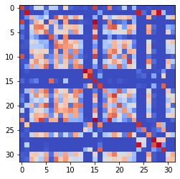

epoch 591 == measurement_heuristic: 0.63+-0.01/0.57+-0.01 --

epoch 592 == measurement_heuristic: 0.62+-0.01/0.57+-0.01 --

epoch 593 == measurement_heuristic: 0.63+-0.02/0.57+-0.01 --

epoch 594 == measurement_heuristic: 0.62+-0.01/0.57+-0.01 --

epoch 595 == measurement_heuristic: 0.64+-0.01/0.57+-0.01 --

epoch 596 == measurement_heuristic: 0.63+-0.01/0.57+-0.01 --

epoch 597 == measurement_heuristic: 0.62+-0.01/0.57+-0.01 --

epoch 598 == measurement_heuristic: 0.64+-0.01/0.57+-0.01 --

epoch 599 == measurement_heuristic: 0.62+-0.01/0.57+-0.01 --

epoch 600 >> measurement_heuristic: 0.63+-0.01/0.56+-0.01 --

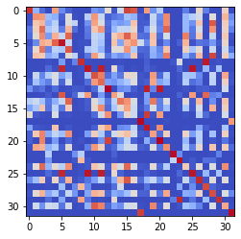

epoch 601 == measurement_heuristic: 0.60+-0.01/0.58+-0.01 --

epoch 602 == measurement_heuristic: 0.63+-0.02/0.57+-0.01 --

epoch 603 == measurement_heuristic: 0.65+-0.01/0.56+-0.01 --

epoch 604 == measurement_heuristic: 0.62+-0.01/0.56+-0.01 --

epoch 605 == measurement_heuristic: 0.64+-0.01/0.60+-0.01 --

epoch 606 == measurement_heuristic: 0.64+-0.01/0.57+-0.01 --

epoch 607 == measurement_heuristic: 0.62+-0.01/0.56+-0.01 --

epoch 608 >> measurement_heuristic: 0.61+-0.01/0.56+-0.01 --

epoch 609 == measurement_heuristic: 0.60+-0.01/0.60+-0.01 --

epoch 610 == measurement_heuristic: 0.63+-0.01/0.57+-0.01 --

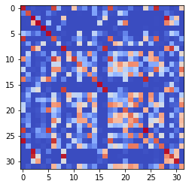

epoch 611 == measurement_heuristic: 0.65+-0.01/0.56+-0.01 --

epoch 612 == measurement_heuristic: 0.60+-0.01/0.56+-0.01 --

epoch 613 == measurement_heuristic: 0.62+-0.01/0.56+-0.01 --

epoch 614 == measurement_heuristic: 0.62+-0.01/0.56+-0.01 --

epoch 615 == measurement_heuristic: 0.64+-0.01/0.57+-0.01 --

epoch 616 == measurement_heuristic: 0.64+-0.01/0.57+-0.01 --

epoch 617 == measurement_heuristic: 0.61+-0.01/0.57+-0.01 --

epoch 618 == measurement_heuristic: 0.60+-0.01/0.56+-0.01 --

epoch 619 == measurement_heuristic: 0.62+-0.01/0.56+-0.01 --

epoch 620 == measurement_heuristic: 0.63+-0.01/0.57+-0.01 --

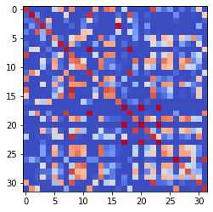

epoch 621 == measurement_heuristic: 0.62+-0.01/0.56+-0.01 --

epoch 622 == measurement_heuristic: 0.60+-0.01/0.56+-0.01 --

epoch 623 >> measurement_heuristic: 0.62+-0.01/0.55+-0.01 --

epoch 624 >> measurement_heuristic: 0.63+-0.01/0.55+-0.01 --

epoch 625 == measurement_heuristic: 0.61+-0.01/0.56+-0.01 --

epoch 626 == measurement_heuristic: 0.61+-0.01/0.56+-0.01 --

epoch 627 == measurement_heuristic: 0.61+-0.01/0.55+-0.01 --

epoch 628 == measurement_heuristic: 0.61+-0.01/0.57+-0.01 --

epoch 629 == measurement_heuristic: 0.62+-0.01/0.56+-0.01 --

epoch 630 == measurement_heuristic: 0.63+-0.01/0.57+-0.01 --

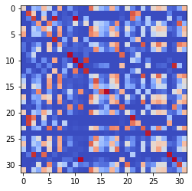

epoch 631 == measurement_heuristic: 0.63+-0.01/0.57+-0.01 --

epoch 632 == measurement_heuristic: 0.60+-0.01/0.56+-0.01 --

epoch 633 >> measurement_heuristic: 0.60+-0.01/0.55+-0.01 --

epoch 634 == measurement_heuristic: 0.59+-0.01/0.56+-0.01 --

epoch 635 == measurement_heuristic: 0.62+-0.01/0.56+-0.01 --

epoch 636 >> measurement_heuristic: 0.60+-0.01/0.54+-0.01 --

epoch 637 == measurement_heuristic: 0.62+-0.01/0.55+-0.01 --

epoch 638 == measurement_heuristic: 0.60+-0.01/0.56+-0.01 --

epoch 639 == measurement_heuristic: 0.59+-0.01/0.55+-0.01 --

epoch 640 == measurement_heuristic: 0.61+-0.01/0.57+-0.01 --

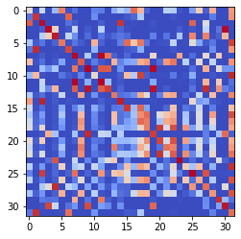

epoch 641 == measurement_heuristic: 0.62+-0.01/0.55+-0.01 --

epoch 642 == measurement_heuristic: 0.63+-0.02/0.57+-0.01 --

epoch 643 == measurement_heuristic: 0.59+-0.01/0.56+-0.01 --

epoch 644 == measurement_heuristic: 0.62+-0.01/0.54+-0.01 --

epoch 645 == measurement_heuristic: 0.60+-0.01/0.56+-0.01 --

epoch 646 == measurement_heuristic: 0.61+-0.01/0.55+-0.01 --

epoch 647 == measurement_heuristic: 0.62+-0.01/0.55+-0.01 --

epoch 648 == measurement_heuristic: 0.59+-0.01/0.56+-0.01 --

epoch 649 == measurement_heuristic: 0.60+-0.01/0.56+-0.01 --

epoch 650 == measurement_heuristic: 0.63+-0.01/0.56+-0.01 --

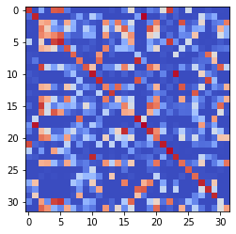

epoch 651 == measurement_heuristic: 0.62+-0.01/0.55+-0.01 --

epoch 652 >> measurement_heuristic: 0.60+-0.01/0.54+-0.01 --

epoch 653 == measurement_heuristic: 0.59+-0.01/0.55+-0.01 --

epoch 654 == measurement_heuristic: 0.58+-0.01/0.56+-0.01 --

epoch 655 == measurement_heuristic: 0.62+-0.01/0.55+-0.01 --

epoch 656 == measurement_heuristic: 0.62+-0.01/0.55+-0.01 --

epoch 657 == measurement_heuristic: 0.59+-0.01/0.55+-0.01 --

epoch 658 == measurement_heuristic: 0.62+-0.01/0.55+-0.01 --

epoch 659 == measurement_heuristic: 0.63+-0.01/0.55+-0.01 --

epoch 660 >> measurement_heuristic: 0.60+-0.01/0.54+-0.01 --

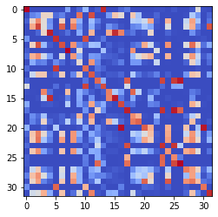

epoch 661 == measurement_heuristic: 0.60+-0.02/0.54+-0.01 --

epoch 662 == measurement_heuristic: 0.62+-0.01/0.55+-0.01 --

epoch 663 == measurement_heuristic: 0.59+-0.01/0.55+-0.01 --

epoch 664 == measurement_heuristic: 0.59+-0.01/0.55+-0.01 --

epoch 665 == measurement_heuristic: 0.61+-0.01/0.56+-0.01 --

epoch 666 == measurement_heuristic: 0.60+-0.01/0.54+-0.01 --

epoch 667 == measurement_heuristic: 0.60+-0.01/0.57+-0.01 --

epoch 668 == measurement_heuristic: 0.62+-0.01/0.57+-0.01 --

epoch 669 == measurement_heuristic: 0.60+-0.01/0.55+-0.01 --

epoch 670 == measurement_heuristic: 0.61+-0.01/0.55+-0.01 --

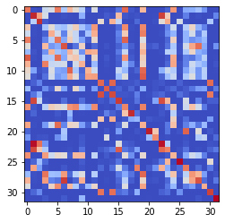

epoch 671 == measurement_heuristic: 0.61+-0.02/0.55+-0.01 --

epoch 672 == measurement_heuristic: 0.61+-0.01/0.55+-0.01 --

epoch 673 == measurement_heuristic: 0.61+-0.01/0.56+-0.01 --

epoch 674 == measurement_heuristic: 0.60+-0.01/0.54+-0.01 --

epoch 675 == measurement_heuristic: 0.58+-0.01/0.56+-0.01 --

epoch 676 == measurement_heuristic: 0.60+-0.01/0.55+-0.01 --

epoch 677 == measurement_heuristic: 0.60+-0.01/0.54+-0.01 --

epoch 678 == measurement_heuristic: 0.63+-0.01/0.55+-0.01 --

epoch 679 == measurement_heuristic: 0.60+-0.01/0.57+-0.01 --

epoch 680 == measurement_heuristic: 0.60+-0.01/0.54+-0.01 --

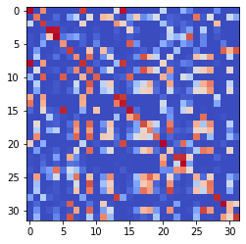

epoch 681 == measurement_heuristic: 0.59+-0.01/0.55+-0.01 --

epoch 682 == measurement_heuristic: 0.62+-0.02/0.55+-0.01 --

epoch 683 == measurement_heuristic: 0.62+-0.01/0.55+-0.01 --

epoch 684 == measurement_heuristic: 0.60+-0.01/0.54+-0.01 --

epoch 685 == measurement_heuristic: 0.61+-0.01/0.55+-0.01 --

epoch 686 == measurement_heuristic: 0.58+-0.01/0.55+-0.01 --

epoch 687 == measurement_heuristic: 0.59+-0.01/0.54+-0.01 --

epoch 688 == measurement_heuristic: 0.57+-0.01/0.55+-0.01 --

epoch 689 == measurement_heuristic: 0.60+-0.01/0.55+-0.01 --

epoch 690 == measurement_heuristic: 0.61+-0.01/0.55+-0.01 --

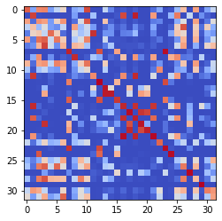

epoch 691 == measurement_heuristic: 0.59+-0.01/0.54+-0.01 --

epoch 692 == measurement_heuristic: 0.59+-0.01/0.54+-0.01 --

epoch 693 == measurement_heuristic: 0.61+-0.02/0.54+-0.01 --

epoch 694 == measurement_heuristic: 0.62+-0.01/0.55+-0.01 --

epoch 695 == measurement_heuristic: 0.58+-0.01/0.54+-0.01 --

epoch 696 >> measurement_heuristic: 0.60+-0.01/0.53+-0.01 --

epoch 697 == measurement_heuristic: 0.60+-0.01/0.53+-0.01 --

epoch 698 == measurement_heuristic: 0.61+-0.01/0.54+-0.01 --

epoch 699 == measurement_heuristic: 0.60+-0.01/0.54+-0.01 --

epoch 700 == measurement_heuristic: 0.59+-0.01/0.55+-0.01 --

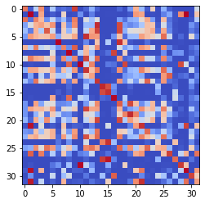

epoch 701 == measurement_heuristic: 0.60+-0.01/0.54+-0.01 --

epoch 702 == measurement_heuristic: 0.57+-0.01/0.54+-0.01 --

epoch 703 == measurement_heuristic: 0.59+-0.01/0.55+-0.01 --

epoch 704 == measurement_heuristic: 0.59+-0.01/0.53+-0.01 --

epoch 705 >> measurement_heuristic: 0.61+-0.01/0.53+-0.01 --

epoch 706 == measurement_heuristic: 0.60+-0.01/0.53+-0.01 --

epoch 707 >> measurement_heuristic: 0.60+-0.01/0.53+-0.01 --

epoch 708 == measurement_heuristic: 0.59+-0.01/0.54+-0.01 --

epoch 709 == measurement_heuristic: 0.59+-0.01/0.53+-0.01 --

epoch 710 == measurement_heuristic: 0.60+-0.01/0.54+-0.01 --

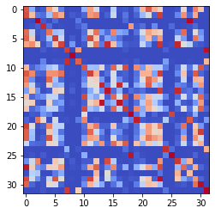

epoch 711 == measurement_heuristic: 0.58+-0.01/0.54+-0.01 --

epoch 712 == measurement_heuristic: 0.61+-0.01/0.54+-0.01 --

epoch 713 == measurement_heuristic: 0.59+-0.01/0.54+-0.01 --

epoch 714 == measurement_heuristic: 0.59+-0.01/0.54+-0.01 --

epoch 715 == measurement_heuristic: 0.61+-0.01/0.53+-0.01 --

epoch 716 == measurement_heuristic: 0.61+-0.01/0.54+-0.01 --

epoch 717 == measurement_heuristic: 0.59+-0.01/0.54+-0.01 --

epoch 718 == measurement_heuristic: 0.60+-0.01/0.53+-0.01 --

epoch 719 == measurement_heuristic: 0.60+-0.01/0.54+-0.01 --

epoch 720 == measurement_heuristic: 0.58+-0.01/0.54+-0.01 --

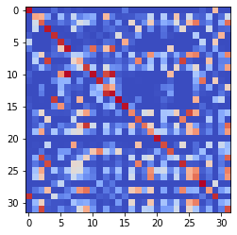

epoch 721 == measurement_heuristic: 0.61+-0.01/0.53+-0.01 --

epoch 722 == measurement_heuristic: 0.59+-0.01/0.53+-0.01 --

epoch 723 == measurement_heuristic: 0.61+-0.01/0.53+-0.01 --

epoch 724 == measurement_heuristic: 0.58+-0.01/0.54+-0.01 --

epoch 725 == measurement_heuristic: 0.59+-0.01/0.54+-0.01 --

epoch 726 == measurement_heuristic: 0.60+-0.01/0.54+-0.01 --

epoch 727 >> measurement_heuristic: 0.60+-0.01/0.53+-0.01 --

epoch 728 == measurement_heuristic: 0.60+-0.01/0.54+-0.01 --

epoch 729 == measurement_heuristic: 0.60+-0.01/0.53+-0.01 --

epoch 730 == measurement_heuristic: 0.60+-0.01/0.54+-0.01 --

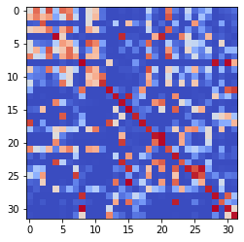

epoch 731 == measurement_heuristic: 0.58+-0.02/0.53+-0.01 --

epoch 732 >> measurement_heuristic: 0.57+-0.01/0.52+-0.01 --

epoch 733 == measurement_heuristic: 0.57+-0.01/0.53+-0.01 --

epoch 734 == measurement_heuristic: 0.57+-0.01/0.53+-0.01 --

epoch 735 == measurement_heuristic: 0.57+-0.01/0.52+-0.01 --

epoch 736 == measurement_heuristic: 0.56+-0.01/0.53+-0.01 --

epoch 737 >> measurement_heuristic: 0.57+-0.01/0.52+-0.01 --

epoch 738 == measurement_heuristic: 0.58+-0.01/0.53+-0.01 --

epoch 739 == measurement_heuristic: 0.59+-0.01/0.53+-0.01 --

epoch 740 == measurement_heuristic: 0.59+-0.01/0.53+-0.01 --

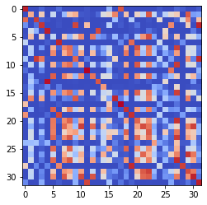

epoch 741 == measurement_heuristic: 0.59+-0.01/0.52+-0.01 --

epoch 742 == measurement_heuristic: 0.59+-0.01/0.53+-0.01 --

epoch 743 == measurement_heuristic: 0.59+-0.01/0.52+-0.01 --

epoch 744 == measurement_heuristic: 0.60+-0.01/0.53+-0.01 --

epoch 745 == measurement_heuristic: 0.57+-0.01/0.53+-0.01 --

epoch 746 >> measurement_heuristic: 0.56+-0.01/0.52+-0.01 --

epoch 747 == measurement_heuristic: 0.59+-0.01/0.52+-0.01 --

epoch 748 == measurement_heuristic: 0.60+-0.01/0.56+-0.01 --

epoch 749 == measurement_heuristic: 0.57+-0.01/0.52+-0.01 --

epoch 750 == measurement_heuristic: 0.57+-0.01/0.53+-0.01 --

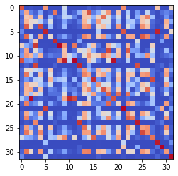

epoch 751 == measurement_heuristic: 0.57+-0.01/0.52+-0.01 --

epoch 752 == measurement_heuristic: 0.58+-0.01/0.53+-0.01 --

epoch 753 == measurement_heuristic: 0.58+-0.01/0.54+-0.01 --

epoch 754 == measurement_heuristic: 0.59+-0.01/0.52+-0.01 --

epoch 755 == measurement_heuristic: 0.58+-0.01/0.53+-0.01 --

epoch 756 == measurement_heuristic: 0.59+-0.02/0.53+-0.01 --

epoch 757 == measurement_heuristic: 0.61+-0.01/0.54+-0.01 --

epoch 758 == measurement_heuristic: 0.60+-0.02/0.53+-0.01 --

epoch 759 == measurement_heuristic: 0.58+-0.01/0.52+-0.01 --

epoch 760 == measurement_heuristic: 0.57+-0.01/0.53+-0.01 --

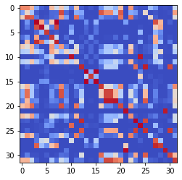

epoch 761 == measurement_heuristic: 0.59+-0.01/0.52+-0.01 --

epoch 762 == measurement_heuristic: 0.57+-0.01/0.52+-0.01 --

epoch 763 == measurement_heuristic: 0.60+-0.01/0.53+-0.01 --

epoch 764 == measurement_heuristic: 0.57+-0.01/0.53+-0.01 --

epoch 765 == measurement_heuristic: 0.58+-0.01/0.53+-0.01 --

epoch 766 == measurement_heuristic: 0.57+-0.01/0.53+-0.01 --

epoch 767 == measurement_heuristic: 0.59+-0.01/0.53+-0.01 --

epoch 768 == measurement_heuristic: 0.59+-0.01/0.53+-0.01 --

epoch 769 == measurement_heuristic: 0.59+-0.01/0.53+-0.01 --

epoch 770 >> measurement_heuristic: 0.59+-0.01/0.51+-0.01 --

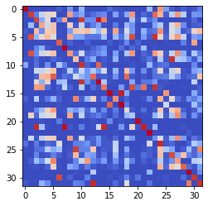

epoch 771 == measurement_heuristic: 0.59+-0.01/0.52+-0.01 --

epoch 772 == measurement_heuristic: 0.58+-0.01/0.52+-0.01 --

epoch 773 == measurement_heuristic: 0.59+-0.01/0.52+-0.01 --

epoch 774 == measurement_heuristic: 0.60+-0.01/0.52+-0.01 --

epoch 775 == measurement_heuristic: 0.56+-0.01/0.53+-0.01 --

epoch 776 >> measurement_heuristic: 0.58+-0.01/0.51+-0.01 --

epoch 777 == measurement_heuristic: 0.57+-0.01/0.52+-0.01 --

epoch 778 == measurement_heuristic: 0.59+-0.01/0.52+-0.01 --

epoch 779 == measurement_heuristic: 0.59+-0.01/0.52+-0.01 --

epoch 780 == measurement_heuristic: 0.58+-0.01/0.52+-0.01 --

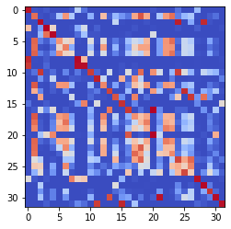

epoch 781 == measurement_heuristic: 0.57+-0.01/0.53+-0.01 --

epoch 782 == measurement_heuristic: 0.58+-0.01/0.52+-0.01 --

epoch 783 == measurement_heuristic: 0.62+-0.01/0.52+-0.01 --

epoch 784 == measurement_heuristic: 0.58+-0.01/0.52+-0.01 --

epoch 785 == measurement_heuristic: 0.56+-0.01/0.52+-0.01 --

epoch 786 == measurement_heuristic: 0.59+-0.01/0.52+-0.01 --

epoch 787 == measurement_heuristic: 0.56+-0.01/0.51+-0.01 --

epoch 788 == measurement_heuristic: 0.58+-0.01/0.53+-0.01 --

epoch 789 == measurement_heuristic: 0.58+-0.01/0.51+-0.01 --

epoch 790 == measurement_heuristic: 0.56+-0.01/0.52+-0.01 --

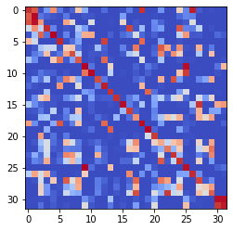

epoch 791 == measurement_heuristic: 0.56+-0.01/0.52+-0.01 --

epoch 792 == measurement_heuristic: 0.58+-0.02/0.51+-0.01 --

epoch 793 == measurement_heuristic: 0.56+-0.01/0.51+-0.01 --

epoch 794 == measurement_heuristic: 0.57+-0.01/0.51+-0.01 --

epoch 795 == measurement_heuristic: 0.55+-0.01/0.52+-0.01 --

epoch 796 >> measurement_heuristic: 0.58+-0.01/0.51+-0.01 --

epoch 797 == measurement_heuristic: 0.58+-0.01/0.51+-0.01 --

epoch 798 == measurement_heuristic: 0.58+-0.01/0.53+-0.01 --

epoch 799 == measurement_heuristic: 0.57+-0.01/0.51+-0.01 --

epoch 800 == measurement_heuristic: 0.58+-0.01/0.53+-0.01 --

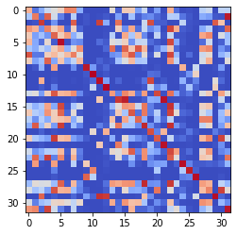

epoch 801 == measurement_heuristic: 0.60+-0.01/0.51+-0.01 --

epoch 802 == measurement_heuristic: 0.55+-0.01/0.52+-0.01 --

epoch 803 == measurement_heuristic: 0.59+-0.01/0.52+-0.01 --

epoch 804 == measurement_heuristic: 0.58+-0.01/0.51+-0.01 --

epoch 805 == measurement_heuristic: 0.58+-0.01/0.52+-0.01 --

epoch 806 == measurement_heuristic: 0.60+-0.01/0.53+-0.01 --

epoch 807 >> measurement_heuristic: 0.57+-0.02/0.51+-0.01 --

epoch 808 == measurement_heuristic: 0.57+-0.01/0.52+-0.01 --

epoch 809 == measurement_heuristic: 0.55+-0.01/0.52+-0.01 --

epoch 810 == measurement_heuristic: 0.60+-0.01/0.54+-0.01 --

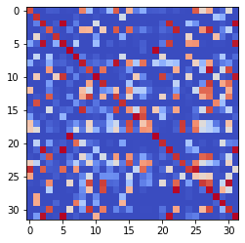

epoch 811 >> measurement_heuristic: 0.58+-0.01/0.50+-0.01 --

epoch 812 == measurement_heuristic: 0.58+-0.01/0.53+-0.01 --

epoch 813 == measurement_heuristic: 0.56+-0.01/0.53+-0.01 --

epoch 814 == measurement_heuristic: 0.58+-0.01/0.52+-0.01 --

epoch 815 == measurement_heuristic: 0.56+-0.01/0.51+-0.01 --

epoch 816 == measurement_heuristic: 0.57+-0.01/0.51+-0.01 --

epoch 817 == measurement_heuristic: 0.57+-0.01/0.51+-0.01 --

epoch 818 == measurement_heuristic: 0.58+-0.01/0.51+-0.01 --

epoch 819 == measurement_heuristic: 0.57+-0.01/0.52+-0.01 --

epoch 820 == measurement_heuristic: 0.59+-0.01/0.53+-0.01 --

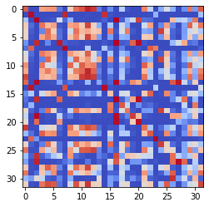

epoch 821 == measurement_heuristic: 0.57+-0.01/0.51+-0.01 --

epoch 822 == measurement_heuristic: 0.56+-0.01/0.51+-0.01 --

epoch 823 == measurement_heuristic: 0.60+-0.01/0.51+-0.01 --

epoch 824 == measurement_heuristic: 0.59+-0.01/0.52+-0.01 --

epoch 825 == measurement_heuristic: 0.60+-0.01/0.52+-0.01 --

epoch 826 == measurement_heuristic: 0.56+-0.01/0.52+-0.01 --

epoch 827 == measurement_heuristic: 0.56+-0.01/0.51+-0.01 --

epoch 828 == measurement_heuristic: 0.57+-0.01/0.51+-0.01 --

epoch 829 == measurement_heuristic: 0.56+-0.01/0.50+-0.01 --

epoch 830 == measurement_heuristic: 0.56+-0.01/0.51+-0.01 --

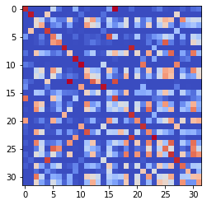

epoch 831 == measurement_heuristic: 0.57+-0.01/0.51+-0.01 --

epoch 832 == measurement_heuristic: 0.59+-0.01/0.52+-0.01 --

epoch 833 == measurement_heuristic: 0.56+-0.02/0.51+-0.01 --

epoch 834 == measurement_heuristic: 0.55+-0.01/0.51+-0.01 --

epoch 835 == measurement_heuristic: 0.57+-0.01/0.52+-0.01 --

epoch 836 == measurement_heuristic: 0.56+-0.01/0.51+-0.01 --

epoch 837 == measurement_heuristic: 0.55+-0.01/0.52+-0.01 --

epoch 838 == measurement_heuristic: 0.59+-0.01/0.52+-0.01 --

epoch 839 == measurement_heuristic: 0.56+-0.01/0.51+-0.01 --

epoch 840 == measurement_heuristic: 0.57+-0.01/0.51+-0.01 --

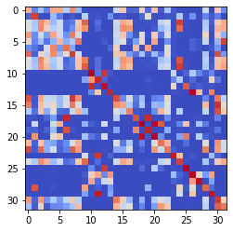

epoch 841 == measurement_heuristic: 0.56+-0.01/0.51+-0.01 --

epoch 842 >> measurement_heuristic: 0.55+-0.01/0.50+-0.01 --

epoch 843 >> measurement_heuristic: 0.55+-0.01/0.50+-0.01 --

epoch 844 == measurement_heuristic: 0.55+-0.01/0.51+-0.01 --

epoch 845 == measurement_heuristic: 0.58+-0.01/0.51+-0.01 --

epoch 846 == measurement_heuristic: 0.55+-0.01/0.50+-0.01 --

epoch 847 == measurement_heuristic: 0.55+-0.01/0.50+-0.01 --

epoch 848 == measurement_heuristic: 0.54+-0.01/0.51+-0.01 --

epoch 849 == measurement_heuristic: 0.58+-0.01/0.50+-0.01 --

epoch 850 == measurement_heuristic: 0.55+-0.01/0.50+-0.01 --

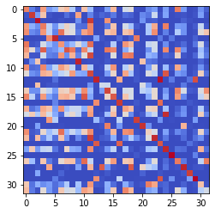

epoch 851 == measurement_heuristic: 0.59+-0.01/0.51+-0.01 --

epoch 852 >> measurement_heuristic: 0.57+-0.01/0.50+-0.01 --

epoch 853 == measurement_heuristic: 0.57+-0.01/0.50+-0.01 --

epoch 854 == measurement_heuristic: 0.58+-0.01/0.53+-0.01 --

epoch 855 == measurement_heuristic: 0.59+-0.02/0.51+-0.01 --

epoch 856 == measurement_heuristic: 0.55+-0.01/0.50+-0.01 --

epoch 857 == measurement_heuristic: 0.57+-0.01/0.50+-0.01 --

epoch 858 == measurement_heuristic: 0.58+-0.01/0.50+-0.01 --

epoch 859 >> measurement_heuristic: 0.54+-0.01/0.50+-0.01 --

epoch 860 == measurement_heuristic: 0.57+-0.01/0.50+-0.01 --

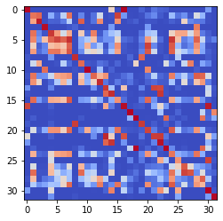

epoch 861 == measurement_heuristic: 0.56+-0.01/0.50+-0.01 --

epoch 862 == measurement_heuristic: 0.56+-0.01/0.51+-0.01 --

epoch 863 == measurement_heuristic: 0.56+-0.01/0.50+-0.01 --

epoch 864 == measurement_heuristic: 0.55+-0.01/0.51+-0.01 --

epoch 865 == measurement_heuristic: 0.54+-0.01/0.51+-0.01 --

epoch 866 == measurement_heuristic: 0.58+-0.01/0.51+-0.01 --

epoch 867 == measurement_heuristic: 0.54+-0.01/0.50+-0.01 --

epoch 868 == measurement_heuristic: 0.54+-0.01/0.51+-0.01 --

epoch 869 == measurement_heuristic: 0.55+-0.01/0.53+-0.01 --

epoch 870 >> measurement_heuristic: 0.57+-0.01/0.49+-0.01 --

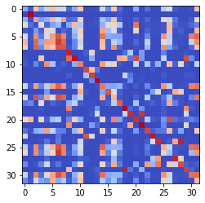

epoch 871 == measurement_heuristic: 0.54+-0.01/0.50+-0.01 --

epoch 872 >> measurement_heuristic: 0.57+-0.01/0.49+-0.01 --

epoch 873 == measurement_heuristic: 0.56+-0.01/0.51+-0.01 --

epoch 874 == measurement_heuristic: 0.56+-0.01/0.51+-0.01 --

epoch 875 == measurement_heuristic: 0.56+-0.01/0.51+-0.01 --

epoch 876 == measurement_heuristic: 0.57+-0.01/0.51+-0.01 --

epoch 877 == measurement_heuristic: 0.56+-0.01/0.49+-0.01 --

epoch 878 == measurement_heuristic: 0.60+-0.01/0.50+-0.01 --

epoch 879 == measurement_heuristic: 0.55+-0.01/0.50+-0.01 --

epoch 880 == measurement_heuristic: 0.55+-0.01/0.50+-0.01 --

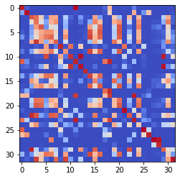

epoch 881 == measurement_heuristic: 0.56+-0.01/0.52+-0.01 --

epoch 882 == measurement_heuristic: 0.55+-0.01/0.49+-0.01 --

epoch 883 == measurement_heuristic: 0.56+-0.01/0.50+-0.01 --

epoch 884 == measurement_heuristic: 0.55+-0.01/0.50+-0.01 --

epoch 885 == measurement_heuristic: 0.55+-0.01/0.50+-0.01 --

epoch 886 == measurement_heuristic: 0.57+-0.01/0.49+-0.01 --

epoch 887 == measurement_heuristic: 0.54+-0.01/0.51+-0.01 --

epoch 888 == measurement_heuristic: 0.55+-0.01/0.52+-0.01 --

epoch 889 == measurement_heuristic: 0.57+-0.01/0.50+-0.01 --

epoch 890 >> measurement_heuristic: 0.54+-0.01/0.49+-0.01 --

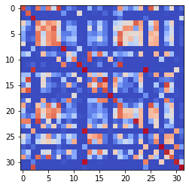

epoch 891 == measurement_heuristic: 0.55+-0.01/0.50+-0.01 --

epoch 892 == measurement_heuristic: 0.56+-0.01/0.50+-0.01 --

epoch 893 >> measurement_heuristic: 0.55+-0.01/0.49+-0.01 --

epoch 894 == measurement_heuristic: 0.55+-0.01/0.49+-0.01 --

epoch 895 == measurement_heuristic: 0.56+-0.02/0.51+-0.01 --

epoch 896 == measurement_heuristic: 0.55+-0.02/0.49+-0.01 --

epoch 897 == measurement_heuristic: 0.56+-0.01/0.50+-0.01 --

epoch 898 == measurement_heuristic: 0.56+-0.01/0.50+-0.01 --

epoch 899 == measurement_heuristic: 0.57+-0.01/0.51+-0.01 --

epoch 900 == measurement_heuristic: 0.57+-0.01/0.50+-0.01 --

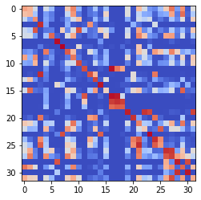

epoch 901 == measurement_heuristic: 0.57+-0.01/0.51+-0.01 --

epoch 902 == measurement_heuristic: 0.58+-0.01/0.49+-0.01 --

epoch 903 == measurement_heuristic: 0.55+-0.01/0.51+-0.01 --

epoch 904 == measurement_heuristic: 0.54+-0.01/0.52+-0.01 --

epoch 905 == measurement_heuristic: 0.55+-0.01/0.49+-0.01 --

epoch 906 == measurement_heuristic: 0.54+-0.01/0.50+-0.01 --

epoch 907 == measurement_heuristic: 0.53+-0.01/0.51+-0.01 --

epoch 908 == measurement_heuristic: 0.55+-0.01/0.50+-0.01 --

epoch 909 >> measurement_heuristic: 0.52+-0.01/0.48+-0.01 --

epoch 910 == measurement_heuristic: 0.53+-0.01/0.49+-0.01 --

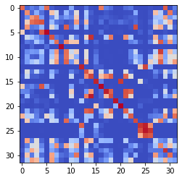

epoch 911 == measurement_heuristic: 0.55+-0.01/0.51+-0.01 --

epoch 912 == measurement_heuristic: 0.59+-0.02/0.49+-0.01 --

epoch 913 == measurement_heuristic: 0.57+-0.01/0.49+-0.01 --

epoch 914 == measurement_heuristic: 0.56+-0.01/0.50+-0.01 --

epoch 915 == measurement_heuristic: 0.55+-0.01/0.49+-0.01 --

epoch 916 == measurement_heuristic: 0.56+-0.01/0.50+-0.01 --

epoch 917 == measurement_heuristic: 0.53+-0.01/0.49+-0.01 --

epoch 918 == measurement_heuristic: 0.54+-0.01/0.51+-0.01 --

epoch 919 == measurement_heuristic: 0.55+-0.01/0.49+-0.01 --

epoch 920 == measurement_heuristic: 0.56+-0.01/0.50+-0.01 --

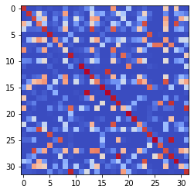

epoch 921 == measurement_heuristic: 0.55+-0.01/0.49+-0.01 --

epoch 922 == measurement_heuristic: 0.54+-0.01/0.50+-0.01 --

epoch 923 >> measurement_heuristic: 0.56+-0.01/0.48+-0.01 --

epoch 924 == measurement_heuristic: 0.55+-0.02/0.49+-0.01 --

epoch 925 == measurement_heuristic: 0.53+-0.01/0.49+-0.01 --

epoch 926 == measurement_heuristic: 0.55+-0.01/0.49+-0.01 --

epoch 927 == measurement_heuristic: 0.56+-0.01/0.50+-0.01 --

epoch 928 == measurement_heuristic: 0.54+-0.01/0.49+-0.01 --

epoch 929 == measurement_heuristic: 0.58+-0.02/0.50+-0.01 --

epoch 930 == measurement_heuristic: 0.54+-0.01/0.50+-0.01 --

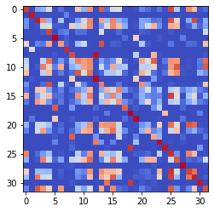

epoch 931 == measurement_heuristic: 0.57+-0.01/0.51+-0.01 --

epoch 932 == measurement_heuristic: 0.56+-0.01/0.49+-0.01 --

epoch 933 == measurement_heuristic: 0.57+-0.02/0.51+-0.01 --

epoch 934 == measurement_heuristic: 0.56+-0.01/0.49+-0.01 --

epoch 935 == measurement_heuristic: 0.55+-0.01/0.51+-0.01 --

epoch 936 == measurement_heuristic: 0.56+-0.01/0.49+-0.01 --

epoch 937 == measurement_heuristic: 0.56+-0.01/0.50+-0.01 --

epoch 938 == measurement_heuristic: 0.55+-0.01/0.50+-0.01 --

epoch 939 == measurement_heuristic: 0.54+-0.01/0.49+-0.01 --

epoch 940 == measurement_heuristic: 0.53+-0.01/0.49+-0.01 --

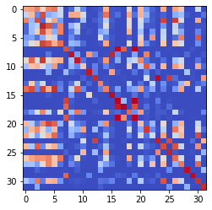

epoch 941 == measurement_heuristic: 0.57+-0.01/0.52+-0.01 --

epoch 942 == measurement_heuristic: 0.56+-0.01/0.49+-0.01 --

epoch 943 == measurement_heuristic: 0.53+-0.01/0.49+-0.01 --

epoch 944 == measurement_heuristic: 0.55+-0.01/0.49+-0.01 --

epoch 945 == measurement_heuristic: 0.52+-0.01/0.49+-0.01 --

epoch 946 == measurement_heuristic: 0.55+-0.01/0.50+-0.01 --

epoch 947 == measurement_heuristic: 0.54+-0.01/0.49+-0.01 --

epoch 948 == measurement_heuristic: 0.55+-0.01/0.49+-0.01 --

epoch 949 >> measurement_heuristic: 0.54+-0.01/0.48+-0.01 --

epoch 950 == measurement_heuristic: 0.57+-0.01/0.49+-0.01 --

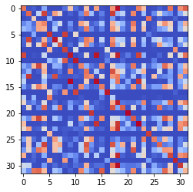

epoch 951 == measurement_heuristic: 0.57+-0.01/0.50+-0.01 --

epoch 952 == measurement_heuristic: 0.55+-0.01/0.49+-0.01 --

epoch 953 == measurement_heuristic: 0.53+-0.01/0.48+-0.01 --

epoch 954 == measurement_heuristic: 0.53+-0.01/0.48+-0.01 --

epoch 955 == measurement_heuristic: 0.54+-0.01/0.49+-0.01 --

epoch 956 == measurement_heuristic: 0.54+-0.01/0.50+-0.01 --

epoch 957 == measurement_heuristic: 0.55+-0.01/0.49+-0.01 --

epoch 958 == measurement_heuristic: 0.54+-0.01/0.48+-0.01 --

epoch 959 == measurement_heuristic: 0.55+-0.01/0.49+-0.01 --

epoch 960 == measurement_heuristic: 0.55+-0.01/0.48+-0.01 --

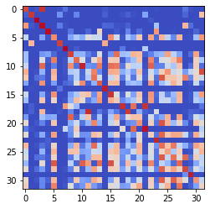

epoch 961 == measurement_heuristic: 0.56+-0.02/0.48+-0.01 --

epoch 962 == measurement_heuristic: 0.54+-0.01/0.48+-0.01 --

epoch 963 == measurement_heuristic: 0.55+-0.01/0.48+-0.01 --

epoch 964 == measurement_heuristic: 0.53+-0.01/0.49+-0.01 --

epoch 965 == measurement_heuristic: 0.54+-0.01/0.48+-0.01 --

epoch 966 == measurement_heuristic: 0.54+-0.02/0.51+-0.01 --

epoch 967 == measurement_heuristic: 0.54+-0.01/0.49+-0.01 --

epoch 968 == measurement_heuristic: 0.54+-0.01/0.48+-0.01 --

epoch 969 == measurement_heuristic: 0.54+-0.01/0.49+-0.01 --

epoch 970 == measurement_heuristic: 0.55+-0.01/0.49+-0.01 --

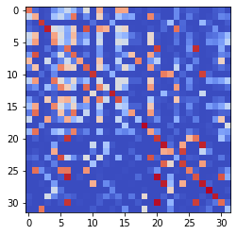

epoch 971 == measurement_heuristic: 0.53+-0.01/0.49+-0.01 --

epoch 972 == measurement_heuristic: 0.56+-0.01/0.48+-0.01 --

epoch 973 == measurement_heuristic: 0.53+-0.01/0.48+-0.01 --

epoch 974 >> measurement_heuristic: 0.55+-0.01/0.48+-0.01 --

epoch 975 == measurement_heuristic: 0.54+-0.01/0.48+-0.01 --

epoch 976 == measurement_heuristic: 0.52+-0.01/0.49+-0.01 --

epoch 977 == measurement_heuristic: 0.53+-0.01/0.52+-0.01 --

epoch 978 == measurement_heuristic: 0.56+-0.01/0.50+-0.01 --

epoch 979 == measurement_heuristic: 0.54+-0.01/0.49+-0.01 --

epoch 980 == measurement_heuristic: 0.53+-0.01/0.48+-0.01 --

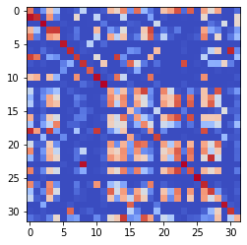

epoch 981 == measurement_heuristic: 0.56+-0.01/0.51+-0.01 --

epoch 982 == measurement_heuristic: 0.56+-0.01/0.49+-0.01 --

epoch 983 == measurement_heuristic: 0.55+-0.01/0.48+-0.01 --

epoch 984 >> measurement_heuristic: 0.54+-0.01/0.47+-0.01 --

epoch 985 == measurement_heuristic: 0.52+-0.01/0.48+-0.01 --

epoch 986 == measurement_heuristic: 0.56+-0.01/0.48+-0.01 --

epoch 987 == measurement_heuristic: 0.57+-0.01/0.49+-0.01 --

epoch 988 == measurement_heuristic: 0.57+-0.02/0.48+-0.01 --

epoch 989 == measurement_heuristic: 0.55+-0.01/0.48+-0.01 --

epoch 990 == measurement_heuristic: 0.54+-0.01/0.53+-0.01 --

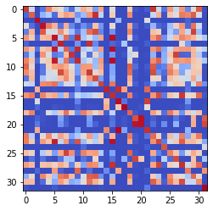

epoch 991 == measurement_heuristic: 0.55+-0.01/0.48+-0.01 --

epoch 992 == measurement_heuristic: 0.52+-0.01/0.48+-0.01 --

epoch 993 == measurement_heuristic: 0.55+-0.01/0.49+-0.01 --

epoch 994 == measurement_heuristic: 0.56+-0.01/0.48+-0.01 --

epoch 995 == measurement_heuristic: 0.52+-0.01/0.48+-0.01 --

epoch 996 == measurement_heuristic: 0.52+-0.01/0.47+-0.01 --

epoch 997 == measurement_heuristic: 0.54+-0.01/0.48+-0.01 --

epoch 998 == measurement_heuristic: 0.55+-0.01/0.47+-0.01 --

epoch 999 == measurement_heuristic: 0.54+-0.01/0.49+-0.01 --

epoch 1000 == measurement_heuristic: 0.54+-0.01/0.48+-0.01 --

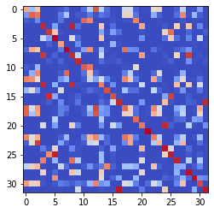

epoch 1001 == measurement_heuristic: 0.54+-0.01/0.48+-0.01 --

epoch 1002 == measurement_heuristic: 0.56+-0.01/0.47+-0.01 --

epoch 1003 == measurement_heuristic: 0.53+-0.01/0.48+-0.01 --

epoch 1004 >> measurement_heuristic: 0.52+-0.01/0.47+-0.01 --

epoch 1005 == measurement_heuristic: 0.56+-0.01/0.49+-0.01 --

epoch 1006 == measurement_heuristic: 0.52+-0.01/0.47+-0.01 --

epoch 1007 == measurement_heuristic: 0.54+-0.01/0.49+-0.01 --

epoch 1008 == measurement_heuristic: 0.53+-0.01/0.47+-0.01 --

epoch 1009 == measurement_heuristic: 0.52+-0.01/0.47+-0.01 --

epoch 1010 == measurement_heuristic: 0.55+-0.01/0.48+-0.01 --

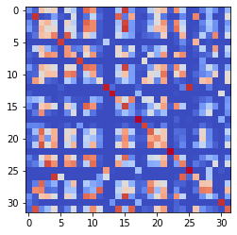

epoch 1011 == measurement_heuristic: 0.53+-0.01/0.47+-0.01 --

epoch 1012 == measurement_heuristic: 0.54+-0.01/0.48+-0.01 --

epoch 1013 == measurement_heuristic: 0.54+-0.01/0.49+-0.01 --

epoch 1014 == measurement_heuristic: 0.52+-0.01/0.48+-0.01 --

epoch 1015 == measurement_heuristic: 0.52+-0.01/0.47+-0.01 --

epoch 1016 == measurement_heuristic: 0.55+-0.01/0.48+-0.01 --

epoch 1017 == measurement_heuristic: 0.55+-0.01/0.49+-0.01 --

epoch 1018 == measurement_heuristic: 0.53+-0.01/0.47+-0.01 --

epoch 1019 == measurement_heuristic: 0.53+-0.01/0.48+-0.01 --

epoch 1020 == measurement_heuristic: 0.53+-0.01/0.47+-0.01 --

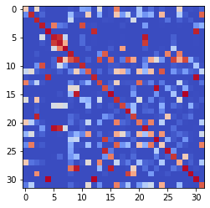

epoch 1021 == measurement_heuristic: 0.54+-0.01/0.49+-0.01 --

epoch 1022 == measurement_heuristic: 0.54+-0.01/0.52+-0.01 --

epoch 1023 >> measurement_heuristic: 0.56+-0.01/0.47+-0.01 --

epoch 1024 >> measurement_heuristic: 0.53+-0.01/0.47+-0.01 --

epoch 1025 == measurement_heuristic: 0.53+-0.01/0.47+-0.01 --

epoch 1026 == measurement_heuristic: 0.53+-0.01/0.49+-0.01 --

epoch 1027 == measurement_heuristic: 0.54+-0.01/0.48+-0.01 --

epoch 1028 == measurement_heuristic: 0.55+-0.01/0.49+-0.01 --

epoch 1029 == measurement_heuristic: 0.54+-0.01/0.49+-0.01 --

epoch 1030 == measurement_heuristic: 0.55+-0.01/0.47+-0.01 --

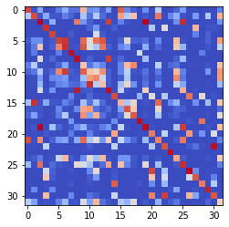

epoch 1031 == measurement_heuristic: 0.53+-0.01/0.47+-0.01 --

epoch 1032 == measurement_heuristic: 0.55+-0.01/0.49+-0.01 --

epoch 1033 == measurement_heuristic: 0.53+-0.01/0.51+-0.01 --

epoch 1034 == measurement_heuristic: 0.53+-0.01/0.50+-0.01 --

epoch 1035 == measurement_heuristic: 0.53+-0.01/0.47+-0.01 --

epoch 1036 == measurement_heuristic: 0.55+-0.01/0.47+-0.01 --

epoch 1037 == measurement_heuristic: 0.54+-0.01/0.48+-0.01 --

epoch 1038 == measurement_heuristic: 0.53+-0.01/0.49+-0.01 --

epoch 1039 == measurement_heuristic: 0.53+-0.01/0.48+-0.01 --

epoch 1040 == measurement_heuristic: 0.51+-0.01/0.47+-0.01 --

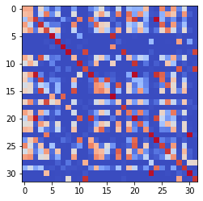

epoch 1041 == measurement_heuristic: 0.52+-0.01/0.48+-0.01 --

epoch 1042 == measurement_heuristic: 0.51+-0.01/0.48+-0.01 --

epoch 1043 == measurement_heuristic: 0.53+-0.01/0.48+-0.01 --

epoch 1044 == measurement_heuristic: 0.51+-0.01/0.47+-0.01 --

epoch 1045 == measurement_heuristic: 0.54+-0.01/0.48+-0.01 --

epoch 1046 == measurement_heuristic: 0.53+-0.01/0.47+-0.01 --

epoch 1047 == measurement_heuristic: 0.53+-0.01/0.47+-0.01 --

epoch 1048 == measurement_heuristic: 0.52+-0.01/0.47+-0.01 --

epoch 1049 == measurement_heuristic: 0.53+-0.01/0.47+-0.01 --

epoch 1050 == measurement_heuristic: 0.54+-0.01/0.47+-0.01 --

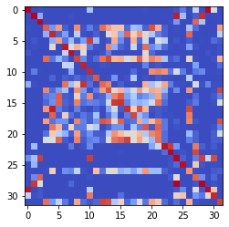

epoch 1051 == measurement_heuristic: 0.54+-0.01/0.48+-0.01 --

epoch 1052 == measurement_heuristic: 0.55+-0.01/0.48+-0.01 --

epoch 1053 == measurement_heuristic: 0.52+-0.01/0.47+-0.01 --

epoch 1054 == measurement_heuristic: 0.55+-0.01/0.47+-0.01 --

epoch 1055 == measurement_heuristic: 0.54+-0.01/0.48+-0.01 --

epoch 1056 == measurement_heuristic: 0.53+-0.01/0.47+-0.01 --

epoch 1057 >> measurement_heuristic: 0.53+-0.01/0.47+-0.01 --

epoch 1058 == measurement_heuristic: 0.56+-0.01/0.48+-0.01 --

epoch 1059 == measurement_heuristic: 0.53+-0.01/0.47+-0.01 --

epoch 1060 == measurement_heuristic: 0.53+-0.01/0.48+-0.01 --

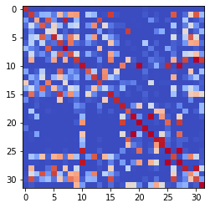

epoch 1061 == measurement_heuristic: 0.51+-0.01/0.47+-0.01 --

epoch 1062 == measurement_heuristic: 0.53+-0.01/0.48+-0.01 --

epoch 1063 == measurement_heuristic: 0.51+-0.01/0.47+-0.01 --

epoch 1064 == measurement_heuristic: 0.51+-0.01/0.47+-0.01 --

epoch 1065 == measurement_heuristic: 0.53+-0.01/0.47+-0.01 --

epoch 1066 >> measurement_heuristic: 0.51+-0.01/0.46+-0.01 --

epoch 1067 == measurement_heuristic: 0.53+-0.01/0.47+-0.01 --

epoch 1068 == measurement_heuristic: 0.54+-0.01/0.49+-0.01 --

epoch 1069 >> measurement_heuristic: 0.55+-0.01/0.46+-0.01 --

epoch 1070 == measurement_heuristic: 0.55+-0.01/0.48+-0.01 --

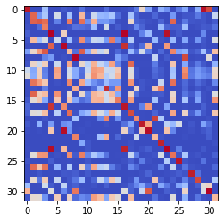

epoch 1071 == measurement_heuristic: 0.52+-0.01/0.47+-0.01 --

epoch 1072 == measurement_heuristic: 0.52+-0.01/0.47+-0.01 --

epoch 1073 == measurement_heuristic: 0.54+-0.01/0.47+-0.01 --

epoch 1074 == measurement_heuristic: 0.52+-0.01/0.47+-0.01 --

epoch 1075 == measurement_heuristic: 0.52+-0.01/0.47+-0.01 --

epoch 1076 == measurement_heuristic: 0.52+-0.01/0.47+-0.01 --

epoch 1077 == measurement_heuristic: 0.55+-0.01/0.47+-0.01 --

epoch 1078 == measurement_heuristic: 0.55+-0.01/0.46+-0.01 --

epoch 1079 == measurement_heuristic: 0.52+-0.01/0.46+-0.01 --

epoch 1080 == measurement_heuristic: 0.53+-0.01/0.48+-0.01 --

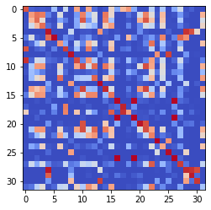

epoch 1081 == measurement_heuristic: 0.52+-0.01/0.46+-0.01 --

epoch 1082 == measurement_heuristic: 0.51+-0.01/0.46+-0.01 --

epoch 1083 == measurement_heuristic: 0.52+-0.01/0.47+-0.01 --

epoch 1084 >> measurement_heuristic: 0.53+-0.01/0.46+-0.01 --

epoch 1085 == measurement_heuristic: 0.51+-0.01/0.46+-0.01 --

epoch 1086 == measurement_heuristic: 0.53+-0.01/0.47+-0.01 --

epoch 1087 == measurement_heuristic: 0.54+-0.01/0.46+-0.01 --

epoch 1088 == measurement_heuristic: 0.52+-0.01/0.46+-0.01 --

epoch 1089 == measurement_heuristic: 0.55+-0.02/0.47+-0.01 --

epoch 1090 >> measurement_heuristic: 0.53+-0.01/0.46+-0.01 --

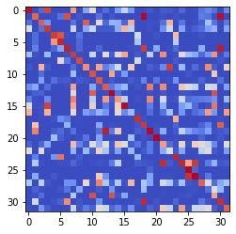

epoch 1091 == measurement_heuristic: 0.53+-0.01/0.47+-0.01 --

epoch 1092 == measurement_heuristic: 0.53+-0.01/0.46+-0.01 --

epoch 1093 == measurement_heuristic: 0.51+-0.01/0.47+-0.01 --

epoch 1094 == measurement_heuristic: 0.53+-0.01/0.49+-0.01 --

epoch 1095 == measurement_heuristic: 0.53+-0.01/0.48+-0.01 --

epoch 1096 == measurement_heuristic: 0.49+-0.01/0.47+-0.01 --

epoch 1097 == measurement_heuristic: 0.52+-0.01/0.47+-0.01 --

epoch 1098 == measurement_heuristic: 0.54+-0.01/0.46+-0.01 --

epoch 1099 == measurement_heuristic: 0.53+-0.01/0.47+-0.01 --

epoch 1100 == measurement_heuristic: 0.53+-0.01/0.47+-0.01 --

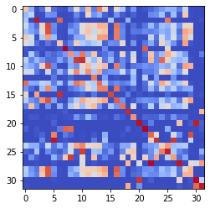

epoch 1101 == measurement_heuristic: 0.49+-0.01/0.47+-0.01 --

epoch 1102 == measurement_heuristic: 0.53+-0.01/0.47+-0.01 --

epoch 1103 == measurement_heuristic: 0.52+-0.01/0.46+-0.01 --

epoch 1104 == measurement_heuristic: 0.53+-0.01/0.47+-0.01 --

epoch 1105 == measurement_heuristic: 0.52+-0.01/0.47+-0.01 --

epoch 1106 == measurement_heuristic: 0.54+-0.01/0.46+-0.01 --

epoch 1107 == measurement_heuristic: 0.51+-0.01/0.46+-0.01 --

epoch 1108 == measurement_heuristic: 0.52+-0.01/0.46+-0.01 --

epoch 1109 == measurement_heuristic: 0.51+-0.01/0.46+-0.01 --

epoch 1110 == measurement_heuristic: 0.51+-0.01/0.48+-0.01 --

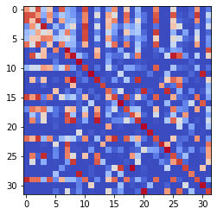

epoch 1111 >> measurement_heuristic: 0.50+-0.01/0.46+-0.01 --

epoch 1112 == measurement_heuristic: 0.51+-0.01/0.46+-0.01 --

epoch 1113 >> measurement_heuristic: 0.49+-0.01/0.45+-0.01 --

epoch 1114 == measurement_heuristic: 0.52+-0.01/0.46+-0.01 --

epoch 1115 == measurement_heuristic: 0.52+-0.01/0.46+-0.01 --

epoch 1116 == measurement_heuristic: 0.51+-0.01/0.46+-0.01 --

epoch 1117 == measurement_heuristic: 0.51+-0.01/0.48+-0.01 --

epoch 1118 == measurement_heuristic: 0.53+-0.01/0.47+-0.01 --

epoch 1119 == measurement_heuristic: 0.53+-0.01/0.46+-0.01 --

epoch 1120 == measurement_heuristic: 0.53+-0.01/0.47+-0.01 --

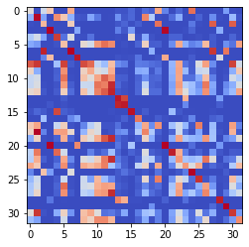

epoch 1121 == measurement_heuristic: 0.52+-0.01/0.50+-0.01 --

epoch 1122 == measurement_heuristic: 0.54+-0.01/0.46+-0.01 --

epoch 1123 == measurement_heuristic: 0.50+-0.01/0.46+-0.01 --

epoch 1124 >> measurement_heuristic: 0.53+-0.01/0.45+-0.01 --

epoch 1125 == measurement_heuristic: 0.51+-0.01/0.46+-0.01 --

epoch 1126 == measurement_heuristic: 0.53+-0.01/0.46+-0.01 --

epoch 1127 == measurement_heuristic: 0.52+-0.01/0.45+-0.01 --

epoch 1128 == measurement_heuristic: 0.53+-0.01/0.47+-0.01 --

epoch 1129 == measurement_heuristic: 0.51+-0.01/0.46+-0.01 --

epoch 1130 == measurement_heuristic: 0.53+-0.01/0.48+-0.01 --

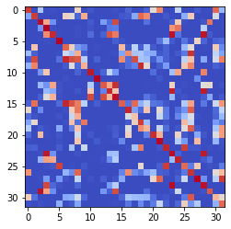

epoch 1131 == measurement_heuristic: 0.52+-0.01/0.46+-0.01 --

epoch 1132 == measurement_heuristic: 0.53+-0.01/0.45+-0.01 --

epoch 1133 == measurement_heuristic: 0.50+-0.01/0.47+-0.01 --

epoch 1134 == measurement_heuristic: 0.52+-0.01/0.46+-0.01 --

epoch 1135 == measurement_heuristic: 0.50+-0.01/0.46+-0.01 --

epoch 1136 == measurement_heuristic: 0.53+-0.01/0.47+-0.01 --

epoch 1137 == measurement_heuristic: 0.51+-0.01/0.47+-0.01 --

epoch 1138 == measurement_heuristic: 0.50+-0.01/0.47+-0.01 --

epoch 1139 == measurement_heuristic: 0.53+-0.01/0.46+-0.01 --

epoch 1140 == measurement_heuristic: 0.53+-0.01/0.46+-0.01 --

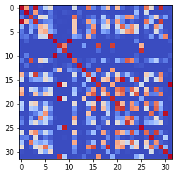

epoch 1141 == measurement_heuristic: 0.49+-0.01/0.46+-0.01 --

epoch 1142 >> measurement_heuristic: 0.49+-0.01/0.45+-0.01 --

epoch 1143 == measurement_heuristic: 0.51+-0.01/0.45+-0.01 --

epoch 1144 == measurement_heuristic: 0.52+-0.01/0.46+-0.01 --

epoch 1145 == measurement_heuristic: 0.52+-0.01/0.47+-0.01 --

epoch 1146 == measurement_heuristic: 0.53+-0.01/0.46+-0.01 --

epoch 1147 == measurement_heuristic: 0.53+-0.01/0.47+-0.01 --

epoch 1148 == measurement_heuristic: 0.52+-0.01/0.45+-0.01 --

epoch 1149 == measurement_heuristic: 0.53+-0.01/0.45+-0.01 --

epoch 1150 == measurement_heuristic: 0.51+-0.01/0.47+-0.01 --

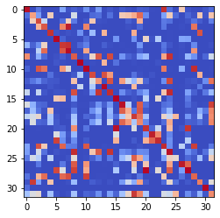

epoch 1151 == measurement_heuristic: 0.53+-0.01/0.47+-0.01 --

epoch 1152 == measurement_heuristic: 0.53+-0.01/0.45+-0.01 --

epoch 1153 == measurement_heuristic: 0.51+-0.01/0.45+-0.01 --

epoch 1154 == measurement_heuristic: 0.52+-0.01/0.46+-0.01 --

epoch 1155 == measurement_heuristic: 0.52+-0.02/0.46+-0.01 --

epoch 1156 == measurement_heuristic: 0.52+-0.01/0.47+-0.01 --

epoch 1157 == measurement_heuristic: 0.53+-0.01/0.47+-0.01 --

epoch 1158 == measurement_heuristic: 0.52+-0.01/0.45+-0.01 --

epoch 1159 == measurement_heuristic: 0.53+-0.01/0.47+-0.01 --

epoch 1160 == measurement_heuristic: 0.49+-0.01/0.45+-0.01 --

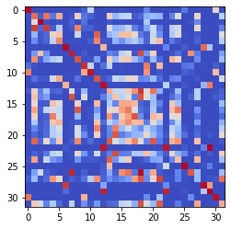

epoch 1161 == measurement_heuristic: 0.49+-0.01/0.45+-0.01 --

epoch 1162 >> measurement_heuristic: 0.49+-0.01/0.44+-0.01 --

epoch 1163 == measurement_heuristic: 0.51+-0.01/0.45+-0.01 --

epoch 1164 == measurement_heuristic: 0.50+-0.01/0.47+-0.01 --

epoch 1165 == measurement_heuristic: 0.50+-0.01/0.46+-0.01 --

epoch 1166 == measurement_heuristic: 0.53+-0.01/0.47+-0.01 --

epoch 1167 == measurement_heuristic: 0.50+-0.01/0.48+-0.01 --

epoch 1168 == measurement_heuristic: 0.51+-0.01/0.46+-0.01 --

epoch 1169 == measurement_heuristic: 0.49+-0.01/0.46+-0.01 --

epoch 1170 == measurement_heuristic: 0.51+-0.01/0.46+-0.01 --

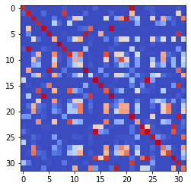

epoch 1171 == measurement_heuristic: 0.49+-0.01/0.47+-0.01 --

epoch 1172 == measurement_heuristic: 0.52+-0.01/0.46+-0.01 --

epoch 1173 == measurement_heuristic: 0.51+-0.01/0.46+-0.01 --

epoch 1174 == measurement_heuristic: 0.52+-0.01/0.45+-0.01 --

epoch 1175 == measurement_heuristic: 0.52+-0.01/0.47+-0.01 --

epoch 1176 == measurement_heuristic: 0.52+-0.01/0.45+-0.01 --

epoch 1177 == measurement_heuristic: 0.51+-0.01/0.47+-0.01 --

epoch 1178 == measurement_heuristic: 0.52+-0.01/0.46+-0.01 --

epoch 1179 == measurement_heuristic: 0.53+-0.01/0.46+-0.01 --

epoch 1180 == measurement_heuristic: 0.52+-0.01/0.46+-0.01 --

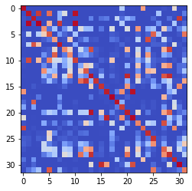

epoch 1181 == measurement_heuristic: 0.49+-0.01/0.45+-0.01 --

epoch 1182 == measurement_heuristic: 0.52+-0.01/0.47+-0.01 --

epoch 1183 == measurement_heuristic: 0.53+-0.01/0.46+-0.01 --

epoch 1184 == measurement_heuristic: 0.50+-0.01/0.45+-0.01 --

epoch 1185 == measurement_heuristic: 0.53+-0.01/0.46+-0.01 --

epoch 1186 == measurement_heuristic: 0.50+-0.01/0.45+-0.01 --

epoch 1187 == measurement_heuristic: 0.50+-0.01/0.46+-0.01 --

epoch 1188 == measurement_heuristic: 0.54+-0.02/0.45+-0.01 --

epoch 1189 == measurement_heuristic: 0.51+-0.01/0.45+-0.01 --

epoch 1190 == measurement_heuristic: 0.52+-0.01/0.45+-0.01 --

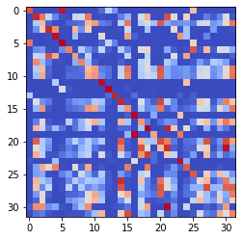

epoch 1191 == measurement_heuristic: 0.53+-0.01/0.47+-0.01 --

epoch 1192 == measurement_heuristic: 0.50+-0.01/0.45+-0.01 --

epoch 1193 == measurement_heuristic: 0.52+-0.01/0.45+-0.01 --

epoch 1194 >> measurement_heuristic: 0.50+-0.01/0.44+-0.01 --

epoch 1195 == measurement_heuristic: 0.49+-0.01/0.45+-0.01 --

epoch 1196 == measurement_heuristic: 0.52+-0.01/0.45+-0.01 --

epoch 1197 == measurement_heuristic: 0.51+-0.01/0.48+-0.01 --

epoch 1198 == measurement_heuristic: 0.52+-0.01/0.45+-0.01 --

epoch 1199 == measurement_heuristic: 0.48+-0.01/0.45+-0.01 --

epoch 1200 == measurement_heuristic: 0.49+-0.01/0.45+-0.01 --

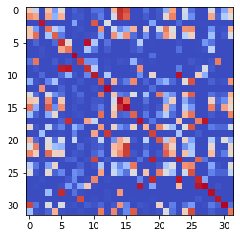

epoch 1201 == measurement_heuristic: 0.52+-0.01/0.46+-0.01 --

epoch 1202 == measurement_heuristic: 0.50+-0.01/0.45+-0.01 --

epoch 1203 == measurement_heuristic: 0.50+-0.01/0.46+-0.01 --

epoch 1204 == measurement_heuristic: 0.51+-0.01/0.46+-0.01 --

epoch 1205 == measurement_heuristic: 0.49+-0.01/0.46+-0.01 --

epoch 1206 == measurement_heuristic: 0.51+-0.01/0.45+-0.01 --

epoch 1207 == measurement_heuristic: 0.51+-0.01/0.45+-0.01 --

epoch 1208 == measurement_heuristic: 0.50+-0.01/0.45+-0.01 --

epoch 1209 == measurement_heuristic: 0.53+-0.01/0.45+-0.01 --

epoch 1210 == measurement_heuristic: 0.53+-0.01/0.45+-0.01 --

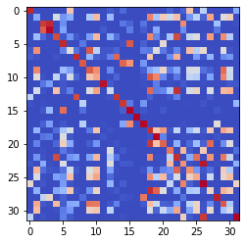

epoch 1211 == measurement_heuristic: 0.49+-0.01/0.46+-0.01 --

epoch 1212 == measurement_heuristic: 0.51+-0.01/0.46+-0.01 --

epoch 1213 == measurement_heuristic: 0.49+-0.01/0.46+-0.01 --

epoch 1214 == measurement_heuristic: 0.53+-0.01/0.47+-0.01 --

epoch 1215 == measurement_heuristic: 0.51+-0.01/0.45+-0.01 --

epoch 1216 == measurement_heuristic: 0.50+-0.01/0.45+-0.01 --

epoch 1217 == measurement_heuristic: 0.50+-0.01/0.49+-0.01 --

epoch 1218 == measurement_heuristic: 0.51+-0.01/0.45+-0.01 --

epoch 1219 == measurement_heuristic: 0.51+-0.01/0.47+-0.01 --

epoch 1220 == measurement_heuristic: 0.52+-0.01/0.47+-0.01 --

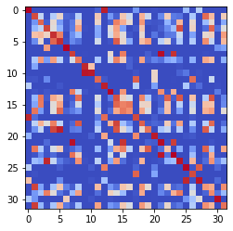

epoch 1221 == measurement_heuristic: 0.52+-0.01/0.46+-0.01 --

epoch 1222 == measurement_heuristic: 0.52+-0.01/0.45+-0.01 --

epoch 1223 == measurement_heuristic: 0.51+-0.01/0.46+-0.01 --

epoch 1224 >> measurement_heuristic: 0.50+-0.01/0.44+-0.01 --

epoch 1225 == measurement_heuristic: 0.49+-0.01/0.45+-0.01 --

epoch 1226 == measurement_heuristic: 0.52+-0.01/0.47+-0.01 --

epoch 1227 == measurement_heuristic: 0.51+-0.01/0.46+-0.01 --

epoch 1228 == measurement_heuristic: 0.52+-0.01/0.46+-0.01 --

epoch 1229 == measurement_heuristic: 0.50+-0.01/0.45+-0.01 --

epoch 1230 == measurement_heuristic: 0.50+-0.01/0.46+-0.01 --

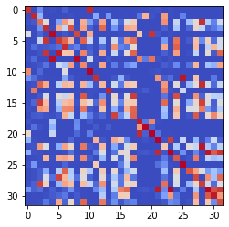

epoch 1231 == measurement_heuristic: 0.50+-0.01/0.45+-0.01 --

epoch 1232 == measurement_heuristic: 0.51+-0.01/0.45+-0.01 --

epoch 1233 == measurement_heuristic: 0.52+-0.01/0.46+-0.01 --

epoch 1234 == measurement_heuristic: 0.50+-0.01/0.45+-0.01 --

epoch 1235 == measurement_heuristic: 0.47+-0.01/0.46+-0.01 --

epoch 1236 == measurement_heuristic: 0.48+-0.01/0.45+-0.01 --

epoch 1237 == measurement_heuristic: 0.52+-0.01/0.48+-0.01 --

epoch 1238 == measurement_heuristic: 0.50+-0.01/0.45+-0.01 --

epoch 1239 == measurement_heuristic: 0.51+-0.01/0.45+-0.01 --

epoch 1240 == measurement_heuristic: 0.51+-0.01/0.46+-0.01 --

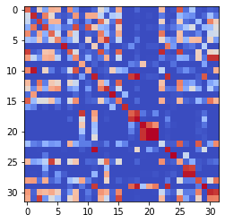

epoch 1241 == measurement_heuristic: 0.51+-0.01/0.46+-0.01 --

epoch 1242 == measurement_heuristic: 0.49+-0.01/0.46+-0.01 --

epoch 1243 == measurement_heuristic: 0.51+-0.01/0.45+-0.01 --

epoch 1244 == measurement_heuristic: 0.49+-0.01/0.46+-0.01 --

epoch 1245 == measurement_heuristic: 0.52+-0.01/0.46+-0.01 --

epoch 1246 == measurement_heuristic: 0.50+-0.01/0.46+-0.01 --

epoch 1247 >> measurement_heuristic: 0.50+-0.01/0.44+-0.01 --

epoch 1248 == measurement_heuristic: 0.52+-0.01/0.45+-0.01 --

epoch 1249 == measurement_heuristic: 0.51+-0.01/0.45+-0.01 --

epoch 1250 == measurement_heuristic: 0.48+-0.01/0.45+-0.01 --

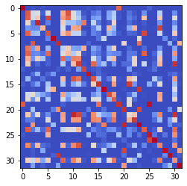

epoch 1251 == measurement_heuristic: 0.49+-0.01/0.45+-0.01 --

epoch 1252 == measurement_heuristic: 0.52+-0.01/0.46+-0.01 --

epoch 1253 == measurement_heuristic: 0.53+-0.01/0.45+-0.01 --

epoch 1254 == measurement_heuristic: 0.50+-0.01/0.45+-0.01 --

epoch 1255 >> measurement_heuristic: 0.50+-0.01/0.44+-0.01 --

epoch 1256 == measurement_heuristic: 0.51+-0.01/0.44+-0.01 --

epoch 1257 == measurement_heuristic: 0.51+-0.01/0.45+-0.01 --

epoch 1258 == measurement_heuristic: 0.49+-0.01/0.44+-0.01 --

epoch 1259 == measurement_heuristic: 0.50+-0.01/0.45+-0.01 --

epoch 1260 == measurement_heuristic: 0.50+-0.01/0.45+-0.01 --

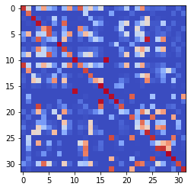

epoch 1261 == measurement_heuristic: 0.53+-0.02/0.48+-0.01 --

epoch 1262 >> measurement_heuristic: 0.50+-0.01/0.44+-0.01 --

epoch 1263 == measurement_heuristic: 0.51+-0.01/0.44+-0.01 --

epoch 1264 >> measurement_heuristic: 0.50+-0.01/0.43+-0.01 --

epoch 1265 == measurement_heuristic: 0.50+-0.01/0.45+-0.01 --

epoch 1266 == measurement_heuristic: 0.50+-0.01/0.44+-0.01 --

epoch 1267 == measurement_heuristic: 0.52+-0.01/0.45+-0.01 --

epoch 1268 == measurement_heuristic: 0.51+-0.01/0.45+-0.01 --

epoch 1269 == measurement_heuristic: 0.47+-0.01/0.44+-0.01 --

epoch 1270 == measurement_heuristic: 0.51+-0.01/0.45+-0.01 --

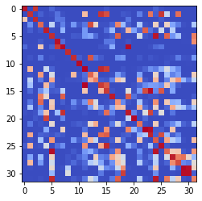

epoch 1271 == measurement_heuristic: 0.50+-0.01/0.45+-0.01 --

epoch 1272 == measurement_heuristic: 0.49+-0.01/0.45+-0.01 --

epoch 1273 == measurement_heuristic: 0.49+-0.01/0.45+-0.01 --

epoch 1274 == measurement_heuristic: 0.49+-0.01/0.44+-0.01 --

epoch 1275 == measurement_heuristic: 0.50+-0.01/0.46+-0.01 --

epoch 1276 == measurement_heuristic: 0.52+-0.01/0.44+-0.01 --

epoch 1277 == measurement_heuristic: 0.49+-0.01/0.45+-0.01 --

epoch 1278 == measurement_heuristic: 0.50+-0.01/0.44+-0.01 --

epoch 1279 == measurement_heuristic: 0.49+-0.01/0.45+-0.01 --

epoch 1280 == measurement_heuristic: 0.49+-0.01/0.45+-0.01 --

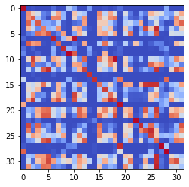

epoch 1281 >> measurement_heuristic: 0.51+-0.01/0.43+-0.01 --

epoch 1282 == measurement_heuristic: 0.51+-0.01/0.45+-0.01 --

epoch 1283 == measurement_heuristic: 0.51+-0.01/0.43+-0.01 --

epoch 1284 == measurement_heuristic: 0.52+-0.01/0.44+-0.01 --

epoch 1285 == measurement_heuristic: 0.49+-0.01/0.45+-0.01 --

epoch 1286 == measurement_heuristic: 0.48+-0.01/0.44+-0.01 --

epoch 1287 == measurement_heuristic: 0.50+-0.01/0.44+-0.01 --

epoch 1288 == measurement_heuristic: 0.51+-0.01/0.44+-0.01 --

epoch 1289 == measurement_heuristic: 0.51+-0.01/0.44+-0.01 --

epoch 1290 == measurement_heuristic: 0.50+-0.01/0.44+-0.01 --

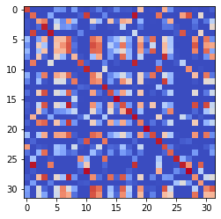

epoch 1291 == measurement_heuristic: 0.51+-0.01/0.44+-0.01 --

epoch 1292 == measurement_heuristic: 0.51+-0.01/0.45+-0.01 --

epoch 1293 == measurement_heuristic: 0.51+-0.01/0.46+-0.01 --

epoch 1294 == measurement_heuristic: 0.49+-0.01/0.43+-0.01 --

epoch 1295 == measurement_heuristic: 0.49+-0.01/0.44+-0.01 --

epoch 1296 == measurement_heuristic: 0.50+-0.01/0.44+-0.01 --

epoch 1297 == measurement_heuristic: 0.50+-0.01/0.44+-0.01 --

epoch 1298 == measurement_heuristic: 0.49+-0.01/0.45+-0.01 --

epoch 1299 == measurement_heuristic: 0.51+-0.01/0.45+-0.01 --

epoch 1300 == measurement_heuristic: 0.50+-0.01/0.45+-0.01 --

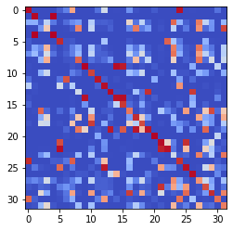

epoch 1301 == measurement_heuristic: 0.51+-0.01/0.44+-0.01 --

epoch 1302 >> measurement_heuristic: 0.48+-0.01/0.43+-0.01 --

epoch 1303 == measurement_heuristic: 0.50+-0.01/0.44+-0.01 --

epoch 1304 == measurement_heuristic: 0.50+-0.01/0.43+-0.01 --

epoch 1305 == measurement_heuristic: 0.50+-0.01/0.43+-0.01 --

epoch 1306 == measurement_heuristic: 0.50+-0.01/0.44+-0.01 --

epoch 1307 == measurement_heuristic: 0.51+-0.01/0.45+-0.01 --

epoch 1308 == measurement_heuristic: 0.49+-0.01/0.45+-0.01 --

epoch 1309 == measurement_heuristic: 0.49+-0.01/0.45+-0.01 --

epoch 1310 == measurement_heuristic: 0.48+-0.01/0.44+-0.01 --

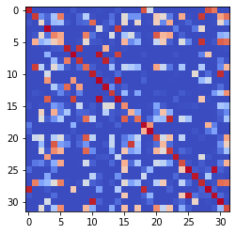

epoch 1311 == measurement_heuristic: 0.48+-0.01/0.44+-0.01 --

epoch 1312 == measurement_heuristic: 0.49+-0.01/0.47+-0.01 --

epoch 1313 == measurement_heuristic: 0.52+-0.01/0.45+-0.01 --

epoch 1314 == measurement_heuristic: 0.50+-0.01/0.44+-0.01 --

epoch 1315 == measurement_heuristic: 0.48+-0.01/0.45+-0.01 --

epoch 1316 == measurement_heuristic: 0.48+-0.01/0.44+-0.01 --

epoch 1317 == measurement_heuristic: 0.49+-0.01/0.45+-0.01 --

epoch 1318 == measurement_heuristic: 0.51+-0.01/0.45+-0.01 --

epoch 1319 >> measurement_heuristic: 0.49+-0.01/0.43+-0.01 --

epoch 1320 == measurement_heuristic: 0.48+-0.01/0.44+-0.01 --

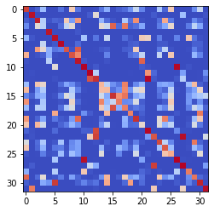

epoch 1321 >> measurement_heuristic: 0.49+-0.01/0.43+-0.01 --

epoch 1322 >> measurement_heuristic: 0.51+-0.01/0.43+-0.01 --

epoch 1323 == measurement_heuristic: 0.48+-0.01/0.43+-0.01 --

epoch 1324 == measurement_heuristic: 0.48+-0.01/0.46+-0.01 --

epoch 1325 == measurement_heuristic: 0.51+-0.01/0.43+-0.01 --

epoch 1326 == measurement_heuristic: 0.49+-0.01/0.44+-0.01 --

epoch 1327 == measurement_heuristic: 0.50+-0.01/0.46+-0.01 --

epoch 1328 == measurement_heuristic: 0.50+-0.01/0.43+-0.01 --

epoch 1329 == measurement_heuristic: 0.49+-0.01/0.45+-0.01 --

epoch 1330 == measurement_heuristic: 0.50+-0.01/0.43+-0.01 --

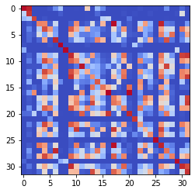

epoch 1331 == measurement_heuristic: 0.51+-0.01/0.44+-0.01 --

epoch 1332 == measurement_heuristic: 0.49+-0.01/0.43+-0.01 --

epoch 1333 == measurement_heuristic: 0.51+-0.01/0.46+-0.01 --

epoch 1334 == measurement_heuristic: 0.50+-0.01/0.44+-0.01 --

epoch 1335 == measurement_heuristic: 0.49+-0.01/0.44+-0.01 --

epoch 1336 == measurement_heuristic: 0.49+-0.01/0.44+-0.01 --

epoch 1337 == measurement_heuristic: 0.50+-0.01/0.43+-0.01 --

epoch 1338 == measurement_heuristic: 0.50+-0.01/0.44+-0.01 --

epoch 1339 == measurement_heuristic: 0.48+-0.01/0.45+-0.01 --

epoch 1340 == measurement_heuristic: 0.49+-0.01/0.46+-0.01 --

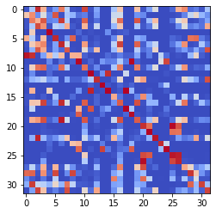

epoch 1341 == measurement_heuristic: 0.49+-0.01/0.44+-0.01 --

epoch 1342 == measurement_heuristic: 0.51+-0.01/0.45+-0.01 --

epoch 1343 == measurement_heuristic: 0.47+-0.01/0.43+-0.01 --

epoch 1344 == measurement_heuristic: 0.49+-0.01/0.44+-0.01 --

epoch 1345 == measurement_heuristic: 0.49+-0.01/0.44+-0.01 --

epoch 1346 == measurement_heuristic: 0.50+-0.01/0.46+-0.01 --

epoch 1347 >> measurement_heuristic: 0.51+-0.01/0.43+-0.01 --

epoch 1348 == measurement_heuristic: 0.48+-0.01/0.44+-0.01 --

epoch 1349 == measurement_heuristic: 0.49+-0.01/0.43+-0.01 --

epoch 1350 >> measurement_heuristic: 0.50+-0.01/0.43+-0.01 --

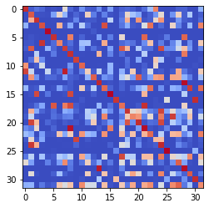

epoch 1351 == measurement_heuristic: 0.47+-0.01/0.43+-0.01 --

epoch 1352 == measurement_heuristic: 0.50+-0.01/0.43+-0.01 --

epoch 1353 == measurement_heuristic: 0.51+-0.01/0.43+-0.01 --

epoch 1354 == measurement_heuristic: 0.51+-0.01/0.43+-0.01 --

epoch 1355 >> measurement_heuristic: 0.47+-0.01/0.42+-0.01 --

epoch 1356 == measurement_heuristic: 0.50+-0.01/0.43+-0.01 --

epoch 1357 == measurement_heuristic: 0.49+-0.01/0.43+-0.01 --

epoch 1358 == measurement_heuristic: 0.48+-0.01/0.43+-0.01 --

epoch 1359 == measurement_heuristic: 0.46+-0.01/0.44+-0.01 --

epoch 1360 == measurement_heuristic: 0.48+-0.01/0.44+-0.01 --

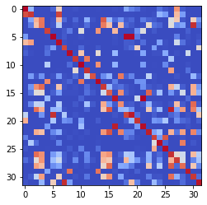

epoch 1361 == measurement_heuristic: 0.50+-0.01/0.42+-0.01 --

epoch 1362 >> measurement_heuristic: 0.47+-0.01/0.42+-0.01 --

epoch 1363 == measurement_heuristic: 0.51+-0.01/0.43+-0.01 --

epoch 1364 == measurement_heuristic: 0.49+-0.01/0.42+-0.01 --

epoch 1365 == measurement_heuristic: 0.49+-0.01/0.44+-0.01 --

epoch 1366 == measurement_heuristic: 0.51+-0.01/0.43+-0.01 --

epoch 1367 == measurement_heuristic: 0.51+-0.01/0.43+-0.01 --

epoch 1368 == measurement_heuristic: 0.52+-0.01/0.43+-0.01 --

epoch 1369 >> measurement_heuristic: 0.50+-0.01/0.42+-0.01 --

epoch 1370 == measurement_heuristic: 0.50+-0.01/0.43+-0.01 --

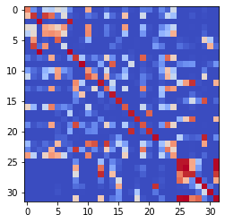

epoch 1371 >> measurement_heuristic: 0.48+-0.01/0.42+-0.01 --

epoch 1372 == measurement_heuristic: 0.47+-0.01/0.42+-0.01 --

epoch 1373 == measurement_heuristic: 0.48+-0.01/0.42+-0.01 --

epoch 1374 == measurement_heuristic: 0.48+-0.01/0.43+-0.01 --

epoch 1375 == measurement_heuristic: 0.50+-0.01/0.43+-0.01 --

epoch 1376 == measurement_heuristic: 0.47+-0.01/0.43+-0.01 --

epoch 1377 == measurement_heuristic: 0.47+-0.01/0.43+-0.01 --

epoch 1378 == measurement_heuristic: 0.49+-0.01/0.42+-0.01 --

epoch 1379 == measurement_heuristic: 0.51+-0.02/0.44+-0.01 --

epoch 1380 == measurement_heuristic: 0.50+-0.01/0.43+-0.01 --

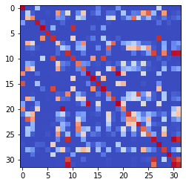

epoch 1381 == measurement_heuristic: 0.51+-0.01/0.42+-0.01 --

epoch 1382 == measurement_heuristic: 0.50+-0.01/0.42+-0.01 --

epoch 1383 == measurement_heuristic: 0.50+-0.01/0.44+-0.01 --

epoch 1384 == measurement_heuristic: 0.49+-0.01/0.43+-0.01 --

epoch 1385 == measurement_heuristic: 0.49+-0.01/0.43+-0.01 --

epoch 1386 == measurement_heuristic: 0.47+-0.01/0.44+-0.01 --

epoch 1387 == measurement_heuristic: 0.47+-0.01/0.43+-0.01 --

epoch 1388 == measurement_heuristic: 0.49+-0.01/0.42+-0.01 --

epoch 1389 == measurement_heuristic: 0.49+-0.01/0.43+-0.01 --

epoch 1390 == measurement_heuristic: 0.49+-0.01/0.43+-0.01 --

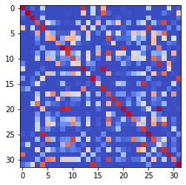

epoch 1391 == measurement_heuristic: 0.48+-0.01/0.43+-0.01 --

epoch 1392 >> measurement_heuristic: 0.47+-0.01/0.42+-0.01 --

epoch 1393 == measurement_heuristic: 0.49+-0.01/0.43+-0.01 --

epoch 1394 == measurement_heuristic: 0.48+-0.01/0.42+-0.01 --

epoch 1395 == measurement_heuristic: 0.48+-0.01/0.44+-0.01 --

epoch 1396 == measurement_heuristic: 0.50+-0.01/0.43+-0.01 --

epoch 1397 == measurement_heuristic: 0.49+-0.01/0.43+-0.01 --

epoch 1398 == measurement_heuristic: 0.48+-0.01/0.43+-0.01 --

epoch 1399 == measurement_heuristic: 0.50+-0.01/0.43+-0.01 --

epoch 1400 == measurement_heuristic: 0.47+-0.01/0.43+-0.01 --

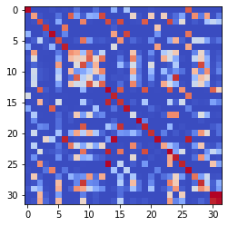

epoch 1401 == measurement_heuristic: 0.48+-0.01/0.42+-0.01 --

epoch 1402 == measurement_heuristic: 0.49+-0.01/0.43+-0.01 --

epoch 1403 == measurement_heuristic: 0.47+-0.01/0.43+-0.01 --

epoch 1404 == measurement_heuristic: 0.48+-0.01/0.42+-0.01 --

epoch 1405 == measurement_heuristic: 0.48+-0.01/0.44+-0.01 --

epoch 1406 == measurement_heuristic: 0.50+-0.01/0.43+-0.01 --

epoch 1407 == measurement_heuristic: 0.50+-0.02/0.43+-0.01 --

epoch 1408 == measurement_heuristic: 0.49+-0.01/0.43+-0.01 --

epoch 1409 == measurement_heuristic: 0.49+-0.01/0.44+-0.01 --

epoch 1410 == measurement_heuristic: 0.48+-0.01/0.44+-0.01 --

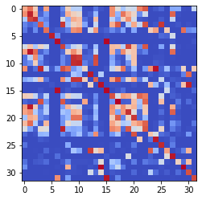

epoch 1411 == measurement_heuristic: 0.50+-0.01/0.45+-0.01 --

epoch 1412 == measurement_heuristic: 0.51+-0.01/0.42+-0.01 --

epoch 1413 == measurement_heuristic: 0.46+-0.01/0.43+-0.01 --

epoch 1414 == measurement_heuristic: 0.48+-0.01/0.43+-0.01 --

epoch 1415 == measurement_heuristic: 0.49+-0.01/0.43+-0.01 --

epoch 1416 >> measurement_heuristic: 0.48+-0.01/0.42+-0.01 --

epoch 1417 == measurement_heuristic: 0.48+-0.01/0.43+-0.01 --

epoch 1418 == measurement_heuristic: 0.48+-0.01/0.44+-0.01 --

epoch 1419 == measurement_heuristic: 0.49+-0.01/0.44+-0.01 --

epoch 1420 == measurement_heuristic: 0.48+-0.01/0.42+-0.01 --

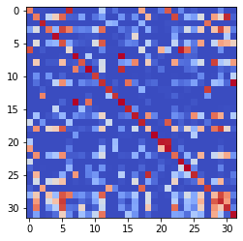

epoch 1421 == measurement_heuristic: 0.48+-0.01/0.43+-0.01 --

epoch 1422 == measurement_heuristic: 0.50+-0.01/0.43+-0.01 --

epoch 1423 == measurement_heuristic: 0.48+-0.01/0.44+-0.01 --

epoch 1424 == measurement_heuristic: 0.48+-0.01/0.42+-0.01 --

epoch 1425 == measurement_heuristic: 0.48+-0.01/0.43+-0.01 --

epoch 1426 == measurement_heuristic: 0.46+-0.01/0.43+-0.01 --

epoch 1427 == measurement_heuristic: 0.46+-0.01/0.43+-0.01 --

epoch 1428 == measurement_heuristic: 0.48+-0.01/0.43+-0.01 --

epoch 1429 == measurement_heuristic: 0.48+-0.01/0.42+-0.01 --

epoch 1430 == measurement_heuristic: 0.47+-0.01/0.42+-0.01 --

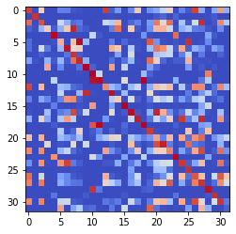

epoch 1431 == measurement_heuristic: 0.49+-0.02/0.44+-0.01 --

epoch 1432 == measurement_heuristic: 0.47+-0.01/0.44+-0.01 --

epoch 1433 == measurement_heuristic: 0.49+-0.01/0.43+-0.01 --

epoch 1434 == measurement_heuristic: 0.50+-0.01/0.43+-0.01 --

epoch 1435 == measurement_heuristic: 0.48+-0.01/0.43+-0.01 --

epoch 1436 == measurement_heuristic: 0.47+-0.01/0.42+-0.01 --

epoch 1437 >> measurement_heuristic: 0.46+-0.01/0.41+-0.01 --

epoch 1438 == measurement_heuristic: 0.49+-0.01/0.43+-0.01 --

epoch 1439 == measurement_heuristic: 0.48+-0.01/0.42+-0.01 --

epoch 1440 == measurement_heuristic: 0.49+-0.01/0.42+-0.01 --

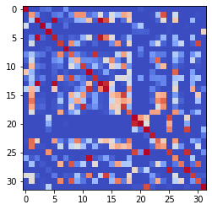

epoch 1441 == measurement_heuristic: 0.48+-0.01/0.42+-0.01 --

epoch 1442 == measurement_heuristic: 0.48+-0.01/0.43+-0.01 --

epoch 1443 == measurement_heuristic: 0.47+-0.01/0.43+-0.01 --

epoch 1444 == measurement_heuristic: 0.49+-0.01/0.42+-0.01 --

epoch 1445 == measurement_heuristic: 0.49+-0.01/0.42+-0.01 --

epoch 1446 == measurement_heuristic: 0.49+-0.01/0.42+-0.01 --

epoch 1447 == measurement_heuristic: 0.49+-0.01/0.43+-0.01 --

epoch 1448 == measurement_heuristic: 0.50+-0.01/0.42+-0.01 --

epoch 1449 == measurement_heuristic: 0.49+-0.01/0.43+-0.01 --

epoch 1450 == measurement_heuristic: 0.48+-0.01/0.43+-0.01 --

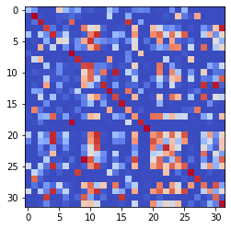

epoch 1451 == measurement_heuristic: 0.48+-0.01/0.43+-0.01 --

epoch 1452 == measurement_heuristic: 0.46+-0.01/0.43+-0.01 --

epoch 1453 == measurement_heuristic: 0.47+-0.01/0.43+-0.01 --

epoch 1454 == measurement_heuristic: 0.50+-0.01/0.43+-0.01 --

epoch 1455 == measurement_heuristic: 0.48+-0.01/0.43+-0.01 --

epoch 1456 == measurement_heuristic: 0.47+-0.01/0.43+-0.01 --

epoch 1457 == measurement_heuristic: 0.48+-0.01/0.42+-0.01 --

epoch 1458 == measurement_heuristic: 0.48+-0.01/0.43+-0.01 --

epoch 1459 >> measurement_heuristic: 0.48+-0.01/0.41+-0.01 --

epoch 1460 == measurement_heuristic: 0.48+-0.01/0.42+-0.01 --

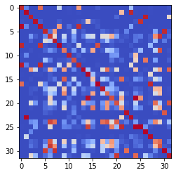

epoch 1461 == measurement_heuristic: 0.49+-0.01/0.43+-0.01 --

epoch 1462 == measurement_heuristic: 0.49+-0.01/0.43+-0.01 --

epoch 1463 == measurement_heuristic: 0.51+-0.01/0.44+-0.01 --

epoch 1464 == measurement_heuristic: 0.48+-0.01/0.43+-0.01 --

epoch 1465 == measurement_heuristic: 0.48+-0.01/0.42+-0.01 --

epoch 1466 == measurement_heuristic: 0.49+-0.01/0.43+-0.01 --

epoch 1467 >> measurement_heuristic: 0.47+-0.01/0.41+-0.01 --

epoch 1468 == measurement_heuristic: 0.46+-0.01/0.42+-0.01 --

epoch 1469 == measurement_heuristic: 0.49+-0.01/0.42+-0.01 --

epoch 1470 == measurement_heuristic: 0.48+-0.01/0.42+-0.01 --

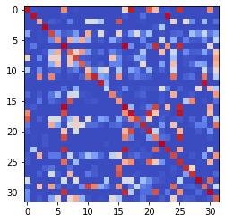

epoch 1471 == measurement_heuristic: 0.49+-0.01/0.43+-0.01 --

epoch 1472 == measurement_heuristic: 0.46+-0.01/0.42+-0.01 --

epoch 1473 == measurement_heuristic: 0.49+-0.01/0.43+-0.01 --

epoch 1474 == measurement_heuristic: 0.47+-0.01/0.43+-0.01 --

epoch 1475 == measurement_heuristic: 0.48+-0.01/0.43+-0.01 --

epoch 1476 == measurement_heuristic: 0.50+-0.01/0.41+-0.01 --

epoch 1477 == measurement_heuristic: 0.47+-0.01/0.42+-0.01 --

epoch 1478 == measurement_heuristic: 0.48+-0.01/0.42+-0.01 --

epoch 1479 == measurement_heuristic: 0.48+-0.01/0.42+-0.01 --

epoch 1480 == measurement_heuristic: 0.48+-0.01/0.42+-0.01 --

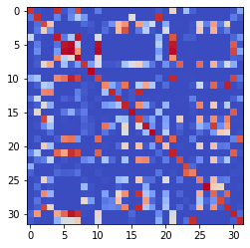

epoch 1481 == measurement_heuristic: 0.48+-0.01/0.43+-0.01 --

epoch 1482 == measurement_heuristic: 0.47+-0.01/0.42+-0.01 --

epoch 1483 == measurement_heuristic: 0.47+-0.01/0.43+-0.01 --

epoch 1484 == measurement_heuristic: 0.47+-0.01/0.43+-0.01 --

epoch 1485 == measurement_heuristic: 0.47+-0.01/0.42+-0.01 --

epoch 1486 == measurement_heuristic: 0.49+-0.02/0.42+-0.01 --

epoch 1487 == measurement_heuristic: 0.48+-0.02/0.42+-0.01 --

epoch 1488 == measurement_heuristic: 0.47+-0.01/0.42+-0.01 --

epoch 1489 == measurement_heuristic: 0.49+-0.01/0.41+-0.01 --

epoch 1490 >> measurement_heuristic: 0.47+-0.01/0.41+-0.01 --

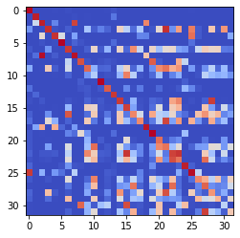

epoch 1491 == measurement_heuristic: 0.49+-0.01/0.45+-0.01 --

epoch 1492 == measurement_heuristic: 0.48+-0.01/0.42+-0.01 --

epoch 1493 == measurement_heuristic: 0.49+-0.01/0.44+-0.01 --

epoch 1494 == measurement_heuristic: 0.50+-0.01/0.41+-0.01 --

epoch 1495 == measurement_heuristic: 0.49+-0.01/0.42+-0.01 --

epoch 1496 == measurement_heuristic: 0.46+-0.01/0.42+-0.01 --

epoch 1497 == measurement_heuristic: 0.49+-0.01/0.42+-0.01 --

epoch 1498 == measurement_heuristic: 0.48+-0.01/0.42+-0.01 --

epoch 1499 == measurement_heuristic: 0.48+-0.01/0.42+-0.01 --

epoch 1500 == measurement_heuristic: 0.48+-0.01/0.42+-0.01 --

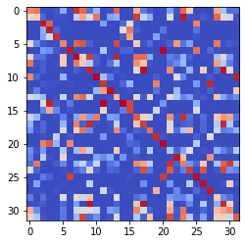

epoch 1501 == measurement_heuristic: 0.47+-0.01/0.41+-0.01 --

epoch 1502 == measurement_heuristic: 0.48+-0.01/0.42+-0.01 --

epoch 1503 == measurement_heuristic: 0.50+-0.01/0.41+-0.01 --

epoch 1504 == measurement_heuristic: 0.46+-0.01/0.43+-0.01 --

epoch 1505 == measurement_heuristic: 0.47+-0.01/0.42+-0.01 --

epoch 1506 == measurement_heuristic: 0.45+-0.01/0.43+-0.01 --

epoch 1507 == measurement_heuristic: 0.47+-0.01/0.41+-0.01 --

epoch 1508 == measurement_heuristic: 0.48+-0.01/0.44+-0.01 --

epoch 1509 == measurement_heuristic: 0.51+-0.01/0.42+-0.01 --

epoch 1510 == measurement_heuristic: 0.45+-0.01/0.41+-0.01 --

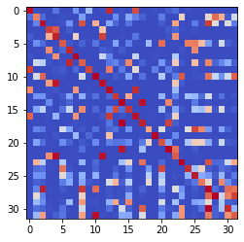

epoch 1511 == measurement_heuristic: 0.48+-0.01/0.42+-0.01 --

epoch 1512 == measurement_heuristic: 0.48+-0.01/0.42+-0.01 --

epoch 1513 == measurement_heuristic: 0.49+-0.01/0.42+-0.01 --

epoch 1514 == measurement_heuristic: 0.50+-0.01/0.42+-0.01 --

epoch 1515 == measurement_heuristic: 0.48+-0.01/0.44+-0.01 --

epoch 1516 == measurement_heuristic: 0.46+-0.01/0.44+-0.01 --

epoch 1517 == measurement_heuristic: 0.49+-0.01/0.42+-0.01 --

epoch 1518 == measurement_heuristic: 0.46+-0.01/0.43+-0.01 --

epoch 1519 == measurement_heuristic: 0.48+-0.01/0.43+-0.01 --

epoch 1520 == measurement_heuristic: 0.47+-0.01/0.41+-0.01 --

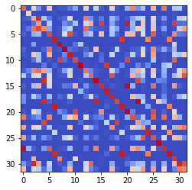

epoch 1521 == measurement_heuristic: 0.47+-0.01/0.47+-0.01 --

epoch 1522 == measurement_heuristic: 0.51+-0.01/0.42+-0.01 --

epoch 1523 == measurement_heuristic: 0.46+-0.01/0.42+-0.01 --

epoch 1524 == measurement_heuristic: 0.46+-0.01/0.42+-0.01 --

epoch 1525 == measurement_heuristic: 0.47+-0.01/0.42+-0.01 --

epoch 1526 == measurement_heuristic: 0.51+-0.01/0.42+-0.01 --

epoch 1527 == measurement_heuristic: 0.46+-0.01/0.46+-0.01 --

epoch 1528 == measurement_heuristic: 0.49+-0.01/0.42+-0.01 --

epoch 1529 == measurement_heuristic: 0.46+-0.01/0.41+-0.01 --

epoch 1530 == measurement_heuristic: 0.47+-0.01/0.42+-0.01 --

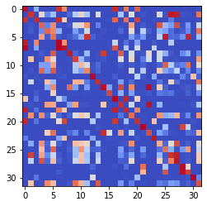

epoch 1531 == measurement_heuristic: 0.48+-0.01/0.41+-0.01 --

epoch 1532 == measurement_heuristic: 0.46+-0.01/0.44+-0.01 --

epoch 1533 == measurement_heuristic: 0.47+-0.01/0.43+-0.01 --

epoch 1534 == measurement_heuristic: 0.48+-0.01/0.42+-0.01 --

epoch 1535 == measurement_heuristic: 0.47+-0.01/0.42+-0.01 --

epoch 1536 == measurement_heuristic: 0.48+-0.01/0.42+-0.01 --

epoch 1537 == measurement_heuristic: 0.48+-0.01/0.43+-0.01 --

epoch 1538 == measurement_heuristic: 0.46+-0.01/0.43+-0.01 --

epoch 1539 == measurement_heuristic: 0.48+-0.01/0.41+-0.01 --

epoch 1540 == measurement_heuristic: 0.47+-0.01/0.41+-0.01 --

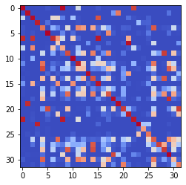

epoch 1541 == measurement_heuristic: 0.48+-0.01/0.43+-0.01 --

epoch 1542 == measurement_heuristic: 0.48+-0.01/0.42+-0.01 --

epoch 1543 == measurement_heuristic: 0.45+-0.01/0.41+-0.01 --

epoch 1544 == measurement_heuristic: 0.48+-0.01/0.41+-0.01 --

epoch 1545 == measurement_heuristic: 0.46+-0.01/0.42+-0.01 --

epoch 1546 == measurement_heuristic: 0.48+-0.01/0.42+-0.01 --

epoch 1547 == measurement_heuristic: 0.45+-0.01/0.41+-0.01 --

epoch 1548 == measurement_heuristic: 0.47+-0.01/0.42+-0.01 --

epoch 1549 == measurement_heuristic: 0.46+-0.01/0.43+-0.01 --

epoch 1550 >> measurement_heuristic: 0.45+-0.01/0.41+-0.01 --

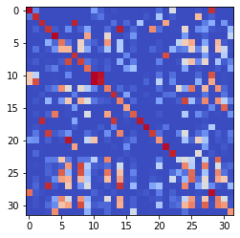

epoch 1551 == measurement_heuristic: 0.46+-0.01/0.42+-0.01 --

epoch 1552 == measurement_heuristic: 0.47+-0.01/0.44+-0.01 --

epoch 1553 == measurement_heuristic: 0.46+-0.01/0.45+-0.01 --

epoch 1554 == measurement_heuristic: 0.50+-0.01/0.42+-0.01 --

epoch 1555 == measurement_heuristic: 0.46+-0.01/0.41+-0.01 --

epoch 1556 == measurement_heuristic: 0.49+-0.01/0.41+-0.01 --

epoch 1557 == measurement_heuristic: 0.46+-0.01/0.41+-0.01 --

epoch 1558 == measurement_heuristic: 0.47+-0.01/0.42+-0.01 --

epoch 1559 == measurement_heuristic: 0.47+-0.01/0.42+-0.01 --

epoch 1560 == measurement_heuristic: 0.47+-0.01/0.44+-0.01 --

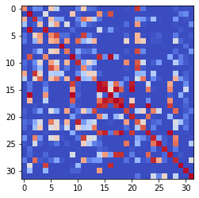

epoch 1561 == measurement_heuristic: 0.49+-0.01/0.43+-0.01 --

epoch 1562 == measurement_heuristic: 0.45+-0.01/0.42+-0.01 --

epoch 1563 == measurement_heuristic: 0.49+-0.01/0.43+-0.01 --

epoch 1564 == measurement_heuristic: 0.48+-0.01/0.41+-0.01 --

epoch 1565 == measurement_heuristic: 0.48+-0.01/0.41+-0.01 --

epoch 1566 == measurement_heuristic: 0.47+-0.01/0.42+-0.01 --

epoch 1567 == measurement_heuristic: 0.48+-0.01/0.41+-0.01 --

epoch 1568 == measurement_heuristic: 0.45+-0.01/0.41+-0.01 --

epoch 1569 == measurement_heuristic: 0.47+-0.01/0.43+-0.01 --

epoch 1570 == measurement_heuristic: 0.45+-0.01/0.41+-0.01 --

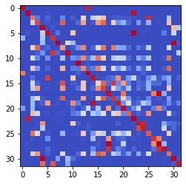

epoch 1571 >> measurement_heuristic: 0.46+-0.01/0.40+-0.01 --

epoch 1572 == measurement_heuristic: 0.45+-0.01/0.42+-0.01 --

epoch 1573 == measurement_heuristic: 0.45+-0.01/0.41+-0.01 --

epoch 1574 == measurement_heuristic: 0.45+-0.01/0.43+-0.01 --

epoch 1575 == measurement_heuristic: 0.47+-0.01/0.41+-0.01 --

epoch 1576 == measurement_heuristic: 0.46+-0.01/0.42+-0.01 --

epoch 1577 == measurement_heuristic: 0.47+-0.01/0.41+-0.01 --

epoch 1578 == measurement_heuristic: 0.47+-0.01/0.41+-0.01 --

epoch 1579 == measurement_heuristic: 0.47+-0.01/0.41+-0.01 --

epoch 1580 == measurement_heuristic: 0.48+-0.01/0.42+-0.01 --

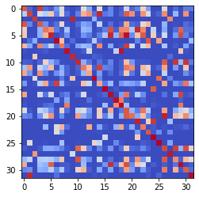

epoch 1581 == measurement_heuristic: 0.45+-0.01/0.41+-0.01 --

epoch 1582 == measurement_heuristic: 0.47+-0.01/0.41+-0.01 --

epoch 1583 == measurement_heuristic: 0.48+-0.01/0.43+-0.01 --

epoch 1584 == measurement_heuristic: 0.49+-0.01/0.42+-0.01 --

epoch 1585 == measurement_heuristic: 0.49+-0.01/0.41+-0.01 --

epoch 1586 == measurement_heuristic: 0.47+-0.01/0.41+-0.01 --

epoch 1587 == measurement_heuristic: 0.46+-0.01/0.41+-0.01 --

epoch 1588 == measurement_heuristic: 0.46+-0.01/0.42+-0.01 --

epoch 1589 == measurement_heuristic: 0.48+-0.01/0.41+-0.01 --

epoch 1590 == measurement_heuristic: 0.46+-0.01/0.41+-0.01 --

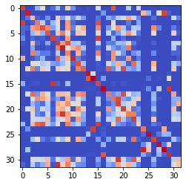

epoch 1591 == measurement_heuristic: 0.47+-0.01/0.43+-0.01 --

epoch 1592 == measurement_heuristic: 0.46+-0.01/0.41+-0.01 --

epoch 1593 == measurement_heuristic: 0.46+-0.01/0.44+-0.01 --

epoch 1594 == measurement_heuristic: 0.48+-0.01/0.41+-0.01 --

epoch 1595 == measurement_heuristic: 0.46+-0.01/0.41+-0.01 --

epoch 1596 == measurement_heuristic: 0.46+-0.01/0.41+-0.01 --

epoch 1597 >> measurement_heuristic: 0.46+-0.01/0.40+-0.01 --

epoch 1598 == measurement_heuristic: 0.48+-0.01/0.41+-0.01 --

epoch 1599 == measurement_heuristic: 0.48+-0.01/0.41+-0.01 --

epoch 1600 == measurement_heuristic: 0.48+-0.01/0.43+-0.01 --

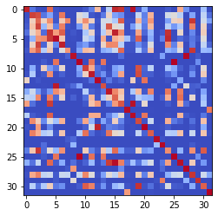

epoch 1601 == measurement_heuristic: 0.47+-0.01/0.42+-0.01 --

epoch 1602 == measurement_heuristic: 0.45+-0.01/0.41+-0.01 --

epoch 1603 == measurement_heuristic: 0.47+-0.01/0.43+-0.01 --

epoch 1604 == measurement_heuristic: 0.46+-0.01/0.42+-0.01 --

epoch 1605 == measurement_heuristic: 0.47+-0.01/0.40+-0.01 --

epoch 1606 == measurement_heuristic: 0.48+-0.01/0.41+-0.01 --

epoch 1607 == measurement_heuristic: 0.48+-0.01/0.41+-0.01 --

epoch 1608 == measurement_heuristic: 0.46+-0.01/0.40+-0.01 --

epoch 1609 == measurement_heuristic: 0.47+-0.01/0.41+-0.01 --

epoch 1610 == measurement_heuristic: 0.48+-0.01/0.43+-0.01 --

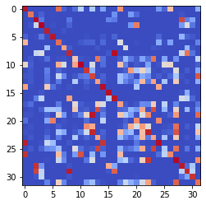

epoch 1611 == measurement_heuristic: 0.48+-0.01/0.40+-0.01 --

epoch 1612 == measurement_heuristic: 0.45+-0.01/0.40+-0.01 --

epoch 1613 == measurement_heuristic: 0.47+-0.01/0.41+-0.01 --

epoch 1614 == measurement_heuristic: 0.45+-0.01/0.41+-0.01 --

epoch 1615 == measurement_heuristic: 0.44+-0.01/0.42+-0.01 --

epoch 1616 == measurement_heuristic: 0.45+-0.01/0.41+-0.01 --

epoch 1617 == measurement_heuristic: 0.47+-0.01/0.41+-0.01 --

epoch 1618 == measurement_heuristic: 0.46+-0.01/0.43+-0.01 --

epoch 1619 == measurement_heuristic: 0.47+-0.01/0.41+-0.01 --

epoch 1620 == measurement_heuristic: 0.45+-0.01/0.40+-0.01 --

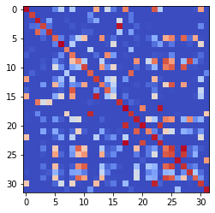

epoch 1621 == measurement_heuristic: 0.47+-0.01/0.41+-0.01 --

epoch 1622 == measurement_heuristic: 0.47+-0.01/0.42+-0.01 --

epoch 1623 == measurement_heuristic: 0.46+-0.01/0.40+-0.01 --

epoch 1624 == measurement_heuristic: 0.47+-0.01/0.42+-0.01 --

epoch 1625 == measurement_heuristic: 0.46+-0.01/0.44+-0.01 --

epoch 1626 == measurement_heuristic: 0.46+-0.01/0.41+-0.01 --

epoch 1627 == measurement_heuristic: 0.45+-0.01/0.41+-0.01 --

epoch 1628 == measurement_heuristic: 0.44+-0.01/0.41+-0.01 --

epoch 1629 == measurement_heuristic: 0.47+-0.01/0.41+-0.01 --

epoch 1630 == measurement_heuristic: 0.45+-0.01/0.43+-0.01 --

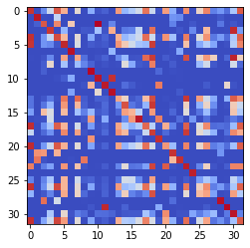

epoch 1631 == measurement_heuristic: 0.45+-0.01/0.42+-0.01 --

epoch 1632 == measurement_heuristic: 0.46+-0.01/0.41+-0.01 --

epoch 1633 == measurement_heuristic: 0.48+-0.01/0.41+-0.01 --

epoch 1634 == measurement_heuristic: 0.46+-0.01/0.41+-0.01 --

epoch 1635 == measurement_heuristic: 0.46+-0.01/0.41+-0.01 --

epoch 1636 == measurement_heuristic: 0.46+-0.01/0.41+-0.01 --

epoch 1637 == measurement_heuristic: 0.47+-0.01/0.43+-0.01 --

epoch 1638 == measurement_heuristic: 0.47+-0.01/0.41+-0.01 --

epoch 1639 == measurement_heuristic: 0.46+-0.01/0.42+-0.01 --

epoch 1640 == measurement_heuristic: 0.47+-0.01/0.46+-0.01 --

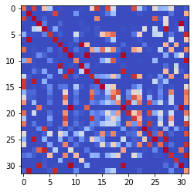

epoch 1641 == measurement_heuristic: 0.48+-0.01/0.42+-0.01 --

epoch 1642 == measurement_heuristic: 0.45+-0.01/0.44+-0.01 --

epoch 1643 == measurement_heuristic: 0.46+-0.01/0.41+-0.01 --

epoch 1644 == measurement_heuristic: 0.47+-0.01/0.40+-0.01 --

epoch 1645 == measurement_heuristic: 0.45+-0.01/0.41+-0.01 --

epoch 1646 == measurement_heuristic: 0.46+-0.01/0.41+-0.01 --

epoch 1647 == measurement_heuristic: 0.46+-0.01/0.40+-0.01 --

epoch 1648 == measurement_heuristic: 0.44+-0.01/0.41+-0.01 --

epoch 1649 == measurement_heuristic: 0.44+-0.01/0.41+-0.01 --

epoch 1650 == measurement_heuristic: 0.48+-0.01/0.41+-0.01 --

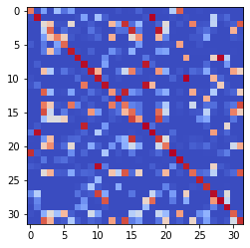

epoch 1651 == measurement_heuristic: 0.46+-0.01/0.45+-0.01 --

epoch 1652 == measurement_heuristic: 0.47+-0.01/0.40+-0.01 --

epoch 1653 == measurement_heuristic: 0.48+-0.01/0.42+-0.01 --

epoch 1654 == measurement_heuristic: 0.46+-0.01/0.42+-0.01 --

epoch 1655 == measurement_heuristic: 0.47+-0.01/0.42+-0.01 --

epoch 1656 == measurement_heuristic: 0.47+-0.01/0.41+-0.01 --

epoch 1657 == measurement_heuristic: 0.47+-0.01/0.42+-0.01 --

epoch 1658 == measurement_heuristic: 0.47+-0.01/0.42+-0.01 --

epoch 1659 == measurement_heuristic: 0.44+-0.01/0.40+-0.01 --

epoch 1660 == measurement_heuristic: 0.45+-0.01/0.41+-0.01 --

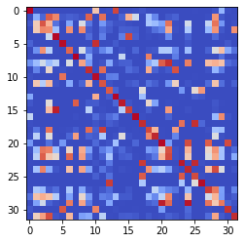

epoch 1661 == measurement_heuristic: 0.47+-0.01/0.41+-0.01 --

epoch 1662 == measurement_heuristic: 0.47+-0.02/0.41+-0.01 --

epoch 1663 == measurement_heuristic: 0.45+-0.01/0.40+-0.01 --

epoch 1664 == measurement_heuristic: 0.46+-0.01/0.41+-0.01 --

epoch 1665 == measurement_heuristic: 0.49+-0.01/0.40+-0.01 --

epoch 1666 == measurement_heuristic: 0.46+-0.01/0.41+-0.01 --

epoch 1667 >> measurement_heuristic: 0.44+-0.01/0.40+-0.01 --

epoch 1668 == measurement_heuristic: 0.48+-0.01/0.43+-0.01 --

epoch 1669 == measurement_heuristic: 0.46+-0.01/0.44+-0.01 --

epoch 1670 >> measurement_heuristic: 0.44+-0.01/0.39+-0.01 --

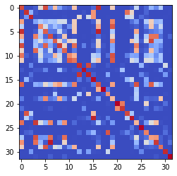

epoch 1671 == measurement_heuristic: 0.46+-0.01/0.40+-0.01 --

epoch 1672 == measurement_heuristic: 0.44+-0.01/0.40+-0.01 --

epoch 1673 == measurement_heuristic: 0.46+-0.01/0.40+-0.01 --

epoch 1674 == measurement_heuristic: 0.45+-0.01/0.41+-0.01 --

epoch 1675 == measurement_heuristic: 0.45+-0.01/0.41+-0.01 --

epoch 1676 == measurement_heuristic: 0.46+-0.01/0.42+-0.01 --

epoch 1677 == measurement_heuristic: 0.47+-0.01/0.43+-0.01 --

epoch 1678 == measurement_heuristic: 0.46+-0.01/0.42+-0.01 --

epoch 1679 == measurement_heuristic: 0.44+-0.01/0.40+-0.01 --

epoch 1680 == measurement_heuristic: 0.44+-0.01/0.41+-0.01 --

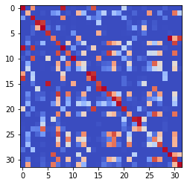

epoch 1681 == measurement_heuristic: 0.43+-0.01/0.41+-0.01 --

epoch 1682 == measurement_heuristic: 0.45+-0.01/0.41+-0.01 --

epoch 1683 == measurement_heuristic: 0.46+-0.01/0.41+-0.01 --

epoch 1684 == measurement_heuristic: 0.46+-0.01/0.42+-0.01 --

epoch 1685 == measurement_heuristic: 0.47+-0.01/0.41+-0.01 --

epoch 1686 == measurement_heuristic: 0.44+-0.01/0.41+-0.01 --

epoch 1687 == measurement_heuristic: 0.43+-0.01/0.40+-0.01 --

epoch 1688 == measurement_heuristic: 0.47+-0.01/0.40+-0.01 --

epoch 1689 == measurement_heuristic: 0.47+-0.01/0.40+-0.01 --

epoch 1690 == measurement_heuristic: 0.46+-0.01/0.42+-0.01 --

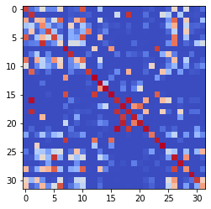

epoch 1691 == measurement_heuristic: 0.47+-0.01/0.41+-0.01 --

epoch 1692 == measurement_heuristic: 0.48+-0.01/0.40+-0.01 --

epoch 1693 == measurement_heuristic: 0.46+-0.01/0.40+-0.01 --

epoch 1694 == measurement_heuristic: 0.45+-0.01/0.41+-0.01 --

epoch 1695 == measurement_heuristic: 0.48+-0.01/0.41+-0.01 --

epoch 1696 == measurement_heuristic: 0.45+-0.01/0.41+-0.01 --

epoch 1697 == measurement_heuristic: 0.46+-0.01/0.40+-0.01 --

epoch 1698 == measurement_heuristic: 0.46+-0.01/0.41+-0.01 --

epoch 1699 == measurement_heuristic: 0.47+-0.01/0.41+-0.01 --

epoch 1700 == measurement_heuristic: 0.46+-0.01/0.40+-0.01 --

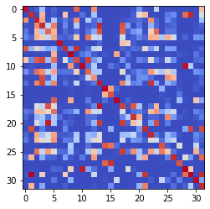

epoch 1701 == measurement_heuristic: 0.46+-0.01/0.41+-0.01 --

epoch 1702 == measurement_heuristic: 0.46+-0.01/0.41+-0.01 --

epoch 1703 >> measurement_heuristic: 0.45+-0.01/0.39+-0.01 --

epoch 1704 == measurement_heuristic: 0.48+-0.01/0.41+-0.01 --

epoch 1705 == measurement_heuristic: 0.46+-0.01/0.41+-0.01 --

epoch 1706 == measurement_heuristic: 0.45+-0.01/0.40+-0.01 --

epoch 1707 == measurement_heuristic: 0.45+-0.01/0.40+-0.01 --

epoch 1708 == measurement_heuristic: 0.46+-0.01/0.42+-0.01 --

epoch 1709 == measurement_heuristic: 0.47+-0.01/0.41+-0.01 --

epoch 1710 >> measurement_heuristic: 0.45+-0.01/0.39+-0.01 --

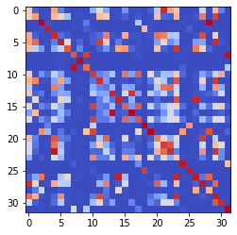

epoch 1711 == measurement_heuristic: 0.48+-0.01/0.41+-0.01 --

epoch 1712 >> measurement_heuristic: 0.49+-0.01/0.39+-0.01 --

epoch 1713 == measurement_heuristic: 0.46+-0.01/0.40+-0.01 --

epoch 1714 == measurement_heuristic: 0.44+-0.01/0.41+-0.01 --

epoch 1715 == measurement_heuristic: 0.45+-0.01/0.40+-0.01 --

epoch 1716 == measurement_heuristic: 0.43+-0.01/0.39+-0.01 --

epoch 1717 == measurement_heuristic: 0.44+-0.01/0.40+-0.01 --

epoch 1718 == measurement_heuristic: 0.46+-0.01/0.42+-0.01 --

epoch 1719 == measurement_heuristic: 0.47+-0.01/0.42+-0.01 --

epoch 1720 == measurement_heuristic: 0.45+-0.01/0.41+-0.01 --

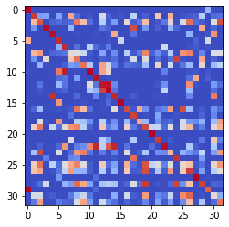

epoch 1721 == measurement_heuristic: 0.46+-0.01/0.39+-0.01 --

epoch 1722 == measurement_heuristic: 0.47+-0.01/0.41+-0.01 --

epoch 1723 == measurement_heuristic: 0.45+-0.01/0.40+-0.01 --

epoch 1724 == measurement_heuristic: 0.45+-0.01/0.42+-0.01 --

epoch 1725 == measurement_heuristic: 0.46+-0.01/0.40+-0.01 --

epoch 1726 == measurement_heuristic: 0.44+-0.01/0.41+-0.01 --

epoch 1727 == measurement_heuristic: 0.44+-0.01/0.39+-0.01 --

epoch 1728 == measurement_heuristic: 0.45+-0.01/0.40+-0.01 --

epoch 1729 == measurement_heuristic: 0.47+-0.01/0.41+-0.01 --

epoch 1730 == measurement_heuristic: 0.46+-0.01/0.41+-0.01 --

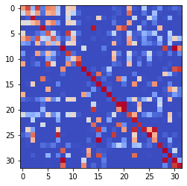

epoch 1731 == measurement_heuristic: 0.44+-0.01/0.40+-0.01 --

epoch 1732 == measurement_heuristic: 0.47+-0.01/0.41+-0.01 --

epoch 1733 == measurement_heuristic: 0.46+-0.01/0.41+-0.01 --

epoch 1734 == measurement_heuristic: 0.46+-0.01/0.39+-0.01 --

epoch 1735 == measurement_heuristic: 0.44+-0.01/0.41+-0.01 --

epoch 1736 == measurement_heuristic: 0.45+-0.01/0.40+-0.01 --

epoch 1737 >> measurement_heuristic: 0.43+-0.01/0.39+-0.01 --

epoch 1738 == measurement_heuristic: 0.45+-0.01/0.40+-0.01 --

epoch 1739 == measurement_heuristic: 0.46+-0.01/0.40+-0.01 --

epoch 1740 == measurement_heuristic: 0.47+-0.02/0.40+-0.01 --

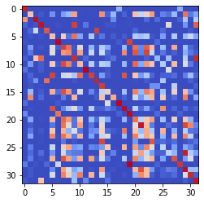

epoch 1741 == measurement_heuristic: 0.43+-0.01/0.41+-0.01 --

epoch 1742 == measurement_heuristic: 0.47+-0.01/0.42+-0.01 --

epoch 1743 == measurement_heuristic: 0.45+-0.01/0.41+-0.01 --

epoch 1744 == measurement_heuristic: 0.46+-0.01/0.43+-0.01 --

epoch 1745 == measurement_heuristic: 0.47+-0.01/0.40+-0.01 --

epoch 1746 == measurement_heuristic: 0.43+-0.01/0.40+-0.01 --

epoch 1747 == measurement_heuristic: 0.46+-0.01/0.41+-0.01 --

epoch 1748 == measurement_heuristic: 0.47+-0.01/0.40+-0.01 --

epoch 1749 == measurement_heuristic: 0.45+-0.01/0.39+-0.01 --

epoch 1750 >> measurement_heuristic: 0.45+-0.01/0.38+-0.01 --

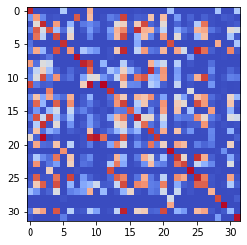

epoch 1751 == measurement_heuristic: 0.44+-0.01/0.40+-0.01 --

epoch 1752 == measurement_heuristic: 0.44+-0.01/0.39+-0.01 --

epoch 1753 == measurement_heuristic: 0.44+-0.01/0.40+-0.01 --

epoch 1754 == measurement_heuristic: 0.45+-0.01/0.41+-0.01 --

epoch 1755 == measurement_heuristic: 0.48+-0.01/0.41+-0.01 --

epoch 1756 == measurement_heuristic: 0.48+-0.02/0.41+-0.01 --

epoch 1757 == measurement_heuristic: 0.44+-0.01/0.40+-0.01 --

epoch 1758 == measurement_heuristic: 0.46+-0.01/0.39+-0.01 --

epoch 1759 == measurement_heuristic: 0.47+-0.01/0.40+-0.01 --

epoch 1760 == measurement_heuristic: 0.45+-0.01/0.39+-0.01 --

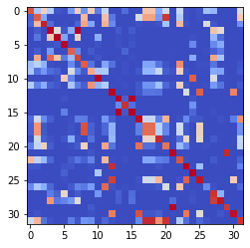

epoch 1761 == measurement_heuristic: 0.44+-0.01/0.40+-0.01 --

epoch 1762 == measurement_heuristic: 0.45+-0.01/0.41+-0.01 --

epoch 1763 == measurement_heuristic: 0.46+-0.01/0.43+-0.01 --

epoch 1764 == measurement_heuristic: 0.46+-0.01/0.39+-0.01 --

epoch 1765 == measurement_heuristic: 0.47+-0.01/0.40+-0.01 --

epoch 1766 == measurement_heuristic: 0.45+-0.01/0.40+-0.01 --

epoch 1767 == measurement_heuristic: 0.46+-0.01/0.42+-0.01 --

epoch 1768 == measurement_heuristic: 0.47+-0.01/0.39+-0.01 --

epoch 1769 == measurement_heuristic: 0.44+-0.01/0.40+-0.01 --

epoch 1770 == measurement_heuristic: 0.46+-0.01/0.40+-0.01 --

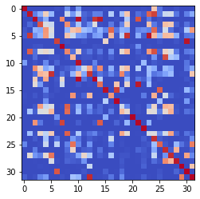

epoch 1771 == measurement_heuristic: 0.47+-0.01/0.39+-0.01 --

epoch 1772 == measurement_heuristic: 0.47+-0.01/0.39+-0.01 --

epoch 1773 == measurement_heuristic: 0.43+-0.01/0.40+-0.01 --

epoch 1774 == measurement_heuristic: 0.45+-0.01/0.40+-0.01 --

epoch 1775 == measurement_heuristic: 0.47+-0.01/0.39+-0.01 --

epoch 1776 == measurement_heuristic: 0.46+-0.01/0.40+-0.01 --

epoch 1777 == measurement_heuristic: 0.46+-0.01/0.40+-0.01 --

epoch 1778 == measurement_heuristic: 0.44+-0.01/0.39+-0.01 --

epoch 1779 == measurement_heuristic: 0.47+-0.01/0.41+-0.01 --

epoch 1780 == measurement_heuristic: 0.44+-0.01/0.39+-0.01 --

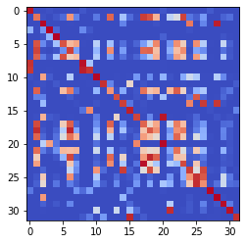

epoch 1781 == measurement_heuristic: 0.43+-0.01/0.40+-0.01 --

epoch 1782 == measurement_heuristic: 0.45+-0.01/0.39+-0.01 --

epoch 1783 == measurement_heuristic: 0.45+-0.01/0.40+-0.01 --

epoch 1784 == measurement_heuristic: 0.44+-0.01/0.40+-0.01 --

epoch 1785 == measurement_heuristic: 0.43+-0.01/0.39+-0.01 --

epoch 1786 == measurement_heuristic: 0.44+-0.01/0.39+-0.01 --

epoch 1787 == measurement_heuristic: 0.45+-0.01/0.41+-0.01 --

epoch 1788 == measurement_heuristic: 0.47+-0.01/0.41+-0.01 --

epoch 1789 == measurement_heuristic: 0.44+-0.01/0.41+-0.01 --

epoch 1790 == measurement_heuristic: 0.44+-0.01/0.40+-0.01 --

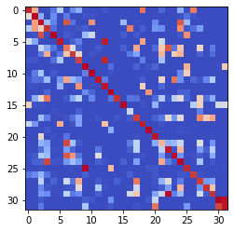

epoch 1791 == measurement_heuristic: 0.48+-0.01/0.45+-0.01 --

epoch 1792 == measurement_heuristic: 0.45+-0.01/0.39+-0.01 --

epoch 1793 == measurement_heuristic: 0.42+-0.01/0.39+-0.01 --

epoch 1794 == measurement_heuristic: 0.47+-0.01/0.40+-0.01 --

epoch 1795 == measurement_heuristic: 0.44+-0.01/0.40+-0.01 --

epoch 1796 == measurement_heuristic: 0.45+-0.01/0.39+-0.01 --

epoch 1797 == measurement_heuristic: 0.44+-0.01/0.41+-0.01 --

epoch 1798 == measurement_heuristic: 0.44+-0.01/0.42+-0.01 --

epoch 1799 == measurement_heuristic: 0.46+-0.01/0.40+-0.01 --

epoch 1800 == measurement_heuristic: 0.44+-0.01/0.39+-0.01 --

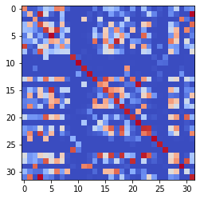

epoch 1801 == measurement_heuristic: 0.44+-0.01/0.40+-0.01 --

epoch 1802 == measurement_heuristic: 0.47+-0.01/0.41+-0.01 --

epoch 1803 == measurement_heuristic: 0.44+-0.01/0.40+-0.01 --

epoch 1804 == measurement_heuristic: 0.46+-0.01/0.39+-0.01 --

epoch 1805 == measurement_heuristic: 0.44+-0.01/0.39+-0.01 --

epoch 1806 == measurement_heuristic: 0.44+-0.01/0.40+-0.01 --

epoch 1807 == measurement_heuristic: 0.46+-0.01/0.41+-0.01 --

epoch 1808 == measurement_heuristic: 0.46+-0.01/0.39+-0.01 --

epoch 1809 == measurement_heuristic: 0.43+-0.01/0.39+-0.01 --

epoch 1810 == measurement_heuristic: 0.45+-0.01/0.40+-0.01 --

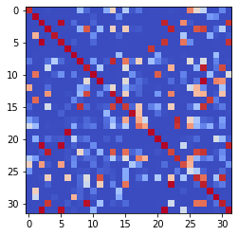

epoch 1811 == measurement_heuristic: 0.45+-0.01/0.41+-0.01 --

epoch 1812 == measurement_heuristic: 0.46+-0.01/0.41+-0.01 --

epoch 1813 == measurement_heuristic: 0.45+-0.01/0.39+-0.01 --

epoch 1814 == measurement_heuristic: 0.44+-0.01/0.40+-0.01 --

epoch 1815 == measurement_heuristic: 0.45+-0.01/0.41+-0.01 --

epoch 1816 == measurement_heuristic: 0.43+-0.01/0.40+-0.01 --

epoch 1817 == measurement_heuristic: 0.43+-0.01/0.39+-0.01 --

epoch 1818 == measurement_heuristic: 0.43+-0.01/0.39+-0.01 --

epoch 1819 == measurement_heuristic: 0.44+-0.01/0.39+-0.01 --

epoch 1820 == measurement_heuristic: 0.44+-0.01/0.40+-0.01 --

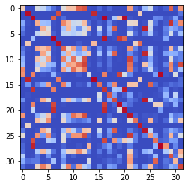

epoch 1821 == measurement_heuristic: 0.42+-0.01/0.39+-0.01 --

epoch 1822 == measurement_heuristic: 0.48+-0.01/0.39+-0.01 --

epoch 1823 == measurement_heuristic: 0.46+-0.01/0.39+-0.01 --

epoch 1824 == measurement_heuristic: 0.42+-0.01/0.42+-0.01 --

epoch 1825 == measurement_heuristic: 0.43+-0.01/0.39+-0.01 --

epoch 1826 == measurement_heuristic: 0.46+-0.01/0.39+-0.01 --

epoch 1827 == measurement_heuristic: 0.44+-0.01/0.40+-0.01 --

epoch 1828 == measurement_heuristic: 0.43+-0.02/0.39+-0.01 --

epoch 1829 == measurement_heuristic: 0.46+-0.01/0.41+-0.01 --

epoch 1830 == measurement_heuristic: 0.45+-0.01/0.40+-0.01 --

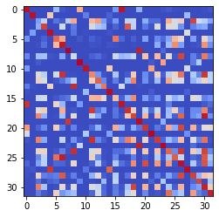

epoch 1831 == measurement_heuristic: 0.47+-0.01/0.39+-0.01 --

epoch 1832 == measurement_heuristic: 0.47+-0.01/0.40+-0.01 --

epoch 1833 == measurement_heuristic: 0.43+-0.01/0.39+-0.01 --

epoch 1834 == measurement_heuristic: 0.47+-0.01/0.40+-0.01 --

epoch 1835 == measurement_heuristic: 0.45+-0.01/0.40+-0.01 --

epoch 1836 == measurement_heuristic: 0.45+-0.01/0.41+-0.01 --

epoch 1837 == measurement_heuristic: 0.43+-0.01/0.39+-0.01 --

epoch 1838 == measurement_heuristic: 0.47+-0.01/0.39+-0.01 --

epoch 1839 == measurement_heuristic: 0.45+-0.01/0.39+-0.01 --

epoch 1840 == measurement_heuristic: 0.45+-0.01/0.40+-0.01 --

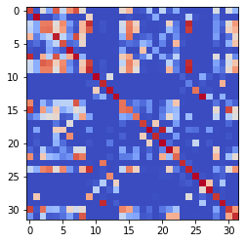

epoch 1841 == measurement_heuristic: 0.44+-0.01/0.40+-0.01 --

epoch 1842 == measurement_heuristic: 0.45+-0.01/0.39+-0.01 --

epoch 1843 == measurement_heuristic: 0.46+-0.01/0.39+-0.01 --

epoch 1844 == measurement_heuristic: 0.44+-0.01/0.40+-0.01 --

epoch 1845 == measurement_heuristic: 0.45+-0.01/0.39+-0.01 --

epoch 1846 == measurement_heuristic: 0.44+-0.01/0.41+-0.01 --

epoch 1847 == measurement_heuristic: 0.45+-0.01/0.39+-0.01 --

epoch 1848 == measurement_heuristic: 0.45+-0.01/0.39+-0.01 --

epoch 1849 == measurement_heuristic: 0.46+-0.02/0.39+-0.01 --

epoch 1850 == measurement_heuristic: 0.47+-0.01/0.40+-0.01 --

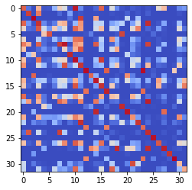

epoch 1851 == measurement_heuristic: 0.46+-0.01/0.40+-0.01 --

epoch 1852 == measurement_heuristic: 0.46+-0.01/0.39+-0.01 --

epoch 1853 == measurement_heuristic: 0.47+-0.01/0.39+-0.01 --

epoch 1854 == measurement_heuristic: 0.44+-0.01/0.40+-0.01 --

epoch 1855 == measurement_heuristic: 0.45+-0.01/0.39+-0.01 --

epoch 1856 == measurement_heuristic: 0.45+-0.01/0.40+-0.01 --

epoch 1857 == measurement_heuristic: 0.43+-0.01/0.40+-0.01 --

epoch 1858 == measurement_heuristic: 0.44+-0.01/0.39+-0.01 --

epoch 1859 == measurement_heuristic: 0.44+-0.01/0.41+-0.01 --

epoch 1860 == measurement_heuristic: 0.44+-0.01/0.40+-0.01 --

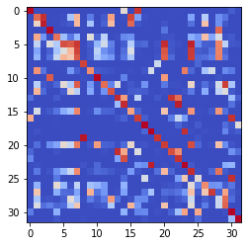

epoch 1861 == measurement_heuristic: 0.45+-0.01/0.39+-0.01 --

epoch 1862 == measurement_heuristic: 0.44+-0.01/0.39+-0.01 --

epoch 1863 == measurement_heuristic: 0.45+-0.01/0.40+-0.01 --

epoch 1864 == measurement_heuristic: 0.43+-0.01/0.39+-0.01 --

epoch 1865 == measurement_heuristic: 0.43+-0.01/0.40+-0.01 --

epoch 1866 == measurement_heuristic: 0.43+-0.01/0.39+-0.01 --

epoch 1867 == measurement_heuristic: 0.44+-0.01/0.39+-0.01 --

epoch 1868 == measurement_heuristic: 0.45+-0.01/0.39+-0.01 --

epoch 1869 == measurement_heuristic: 0.45+-0.01/0.39+-0.01 --

epoch 1870 == measurement_heuristic: 0.44+-0.01/0.39+-0.01 --

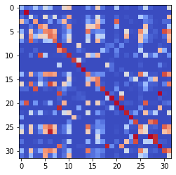

epoch 1871 == measurement_heuristic: 0.47+-0.01/0.39+-0.01 --

epoch 1872 == measurement_heuristic: 0.45+-0.01/0.40+-0.01 --

epoch 1873 == measurement_heuristic: 0.44+-0.01/0.39+-0.01 --

epoch 1874 == measurement_heuristic: 0.46+-0.01/0.43+-0.01 --

epoch 1875 == measurement_heuristic: 0.47+-0.01/0.40+-0.01 --

epoch 1876 == measurement_heuristic: 0.42+-0.01/0.38+-0.01 --

epoch 1877 == measurement_heuristic: 0.44+-0.01/0.41+-0.01 --

epoch 1878 == measurement_heuristic: 0.46+-0.01/0.40+-0.01 --

epoch 1879 == measurement_heuristic: 0.44+-0.01/0.39+-0.01 --

epoch 1880 == measurement_heuristic: 0.46+-0.01/0.39+-0.01 --

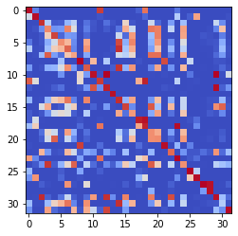

epoch 1881 == measurement_heuristic: 0.44+-0.01/0.39+-0.01 --

epoch 1882 == measurement_heuristic: 0.45+-0.01/0.39+-0.01 --

epoch 1883 == measurement_heuristic: 0.44+-0.01/0.39+-0.01 --

epoch 1884 == measurement_heuristic: 0.44+-0.01/0.40+-0.01 --

epoch 1885 == measurement_heuristic: 0.46+-0.01/0.39+-0.01 --

epoch 1886 == measurement_heuristic: 0.43+-0.01/0.39+-0.01 --

epoch 1887 == measurement_heuristic: 0.43+-0.01/0.40+-0.01 --

epoch 1888 == measurement_heuristic: 0.45+-0.01/0.40+-0.01 --

epoch 1889 == measurement_heuristic: 0.45+-0.01/0.40+-0.01 --

epoch 1890 == measurement_heuristic: 0.44+-0.01/0.40+-0.01 --

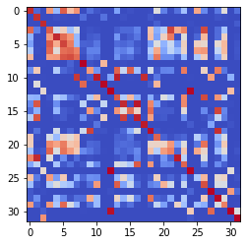

epoch 1891 == measurement_heuristic: 0.44+-0.01/0.39+-0.01 --

epoch 1892 == measurement_heuristic: 0.47+-0.01/0.39+-0.01 --

epoch 1893 == measurement_heuristic: 0.47+-0.01/0.40+-0.01 --

epoch 1894 == measurement_heuristic: 0.43+-0.01/0.39+-0.01 --

epoch 1895 == measurement_heuristic: 0.43+-0.01/0.41+-0.01 --

epoch 1896 == measurement_heuristic: 0.42+-0.01/0.39+-0.01 --

epoch 1897 == measurement_heuristic: 0.46+-0.01/0.40+-0.01 --

epoch 1898 == measurement_heuristic: 0.42+-0.01/0.39+-0.01 --

epoch 1899 == measurement_heuristic: 0.46+-0.01/0.41+-0.01 --

epoch 1900 == measurement_heuristic: 0.44+-0.01/0.40+-0.01 --

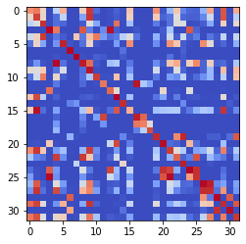

epoch 1901 == measurement_heuristic: 0.43+-0.01/0.39+-0.01 --

epoch 1902 >> measurement_heuristic: 0.46+-0.01/0.38+-0.01 --

epoch 1903 == measurement_heuristic: 0.43+-0.01/0.40+-0.01 --

epoch 1904 == measurement_heuristic: 0.42+-0.01/0.39+-0.01 --

epoch 1905 == measurement_heuristic: 0.44+-0.01/0.40+-0.01 --

epoch 1906 == measurement_heuristic: 0.43+-0.01/0.40+-0.01 --

epoch 1907 == measurement_heuristic: 0.45+-0.01/0.41+-0.01 --

epoch 1908 == measurement_heuristic: 0.45+-0.01/0.39+-0.01 --

epoch 1909 == measurement_heuristic: 0.47+-0.01/0.40+-0.01 --

epoch 1910 == measurement_heuristic: 0.45+-0.01/0.40+-0.01 --

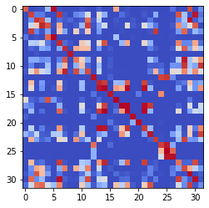

epoch 1911 == measurement_heuristic: 0.44+-0.01/0.39+-0.01 --

epoch 1912 == measurement_heuristic: 0.44+-0.01/0.39+-0.01 --

epoch 1913 == measurement_heuristic: 0.45+-0.01/0.39+-0.01 --

epoch 1914 == measurement_heuristic: 0.44+-0.01/0.40+-0.01 --

epoch 1915 == measurement_heuristic: 0.45+-0.01/0.39+-0.01 --

epoch 1916 == measurement_heuristic: 0.45+-0.01/0.39+-0.01 --

epoch 1917 == measurement_heuristic: 0.43+-0.01/0.39+-0.01 --

epoch 1918 == measurement_heuristic: 0.46+-0.01/0.39+-0.01 --

epoch 1919 == measurement_heuristic: 0.43+-0.01/0.40+-0.01 --

epoch 1920 == measurement_heuristic: 0.44+-0.01/0.39+-0.01 --

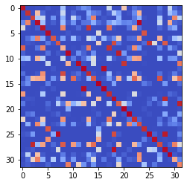

epoch 1921 == measurement_heuristic: 0.46+-0.01/0.39+-0.01 --

epoch 1922 == measurement_heuristic: 0.44+-0.01/0.39+-0.01 --

epoch 1923 == measurement_heuristic: 0.43+-0.01/0.39+-0.01 --

epoch 1924 == measurement_heuristic: 0.41+-0.01/0.39+-0.01 --

epoch 1925 == measurement_heuristic: 0.45+-0.01/0.40+-0.01 --

epoch 1926 == measurement_heuristic: 0.44+-0.01/0.39+-0.01 --

epoch 1927 == measurement_heuristic: 0.44+-0.01/0.38+-0.01 --

epoch 1928 == measurement_heuristic: 0.45+-0.01/0.39+-0.01 --

epoch 1929 == measurement_heuristic: 0.44+-0.01/0.40+-0.01 --

epoch 1930 == measurement_heuristic: 0.43+-0.01/0.38+-0.01 --

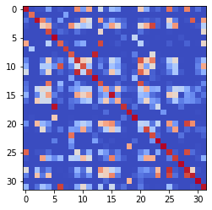

epoch 1931 == measurement_heuristic: 0.44+-0.01/0.39+-0.01 --

epoch 1932 == measurement_heuristic: 0.46+-0.01/0.40+-0.01 --

epoch 1933 == measurement_heuristic: 0.43+-0.01/0.39+-0.01 --

epoch 1934 == measurement_heuristic: 0.44+-0.01/0.39+-0.01 --

epoch 1935 == measurement_heuristic: 0.44+-0.01/0.39+-0.01 --

epoch 1936 == measurement_heuristic: 0.45+-0.01/0.40+-0.01 --

epoch 1937 == measurement_heuristic: 0.43+-0.01/0.39+-0.01 --

epoch 1938 == measurement_heuristic: 0.45+-0.01/0.44+-0.01 --

epoch 1939 == measurement_heuristic: 0.43+-0.01/0.40+-0.01 --

epoch 1940 == measurement_heuristic: 0.44+-0.01/0.38+-0.01 --

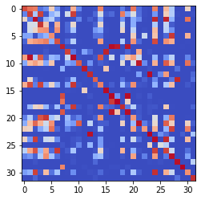

epoch 1941 == measurement_heuristic: 0.43+-0.01/0.39+-0.01 --

epoch 1942 >> measurement_heuristic: 0.43+-0.01/0.38+-0.01 --

epoch 1943 == measurement_heuristic: 0.43+-0.01/0.39+-0.01 --

epoch 1944 == measurement_heuristic: 0.44+-0.01/0.39+-0.01 --

epoch 1945 == measurement_heuristic: 0.47+-0.01/0.38+-0.01 --

epoch 1946 == measurement_heuristic: 0.43+-0.01/0.38+-0.01 --

epoch 1947 == measurement_heuristic: 0.44+-0.01/0.39+-0.01 --

epoch 1948 == measurement_heuristic: 0.45+-0.01/0.39+-0.01 --

epoch 1949 == measurement_heuristic: 0.45+-0.01/0.39+-0.01 --

epoch 1950 == measurement_heuristic: 0.43+-0.01/0.39+-0.01 --

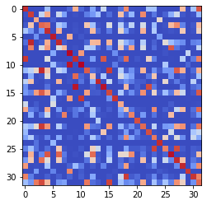

epoch 1951 == measurement_heuristic: 0.44+-0.01/0.39+-0.01 --

epoch 1952 == measurement_heuristic: 0.43+-0.01/0.39+-0.01 --

epoch 1953 == measurement_heuristic: 0.45+-0.01/0.40+-0.01 --

epoch 1954 == measurement_heuristic: 0.45+-0.01/0.44+-0.01 --

epoch 1955 == measurement_heuristic: 0.44+-0.01/0.38+-0.01 --

epoch 1956 == measurement_heuristic: 0.45+-0.01/0.40+-0.01 --

epoch 1957 == measurement_heuristic: 0.44+-0.01/0.39+-0.01 --

epoch 1958 == measurement_heuristic: 0.44+-0.01/0.39+-0.01 --

epoch 1959 == measurement_heuristic: 0.42+-0.01/0.39+-0.01 --

epoch 1960 == measurement_heuristic: 0.46+-0.01/0.39+-0.01 --

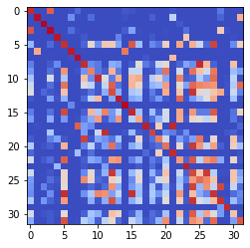

epoch 1961 == measurement_heuristic: 0.44+-0.01/0.40+-0.01 --

epoch 1962 == measurement_heuristic: 0.45+-0.01/0.39+-0.01 --

epoch 1963 == measurement_heuristic: 0.44+-0.01/0.39+-0.01 --

epoch 1964 == measurement_heuristic: 0.43+-0.01/0.40+-0.01 --

epoch 1965 == measurement_heuristic: 0.44+-0.01/0.38+-0.01 --

epoch 1966 == measurement_heuristic: 0.45+-0.01/0.39+-0.01 --

epoch 1967 == measurement_heuristic: 0.44+-0.01/0.40+-0.01 --

epoch 1968 == measurement_heuristic: 0.44+-0.01/0.38+-0.01 --

epoch 1969 == measurement_heuristic: 0.41+-0.01/0.38+-0.01 --

epoch 1970 >> measurement_heuristic: 0.43+-0.01/0.38+-0.01 --

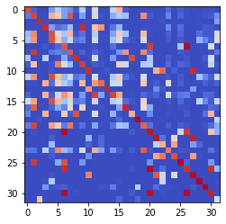

epoch 1971 == measurement_heuristic: 0.45+-0.01/0.39+-0.01 --

epoch 1972 == measurement_heuristic: 0.44+-0.01/0.38+-0.01 --

epoch 1973 == measurement_heuristic: 0.47+-0.02/0.39+-0.01 --

epoch 1974 >> measurement_heuristic: 0.43+-0.01/0.37+-0.01 --

epoch 1975 == measurement_heuristic: 0.46+-0.01/0.39+-0.01 --

epoch 1976 == measurement_heuristic: 0.43+-0.01/0.38+-0.01 --

epoch 1977 == measurement_heuristic: 0.43+-0.01/0.40+-0.01 --

epoch 1978 == measurement_heuristic: 0.45+-0.01/0.38+-0.01 --

epoch 1979 == measurement_heuristic: 0.45+-0.01/0.39+-0.01 --

epoch 1980 == measurement_heuristic: 0.43+-0.01/0.40+-0.01 --

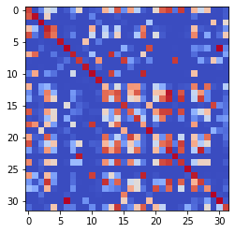

epoch 1981 == measurement_heuristic: 0.43+-0.01/0.38+-0.01 --

epoch 1982 == measurement_heuristic: 0.44+-0.01/0.39+-0.01 --

epoch 1983 == measurement_heuristic: 0.43+-0.01/0.41+-0.01 --

epoch 1984 == measurement_heuristic: 0.44+-0.01/0.39+-0.01 --

epoch 1985 == measurement_heuristic: 0.44+-0.01/0.38+-0.01 --

epoch 1986 == measurement_heuristic: 0.43+-0.01/0.40+-0.01 --

epoch 1987 == measurement_heuristic: 0.47+-0.01/0.39+-0.01 --

epoch 1988 == measurement_heuristic: 0.45+-0.01/0.40+-0.01 --

epoch 1989 == measurement_heuristic: 0.45+-0.01/0.39+-0.01 --

epoch 1990 == measurement_heuristic: 0.43+-0.01/0.38+-0.01 --

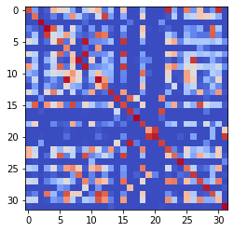

epoch 1991 == measurement_heuristic: 0.43+-0.01/0.39+-0.01 --

epoch 1992 == measurement_heuristic: 0.43+-0.01/0.38+-0.01 --

epoch 1993 == measurement_heuristic: 0.46+-0.01/0.39+-0.01 --

epoch 1994 == measurement_heuristic: 0.44+-0.01/0.41+-0.01 --

epoch 1995 == measurement_heuristic: 0.45+-0.01/0.40+-0.01 --

epoch 1996 == measurement_heuristic: 0.44+-0.01/0.39+-0.01 --

epoch 1997 == measurement_heuristic: 0.47+-0.02/0.41+-0.01 --

epoch 1998 == measurement_heuristic: 0.44+-0.01/0.39+-0.01 --

epoch 1999 == measurement_heuristic: 0.43+-0.01/0.38+-0.01 --

epoch 2000 == measurement_heuristic: 0.43+-0.01/0.40+-0.01 --

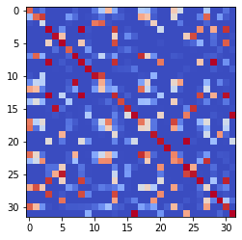

epoch 2001 == measurement_heuristic: 0.43+-0.01/0.38+-0.01 --

epoch 2002 == measurement_heuristic: 0.45+-0.01/0.40+-0.01 --

epoch 2003 == measurement_heuristic: 0.45+-0.01/0.39+-0.01 --

epoch 2004 == measurement_heuristic: 0.44+-0.01/0.38+-0.01 --

epoch 2005 == measurement_heuristic: 0.43+-0.01/0.39+-0.01 --

epoch 2006 == measurement_heuristic: 0.44+-0.01/0.39+-0.01 --

epoch 2007 == measurement_heuristic: 0.44+-0.01/0.39+-0.01 --

epoch 2008 == measurement_heuristic: 0.43+-0.01/0.38+-0.01 --

epoch 2009 == measurement_heuristic: 0.45+-0.01/0.38+-0.01 --

epoch 2010 == measurement_heuristic: 0.42+-0.01/0.39+-0.01 --

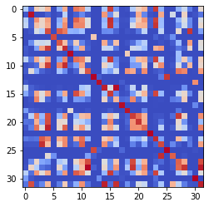

epoch 2011 == measurement_heuristic: 0.43+-0.01/0.39+-0.01 --

epoch 2012 == measurement_heuristic: 0.42+-0.01/0.39+-0.01 --

epoch 2013 == measurement_heuristic: 0.45+-0.01/0.40+-0.01 --

epoch 2014 == measurement_heuristic: 0.44+-0.01/0.39+-0.01 --

epoch 2015 == measurement_heuristic: 0.44+-0.01/0.38+-0.01 --

epoch 2016 == measurement_heuristic: 0.44+-0.01/0.39+-0.01 --

epoch 2017 == measurement_heuristic: 0.45+-0.01/0.38+-0.01 --

epoch 2018 == measurement_heuristic: 0.47+-0.01/0.39+-0.01 --

epoch 2019 == measurement_heuristic: 0.44+-0.01/0.39+-0.01 --

epoch 2020 == measurement_heuristic: 0.46+-0.01/0.39+-0.01 --

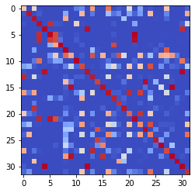

epoch 2021 == measurement_heuristic: 0.45+-0.01/0.39+-0.01 --

epoch 2022 == measurement_heuristic: 0.42+-0.01/0.38+-0.01 --

epoch 2023 == measurement_heuristic: 0.44+-0.01/0.38+-0.01 --

epoch 2024 == measurement_heuristic: 0.46+-0.01/0.38+-0.01 --

epoch 2025 == measurement_heuristic: 0.42+-0.01/0.38+-0.01 --

epoch 2026 == measurement_heuristic: 0.43+-0.01/0.38+-0.01 --

epoch 2027 == measurement_heuristic: 0.44+-0.01/0.39+-0.01 --

epoch 2028 == measurement_heuristic: 0.43+-0.01/0.38+-0.01 --

epoch 2029 == measurement_heuristic: 0.42+-0.01/0.39+-0.01 --

epoch 2030 == measurement_heuristic: 0.43+-0.01/0.38+-0.01 --

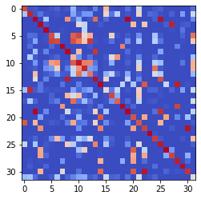

epoch 2031 == measurement_heuristic: 0.43+-0.01/0.38+-0.01 --

epoch 2032 == measurement_heuristic: 0.44+-0.01/0.38+-0.01 --

epoch 2033 == measurement_heuristic: 0.44+-0.01/0.39+-0.01 --

epoch 2034 == measurement_heuristic: 0.44+-0.01/0.38+-0.01 --

epoch 2035 == measurement_heuristic: 0.46+-0.01/0.38+-0.01 --

epoch 2036 == measurement_heuristic: 0.43+-0.01/0.39+-0.01 --

epoch 2037 == measurement_heuristic: 0.46+-0.01/0.39+-0.01 --

epoch 2038 == measurement_heuristic: 0.43+-0.01/0.38+-0.01 --

epoch 2039 >> measurement_heuristic: 0.44+-0.01/0.37+-0.01 --

epoch 2040 == measurement_heuristic: 0.45+-0.01/0.38+-0.01 --

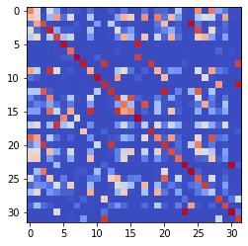

epoch 2041 == measurement_heuristic: 0.44+-0.01/0.40+-0.01 --

epoch 2042 == measurement_heuristic: 0.44+-0.01/0.40+-0.01 --

epoch 2043 == measurement_heuristic: 0.43+-0.01/0.39+-0.01 --

epoch 2044 == measurement_heuristic: 0.45+-0.01/0.38+-0.01 --

epoch 2045 >> measurement_heuristic: 0.44+-0.01/0.37+-0.01 --

epoch 2046 == measurement_heuristic: 0.42+-0.01/0.40+-0.01 --

epoch 2047 == measurement_heuristic: 0.44+-0.01/0.39+-0.01 --

epoch 2048 == measurement_heuristic: 0.44+-0.02/0.38+-0.01 --

epoch 2049 == measurement_heuristic: 0.45+-0.01/0.38+-0.01 --

epoch 2050 == measurement_heuristic: 0.43+-0.01/0.40+-0.01 --

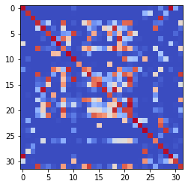

epoch 2051 == measurement_heuristic: 0.43+-0.01/0.38+-0.01 --

epoch 2052 == measurement_heuristic: 0.41+-0.01/0.39+-0.01 --

epoch 2053 == measurement_heuristic: 0.42+-0.01/0.39+-0.01 --

epoch 2054 == measurement_heuristic: 0.42+-0.01/0.41+-0.01 --

epoch 2055 == measurement_heuristic: 0.43+-0.01/0.38+-0.01 --

epoch 2056 == measurement_heuristic: 0.42+-0.01/0.38+-0.01 --

epoch 2057 == measurement_heuristic: 0.43+-0.01/0.39+-0.01 --

epoch 2058 >> measurement_heuristic: 0.43+-0.01/0.37+-0.01 --

epoch 2059 == measurement_heuristic: 0.42+-0.01/0.38+-0.01 --

epoch 2060 == measurement_heuristic: 0.44+-0.01/0.39+-0.01 --

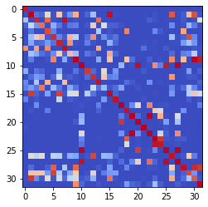

epoch 2061 == measurement_heuristic: 0.44+-0.01/0.38+-0.01 --

epoch 2062 == measurement_heuristic: 0.42+-0.01/0.38+-0.01 --

epoch 2063 == measurement_heuristic: 0.42+-0.01/0.38+-0.01 --

epoch 2064 == measurement_heuristic: 0.43+-0.01/0.38+-0.01 --

epoch 2065 == measurement_heuristic: 0.42+-0.01/0.38+-0.01 --

epoch 2066 == measurement_heuristic: 0.43+-0.01/0.38+-0.01 --

epoch 2067 == measurement_heuristic: 0.44+-0.01/0.38+-0.01 --

epoch 2068 == measurement_heuristic: 0.43+-0.01/0.41+-0.01 --

epoch 2069 == measurement_heuristic: 0.46+-0.01/0.38+-0.01 --

epoch 2070 == measurement_heuristic: 0.43+-0.01/0.38+-0.01 --

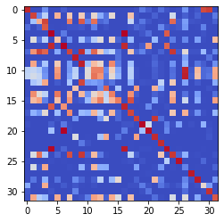

epoch 2071 == measurement_heuristic: 0.45+-0.01/0.38+-0.01 --

epoch 2072 == measurement_heuristic: 0.42+-0.01/0.38+-0.01 --

epoch 2073 == measurement_heuristic: 0.43+-0.01/0.39+-0.01 --

epoch 2074 == measurement_heuristic: 0.44+-0.01/0.39+-0.01 --

epoch 2075 == measurement_heuristic: 0.43+-0.01/0.39+-0.01 --

epoch 2076 == measurement_heuristic: 0.43+-0.01/0.39+-0.01 --

epoch 2077 == measurement_heuristic: 0.44+-0.01/0.40+-0.01 --

epoch 2078 == measurement_heuristic: 0.43+-0.01/0.41+-0.01 --

epoch 2079 == measurement_heuristic: 0.43+-0.01/0.39+-0.01 --

epoch 2080 == measurement_heuristic: 0.43+-0.01/0.39+-0.01 --

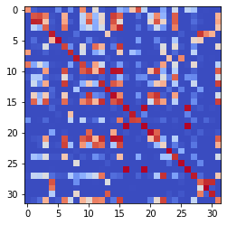

epoch 2081 == measurement_heuristic: 0.43+-0.01/0.38+-0.01 --

epoch 2082 == measurement_heuristic: 0.43+-0.01/0.39+-0.01 --

epoch 2083 == measurement_heuristic: 0.40+-0.01/0.38+-0.01 --

epoch 2084 == measurement_heuristic: 0.41+-0.01/0.39+-0.01 --

epoch 2085 == measurement_heuristic: 0.43+-0.01/0.38+-0.01 --

epoch 2086 == measurement_heuristic: 0.42+-0.01/0.39+-0.01 --

epoch 2087 == measurement_heuristic: 0.43+-0.02/0.38+-0.01 --

epoch 2088 == measurement_heuristic: 0.42+-0.01/0.38+-0.01 --

epoch 2089 == measurement_heuristic: 0.42+-0.01/0.38+-0.01 --

epoch 2090 == measurement_heuristic: 0.43+-0.01/0.42+-0.01 --

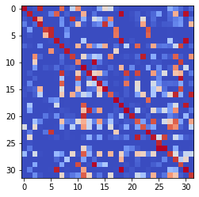

epoch 2091 == measurement_heuristic: 0.41+-0.01/0.39+-0.01 --

epoch 2092 == measurement_heuristic: 0.43+-0.01/0.39+-0.01 --

epoch 2093 == measurement_heuristic: 0.41+-0.01/0.40+-0.01 --

epoch 2094 == measurement_heuristic: 0.43+-0.01/0.42+-0.01 --

epoch 2095 == measurement_heuristic: 0.43+-0.01/0.39+-0.01 --

epoch 2096 == measurement_heuristic: 0.42+-0.01/0.38+-0.01 --

epoch 2097 == measurement_heuristic: 0.43+-0.01/0.38+-0.01 --

epoch 2098 == measurement_heuristic: 0.41+-0.01/0.37+-0.01 --

epoch 2099 == measurement_heuristic: 0.43+-0.01/0.40+-0.01 --

epoch 2100 == measurement_heuristic: 0.42+-0.01/0.39+-0.01 --

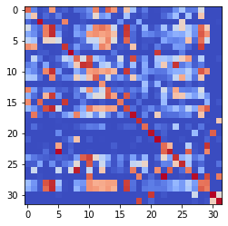

epoch 2101 == measurement_heuristic: 0.43+-0.01/0.40+-0.01 --

epoch 2102 == measurement_heuristic: 0.46+-0.01/0.38+-0.01 --

epoch 2103 == measurement_heuristic: 0.41+-0.01/0.37+-0.01 --

epoch 2104 == measurement_heuristic: 0.43+-0.01/0.38+-0.01 --

epoch 2105 == measurement_heuristic: 0.42+-0.01/0.40+-0.01 --

epoch 2106 == measurement_heuristic: 0.43+-0.01/0.37+-0.01 --

epoch 2107 == measurement_heuristic: 0.43+-0.01/0.42+-0.01 --

epoch 2108 == measurement_heuristic: 0.42+-0.01/0.38+-0.01 --

epoch 2109 == measurement_heuristic: 0.44+-0.01/0.38+-0.01 --

epoch 2110 == measurement_heuristic: 0.43+-0.01/0.38+-0.01 --

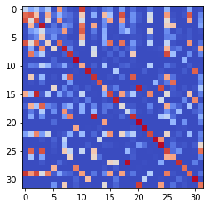

epoch 2111 == measurement_heuristic: 0.45+-0.01/0.38+-0.01 --

epoch 2112 == measurement_heuristic: 0.44+-0.01/0.40+-0.01 --

epoch 2113 == measurement_heuristic: 0.44+-0.01/0.38+-0.01 --

epoch 2114 == measurement_heuristic: 0.42+-0.01/0.40+-0.01 --

epoch 2115 == measurement_heuristic: 0.44+-0.01/0.39+-0.01 --

epoch 2116 == measurement_heuristic: 0.44+-0.01/0.39+-0.01 --

epoch 2117 == measurement_heuristic: 0.45+-0.01/0.38+-0.01 --

epoch 2118 == measurement_heuristic: 0.43+-0.01/0.38+-0.01 --

epoch 2119 == measurement_heuristic: 0.42+-0.01/0.41+-0.01 --

epoch 2120 == measurement_heuristic: 0.45+-0.02/0.38+-0.01 --

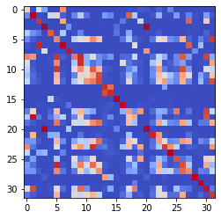

epoch 2121 == measurement_heuristic: 0.41+-0.01/0.39+-0.01 --

epoch 2122 == measurement_heuristic: 0.44+-0.01/0.38+-0.01 --

epoch 2123 == measurement_heuristic: 0.43+-0.01/0.38+-0.01 --

epoch 2124 >> measurement_heuristic: 0.42+-0.01/0.37+-0.01 --

epoch 2125 == measurement_heuristic: 0.44+-0.01/0.38+-0.01 --

epoch 2126 == measurement_heuristic: 0.43+-0.01/0.41+-0.01 --

epoch 2127 == measurement_heuristic: 0.44+-0.01/0.39+-0.01 --

epoch 2128 == measurement_heuristic: 0.44+-0.01/0.38+-0.01 --

epoch 2129 == measurement_heuristic: 0.43+-0.01/0.39+-0.01 --

epoch 2130 == measurement_heuristic: 0.43+-0.01/0.39+-0.01 --

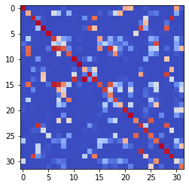

epoch 2131 == measurement_heuristic: 0.44+-0.01/0.38+-0.01 --

epoch 2132 == measurement_heuristic: 0.44+-0.01/0.37+-0.01 --

epoch 2133 == measurement_heuristic: 0.44+-0.01/0.39+-0.01 --

epoch 2134 == measurement_heuristic: 0.42+-0.01/0.38+-0.01 --

epoch 2135 == measurement_heuristic: 0.44+-0.01/0.37+-0.01 --

epoch 2136 == measurement_heuristic: 0.46+-0.02/0.38+-0.01 --

epoch 2137 == measurement_heuristic: 0.44+-0.01/0.38+-0.01 --

epoch 2138 == measurement_heuristic: 0.42+-0.01/0.39+-0.01 --

epoch 2139 == measurement_heuristic: 0.42+-0.01/0.38+-0.01 --

epoch 2140 == measurement_heuristic: 0.40+-0.01/0.38+-0.01 --

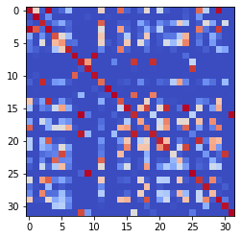

epoch 2141 == measurement_heuristic: 0.45+-0.01/0.38+-0.01 --

epoch 2142 == measurement_heuristic: 0.44+-0.01/0.37+-0.01 --

epoch 2143 == measurement_heuristic: 0.42+-0.01/0.38+-0.01 --

epoch 2144 == measurement_heuristic: 0.43+-0.01/0.38+-0.01 --

epoch 2145 == measurement_heuristic: 0.43+-0.01/0.37+-0.01 --

epoch 2146 == measurement_heuristic: 0.43+-0.01/0.39+-0.01 --

epoch 2147 == measurement_heuristic: 0.43+-0.01/0.38+-0.01 --

epoch 2148 == measurement_heuristic: 0.44+-0.01/0.38+-0.01 --

epoch 2149 == measurement_heuristic: 0.44+-0.01/0.38+-0.01 --

epoch 2150 == measurement_heuristic: 0.46+-0.01/0.38+-0.01 --

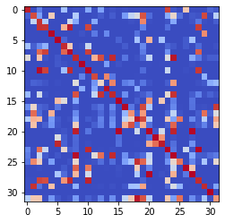

epoch 2151 == measurement_heuristic: 0.43+-0.01/0.38+-0.01 --

epoch 2152 == measurement_heuristic: 0.42+-0.01/0.37+-0.01 --

epoch 2153 == measurement_heuristic: 0.45+-0.01/0.38+-0.01 --

epoch 2154 == measurement_heuristic: 0.44+-0.01/0.39+-0.01 --

epoch 2155 == measurement_heuristic: 0.42+-0.01/0.38+-0.01 --

epoch 2156 == measurement_heuristic: 0.43+-0.01/0.39+-0.01 --

epoch 2157 == measurement_heuristic: 0.41+-0.01/0.37+-0.01 --

epoch 2158 == measurement_heuristic: 0.42+-0.01/0.40+-0.01 --

epoch 2159 == measurement_heuristic: 0.41+-0.01/0.38+-0.01 --

epoch 2160 == measurement_heuristic: 0.43+-0.01/0.37+-0.01 --

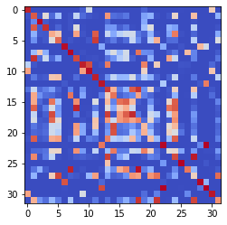

epoch 2161 == measurement_heuristic: 0.43+-0.01/0.39+-0.01 --

epoch 2162 == measurement_heuristic: 0.43+-0.01/0.37+-0.01 --

epoch 2163 == measurement_heuristic: 0.42+-0.01/0.37+-0.01 --

epoch 2164 == measurement_heuristic: 0.43+-0.01/0.39+-0.01 --

epoch 2165 == measurement_heuristic: 0.43+-0.01/0.38+-0.01 --

epoch 2166 == measurement_heuristic: 0.44+-0.01/0.38+-0.01 --

epoch 2167 == measurement_heuristic: 0.43+-0.01/0.38+-0.01 --

epoch 2168 == measurement_heuristic: 0.45+-0.01/0.39+-0.01 --

epoch 2169 == measurement_heuristic: 0.41+-0.01/0.39+-0.01 --

epoch 2170 >> measurement_heuristic: 0.43+-0.01/0.37+-0.01 --

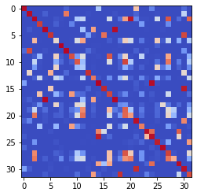

epoch 2171 == measurement_heuristic: 0.41+-0.01/0.37+-0.01 --

epoch 2172 == measurement_heuristic: 0.43+-0.01/0.39+-0.01 --

epoch 2173 == measurement_heuristic: 0.42+-0.01/0.38+-0.01 --

epoch 2174 == measurement_heuristic: 0.42+-0.01/0.39+-0.01 --

epoch 2175 == measurement_heuristic: 0.41+-0.01/0.39+-0.01 --

epoch 2176 == measurement_heuristic: 0.43+-0.01/0.37+-0.01 --

epoch 2177 == measurement_heuristic: 0.42+-0.01/0.37+-0.01 --

epoch 2178 == measurement_heuristic: 0.41+-0.01/0.37+-0.01 --

epoch 2179 == measurement_heuristic: 0.42+-0.01/0.38+-0.01 --

epoch 2180 == measurement_heuristic: 0.40+-0.01/0.37+-0.01 --

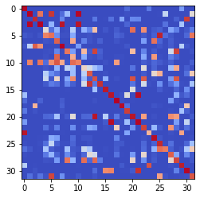

epoch 2181 == measurement_heuristic: 0.42+-0.01/0.37+-0.01 --

epoch 2182 == measurement_heuristic: 0.41+-0.01/0.37+-0.01 --

epoch 2183 == measurement_heuristic: 0.43+-0.01/0.37+-0.01 --

epoch 2184 == measurement_heuristic: 0.44+-0.01/0.38+-0.01 --

epoch 2185 == measurement_heuristic: 0.42+-0.01/0.37+-0.01 --

epoch 2186 == measurement_heuristic: 0.41+-0.01/0.37+-0.01 --

epoch 2187 == measurement_heuristic: 0.45+-0.01/0.39+-0.01 --

epoch 2188 == measurement_heuristic: 0.41+-0.01/0.37+-0.01 --

epoch 2189 == measurement_heuristic: 0.42+-0.01/0.38+-0.01 --

epoch 2190 == measurement_heuristic: 0.44+-0.01/0.38+-0.01 --

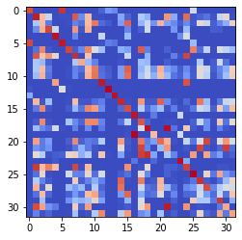

epoch 2191 == measurement_heuristic: 0.44+-0.01/0.37+-0.01 --

epoch 2192 == measurement_heuristic: 0.44+-0.01/0.37+-0.01 --

epoch 2193 == measurement_heuristic: 0.44+-0.01/0.37+-0.01 --

epoch 2194 == measurement_heuristic: 0.44+-0.01/0.38+-0.01 --

epoch 2195 == measurement_heuristic: 0.42+-0.01/0.37+-0.01 --

epoch 2196 == measurement_heuristic: 0.43+-0.01/0.38+-0.01 --

epoch 2197 == measurement_heuristic: 0.43+-0.01/0.38+-0.01 --

epoch 2198 == measurement_heuristic: 0.44+-0.01/0.38+-0.01 --

epoch 2199 == measurement_heuristic: 0.42+-0.01/0.37+-0.01 --

epoch 2200 == measurement_heuristic: 0.41+-0.01/0.38+-0.01 --

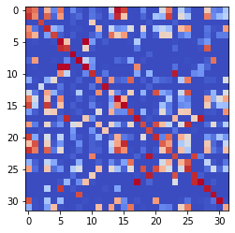

epoch 2201 == measurement_heuristic: 0.42+-0.01/0.37+-0.01 --

epoch 2202 == measurement_heuristic: 0.42+-0.01/0.38+-0.01 --

epoch 2203 == measurement_heuristic: 0.41+-0.01/0.42+-0.01 --

epoch 2204 == measurement_heuristic: 0.42+-0.01/0.37+-0.01 --

epoch 2205 == measurement_heuristic: 0.40+-0.01/0.37+-0.01 --

epoch 2206 == measurement_heuristic: 0.40+-0.01/0.38+-0.01 --

epoch 2207 == measurement_heuristic: 0.43+-0.01/0.39+-0.01 --

epoch 2208 == measurement_heuristic: 0.44+-0.01/0.38+-0.01 --

epoch 2209 == measurement_heuristic: 0.43+-0.01/0.38+-0.01 --

epoch 2210 >> measurement_heuristic: 0.42+-0.01/0.36+-0.01 --

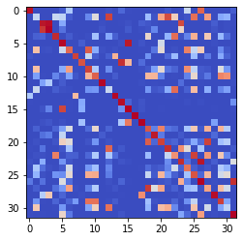

epoch 2211 == measurement_heuristic: 0.42+-0.01/0.37+-0.01 --

epoch 2212 == measurement_heuristic: 0.43+-0.01/0.37+-0.01 --

epoch 2213 == measurement_heuristic: 0.41+-0.01/0.37+-0.01 --

epoch 2214 == measurement_heuristic: 0.44+-0.01/0.37+-0.01 --

epoch 2215 == measurement_heuristic: 0.43+-0.01/0.39+-0.01 --

epoch 2216 >> measurement_heuristic: 0.42+-0.01/0.36+-0.01 --

epoch 2217 == measurement_heuristic: 0.43+-0.01/0.37+-0.01 --

epoch 2218 == measurement_heuristic: 0.44+-0.01/0.37+-0.01 --

epoch 2219 == measurement_heuristic: 0.41+-0.01/0.37+-0.01 --

epoch 2220 == measurement_heuristic: 0.42+-0.01/0.38+-0.01 --

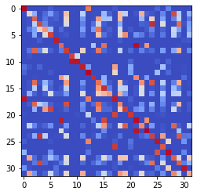

epoch 2221 == measurement_heuristic: 0.42+-0.01/0.38+-0.01 --

epoch 2222 == measurement_heuristic: 0.41+-0.01/0.38+-0.01 --

epoch 2223 == measurement_heuristic: 0.43+-0.01/0.41+-0.01 --

epoch 2224 == measurement_heuristic: 0.42+-0.01/0.38+-0.01 --

epoch 2225 == measurement_heuristic: 0.42+-0.01/0.38+-0.01 --

epoch 2226 == measurement_heuristic: 0.42+-0.01/0.38+-0.01 --

epoch 2227 == measurement_heuristic: 0.42+-0.01/0.37+-0.01 --

epoch 2228 == measurement_heuristic: 0.44+-0.01/0.37+-0.01 --

epoch 2229 == measurement_heuristic: 0.43+-0.01/0.37+-0.01 --

epoch 2230 == measurement_heuristic: 0.42+-0.01/0.38+-0.01 --

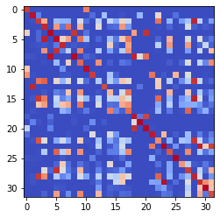

epoch 2231 == measurement_heuristic: 0.42+-0.01/0.39+-0.01 --

epoch 2232 == measurement_heuristic: 0.44+-0.01/0.37+-0.01 --

epoch 2233 == measurement_heuristic: 0.42+-0.01/0.37+-0.01 --

epoch 2234 == measurement_heuristic: 0.42+-0.01/0.37+-0.01 --

epoch 2235 == measurement_heuristic: 0.41+-0.01/0.37+-0.01 --

epoch 2236 == measurement_heuristic: 0.43+-0.01/0.38+-0.01 --

epoch 2237 == measurement_heuristic: 0.42+-0.01/0.37+-0.01 --

epoch 2238 == measurement_heuristic: 0.41+-0.01/0.39+-0.01 --

epoch 2239 == measurement_heuristic: 0.41+-0.01/0.37+-0.01 --

epoch 2240 == measurement_heuristic: 0.42+-0.01/0.38+-0.01 --

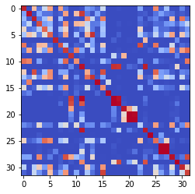

epoch 2241 == measurement_heuristic: 0.40+-0.01/0.36+-0.01 --

epoch 2242 == measurement_heuristic: 0.40+-0.01/0.38+-0.01 --

epoch 2243 == measurement_heuristic: 0.42+-0.01/0.38+-0.01 --

epoch 2244 == measurement_heuristic: 0.41+-0.01/0.37+-0.01 --

epoch 2245 == measurement_heuristic: 0.42+-0.01/0.38+-0.01 --

epoch 2246 == measurement_heuristic: 0.41+-0.01/0.38+-0.01 --

epoch 2247 == measurement_heuristic: 0.41+-0.01/0.37+-0.01 --

epoch 2248 == measurement_heuristic: 0.44+-0.01/0.39+-0.01 --

epoch 2249 == measurement_heuristic: 0.42+-0.01/0.38+-0.01 --

epoch 2250 == measurement_heuristic: 0.42+-0.01/0.37+-0.01 --

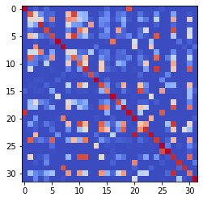

epoch 2251 == measurement_heuristic: 0.43+-0.01/0.39+-0.01 --

epoch 2252 == measurement_heuristic: 0.44+-0.01/0.38+-0.01 --

epoch 2253 == measurement_heuristic: 0.41+-0.01/0.37+-0.01 --

epoch 2254 == measurement_heuristic: 0.43+-0.01/0.38+-0.01 --

epoch 2255 == measurement_heuristic: 0.43+-0.01/0.38+-0.01 --

epoch 2256 == measurement_heuristic: 0.45+-0.01/0.39+-0.01 --

epoch 2257 == measurement_heuristic: 0.42+-0.01/0.37+-0.01 --

epoch 2258 == measurement_heuristic: 0.43+-0.01/0.36+-0.01 --

epoch 2259 == measurement_heuristic: 0.43+-0.01/0.37+-0.01 --

epoch 2260 == measurement_heuristic: 0.42+-0.01/0.36+-0.01 --

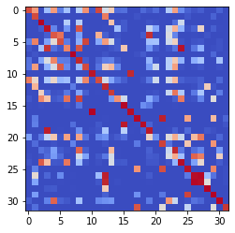

epoch 2261 == measurement_heuristic: 0.42+-0.01/0.38+-0.01 --

epoch 2262 == measurement_heuristic: 0.44+-0.01/0.39+-0.01 --

epoch 2263 >> measurement_heuristic: 0.43+-0.01/0.36+-0.01 --

epoch 2264 == measurement_heuristic: 0.40+-0.01/0.37+-0.01 --

epoch 2265 == measurement_heuristic: 0.41+-0.01/0.37+-0.01 --

epoch 2266 == measurement_heuristic: 0.41+-0.01/0.38+-0.01 --

epoch 2267 == measurement_heuristic: 0.41+-0.01/0.37+-0.01 --

epoch 2268 == measurement_heuristic: 0.42+-0.01/0.37+-0.01 --

epoch 2269 == measurement_heuristic: 0.41+-0.01/0.37+-0.01 --

epoch 2270 == measurement_heuristic: 0.43+-0.01/0.37+-0.01 --

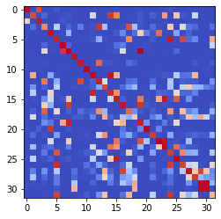

epoch 2271 == measurement_heuristic: 0.45+-0.01/0.38+-0.01 --

epoch 2272 == measurement_heuristic: 0.45+-0.01/0.37+-0.01 --

epoch 2273 == measurement_heuristic: 0.40+-0.01/0.37+-0.01 --

epoch 2274 == measurement_heuristic: 0.41+-0.01/0.36+-0.01 --

epoch 2275 == measurement_heuristic: 0.41+-0.01/0.36+-0.01 --

epoch 2276 == measurement_heuristic: 0.41+-0.01/0.37+-0.01 --

epoch 2277 == measurement_heuristic: 0.43+-0.01/0.38+-0.01 --

epoch 2278 >> measurement_heuristic: 0.42+-0.01/0.36+-0.01 --

epoch 2279 == measurement_heuristic: 0.44+-0.01/0.37+-0.01 --

epoch 2280 == measurement_heuristic: 0.41+-0.01/0.37+-0.01 --

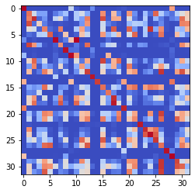

epoch 2281 == measurement_heuristic: 0.42+-0.01/0.36+-0.01 --

epoch 2282 == measurement_heuristic: 0.42+-0.01/0.37+-0.01 --

epoch 2283 == measurement_heuristic: 0.43+-0.01/0.37+-0.01 --

epoch 2284 == measurement_heuristic: 0.43+-0.01/0.36+-0.01 --

epoch 2285 == measurement_heuristic: 0.43+-0.01/0.36+-0.01 --

epoch 2286 == measurement_heuristic: 0.41+-0.01/0.38+-0.01 --

epoch 2287 == measurement_heuristic: 0.40+-0.01/0.38+-0.01 --

epoch 2288 == measurement_heuristic: 0.43+-0.01/0.37+-0.01 --

epoch 2289 == measurement_heuristic: 0.41+-0.01/0.37+-0.01 --

epoch 2290 == measurement_heuristic: 0.42+-0.01/0.37+-0.01 --

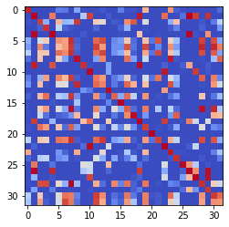

epoch 2291 == measurement_heuristic: 0.42+-0.01/0.38+-0.01 --

epoch 2292 == measurement_heuristic: 0.43+-0.01/0.37+-0.01 --

epoch 2293 == measurement_heuristic: 0.46+-0.01/0.37+-0.01 --

epoch 2294 == measurement_heuristic: 0.41+-0.01/0.36+-0.01 --

epoch 2295 == measurement_heuristic: 0.39+-0.01/0.37+-0.01 --

epoch 2296 == measurement_heuristic: 0.46+-0.01/0.38+-0.01 --

epoch 2297 == measurement_heuristic: 0.42+-0.01/0.37+-0.01 --

epoch 2298 == measurement_heuristic: 0.40+-0.01/0.37+-0.01 --

epoch 2299 == measurement_heuristic: 0.40+-0.01/0.37+-0.01 --

epoch 2300 == measurement_heuristic: 0.43+-0.01/0.37+-0.01 --

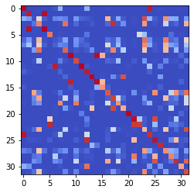

epoch 2301 == measurement_heuristic: 0.43+-0.01/0.37+-0.01 --

epoch 2302 == measurement_heuristic: 0.41+-0.01/0.37+-0.01 --

epoch 2303 == measurement_heuristic: 0.43+-0.01/0.37+-0.01 --

epoch 2304 == measurement_heuristic: 0.43+-0.01/0.36+-0.01 --

epoch 2305 == measurement_heuristic: 0.43+-0.01/0.38+-0.01 --

epoch 2306 == measurement_heuristic: 0.41+-0.01/0.37+-0.01 --

epoch 2307 == measurement_heuristic: 0.42+-0.01/0.37+-0.01 --

epoch 2308 == measurement_heuristic: 0.41+-0.01/0.37+-0.01 --

epoch 2309 == measurement_heuristic: 0.42+-0.01/0.38+-0.01 --

epoch 2310 == measurement_heuristic: 0.43+-0.01/0.36+-0.01 --

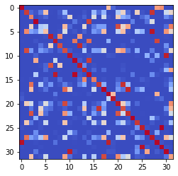

epoch 2311 == measurement_heuristic: 0.40+-0.01/0.37+-0.01 --

epoch 2312 == measurement_heuristic: 0.41+-0.01/0.37+-0.01 --

epoch 2313 == measurement_heuristic: 0.42+-0.01/0.37+-0.01 --

epoch 2314 == measurement_heuristic: 0.42+-0.01/0.36+-0.01 --

epoch 2315 == measurement_heuristic: 0.42+-0.01/0.36+-0.01 --

epoch 2316 == measurement_heuristic: 0.41+-0.01/0.37+-0.01 --

epoch 2317 == measurement_heuristic: 0.41+-0.01/0.36+-0.01 --

epoch 2318 == measurement_heuristic: 0.41+-0.01/0.36+-0.01 --

epoch 2319 == measurement_heuristic: 0.44+-0.01/0.37+-0.01 --

epoch 2320 == measurement_heuristic: 0.42+-0.01/0.38+-0.01 --

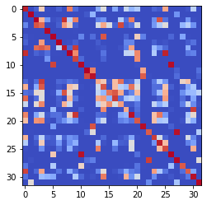

epoch 2321 == measurement_heuristic: 0.42+-0.01/0.37+-0.01 --

epoch 2322 == measurement_heuristic: 0.41+-0.01/0.37+-0.01 --

epoch 2323 >> measurement_heuristic: 0.40+-0.01/0.35+-0.01 --

epoch 2324 == measurement_heuristic: 0.40+-0.01/0.36+-0.01 --

epoch 2325 == measurement_heuristic: 0.41+-0.01/0.38+-0.01 --

epoch 2326 == measurement_heuristic: 0.43+-0.01/0.39+-0.01 --

epoch 2327 == measurement_heuristic: 0.42+-0.01/0.35+-0.01 --

epoch 2328 >> measurement_heuristic: 0.40+-0.01/0.35+-0.01 --

epoch 2329 == measurement_heuristic: 0.42+-0.01/0.35+-0.01 --

epoch 2330 == measurement_heuristic: 0.43+-0.01/0.37+-0.01 --

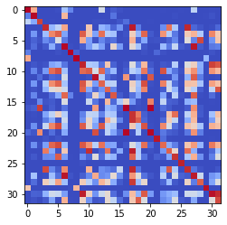

epoch 2331 == measurement_heuristic: 0.41+-0.01/0.37+-0.01 --

epoch 2332 == measurement_heuristic: 0.41+-0.01/0.36+-0.01 --

epoch 2333 == measurement_heuristic: 0.42+-0.01/0.36+-0.01 --

epoch 2334 == measurement_heuristic: 0.41+-0.01/0.36+-0.01 --

epoch 2335 == measurement_heuristic: 0.42+-0.01/0.37+-0.01 --

epoch 2336 == measurement_heuristic: 0.41+-0.01/0.35+-0.01 --

epoch 2337 == measurement_heuristic: 0.40+-0.01/0.37+-0.01 --

epoch 2338 == measurement_heuristic: 0.41+-0.01/0.36+-0.01 --

epoch 2339 == measurement_heuristic: 0.40+-0.01/0.36+-0.01 --

epoch 2340 == measurement_heuristic: 0.45+-0.01/0.36+-0.01 --

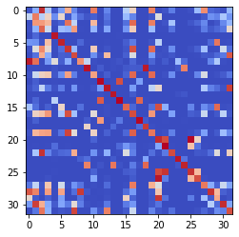

epoch 2341 == measurement_heuristic: 0.42+-0.01/0.36+-0.01 --

epoch 2342 == measurement_heuristic: 0.40+-0.01/0.36+-0.01 --

epoch 2343 == measurement_heuristic: 0.43+-0.01/0.36+-0.01 --

epoch 2344 == measurement_heuristic: 0.42+-0.01/0.35+-0.01 --

epoch 2345 == measurement_heuristic: 0.41+-0.01/0.37+-0.01 --

epoch 2346 == measurement_heuristic: 0.42+-0.01/0.37+-0.01 --

epoch 2347 == measurement_heuristic: 0.43+-0.01/0.36+-0.01 --

epoch 2348 == measurement_heuristic: 0.41+-0.01/0.37+-0.01 --

epoch 2349 == measurement_heuristic: 0.43+-0.01/0.37+-0.01 --

epoch 2350 == measurement_heuristic: 0.41+-0.01/0.36+-0.01 --

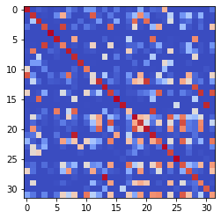

epoch 2351 == measurement_heuristic: 0.39+-0.01/0.37+-0.01 --

epoch 2352 == measurement_heuristic: 0.41+-0.01/0.38+-0.01 --

epoch 2353 == measurement_heuristic: 0.40+-0.01/0.36+-0.01 --

epoch 2354 == measurement_heuristic: 0.43+-0.01/0.36+-0.01 --

epoch 2355 == measurement_heuristic: 0.41+-0.01/0.36+-0.01 --

epoch 2356 == measurement_heuristic: 0.43+-0.01/0.39+-0.01 --

epoch 2357 == measurement_heuristic: 0.43+-0.01/0.36+-0.01 --

epoch 2358 == measurement_heuristic: 0.43+-0.02/0.37+-0.01 --

epoch 2359 == measurement_heuristic: 0.40+-0.01/0.36+-0.01 --

epoch 2360 == measurement_heuristic: 0.41+-0.01/0.36+-0.01 --

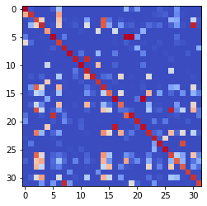

epoch 2361 == measurement_heuristic: 0.39+-0.01/0.37+-0.01 --

epoch 2362 == measurement_heuristic: 0.40+-0.01/0.37+-0.01 --

epoch 2363 == measurement_heuristic: 0.41+-0.01/0.37+-0.01 --

epoch 2364 == measurement_heuristic: 0.44+-0.01/0.36+-0.01 --

epoch 2365 == measurement_heuristic: 0.41+-0.01/0.37+-0.01 --

epoch 2366 == measurement_heuristic: 0.42+-0.01/0.40+-0.01 --

epoch 2367 == measurement_heuristic: 0.41+-0.01/0.36+-0.01 --

epoch 2368 == measurement_heuristic: 0.43+-0.01/0.37+-0.01 --

epoch 2369 == measurement_heuristic: 0.40+-0.01/0.36+-0.01 --

epoch 2370 == measurement_heuristic: 0.40+-0.01/0.36+-0.01 --

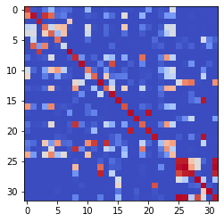

epoch 2371 == measurement_heuristic: 0.43+-0.01/0.38+-0.01 --

epoch 2372 == measurement_heuristic: 0.40+-0.01/0.36+-0.01 --

epoch 2373 == measurement_heuristic: 0.42+-0.01/0.37+-0.01 --

epoch 2374 == measurement_heuristic: 0.41+-0.01/0.37+-0.01 --

epoch 2375 == measurement_heuristic: 0.42+-0.01/0.36+-0.01 --

epoch 2376 == measurement_heuristic: 0.42+-0.01/0.39+-0.01 --

epoch 2377 == measurement_heuristic: 0.43+-0.01/0.37+-0.01 --

epoch 2378 == measurement_heuristic: 0.41+-0.01/0.36+-0.01 --

epoch 2379 == measurement_heuristic: 0.42+-0.01/0.37+-0.01 --

epoch 2380 == measurement_heuristic: 0.42+-0.01/0.37+-0.01 --

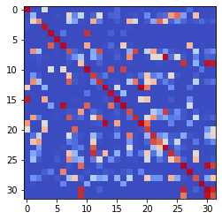

epoch 2381 == measurement_heuristic: 0.40+-0.01/0.39+-0.01 --

epoch 2382 == measurement_heuristic: 0.41+-0.01/0.37+-0.01 --

epoch 2383 == measurement_heuristic: 0.42+-0.01/0.36+-0.01 --

epoch 2384 == measurement_heuristic: 0.41+-0.01/0.37+-0.01 --

epoch 2385 == measurement_heuristic: 0.41+-0.01/0.38+-0.01 --

epoch 2386 == measurement_heuristic: 0.41+-0.01/0.36+-0.01 --

epoch 2387 == measurement_heuristic: 0.41+-0.01/0.37+-0.01 --

epoch 2388 == measurement_heuristic: 0.42+-0.01/0.36+-0.01 --

epoch 2389 == measurement_heuristic: 0.43+-0.01/0.37+-0.01 --

epoch 2390 == measurement_heuristic: 0.39+-0.01/0.36+-0.01 --

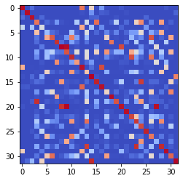

epoch 2391 == measurement_heuristic: 0.41+-0.01/0.36+-0.01 --

epoch 2392 == measurement_heuristic: 0.41+-0.01/0.37+-0.01 --

epoch 2393 == measurement_heuristic: 0.41+-0.01/0.36+-0.01 --

epoch 2394 == measurement_heuristic: 0.40+-0.01/0.37+-0.01 --

epoch 2395 == measurement_heuristic: 0.42+-0.01/0.41+-0.01 --

epoch 2396 == measurement_heuristic: 0.42+-0.01/0.38+-0.01 --

epoch 2397 == measurement_heuristic: 0.42+-0.01/0.37+-0.01 --

epoch 2398 == measurement_heuristic: 0.41+-0.01/0.36+-0.01 --

epoch 2399 == measurement_heuristic: 0.43+-0.01/0.37+-0.01 --

epoch 2400 == measurement_heuristic: 0.42+-0.01/0.37+-0.01 --

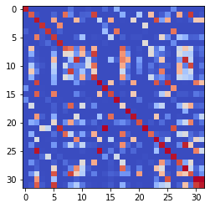

epoch 2401 == measurement_heuristic: 0.42+-0.01/0.36+-0.01 --

epoch 2402 == measurement_heuristic: 0.43+-0.01/0.36+-0.01 --

epoch 2403 == measurement_heuristic: 0.41+-0.01/0.37+-0.01 --

epoch 2404 == measurement_heuristic: 0.41+-0.01/0.38+-0.01 --

epoch 2405 == measurement_heuristic: 0.40+-0.01/0.36+-0.01 --

epoch 2406 == measurement_heuristic: 0.42+-0.01/0.35+-0.01 --

epoch 2407 == measurement_heuristic: 0.42+-0.01/0.37+-0.01 --

epoch 2408 == measurement_heuristic: 0.41+-0.01/0.37+-0.01 --

epoch 2409 == measurement_heuristic: 0.42+-0.01/0.37+-0.01 --

epoch 2410 == measurement_heuristic: 0.41+-0.01/0.37+-0.01 --

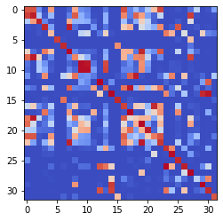

epoch 2411 == measurement_heuristic: 0.43+-0.01/0.38+-0.01 --

epoch 2412 == measurement_heuristic: 0.42+-0.01/0.37+-0.01 --

epoch 2413 == measurement_heuristic: 0.42+-0.01/0.36+-0.01 --

epoch 2414 == measurement_heuristic: 0.42+-0.01/0.39+-0.01 --

epoch 2415 == measurement_heuristic: 0.40+-0.01/0.36+-0.01 --

epoch 2416 == measurement_heuristic: 0.44+-0.01/0.36+-0.01 --

epoch 2417 == measurement_heuristic: 0.40+-0.01/0.36+-0.01 --

epoch 2418 == measurement_heuristic: 0.41+-0.01/0.36+-0.01 --

epoch 2419 == measurement_heuristic: 0.41+-0.01/0.35+-0.01 --

epoch 2420 == measurement_heuristic: 0.39+-0.01/0.36+-0.01 --

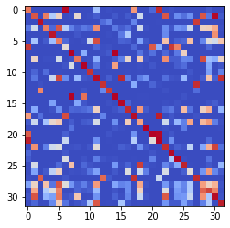

epoch 2421 == measurement_heuristic: 0.41+-0.01/0.38+-0.01 --

epoch 2422 == measurement_heuristic: 0.42+-0.01/0.35+-0.01 --

epoch 2423 == measurement_heuristic: 0.41+-0.01/0.37+-0.01 --

epoch 2424 == measurement_heuristic: 0.40+-0.01/0.36+-0.01 --

epoch 2425 == measurement_heuristic: 0.42+-0.01/0.38+-0.01 --

epoch 2426 == measurement_heuristic: 0.41+-0.01/0.36+-0.01 --

epoch 2427 == measurement_heuristic: 0.44+-0.01/0.37+-0.01 --

epoch 2428 == measurement_heuristic: 0.43+-0.01/0.36+-0.01 --

epoch 2429 == measurement_heuristic: 0.42+-0.01/0.36+-0.01 --

epoch 2430 == measurement_heuristic: 0.43+-0.01/0.37+-0.01 --

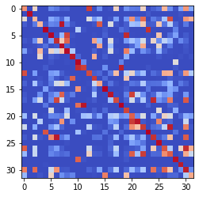

epoch 2431 == measurement_heuristic: 0.44+-0.01/0.37+-0.01 --

epoch 2432 == measurement_heuristic: 0.43+-0.01/0.36+-0.01 --

epoch 2433 == measurement_heuristic: 0.42+-0.01/0.36+-0.01 --

epoch 2434 == measurement_heuristic: 0.40+-0.01/0.36+-0.01 --

epoch 2435 == measurement_heuristic: 0.42+-0.01/0.36+-0.01 --

epoch 2436 == measurement_heuristic: 0.41+-0.01/0.38+-0.01 --

epoch 2437 == measurement_heuristic: 0.41+-0.01/0.35+-0.01 --

epoch 2438 == measurement_heuristic: 0.42+-0.01/0.36+-0.01 --

epoch 2439 == measurement_heuristic: 0.42+-0.01/0.38+-0.01 --

epoch 2440 == measurement_heuristic: 0.41+-0.01/0.36+-0.01 --

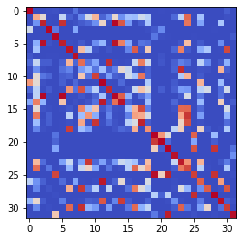

epoch 2441 == measurement_heuristic: 0.41+-0.01/0.36+-0.01 --

epoch 2442 == measurement_heuristic: 0.42+-0.01/0.37+-0.01 --

epoch 2443 == measurement_heuristic: 0.42+-0.01/0.36+-0.01 --

epoch 2444 == measurement_heuristic: 0.39+-0.01/0.36+-0.01 --

epoch 2445 == measurement_heuristic: 0.40+-0.01/0.36+-0.01 --

epoch 2446 == measurement_heuristic: 0.39+-0.01/0.36+-0.01 --

epoch 2447 == measurement_heuristic: 0.42+-0.01/0.38+-0.01 --

epoch 2448 == measurement_heuristic: 0.41+-0.01/0.38+-0.01 --

epoch 2449 == measurement_heuristic: 0.42+-0.01/0.37+-0.01 --

epoch 2450 == measurement_heuristic: 0.40+-0.01/0.36+-0.01 --

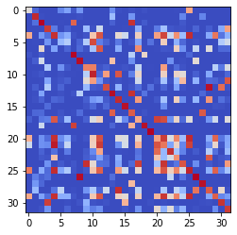

epoch 2451 == measurement_heuristic: 0.41+-0.01/0.36+-0.01 --

epoch 2452 == measurement_heuristic: 0.40+-0.01/0.38+-0.01 --

epoch 2453 == measurement_heuristic: 0.41+-0.01/0.36+-0.01 --

epoch 2454 == measurement_heuristic: 0.41+-0.01/0.37+-0.01 --

epoch 2455 == measurement_heuristic: 0.42+-0.01/0.36+-0.01 --

epoch 2456 == measurement_heuristic: 0.38+-0.01/0.36+-0.01 --

epoch 2457 == measurement_heuristic: 0.39+-0.01/0.36+-0.01 --

epoch 2458 == measurement_heuristic: 0.41+-0.01/0.36+-0.01 --

epoch 2459 == measurement_heuristic: 0.42+-0.01/0.36+-0.01 --

epoch 2460 == measurement_heuristic: 0.40+-0.01/0.37+-0.01 --

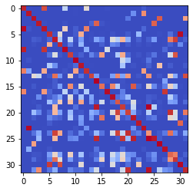

epoch 2461 == measurement_heuristic: 0.39+-0.01/0.35+-0.01 --

epoch 2462 == measurement_heuristic: 0.41+-0.01/0.36+-0.01 --

epoch 2463 == measurement_heuristic: 0.42+-0.01/0.36+-0.01 --

epoch 2464 >> measurement_heuristic: 0.40+-0.01/0.35+-0.01 --

epoch 2465 == measurement_heuristic: 0.40+-0.01/0.36+-0.01 --

epoch 2466 == measurement_heuristic: 0.41+-0.01/0.36+-0.01 --

epoch 2467 == measurement_heuristic: 0.44+-0.01/0.35+-0.01 --

epoch 2468 == measurement_heuristic: 0.45+-0.01/0.36+-0.01 --

epoch 2469 == measurement_heuristic: 0.41+-0.01/0.37+-0.01 --

epoch 2470 == measurement_heuristic: 0.44+-0.01/0.37+-0.01 --

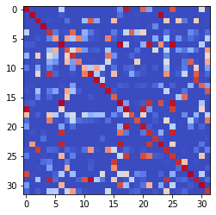

epoch 2471 == measurement_heuristic: 0.40+-0.01/0.38+-0.01 --

epoch 2472 == measurement_heuristic: 0.41+-0.01/0.37+-0.01 --

epoch 2473 == measurement_heuristic: 0.41+-0.01/0.36+-0.01 --

epoch 2474 == measurement_heuristic: 0.40+-0.01/0.36+-0.01 --

epoch 2475 == measurement_heuristic: 0.39+-0.01/0.35+-0.01 --

epoch 2476 == measurement_heuristic: 0.42+-0.01/0.36+-0.01 --

epoch 2477 >> measurement_heuristic: 0.42+-0.01/0.35+-0.01 --

epoch 2478 == measurement_heuristic: 0.42+-0.01/0.36+-0.01 --

epoch 2479 == measurement_heuristic: 0.41+-0.01/0.36+-0.01 --

epoch 2480 == measurement_heuristic: 0.42+-0.01/0.36+-0.01 --

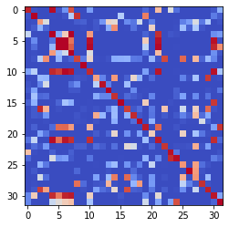

epoch 2481 == measurement_heuristic: 0.41+-0.01/0.35+-0.01 --

epoch 2482 == measurement_heuristic: 0.41+-0.01/0.38+-0.01 --

epoch 2483 == measurement_heuristic: 0.40+-0.01/0.35+-0.01 --

epoch 2484 == measurement_heuristic: 0.41+-0.01/0.35+-0.01 --

epoch 2485 == measurement_heuristic: 0.39+-0.01/0.36+-0.01 --

epoch 2486 == measurement_heuristic: 0.41+-0.01/0.37+-0.01 --

epoch 2487 == measurement_heuristic: 0.41+-0.01/0.36+-0.01 --

epoch 2488 == measurement_heuristic: 0.42+-0.01/0.37+-0.01 --

epoch 2489 == measurement_heuristic: 0.41+-0.01/0.35+-0.01 --

epoch 2490 == measurement_heuristic: 0.40+-0.01/0.36+-0.01 --

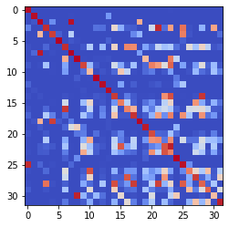

epoch 2491 == measurement_heuristic: 0.41+-0.01/0.35+-0.01 --

epoch 2492 == measurement_heuristic: 0.41+-0.01/0.37+-0.01 --

epoch 2493 == measurement_heuristic: 0.42+-0.01/0.36+-0.01 --

epoch 2494 == measurement_heuristic: 0.42+-0.01/0.35+-0.01 --

epoch 2495 == measurement_heuristic: 0.42+-0.01/0.37+-0.01 --

epoch 2496 == measurement_heuristic: 0.41+-0.01/0.36+-0.01 --

epoch 2497 == measurement_heuristic: 0.41+-0.01/0.37+-0.01 --

epoch 2498 == measurement_heuristic: 0.42+-0.01/0.35+-0.01 --

epoch 2499 >> measurement_heuristic: 0.39+-0.01/0.35+-0.01 --

epoch 2500 == measurement_heuristic: 0.40+-0.01/0.35+-0.01 --

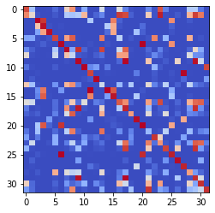

epoch 2501 == measurement_heuristic: 0.41+-0.01/0.36+-0.01 --

epoch 2502 == measurement_heuristic: 0.41+-0.01/0.35+-0.01 --

epoch 2503 == measurement_heuristic: 0.41+-0.01/0.36+-0.01 --

epoch 2504 == measurement_heuristic: 0.42+-0.01/0.35+-0.01 --

epoch 2505 == measurement_heuristic: 0.43+-0.01/0.36+-0.01 --

epoch 2506 == measurement_heuristic: 0.42+-0.01/0.36+-0.01 --

epoch 2507 == measurement_heuristic: 0.41+-0.01/0.35+-0.01 --

epoch 2508 == measurement_heuristic: 0.41+-0.01/0.35+-0.01 --

epoch 2509 == measurement_heuristic: 0.38+-0.01/0.36+-0.01 --

epoch 2510 == measurement_heuristic: 0.38+-0.01/0.37+-0.01 --

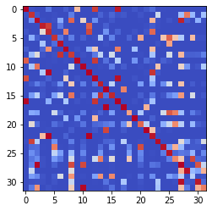

epoch 2511 == measurement_heuristic: 0.41+-0.01/0.36+-0.01 --

epoch 2512 == measurement_heuristic: 0.41+-0.01/0.36+-0.01 --

epoch 2513 == measurement_heuristic: 0.41+-0.01/0.36+-0.01 --

epoch 2514 == measurement_heuristic: 0.39+-0.01/0.36+-0.01 --

epoch 2515 == measurement_heuristic: 0.40+-0.01/0.36+-0.01 --

epoch 2516 == measurement_heuristic: 0.40+-0.01/0.38+-0.01 --

epoch 2517 == measurement_heuristic: 0.43+-0.01/0.36+-0.01 --

epoch 2518 == measurement_heuristic: 0.43+-0.01/0.36+-0.01 --

epoch 2519 == measurement_heuristic: 0.41+-0.01/0.36+-0.01 --

epoch 2520 == measurement_heuristic: 0.41+-0.01/0.37+-0.01 --

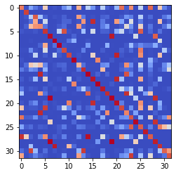

epoch 2521 == measurement_heuristic: 0.40+-0.01/0.36+-0.01 --

epoch 2522 == measurement_heuristic: 0.40+-0.01/0.37+-0.01 --

epoch 2523 == measurement_heuristic: 0.42+-0.01/0.36+-0.01 --

epoch 2524 == measurement_heuristic: 0.43+-0.01/0.35+-0.01 --

epoch 2525 == measurement_heuristic: 0.42+-0.01/0.36+-0.01 --

epoch 2526 == measurement_heuristic: 0.43+-0.01/0.36+-0.01 --

epoch 2527 == measurement_heuristic: 0.40+-0.01/0.37+-0.01 --

epoch 2528 == measurement_heuristic: 0.40+-0.01/0.35+-0.01 --

epoch 2529 == measurement_heuristic: 0.43+-0.01/0.36+-0.01 --

epoch 2530 == measurement_heuristic: 0.42+-0.01/0.36+-0.01 --

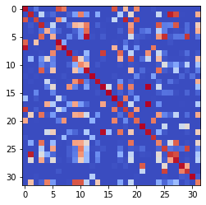

epoch 2531 == measurement_heuristic: 0.40+-0.01/0.36+-0.01 --

epoch 2532 == measurement_heuristic: 0.40+-0.01/0.35+-0.01 --

epoch 2533 == measurement_heuristic: 0.40+-0.01/0.35+-0.01 --

epoch 2534 == measurement_heuristic: 0.42+-0.01/0.36+-0.01 --

epoch 2535 == measurement_heuristic: 0.40+-0.01/0.36+-0.01 --

epoch 2536 == measurement_heuristic: 0.42+-0.01/0.35+-0.01 --

epoch 2537 == measurement_heuristic: 0.39+-0.01/0.35+-0.01 --

epoch 2538 == measurement_heuristic: 0.42+-0.01/0.35+-0.01 --

epoch 2539 == measurement_heuristic: 0.42+-0.01/0.38+-0.01 --

epoch 2540 == measurement_heuristic: 0.40+-0.01/0.36+-0.01 --

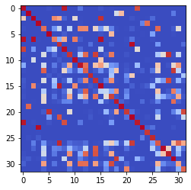

epoch 2541 == measurement_heuristic: 0.40+-0.01/0.37+-0.01 --

epoch 2542 >> measurement_heuristic: 0.41+-0.01/0.35+-0.01 --

epoch 2543 == measurement_heuristic: 0.41+-0.01/0.37+-0.01 --

epoch 2544 == measurement_heuristic: 0.42+-0.01/0.36+-0.01 --

epoch 2545 == measurement_heuristic: 0.39+-0.01/0.35+-0.01 --

epoch 2546 == measurement_heuristic: 0.43+-0.01/0.42+-0.01 --

epoch 2547 == measurement_heuristic: 0.42+-0.01/0.36+-0.01 --

epoch 2548 == measurement_heuristic: 0.40+-0.01/0.36+-0.01 --

epoch 2549 == measurement_heuristic: 0.40+-0.01/0.35+-0.01 --

epoch 2550 == measurement_heuristic: 0.41+-0.01/0.36+-0.01 --

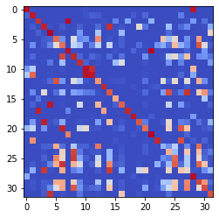

epoch 2551 == measurement_heuristic: 0.39+-0.01/0.37+-0.01 --

epoch 2552 == measurement_heuristic: 0.43+-0.01/0.36+-0.01 --

epoch 2553 == measurement_heuristic: 0.41+-0.01/0.36+-0.01 --

epoch 2554 == measurement_heuristic: 0.41+-0.01/0.36+-0.01 --

epoch 2555 == measurement_heuristic: 0.40+-0.01/0.36+-0.01 --

epoch 2556 == measurement_heuristic: 0.42+-0.01/0.36+-0.01 --

epoch 2557 == measurement_heuristic: 0.40+-0.01/0.35+-0.01 --

epoch 2558 == measurement_heuristic: 0.39+-0.01/0.35+-0.01 --

epoch 2559 == measurement_heuristic: 0.41+-0.01/0.37+-0.01 --

epoch 2560 == measurement_heuristic: 0.39+-0.01/0.35+-0.01 --

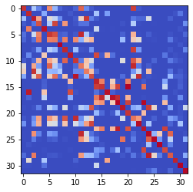

epoch 2561 == measurement_heuristic: 0.39+-0.01/0.36+-0.01 --

epoch 2562 == measurement_heuristic: 0.39+-0.01/0.36+-0.01 --

epoch 2563 == measurement_heuristic: 0.42+-0.01/0.36+-0.01 --

epoch 2564 == measurement_heuristic: 0.41+-0.01/0.36+-0.01 --

epoch 2565 == measurement_heuristic: 0.42+-0.01/0.36+-0.01 --

epoch 2566 == measurement_heuristic: 0.42+-0.01/0.36+-0.01 --

epoch 2567 == measurement_heuristic: 0.41+-0.01/0.37+-0.01 --

epoch 2568 == measurement_heuristic: 0.40+-0.01/0.35+-0.01 --

epoch 2569 == measurement_heuristic: 0.42+-0.01/0.36+-0.01 --

epoch 2570 == measurement_heuristic: 0.41+-0.01/0.38+-0.01 --

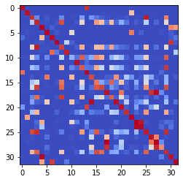

epoch 2571 == measurement_heuristic: 0.44+-0.01/0.38+-0.01 --

epoch 2572 == measurement_heuristic: 0.40+-0.01/0.36+-0.01 --

epoch 2573 == measurement_heuristic: 0.44+-0.01/0.36+-0.01 --

epoch 2574 == measurement_heuristic: 0.39+-0.01/0.36+-0.01 --

epoch 2575 == measurement_heuristic: 0.41+-0.01/0.36+-0.01 --

epoch 2576 == measurement_heuristic: 0.42+-0.01/0.36+-0.01 --

epoch 2577 == measurement_heuristic: 0.40+-0.01/0.36+-0.01 --

epoch 2578 == measurement_heuristic: 0.42+-0.01/0.39+-0.01 --

epoch 2579 == measurement_heuristic: 0.39+-0.01/0.35+-0.01 --

epoch 2580 == measurement_heuristic: 0.42+-0.01/0.36+-0.01 --

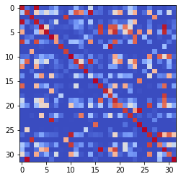

epoch 2581 == measurement_heuristic: 0.38+-0.01/0.36+-0.01 --

epoch 2582 == measurement_heuristic: 0.40+-0.01/0.37+-0.01 --

epoch 2583 == measurement_heuristic: 0.40+-0.01/0.36+-0.01 --

epoch 2584 == measurement_heuristic: 0.41+-0.01/0.37+-0.01 --

epoch 2585 == measurement_heuristic: 0.41+-0.01/0.37+-0.01 --

epoch 2586 == measurement_heuristic: 0.40+-0.01/0.36+-0.01 --

epoch 2587 == measurement_heuristic: 0.41+-0.01/0.35+-0.01 --

epoch 2588 == measurement_heuristic: 0.42+-0.01/0.36+-0.01 --

epoch 2589 == measurement_heuristic: 0.39+-0.01/0.35+-0.01 --

epoch 2590 == measurement_heuristic: 0.41+-0.01/0.37+-0.01 --

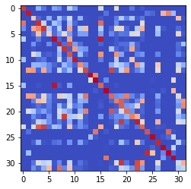

epoch 2591 == measurement_heuristic: 0.43+-0.01/0.39+-0.01 --

epoch 2592 == measurement_heuristic: 0.41+-0.01/0.36+-0.01 --

epoch 2593 == measurement_heuristic: 0.42+-0.01/0.36+-0.01 --

epoch 2594 == measurement_heuristic: 0.41+-0.01/0.35+-0.01 --

epoch 2595 == measurement_heuristic: 0.42+-0.01/0.36+-0.01 --

epoch 2596 == measurement_heuristic: 0.39+-0.01/0.35+-0.01 --

epoch 2597 == measurement_heuristic: 0.40+-0.01/0.35+-0.01 --

epoch 2598 == measurement_heuristic: 0.41+-0.01/0.37+-0.01 --

epoch 2599 == measurement_heuristic: 0.41+-0.01/0.36+-0.01 --

epoch 2600 == measurement_heuristic: 0.40+-0.01/0.35+-0.01 --

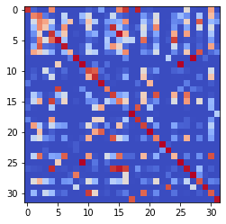

epoch 2601 == measurement_heuristic: 0.41+-0.01/0.35+-0.01 --

epoch 2602 == measurement_heuristic: 0.43+-0.01/0.36+-0.01 --

epoch 2603 == measurement_heuristic: 0.38+-0.01/0.36+-0.01 --

epoch 2604 == measurement_heuristic: 0.43+-0.01/0.38+-0.01 --

epoch 2605 == measurement_heuristic: 0.42+-0.01/0.35+-0.01 --

epoch 2606 == measurement_heuristic: 0.40+-0.01/0.35+-0.01 --

epoch 2607 == measurement_heuristic: 0.40+-0.01/0.37+-0.01 --

epoch 2608 == measurement_heuristic: 0.38+-0.01/0.36+-0.01 --

epoch 2609 == measurement_heuristic: 0.41+-0.01/0.36+-0.01 --

epoch 2610 == measurement_heuristic: 0.41+-0.01/0.35+-0.01 --

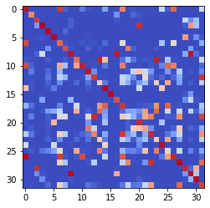

epoch 2611 == measurement_heuristic: 0.40+-0.01/0.36+-0.01 --

epoch 2612 == measurement_heuristic: 0.41+-0.01/0.36+-0.01 --

epoch 2613 == measurement_heuristic: 0.40+-0.01/0.36+-0.01 --

epoch 2614 == measurement_heuristic: 0.39+-0.01/0.36+-0.01 --

epoch 2615 == measurement_heuristic: 0.42+-0.01/0.36+-0.01 --

epoch 2616 == measurement_heuristic: 0.41+-0.01/0.36+-0.01 --

epoch 2617 == measurement_heuristic: 0.41+-0.01/0.36+-0.01 --

epoch 2618 == measurement_heuristic: 0.41+-0.01/0.35+-0.01 --

epoch 2619 == measurement_heuristic: 0.39+-0.01/0.36+-0.01 --

epoch 2620 == measurement_heuristic: 0.40+-0.01/0.35+-0.01 --

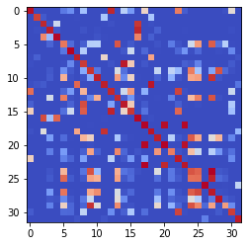

epoch 2621 == measurement_heuristic: 0.40+-0.01/0.36+-0.01 --

epoch 2622 == measurement_heuristic: 0.41+-0.01/0.37+-0.01 --

epoch 2623 == measurement_heuristic: 0.41+-0.01/0.39+-0.01 --

epoch 2624 == measurement_heuristic: 0.41+-0.01/0.36+-0.01 --

epoch 2625 == measurement_heuristic: 0.41+-0.01/0.37+-0.01 --

epoch 2626 == measurement_heuristic: 0.43+-0.01/0.38+-0.01 --

epoch 2627 == measurement_heuristic: 0.42+-0.01/0.35+-0.01 --

epoch 2628 == measurement_heuristic: 0.40+-0.01/0.35+-0.01 --

epoch 2629 == measurement_heuristic: 0.42+-0.01/0.36+-0.01 --

epoch 2630 == measurement_heuristic: 0.42+-0.01/0.35+-0.01 --

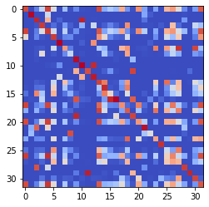

epoch 2631 == measurement_heuristic: 0.39+-0.01/0.36+-0.01 --

epoch 2632 == measurement_heuristic: 0.39+-0.01/0.36+-0.01 --

epoch 2633 == measurement_heuristic: 0.40+-0.01/0.35+-0.01 --

epoch 2634 == measurement_heuristic: 0.40+-0.01/0.37+-0.01 --

epoch 2635 == measurement_heuristic: 0.42+-0.01/0.35+-0.01 --

epoch 2636 == measurement_heuristic: 0.41+-0.01/0.35+-0.01 --

epoch 2637 == measurement_heuristic: 0.39+-0.01/0.35+-0.01 --

epoch 2638 == measurement_heuristic: 0.41+-0.01/0.37+-0.01 --

epoch 2639 == measurement_heuristic: 0.40+-0.01/0.36+-0.01 --

epoch 2640 == measurement_heuristic: 0.40+-0.01/0.35+-0.01 --

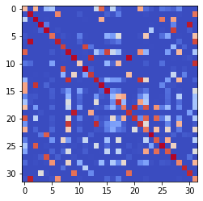

epoch 2641 == measurement_heuristic: 0.41+-0.01/0.36+-0.01 --

epoch 2642 == measurement_heuristic: 0.40+-0.01/0.36+-0.01 --

epoch 2643 == measurement_heuristic: 0.41+-0.01/0.35+-0.01 --

epoch 2644 == measurement_heuristic: 0.42+-0.01/0.37+-0.01 --

epoch 2645 == measurement_heuristic: 0.38+-0.01/0.35+-0.01 --

epoch 2646 == measurement_heuristic: 0.42+-0.01/0.37+-0.01 --

epoch 2647 == measurement_heuristic: 0.41+-0.01/0.36+-0.01 --

epoch 2648 == measurement_heuristic: 0.41+-0.01/0.36+-0.01 --

epoch 2649 == measurement_heuristic: 0.41+-0.01/0.38+-0.01 --

epoch 2650 == measurement_heuristic: 0.39+-0.01/0.35+-0.01 --

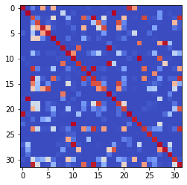

epoch 2651 == measurement_heuristic: 0.39+-0.01/0.35+-0.01 --

epoch 2652 == measurement_heuristic: 0.38+-0.01/0.36+-0.01 --

epoch 2653 == measurement_heuristic: 0.40+-0.01/0.35+-0.01 --

epoch 2654 == measurement_heuristic: 0.39+-0.01/0.35+-0.01 --

epoch 2655 == measurement_heuristic: 0.39+-0.01/0.35+-0.01 --

epoch 2656 == measurement_heuristic: 0.39+-0.01/0.35+-0.01 --

epoch 2657 == measurement_heuristic: 0.39+-0.01/0.38+-0.01 --

epoch 2658 == measurement_heuristic: 0.42+-0.01/0.36+-0.01 --

epoch 2659 == measurement_heuristic: 0.41+-0.01/0.35+-0.01 --

epoch 2660 == measurement_heuristic: 0.40+-0.01/0.35+-0.01 --

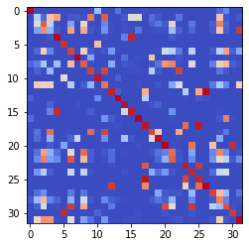

epoch 2661 == measurement_heuristic: 0.39+-0.01/0.35+-0.01 --

epoch 2662 == measurement_heuristic: 0.40+-0.01/0.36+-0.01 --

epoch 2663 >> measurement_heuristic: 0.41+-0.01/0.35+-0.01 --

epoch 2664 >> measurement_heuristic: 0.41+-0.01/0.34+-0.01 --

epoch 2665 == measurement_heuristic: 0.41+-0.01/0.35+-0.01 --

epoch 2666 == measurement_heuristic: 0.39+-0.01/0.35+-0.01 --

epoch 2667 == measurement_heuristic: 0.40+-0.01/0.35+-0.01 --

epoch 2668 == measurement_heuristic: 0.40+-0.01/0.35+-0.01 --

epoch 2669 == measurement_heuristic: 0.39+-0.01/0.36+-0.01 --

epoch 2670 == measurement_heuristic: 0.40+-0.01/0.36+-0.01 --

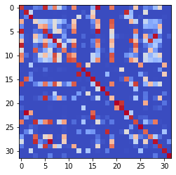

epoch 2671 >> measurement_heuristic: 0.39+-0.01/0.34+-0.01 --

epoch 2672 == measurement_heuristic: 0.40+-0.01/0.35+-0.01 --

epoch 2673 == measurement_heuristic: 0.39+-0.01/0.35+-0.01 --

epoch 2674 >> measurement_heuristic: 0.40+-0.01/0.34+-0.01 --

epoch 2675 == measurement_heuristic: 0.42+-0.01/0.34+-0.01 --

epoch 2676 == measurement_heuristic: 0.39+-0.01/0.35+-0.01 --

epoch 2677 == measurement_heuristic: 0.40+-0.01/0.35+-0.01 --

epoch 2678 == measurement_heuristic: 0.40+-0.01/0.35+-0.01 --

epoch 2679 == measurement_heuristic: 0.40+-0.01/0.35+-0.01 --

epoch 2680 == measurement_heuristic: 0.41+-0.01/0.35+-0.01 --

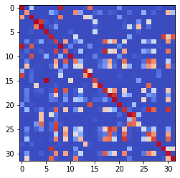

epoch 2681 == measurement_heuristic: 0.38+-0.01/0.35+-0.01 --

epoch 2682 == measurement_heuristic: 0.41+-0.01/0.35+-0.01 --

epoch 2683 == measurement_heuristic: 0.39+-0.01/0.37+-0.01 --

epoch 2684 == measurement_heuristic: 0.40+-0.01/0.36+-0.01 --

epoch 2685 == measurement_heuristic: 0.41+-0.01/0.37+-0.01 --

epoch 2686 == measurement_heuristic: 0.39+-0.01/0.35+-0.01 --

epoch 2687 == measurement_heuristic: 0.38+-0.01/0.36+-0.01 --

epoch 2688 == measurement_heuristic: 0.40+-0.01/0.35+-0.01 --

epoch 2689 == measurement_heuristic: 0.41+-0.01/0.35+-0.01 --

epoch 2690 == measurement_heuristic: 0.41+-0.01/0.35+-0.01 --

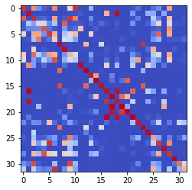

epoch 2691 == measurement_heuristic: 0.39+-0.01/0.35+-0.01 --

epoch 2692 == measurement_heuristic: 0.43+-0.01/0.37+-0.01 --

epoch 2693 == measurement_heuristic: 0.41+-0.01/0.35+-0.01 --

epoch 2694 == measurement_heuristic: 0.40+-0.01/0.35+-0.01 --

epoch 2695 == measurement_heuristic: 0.39+-0.01/0.36+-0.01 --

epoch 2696 == measurement_heuristic: 0.43+-0.01/0.36+-0.01 --

epoch 2697 == measurement_heuristic: 0.41+-0.01/0.35+-0.01 --

epoch 2698 == measurement_heuristic: 0.40+-0.01/0.36+-0.01 --

epoch 2699 == measurement_heuristic: 0.42+-0.02/0.35+-0.01 --

epoch 2700 == measurement_heuristic: 0.40+-0.01/0.35+-0.01 --

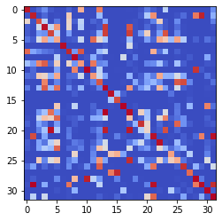

epoch 2701 == measurement_heuristic: 0.39+-0.01/0.36+-0.01 --

epoch 2702 == measurement_heuristic: 0.40+-0.01/0.36+-0.01 --

epoch 2703 == measurement_heuristic: 0.41+-0.01/0.36+-0.01 --

epoch 2704 == measurement_heuristic: 0.43+-0.01/0.35+-0.01 --

epoch 2705 == measurement_heuristic: 0.40+-0.01/0.35+-0.01 --

epoch 2706 == measurement_heuristic: 0.40+-0.01/0.35+-0.01 --

epoch 2707 == measurement_heuristic: 0.40+-0.01/0.35+-0.01 --

epoch 2708 == measurement_heuristic: 0.41+-0.01/0.37+-0.01 --

epoch 2709 == measurement_heuristic: 0.42+-0.01/0.35+-0.01 --

epoch 2710 == measurement_heuristic: 0.40+-0.01/0.35+-0.01 --

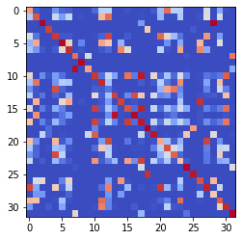

epoch 2711 == measurement_heuristic: 0.40+-0.01/0.36+-0.01 --

epoch 2712 == measurement_heuristic: 0.40+-0.01/0.35+-0.01 --

epoch 2713 >> measurement_heuristic: 0.40+-0.01/0.34+-0.01 --

epoch 2714 == measurement_heuristic: 0.39+-0.01/0.35+-0.01 --

epoch 2715 == measurement_heuristic: 0.41+-0.01/0.36+-0.01 --

epoch 2716 == measurement_heuristic: 0.39+-0.01/0.37+-0.01 --

epoch 2717 == measurement_heuristic: 0.41+-0.01/0.35+-0.01 --

epoch 2718 == measurement_heuristic: 0.39+-0.01/0.36+-0.01 --

epoch 2719 == measurement_heuristic: 0.39+-0.01/0.35+-0.01 --

epoch 2720 == measurement_heuristic: 0.40+-0.01/0.37+-0.01 --

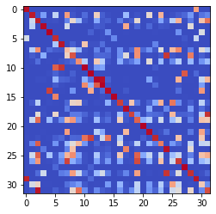

epoch 2721 == measurement_heuristic: 0.38+-0.01/0.35+-0.01 --

epoch 2722 == measurement_heuristic: 0.39+-0.01/0.35+-0.01 --

epoch 2723 == measurement_heuristic: 0.41+-0.01/0.36+-0.01 --

epoch 2724 == measurement_heuristic: 0.41+-0.01/0.35+-0.01 --

epoch 2725 == measurement_heuristic: 0.42+-0.01/0.37+-0.01 --

epoch 2726 == measurement_heuristic: 0.42+-0.01/0.35+-0.01 --

epoch 2727 == measurement_heuristic: 0.42+-0.01/0.35+-0.01 --

epoch 2728 == measurement_heuristic: 0.39+-0.01/0.35+-0.01 --

epoch 2729 == measurement_heuristic: 0.39+-0.01/0.36+-0.01 --

epoch 2730 == measurement_heuristic: 0.39+-0.01/0.36+-0.01 --

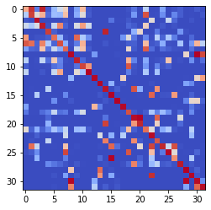

epoch 2731 == measurement_heuristic: 0.40+-0.01/0.35+-0.01 --

epoch 2732 == measurement_heuristic: 0.40+-0.01/0.35+-0.01 --

epoch 2733 == measurement_heuristic: 0.39+-0.01/0.36+-0.01 --

epoch 2734 == measurement_heuristic: 0.40+-0.01/0.35+-0.01 --

epoch 2735 == measurement_heuristic: 0.40+-0.01/0.36+-0.01 --

epoch 2736 == measurement_heuristic: 0.39+-0.01/0.36+-0.01 --

epoch 2737 == measurement_heuristic: 0.42+-0.01/0.36+-0.01 --

epoch 2738 == measurement_heuristic: 0.39+-0.01/0.35+-0.01 --

epoch 2739 == measurement_heuristic: 0.41+-0.01/0.35+-0.01 --

epoch 2740 == measurement_heuristic: 0.38+-0.01/0.34+-0.01 --

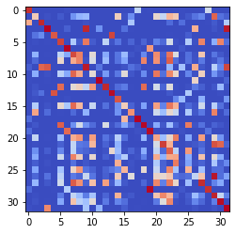

epoch 2741 == measurement_heuristic: 0.41+-0.01/0.35+-0.01 --

epoch 2742 == measurement_heuristic: 0.39+-0.01/0.36+-0.01 --

epoch 2743 == measurement_heuristic: 0.40+-0.01/0.35+-0.01 --

epoch 2744 == measurement_heuristic: 0.40+-0.01/0.35+-0.01 --

epoch 2745 == measurement_heuristic: 0.40+-0.01/0.37+-0.01 --

epoch 2746 == measurement_heuristic: 0.40+-0.01/0.35+-0.01 --

epoch 2747 == measurement_heuristic: 0.40+-0.01/0.36+-0.01 --

epoch 2748 == measurement_heuristic: 0.40+-0.01/0.35+-0.01 --

epoch 2749 == measurement_heuristic: 0.41+-0.01/0.36+-0.01 --

epoch 2750 == measurement_heuristic: 0.40+-0.01/0.36+-0.01 --

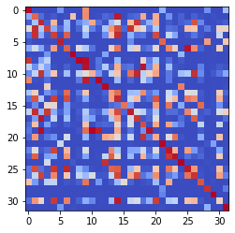

epoch 2751 == measurement_heuristic: 0.40+-0.01/0.36+-0.01 --

epoch 2752 == measurement_heuristic: 0.41+-0.01/0.35+-0.01 --

epoch 2753 == measurement_heuristic: 0.40+-0.01/0.34+-0.01 --

epoch 2754 == measurement_heuristic: 0.37+-0.01/0.34+-0.01 --

epoch 2755 == measurement_heuristic: 0.40+-0.01/0.36+-0.01 --

epoch 2756 == measurement_heuristic: 0.41+-0.01/0.35+-0.01 --

epoch 2757 == measurement_heuristic: 0.39+-0.01/0.35+-0.01 --

epoch 2758 == measurement_heuristic: 0.37+-0.01/0.35+-0.01 --

epoch 2759 == measurement_heuristic: 0.39+-0.01/0.35+-0.01 --

epoch 2760 == measurement_heuristic: 0.39+-0.01/0.36+-0.01 --

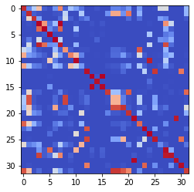

epoch 2761 == measurement_heuristic: 0.39+-0.01/0.36+-0.01 --

epoch 2762 == measurement_heuristic: 0.39+-0.01/0.34+-0.01 --

epoch 2763 == measurement_heuristic: 0.37+-0.01/0.34+-0.01 --

epoch 2764 == measurement_heuristic: 0.38+-0.01/0.34+-0.01 --

epoch 2765 == measurement_heuristic: 0.39+-0.01/0.35+-0.01 --

epoch 2766 == measurement_heuristic: 0.40+-0.01/0.35+-0.01 --

epoch 2767 == measurement_heuristic: 0.40+-0.01/0.35+-0.01 --

epoch 2768 == measurement_heuristic: 0.39+-0.01/0.35+-0.01 --

epoch 2769 == measurement_heuristic: 0.38+-0.01/0.35+-0.01 --

epoch 2770 == measurement_heuristic: 0.40+-0.01/0.35+-0.01 --

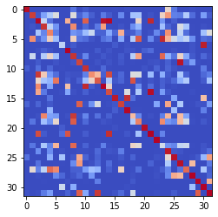

epoch 2771 == measurement_heuristic: 0.37+-0.01/0.36+-0.01 --

epoch 2772 == measurement_heuristic: 0.38+-0.01/0.37+-0.01 --

epoch 2773 == measurement_heuristic: 0.39+-0.01/0.35+-0.01 --

epoch 2774 == measurement_heuristic: 0.40+-0.01/0.35+-0.01 --

epoch 2775 == measurement_heuristic: 0.38+-0.01/0.35+-0.01 --

epoch 2776 == measurement_heuristic: 0.40+-0.01/0.34+-0.01 --

epoch 2777 >> measurement_heuristic: 0.38+-0.01/0.34+-0.01 --

epoch 2778 == measurement_heuristic: 0.41+-0.01/0.34+-0.01 --

epoch 2779 == measurement_heuristic: 0.40+-0.01/0.38+-0.01 --

epoch 2780 == measurement_heuristic: 0.42+-0.01/0.35+-0.01 --

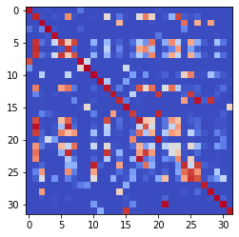

epoch 2781 == measurement_heuristic: 0.40+-0.01/0.34+-0.01 --

epoch 2782 == measurement_heuristic: 0.40+-0.01/0.34+-0.01 --

epoch 2783 == measurement_heuristic: 0.39+-0.01/0.37+-0.01 --

epoch 2784 >> measurement_heuristic: 0.40+-0.01/0.34+-0.01 --

epoch 2785 == measurement_heuristic: 0.36+-0.01/0.34+-0.01 --

epoch 2786 == measurement_heuristic: 0.38+-0.01/0.35+-0.01 --

epoch 2787 == measurement_heuristic: 0.37+-0.01/0.35+-0.01 --

epoch 2788 == measurement_heuristic: 0.38+-0.01/0.35+-0.01 --

epoch 2789 == measurement_heuristic: 0.40+-0.01/0.35+-0.01 --

epoch 2790 == measurement_heuristic: 0.40+-0.01/0.35+-0.01 --

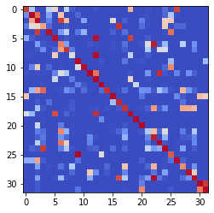

epoch 2791 == measurement_heuristic: 0.41+-0.01/0.37+-0.01 --

epoch 2792 == measurement_heuristic: 0.40+-0.01/0.35+-0.01 --

epoch 2793 == measurement_heuristic: 0.41+-0.01/0.35+-0.01 --

epoch 2794 == measurement_heuristic: 0.39+-0.01/0.35+-0.01 --

epoch 2795 == measurement_heuristic: 0.39+-0.01/0.35+-0.01 --

epoch 2796 == measurement_heuristic: 0.38+-0.01/0.35+-0.01 --

epoch 2797 == measurement_heuristic: 0.40+-0.01/0.35+-0.01 --

epoch 2798 == measurement_heuristic: 0.39+-0.01/0.35+-0.01 --

epoch 2799 == measurement_heuristic: 0.39+-0.01/0.36+-0.01 --

epoch 2800 == measurement_heuristic: 0.40+-0.01/0.36+-0.01 --

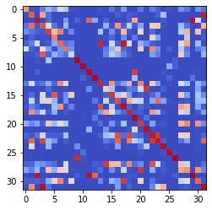

epoch 2801 == measurement_heuristic: 0.40+-0.01/0.35+-0.01 --

epoch 2802 == measurement_heuristic: 0.40+-0.01/0.34+-0.01 --

epoch 2803 == measurement_heuristic: 0.40+-0.01/0.36+-0.01 --

epoch 2804 == measurement_heuristic: 0.39+-0.01/0.36+-0.01 --

epoch 2805 == measurement_heuristic: 0.39+-0.01/0.34+-0.01 --

epoch 2806 == measurement_heuristic: 0.40+-0.01/0.34+-0.01 --

epoch 2807 == measurement_heuristic: 0.38+-0.01/0.36+-0.01 --

epoch 2808 == measurement_heuristic: 0.37+-0.01/0.35+-0.01 --

epoch 2809 == measurement_heuristic: 0.38+-0.01/0.35+-0.01 --

epoch 2810 == measurement_heuristic: 0.39+-0.01/0.35+-0.01 --

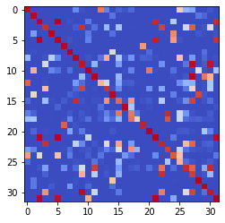

epoch 2811 == measurement_heuristic: 0.39+-0.01/0.36+-0.01 --

epoch 2812 == measurement_heuristic: 0.41+-0.01/0.36+-0.01 --

epoch 2813 == measurement_heuristic: 0.40+-0.01/0.35+-0.01 --

epoch 2814 == measurement_heuristic: 0.39+-0.01/0.35+-0.01 --

epoch 2815 == measurement_heuristic: 0.39+-0.01/0.34+-0.01 --

epoch 2816 == measurement_heuristic: 0.41+-0.01/0.35+-0.01 --

epoch 2817 == measurement_heuristic: 0.40+-0.01/0.34+-0.01 --

epoch 2818 == measurement_heuristic: 0.39+-0.01/0.34+-0.01 --

epoch 2819 == measurement_heuristic: 0.37+-0.01/0.34+-0.01 --

epoch 2820 == measurement_heuristic: 0.36+-0.01/0.34+-0.01 --

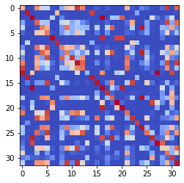

epoch 2821 == measurement_heuristic: 0.41+-0.01/0.34+-0.01 --

epoch 2822 == measurement_heuristic: 0.39+-0.01/0.35+-0.01 --

epoch 2823 == measurement_heuristic: 0.40+-0.01/0.35+-0.01 --

epoch 2824 == measurement_heuristic: 0.39+-0.01/0.35+-0.01 --

epoch 2825 == measurement_heuristic: 0.40+-0.01/0.36+-0.01 --

epoch 2826 == measurement_heuristic: 0.41+-0.01/0.35+-0.01 --

epoch 2827 == measurement_heuristic: 0.38+-0.01/0.35+-0.01 --

epoch 2828 == measurement_heuristic: 0.38+-0.01/0.35+-0.01 --

epoch 2829 == measurement_heuristic: 0.39+-0.01/0.35+-0.01 --

epoch 2830 == measurement_heuristic: 0.38+-0.01/0.35+-0.01 --

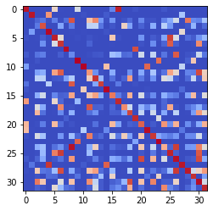

epoch 2831 == measurement_heuristic: 0.40+-0.01/0.34+-0.01 --

epoch 2832 == measurement_heuristic: 0.40+-0.01/0.36+-0.01 --

epoch 2833 == measurement_heuristic: 0.41+-0.01/0.35+-0.01 --

epoch 2834 == measurement_heuristic: 0.40+-0.01/0.35+-0.01 --

epoch 2835 == measurement_heuristic: 0.37+-0.01/0.35+-0.01 --

epoch 2836 == measurement_heuristic: 0.40+-0.01/0.34+-0.01 --

epoch 2837 == measurement_heuristic: 0.38+-0.01/0.34+-0.01 --

epoch 2838 == measurement_heuristic: 0.41+-0.01/0.36+-0.01 --

epoch 2839 == measurement_heuristic: 0.39+-0.01/0.35+-0.01 --

epoch 2840 == measurement_heuristic: 0.39+-0.01/0.36+-0.01 --

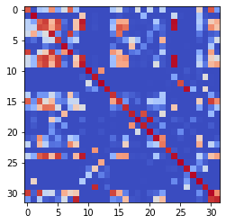

epoch 2841 == measurement_heuristic: 0.37+-0.01/0.35+-0.01 --

epoch 2842 == measurement_heuristic: 0.39+-0.01/0.35+-0.01 --

epoch 2843 == measurement_heuristic: 0.41+-0.01/0.35+-0.01 --

epoch 2844 == measurement_heuristic: 0.38+-0.01/0.34+-0.01 --

epoch 2845 == measurement_heuristic: 0.40+-0.01/0.34+-0.01 --

epoch 2846 == measurement_heuristic: 0.38+-0.01/0.35+-0.01 --

epoch 2847 == measurement_heuristic: 0.37+-0.01/0.35+-0.01 --

epoch 2848 == measurement_heuristic: 0.41+-0.01/0.35+-0.01 --

epoch 2849 == measurement_heuristic: 0.41+-0.01/0.34+-0.01 --

epoch 2850 == measurement_heuristic: 0.39+-0.01/0.36+-0.01 --

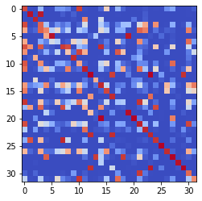

epoch 2851 == measurement_heuristic: 0.40+-0.01/0.34+-0.01 --

epoch 2852 == measurement_heuristic: 0.39+-0.01/0.35+-0.01 --

epoch 2853 == measurement_heuristic: 0.40+-0.01/0.35+-0.01 --

epoch 2854 == measurement_heuristic: 0.39+-0.01/0.36+-0.01 --

epoch 2855 == measurement_heuristic: 0.41+-0.01/0.35+-0.01 --

epoch 2856 >> measurement_heuristic: 0.39+-0.01/0.34+-0.01 --

epoch 2857 == measurement_heuristic: 0.40+-0.01/0.35+-0.01 --

epoch 2858 == measurement_heuristic: 0.38+-0.01/0.35+-0.01 --

epoch 2859 == measurement_heuristic: 0.41+-0.01/0.34+-0.01 --

epoch 2860 == measurement_heuristic: 0.37+-0.01/0.34+-0.01 --

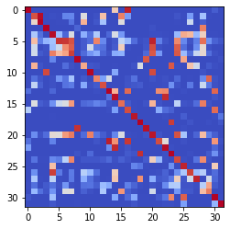

epoch 2861 == measurement_heuristic: 0.39+-0.01/0.35+-0.01 --

epoch 2862 == measurement_heuristic: 0.37+-0.01/0.35+-0.01 --

epoch 2863 == measurement_heuristic: 0.39+-0.01/0.35+-0.01 --

epoch 2864 == measurement_heuristic: 0.40+-0.01/0.35+-0.01 --

epoch 2865 == measurement_heuristic: 0.40+-0.01/0.34+-0.01 --

epoch 2866 == measurement_heuristic: 0.39+-0.01/0.35+-0.01 --

epoch 2867 == measurement_heuristic: 0.40+-0.01/0.37+-0.01 --

epoch 2868 == measurement_heuristic: 0.40+-0.01/0.36+-0.01 --

epoch 2869 == measurement_heuristic: 0.39+-0.01/0.35+-0.01 --

epoch 2870 == measurement_heuristic: 0.39+-0.01/0.34+-0.01 --

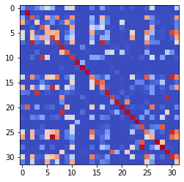

epoch 2871 == measurement_heuristic: 0.38+-0.01/0.34+-0.01 --

epoch 2872 == measurement_heuristic: 0.41+-0.01/0.34+-0.01 --

epoch 2873 == measurement_heuristic: 0.39+-0.01/0.36+-0.01 --

epoch 2874 == measurement_heuristic: 0.41+-0.01/0.35+-0.01 --

epoch 2875 == measurement_heuristic: 0.41+-0.01/0.35+-0.01 --

epoch 2876 == measurement_heuristic: 0.38+-0.01/0.37+-0.01 --

epoch 2877 == measurement_heuristic: 0.40+-0.01/0.36+-0.01 --

epoch 2878 == measurement_heuristic: 0.38+-0.01/0.35+-0.01 --

epoch 2879 == measurement_heuristic: 0.40+-0.01/0.39+-0.01 --

epoch 2880 == measurement_heuristic: 0.38+-0.01/0.34+-0.01 --

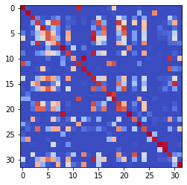

epoch 2881 == measurement_heuristic: 0.41+-0.01/0.36+-0.01 --

epoch 2882 == measurement_heuristic: 0.37+-0.01/0.34+-0.01 --

epoch 2883 == measurement_heuristic: 0.40+-0.01/0.34+-0.01 --

epoch 2884 == measurement_heuristic: 0.40+-0.01/0.34+-0.01 --

epoch 2885 == measurement_heuristic: 0.40+-0.01/0.35+-0.01 --

epoch 2886 == measurement_heuristic: 0.40+-0.01/0.35+-0.01 --

epoch 2887 == measurement_heuristic: 0.40+-0.01/0.34+-0.01 --

epoch 2888 == measurement_heuristic: 0.39+-0.01/0.34+-0.01 --

epoch 2889 == measurement_heuristic: 0.42+-0.01/0.35+-0.01 --

epoch 2890 == measurement_heuristic: 0.40+-0.01/0.36+-0.01 --

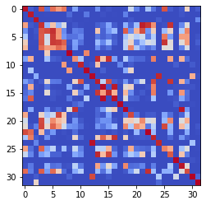

epoch 2891 >> measurement_heuristic: 0.39+-0.01/0.33+-0.01 --

epoch 2892 == measurement_heuristic: 0.37+-0.01/0.34+-0.01 --

epoch 2893 == measurement_heuristic: 0.40+-0.01/0.35+-0.01 --

epoch 2894 == measurement_heuristic: 0.39+-0.01/0.35+-0.01 --

epoch 2895 == measurement_heuristic: 0.38+-0.01/0.34+-0.01 --

epoch 2896 == measurement_heuristic: 0.39+-0.01/0.35+-0.01 --

epoch 2897 == measurement_heuristic: 0.39+-0.01/0.35+-0.01 --

epoch 2898 == measurement_heuristic: 0.40+-0.01/0.35+-0.01 --

epoch 2899 == measurement_heuristic: 0.40+-0.01/0.35+-0.01 --

epoch 2900 == measurement_heuristic: 0.39+-0.01/0.35+-0.01 --

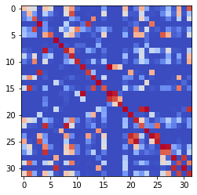

epoch 2901 == measurement_heuristic: 0.38+-0.01/0.34+-0.01 --

epoch 2902 == measurement_heuristic: 0.39+-0.01/0.35+-0.01 --

epoch 2903 == measurement_heuristic: 0.39+-0.01/0.34+-0.01 --

epoch 2904 == measurement_heuristic: 0.40+-0.01/0.36+-0.01 --

epoch 2905 == measurement_heuristic: 0.38+-0.01/0.35+-0.01 --

epoch 2906 == measurement_heuristic: 0.39+-0.01/0.39+-0.01 --

epoch 2907 == measurement_heuristic: 0.39+-0.01/0.35+-0.01 --

epoch 2908 == measurement_heuristic: 0.40+-0.01/0.35+-0.01 --

epoch 2909 == measurement_heuristic: 0.39+-0.01/0.34+-0.01 --

epoch 2910 == measurement_heuristic: 0.40+-0.01/0.34+-0.01 --

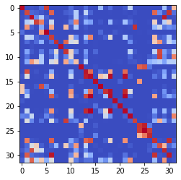

epoch 2911 == measurement_heuristic: 0.38+-0.01/0.35+-0.01 --

epoch 2912 == measurement_heuristic: 0.39+-0.01/0.35+-0.01 --

epoch 2913 == measurement_heuristic: 0.41+-0.01/0.36+-0.01 --

epoch 2914 == measurement_heuristic: 0.38+-0.01/0.34+-0.01 --

epoch 2915 == measurement_heuristic: 0.39+-0.01/0.35+-0.01 --

epoch 2916 == measurement_heuristic: 0.39+-0.01/0.36+-0.01 --

epoch 2917 == measurement_heuristic: 0.39+-0.01/0.36+-0.01 --

epoch 2918 == measurement_heuristic: 0.40+-0.01/0.35+-0.01 --

epoch 2919 == measurement_heuristic: 0.41+-0.01/0.34+-0.01 --

epoch 2920 == measurement_heuristic: 0.38+-0.01/0.35+-0.01 --

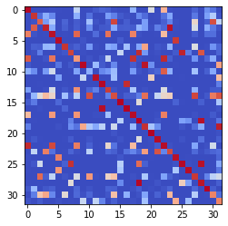

epoch 2921 == measurement_heuristic: 0.40+-0.01/0.34+-0.01 --

epoch 2922 == measurement_heuristic: 0.38+-0.01/0.35+-0.01 --

epoch 2923 == measurement_heuristic: 0.41+-0.01/0.35+-0.01 --

epoch 2924 == measurement_heuristic: 0.38+-0.01/0.34+-0.01 --

epoch 2925 == measurement_heuristic: 0.38+-0.01/0.34+-0.01 --

epoch 2926 == measurement_heuristic: 0.39+-0.01/0.35+-0.01 --

epoch 2927 == measurement_heuristic: 0.38+-0.01/0.35+-0.01 --

epoch 2928 == measurement_heuristic: 0.41+-0.01/0.34+-0.01 --

epoch 2929 == measurement_heuristic: 0.39+-0.01/0.35+-0.01 --

epoch 2930 == measurement_heuristic: 0.38+-0.01/0.34+-0.01 --

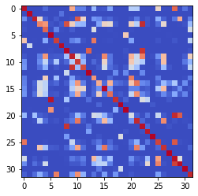

epoch 2931 == measurement_heuristic: 0.37+-0.01/0.35+-0.01 --

epoch 2932 == measurement_heuristic: 0.40+-0.01/0.35+-0.01 --

epoch 2933 == measurement_heuristic: 0.38+-0.01/0.34+-0.01 --

epoch 2934 == measurement_heuristic: 0.39+-0.01/0.34+-0.01 --

epoch 2935 == measurement_heuristic: 0.40+-0.01/0.35+-0.01 --

epoch 2936 == measurement_heuristic: 0.38+-0.01/0.35+-0.01 --

epoch 2937 == measurement_heuristic: 0.40+-0.01/0.34+-0.01 --

epoch 2938 == measurement_heuristic: 0.39+-0.01/0.35+-0.01 --

epoch 2939 == measurement_heuristic: 0.39+-0.01/0.35+-0.01 --

epoch 2940 == measurement_heuristic: 0.39+-0.01/0.35+-0.01 --

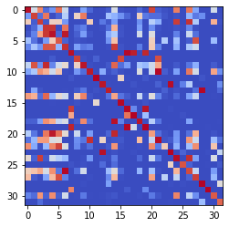

epoch 2941 == measurement_heuristic: 0.40+-0.01/0.35+-0.01 --

epoch 2942 == measurement_heuristic: 0.39+-0.01/0.34+-0.01 --

epoch 2943 == measurement_heuristic: 0.40+-0.01/0.35+-0.01 --

epoch 2944 == measurement_heuristic: 0.38+-0.01/0.34+-0.01 --

epoch 2945 == measurement_heuristic: 0.38+-0.01/0.34+-0.01 --

epoch 2946 == measurement_heuristic: 0.38+-0.01/0.36+-0.01 --

epoch 2947 == measurement_heuristic: 0.41+-0.01/0.34+-0.01 --

epoch 2948 == measurement_heuristic: 0.38+-0.01/0.35+-0.01 --

epoch 2949 == measurement_heuristic: 0.37+-0.01/0.34+-0.01 --

epoch 2950 == measurement_heuristic: 0.39+-0.01/0.34+-0.01 --

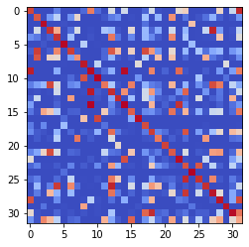

epoch 2951 == measurement_heuristic: 0.39+-0.01/0.35+-0.01 --

epoch 2952 == measurement_heuristic: 0.39+-0.01/0.37+-0.01 --

epoch 2953 == measurement_heuristic: 0.39+-0.01/0.34+-0.01 --

epoch 2954 == measurement_heuristic: 0.39+-0.01/0.35+-0.01 --

epoch 2955 == measurement_heuristic: 0.38+-0.01/0.36+-0.01 --

epoch 2956 >> measurement_heuristic: 0.39+-0.01/0.33+-0.01 --

epoch 2957 == measurement_heuristic: 0.39+-0.01/0.34+-0.01 --

epoch 2958 == measurement_heuristic: 0.37+-0.01/0.34+-0.01 --

epoch 2959 == measurement_heuristic: 0.39+-0.01/0.36+-0.01 --

epoch 2960 >> measurement_heuristic: 0.39+-0.01/0.33+-0.01 --

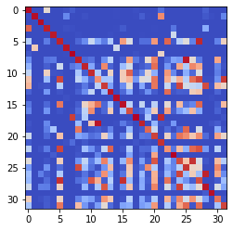

epoch 2961 == measurement_heuristic: 0.39+-0.01/0.34+-0.01 --

epoch 2962 == measurement_heuristic: 0.38+-0.01/0.36+-0.01 --

epoch 2963 == measurement_heuristic: 0.38+-0.01/0.34+-0.01 --

epoch 2964 == measurement_heuristic: 0.38+-0.01/0.34+-0.01 --

epoch 2965 == measurement_heuristic: 0.38+-0.01/0.35+-0.01 --

epoch 2966 == measurement_heuristic: 0.40+-0.01/0.34+-0.01 --

epoch 2967 == measurement_heuristic: 0.39+-0.01/0.34+-0.01 --

epoch 2968 == measurement_heuristic: 0.37+-0.01/0.34+-0.01 --

epoch 2969 == measurement_heuristic: 0.40+-0.01/0.35+-0.01 --

epoch 2970 == measurement_heuristic: 0.39+-0.01/0.34+-0.01 --

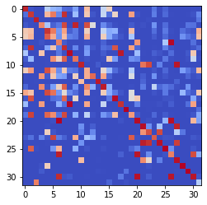

epoch 2971 == measurement_heuristic: 0.39+-0.01/0.37+-0.01 --

epoch 2972 == measurement_heuristic: 0.39+-0.01/0.35+-0.01 --

epoch 2973 == measurement_heuristic: 0.37+-0.01/0.33+-0.01 --

epoch 2974 == measurement_heuristic: 0.38+-0.01/0.33+-0.01 --

epoch 2975 == measurement_heuristic: 0.38+-0.01/0.34+-0.01 --

epoch 2976 == measurement_heuristic: 0.41+-0.01/0.35+-0.01 --

epoch 2977 == measurement_heuristic: 0.38+-0.01/0.34+-0.01 --

epoch 2978 == measurement_heuristic: 0.36+-0.01/0.33+-0.01 --

epoch 2979 == measurement_heuristic: 0.40+-0.01/0.34+-0.01 --

epoch 2980 == measurement_heuristic: 0.40+-0.01/0.34+-0.01 --

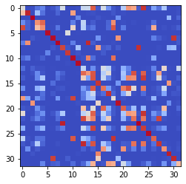

epoch 2981 == measurement_heuristic: 0.40+-0.01/0.34+-0.01 --

epoch 2982 == measurement_heuristic: 0.40+-0.01/0.34+-0.01 --

epoch 2983 == measurement_heuristic: 0.38+-0.01/0.36+-0.01 --

epoch 2984 == measurement_heuristic: 0.37+-0.01/0.33+-0.01 --

epoch 2985 == measurement_heuristic: 0.39+-0.01/0.34+-0.01 --

epoch 2986 == measurement_heuristic: 0.40+-0.01/0.35+-0.01 --

epoch 2987 == measurement_heuristic: 0.39+-0.01/0.35+-0.01 --

epoch 2988 == measurement_heuristic: 0.38+-0.01/0.36+-0.01 --

epoch 2989 == measurement_heuristic: 0.38+-0.01/0.35+-0.01 --

epoch 2990 == measurement_heuristic: 0.40+-0.01/0.35+-0.01 --

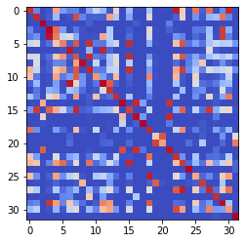

epoch 2991 == measurement_heuristic: 0.40+-0.01/0.34+-0.01 --

epoch 2992 == measurement_heuristic: 0.36+-0.01/0.34+-0.01 --

epoch 2993 == measurement_heuristic: 0.39+-0.01/0.33+-0.01 --

epoch 2994 == measurement_heuristic: 0.38+-0.01/0.33+-0.01 --

epoch 2995 == measurement_heuristic: 0.41+-0.01/0.36+-0.01 --

epoch 2996 == measurement_heuristic: 0.38+-0.01/0.35+-0.01 --

epoch 2997 == measurement_heuristic: 0.38+-0.01/0.33+-0.01 --

epoch 2998 == measurement_heuristic: 0.37+-0.01/0.34+-0.01 --

epoch 2999 == measurement_heuristic: 0.41+-0.01/0.34+-0.01 --

epoch 3000 == measurement_heuristic: 0.40+-0.01/0.35+-0.01 --

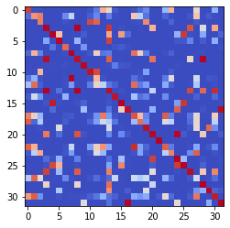

epoch 3001 == measurement_heuristic: 0.39+-0.01/0.34+-0.01 --

epoch 3002 == measurement_heuristic: 0.39+-0.01/0.34+-0.01 --

epoch 3003 == measurement_heuristic: 0.38+-0.01/0.35+-0.01 --

epoch 3004 == measurement_heuristic: 0.41+-0.01/0.35+-0.01 --

epoch 3005 == measurement_heuristic: 0.38+-0.01/0.34+-0.01 --

epoch 3006 == measurement_heuristic: 0.38+-0.01/0.33+-0.01 --

epoch 3007 == measurement_heuristic: 0.37+-0.01/0.34+-0.01 --

epoch 3008 == measurement_heuristic: 0.37+-0.01/0.33+-0.01 --

epoch 3009 == measurement_heuristic: 0.37+-0.01/0.34+-0.01 --

epoch 3010 == measurement_heuristic: 0.38+-0.01/0.34+-0.01 --

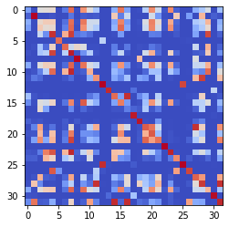

epoch 3011 == measurement_heuristic: 0.39+-0.01/0.34+-0.01 --

epoch 3012 == measurement_heuristic: 0.39+-0.01/0.34+-0.01 --

epoch 3013 == measurement_heuristic: 0.39+-0.01/0.36+-0.01 --

epoch 3014 == measurement_heuristic: 0.38+-0.01/0.34+-0.01 --

epoch 3015 == measurement_heuristic: 0.39+-0.01/0.33+-0.01 --

epoch 3016 == measurement_heuristic: 0.38+-0.01/0.33+-0.01 --

epoch 3017 == measurement_heuristic: 0.38+-0.01/0.33+-0.01 --

epoch 3018 == measurement_heuristic: 0.40+-0.01/0.36+-0.01 --

epoch 3019 == measurement_heuristic: 0.36+-0.01/0.34+-0.01 --

epoch 3020 == measurement_heuristic: 0.39+-0.01/0.33+-0.01 --

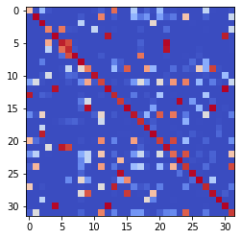

epoch 3021 == measurement_heuristic: 0.38+-0.01/0.35+-0.01 --

epoch 3022 == measurement_heuristic: 0.39+-0.01/0.34+-0.01 --

epoch 3023 == measurement_heuristic: 0.38+-0.01/0.35+-0.01 --

epoch 3024 == measurement_heuristic: 0.38+-0.01/0.35+-0.01 --

epoch 3025 == measurement_heuristic: 0.38+-0.01/0.37+-0.01 --

epoch 3026 == measurement_heuristic: 0.38+-0.01/0.35+-0.01 --

epoch 3027 == measurement_heuristic: 0.39+-0.01/0.33+-0.01 --

epoch 3028 == measurement_heuristic: 0.38+-0.01/0.34+-0.01 --

epoch 3029 == measurement_heuristic: 0.38+-0.01/0.33+-0.01 --

epoch 3030 == measurement_heuristic: 0.39+-0.01/0.33+-0.01 --

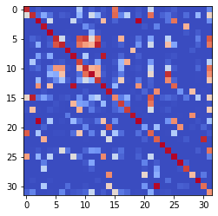

epoch 3031 == measurement_heuristic: 0.39+-0.01/0.34+-0.01 --

epoch 3032 == measurement_heuristic: 0.38+-0.01/0.35+-0.01 --

epoch 3033 == measurement_heuristic: 0.39+-0.01/0.35+-0.01 --

epoch 3034 == measurement_heuristic: 0.37+-0.01/0.35+-0.01 --

epoch 3035 == measurement_heuristic: 0.38+-0.01/0.35+-0.01 --

epoch 3036 == measurement_heuristic: 0.38+-0.01/0.33+-0.01 --

epoch 3037 == measurement_heuristic: 0.39+-0.01/0.35+-0.01 --

epoch 3038 == measurement_heuristic: 0.39+-0.01/0.35+-0.01 --

epoch 3039 == measurement_heuristic: 0.41+-0.01/0.34+-0.01 --

epoch 3040 == measurement_heuristic: 0.39+-0.01/0.35+-0.01 --

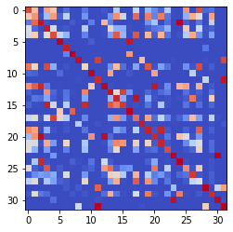

epoch 3041 == measurement_heuristic: 0.38+-0.01/0.34+-0.01 --

epoch 3042 == measurement_heuristic: 0.39+-0.01/0.34+-0.01 --

epoch 3043 == measurement_heuristic: 0.42+-0.01/0.35+-0.01 --

epoch 3044 == measurement_heuristic: 0.40+-0.01/0.35+-0.01 --

epoch 3045 == measurement_heuristic: 0.38+-0.01/0.33+-0.01 --

epoch 3046 == measurement_heuristic: 0.39+-0.01/0.35+-0.01 --

epoch 3047 == measurement_heuristic: 0.38+-0.01/0.36+-0.01 --

epoch 3048 == measurement_heuristic: 0.39+-0.01/0.36+-0.01 --

epoch 3049 == measurement_heuristic: 0.39+-0.01/0.34+-0.01 --

epoch 3050 == measurement_heuristic: 0.38+-0.01/0.34+-0.01 --

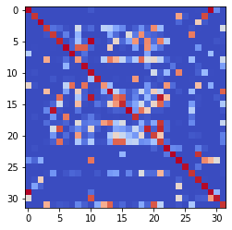

epoch 3051 == measurement_heuristic: 0.40+-0.01/0.34+-0.01 --

epoch 3052 == measurement_heuristic: 0.36+-0.01/0.35+-0.01 --

epoch 3053 == measurement_heuristic: 0.39+-0.01/0.34+-0.01 --

epoch 3054 == measurement_heuristic: 0.38+-0.01/0.34+-0.01 --

epoch 3055 == measurement_heuristic: 0.39+-0.01/0.35+-0.01 --

epoch 3056 == measurement_heuristic: 0.38+-0.01/0.34+-0.01 --

epoch 3057 == measurement_heuristic: 0.38+-0.01/0.34+-0.01 --

epoch 3058 == measurement_heuristic: 0.38+-0.01/0.34+-0.01 --

epoch 3059 == measurement_heuristic: 0.39+-0.01/0.35+-0.01 --

epoch 3060 == measurement_heuristic: 0.39+-0.01/0.34+-0.01 --

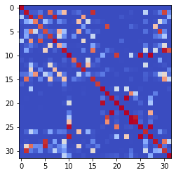

epoch 3061 == measurement_heuristic: 0.38+-0.01/0.35+-0.01 --

epoch 3062 == measurement_heuristic: 0.40+-0.01/0.36+-0.01 --

epoch 3063 == measurement_heuristic: 0.41+-0.01/0.36+-0.01 --

epoch 3064 >> measurement_heuristic: 0.38+-0.01/0.33+-0.01 --

epoch 3065 == measurement_heuristic: 0.39+-0.01/0.34+-0.01 --

epoch 3066 == measurement_heuristic: 0.37+-0.01/0.35+-0.01 --

epoch 3067 == measurement_heuristic: 0.39+-0.01/0.33+-0.01 --

epoch 3068 == measurement_heuristic: 0.40+-0.01/0.34+-0.01 --

epoch 3069 == measurement_heuristic: 0.39+-0.01/0.33+-0.01 --

epoch 3070 == measurement_heuristic: 0.38+-0.01/0.33+-0.01 --

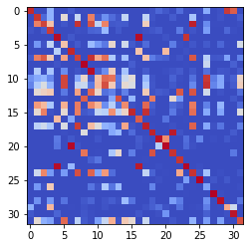

epoch 3071 == measurement_heuristic: 0.40+-0.01/0.35+-0.01 --

epoch 3072 == measurement_heuristic: 0.37+-0.01/0.35+-0.01 --

epoch 3073 >> measurement_heuristic: 0.38+-0.01/0.33+-0.01 --

epoch 3074 == measurement_heuristic: 0.40+-0.01/0.34+-0.01 --

epoch 3075 == measurement_heuristic: 0.36+-0.01/0.33+-0.01 --

epoch 3076 == measurement_heuristic: 0.39+-0.01/0.34+-0.01 --

epoch 3077 == measurement_heuristic: 0.39+-0.01/0.34+-0.01 --

epoch 3078 == measurement_heuristic: 0.38+-0.01/0.34+-0.01 --

epoch 3079 == measurement_heuristic: 0.37+-0.01/0.34+-0.01 --

epoch 3080 == measurement_heuristic: 0.37+-0.01/0.35+-0.01 --

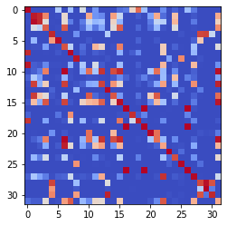

epoch 3081 == measurement_heuristic: 0.39+-0.01/0.36+-0.01 --

epoch 3082 == measurement_heuristic: 0.39+-0.01/0.34+-0.01 --

epoch 3083 == measurement_heuristic: 0.38+-0.01/0.34+-0.01 --

epoch 3084 == measurement_heuristic: 0.39+-0.01/0.34+-0.01 --

epoch 3085 == measurement_heuristic: 0.39+-0.01/0.33+-0.01 --

epoch 3086 == measurement_heuristic: 0.39+-0.01/0.33+-0.01 --

epoch 3087 == measurement_heuristic: 0.38+-0.01/0.34+-0.01 --

epoch 3088 == measurement_heuristic: 0.37+-0.01/0.35+-0.01 --

epoch 3089 == measurement_heuristic: 0.42+-0.01/0.35+-0.01 --

epoch 3090 == measurement_heuristic: 0.38+-0.01/0.36+-0.01 --

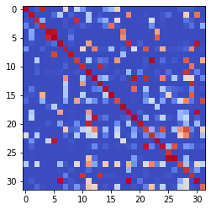

epoch 3091 == measurement_heuristic: 0.38+-0.01/0.34+-0.01 --

epoch 3092 == measurement_heuristic: 0.38+-0.01/0.33+-0.01 --

epoch 3093 >> measurement_heuristic: 0.38+-0.01/0.33+-0.01 --

epoch 3094 == measurement_heuristic: 0.37+-0.01/0.34+-0.01 --

epoch 3095 == measurement_heuristic: 0.37+-0.01/0.35+-0.01 --

epoch 3096 == measurement_heuristic: 0.37+-0.01/0.34+-0.01 --

epoch 3097 == measurement_heuristic: 0.38+-0.01/0.34+-0.01 --

epoch 3098 == measurement_heuristic: 0.38+-0.01/0.34+-0.01 --

epoch 3099 == measurement_heuristic: 0.38+-0.01/0.35+-0.01 --

epoch 3100 == measurement_heuristic: 0.39+-0.01/0.34+-0.01 --

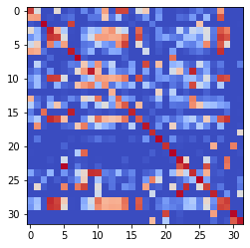

epoch 3101 == measurement_heuristic: 0.39+-0.01/0.33+-0.01 --

epoch 3102 == measurement_heuristic: 0.38+-0.01/0.34+-0.01 --

epoch 3103 == measurement_heuristic: 0.38+-0.01/0.34+-0.01 --

epoch 3104 == measurement_heuristic: 0.37+-0.01/0.33+-0.01 --

epoch 3105 == measurement_heuristic: 0.41+-0.01/0.35+-0.01 --

epoch 3106 == measurement_heuristic: 0.37+-0.01/0.33+-0.01 --

epoch 3107 == measurement_heuristic: 0.39+-0.01/0.34+-0.01 --

epoch 3108 == measurement_heuristic: 0.39+-0.01/0.34+-0.01 --

epoch 3109 == measurement_heuristic: 0.38+-0.01/0.33+-0.01 --

epoch 3110 >> measurement_heuristic: 0.38+-0.01/0.32+-0.01 --

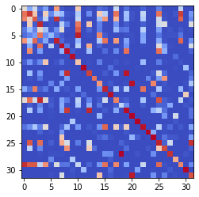

epoch 3111 == measurement_heuristic: 0.38+-0.01/0.33+-0.01 --

epoch 3112 == measurement_heuristic: 0.37+-0.01/0.34+-0.01 --

epoch 3113 == measurement_heuristic: 0.37+-0.01/0.35+-0.01 --

epoch 3114 == measurement_heuristic: 0.39+-0.01/0.33+-0.01 --

epoch 3115 == measurement_heuristic: 0.38+-0.01/0.33+-0.01 --

epoch 3116 == measurement_heuristic: 0.37+-0.01/0.33+-0.01 --

epoch 3117 == measurement_heuristic: 0.38+-0.01/0.34+-0.01 --

epoch 3118 == measurement_heuristic: 0.39+-0.01/0.36+-0.01 --

epoch 3119 == measurement_heuristic: 0.38+-0.01/0.34+-0.01 --

epoch 3120 == measurement_heuristic: 0.39+-0.01/0.36+-0.01 --

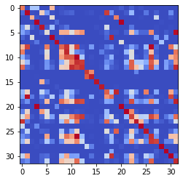

epoch 3121 == measurement_heuristic: 0.40+-0.01/0.34+-0.01 --

epoch 3122 == measurement_heuristic: 0.37+-0.01/0.33+-0.01 --

epoch 3123 == measurement_heuristic: 0.39+-0.01/0.35+-0.01 --

epoch 3124 == measurement_heuristic: 0.39+-0.01/0.33+-0.01 --

epoch 3125 == measurement_heuristic: 0.39+-0.01/0.33+-0.01 --

epoch 3126 == measurement_heuristic: 0.37+-0.01/0.35+-0.01 --

epoch 3127 == measurement_heuristic: 0.38+-0.01/0.34+-0.01 --

epoch 3128 == measurement_heuristic: 0.40+-0.01/0.33+-0.01 --

epoch 3129 == measurement_heuristic: 0.37+-0.01/0.34+-0.01 --

epoch 3130 == measurement_heuristic: 0.40+-0.01/0.34+-0.01 --

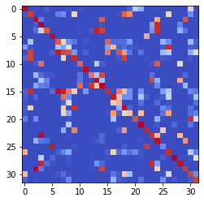

epoch 3131 == measurement_heuristic: 0.37+-0.01/0.34+-0.01 --

epoch 3132 == measurement_heuristic: 0.38+-0.01/0.35+-0.01 --

epoch 3133 == measurement_heuristic: 0.39+-0.01/0.33+-0.01 --

epoch 3134 == measurement_heuristic: 0.38+-0.01/0.33+-0.01 --

epoch 3135 == measurement_heuristic: 0.40+-0.01/0.33+-0.01 --

epoch 3136 == measurement_heuristic: 0.39+-0.01/0.33+-0.01 --

epoch 3137 == measurement_heuristic: 0.39+-0.01/0.33+-0.01 --

epoch 3138 == measurement_heuristic: 0.38+-0.01/0.35+-0.01 --

epoch 3139 == measurement_heuristic: 0.37+-0.01/0.34+-0.01 --

epoch 3140 == measurement_heuristic: 0.38+-0.01/0.34+-0.01 --

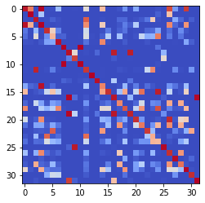

epoch 3141 == measurement_heuristic: 0.38+-0.01/0.33+-0.01 --

epoch 3142 == measurement_heuristic: 0.40+-0.01/0.34+-0.01 --

epoch 3143 == measurement_heuristic: 0.37+-0.01/0.34+-0.01 --

epoch 3144 == measurement_heuristic: 0.39+-0.01/0.34+-0.01 --

epoch 3145 == measurement_heuristic: 0.38+-0.01/0.37+-0.01 --

epoch 3146 == measurement_heuristic: 0.37+-0.01/0.33+-0.01 --

epoch 3147 == measurement_heuristic: 0.37+-0.01/0.36+-0.01 --

epoch 3148 == measurement_heuristic: 0.38+-0.01/0.34+-0.01 --

epoch 3149 == measurement_heuristic: 0.36+-0.01/0.33+-0.01 --

epoch 3150 == measurement_heuristic: 0.38+-0.01/0.34+-0.01 --

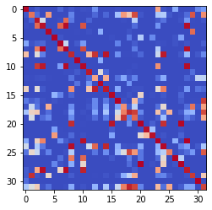

epoch 3151 == measurement_heuristic: 0.39+-0.01/0.33+-0.01 --

epoch 3152 == measurement_heuristic: 0.38+-0.01/0.34+-0.01 --

epoch 3153 == measurement_heuristic: 0.37+-0.01/0.33+-0.01 --

epoch 3154 >> measurement_heuristic: 0.37+-0.01/0.32+-0.01 --

epoch 3155 == measurement_heuristic: 0.40+-0.01/0.33+-0.01 --

epoch 3156 == measurement_heuristic: 0.40+-0.01/0.33+-0.01 --

epoch 3157 == measurement_heuristic: 0.38+-0.01/0.34+-0.01 --

epoch 3158 == measurement_heuristic: 0.41+-0.01/0.34+-0.01 --

epoch 3159 == measurement_heuristic: 0.39+-0.01/0.33+-0.01 --

epoch 3160 == measurement_heuristic: 0.39+-0.01/0.34+-0.01 --

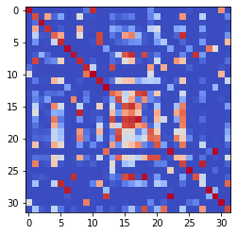

epoch 3161 == measurement_heuristic: 0.38+-0.01/0.33+-0.01 --

epoch 3162 == measurement_heuristic: 0.40+-0.01/0.37+-0.01 --

epoch 3163 == measurement_heuristic: 0.40+-0.01/0.35+-0.01 --

epoch 3164 == measurement_heuristic: 0.40+-0.01/0.34+-0.01 --

epoch 3165 == measurement_heuristic: 0.38+-0.01/0.34+-0.01 --

epoch 3166 == measurement_heuristic: 0.40+-0.01/0.33+-0.01 --

epoch 3167 == measurement_heuristic: 0.39+-0.01/0.34+-0.01 --

epoch 3168 == measurement_heuristic: 0.37+-0.01/0.35+-0.01 --

epoch 3169 == measurement_heuristic: 0.38+-0.01/0.35+-0.01 --

epoch 3170 == measurement_heuristic: 0.37+-0.01/0.34+-0.01 --

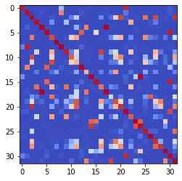

epoch 3171 == measurement_heuristic: 0.37+-0.01/0.33+-0.01 --

epoch 3172 == measurement_heuristic: 0.35+-0.01/0.36+-0.01 --

epoch 3173 == measurement_heuristic: 0.38+-0.01/0.32+-0.01 --

epoch 3174 == measurement_heuristic: 0.37+-0.01/0.35+-0.01 --

epoch 3175 == measurement_heuristic: 0.37+-0.01/0.34+-0.01 --

epoch 3176 == measurement_heuristic: 0.38+-0.01/0.34+-0.01 --

epoch 3177 == measurement_heuristic: 0.37+-0.01/0.35+-0.01 --

epoch 3178 == measurement_heuristic: 0.36+-0.01/0.34+-0.01 --

epoch 3179 == measurement_heuristic: 0.38+-0.01/0.33+-0.01 --

epoch 3180 == measurement_heuristic: 0.39+-0.01/0.35+-0.01 --

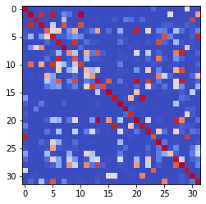

epoch 3181 == measurement_heuristic: 0.40+-0.01/0.34+-0.01 --

epoch 3182 == measurement_heuristic: 0.39+-0.01/0.33+-0.01 --

epoch 3183 == measurement_heuristic: 0.36+-0.01/0.34+-0.01 --

epoch 3184 == measurement_heuristic: 0.39+-0.01/0.35+-0.01 --

epoch 3185 == measurement_heuristic: 0.38+-0.01/0.34+-0.01 --

epoch 3186 == measurement_heuristic: 0.38+-0.01/0.33+-0.01 --

epoch 3187 == measurement_heuristic: 0.37+-0.01/0.34+-0.01 --

epoch 3188 == measurement_heuristic: 0.38+-0.01/0.34+-0.01 --

epoch 3189 == measurement_heuristic: 0.38+-0.01/0.33+-0.01 --

epoch 3190 == measurement_heuristic: 0.37+-0.01/0.33+-0.01 --

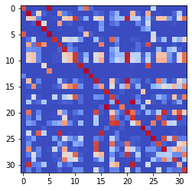

epoch 3191 == measurement_heuristic: 0.38+-0.01/0.32+-0.01 --

epoch 3192 == measurement_heuristic: 0.38+-0.01/0.33+-0.01 --

epoch 3193 == measurement_heuristic: 0.39+-0.01/0.34+-0.01 --

epoch 3194 == measurement_heuristic: 0.37+-0.01/0.35+-0.01 --

epoch 3195 == measurement_heuristic: 0.39+-0.01/0.34+-0.01 --

epoch 3196 == measurement_heuristic: 0.36+-0.01/0.34+-0.01 --

epoch 3197 == measurement_heuristic: 0.39+-0.01/0.33+-0.01 --

epoch 3198 == measurement_heuristic: 0.37+-0.01/0.33+-0.01 --

epoch 3199 == measurement_heuristic: 0.36+-0.01/0.32+-0.01 --

epoch 3200 == measurement_heuristic: 0.37+-0.01/0.33+-0.01 --

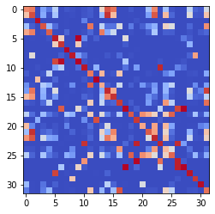

epoch 3201 == measurement_heuristic: 0.36+-0.01/0.33+-0.01 --

epoch 3202 == measurement_heuristic: 0.40+-0.01/0.33+-0.01 --

epoch 3203 == measurement_heuristic: 0.38+-0.01/0.34+-0.01 --

epoch 3204 == measurement_heuristic: 0.39+-0.01/0.33+-0.01 --

epoch 3205 == measurement_heuristic: 0.39+-0.01/0.33+-0.01 --

epoch 3206 == measurement_heuristic: 0.39+-0.01/0.33+-0.01 --

epoch 3207 == measurement_heuristic: 0.38+-0.01/0.34+-0.01 --

epoch 3208 == measurement_heuristic: 0.38+-0.01/0.34+-0.01 --

epoch 3209 == measurement_heuristic: 0.39+-0.01/0.34+-0.01 --

epoch 3210 == measurement_heuristic: 0.39+-0.01/0.33+-0.01 --

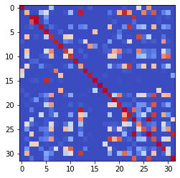

epoch 3211 == measurement_heuristic: 0.37+-0.01/0.33+-0.01 --

epoch 3212 == measurement_heuristic: 0.38+-0.01/0.34+-0.01 --

epoch 3213 == measurement_heuristic: 0.37+-0.01/0.33+-0.01 --

epoch 3214 == measurement_heuristic: 0.37+-0.01/0.33+-0.01 --

epoch 3215 == measurement_heuristic: 0.36+-0.01/0.34+-0.01 --

epoch 3216 == measurement_heuristic: 0.39+-0.01/0.34+-0.01 --

epoch 3217 == measurement_heuristic: 0.37+-0.01/0.34+-0.01 --

epoch 3218 == measurement_heuristic: 0.39+-0.01/0.35+-0.01 --

epoch 3219 == measurement_heuristic: 0.38+-0.01/0.33+-0.01 --

epoch 3220 == measurement_heuristic: 0.39+-0.01/0.33+-0.01 --

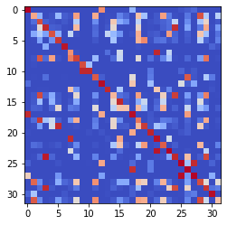

epoch 3221 == measurement_heuristic: 0.38+-0.01/0.33+-0.01 --

epoch 3222 == measurement_heuristic: 0.38+-0.01/0.33+-0.01 --

epoch 3223 == measurement_heuristic: 0.40+-0.01/0.33+-0.01 --

epoch 3224 == measurement_heuristic: 0.38+-0.01/0.33+-0.01 --

epoch 3225 == measurement_heuristic: 0.41+-0.01/0.33+-0.01 --

epoch 3226 == measurement_heuristic: 0.39+-0.01/0.34+-0.01 --

epoch 3227 == measurement_heuristic: 0.38+-0.01/0.35+-0.01 --

epoch 3228 == measurement_heuristic: 0.39+-0.01/0.33+-0.01 --

epoch 3229 == measurement_heuristic: 0.39+-0.01/0.35+-0.01 --

epoch 3230 == measurement_heuristic: 0.37+-0.01/0.35+-0.01 --

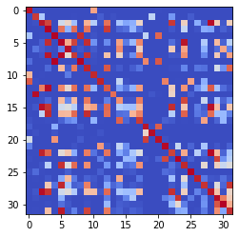

epoch 3231 == measurement_heuristic: 0.37+-0.01/0.34+-0.01 --

epoch 3232 == measurement_heuristic: 0.39+-0.01/0.33+-0.01 --

epoch 3233 == measurement_heuristic: 0.40+-0.01/0.35+-0.01 --

epoch 3234 == measurement_heuristic: 0.39+-0.01/0.33+-0.01 --

epoch 3235 == measurement_heuristic: 0.38+-0.01/0.34+-0.01 --

epoch 3236 == measurement_heuristic: 0.37+-0.01/0.33+-0.01 --

epoch 3237 == measurement_heuristic: 0.39+-0.01/0.34+-0.01 --

epoch 3238 == measurement_heuristic: 0.38+-0.01/0.33+-0.01 --

epoch 3239 == measurement_heuristic: 0.36+-0.01/0.33+-0.01 --

epoch 3240 == measurement_heuristic: 0.37+-0.01/0.35+-0.01 --

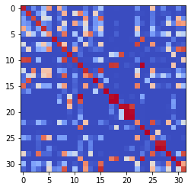

epoch 3241 == measurement_heuristic: 0.36+-0.01/0.33+-0.01 --

epoch 3242 == measurement_heuristic: 0.38+-0.01/0.33+-0.01 --

epoch 3243 == measurement_heuristic: 0.37+-0.01/0.34+-0.01 --

epoch 3244 == measurement_heuristic: 0.35+-0.01/0.33+-0.01 --

epoch 3245 == measurement_heuristic: 0.39+-0.01/0.35+-0.01 --

epoch 3246 == measurement_heuristic: 0.38+-0.01/0.34+-0.01 --

epoch 3247 == measurement_heuristic: 0.39+-0.01/0.34+-0.01 --

epoch 3248 == measurement_heuristic: 0.37+-0.01/0.34+-0.01 --

epoch 3249 == measurement_heuristic: 0.38+-0.01/0.34+-0.01 --

epoch 3250 == measurement_heuristic: 0.36+-0.01/0.33+-0.01 --

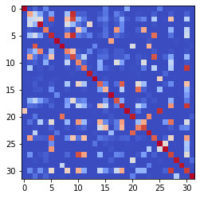

epoch 3251 == measurement_heuristic: 0.40+-0.01/0.34+-0.01 --

epoch 3252 == measurement_heuristic: 0.41+-0.01/0.35+-0.01 --

epoch 3253 == measurement_heuristic: 0.37+-0.01/0.33+-0.01 --

epoch 3254 == measurement_heuristic: 0.38+-0.01/0.37+-0.01 --

epoch 3255 >> measurement_heuristic: 0.38+-0.01/0.32+-0.01 --

epoch 3256 == measurement_heuristic: 0.39+-0.01/0.33+-0.01 --

epoch 3257 == measurement_heuristic: 0.39+-0.01/0.33+-0.01 --

epoch 3258 == measurement_heuristic: 0.40+-0.01/0.34+-0.01 --

epoch 3259 == measurement_heuristic: 0.38+-0.01/0.33+-0.01 --

epoch 3260 == measurement_heuristic: 0.36+-0.01/0.33+-0.01 --

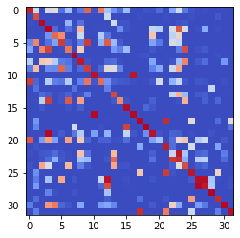

epoch 3261 == measurement_heuristic: 0.41+-0.01/0.35+-0.01 --

epoch 3262 >> measurement_heuristic: 0.38+-0.01/0.32+-0.01 --

epoch 3263 == measurement_heuristic: 0.38+-0.01/0.34+-0.01 --

epoch 3264 == measurement_heuristic: 0.39+-0.01/0.33+-0.01 --

epoch 3265 == measurement_heuristic: 0.38+-0.01/0.33+-0.01 --

epoch 3266 == measurement_heuristic: 0.37+-0.01/0.33+-0.01 --

epoch 3267 == measurement_heuristic: 0.39+-0.01/0.33+-0.01 --

epoch 3268 == measurement_heuristic: 0.37+-0.01/0.33+-0.01 --

epoch 3269 == measurement_heuristic: 0.40+-0.01/0.35+-0.01 --

epoch 3270 == measurement_heuristic: 0.38+-0.01/0.32+-0.01 --

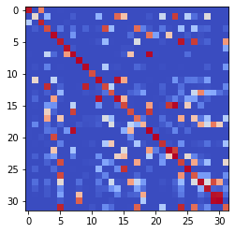

epoch 3271 == measurement_heuristic: 0.41+-0.01/0.35+-0.01 --

epoch 3272 == measurement_heuristic: 0.38+-0.01/0.34+-0.01 --

epoch 3273 == measurement_heuristic: 0.38+-0.01/0.33+-0.01 --

epoch 3274 == measurement_heuristic: 0.37+-0.01/0.34+-0.01 --

epoch 3275 == measurement_heuristic: 0.37+-0.01/0.33+-0.01 --

epoch 3276 == measurement_heuristic: 0.37+-0.01/0.33+-0.01 --

epoch 3277 == measurement_heuristic: 0.38+-0.01/0.33+-0.01 --

epoch 3278 == measurement_heuristic: 0.37+-0.01/0.33+-0.01 --

epoch 3279 == measurement_heuristic: 0.40+-0.01/0.33+-0.01 --

epoch 3280 == measurement_heuristic: 0.37+-0.01/0.33+-0.01 --

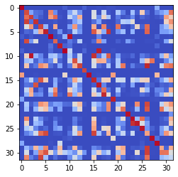

epoch 3281 == measurement_heuristic: 0.38+-0.01/0.33+-0.01 --

epoch 3282 == measurement_heuristic: 0.37+-0.01/0.33+-0.01 --

epoch 3283 == measurement_heuristic: 0.38+-0.01/0.33+-0.01 --

epoch 3284 == measurement_heuristic: 0.37+-0.01/0.33+-0.01 --

epoch 3285 == measurement_heuristic: 0.37+-0.01/0.34+-0.01 --

epoch 3286 == measurement_heuristic: 0.39+-0.01/0.33+-0.01 --

epoch 3287 == measurement_heuristic: 0.37+-0.01/0.32+-0.01 --

epoch 3288 == measurement_heuristic: 0.36+-0.01/0.34+-0.01 --

epoch 3289 == measurement_heuristic: 0.37+-0.01/0.33+-0.01 --

epoch 3290 == measurement_heuristic: 0.38+-0.01/0.34+-0.01 --

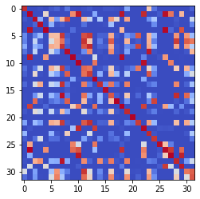

epoch 3291 == measurement_heuristic: 0.37+-0.01/0.34+-0.01 --

epoch 3292 == measurement_heuristic: 0.37+-0.01/0.33+-0.01 --

epoch 3293 == measurement_heuristic: 0.39+-0.01/0.34+-0.01 --

epoch 3294 == measurement_heuristic: 0.38+-0.01/0.33+-0.01 --

epoch 3295 == measurement_heuristic: 0.38+-0.01/0.33+-0.01 --

epoch 3296 == measurement_heuristic: 0.38+-0.01/0.34+-0.01 --

epoch 3297 == measurement_heuristic: 0.38+-0.01/0.33+-0.01 --

epoch 3298 == measurement_heuristic: 0.37+-0.01/0.33+-0.01 --

epoch 3299 == measurement_heuristic: 0.37+-0.01/0.33+-0.01 --

epoch 3300 == measurement_heuristic: 0.37+-0.01/0.32+-0.01 --

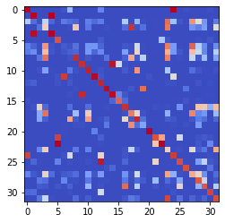

epoch 3301 == measurement_heuristic: 0.37+-0.01/0.32+-0.01 --

epoch 3302 == measurement_heuristic: 0.38+-0.01/0.33+-0.01 --

epoch 3303 == measurement_heuristic: 0.40+-0.01/0.34+-0.01 --

epoch 3304 == measurement_heuristic: 0.36+-0.01/0.34+-0.01 --

epoch 3305 == measurement_heuristic: 0.36+-0.01/0.32+-0.01 --

epoch 3306 == measurement_heuristic: 0.36+-0.01/0.34+-0.01 --

epoch 3307 == measurement_heuristic: 0.38+-0.01/0.33+-0.01 --

epoch 3308 == measurement_heuristic: 0.36+-0.01/0.32+-0.01 --

epoch 3309 == measurement_heuristic: 0.37+-0.01/0.33+-0.01 --

epoch 3310 == measurement_heuristic: 0.36+-0.01/0.33+-0.01 --

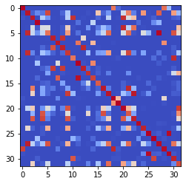

epoch 3311 == measurement_heuristic: 0.36+-0.01/0.35+-0.01 --

epoch 3312 == measurement_heuristic: 0.37+-0.01/0.33+-0.01 --

epoch 3313 == measurement_heuristic: 0.37+-0.01/0.33+-0.01 --

epoch 3314 == measurement_heuristic: 0.39+-0.01/0.34+-0.01 --

epoch 3315 == measurement_heuristic: 0.37+-0.01/0.33+-0.01 --

epoch 3316 == measurement_heuristic: 0.36+-0.01/0.33+-0.01 --

epoch 3317 == measurement_heuristic: 0.37+-0.01/0.33+-0.01 --

epoch 3318 == measurement_heuristic: 0.37+-0.01/0.34+-0.01 --

epoch 3319 == measurement_heuristic: 0.38+-0.01/0.33+-0.01 --

epoch 3320 == measurement_heuristic: 0.37+-0.01/0.33+-0.01 --

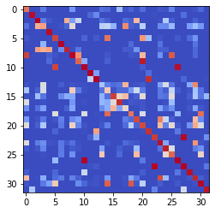

epoch 3321 == measurement_heuristic: 0.37+-0.01/0.33+-0.01 --

epoch 3322 >> measurement_heuristic: 0.39+-0.01/0.32+-0.01 --

epoch 3323 == measurement_heuristic: 0.37+-0.01/0.33+-0.01 --

epoch 3324 == measurement_heuristic: 0.36+-0.01/0.32+-0.01 --

epoch 3325 == measurement_heuristic: 0.37+-0.01/0.32+-0.01 --

epoch 3326 == measurement_heuristic: 0.36+-0.01/0.32+-0.01 --

epoch 3327 == measurement_heuristic: 0.39+-0.01/0.33+-0.01 --

epoch 3328 == measurement_heuristic: 0.37+-0.01/0.33+-0.01 --

epoch 3329 == measurement_heuristic: 0.37+-0.01/0.33+-0.01 --

epoch 3330 == measurement_heuristic: 0.39+-0.01/0.33+-0.01 --

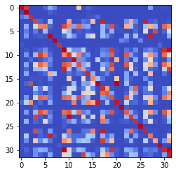

epoch 3331 == measurement_heuristic: 0.39+-0.01/0.35+-0.01 --

epoch 3332 == measurement_heuristic: 0.37+-0.01/0.33+-0.01 --

epoch 3333 == measurement_heuristic: 0.38+-0.01/0.33+-0.01 --

epoch 3334 == measurement_heuristic: 0.39+-0.01/0.35+-0.01 --

epoch 3335 == measurement_heuristic: 0.40+-0.01/0.33+-0.01 --

epoch 3336 == measurement_heuristic: 0.37+-0.01/0.37+-0.01 --

epoch 3337 == measurement_heuristic: 0.37+-0.01/0.34+-0.01 --

epoch 3338 == measurement_heuristic: 0.37+-0.01/0.34+-0.01 --

epoch 3339 == measurement_heuristic: 0.37+-0.01/0.34+-0.01 --

epoch 3340 == measurement_heuristic: 0.38+-0.01/0.32+-0.01 --

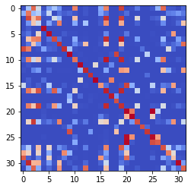

epoch 3341 == measurement_heuristic: 0.36+-0.01/0.33+-0.01 --

epoch 3342 == measurement_heuristic: 0.37+-0.01/0.33+-0.01 --

epoch 3343 == measurement_heuristic: 0.35+-0.01/0.35+-0.01 --

epoch 3344 == measurement_heuristic: 0.39+-0.01/0.33+-0.01 --

epoch 3345 == measurement_heuristic: 0.38+-0.01/0.32+-0.01 --

epoch 3346 == measurement_heuristic: 0.36+-0.01/0.34+-0.01 --

epoch 3347 == measurement_heuristic: 0.37+-0.01/0.32+-0.01 --

epoch 3348 == measurement_heuristic: 0.38+-0.01/0.34+-0.01 --

epoch 3349 == measurement_heuristic: 0.38+-0.01/0.34+-0.01 --

epoch 3350 == measurement_heuristic: 0.37+-0.01/0.34+-0.01 --

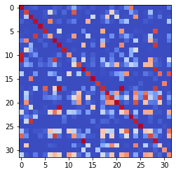

epoch 3351 == measurement_heuristic: 0.38+-0.01/0.34+-0.01 --

epoch 3352 == measurement_heuristic: 0.38+-0.01/0.34+-0.01 --

epoch 3353 == measurement_heuristic: 0.38+-0.01/0.33+-0.01 --

epoch 3354 == measurement_heuristic: 0.37+-0.01/0.33+-0.01 --

epoch 3355 == measurement_heuristic: 0.35+-0.01/0.34+-0.01 --

epoch 3356 == measurement_heuristic: 0.38+-0.01/0.34+-0.01 --

epoch 3357 == measurement_heuristic: 0.39+-0.01/0.32+-0.01 --

epoch 3358 == measurement_heuristic: 0.36+-0.01/0.33+-0.01 --

epoch 3359 == measurement_heuristic: 0.36+-0.01/0.33+-0.01 --

epoch 3360 == measurement_heuristic: 0.37+-0.01/0.32+-0.01 --

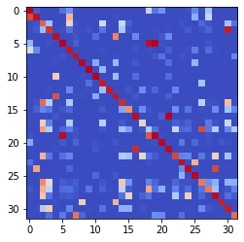

epoch 3361 == measurement_heuristic: 0.37+-0.01/0.33+-0.01 --

epoch 3362 == measurement_heuristic: 0.38+-0.01/0.32+-0.01 --

epoch 3363 == measurement_heuristic: 0.37+-0.01/0.32+-0.01 --

epoch 3364 == measurement_heuristic: 0.37+-0.01/0.33+-0.01 --

epoch 3365 == measurement_heuristic: 0.38+-0.01/0.32+-0.01 --

epoch 3366 == measurement_heuristic: 0.39+-0.01/0.34+-0.01 --

epoch 3367 == measurement_heuristic: 0.37+-0.01/0.32+-0.01 --

epoch 3368 == measurement_heuristic: 0.36+-0.01/0.33+-0.01 --

epoch 3369 == measurement_heuristic: 0.36+-0.01/0.33+-0.01 --

epoch 3370 == measurement_heuristic: 0.37+-0.01/0.34+-0.01 --

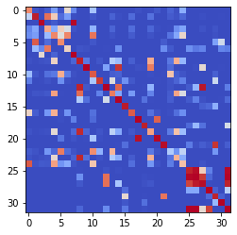

epoch 3371 == measurement_heuristic: 0.39+-0.01/0.32+-0.01 --

epoch 3372 == measurement_heuristic: 0.38+-0.01/0.33+-0.01 --

epoch 3373 == measurement_heuristic: 0.36+-0.01/0.33+-0.01 --

epoch 3374 == measurement_heuristic: 0.37+-0.01/0.33+-0.01 --

epoch 3375 == measurement_heuristic: 0.38+-0.01/0.32+-0.01 --

epoch 3376 == measurement_heuristic: 0.40+-0.01/0.33+-0.01 --

epoch 3377 == measurement_heuristic: 0.36+-0.01/0.34+-0.01 --

epoch 3378 == measurement_heuristic: 0.37+-0.01/0.33+-0.01 --

epoch 3379 == measurement_heuristic: 0.37+-0.01/0.33+-0.01 --

epoch 3380 == measurement_heuristic: 0.36+-0.01/0.33+-0.01 --

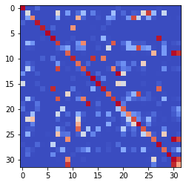

epoch 3381 == measurement_heuristic: 0.38+-0.01/0.35+-0.01 --

epoch 3382 == measurement_heuristic: 0.36+-0.01/0.33+-0.01 --

epoch 3383 == measurement_heuristic: 0.39+-0.01/0.33+-0.01 --

epoch 3384 == measurement_heuristic: 0.38+-0.01/0.34+-0.01 --

epoch 3385 == measurement_heuristic: 0.38+-0.01/0.33+-0.01 --

epoch 3386 == measurement_heuristic: 0.40+-0.01/0.34+-0.01 --

epoch 3387 == measurement_heuristic: 0.40+-0.01/0.32+-0.01 --

epoch 3388 == measurement_heuristic: 0.36+-0.01/0.32+-0.01 --

epoch 3389 == measurement_heuristic: 0.38+-0.01/0.36+-0.01 --

epoch 3390 == measurement_heuristic: 0.38+-0.01/0.34+-0.01 --

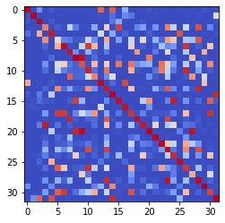

epoch 3391 == measurement_heuristic: 0.38+-0.01/0.32+-0.01 --

epoch 3392 == measurement_heuristic: 0.36+-0.01/0.33+-0.01 --

epoch 3393 == measurement_heuristic: 0.35+-0.01/0.32+-0.01 --

epoch 3394 == measurement_heuristic: 0.38+-0.01/0.34+-0.01 --

epoch 3395 == measurement_heuristic: 0.37+-0.01/0.32+-0.01 --

epoch 3396 == measurement_heuristic: 0.37+-0.01/0.34+-0.01 --

epoch 3397 == measurement_heuristic: 0.37+-0.01/0.34+-0.01 --

epoch 3398 == measurement_heuristic: 0.36+-0.01/0.33+-0.01 --

epoch 3399 == measurement_heuristic: 0.39+-0.01/0.33+-0.01 --

epoch 3400 == measurement_heuristic: 0.35+-0.01/0.33+-0.01 --

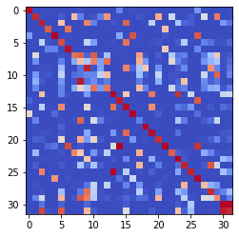

epoch 3401 == measurement_heuristic: 0.38+-0.01/0.34+-0.01 --

epoch 3402 == measurement_heuristic: 0.36+-0.01/0.33+-0.01 --

epoch 3403 == measurement_heuristic: 0.37+-0.01/0.32+-0.01 --

epoch 3404 == measurement_heuristic: 0.38+-0.01/0.32+-0.01 --

epoch 3405 == measurement_heuristic: 0.37+-0.01/0.32+-0.01 --

epoch 3406 == measurement_heuristic: 0.38+-0.01/0.34+-0.01 --

epoch 3407 == measurement_heuristic: 0.38+-0.01/0.32+-0.01 --

epoch 3408 == measurement_heuristic: 0.35+-0.01/0.32+-0.01 --

epoch 3409 == measurement_heuristic: 0.38+-0.01/0.37+-0.01 --

epoch 3410 == measurement_heuristic: 0.38+-0.01/0.33+-0.01 --

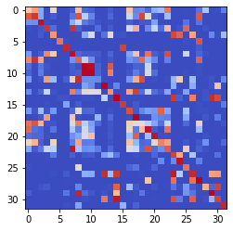

epoch 3411 == measurement_heuristic: 0.36+-0.01/0.32+-0.01 --

epoch 3412 == measurement_heuristic: 0.38+-0.01/0.32+-0.01 --

epoch 3413 == measurement_heuristic: 0.37+-0.01/0.32+-0.01 --

epoch 3414 == measurement_heuristic: 0.39+-0.01/0.34+-0.01 --

epoch 3415 == measurement_heuristic: 0.37+-0.01/0.34+-0.01 --

epoch 3416 == measurement_heuristic: 0.39+-0.01/0.35+-0.01 --

epoch 3417 == measurement_heuristic: 0.38+-0.01/0.32+-0.01 --

epoch 3418 == measurement_heuristic: 0.37+-0.01/0.33+-0.01 --

epoch 3419 == measurement_heuristic: 0.37+-0.01/0.32+-0.01 --

epoch 3420 == measurement_heuristic: 0.36+-0.01/0.33+-0.01 --

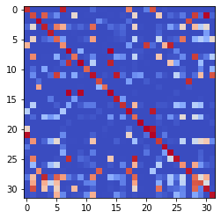

epoch 3421 == measurement_heuristic: 0.37+-0.01/0.32+-0.01 --

epoch 3422 == measurement_heuristic: 0.38+-0.01/0.32+-0.01 --

epoch 3423 == measurement_heuristic: 0.37+-0.01/0.35+-0.01 --

epoch 3424 == measurement_heuristic: 0.36+-0.01/0.33+-0.01 --

epoch 3425 == measurement_heuristic: 0.37+-0.01/0.32+-0.01 --

epoch 3426 == measurement_heuristic: 0.34+-0.01/0.32+-0.01 --

epoch 3427 == measurement_heuristic: 0.38+-0.01/0.35+-0.01 --

epoch 3428 == measurement_heuristic: 0.37+-0.01/0.33+-0.01 --

epoch 3429 == measurement_heuristic: 0.38+-0.01/0.32+-0.01 --

epoch 3430 == measurement_heuristic: 0.36+-0.01/0.33+-0.01 --

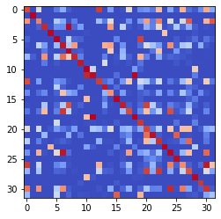

epoch 3431 == measurement_heuristic: 0.38+-0.01/0.34+-0.01 --

epoch 3432 == measurement_heuristic: 0.37+-0.01/0.35+-0.01 --

epoch 3433 == measurement_heuristic: 0.38+-0.01/0.34+-0.01 --

epoch 3434 == measurement_heuristic: 0.36+-0.01/0.32+-0.01 --

epoch 3435 == measurement_heuristic: 0.40+-0.01/0.34+-0.01 --

epoch 3436 == measurement_heuristic: 0.36+-0.01/0.33+-0.01 --

epoch 3437 == measurement_heuristic: 0.36+-0.01/0.32+-0.01 --

epoch 3438 == measurement_heuristic: 0.38+-0.01/0.33+-0.01 --

epoch 3439 == measurement_heuristic: 0.37+-0.01/0.33+-0.01 --

epoch 3440 == measurement_heuristic: 0.39+-0.01/0.34+-0.01 --

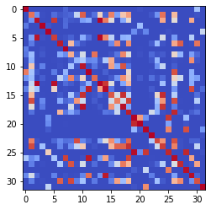

epoch 3441 == measurement_heuristic: 0.37+-0.01/0.32+-0.01 --

epoch 3442 == measurement_heuristic: 0.37+-0.01/0.32+-0.01 --

epoch 3443 == measurement_heuristic: 0.39+-0.01/0.33+-0.01 --

epoch 3444 == measurement_heuristic: 0.37+-0.01/0.34+-0.01 --

epoch 3445 == measurement_heuristic: 0.38+-0.01/0.33+-0.01 --

epoch 3446 == measurement_heuristic: 0.36+-0.01/0.32+-0.01 --

epoch 3447 >> measurement_heuristic: 0.35+-0.01/0.31+-0.01 --

epoch 3448 == measurement_heuristic: 0.37+-0.01/0.33+-0.01 --

epoch 3449 == measurement_heuristic: 0.36+-0.01/0.32+-0.01 --

epoch 3450 == measurement_heuristic: 0.35+-0.01/0.32+-0.01 --

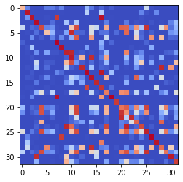

epoch 3451 == measurement_heuristic: 0.36+-0.01/0.32+-0.01 --

epoch 3452 == measurement_heuristic: 0.37+-0.01/0.33+-0.01 --

epoch 3453 == measurement_heuristic: 0.35+-0.01/0.34+-0.01 --

epoch 3454 == measurement_heuristic: 0.37+-0.01/0.33+-0.01 --

epoch 3455 == measurement_heuristic: 0.36+-0.01/0.32+-0.01 --

epoch 3456 == measurement_heuristic: 0.35+-0.01/0.32+-0.01 --

epoch 3457 == measurement_heuristic: 0.37+-0.01/0.32+-0.01 --

epoch 3458 == measurement_heuristic: 0.35+-0.01/0.33+-0.01 --

epoch 3459 == measurement_heuristic: 0.38+-0.01/0.34+-0.01 --

epoch 3460 == measurement_heuristic: 0.37+-0.01/0.33+-0.01 --

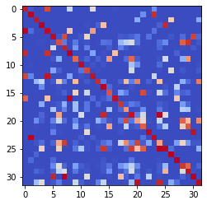

epoch 3461 == measurement_heuristic: 0.36+-0.01/0.34+-0.01 --

epoch 3462 == measurement_heuristic: 0.39+-0.01/0.33+-0.01 --

epoch 3463 == measurement_heuristic: 0.36+-0.01/0.32+-0.01 --

epoch 3464 == measurement_heuristic: 0.36+-0.01/0.32+-0.01 --

epoch 3465 == measurement_heuristic: 0.35+-0.01/0.32+-0.01 --

epoch 3466 == measurement_heuristic: 0.37+-0.01/0.32+-0.01 --

epoch 3467 == measurement_heuristic: 0.37+-0.01/0.34+-0.01 --

epoch 3468 == measurement_heuristic: 0.35+-0.01/0.34+-0.01 --

epoch 3469 == measurement_heuristic: 0.37+-0.01/0.32+-0.01 --

epoch 3470 == measurement_heuristic: 0.36+-0.01/0.33+-0.01 --

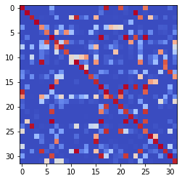

epoch 3471 == measurement_heuristic: 0.38+-0.01/0.32+-0.01 --

epoch 3472 == measurement_heuristic: 0.37+-0.01/0.33+-0.01 --

epoch 3473 == measurement_heuristic: 0.37+-0.01/0.33+-0.01 --

epoch 3474 == measurement_heuristic: 0.37+-0.01/0.32+-0.01 --

epoch 3475 == measurement_heuristic: 0.39+-0.01/0.34+-0.01 --

epoch 3476 == measurement_heuristic: 0.38+-0.01/0.35+-0.01 --

epoch 3477 == measurement_heuristic: 0.38+-0.01/0.33+-0.01 --

epoch 3478 == measurement_heuristic: 0.36+-0.01/0.34+-0.01 --

epoch 3479 == measurement_heuristic: 0.37+-0.01/0.33+-0.01 --

epoch 3480 == measurement_heuristic: 0.36+-0.01/0.33+-0.01 --

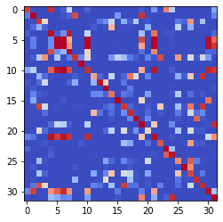

epoch 3481 == measurement_heuristic: 0.35+-0.01/0.31+-0.01 --

epoch 3482 == measurement_heuristic: 0.38+-0.01/0.36+-0.01 --

epoch 3483 == measurement_heuristic: 0.37+-0.01/0.32+-0.01 --

epoch 3484 == measurement_heuristic: 0.37+-0.01/0.34+-0.01 --

epoch 3485 == measurement_heuristic: 0.37+-0.01/0.32+-0.01 --

epoch 3486 == measurement_heuristic: 0.37+-0.01/0.33+-0.01 --

epoch 3487 == measurement_heuristic: 0.38+-0.01/0.33+-0.01 --

epoch 3488 == measurement_heuristic: 0.39+-0.01/0.32+-0.01 --

epoch 3489 == measurement_heuristic: 0.39+-0.01/0.33+-0.01 --

epoch 3490 == measurement_heuristic: 0.36+-0.01/0.32+-0.01 --

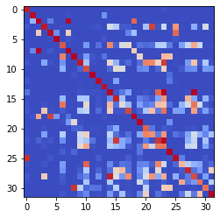

epoch 3491 == measurement_heuristic: 0.37+-0.01/0.32+-0.01 --

epoch 3492 == measurement_heuristic: 0.36+-0.01/0.33+-0.01 --

epoch 3493 == measurement_heuristic: 0.36+-0.01/0.32+-0.01 --

epoch 3494 == measurement_heuristic: 0.38+-0.01/0.34+-0.01 --

epoch 3495 == measurement_heuristic: 0.40+-0.01/0.33+-0.01 --

epoch 3496 == measurement_heuristic: 0.35+-0.01/0.33+-0.01 --

epoch 3497 == measurement_heuristic: 0.37+-0.01/0.32+-0.01 --

epoch 3498 == measurement_heuristic: 0.39+-0.01/0.32+-0.01 --

epoch 3499 == measurement_heuristic: 0.36+-0.01/0.33+-0.01 --

epoch 3500 == measurement_heuristic: 0.35+-0.01/0.33+-0.01 --

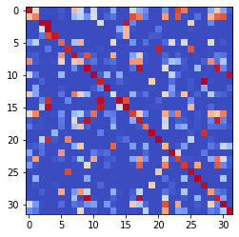

epoch 3501 == measurement_heuristic: 0.37+-0.01/0.35+-0.01 --

epoch 3502 == measurement_heuristic: 0.39+-0.01/0.37+-0.01 --

epoch 3503 == measurement_heuristic: 0.40+-0.01/0.33+-0.01 --

epoch 3504 == measurement_heuristic: 0.37+-0.01/0.33+-0.01 --

epoch 3505 == measurement_heuristic: 0.38+-0.01/0.32+-0.01 --

epoch 3506 == measurement_heuristic: 0.41+-0.01/0.35+-0.01 --

epoch 3507 == measurement_heuristic: 0.36+-0.01/0.34+-0.01 --

epoch 3508 == measurement_heuristic: 0.37+-0.01/0.32+-0.01 --

epoch 3509 == measurement_heuristic: 0.37+-0.01/0.33+-0.01 --

epoch 3510 == measurement_heuristic: 0.38+-0.01/0.35+-0.01 --

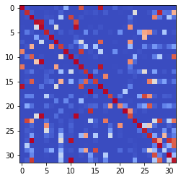

epoch 3511 == measurement_heuristic: 0.38+-0.01/0.34+-0.01 --

epoch 3512 == measurement_heuristic: 0.36+-0.01/0.32+-0.01 --

epoch 3513 == measurement_heuristic: 0.36+-0.01/0.32+-0.01 --

epoch 3514 == measurement_heuristic: 0.37+-0.01/0.32+-0.01 --

epoch 3515 == measurement_heuristic: 0.37+-0.01/0.32+-0.01 --

epoch 3516 == measurement_heuristic: 0.39+-0.01/0.33+-0.01 --

epoch 3517 == measurement_heuristic: 0.38+-0.01/0.33+-0.01 --

epoch 3518 == measurement_heuristic: 0.38+-0.01/0.33+-0.01 --

epoch 3519 == measurement_heuristic: 0.39+-0.02/0.32+-0.01 --

epoch 3520 == measurement_heuristic: 0.37+-0.01/0.35+-0.01 --

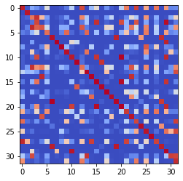

epoch 3521 == measurement_heuristic: 0.36+-0.01/0.33+-0.01 --

epoch 3522 == measurement_heuristic: 0.38+-0.01/0.34+-0.01 --

epoch 3523 == measurement_heuristic: 0.39+-0.01/0.33+-0.01 --

epoch 3524 >> measurement_heuristic: 0.37+-0.01/0.31+-0.01 --

epoch 3525 == measurement_heuristic: 0.38+-0.01/0.33+-0.01 --

epoch 3526 == measurement_heuristic: 0.38+-0.01/0.34+-0.01 --

epoch 3527 == measurement_heuristic: 0.36+-0.01/0.33+-0.01 --

epoch 3528 == measurement_heuristic: 0.38+-0.01/0.33+-0.01 --

epoch 3529 == measurement_heuristic: 0.36+-0.01/0.33+-0.01 --

epoch 3530 == measurement_heuristic: 0.36+-0.01/0.34+-0.01 --

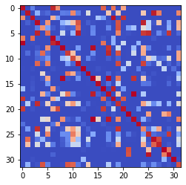

epoch 3531 == measurement_heuristic: 0.39+-0.01/0.33+-0.01 --

epoch 3532 == measurement_heuristic: 0.39+-0.01/0.34+-0.01 --

epoch 3533 == measurement_heuristic: 0.37+-0.01/0.34+-0.01 --

epoch 3534 == measurement_heuristic: 0.37+-0.01/0.32+-0.01 --

epoch 3535 == measurement_heuristic: 0.35+-0.01/0.32+-0.01 --

epoch 3536 == measurement_heuristic: 0.37+-0.01/0.34+-0.01 --

epoch 3537 == measurement_heuristic: 0.36+-0.01/0.32+-0.01 --

epoch 3538 == measurement_heuristic: 0.35+-0.01/0.33+-0.01 --

epoch 3539 == measurement_heuristic: 0.38+-0.01/0.34+-0.01 --

epoch 3540 == measurement_heuristic: 0.37+-0.01/0.32+-0.01 --

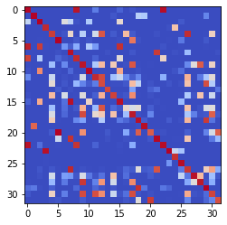

epoch 3541 == measurement_heuristic: 0.37+-0.01/0.33+-0.01 --

epoch 3542 == measurement_heuristic: 0.39+-0.01/0.33+-0.01 --

epoch 3543 == measurement_heuristic: 0.35+-0.01/0.34+-0.01 --

epoch 3544 >> measurement_heuristic: 0.35+-0.01/0.31+-0.01 --

epoch 3545 == measurement_heuristic: 0.36+-0.01/0.33+-0.01 --

epoch 3546 == measurement_heuristic: 0.34+-0.01/0.34+-0.01 --

epoch 3547 == measurement_heuristic: 0.37+-0.01/0.33+-0.01 --

epoch 3548 == measurement_heuristic: 0.37+-0.01/0.32+-0.01 --

epoch 3549 == measurement_heuristic: 0.40+-0.01/0.33+-0.01 --

epoch 3550 == measurement_heuristic: 0.36+-0.01/0.33+-0.01 --

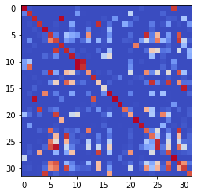

epoch 3551 == measurement_heuristic: 0.35+-0.01/0.33+-0.01 --

epoch 3552 == measurement_heuristic: 0.38+-0.01/0.32+-0.01 --

epoch 3553 == measurement_heuristic: 0.38+-0.01/0.32+-0.01 --

epoch 3554 == measurement_heuristic: 0.40+-0.01/0.33+-0.01 --

epoch 3555 == measurement_heuristic: 0.36+-0.01/0.32+-0.01 --

epoch 3556 == measurement_heuristic: 0.34+-0.01/0.33+-0.01 --

epoch 3557 == measurement_heuristic: 0.37+-0.01/0.31+-0.01 --

epoch 3558 == measurement_heuristic: 0.36+-0.01/0.34+-0.01 --

epoch 3559 == measurement_heuristic: 0.38+-0.01/0.32+-0.01 --

epoch 3560 == measurement_heuristic: 0.37+-0.01/0.33+-0.01 --

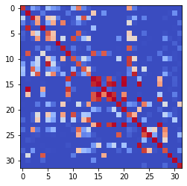

epoch 3561 == measurement_heuristic: 0.38+-0.01/0.32+-0.01 --

epoch 3562 == measurement_heuristic: 0.37+-0.01/0.33+-0.01 --

epoch 3563 == measurement_heuristic: 0.37+-0.01/0.32+-0.01 --

epoch 3564 == measurement_heuristic: 0.34+-0.01/0.32+-0.01 --

epoch 3565 == measurement_heuristic: 0.36+-0.01/0.32+-0.01 --

epoch 3566 == measurement_heuristic: 0.37+-0.01/0.33+-0.01 --

epoch 3567 == measurement_heuristic: 0.38+-0.01/0.33+-0.01 --

epoch 3568 == measurement_heuristic: 0.36+-0.01/0.33+-0.01 --

epoch 3569 == measurement_heuristic: 0.35+-0.01/0.32+-0.01 --

epoch 3570 == measurement_heuristic: 0.39+-0.01/0.33+-0.01 --

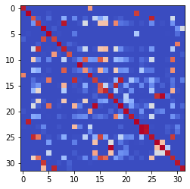

epoch 3571 == measurement_heuristic: 0.38+-0.01/0.35+-0.01 --

epoch 3572 == measurement_heuristic: 0.38+-0.01/0.32+-0.01 --

epoch 3573 == measurement_heuristic: 0.37+-0.01/0.33+-0.01 --

epoch 3574 == measurement_heuristic: 0.35+-0.01/0.33+-0.01 --

epoch 3575 == measurement_heuristic: 0.35+-0.01/0.31+-0.01 --

epoch 3576 >> measurement_heuristic: 0.36+-0.01/0.31+-0.01 --

epoch 3577 == measurement_heuristic: 0.37+-0.01/0.31+-0.01 --

epoch 3578 == measurement_heuristic: 0.36+-0.01/0.34+-0.01 --

epoch 3579 == measurement_heuristic: 0.37+-0.01/0.32+-0.01 --

epoch 3580 == measurement_heuristic: 0.36+-0.01/0.32+-0.01 --

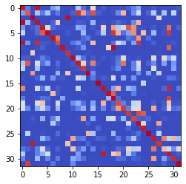

epoch 3581 == measurement_heuristic: 0.36+-0.01/0.33+-0.01 --

epoch 3582 == measurement_heuristic: 0.38+-0.01/0.35+-0.01 --

epoch 3583 == measurement_heuristic: 0.37+-0.01/0.33+-0.01 --

epoch 3584 == measurement_heuristic: 0.37+-0.01/0.33+-0.01 --

epoch 3585 >> measurement_heuristic: 0.38+-0.01/0.31+-0.01 --

epoch 3586 == measurement_heuristic: 0.36+-0.01/0.33+-0.01 --

epoch 3587 == measurement_heuristic: 0.37+-0.01/0.33+-0.01 --

epoch 3588 == measurement_heuristic: 0.36+-0.01/0.32+-0.01 --

epoch 3589 == measurement_heuristic: 0.37+-0.01/0.32+-0.01 --

epoch 3590 == measurement_heuristic: 0.39+-0.01/0.33+-0.01 --

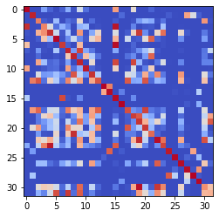

epoch 3591 == measurement_heuristic: 0.38+-0.01/0.33+-0.01 --

epoch 3592 == measurement_heuristic: 0.34+-0.01/0.32+-0.01 --

epoch 3593 == measurement_heuristic: 0.37+-0.01/0.32+-0.01 --

epoch 3594 == measurement_heuristic: 0.36+-0.01/0.32+-0.01 --

epoch 3595 == measurement_heuristic: 0.36+-0.01/0.34+-0.01 --

epoch 3596 == measurement_heuristic: 0.39+-0.01/0.32+-0.01 --

epoch 3597 == measurement_heuristic: 0.35+-0.01/0.31+-0.01 --

epoch 3598 == measurement_heuristic: 0.38+-0.01/0.32+-0.01 --

epoch 3599 == measurement_heuristic: 0.37+-0.01/0.36+-0.01 --

epoch 3600 == measurement_heuristic: 0.34+-0.01/0.32+-0.01 --

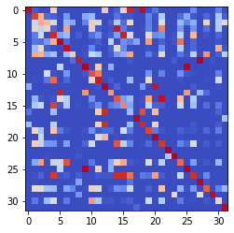

epoch 3601 == measurement_heuristic: 0.36+-0.01/0.33+-0.01 --

epoch 3602 == measurement_heuristic: 0.36+-0.01/0.32+-0.01 --

epoch 3603 == measurement_heuristic: 0.37+-0.01/0.32+-0.01 --

epoch 3604 == measurement_heuristic: 0.36+-0.01/0.32+-0.01 --

epoch 3605 == measurement_heuristic: 0.36+-0.01/0.32+-0.01 --

epoch 3606 == measurement_heuristic: 0.36+-0.01/0.32+-0.01 --

epoch 3607 == measurement_heuristic: 0.37+-0.01/0.32+-0.01 --

epoch 3608 == measurement_heuristic: 0.37+-0.01/0.33+-0.01 --

epoch 3609 == measurement_heuristic: 0.37+-0.01/0.32+-0.01 --

epoch 3610 == measurement_heuristic: 0.37+-0.01/0.32+-0.01 --

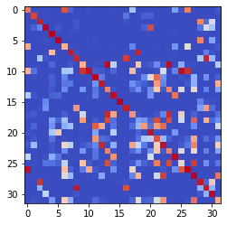

epoch 3611 == measurement_heuristic: 0.38+-0.01/0.34+-0.01 --

epoch 3612 == measurement_heuristic: 0.37+-0.01/0.34+-0.01 --

epoch 3613 == measurement_heuristic: 0.36+-0.01/0.32+-0.01 --

epoch 3614 == measurement_heuristic: 0.34+-0.01/0.31+-0.01 --

epoch 3615 == measurement_heuristic: 0.35+-0.01/0.31+-0.01 --

epoch 3616 == measurement_heuristic: 0.36+-0.01/0.33+-0.01 --

epoch 3617 == measurement_heuristic: 0.36+-0.01/0.32+-0.01 --

epoch 3618 == measurement_heuristic: 0.37+-0.01/0.32+-0.01 --

epoch 3619 == measurement_heuristic: 0.35+-0.01/0.32+-0.01 --

epoch 3620 == measurement_heuristic: 0.36+-0.01/0.32+-0.01 --

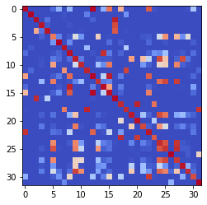

epoch 3621 == measurement_heuristic: 0.34+-0.01/0.32+-0.01 --

epoch 3622 == measurement_heuristic: 0.36+-0.01/0.32+-0.01 --

epoch 3623 == measurement_heuristic: 0.37+-0.01/0.34+-0.01 --

epoch 3624 == measurement_heuristic: 0.38+-0.01/0.33+-0.01 --

epoch 3625 == measurement_heuristic: 0.36+-0.01/0.31+-0.01 --

epoch 3626 == measurement_heuristic: 0.38+-0.01/0.31+-0.01 --

epoch 3627 == measurement_heuristic: 0.37+-0.01/0.33+-0.01 --

epoch 3628 == measurement_heuristic: 0.36+-0.01/0.35+-0.01 --

epoch 3629 == measurement_heuristic: 0.35+-0.01/0.32+-0.01 --

epoch 3630 == measurement_heuristic: 0.36+-0.01/0.34+-0.01 --

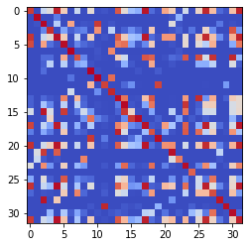

epoch 3631 == measurement_heuristic: 0.36+-0.01/0.32+-0.01 --

epoch 3632 == measurement_heuristic: 0.34+-0.01/0.32+-0.01 --

epoch 3633 == measurement_heuristic: 0.36+-0.01/0.32+-0.01 --

epoch 3634 == measurement_heuristic: 0.35+-0.01/0.32+-0.01 --

epoch 3635 == measurement_heuristic: 0.36+-0.01/0.32+-0.01 --

epoch 3636 == measurement_heuristic: 0.37+-0.01/0.32+-0.01 --

epoch 3637 == measurement_heuristic: 0.37+-0.01/0.32+-0.01 --

epoch 3638 == measurement_heuristic: 0.38+-0.01/0.33+-0.01 --

epoch 3639 == measurement_heuristic: 0.37+-0.01/0.31+-0.01 --

epoch 3640 == measurement_heuristic: 0.34+-0.01/0.32+-0.01 --

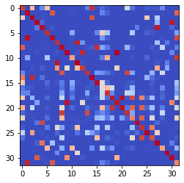

epoch 3641 == measurement_heuristic: 0.36+-0.01/0.32+-0.01 --

epoch 3642 == measurement_heuristic: 0.38+-0.01/0.32+-0.01 --

epoch 3643 == measurement_heuristic: 0.37+-0.01/0.33+-0.01 --

epoch 3644 == measurement_heuristic: 0.39+-0.01/0.31+-0.01 --

epoch 3645 == measurement_heuristic: 0.38+-0.01/0.32+-0.01 --

epoch 3646 == measurement_heuristic: 0.36+-0.01/0.34+-0.01 --

epoch 3647 == measurement_heuristic: 0.34+-0.01/0.33+-0.01 --

epoch 3648 == measurement_heuristic: 0.37+-0.01/0.32+-0.01 --

epoch 3649 == measurement_heuristic: 0.36+-0.01/0.33+-0.01 --

epoch 3650 == measurement_heuristic: 0.37+-0.01/0.32+-0.01 --

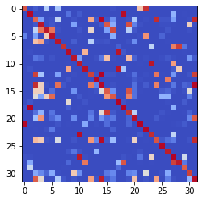

epoch 3651 == measurement_heuristic: 0.37+-0.01/0.33+-0.01 --

epoch 3652 == measurement_heuristic: 0.37+-0.01/0.34+-0.01 --

epoch 3653 == measurement_heuristic: 0.37+-0.01/0.32+-0.01 --

epoch 3654 == measurement_heuristic: 0.35+-0.01/0.31+-0.01 --

epoch 3655 == measurement_heuristic: 0.36+-0.01/0.33+-0.01 --

epoch 3656 == measurement_heuristic: 0.40+-0.01/0.33+-0.01 --

epoch 3657 == measurement_heuristic: 0.37+-0.01/0.32+-0.01 --

epoch 3658 == measurement_heuristic: 0.36+-0.01/0.33+-0.01 --

epoch 3659 == measurement_heuristic: 0.37+-0.01/0.32+-0.01 --

epoch 3660 == measurement_heuristic: 0.37+-0.01/0.32+-0.01 --

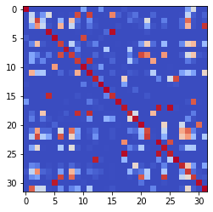

epoch 3661 == measurement_heuristic: 0.36+-0.01/0.32+-0.01 --

epoch 3662 == measurement_heuristic: 0.35+-0.01/0.32+-0.01 --

epoch 3663 == measurement_heuristic: 0.36+-0.01/0.32+-0.01 --

epoch 3664 == measurement_heuristic: 0.39+-0.01/0.32+-0.01 --

epoch 3665 == measurement_heuristic: 0.37+-0.01/0.31+-0.01 --

epoch 3666 == measurement_heuristic: 0.36+-0.01/0.34+-0.01 --

epoch 3667 == measurement_heuristic: 0.39+-0.01/0.31+-0.01 --

epoch 3668 == measurement_heuristic: 0.38+-0.01/0.32+-0.01 --

epoch 3669 == measurement_heuristic: 0.37+-0.01/0.31+-0.01 --

epoch 3670 == measurement_heuristic: 0.37+-0.01/0.32+-0.01 --

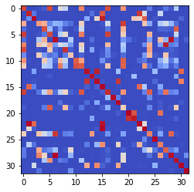

epoch 3671 == measurement_heuristic: 0.34+-0.01/0.31+-0.01 --

epoch 3672 == measurement_heuristic: 0.38+-0.01/0.32+-0.01 --

epoch 3673 == measurement_heuristic: 0.37+-0.01/0.31+-0.01 --

epoch 3674 == measurement_heuristic: 0.38+-0.01/0.34+-0.01 --

epoch 3675 == measurement_heuristic: 0.35+-0.01/0.31+-0.01 --

epoch 3676 == measurement_heuristic: 0.38+-0.01/0.34+-0.01 --

epoch 3677 == measurement_heuristic: 0.37+-0.01/0.32+-0.01 --

epoch 3678 == measurement_heuristic: 0.37+-0.01/0.31+-0.01 --

epoch 3679 == measurement_heuristic: 0.40+-0.01/0.32+-0.01 --

epoch 3680 == measurement_heuristic: 0.35+-0.01/0.32+-0.01 --

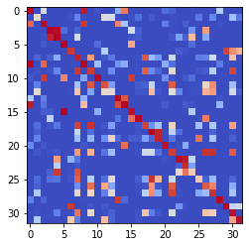

epoch 3681 == measurement_heuristic: 0.36+-0.01/0.31+-0.01 --

epoch 3682 == measurement_heuristic: 0.35+-0.01/0.33+-0.01 --

epoch 3683 == measurement_heuristic: 0.36+-0.01/0.33+-0.01 --

epoch 3684 == measurement_heuristic: 0.38+-0.01/0.32+-0.01 --

epoch 3685 >> measurement_heuristic: 0.35+-0.01/0.31+-0.01 --

epoch 3686 == measurement_heuristic: 0.34+-0.01/0.32+-0.01 --

epoch 3687 == measurement_heuristic: 0.35+-0.01/0.32+-0.01 --

epoch 3688 == measurement_heuristic: 0.37+-0.01/0.32+-0.01 --

epoch 3689 == measurement_heuristic: 0.38+-0.01/0.32+-0.01 --

epoch 3690 == measurement_heuristic: 0.36+-0.01/0.33+-0.01 --

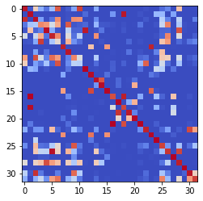

epoch 3691 == measurement_heuristic: 0.37+-0.01/0.34+-0.01 --

epoch 3692 == measurement_heuristic: 0.38+-0.01/0.32+-0.01 --

epoch 3693 == measurement_heuristic: 0.37+-0.01/0.33+-0.01 --

epoch 3694 == measurement_heuristic: 0.36+-0.01/0.32+-0.01 --

epoch 3695 == measurement_heuristic: 0.35+-0.01/0.32+-0.01 --

epoch 3696 == measurement_heuristic: 0.38+-0.01/0.32+-0.01 --

epoch 3697 == measurement_heuristic: 0.38+-0.01/0.31+-0.01 --

epoch 3698 == measurement_heuristic: 0.37+-0.01/0.34+-0.01 --

epoch 3699 == measurement_heuristic: 0.38+-0.01/0.32+-0.01 --

epoch 3700 == measurement_heuristic: 0.35+-0.01/0.32+-0.01 --

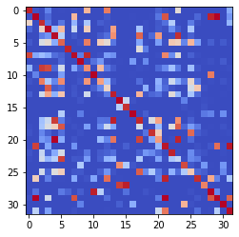

epoch 3701 == measurement_heuristic: 0.37+-0.01/0.33+-0.01 --

epoch 3702 == measurement_heuristic: 0.36+-0.01/0.31+-0.01 --

epoch 3703 == measurement_heuristic: 0.37+-0.01/0.32+-0.01 --

epoch 3704 == measurement_heuristic: 0.36+-0.01/0.33+-0.01 --

epoch 3705 == measurement_heuristic: 0.35+-0.01/0.31+-0.01 --

epoch 3706 == measurement_heuristic: 0.35+-0.01/0.33+-0.01 --

epoch 3707 == measurement_heuristic: 0.36+-0.01/0.31+-0.01 --

epoch 3708 == measurement_heuristic: 0.35+-0.01/0.32+-0.01 --

epoch 3709 == measurement_heuristic: 0.36+-0.01/0.32+-0.01 --

epoch 3710 == measurement_heuristic: 0.37+-0.01/0.31+-0.01 --

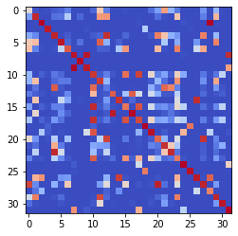

epoch 3711 == measurement_heuristic: 0.37+-0.01/0.32+-0.01 --

epoch 3712 == measurement_heuristic: 0.36+-0.01/0.32+-0.01 --

epoch 3713 == measurement_heuristic: 0.37+-0.01/0.32+-0.01 --

epoch 3714 == measurement_heuristic: 0.35+-0.01/0.32+-0.01 --

epoch 3715 == measurement_heuristic: 0.36+-0.01/0.32+-0.01 --

epoch 3716 == measurement_heuristic: 0.35+-0.01/0.32+-0.01 --

epoch 3717 == measurement_heuristic: 0.36+-0.01/0.31+-0.01 --

epoch 3718 == measurement_heuristic: 0.33+-0.01/0.33+-0.01 --

epoch 3719 == measurement_heuristic: 0.35+-0.01/0.32+-0.01 --

epoch 3720 == measurement_heuristic: 0.37+-0.01/0.32+-0.01 --

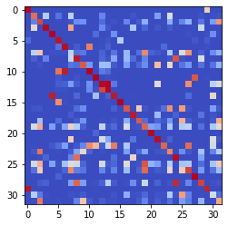

epoch 3721 == measurement_heuristic: 0.36+-0.01/0.32+-0.01 --

epoch 3722 == measurement_heuristic: 0.37+-0.01/0.31+-0.01 --

epoch 3723 == measurement_heuristic: 0.39+-0.01/0.31+-0.01 --

epoch 3724 == measurement_heuristic: 0.37+-0.01/0.33+-0.01 --

epoch 3725 == measurement_heuristic: 0.37+-0.01/0.33+-0.01 --

epoch 3726 == measurement_heuristic: 0.36+-0.01/0.34+-0.01 --

epoch 3727 == measurement_heuristic: 0.38+-0.01/0.31+-0.01 --

epoch 3728 == measurement_heuristic: 0.36+-0.01/0.32+-0.01 --

epoch 3729 == measurement_heuristic: 0.35+-0.01/0.34+-0.01 --

epoch 3730 == measurement_heuristic: 0.36+-0.01/0.31+-0.01 --

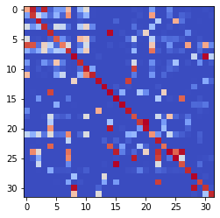

epoch 3731 == measurement_heuristic: 0.36+-0.01/0.34+-0.01 --

epoch 3732 == measurement_heuristic: 0.35+-0.01/0.34+-0.01 --

epoch 3733 == measurement_heuristic: 0.36+-0.01/0.33+-0.01 --

epoch 3734 == measurement_heuristic: 0.38+-0.01/0.31+-0.01 --

epoch 3735 == measurement_heuristic: 0.37+-0.01/0.32+-0.01 --

epoch 3736 == measurement_heuristic: 0.37+-0.01/0.33+-0.01 --

epoch 3737 == measurement_heuristic: 0.37+-0.01/0.32+-0.01 --

epoch 3738 == measurement_heuristic: 0.35+-0.01/0.31+-0.01 --

epoch 3739 == measurement_heuristic: 0.35+-0.01/0.31+-0.01 --

epoch 3740 == measurement_heuristic: 0.38+-0.01/0.32+-0.01 --

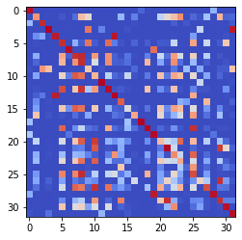

epoch 3741 == measurement_heuristic: 0.37+-0.01/0.32+-0.01 --

epoch 3742 == measurement_heuristic: 0.35+-0.01/0.31+-0.01 --

epoch 3743 == measurement_heuristic: 0.36+-0.01/0.33+-0.01 --

epoch 3744 == measurement_heuristic: 0.38+-0.01/0.31+-0.01 --

epoch 3745 == measurement_heuristic: 0.36+-0.01/0.32+-0.01 --

epoch 3746 == measurement_heuristic: 0.36+-0.01/0.32+-0.01 --

epoch 3747 == measurement_heuristic: 0.37+-0.01/0.32+-0.01 --

epoch 3748 == measurement_heuristic: 0.36+-0.01/0.31+-0.01 --

epoch 3749 == measurement_heuristic: 0.37+-0.01/0.33+-0.01 --

epoch 3750 == measurement_heuristic: 0.36+-0.01/0.31+-0.01 --

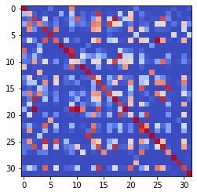

epoch 3751 == measurement_heuristic: 0.36+-0.01/0.32+-0.01 --

epoch 3752 == measurement_heuristic: 0.35+-0.01/0.31+-0.01 --

epoch 3753 == measurement_heuristic: 0.37+-0.01/0.33+-0.01 --

epoch 3754 == measurement_heuristic: 0.39+-0.01/0.32+-0.01 --

epoch 3755 == measurement_heuristic: 0.33+-0.01/0.31+-0.01 --

epoch 3756 == measurement_heuristic: 0.38+-0.01/0.32+-0.01 --

epoch 3757 == measurement_heuristic: 0.40+-0.01/0.31+-0.01 --

epoch 3758 == measurement_heuristic: 0.35+-0.01/0.31+-0.01 --

epoch 3759 == measurement_heuristic: 0.37+-0.01/0.31+-0.01 --

epoch 3760 == measurement_heuristic: 0.35+-0.01/0.31+-0.01 --

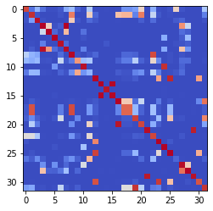

epoch 3761 == measurement_heuristic: 0.38+-0.01/0.31+-0.01 --

epoch 3762 == measurement_heuristic: 0.35+-0.01/0.31+-0.01 --

epoch 3763 == measurement_heuristic: 0.36+-0.01/0.32+-0.01 --

epoch 3764 == measurement_heuristic: 0.36+-0.01/0.31+-0.01 --

epoch 3765 == measurement_heuristic: 0.34+-0.01/0.31+-0.01 --

epoch 3766 == measurement_heuristic: 0.35+-0.01/0.33+-0.01 --

epoch 3767 == measurement_heuristic: 0.37+-0.01/0.32+-0.01 --

epoch 3768 == measurement_heuristic: 0.36+-0.01/0.32+-0.01 --

epoch 3769 == measurement_heuristic: 0.36+-0.01/0.33+-0.01 --

epoch 3770 == measurement_heuristic: 0.36+-0.01/0.31+-0.01 --

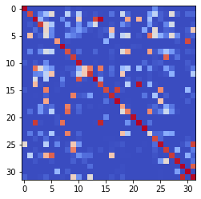

epoch 3771 == measurement_heuristic: 0.36+-0.01/0.33+-0.01 --

epoch 3772 == measurement_heuristic: 0.37+-0.01/0.33+-0.01 --

epoch 3773 == measurement_heuristic: 0.36+-0.01/0.31+-0.01 --

epoch 3774 == measurement_heuristic: 0.37+-0.01/0.33+-0.01 --

epoch 3775 == measurement_heuristic: 0.36+-0.01/0.39+-0.01 --

epoch 3776 == measurement_heuristic: 0.36+-0.01/0.32+-0.01 --

epoch 3777 == measurement_heuristic: 0.36+-0.01/0.31+-0.01 --

epoch 3778 == measurement_heuristic: 0.36+-0.01/0.33+-0.01 --

epoch 3779 == measurement_heuristic: 0.36+-0.01/0.32+-0.01 --

epoch 3780 == measurement_heuristic: 0.35+-0.01/0.31+-0.01 --

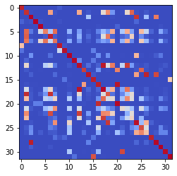

epoch 3781 == measurement_heuristic: 0.37+-0.01/0.32+-0.01 --

epoch 3782 == measurement_heuristic: 0.36+-0.01/0.32+-0.01 --

epoch 3783 == measurement_heuristic: 0.37+-0.01/0.31+-0.01 --

epoch 3784 == measurement_heuristic: 0.33+-0.01/0.32+-0.01 --

epoch 3785 == measurement_heuristic: 0.36+-0.01/0.32+-0.01 --

epoch 3786 == measurement_heuristic: 0.37+-0.01/0.33+-0.01 --

epoch 3787 == measurement_heuristic: 0.38+-0.01/0.32+-0.01 --

epoch 3788 == measurement_heuristic: 0.36+-0.01/0.32+-0.01 --

epoch 3789 == measurement_heuristic: 0.36+-0.01/0.31+-0.01 --

epoch 3790 == measurement_heuristic: 0.36+-0.01/0.32+-0.01 --

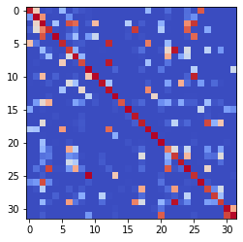

epoch 3791 == measurement_heuristic: 0.37+-0.01/0.32+-0.01 --

epoch 3792 == measurement_heuristic: 0.36+-0.01/0.32+-0.01 --

epoch 3793 == measurement_heuristic: 0.38+-0.01/0.33+-0.01 --

epoch 3794 == measurement_heuristic: 0.37+-0.01/0.33+-0.01 --

epoch 3795 == measurement_heuristic: 0.38+-0.01/0.32+-0.01 --

epoch 3796 == measurement_heuristic: 0.37+-0.01/0.31+-0.01 --

epoch 3797 == measurement_heuristic: 0.38+-0.01/0.32+-0.01 --

epoch 3798 == measurement_heuristic: 0.36+-0.01/0.31+-0.01 --

epoch 3799 == measurement_heuristic: 0.35+-0.01/0.32+-0.01 --

epoch 3800 == measurement_heuristic: 0.37+-0.01/0.32+-0.01 --

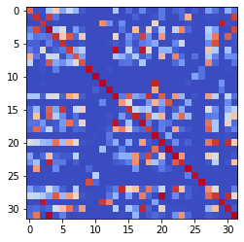

epoch 3801 == measurement_heuristic: 0.35+-0.01/0.31+-0.01 --

epoch 3802 == measurement_heuristic: 0.37+-0.01/0.34+-0.01 --

epoch 3803 == measurement_heuristic: 0.34+-0.01/0.31+-0.01 --

epoch 3804 == measurement_heuristic: 0.35+-0.01/0.31+-0.01 --

epoch 3805 == measurement_heuristic: 0.35+-0.01/0.32+-0.01 --

epoch 3806 == measurement_heuristic: 0.37+-0.01/0.31+-0.01 --

epoch 3807 == measurement_heuristic: 0.36+-0.01/0.33+-0.01 --

epoch 3808 == measurement_heuristic: 0.35+-0.01/0.31+-0.01 --

epoch 3809 == measurement_heuristic: 0.34+-0.01/0.31+-0.01 --

epoch 3810 == measurement_heuristic: 0.36+-0.01/0.36+-0.01 --

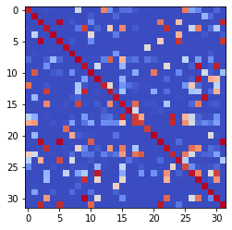

epoch 3811 == measurement_heuristic: 0.37+-0.01/0.31+-0.01 --

epoch 3812 >> measurement_heuristic: 0.35+-0.01/0.30+-0.01 --

epoch 3813 == measurement_heuristic: 0.35+-0.01/0.31+-0.01 --

epoch 3814 == measurement_heuristic: 0.36+-0.01/0.31+-0.01 --

epoch 3815 == measurement_heuristic: 0.36+-0.01/0.32+-0.01 --

epoch 3816 == measurement_heuristic: 0.37+-0.01/0.31+-0.01 --

epoch 3817 == measurement_heuristic: 0.35+-0.01/0.32+-0.01 --

epoch 3818 == measurement_heuristic: 0.35+-0.01/0.31+-0.01 --

epoch 3819 == measurement_heuristic: 0.37+-0.01/0.33+-0.01 --

epoch 3820 == measurement_heuristic: 0.36+-0.01/0.32+-0.01 --

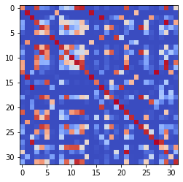

epoch 3821 == measurement_heuristic: 0.36+-0.01/0.32+-0.01 --

epoch 3822 == measurement_heuristic: 0.39+-0.01/0.32+-0.01 --

epoch 3823 == measurement_heuristic: 0.35+-0.01/0.32+-0.01 --

epoch 3824 == measurement_heuristic: 0.35+-0.01/0.36+-0.01 --

epoch 3825 == measurement_heuristic: 0.37+-0.01/0.32+-0.01 --

epoch 3826 == measurement_heuristic: 0.37+-0.01/0.31+-0.01 --

epoch 3827 == measurement_heuristic: 0.38+-0.01/0.31+-0.01 --

epoch 3828 == measurement_heuristic: 0.34+-0.01/0.33+-0.01 --

epoch 3829 == measurement_heuristic: 0.35+-0.01/0.31+-0.01 --

epoch 3830 == measurement_heuristic: 0.35+-0.01/0.32+-0.01 --

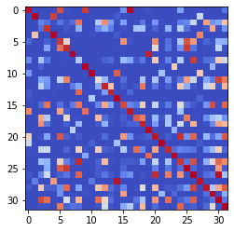

epoch 3831 == measurement_heuristic: 0.33+-0.01/0.32+-0.01 --

epoch 3832 == measurement_heuristic: 0.36+-0.01/0.31+-0.01 --

epoch 3833 == measurement_heuristic: 0.33+-0.01/0.31+-0.01 --

epoch 3834 == measurement_heuristic: 0.33+-0.01/0.31+-0.01 --

epoch 3835 == measurement_heuristic: 0.35+-0.01/0.31+-0.01 --

epoch 3836 == measurement_heuristic: 0.36+-0.01/0.31+-0.01 --

epoch 3837 == measurement_heuristic: 0.36+-0.01/0.32+-0.01 --

epoch 3838 == measurement_heuristic: 0.37+-0.01/0.32+-0.01 --

epoch 3839 == measurement_heuristic: 0.35+-0.01/0.33+-0.01 --

epoch 3840 == measurement_heuristic: 0.37+-0.01/0.32+-0.01 --

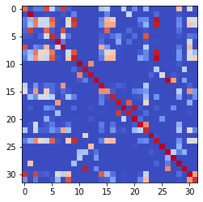

epoch 3841 == measurement_heuristic: 0.37+-0.01/0.32+-0.01 --

epoch 3842 == measurement_heuristic: 0.37+-0.01/0.31+-0.01 --

epoch 3843 == measurement_heuristic: 0.36+-0.01/0.33+-0.01 --

epoch 3844 == measurement_heuristic: 0.35+-0.01/0.32+-0.01 --

epoch 3845 == measurement_heuristic: 0.37+-0.01/0.33+-0.01 --

epoch 3846 == measurement_heuristic: 0.35+-0.01/0.30+-0.01 --

epoch 3847 == measurement_heuristic: 0.36+-0.01/0.32+-0.01 --

epoch 3848 == measurement_heuristic: 0.35+-0.01/0.32+-0.01 --

epoch 3849 == measurement_heuristic: 0.36+-0.01/0.34+-0.01 --

epoch 3850 == measurement_heuristic: 0.36+-0.01/0.31+-0.01 --

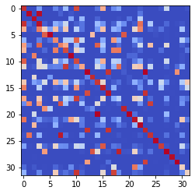

epoch 3851 == measurement_heuristic: 0.35+-0.01/0.31+-0.01 --

epoch 3852 == measurement_heuristic: 0.37+-0.01/0.34+-0.01 --

epoch 3853 == measurement_heuristic: 0.35+-0.01/0.31+-0.01 --

epoch 3854 == measurement_heuristic: 0.36+-0.01/0.33+-0.01 --

epoch 3855 == measurement_heuristic: 0.36+-0.01/0.32+-0.01 --

epoch 3856 == measurement_heuristic: 0.38+-0.01/0.32+-0.01 --

epoch 3857 == measurement_heuristic: 0.36+-0.01/0.32+-0.01 --

epoch 3858 == measurement_heuristic: 0.37+-0.01/0.31+-0.01 --

epoch 3859 == measurement_heuristic: 0.36+-0.01/0.31+-0.01 --

epoch 3860 == measurement_heuristic: 0.34+-0.01/0.32+-0.01 --

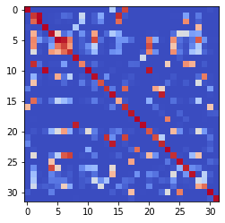

epoch 3861 == measurement_heuristic: 0.37+-0.01/0.31+-0.01 --

epoch 3862 == measurement_heuristic: 0.35+-0.01/0.32+-0.01 --

epoch 3863 == measurement_heuristic: 0.36+-0.01/0.32+-0.01 --

epoch 3864 == measurement_heuristic: 0.34+-0.01/0.31+-0.01 --

epoch 3865 == measurement_heuristic: 0.36+-0.01/0.32+-0.01 --

epoch 3866 == measurement_heuristic: 0.37+-0.01/0.33+-0.01 --

epoch 3867 == measurement_heuristic: 0.35+-0.01/0.31+-0.01 --

epoch 3868 == measurement_heuristic: 0.36+-0.01/0.31+-0.01 --

epoch 3869 == measurement_heuristic: 0.36+-0.01/0.32+-0.01 --

epoch 3870 == measurement_heuristic: 0.35+-0.01/0.31+-0.01 --

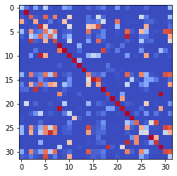

epoch 3871 == measurement_heuristic: 0.36+-0.01/0.34+-0.01 --

epoch 3872 == measurement_heuristic: 0.36+-0.01/0.32+-0.01 --

epoch 3873 == measurement_heuristic: 0.36+-0.01/0.32+-0.01 --

epoch 3874 == measurement_heuristic: 0.37+-0.01/0.31+-0.01 --

epoch 3875 == measurement_heuristic: 0.36+-0.01/0.31+-0.01 --

epoch 3876 == measurement_heuristic: 0.36+-0.01/0.35+-0.01 --

epoch 3877 == measurement_heuristic: 0.35+-0.01/0.31+-0.01 --

epoch 3878 == measurement_heuristic: 0.37+-0.01/0.32+-0.01 --

epoch 3879 == measurement_heuristic: 0.37+-0.01/0.31+-0.01 --

epoch 3880 == measurement_heuristic: 0.39+-0.01/0.32+-0.01 --

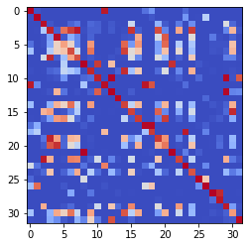

epoch 3881 == measurement_heuristic: 0.37+-0.01/0.32+-0.01 --

epoch 3882 == measurement_heuristic: 0.34+-0.01/0.33+-0.01 --

epoch 3883 >> measurement_heuristic: 0.35+-0.01/0.30+-0.01 --

epoch 3884 == measurement_heuristic: 0.36+-0.01/0.33+-0.01 --

epoch 3885 == measurement_heuristic: 0.37+-0.01/0.31+-0.01 --

epoch 3886 == measurement_heuristic: 0.36+-0.01/0.32+-0.01 --

epoch 3887 == measurement_heuristic: 0.36+-0.01/0.31+-0.01 --

epoch 3888 == measurement_heuristic: 0.36+-0.01/0.31+-0.01 --

epoch 3889 >> measurement_heuristic: 0.37+-0.01/0.30+-0.01 --

epoch 3890 == measurement_heuristic: 0.37+-0.01/0.32+-0.01 --

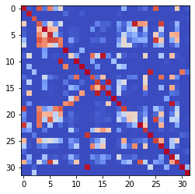

epoch 3891 == measurement_heuristic: 0.36+-0.01/0.30+-0.01 --

epoch 3892 == measurement_heuristic: 0.33+-0.01/0.30+-0.01 --

epoch 3893 == measurement_heuristic: 0.36+-0.01/0.31+-0.01 --

epoch 3894 == measurement_heuristic: 0.35+-0.01/0.31+-0.01 --

epoch 3895 == measurement_heuristic: 0.34+-0.01/0.32+-0.01 --

epoch 3896 == measurement_heuristic: 0.35+-0.01/0.31+-0.01 --

epoch 3897 == measurement_heuristic: 0.35+-0.01/0.32+-0.01 --

epoch 3898 == measurement_heuristic: 0.35+-0.01/0.31+-0.01 --

epoch 3899 == measurement_heuristic: 0.35+-0.01/0.30+-0.01 --

epoch 3900 == measurement_heuristic: 0.37+-0.01/0.31+-0.01 --

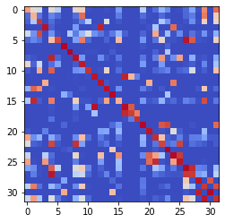

epoch 3901 == measurement_heuristic: 0.37+-0.01/0.33+-0.01 --

epoch 3902 == measurement_heuristic: 0.37+-0.01/0.32+-0.01 --

epoch 3903 == measurement_heuristic: 0.36+-0.01/0.31+-0.01 --

epoch 3904 == measurement_heuristic: 0.35+-0.01/0.30+-0.01 --

epoch 3905 == measurement_heuristic: 0.37+-0.01/0.30+-0.01 --

epoch 3906 == measurement_heuristic: 0.34+-0.01/0.31+-0.01 --

epoch 3907 == measurement_heuristic: 0.33+-0.01/0.30+-0.01 --

epoch 3908 == measurement_heuristic: 0.36+-0.01/0.31+-0.01 --

epoch 3909 == measurement_heuristic: 0.35+-0.01/0.32+-0.01 --

epoch 3910 == measurement_heuristic: 0.38+-0.01/0.35+-0.01 --

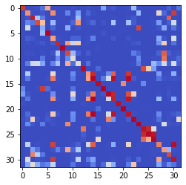

epoch 3911 == measurement_heuristic: 0.36+-0.01/0.31+-0.01 --

epoch 3912 == measurement_heuristic: 0.37+-0.01/0.31+-0.01 --

epoch 3913 == measurement_heuristic: 0.35+-0.01/0.31+-0.01 --

epoch 3914 == measurement_heuristic: 0.36+-0.01/0.32+-0.01 --

epoch 3915 == measurement_heuristic: 0.36+-0.01/0.32+-0.01 --

epoch 3916 == measurement_heuristic: 0.35+-0.01/0.30+-0.01 --

epoch 3917 == measurement_heuristic: 0.35+-0.01/0.31+-0.01 --

epoch 3918 == measurement_heuristic: 0.34+-0.01/0.31+-0.01 --

epoch 3919 == measurement_heuristic: 0.37+-0.01/0.32+-0.01 --

epoch 3920 == measurement_heuristic: 0.36+-0.01/0.32+-0.01 --

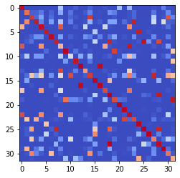

epoch 3921 == measurement_heuristic: 0.34+-0.01/0.31+-0.01 --

epoch 3922 == measurement_heuristic: 0.37+-0.01/0.31+-0.01 --

epoch 3923 == measurement_heuristic: 0.35+-0.01/0.31+-0.01 --

epoch 3924 == measurement_heuristic: 0.34+-0.01/0.31+-0.01 --

epoch 3925 == measurement_heuristic: 0.35+-0.01/0.32+-0.01 --

epoch 3926 == measurement_heuristic: 0.35+-0.01/0.31+-0.01 --

epoch 3927 == measurement_heuristic: 0.37+-0.01/0.31+-0.01 --

epoch 3928 == measurement_heuristic: 0.36+-0.01/0.31+-0.01 --

epoch 3929 == measurement_heuristic: 0.36+-0.01/0.30+-0.01 --

epoch 3930 == measurement_heuristic: 0.36+-0.01/0.31+-0.01 --

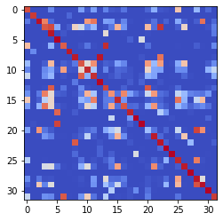

epoch 3931 == measurement_heuristic: 0.35+-0.01/0.32+-0.01 --

epoch 3932 == measurement_heuristic: 0.38+-0.01/0.32+-0.01 --

epoch 3933 == measurement_heuristic: 0.36+-0.01/0.32+-0.01 --

epoch 3934 == measurement_heuristic: 0.36+-0.01/0.31+-0.01 --

epoch 3935 >> measurement_heuristic: 0.34+-0.01/0.30+-0.01 --

epoch 3936 == measurement_heuristic: 0.37+-0.01/0.31+-0.01 --

epoch 3937 == measurement_heuristic: 0.36+-0.01/0.32+-0.01 --

epoch 3938 == measurement_heuristic: 0.35+-0.01/0.31+-0.01 --

epoch 3939 == measurement_heuristic: 0.38+-0.01/0.32+-0.01 --

epoch 3940 == measurement_heuristic: 0.36+-0.01/0.32+-0.01 --

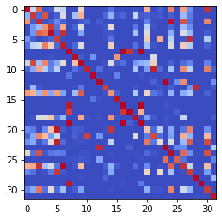

epoch 3941 == measurement_heuristic: 0.35+-0.01/0.32+-0.01 --

epoch 3942 == measurement_heuristic: 0.37+-0.01/0.33+-0.01 --

epoch 3943 == measurement_heuristic: 0.36+-0.01/0.31+-0.01 --

epoch 3944 == measurement_heuristic: 0.34+-0.01/0.31+-0.01 --

epoch 3945 == measurement_heuristic: 0.37+-0.01/0.32+-0.01 --

epoch 3946 == measurement_heuristic: 0.35+-0.01/0.32+-0.01 --

epoch 3947 == measurement_heuristic: 0.35+-0.01/0.32+-0.01 --

epoch 3948 == measurement_heuristic: 0.35+-0.01/0.33+-0.01 --

epoch 3949 == measurement_heuristic: 0.36+-0.01/0.32+-0.01 --

epoch 3950 == measurement_heuristic: 0.36+-0.01/0.32+-0.01 --

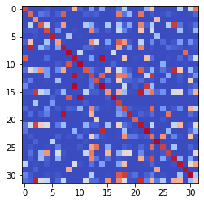

epoch 3951 == measurement_heuristic: 0.34+-0.01/0.32+-0.01 --

epoch 3952 == measurement_heuristic: 0.38+-0.01/0.32+-0.01 --

epoch 3953 == measurement_heuristic: 0.36+-0.01/0.30+-0.01 --

epoch 3954 == measurement_heuristic: 0.35+-0.01/0.31+-0.01 --

epoch 3955 == measurement_heuristic: 0.35+-0.01/0.30+-0.01 --

epoch 3956 == measurement_heuristic: 0.37+-0.01/0.31+-0.01 --

epoch 3957 == measurement_heuristic: 0.35+-0.01/0.31+-0.01 --

epoch 3958 == measurement_heuristic: 0.34+-0.01/0.32+-0.01 --

epoch 3959 == measurement_heuristic: 0.35+-0.01/0.33+-0.01 --

epoch 3960 == measurement_heuristic: 0.34+-0.01/0.31+-0.01 --

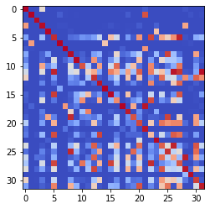

epoch 3961 == measurement_heuristic: 0.35+-0.01/0.31+-0.01 --

epoch 3962 == measurement_heuristic: 0.34+-0.01/0.32+-0.01 --

epoch 3963 == measurement_heuristic: 0.37+-0.01/0.32+-0.01 --

epoch 3964 == measurement_heuristic: 0.37+-0.01/0.32+-0.01 --

epoch 3965 == measurement_heuristic: 0.35+-0.01/0.31+-0.01 --

epoch 3966 == measurement_heuristic: 0.34+-0.01/0.31+-0.01 --

epoch 3967 == measurement_heuristic: 0.36+-0.01/0.31+-0.01 --

epoch 3968 == measurement_heuristic: 0.35+-0.01/0.30+-0.01 --

epoch 3969 == measurement_heuristic: 0.34+-0.01/0.31+-0.01 --

epoch 3970 == measurement_heuristic: 0.35+-0.01/0.31+-0.01 --

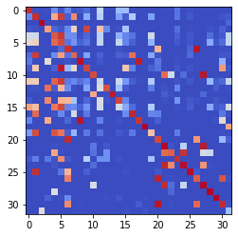

epoch 3971 == measurement_heuristic: 0.35+-0.01/0.31+-0.01 --

epoch 3972 >> measurement_heuristic: 0.36+-0.01/0.30+-0.01 --

epoch 3973 == measurement_heuristic: 0.38+-0.01/0.31+-0.01 --

epoch 3974 == measurement_heuristic: 0.35+-0.01/0.30+-0.01 --

epoch 3975 == measurement_heuristic: 0.37+-0.01/0.31+-0.01 --

epoch 3976 == measurement_heuristic: 0.36+-0.01/0.31+-0.01 --

epoch 3977 == measurement_heuristic: 0.38+-0.01/0.31+-0.01 --

epoch 3978 == measurement_heuristic: 0.34+-0.01/0.32+-0.01 --

epoch 3979 == measurement_heuristic: 0.37+-0.01/0.33+-0.01 --

epoch 3980 == measurement_heuristic: 0.36+-0.01/0.32+-0.01 --

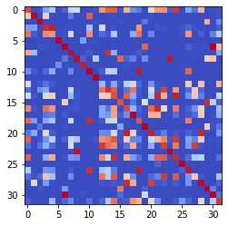

epoch 3981 == measurement_heuristic: 0.37+-0.01/0.30+-0.01 --

epoch 3982 == measurement_heuristic: 0.35+-0.01/0.32+-0.01 --

epoch 3983 == measurement_heuristic: 0.36+-0.01/0.31+-0.01 --

epoch 3984 == measurement_heuristic: 0.34+-0.01/0.31+-0.01 --

epoch 3985 == measurement_heuristic: 0.36+-0.01/0.31+-0.01 --

epoch 3986 == measurement_heuristic: 0.34+-0.01/0.31+-0.01 --

epoch 3987 == measurement_heuristic: 0.36+-0.01/0.31+-0.01 --

epoch 3988 == measurement_heuristic: 0.36+-0.01/0.31+-0.01 --

epoch 3989 == measurement_heuristic: 0.37+-0.01/0.34+-0.01 --

epoch 3990 == measurement_heuristic: 0.37+-0.01/0.31+-0.01 --

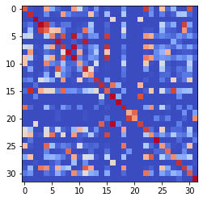

epoch 3991 == measurement_heuristic: 0.35+-0.01/0.31+-0.01 --

epoch 3992 == measurement_heuristic: 0.36+-0.01/0.33+-0.01 --

epoch 3993 == measurement_heuristic: 0.36+-0.01/0.32+-0.01 --

epoch 3994 == measurement_heuristic: 0.35+-0.01/0.31+-0.01 --

epoch 3995 == measurement_heuristic: 0.34+-0.01/0.30+-0.01 --

epoch 3996 == measurement_heuristic: 0.35+-0.01/0.31+-0.01 --

epoch 3997 == measurement_heuristic: 0.39+-0.01/0.33+-0.01 --

epoch 3998 == measurement_heuristic: 0.37+-0.01/0.33+-0.01 --

epoch 3999 == measurement_heuristic: 0.35+-0.01/0.32+-0.01 --

epoch 4000 == measurement_heuristic: 0.35+-0.01/0.33+-0.01 --

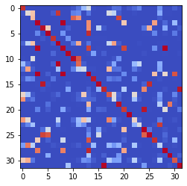

epoch 4001 == measurement_heuristic: 0.38+-0.01/0.31+-0.01 --

epoch 4002 == measurement_heuristic: 0.36+-0.01/0.33+-0.01 --

epoch 4003 == measurement_heuristic: 0.36+-0.01/0.34+-0.01 --

epoch 4004 == measurement_heuristic: 0.38+-0.01/0.31+-0.01 --

epoch 4005 == measurement_heuristic: 0.35+-0.01/0.32+-0.01 --

epoch 4006 == measurement_heuristic: 0.36+-0.01/0.32+-0.01 --

epoch 4007 == measurement_heuristic: 0.38+-0.01/0.31+-0.01 --

epoch 4008 == measurement_heuristic: 0.37+-0.01/0.32+-0.01 --

epoch 4009 == measurement_heuristic: 0.37+-0.01/0.31+-0.01 --

epoch 4010 == measurement_heuristic: 0.33+-0.01/0.32+-0.01 --

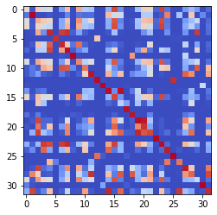

epoch 4011 == measurement_heuristic: 0.37+-0.01/0.31+-0.01 --

epoch 4012 == measurement_heuristic: 0.33+-0.01/0.31+-0.01 --

epoch 4013 == measurement_heuristic: 0.37+-0.01/0.33+-0.01 --

epoch 4014 == measurement_heuristic: 0.35+-0.01/0.33+-0.01 --

epoch 4015 == measurement_heuristic: 0.36+-0.01/0.31+-0.01 --

epoch 4016 == measurement_heuristic: 0.35+-0.01/0.31+-0.01 --

epoch 4017 == measurement_heuristic: 0.35+-0.01/0.30+-0.01 --

epoch 4018 == measurement_heuristic: 0.37+-0.01/0.32+-0.01 --

epoch 4019 == measurement_heuristic: 0.34+-0.01/0.31+-0.01 --

epoch 4020 == measurement_heuristic: 0.33+-0.01/0.31+-0.01 --

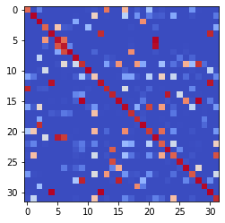

epoch 4021 == measurement_heuristic: 0.34+-0.01/0.30+-0.01 --

epoch 4022 == measurement_heuristic: 0.36+-0.01/0.31+-0.01 --

epoch 4023 == measurement_heuristic: 0.36+-0.01/0.31+-0.01 --

epoch 4024 == measurement_heuristic: 0.35+-0.01/0.32+-0.01 --

epoch 4025 == measurement_heuristic: 0.34+-0.01/0.30+-0.01 --

epoch 4026 == measurement_heuristic: 0.37+-0.01/0.32+-0.01 --

epoch 4027 == measurement_heuristic: 0.35+-0.01/0.31+-0.01 --

epoch 4028 == measurement_heuristic: 0.36+-0.01/0.32+-0.01 --

epoch 4029 == measurement_heuristic: 0.35+-0.01/0.32+-0.01 --

epoch 4030 == measurement_heuristic: 0.36+-0.01/0.31+-0.01 --

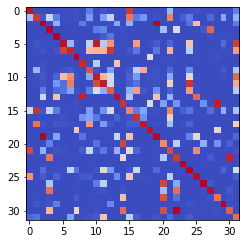

epoch 4031 == measurement_heuristic: 0.35+-0.01/0.32+-0.01 --

epoch 4032 == measurement_heuristic: 0.35+-0.01/0.32+-0.01 --

epoch 4033 == measurement_heuristic: 0.36+-0.01/0.32+-0.01 --

epoch 4034 == measurement_heuristic: 0.36+-0.01/0.31+-0.01 --

epoch 4035 == measurement_heuristic: 0.35+-0.01/0.32+-0.01 --

epoch 4036 == measurement_heuristic: 0.33+-0.01/0.30+-0.01 --

epoch 4037 == measurement_heuristic: 0.36+-0.01/0.32+-0.01 --

epoch 4038 == measurement_heuristic: 0.34+-0.01/0.31+-0.01 --

epoch 4039 == measurement_heuristic: 0.33+-0.01/0.31+-0.01 --

epoch 4040 == measurement_heuristic: 0.35+-0.01/0.31+-0.01 --

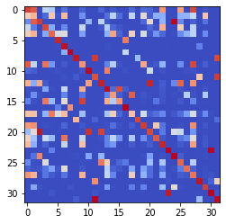

epoch 4041 == measurement_heuristic: 0.36+-0.01/0.32+-0.01 --

epoch 4042 == measurement_heuristic: 0.35+-0.01/0.32+-0.01 --

epoch 4043 == measurement_heuristic: 0.35+-0.01/0.31+-0.01 --

epoch 4044 == measurement_heuristic: 0.33+-0.01/0.32+-0.01 --

epoch 4045 == measurement_heuristic: 0.36+-0.01/0.32+-0.01 --

epoch 4046 == measurement_heuristic: 0.37+-0.01/0.31+-0.01 --

epoch 4047 == measurement_heuristic: 0.35+-0.01/0.32+-0.01 --

epoch 4048 == measurement_heuristic: 0.37+-0.01/0.32+-0.01 --

epoch 4049 == measurement_heuristic: 0.35+-0.01/0.32+-0.01 --

epoch 4050 == measurement_heuristic: 0.36+-0.01/0.30+-0.01 --

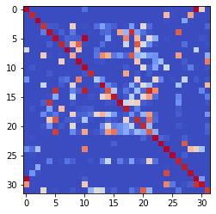

epoch 4051 == measurement_heuristic: 0.36+-0.01/0.32+-0.01 --

epoch 4052 == measurement_heuristic: 0.35+-0.01/0.31+-0.01 --

epoch 4053 == measurement_heuristic: 0.35+-0.01/0.31+-0.01 --

epoch 4054 == measurement_heuristic: 0.34+-0.01/0.30+-0.01 --

epoch 4055 == measurement_heuristic: 0.35+-0.01/0.30+-0.01 --

epoch 4056 == measurement_heuristic: 0.35+-0.01/0.31+-0.01 --

epoch 4057 == measurement_heuristic: 0.34+-0.01/0.32+-0.01 --

epoch 4058 == measurement_heuristic: 0.34+-0.01/0.30+-0.01 --

epoch 4059 == measurement_heuristic: 0.36+-0.01/0.31+-0.01 --

epoch 4060 == measurement_heuristic: 0.36+-0.01/0.34+-0.01 --

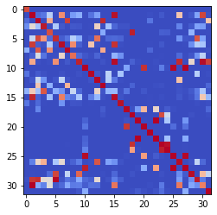

epoch 4061 == measurement_heuristic: 0.36+-0.01/0.31+-0.01 --

epoch 4062 == measurement_heuristic: 0.36+-0.01/0.32+-0.01 --

epoch 4063 == measurement_heuristic: 0.36+-0.01/0.31+-0.01 --

epoch 4064 == measurement_heuristic: 0.36+-0.01/0.32+-0.01 --

epoch 4065 == measurement_heuristic: 0.34+-0.01/0.31+-0.01 --

epoch 4066 == measurement_heuristic: 0.34+-0.01/0.31+-0.01 --

epoch 4067 == measurement_heuristic: 0.35+-0.01/0.32+-0.01 --

epoch 4068 == measurement_heuristic: 0.33+-0.01/0.31+-0.01 --

epoch 4069 == measurement_heuristic: 0.36+-0.01/0.31+-0.01 --

epoch 4070 == measurement_heuristic: 0.36+-0.01/0.33+-0.01 --

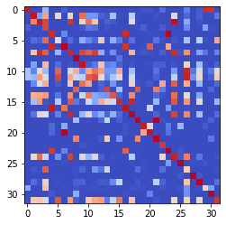

epoch 4071 == measurement_heuristic: 0.36+-0.01/0.32+-0.01 --

epoch 4072 == measurement_heuristic: 0.34+-0.01/0.32+-0.01 --

epoch 4073 == measurement_heuristic: 0.37+-0.01/0.32+-0.01 --

epoch 4074 == measurement_heuristic: 0.36+-0.01/0.31+-0.01 --

epoch 4075 == measurement_heuristic: 0.36+-0.01/0.32+-0.01 --

epoch 4076 == measurement_heuristic: 0.34+-0.01/0.31+-0.01 --

epoch 4077 == measurement_heuristic: 0.35+-0.02/0.31+-0.01 --

epoch 4078 == measurement_heuristic: 0.35+-0.01/0.32+-0.01 --

epoch 4079 == measurement_heuristic: 0.34+-0.01/0.31+-0.01 --

epoch 4080 == measurement_heuristic: 0.36+-0.01/0.32+-0.01 --

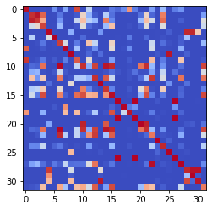

epoch 4081 == measurement_heuristic: 0.35+-0.01/0.31+-0.01 --

epoch 4082 == measurement_heuristic: 0.35+-0.01/0.31+-0.01 --

epoch 4083 == measurement_heuristic: 0.37+-0.01/0.31+-0.01 --

epoch 4084 == measurement_heuristic: 0.35+-0.01/0.31+-0.01 --

epoch 4085 == measurement_heuristic: 0.35+-0.01/0.30+-0.01 --

epoch 4086 == measurement_heuristic: 0.36+-0.01/0.33+-0.01 --

epoch 4087 == measurement_heuristic: 0.36+-0.01/0.31+-0.01 --

epoch 4088 == measurement_heuristic: 0.36+-0.01/0.32+-0.01 --

epoch 4089 == measurement_heuristic: 0.36+-0.01/0.32+-0.01 --

epoch 4090 == measurement_heuristic: 0.34+-0.01/0.30+-0.01 --

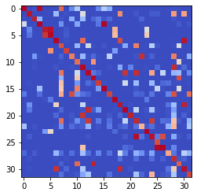

epoch 4091 == measurement_heuristic: 0.35+-0.01/0.30+-0.01 --

epoch 4092 == measurement_heuristic: 0.34+-0.01/0.31+-0.01 --

epoch 4093 == measurement_heuristic: 0.35+-0.01/0.31+-0.01 --

epoch 4094 == measurement_heuristic: 0.36+-0.01/0.32+-0.01 --

epoch 4095 == measurement_heuristic: 0.37+-0.01/0.31+-0.01 --

epoch 4096 == measurement_heuristic: 0.35+-0.01/0.32+-0.01 --

epoch 4097 == measurement_heuristic: 0.36+-0.01/0.30+-0.01 --

epoch 4098 == measurement_heuristic: 0.34+-0.01/0.31+-0.01 --

epoch 4099 == measurement_heuristic: 0.36+-0.01/0.31+-0.01 --

epoch 4100 == measurement_heuristic: 0.34+-0.01/0.30+-0.01 --

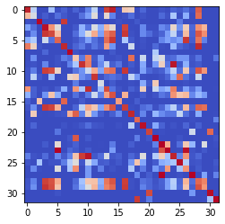

epoch 4101 == measurement_heuristic: 0.36+-0.01/0.31+-0.01 --

epoch 4102 == measurement_heuristic: 0.35+-0.01/0.32+-0.01 --

epoch 4103 == measurement_heuristic: 0.35+-0.01/0.31+-0.01 --

epoch 4104 == measurement_heuristic: 0.37+-0.01/0.32+-0.01 --

epoch 4105 == measurement_heuristic: 0.36+-0.01/0.31+-0.01 --

epoch 4106 == measurement_heuristic: 0.36+-0.01/0.32+-0.01 --

epoch 4107 == measurement_heuristic: 0.35+-0.01/0.30+-0.01 --

epoch 4108 == measurement_heuristic: 0.36+-0.01/0.30+-0.01 --

epoch 4109 == measurement_heuristic: 0.34+-0.01/0.30+-0.01 --

epoch 4110 == measurement_heuristic: 0.35+-0.01/0.31+-0.01 --

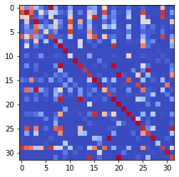

epoch 4111 == measurement_heuristic: 0.39+-0.01/0.33+-0.01 --

epoch 4112 == measurement_heuristic: 0.34+-0.01/0.30+-0.01 --

epoch 4113 == measurement_heuristic: 0.34+-0.01/0.31+-0.01 --

epoch 4114 == measurement_heuristic: 0.38+-0.01/0.31+-0.01 --

epoch 4115 == measurement_heuristic: 0.37+-0.01/0.31+-0.01 --

epoch 4116 == measurement_heuristic: 0.36+-0.01/0.31+-0.01 --

epoch 4117 == measurement_heuristic: 0.34+-0.01/0.32+-0.01 --

epoch 4118 == measurement_heuristic: 0.35+-0.01/0.31+-0.01 --

epoch 4119 == measurement_heuristic: 0.34+-0.01/0.31+-0.01 --

epoch 4120 == measurement_heuristic: 0.35+-0.01/0.31+-0.01 --

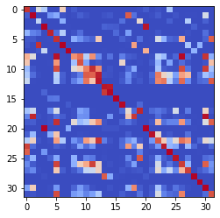

epoch 4121 == measurement_heuristic: 0.34+-0.01/0.31+-0.01 --

epoch 4122 == measurement_heuristic: 0.34+-0.01/0.31+-0.01 --

epoch 4123 >> measurement_heuristic: 0.35+-0.01/0.29+-0.01 --

epoch 4124 == measurement_heuristic: 0.35+-0.01/0.32+-0.01 --

epoch 4125 == measurement_heuristic: 0.35+-0.01/0.31+-0.01 --

epoch 4126 == measurement_heuristic: 0.35+-0.01/0.31+-0.01 --

epoch 4127 == measurement_heuristic: 0.35+-0.01/0.32+-0.01 --

epoch 4128 == measurement_heuristic: 0.34+-0.01/0.30+-0.01 --

epoch 4129 == measurement_heuristic: 0.36+-0.01/0.30+-0.01 --

epoch 4130 == measurement_heuristic: 0.36+-0.01/0.31+-0.01 --

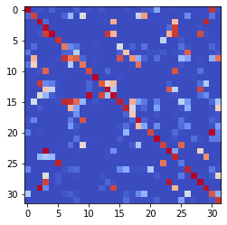

epoch 4131 == measurement_heuristic: 0.36+-0.01/0.31+-0.01 --

epoch 4132 == measurement_heuristic: 0.35+-0.01/0.31+-0.01 --

epoch 4133 == measurement_heuristic: 0.36+-0.01/0.31+-0.01 --

epoch 4134 == measurement_heuristic: 0.33+-0.01/0.32+-0.01 --

epoch 4135 == measurement_heuristic: 0.38+-0.01/0.31+-0.01 --

epoch 4136 == measurement_heuristic: 0.35+-0.01/0.31+-0.01 --

epoch 4137 == measurement_heuristic: 0.34+-0.01/0.30+-0.01 --

epoch 4138 == measurement_heuristic: 0.35+-0.01/0.31+-0.01 --

epoch 4139 == measurement_heuristic: 0.35+-0.01/0.31+-0.01 --

epoch 4140 == measurement_heuristic: 0.36+-0.01/0.31+-0.01 --

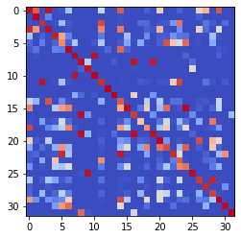

epoch 4141 == measurement_heuristic: 0.36+-0.01/0.31+-0.01 --

epoch 4142 == measurement_heuristic: 0.34+-0.01/0.31+-0.01 --

epoch 4143 == measurement_heuristic: 0.34+-0.01/0.31+-0.01 --

epoch 4144 == measurement_heuristic: 0.35+-0.01/0.32+-0.01 --

epoch 4145 == measurement_heuristic: 0.34+-0.01/0.31+-0.01 --

epoch 4146 == measurement_heuristic: 0.37+-0.01/0.30+-0.01 --

epoch 4147 == measurement_heuristic: 0.36+-0.01/0.31+-0.01 --

epoch 4148 == measurement_heuristic: 0.34+-0.01/0.30+-0.01 --

epoch 4149 == measurement_heuristic: 0.37+-0.01/0.32+-0.01 --

epoch 4150 == measurement_heuristic: 0.35+-0.01/0.30+-0.01 --

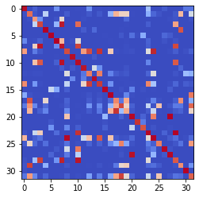

epoch 4151 == measurement_heuristic: 0.35+-0.01/0.29+-0.01 --

epoch 4152 == measurement_heuristic: 0.33+-0.01/0.30+-0.01 --

epoch 4153 == measurement_heuristic: 0.37+-0.01/0.31+-0.01 --

epoch 4154 == measurement_heuristic: 0.34+-0.01/0.30+-0.01 --

epoch 4155 == measurement_heuristic: 0.34+-0.01/0.30+-0.01 --

epoch 4156 == measurement_heuristic: 0.34+-0.01/0.31+-0.01 --

epoch 4157 == measurement_heuristic: 0.35+-0.01/0.31+-0.01 --

epoch 4158 == measurement_heuristic: 0.34+-0.01/0.33+-0.01 --

epoch 4159 == measurement_heuristic: 0.36+-0.01/0.32+-0.01 --

epoch 4160 == measurement_heuristic: 0.35+-0.01/0.32+-0.01 --

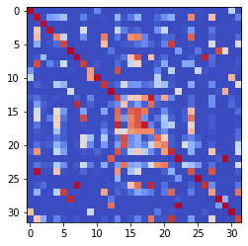

epoch 4161 == measurement_heuristic: 0.35+-0.01/0.30+-0.01 --

epoch 4162 == measurement_heuristic: 0.36+-0.01/0.31+-0.01 --

epoch 4163 == measurement_heuristic: 0.35+-0.01/0.30+-0.01 --

epoch 4164 == measurement_heuristic: 0.37+-0.01/0.30+-0.01 --

epoch 4165 == measurement_heuristic: 0.35+-0.01/0.30+-0.01 --

epoch 4166 == measurement_heuristic: 0.34+-0.01/0.30+-0.01 --

epoch 4167 == measurement_heuristic: 0.35+-0.01/0.31+-0.01 --

epoch 4168 == measurement_heuristic: 0.37+-0.01/0.34+-0.01 --

epoch 4169 == measurement_heuristic: 0.35+-0.01/0.34+-0.01 --

epoch 4170 == measurement_heuristic: 0.35+-0.01/0.30+-0.01 --

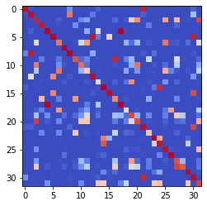

epoch 4171 == measurement_heuristic: 0.37+-0.01/0.31+-0.01 --

epoch 4172 == measurement_heuristic: 0.35+-0.01/0.30+-0.01 --

epoch 4173 == measurement_heuristic: 0.33+-0.01/0.30+-0.01 --

epoch 4174 == measurement_heuristic: 0.37+-0.01/0.30+-0.01 --

epoch 4175 == measurement_heuristic: 0.34+-0.01/0.30+-0.01 --

epoch 4176 == measurement_heuristic: 0.34+-0.01/0.30+-0.01 --

epoch 4177 == measurement_heuristic: 0.36+-0.01/0.31+-0.01 --

epoch 4178 == measurement_heuristic: 0.35+-0.01/0.31+-0.01 --

epoch 4179 == measurement_heuristic: 0.36+-0.01/0.31+-0.01 --

epoch 4180 == measurement_heuristic: 0.38+-0.01/0.31+-0.01 --

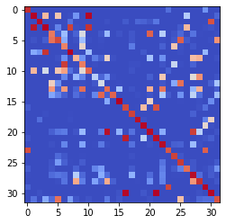

epoch 4181 == measurement_heuristic: 0.36+-0.01/0.31+-0.01 --

epoch 4182 == measurement_heuristic: 0.34+-0.01/0.30+-0.01 --

epoch 4183 == measurement_heuristic: 0.37+-0.01/0.30+-0.01 --

epoch 4184 == measurement_heuristic: 0.33+-0.01/0.30+-0.01 --

epoch 4185 == measurement_heuristic: 0.33+-0.01/0.31+-0.01 --

epoch 4186 >> measurement_heuristic: 0.35+-0.01/0.29+-0.01 --

epoch 4187 == measurement_heuristic: 0.36+-0.01/0.30+-0.01 --

epoch 4188 == measurement_heuristic: 0.35+-0.01/0.30+-0.01 --

epoch 4189 == measurement_heuristic: 0.34+-0.01/0.30+-0.01 --

epoch 4190 == measurement_heuristic: 0.35+-0.01/0.31+-0.01 --

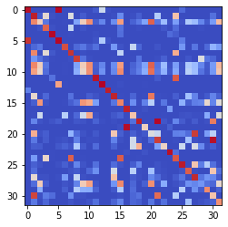

epoch 4191 == measurement_heuristic: 0.34+-0.01/0.30+-0.01 --

epoch 4192 == measurement_heuristic: 0.36+-0.01/0.32+-0.01 --

epoch 4193 == measurement_heuristic: 0.36+-0.01/0.30+-0.01 --

epoch 4194 == measurement_heuristic: 0.36+-0.01/0.30+-0.01 --

epoch 4195 == measurement_heuristic: 0.34+-0.01/0.30+-0.01 --

epoch 4196 == measurement_heuristic: 0.36+-0.01/0.33+-0.01 --

epoch 4197 == measurement_heuristic: 0.34+-0.01/0.30+-0.01 --

epoch 4198 == measurement_heuristic: 0.34+-0.01/0.30+-0.01 --

epoch 4199 == measurement_heuristic: 0.35+-0.01/0.31+-0.01 --

epoch 4200 == measurement_heuristic: 0.35+-0.01/0.31+-0.01 --

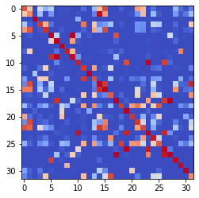

epoch 4201 == measurement_heuristic: 0.37+-0.01/0.31+-0.01 --

epoch 4202 == measurement_heuristic: 0.35+-0.01/0.31+-0.01 --

epoch 4203 == measurement_heuristic: 0.34+-0.01/0.30+-0.01 --

epoch 4204 == measurement_heuristic: 0.35+-0.01/0.30+-0.01 --

epoch 4205 == measurement_heuristic: 0.36+-0.01/0.31+-0.01 --

epoch 4206 == measurement_heuristic: 0.34+-0.01/0.30+-0.01 --

epoch 4207 == measurement_heuristic: 0.34+-0.01/0.30+-0.01 --

epoch 4208 == measurement_heuristic: 0.32+-0.01/0.31+-0.01 --

epoch 4209 == measurement_heuristic: 0.35+-0.01/0.31+-0.01 --

epoch 4210 == measurement_heuristic: 0.35+-0.01/0.30+-0.01 --

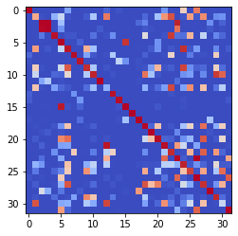

epoch 4211 == measurement_heuristic: 0.35+-0.01/0.30+-0.01 --

epoch 4212 == measurement_heuristic: 0.36+-0.01/0.30+-0.01 --

epoch 4213 == measurement_heuristic: 0.35+-0.01/0.30+-0.01 --

epoch 4214 == measurement_heuristic: 0.35+-0.01/0.30+-0.01 --

epoch 4215 == measurement_heuristic: 0.35+-0.01/0.30+-0.01 --

epoch 4216 == measurement_heuristic: 0.35+-0.01/0.31+-0.01 --

epoch 4217 == measurement_heuristic: 0.36+-0.01/0.30+-0.01 --

epoch 4218 == measurement_heuristic: 0.33+-0.01/0.30+-0.01 --

epoch 4219 >> measurement_heuristic: 0.35+-0.01/0.29+-0.01 --

epoch 4220 == measurement_heuristic: 0.35+-0.01/0.31+-0.01 --

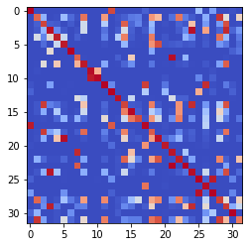

epoch 4221 == measurement_heuristic: 0.36+-0.01/0.30+-0.01 --

epoch 4222 == measurement_heuristic: 0.34+-0.01/0.31+-0.01 --

epoch 4223 == measurement_heuristic: 0.34+-0.01/0.31+-0.01 --

epoch 4224 == measurement_heuristic: 0.34+-0.01/0.31+-0.01 --

epoch 4225 == measurement_heuristic: 0.34+-0.01/0.30+-0.01 --

epoch 4226 >> measurement_heuristic: 0.34+-0.01/0.29+-0.01 --

epoch 4227 == measurement_heuristic: 0.35+-0.01/0.30+-0.01 --

epoch 4228 == measurement_heuristic: 0.36+-0.01/0.32+-0.01 --

epoch 4229 == measurement_heuristic: 0.35+-0.01/0.30+-0.01 --

epoch 4230 == measurement_heuristic: 0.37+-0.01/0.31+-0.01 --

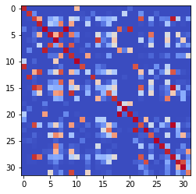

epoch 4231 == measurement_heuristic: 0.37+-0.01/0.31+-0.01 --

epoch 4232 == measurement_heuristic: 0.33+-0.01/0.30+-0.01 --

epoch 4233 == measurement_heuristic: 0.35+-0.01/0.31+-0.01 --

epoch 4234 == measurement_heuristic: 0.34+-0.01/0.30+-0.01 --

epoch 4235 == measurement_heuristic: 0.34+-0.01/0.30+-0.01 --

epoch 4236 == measurement_heuristic: 0.35+-0.01/0.30+-0.01 --

epoch 4237 >> measurement_heuristic: 0.34+-0.01/0.29+-0.01 --

epoch 4238 == measurement_heuristic: 0.36+-0.01/0.30+-0.01 --

epoch 4239 == measurement_heuristic: 0.38+-0.01/0.31+-0.01 --

epoch 4240 == measurement_heuristic: 0.37+-0.01/0.30+-0.01 --

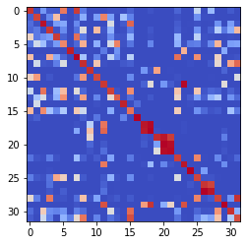

epoch 4241 == measurement_heuristic: 0.34+-0.01/0.30+-0.01 --

epoch 4242 == measurement_heuristic: 0.35+-0.01/0.35+-0.01 --

epoch 4243 == measurement_heuristic: 0.36+-0.01/0.30+-0.01 --

epoch 4244 == measurement_heuristic: 0.34+-0.01/0.30+-0.01 --

epoch 4245 == measurement_heuristic: 0.35+-0.01/0.30+-0.01 --

epoch 4246 == measurement_heuristic: 0.35+-0.01/0.31+-0.01 --

epoch 4247 == measurement_heuristic: 0.37+-0.01/0.29+-0.01 --

epoch 4248 == measurement_heuristic: 0.36+-0.01/0.31+-0.01 --

epoch 4249 == measurement_heuristic: 0.37+-0.01/0.30+-0.01 --

epoch 4250 == measurement_heuristic: 0.36+-0.01/0.30+-0.01 --

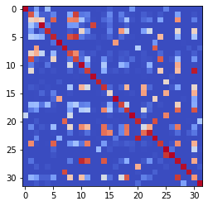

epoch 4251 == measurement_heuristic: 0.34+-0.01/0.30+-0.01 --

epoch 4252 == measurement_heuristic: 0.37+-0.01/0.30+-0.01 --

epoch 4253 == measurement_heuristic: 0.37+-0.01/0.34+-0.01 --

epoch 4254 == measurement_heuristic: 0.36+-0.01/0.29+-0.01 --

epoch 4255 == measurement_heuristic: 0.34+-0.01/0.30+-0.01 --

epoch 4256 == measurement_heuristic: 0.33+-0.01/0.30+-0.01 --

epoch 4257 == measurement_heuristic: 0.35+-0.01/0.29+-0.01 --

epoch 4258 == measurement_heuristic: 0.35+-0.01/0.31+-0.01 --

epoch 4259 == measurement_heuristic: 0.35+-0.01/0.30+-0.01 --

epoch 4260 == measurement_heuristic: 0.35+-0.01/0.30+-0.01 --

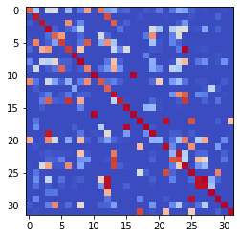

epoch 4261 == measurement_heuristic: 0.35+-0.01/0.31+-0.01 --

epoch 4262 == measurement_heuristic: 0.35+-0.01/0.33+-0.01 --

epoch 4263 == measurement_heuristic: 0.34+-0.01/0.31+-0.01 --

epoch 4264 == measurement_heuristic: 0.35+-0.01/0.32+-0.01 --

epoch 4265 == measurement_heuristic: 0.36+-0.01/0.30+-0.01 --

epoch 4266 == measurement_heuristic: 0.36+-0.01/0.30+-0.01 --

epoch 4267 == measurement_heuristic: 0.34+-0.01/0.29+-0.01 --

epoch 4268 == measurement_heuristic: 0.35+-0.01/0.30+-0.01 --

epoch 4269 == measurement_heuristic: 0.37+-0.01/0.30+-0.01 --

epoch 4270 == measurement_heuristic: 0.37+-0.01/0.30+-0.01 --

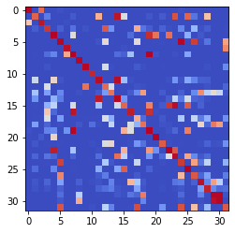

epoch 4271 == measurement_heuristic: 0.34+-0.01/0.29+-0.01 --

epoch 4272 == measurement_heuristic: 0.34+-0.01/0.31+-0.01 --

epoch 4273 == measurement_heuristic: 0.35+-0.01/0.29+-0.01 --

epoch 4274 == measurement_heuristic: 0.35+-0.01/0.30+-0.01 --

epoch 4275 == measurement_heuristic: 0.37+-0.01/0.33+-0.01 --

epoch 4276 == measurement_heuristic: 0.35+-0.01/0.30+-0.01 --

epoch 4277 == measurement_heuristic: 0.36+-0.01/0.29+-0.01 --

epoch 4278 == measurement_heuristic: 0.35+-0.01/0.32+-0.01 --

epoch 4279 == measurement_heuristic: 0.36+-0.01/0.30+-0.01 --

epoch 4280 == measurement_heuristic: 0.36+-0.01/0.30+-0.01 --

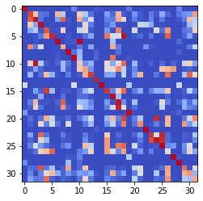

epoch 4281 == measurement_heuristic: 0.34+-0.01/0.31+-0.01 --

epoch 4282 == measurement_heuristic: 0.38+-0.01/0.31+-0.01 --

epoch 4283 == measurement_heuristic: 0.35+-0.01/0.30+-0.01 --

epoch 4284 == measurement_heuristic: 0.36+-0.01/0.30+-0.01 --

epoch 4285 == measurement_heuristic: 0.33+-0.01/0.30+-0.01 --

epoch 4286 == measurement_heuristic: 0.36+-0.01/0.29+-0.01 --

epoch 4287 == measurement_heuristic: 0.35+-0.01/0.30+-0.01 --

epoch 4288 == measurement_heuristic: 0.34+-0.01/0.30+-0.01 --

epoch 4289 == measurement_heuristic: 0.35+-0.01/0.30+-0.01 --

epoch 4290 == measurement_heuristic: 0.34+-0.01/0.30+-0.01 --

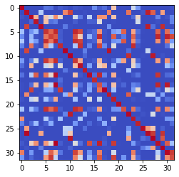

epoch 4291 == measurement_heuristic: 0.33+-0.01/0.29+-0.01 --

epoch 4292 == measurement_heuristic: 0.34+-0.01/0.30+-0.01 --

epoch 4293 == measurement_heuristic: 0.34+-0.01/0.31+-0.01 --

epoch 4294 == measurement_heuristic: 0.34+-0.01/0.30+-0.01 --

epoch 4295 == measurement_heuristic: 0.36+-0.01/0.31+-0.01 --

epoch 4296 == measurement_heuristic: 0.32+-0.01/0.30+-0.01 --

epoch 4297 == measurement_heuristic: 0.34+-0.01/0.30+-0.01 --

epoch 4298 == measurement_heuristic: 0.35+-0.01/0.29+-0.01 --

epoch 4299 == measurement_heuristic: 0.36+-0.01/0.31+-0.01 --

epoch 4300 == measurement_heuristic: 0.37+-0.01/0.29+-0.01 --

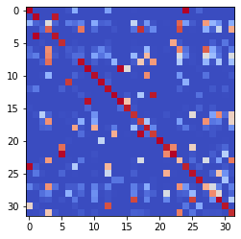

epoch 4301 == measurement_heuristic: 0.34+-0.01/0.32+-0.01 --

epoch 4302 == measurement_heuristic: 0.35+-0.01/0.30+-0.01 --

epoch 4303 == measurement_heuristic: 0.34+-0.01/0.32+-0.01 --

epoch 4304 == measurement_heuristic: 0.34+-0.01/0.31+-0.01 --

epoch 4305 == measurement_heuristic: 0.34+-0.01/0.31+-0.01 --

epoch 4306 == measurement_heuristic: 0.36+-0.01/0.31+-0.01 --

epoch 4307 == measurement_heuristic: 0.34+-0.01/0.29+-0.01 --

epoch 4308 == measurement_heuristic: 0.34+-0.01/0.31+-0.01 --

epoch 4309 == measurement_heuristic: 0.34+-0.01/0.32+-0.01 --

epoch 4310 == measurement_heuristic: 0.36+-0.01/0.32+-0.01 --

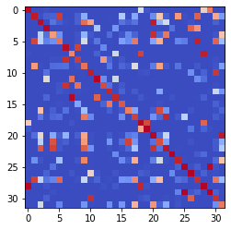

epoch 4311 == measurement_heuristic: 0.35+-0.01/0.31+-0.01 --

epoch 4312 == measurement_heuristic: 0.35+-0.01/0.29+-0.01 --

epoch 4313 == measurement_heuristic: 0.34+-0.01/0.30+-0.01 --

epoch 4314 == measurement_heuristic: 0.34+-0.01/0.31+-0.01 --

epoch 4315 == measurement_heuristic: 0.35+-0.01/0.31+-0.01 --

epoch 4316 == measurement_heuristic: 0.34+-0.01/0.31+-0.01 --

epoch 4317 == measurement_heuristic: 0.35+-0.01/0.29+-0.01 --

epoch 4318 == measurement_heuristic: 0.35+-0.01/0.31+-0.01 --

epoch 4319 == measurement_heuristic: 0.34+-0.01/0.31+-0.01 --

epoch 4320 == measurement_heuristic: 0.34+-0.01/0.33+-0.01 --

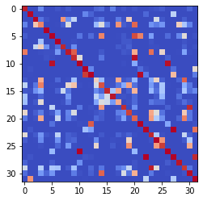

epoch 4321 == measurement_heuristic: 0.35+-0.01/0.30+-0.01 --

epoch 4322 == measurement_heuristic: 0.36+-0.01/0.30+-0.01 --

epoch 4323 == measurement_heuristic: 0.36+-0.01/0.29+-0.01 --

epoch 4324 == measurement_heuristic: 0.35+-0.01/0.31+-0.01 --

epoch 4325 == measurement_heuristic: 0.33+-0.01/0.31+-0.01 --

epoch 4326 == measurement_heuristic: 0.35+-0.01/0.29+-0.01 --

epoch 4327 == measurement_heuristic: 0.36+-0.01/0.31+-0.01 --

epoch 4328 == measurement_heuristic: 0.33+-0.01/0.30+-0.01 --

epoch 4329 == measurement_heuristic: 0.33+-0.01/0.31+-0.01 --

epoch 4330 == measurement_heuristic: 0.36+-0.01/0.33+-0.01 --

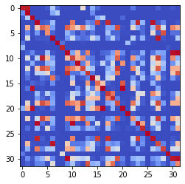

epoch 4331 == measurement_heuristic: 0.37+-0.01/0.30+-0.01 --

epoch 4332 == measurement_heuristic: 0.37+-0.01/0.32+-0.01 --

epoch 4333 == measurement_heuristic: 0.36+-0.01/0.31+-0.01 --

epoch 4334 == measurement_heuristic: 0.33+-0.01/0.29+-0.01 --

epoch 4335 == measurement_heuristic: 0.35+-0.01/0.30+-0.01 --

epoch 4336 == measurement_heuristic: 0.34+-0.01/0.30+-0.01 --

epoch 4337 == measurement_heuristic: 0.33+-0.01/0.31+-0.01 --

epoch 4338 == measurement_heuristic: 0.33+-0.01/0.30+-0.01 --

epoch 4339 == measurement_heuristic: 0.34+-0.01/0.32+-0.01 --

epoch 4340 == measurement_heuristic: 0.34+-0.01/0.31+-0.01 --

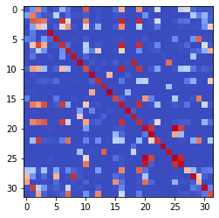

epoch 4341 == measurement_heuristic: 0.32+-0.01/0.30+-0.01 --

epoch 4342 == measurement_heuristic: 0.35+-0.01/0.29+-0.01 --

epoch 4343 == measurement_heuristic: 0.34+-0.01/0.30+-0.01 --

epoch 4344 == measurement_heuristic: 0.36+-0.01/0.31+-0.01 --

epoch 4345 == measurement_heuristic: 0.36+-0.01/0.30+-0.01 --

epoch 4346 == measurement_heuristic: 0.35+-0.01/0.30+-0.01 --

epoch 4347 == measurement_heuristic: 0.32+-0.01/0.29+-0.01 --

epoch 4348 == measurement_heuristic: 0.34+-0.01/0.30+-0.01 --

epoch 4349 == measurement_heuristic: 0.34+-0.01/0.30+-0.01 --

epoch 4350 == measurement_heuristic: 0.34+-0.01/0.30+-0.01 --

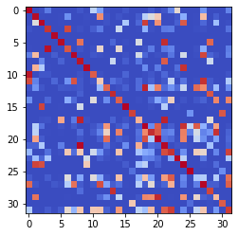

epoch 4351 == measurement_heuristic: 0.36+-0.01/0.30+-0.01 --

epoch 4352 == measurement_heuristic: 0.34+-0.01/0.29+-0.01 --

epoch 4353 == measurement_heuristic: 0.34+-0.01/0.29+-0.01 --

epoch 4354 == measurement_heuristic: 0.33+-0.01/0.29+-0.01 --

epoch 4355 == measurement_heuristic: 0.36+-0.01/0.30+-0.01 --

epoch 4356 == measurement_heuristic: 0.34+-0.01/0.30+-0.01 --

epoch 4357 == measurement_heuristic: 0.33+-0.01/0.30+-0.01 --

epoch 4358 == measurement_heuristic: 0.34+-0.01/0.30+-0.01 --

epoch 4359 == measurement_heuristic: 0.34+-0.01/0.29+-0.01 --

epoch 4360 == measurement_heuristic: 0.34+-0.01/0.30+-0.01 --

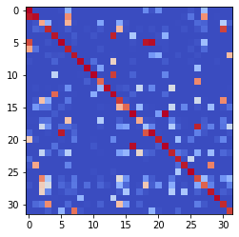

epoch 4361 == measurement_heuristic: 0.34+-0.01/0.30+-0.01 --

epoch 4362 == measurement_heuristic: 0.36+-0.01/0.30+-0.01 --

epoch 4363 == measurement_heuristic: 0.33+-0.01/0.30+-0.01 --

epoch 4364 == measurement_heuristic: 0.32+-0.01/0.30+-0.01 --

epoch 4365 == measurement_heuristic: 0.35+-0.01/0.32+-0.01 --

epoch 4366 == measurement_heuristic: 0.34+-0.01/0.29+-0.01 --

epoch 4367 == measurement_heuristic: 0.34+-0.01/0.31+-0.01 --

epoch 4368 == measurement_heuristic: 0.35+-0.01/0.30+-0.01 --

epoch 4369 == measurement_heuristic: 0.35+-0.01/0.31+-0.01 --

epoch 4370 == measurement_heuristic: 0.34+-0.01/0.31+-0.01 --

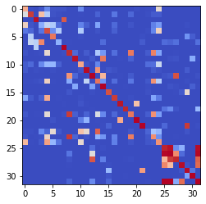

epoch 4371 == measurement_heuristic: 0.34+-0.01/0.30+-0.01 --

epoch 4372 == measurement_heuristic: 0.34+-0.01/0.30+-0.01 --

epoch 4373 == measurement_heuristic: 0.33+-0.01/0.30+-0.01 --

epoch 4374 == measurement_heuristic: 0.33+-0.01/0.31+-0.01 --

epoch 4375 == measurement_heuristic: 0.33+-0.01/0.29+-0.01 --

epoch 4376 == measurement_heuristic: 0.33+-0.01/0.30+-0.01 --

epoch 4377 == measurement_heuristic: 0.34+-0.01/0.31+-0.01 --

epoch 4378 == measurement_heuristic: 0.37+-0.01/0.32+-0.01 --

epoch 4379 == measurement_heuristic: 0.36+-0.01/0.33+-0.01 --

epoch 4380 == measurement_heuristic: 0.35+-0.01/0.30+-0.01 --

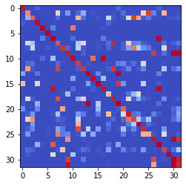

epoch 4381 == measurement_heuristic: 0.34+-0.01/0.30+-0.01 --

epoch 4382 == measurement_heuristic: 0.35+-0.01/0.29+-0.01 --

epoch 4383 == measurement_heuristic: 0.34+-0.01/0.31+-0.01 --

epoch 4384 == measurement_heuristic: 0.36+-0.01/0.29+-0.01 --

epoch 4385 == measurement_heuristic: 0.34+-0.01/0.29+-0.01 --

epoch 4386 == measurement_heuristic: 0.34+-0.01/0.30+-0.01 --

epoch 4387 == measurement_heuristic: 0.35+-0.01/0.29+-0.01 --

epoch 4388 == measurement_heuristic: 0.34+-0.01/0.31+-0.01 --

epoch 4389 == measurement_heuristic: 0.36+-0.01/0.30+-0.01 --

epoch 4390 == measurement_heuristic: 0.35+-0.01/0.30+-0.01 --

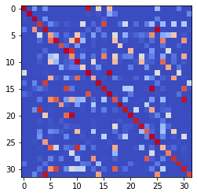

epoch 4391 == measurement_heuristic: 0.34+-0.01/0.30+-0.01 --

epoch 4392 == measurement_heuristic: 0.35+-0.01/0.30+-0.01 --

epoch 4393 == measurement_heuristic: 0.34+-0.01/0.30+-0.01 --

epoch 4394 == measurement_heuristic: 0.33+-0.01/0.32+-0.01 --

epoch 4395 == measurement_heuristic: 0.35+-0.01/0.29+-0.01 --

epoch 4396 == measurement_heuristic: 0.35+-0.01/0.31+-0.01 --

epoch 4397 == measurement_heuristic: 0.34+-0.01/0.29+-0.01 --

epoch 4398 == measurement_heuristic: 0.36+-0.01/0.31+-0.01 --

epoch 4399 == measurement_heuristic: 0.33+-0.01/0.31+-0.01 --

epoch 4400 == measurement_heuristic: 0.32+-0.01/0.31+-0.01 --

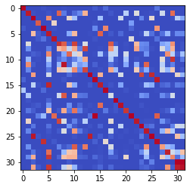

epoch 4401 == measurement_heuristic: 0.35+-0.01/0.32+-0.01 --

epoch 4402 == measurement_heuristic: 0.35+-0.01/0.34+-0.01 --

epoch 4403 == measurement_heuristic: 0.36+-0.01/0.31+-0.01 --

epoch 4404 == measurement_heuristic: 0.35+-0.01/0.30+-0.01 --

epoch 4405 == measurement_heuristic: 0.34+-0.01/0.30+-0.01 --

epoch 4406 == measurement_heuristic: 0.35+-0.01/0.29+-0.01 --

epoch 4407 == measurement_heuristic: 0.33+-0.01/0.31+-0.01 --

epoch 4408 == measurement_heuristic: 0.36+-0.01/0.31+-0.01 --

epoch 4409 == measurement_heuristic: 0.35+-0.01/0.32+-0.01 --

epoch 4410 == measurement_heuristic: 0.33+-0.01/0.30+-0.01 --

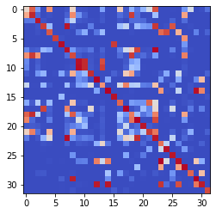

epoch 4411 == measurement_heuristic: 0.35+-0.01/0.31+-0.01 --

epoch 4412 == measurement_heuristic: 0.33+-0.01/0.30+-0.01 --

epoch 4413 == measurement_heuristic: 0.34+-0.01/0.30+-0.01 --

epoch 4414 == measurement_heuristic: 0.35+-0.01/0.30+-0.01 --

epoch 4415 == measurement_heuristic: 0.35+-0.01/0.30+-0.01 --

epoch 4416 == measurement_heuristic: 0.35+-0.01/0.30+-0.01 --

epoch 4417 == measurement_heuristic: 0.36+-0.01/0.30+-0.01 --

epoch 4418 == measurement_heuristic: 0.36+-0.01/0.29+-0.01 --

epoch 4419 == measurement_heuristic: 0.32+-0.01/0.30+-0.01 --

epoch 4420 == measurement_heuristic: 0.35+-0.01/0.29+-0.01 --

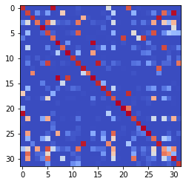

epoch 4421 == measurement_heuristic: 0.36+-0.01/0.30+-0.01 --

epoch 4422 == measurement_heuristic: 0.35+-0.01/0.30+-0.01 --

epoch 4423 == measurement_heuristic: 0.35+-0.01/0.30+-0.01 --

epoch 4424 == measurement_heuristic: 0.34+-0.01/0.29+-0.01 --

epoch 4425 == measurement_heuristic: 0.34+-0.01/0.31+-0.01 --

epoch 4426 == measurement_heuristic: 0.33+-0.01/0.30+-0.01 --

epoch 4427 == measurement_heuristic: 0.35+-0.01/0.29+-0.01 --

epoch 4428 == measurement_heuristic: 0.35+-0.01/0.30+-0.01 --

epoch 4429 == measurement_heuristic: 0.33+-0.01/0.29+-0.01 --

epoch 4430 == measurement_heuristic: 0.34+-0.01/0.29+-0.01 --

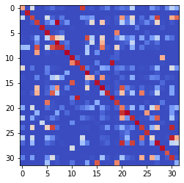

epoch 4431 == measurement_heuristic: 0.34+-0.01/0.31+-0.01 --

epoch 4432 == measurement_heuristic: 0.34+-0.01/0.30+-0.01 --

epoch 4433 == measurement_heuristic: 0.33+-0.01/0.30+-0.01 --

epoch 4434 == measurement_heuristic: 0.33+-0.01/0.29+-0.01 --

epoch 4435 == measurement_heuristic: 0.35+-0.01/0.30+-0.01 --

epoch 4436 == measurement_heuristic: 0.33+-0.01/0.29+-0.01 --

INFO:tensorflow:Restoring parameters from ../models/tmp/best_validation

INFO:tensorflow:Restoring parameters from ../models/tmp/best_validation

epoch 0 >> proposed_mle: 36.28+-0.06 --

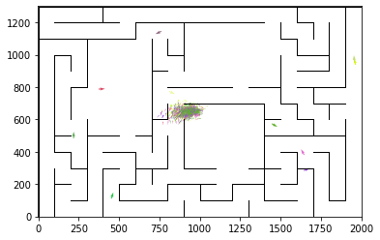

epoch 1 >> proposed_mle: 35.93+-0.10/35.21+-0.12 --

epoch 2 >> proposed_mle: 34.83+-0.16/33.68+-0.18 --

epoch 3 >> proposed_mle: 33.84+-0.22/32.84+-0.17 --

epoch 4 >> proposed_mle: 32.66+-0.25/31.24+-0.18 --

epoch 5 >> proposed_mle: 31.69+-0.29/29.92+-0.21 --

epoch 6 == proposed_mle: 31.39+-0.30/30.02+-0.18 --

epoch 7 >> proposed_mle: 30.90+-0.29/29.36+-0.20 --

epoch 8 >> proposed_mle: 30.20+-0.30/29.23+-0.20 --

epoch 9 == proposed_mle: 29.89+-0.22/29.32+-0.21 --

epoch 10 >> proposed_mle: 29.99+-0.24/28.33+-0.22 --

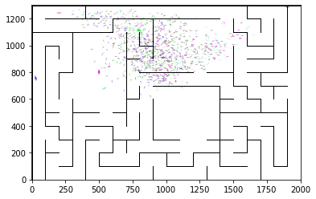

epoch 11 == proposed_mle: 29.49+-0.28/28.40+-0.23 --

epoch 12 == proposed_mle: 29.61+-0.26/28.49+-0.20 --

epoch 13 == proposed_mle: 29.68+-0.27/28.72+-0.22 --

epoch 14 == proposed_mle: 30.68+-0.31/28.48+-0.21 --

epoch 15 >> proposed_mle: 29.03+-0.28/28.03+-0.21 --

epoch 16 == proposed_mle: 29.48+-0.28/28.10+-0.21 --

epoch 17 >> proposed_mle: 29.57+-0.29/27.91+-0.21 --

epoch 18 == proposed_mle: 29.50+-0.27/28.80+-0.23 --

epoch 19 == proposed_mle: 29.87+-0.26/28.82+-0.23 --

epoch 20 == proposed_mle: 29.01+-0.27/28.04+-0.21 --

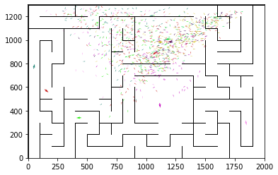

epoch 21 >> proposed_mle: 29.20+-0.30/27.68+-0.24 --

epoch 22 >> proposed_mle: 28.25+-0.32/27.61+-0.22 --

epoch 23 >> proposed_mle: 28.99+-0.33/27.46+-0.25 --

epoch 24 == proposed_mle: 28.37+-0.34/27.63+-0.23 --

epoch 25 >> proposed_mle: 28.67+-0.27/27.40+-0.23 --

epoch 26 == proposed_mle: 28.42+-0.30/27.44+-0.25 --

epoch 27 == proposed_mle: 28.25+-0.31/27.50+-0.23 --

epoch 28 == proposed_mle: 27.93+-0.27/27.48+-0.22 --

epoch 29 >> proposed_mle: 28.13+-0.32/27.20+-0.23 --

epoch 30 == proposed_mle: 28.04+-0.25/27.31+-0.23 --

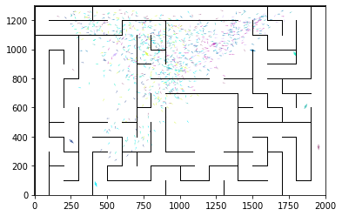

epoch 31 == proposed_mle: 28.76+-0.36/27.33+-0.23 --

epoch 32 >> proposed_mle: 28.08+-0.29/27.09+-0.25 --

epoch 33 == proposed_mle: 28.14+-0.30/27.26+-0.21 --

epoch 34 == proposed_mle: 28.35+-0.33/27.45+-0.22 --

epoch 35 >> proposed_mle: 28.00+-0.30/26.72+-0.24 --

epoch 36 >> proposed_mle: 27.54+-0.34/26.54+-0.24 --

epoch 37 == proposed_mle: 27.53+-0.24/26.77+-0.22 --

epoch 38 >> proposed_mle: 27.14+-0.33/26.34+-0.24 --

epoch 39 == proposed_mle: 27.91+-0.32/26.85+-0.23 --

epoch 40 == proposed_mle: 27.76+-0.26/26.58+-0.23 --

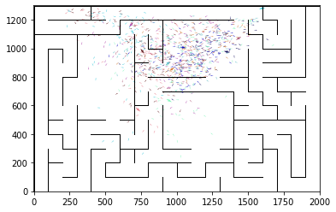

epoch 41 == proposed_mle: 27.50+-0.29/26.73+-0.25 --

epoch 42 == proposed_mle: 27.20+-0.34/26.59+-0.24 --

epoch 43 == proposed_mle: 27.52+-0.37/26.37+-0.25 --

epoch 44 >> proposed_mle: 27.23+-0.26/26.14+-0.24 --

epoch 45 == proposed_mle: 27.85+-0.30/26.42+-0.24 --

epoch 46 >> proposed_mle: 27.72+-0.32/26.12+-0.24 --

epoch 47 == proposed_mle: 27.57+-0.31/26.49+-0.24 --

epoch 48 >> proposed_mle: 26.92+-0.29/25.91+-0.22 --

epoch 49 == proposed_mle: 27.03+-0.31/26.04+-0.26 --

epoch 50 >> proposed_mle: 27.17+-0.35/25.80+-0.25 --

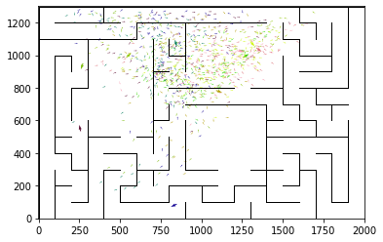

epoch 51 >> proposed_mle: 26.76+-0.34/25.78+-0.26 --

epoch 52 == proposed_mle: 27.03+-0.27/25.86+-0.24 --

epoch 53 == proposed_mle: 27.36+-0.30/25.91+-0.23 --

epoch 54 == proposed_mle: 26.85+-0.33/26.13+-0.26 --

epoch 55 >> proposed_mle: 27.04+-0.35/25.75+-0.25 --

epoch 56 == proposed_mle: 27.91+-0.35/25.88+-0.23 --

epoch 57 == proposed_mle: 27.14+-0.32/26.06+-0.25 --

epoch 58 == proposed_mle: 27.33+-0.31/25.92+-0.25 --

epoch 59 == proposed_mle: 27.24+-0.27/25.93+-0.23 --

epoch 60 >> proposed_mle: 26.55+-0.40/25.46+-0.25 --

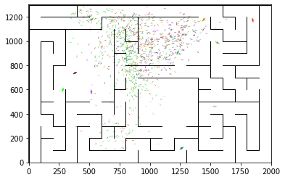

epoch 61 == proposed_mle: 26.87+-0.28/26.06+-0.25 --

epoch 62 == proposed_mle: 26.56+-0.30/25.66+-0.24 --

epoch 63 == proposed_mle: 26.56+-0.33/25.58+-0.24 --

epoch 64 == proposed_mle: 26.96+-0.31/25.46+-0.25 --

epoch 65 == proposed_mle: 26.54+-0.34/25.46+-0.24 --

epoch 66 == proposed_mle: 26.66+-0.39/25.61+-0.25 --

epoch 67 >> proposed_mle: 26.25+-0.26/25.42+-0.26 --

epoch 68 == proposed_mle: 26.89+-0.28/25.55+-0.24 --

epoch 69 >> proposed_mle: 26.31+-0.28/25.33+-0.25 --

epoch 70 == proposed_mle: 26.68+-0.34/25.38+-0.24 --

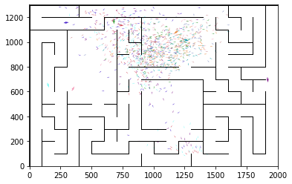

epoch 71 == proposed_mle: 26.46+-0.34/25.34+-0.26 --

epoch 72 == proposed_mle: 26.81+-0.34/25.71+-0.24 --

epoch 73 == proposed_mle: 26.45+-0.38/25.68+-0.26 --

epoch 74 >> proposed_mle: 26.34+-0.27/25.28+-0.25 --

epoch 75 == proposed_mle: 25.97+-0.33/25.40+-0.25 --

epoch 76 == proposed_mle: 26.17+-0.35/25.39+-0.26 --

epoch 77 == proposed_mle: 26.51+-0.33/25.63+-0.25 --

epoch 78 >> proposed_mle: 26.38+-0.27/25.08+-0.24 --

epoch 79 == proposed_mle: 26.56+-0.34/25.54+-0.25 --

epoch 80 == proposed_mle: 26.10+-0.28/25.19+-0.25 --

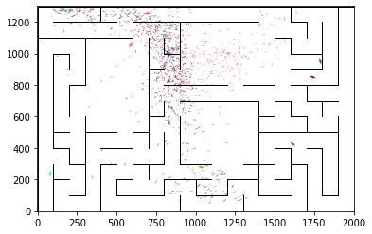

epoch 81 == proposed_mle: 26.11+-0.36/25.23+-0.25 --

epoch 82 == proposed_mle: 26.24+-0.32/25.19+-0.25 --

epoch 83 == proposed_mle: 26.17+-0.32/25.30+-0.26 --

epoch 84 == proposed_mle: 26.22+-0.33/25.38+-0.25 --

epoch 85 >> proposed_mle: 26.08+-0.24/24.97+-0.25 --

epoch 86 == proposed_mle: 26.23+-0.31/24.97+-0.26 --

epoch 87 >> proposed_mle: 25.97+-0.32/24.95+-0.25 --

epoch 88 == proposed_mle: 25.06+-0.30/25.04+-0.27 --

epoch 89 == proposed_mle: 26.10+-0.32/24.96+-0.26 --

epoch 90 == proposed_mle: 25.80+-0.27/24.98+-0.26 --

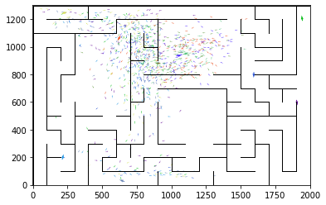

epoch 91 >> proposed_mle: 26.28+-0.36/24.86+-0.24 --

epoch 92 == proposed_mle: 26.41+-0.29/25.03+-0.25 --

epoch 93 >> proposed_mle: 25.96+-0.31/24.64+-0.25 --

epoch 94 == proposed_mle: 26.03+-0.37/24.80+-0.26 --

epoch 95 == proposed_mle: 26.04+-0.30/24.94+-0.25 --

epoch 96 >> proposed_mle: 25.54+-0.35/24.63+-0.27 --

epoch 97 == proposed_mle: 25.45+-0.34/24.75+-0.25 --

epoch 98 == proposed_mle: 25.83+-0.33/24.76+-0.25 --

epoch 99 == proposed_mle: 25.72+-0.30/24.73+-0.23 --

epoch 100 == proposed_mle: 25.59+-0.35/24.73+-0.26 --

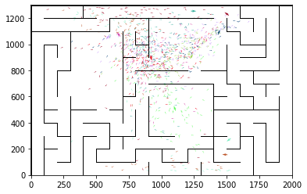

epoch 101 == proposed_mle: 26.44+-0.32/24.93+-0.24 --

epoch 102 == proposed_mle: 25.66+-0.33/24.99+-0.25 --

epoch 103 >> proposed_mle: 26.40+-0.35/24.61+-0.25 --

epoch 104 == proposed_mle: 25.81+-0.37/24.61+-0.26 --

epoch 105 >> proposed_mle: 25.50+-0.36/24.43+-0.26 --

epoch 106 >> proposed_mle: 24.94+-0.32/24.32+-0.26 --

epoch 107 == proposed_mle: 25.02+-0.33/24.49+-0.25 --

epoch 108 == proposed_mle: 24.96+-0.30/24.32+-0.25 --

epoch 109 >> proposed_mle: 24.95+-0.40/24.19+-0.26 --

epoch 110 == proposed_mle: 25.20+-0.36/24.32+-0.25 --

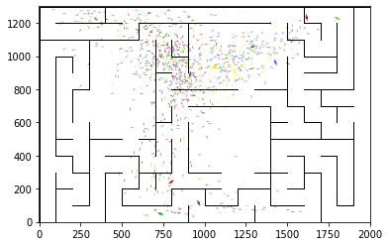

epoch 111 == proposed_mle: 25.39+-0.33/24.89+-0.24 --

epoch 112 == proposed_mle: 25.16+-0.34/24.41+-0.23 --

epoch 113 == proposed_mle: 25.40+-0.37/24.23+-0.24 --

epoch 114 == proposed_mle: 24.99+-0.34/24.38+-0.25 --

epoch 115 == proposed_mle: 25.12+-0.34/24.25+-0.25 --

epoch 116 >> proposed_mle: 25.60+-0.28/24.18+-0.25 --

epoch 117 == proposed_mle: 25.57+-0.33/24.19+-0.25 --

epoch 118 >> proposed_mle: 25.87+-0.32/24.03+-0.25 --

epoch 119 == proposed_mle: 24.91+-0.31/24.07+-0.26 --

epoch 120 == proposed_mle: 24.99+-0.31/24.28+-0.25 --

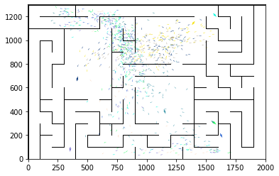

epoch 121 == proposed_mle: 25.37+-0.31/24.30+-0.26 --

epoch 122 == proposed_mle: 25.08+-0.34/24.11+-0.25 --

epoch 123 == proposed_mle: 25.44+-0.34/24.18+-0.25 --

epoch 124 == proposed_mle: 25.35+-0.30/24.18+-0.24 --

epoch 125 >> proposed_mle: 25.46+-0.30/23.99+-0.25 --

epoch 126 >> proposed_mle: 25.61+-0.33/23.78+-0.25 --

epoch 127 == proposed_mle: 24.93+-0.30/24.58+-0.22 --

epoch 128 == proposed_mle: 25.79+-0.29/24.25+-0.24 --

epoch 129 == proposed_mle: 24.94+-0.33/24.15+-0.24 --

epoch 130 == proposed_mle: 25.37+-0.28/24.09+-0.24 --

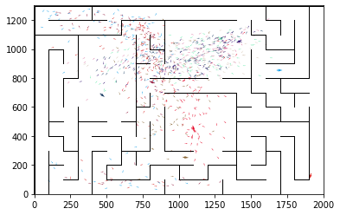

epoch 131 == proposed_mle: 25.80+-0.28/24.30+-0.23 --

epoch 132 == proposed_mle: 25.21+-0.34/24.17+-0.23 --

epoch 133 >> proposed_mle: 24.79+-0.28/23.65+-0.26 --

epoch 134 == proposed_mle: 25.16+-0.34/23.72+-0.25 --

epoch 135 == proposed_mle: 24.82+-0.31/24.13+-0.24 --

epoch 136 == proposed_mle: 24.97+-0.30/23.78+-0.25 --

epoch 137 == proposed_mle: 24.52+-0.31/23.82+-0.26 --

epoch 138 == proposed_mle: 25.59+-0.32/23.87+-0.25 --

epoch 139 == proposed_mle: 25.24+-0.28/24.41+-0.25 --

epoch 140 == proposed_mle: 25.15+-0.28/24.07+-0.25 --

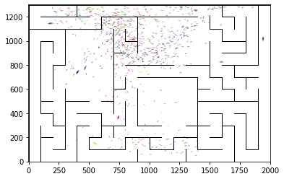

epoch 141 >> proposed_mle: 25.00+-0.32/23.37+-0.27 --

epoch 142 == proposed_mle: 24.49+-0.32/23.72+-0.26 --

epoch 143 == proposed_mle: 24.13+-0.34/23.60+-0.24 --

epoch 144 == proposed_mle: 24.88+-0.37/23.90+-0.24 --

epoch 145 == proposed_mle: 25.39+-0.31/23.72+-0.25 --

epoch 146 == proposed_mle: 24.35+-0.32/23.72+-0.26 --

epoch 147 == proposed_mle: 25.05+-0.30/23.90+-0.26 --

epoch 148 == proposed_mle: 24.76+-0.35/23.85+-0.25 --

epoch 149 == proposed_mle: 24.41+-0.38/23.54+-0.26 --

epoch 150 == proposed_mle: 24.57+-0.36/23.52+-0.25 --

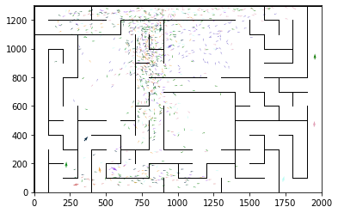

epoch 151 == proposed_mle: 24.77+-0.26/23.57+-0.25 --

epoch 152 >> proposed_mle: 24.70+-0.25/23.26+-0.24 --

epoch 153 >> proposed_mle: 24.90+-0.37/23.21+-0.27 --

epoch 154 == proposed_mle: 24.47+-0.34/23.27+-0.23 --

epoch 155 == proposed_mle: 24.18+-0.32/23.39+-0.24 --

epoch 156 == proposed_mle: 24.91+-0.38/23.54+-0.25 --

epoch 157 == proposed_mle: 24.77+-0.34/23.80+-0.25 --

epoch 158 == proposed_mle: 24.31+-0.31/23.46+-0.24 --

epoch 159 == proposed_mle: 24.54+-0.33/23.36+-0.25 --

epoch 160 == proposed_mle: 24.46+-0.38/23.38+-0.25 --

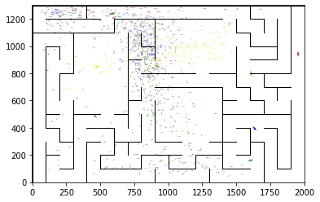

epoch 161 >> proposed_mle: 24.15+-0.33/23.19+-0.24 --

epoch 162 >> proposed_mle: 24.31+-0.35/23.12+-0.25 --

epoch 163 == proposed_mle: 24.76+-0.33/23.16+-0.26 --

epoch 164 >> proposed_mle: 24.09+-0.30/23.08+-0.25 --

epoch 165 >> proposed_mle: 24.37+-0.35/22.95+-0.25 --

epoch 166 >> proposed_mle: 24.36+-0.38/22.84+-0.24 --

epoch 167 == proposed_mle: 23.65+-0.32/23.17+-0.25 --

epoch 168 == proposed_mle: 23.52+-0.36/23.17+-0.24 --

epoch 169 == proposed_mle: 24.18+-0.30/23.24+-0.25 --

epoch 170 == proposed_mle: 24.08+-0.33/22.94+-0.24 --

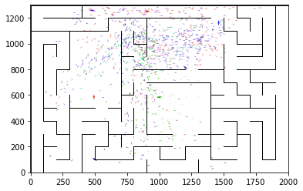

epoch 171 == proposed_mle: 24.00+-0.34/23.08+-0.25 --

epoch 172 == proposed_mle: 24.29+-0.33/23.07+-0.25 --

epoch 173 == proposed_mle: 24.89+-0.34/23.32+-0.25 --

epoch 174 >> proposed_mle: 24.46+-0.36/22.75+-0.23 --

epoch 175 == proposed_mle: 24.21+-0.29/23.05+-0.24 --

epoch 176 == proposed_mle: 23.94+-0.32/23.17+-0.25 --

epoch 177 == proposed_mle: 24.43+-0.35/23.07+-0.25 --

epoch 178 == proposed_mle: 24.99+-0.32/22.98+-0.24 --

epoch 179 == proposed_mle: 23.62+-0.32/23.02+-0.26 --

epoch 180 == proposed_mle: 23.75+-0.35/22.83+-0.25 --

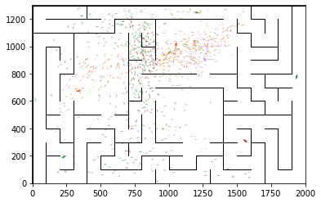

epoch 181 == proposed_mle: 24.11+-0.33/22.81+-0.26 --

epoch 182 == proposed_mle: 24.06+-0.30/23.32+-0.26 --

epoch 183 == proposed_mle: 24.45+-0.31/22.95+-0.25 --

epoch 184 == proposed_mle: 24.15+-0.35/23.16+-0.26 --

epoch 185 == proposed_mle: 24.49+-0.41/23.09+-0.24 --

epoch 186 == proposed_mle: 24.83+-0.36/23.03+-0.25 --

epoch 187 >> proposed_mle: 24.51+-0.29/22.67+-0.23 --

epoch 188 == proposed_mle: 23.32+-0.37/22.72+-0.25 --

epoch 189 == proposed_mle: 24.26+-0.34/23.03+-0.24 --

epoch 190 == proposed_mle: 23.88+-0.41/22.67+-0.25 --

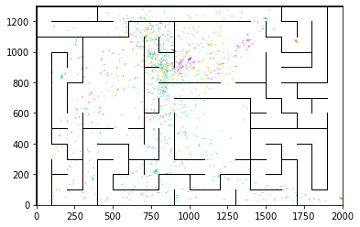

epoch 191 == proposed_mle: 24.00+-0.39/22.70+-0.24 --

epoch 192 >> proposed_mle: 23.64+-0.36/22.60+-0.25 --

epoch 193 == proposed_mle: 23.31+-0.37/22.90+-0.24 --

epoch 194 == proposed_mle: 24.07+-0.28/22.77+-0.24 --

epoch 195 >> proposed_mle: 23.38+-0.30/22.57+-0.24 --

epoch 196 == proposed_mle: 23.62+-0.30/22.57+-0.25 --

epoch 197 == proposed_mle: 23.56+-0.43/22.58+-0.24 --

epoch 198 == proposed_mle: 23.50+-0.36/22.76+-0.25 --

epoch 199 == proposed_mle: 23.34+-0.31/22.96+-0.24 --

epoch 200 >> proposed_mle: 22.78+-0.34/22.43+-0.25 --

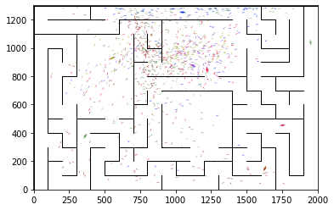

epoch 201 == proposed_mle: 24.30+-0.32/22.65+-0.23 --

epoch 202 == proposed_mle: 24.22+-0.26/22.58+-0.23 --

epoch 203 == proposed_mle: 23.95+-0.39/22.62+-0.25 --

epoch 204 == proposed_mle: 23.24+-0.33/22.65+-0.23 --

epoch 205 == proposed_mle: 24.07+-0.30/22.61+-0.26 --

epoch 206 == proposed_mle: 22.98+-0.34/22.48+-0.25 --

epoch 207 >> proposed_mle: 23.67+-0.29/22.27+-0.26 --

epoch 208 == proposed_mle: 24.05+-0.33/22.64+-0.24 --

epoch 209 == proposed_mle: 23.73+-0.35/22.78+-0.28 --

epoch 210 == proposed_mle: 23.89+-0.34/22.60+-0.26 --

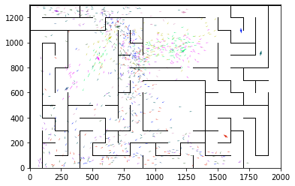

epoch 211 == proposed_mle: 23.32+-0.37/22.59+-0.26 --

epoch 212 == proposed_mle: 23.84+-0.30/22.44+-0.22 --

epoch 213 == proposed_mle: 23.53+-0.41/22.55+-0.24 --

epoch 214 == proposed_mle: 23.61+-0.33/22.42+-0.25 --

epoch 215 == proposed_mle: 23.64+-0.35/22.32+-0.26 --

epoch 216 == proposed_mle: 23.27+-0.40/22.34+-0.25 --

epoch 217 == proposed_mle: 24.45+-0.30/22.55+-0.25 --

epoch 218 == proposed_mle: 23.68+-0.37/22.55+-0.23 --

epoch 219 == proposed_mle: 23.54+-0.32/22.28+-0.24 --

epoch 220 == proposed_mle: 23.89+-0.29/22.55+-0.24 --

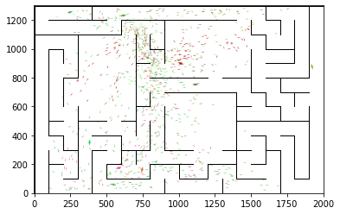

epoch 221 >> proposed_mle: 23.97+-0.28/22.24+-0.25 --

epoch 222 == proposed_mle: 23.70+-0.36/22.28+-0.25 --

epoch 223 == proposed_mle: 23.42+-0.35/22.42+-0.24 --

epoch 224 == proposed_mle: 23.31+-0.31/22.29+-0.24 --

epoch 225 == proposed_mle: 23.40+-0.26/22.43+-0.25 --

epoch 226 == proposed_mle: 23.71+-0.34/22.42+-0.24 --

epoch 227 == proposed_mle: 23.87+-0.27/22.34+-0.23 --

epoch 228 == proposed_mle: 23.29+-0.34/22.24+-0.24 --

epoch 229 == proposed_mle: 23.68+-0.33/22.74+-0.24 --

epoch 230 == proposed_mle: 23.50+-0.30/22.39+-0.25 --

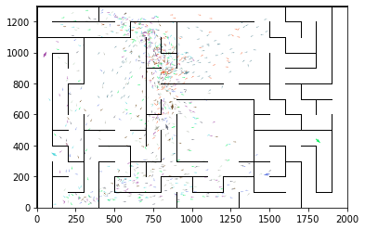

epoch 231 >> proposed_mle: 23.40+-0.35/22.16+-0.25 --

epoch 232 >> proposed_mle: 23.25+-0.32/22.14+-0.24 --

epoch 233 >> proposed_mle: 22.51+-0.32/22.10+-0.25 --

epoch 234 == proposed_mle: 23.28+-0.30/22.31+-0.22 --

epoch 235 == proposed_mle: 23.60+-0.35/22.37+-0.24 --

epoch 236 == proposed_mle: 23.82+-0.36/22.26+-0.25 --

epoch 237 == proposed_mle: 23.62+-0.32/22.39+-0.24 --

epoch 238 == proposed_mle: 23.44+-0.33/22.14+-0.24 --

epoch 239 >> proposed_mle: 22.95+-0.36/22.06+-0.25 --

epoch 240 >> proposed_mle: 23.82+-0.33/21.85+-0.25 --

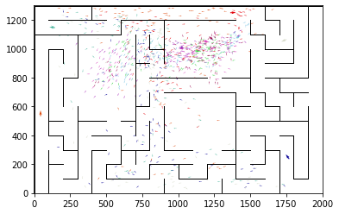

epoch 241 == proposed_mle: 22.66+-0.31/22.18+-0.23 --

epoch 242 == proposed_mle: 23.08+-0.33/21.99+-0.24 --

epoch 243 == proposed_mle: 22.74+-0.35/22.08+-0.24 --

epoch 244 == proposed_mle: 23.39+-0.37/22.11+-0.24 --

epoch 245 >> proposed_mle: 23.23+-0.36/21.83+-0.25 --

epoch 246 == proposed_mle: 22.57+-0.36/22.02+-0.23 --

epoch 247 == proposed_mle: 23.12+-0.29/22.18+-0.24 --

epoch 248 == proposed_mle: 22.22+-0.29/21.87+-0.24 --

epoch 249 == proposed_mle: 23.09+-0.35/21.91+-0.24 --

epoch 250 == proposed_mle: 23.41+-0.37/22.16+-0.25 --

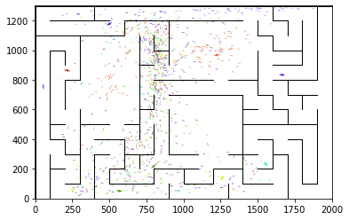

epoch 251 == proposed_mle: 23.57+-0.32/22.06+-0.27 --

epoch 252 == proposed_mle: 22.89+-0.37/22.08+-0.25 --

epoch 253 == proposed_mle: 22.99+-0.31/22.16+-0.26 --

epoch 254 == proposed_mle: 23.15+-0.36/21.86+-0.25 --

epoch 255 >> proposed_mle: 21.84+-0.32/21.77+-0.25 --

epoch 256 == proposed_mle: 22.93+-0.34/21.90+-0.25 --

epoch 257 >> proposed_mle: 22.91+-0.42/21.74+-0.26 --

epoch 258 >> proposed_mle: 22.73+-0.30/21.67+-0.26 --

epoch 259 == proposed_mle: 23.22+-0.36/22.03+-0.23 --

epoch 260 == proposed_mle: 23.15+-0.32/21.87+-0.26 --

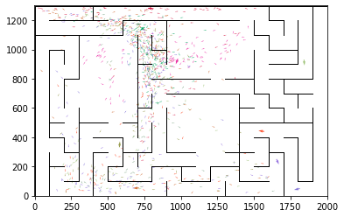

epoch 261 == proposed_mle: 23.18+-0.34/21.79+-0.25 --

epoch 262 == proposed_mle: 23.19+-0.36/21.85+-0.25 --

epoch 263 == proposed_mle: 22.97+-0.27/21.90+-0.24 --

epoch 264 == proposed_mle: 24.11+-0.41/22.08+-0.24 --

epoch 265 == proposed_mle: 23.48+-0.37/22.04+-0.25 --

epoch 266 == proposed_mle: 23.64+-0.36/21.91+-0.25 --

epoch 267 == proposed_mle: 23.28+-0.40/21.98+-0.27 --

epoch 268 == proposed_mle: 23.09+-0.38/21.97+-0.26 --

epoch 269 >> proposed_mle: 22.94+-0.31/21.62+-0.26 --

epoch 270 == proposed_mle: 22.66+-0.35/22.09+-0.25 --

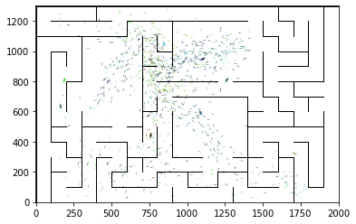

epoch 271 == proposed_mle: 22.57+-0.26/21.72+-0.24 --

epoch 272 >> proposed_mle: 22.79+-0.37/21.53+-0.26 --

epoch 273 == proposed_mle: 22.60+-0.34/21.68+-0.23 --

epoch 274 == proposed_mle: 23.38+-0.34/21.58+-0.25 --

epoch 275 >> proposed_mle: 22.39+-0.34/21.42+-0.24 --

epoch 276 == proposed_mle: 22.70+-0.37/21.63+-0.25 --

epoch 277 >> proposed_mle: 22.29+-0.29/21.42+-0.25 --

epoch 278 == proposed_mle: 23.06+-0.36/21.65+-0.26 --

epoch 279 == proposed_mle: 22.69+-0.31/21.87+-0.22 --

epoch 280 == proposed_mle: 23.15+-0.34/21.74+-0.22 --

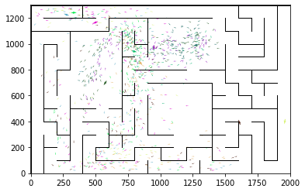

epoch 281 == proposed_mle: 22.03+-0.36/21.54+-0.26 --

epoch 282 == proposed_mle: 23.07+-0.30/21.47+-0.26 --

epoch 283 == proposed_mle: 22.88+-0.33/21.76+-0.25 --

epoch 284 >> proposed_mle: 23.43+-0.31/21.36+-0.23 --

epoch 285 == proposed_mle: 22.81+-0.36/21.50+-0.26 --

epoch 286 == proposed_mle: 22.56+-0.36/21.41+-0.24 --

epoch 287 >> proposed_mle: 21.90+-0.28/21.34+-0.25 --

epoch 288 == proposed_mle: 22.38+-0.40/21.38+-0.24 --

epoch 289 == proposed_mle: 22.99+-0.34/21.57+-0.24 --

epoch 290 == proposed_mle: 22.20+-0.35/21.53+-0.27 --

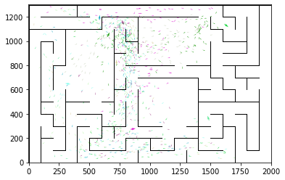

epoch 291 >> proposed_mle: 22.85+-0.32/21.33+-0.24 --

epoch 292 >> proposed_mle: 22.57+-0.31/21.33+-0.24 --

epoch 293 == proposed_mle: 22.16+-0.39/21.35+-0.24 --

epoch 294 >> proposed_mle: 22.71+-0.33/21.26+-0.25 --

epoch 295 == proposed_mle: 23.37+-0.29/21.56+-0.23 --

epoch 296 >> proposed_mle: 22.67+-0.30/21.21+-0.26 --

epoch 297 == proposed_mle: 22.28+-0.34/21.23+-0.25 --

epoch 298 == proposed_mle: 22.57+-0.34/21.36+-0.24 --

epoch 299 == proposed_mle: 22.25+-0.30/21.28+-0.24 --

epoch 300 >> proposed_mle: 22.88+-0.33/21.14+-0.24 --

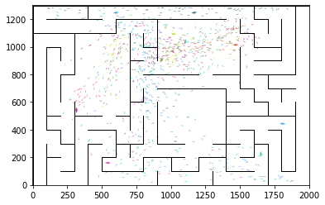

epoch 301 >> proposed_mle: 22.18+-0.32/21.10+-0.24 --

epoch 302 == proposed_mle: 22.17+-0.41/21.22+-0.26 --

epoch 303 == proposed_mle: 22.50+-0.40/21.39+-0.24 --

epoch 304 == proposed_mle: 22.68+-0.33/21.54+-0.24 --

epoch 305 == proposed_mle: 22.44+-0.33/21.27+-0.22 --

epoch 306 == proposed_mle: 22.50+-0.35/21.21+-0.24 --

epoch 307 >> proposed_mle: 22.46+-0.40/21.02+-0.24 --

epoch 308 == proposed_mle: 22.85+-0.34/21.47+-0.23 --

epoch 309 == proposed_mle: 21.98+-0.29/21.29+-0.21 --

epoch 310 == proposed_mle: 22.60+-0.35/21.48+-0.25 --

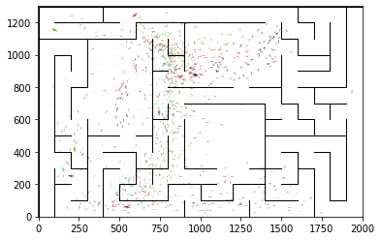

epoch 311 == proposed_mle: 22.54+-0.38/21.03+-0.24 --

epoch 312 == proposed_mle: 22.35+-0.35/21.30+-0.23 --

epoch 313 == proposed_mle: 22.16+-0.29/21.34+-0.27 --

epoch 314 == proposed_mle: 21.88+-0.37/21.33+-0.25 --

epoch 315 == proposed_mle: 22.87+-0.36/21.22+-0.23 --

epoch 316 >> proposed_mle: 22.14+-0.42/20.87+-0.24 --

epoch 317 >> proposed_mle: 21.49+-0.34/20.79+-0.24 --

epoch 318 == proposed_mle: 22.77+-0.36/21.16+-0.25 --

epoch 319 >> proposed_mle: 21.57+-0.42/20.74+-0.24 --

epoch 320 == proposed_mle: 22.32+-0.33/20.76+-0.23 --

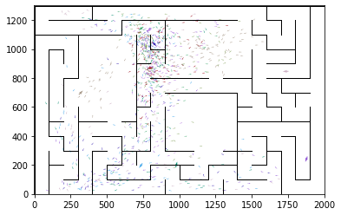

epoch 321 == proposed_mle: 22.41+-0.34/20.97+-0.25 --

epoch 322 == proposed_mle: 21.41+-0.32/20.94+-0.23 --

epoch 323 == proposed_mle: 22.55+-0.29/21.29+-0.25 --

epoch 324 == proposed_mle: 22.34+-0.39/21.11+-0.26 --

epoch 325 == proposed_mle: 22.38+-0.35/21.08+-0.25 --

epoch 326 == proposed_mle: 22.22+-0.38/21.22+-0.24 --

epoch 327 == proposed_mle: 22.64+-0.28/21.21+-0.24 --

epoch 328 == proposed_mle: 22.20+-0.32/21.15+-0.24 --

epoch 329 == proposed_mle: 21.37+-0.36/21.04+-0.24 --

epoch 330 == proposed_mle: 21.97+-0.39/21.20+-0.24 --

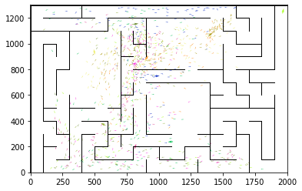

epoch 331 == proposed_mle: 21.61+-0.41/21.19+-0.25 --

epoch 332 == proposed_mle: 21.49+-0.30/21.08+-0.24 --

epoch 333 == proposed_mle: 21.24+-0.35/21.10+-0.24 --

epoch 334 == proposed_mle: 22.20+-0.33/21.18+-0.24 --

epoch 335 == proposed_mle: 22.11+-0.35/20.86+-0.24 --

epoch 336 >> proposed_mle: 22.57+-0.36/20.72+-0.24 --

epoch 337 == proposed_mle: 21.66+-0.30/20.84+-0.26 --

epoch 338 == proposed_mle: 21.47+-0.39/20.86+-0.24 --

epoch 339 == proposed_mle: 21.83+-0.33/20.83+-0.25 --

epoch 340 == proposed_mle: 22.08+-0.36/20.98+-0.26 --

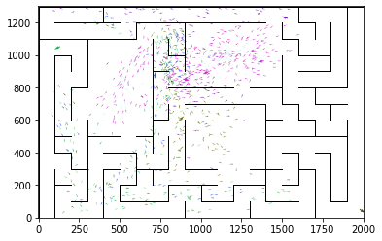

epoch 341 == proposed_mle: 22.46+-0.33/21.30+-0.25 --

epoch 342 == proposed_mle: 22.44+-0.35/21.12+-0.23 --

epoch 343 == proposed_mle: 22.05+-0.37/21.31+-0.25 --

epoch 344 == proposed_mle: 21.30+-0.35/20.90+-0.23 --

epoch 345 == proposed_mle: 22.26+-0.35/21.31+-0.24 --

epoch 346 == proposed_mle: 22.38+-0.40/21.02+-0.26 --

epoch 347 == proposed_mle: 21.80+-0.36/20.86+-0.25 --

epoch 348 == proposed_mle: 21.44+-0.37/20.98+-0.24 --

epoch 349 == proposed_mle: 21.67+-0.33/20.87+-0.25 --

epoch 350 == proposed_mle: 21.63+-0.34/21.05+-0.26 --

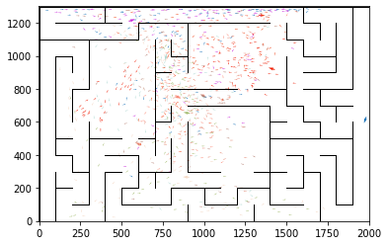

epoch 351 == proposed_mle: 22.06+-0.29/20.85+-0.23 --

epoch 352 == proposed_mle: 21.69+-0.36/20.74+-0.24 --

epoch 353 == proposed_mle: 21.28+-0.40/20.76+-0.26 --

epoch 354 >> proposed_mle: 21.91+-0.33/20.70+-0.25 --

epoch 355 >> proposed_mle: 22.28+-0.33/20.64+-0.25 --

epoch 356 == proposed_mle: 21.88+-0.35/21.02+-0.24 --

epoch 357 >> proposed_mle: 21.99+-0.34/20.59+-0.24 --

epoch 358 == proposed_mle: 21.60+-0.31/20.64+-0.26 --

epoch 359 == proposed_mle: 21.62+-0.35/20.81+-0.23 --

epoch 360 >> proposed_mle: 21.55+-0.36/20.55+-0.25 --

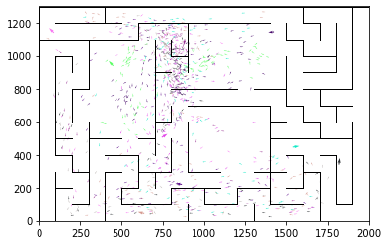

epoch 361 >> proposed_mle: 22.07+-0.33/20.51+-0.24 --

epoch 362 >> proposed_mle: 21.37+-0.35/20.47+-0.24 --

epoch 363 == proposed_mle: 22.03+-0.31/20.67+-0.24 --

epoch 364 >> proposed_mle: 21.15+-0.27/20.42+-0.23 --

epoch 365 == proposed_mle: 22.03+-0.33/20.50+-0.24 --

epoch 366 == proposed_mle: 21.58+-0.34/20.88+-0.25 --

epoch 367 == proposed_mle: 21.92+-0.32/20.79+-0.25 --

epoch 368 == proposed_mle: 21.33+-0.36/20.79+-0.24 --

epoch 369 == proposed_mle: 21.31+-0.32/20.52+-0.25 --

epoch 370 == proposed_mle: 21.93+-0.35/20.51+-0.24 --

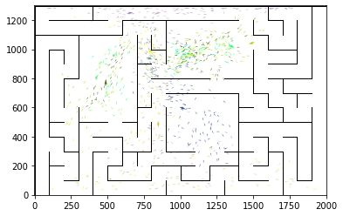

epoch 371 >> proposed_mle: 20.97+-0.36/20.27+-0.24 --

epoch 372 == proposed_mle: 21.22+-0.33/20.81+-0.24 --

epoch 373 == proposed_mle: 21.27+-0.31/20.41+-0.23 --

epoch 374 == proposed_mle: 21.92+-0.34/20.54+-0.23 --

epoch 375 == proposed_mle: 21.61+-0.35/20.78+-0.23 --

epoch 376 == proposed_mle: 21.80+-0.40/20.64+-0.24 --

epoch 377 == proposed_mle: 21.95+-0.37/20.66+-0.24 --

epoch 378 == proposed_mle: 22.06+-0.30/20.60+-0.23 --

epoch 379 == proposed_mle: 21.53+-0.32/20.61+-0.24 --

epoch 380 == proposed_mle: 21.95+-0.35/20.60+-0.24 --

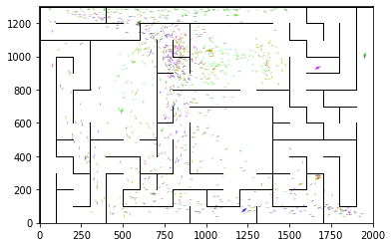

epoch 381 == proposed_mle: 21.35+-0.33/20.54+-0.23 --

epoch 382 == proposed_mle: 22.08+-0.30/20.46+-0.21 --

epoch 383 == proposed_mle: 21.87+-0.37/20.56+-0.23 --

epoch 384 == proposed_mle: 21.64+-0.39/20.70+-0.25 --

epoch 385 == proposed_mle: 21.45+-0.34/20.60+-0.26 --

epoch 386 == proposed_mle: 21.35+-0.37/20.48+-0.25 --

epoch 387 == proposed_mle: 21.61+-0.40/20.77+-0.23 --

epoch 388 == proposed_mle: 21.97+-0.36/20.77+-0.25 --

epoch 389 == proposed_mle: 21.59+-0.37/20.61+-0.25 --

epoch 390 == proposed_mle: 21.17+-0.36/20.49+-0.25 --

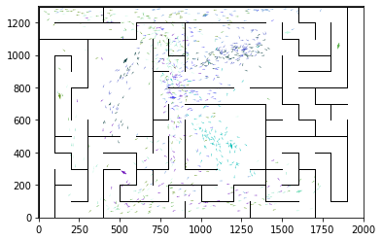

epoch 391 == proposed_mle: 20.95+-0.34/20.55+-0.25 --

epoch 392 == proposed_mle: 21.51+-0.32/20.60+-0.25 --

epoch 393 == proposed_mle: 22.14+-0.35/20.67+-0.26 --

epoch 394 == proposed_mle: 21.45+-0.33/20.64+-0.25 --

epoch 395 == proposed_mle: 21.47+-0.34/20.59+-0.25 --

epoch 396 == proposed_mle: 21.49+-0.34/20.34+-0.23 --

epoch 397 == proposed_mle: 21.30+-0.37/20.62+-0.24 --

epoch 398 == proposed_mle: 21.34+-0.27/20.31+-0.24 --

epoch 399 == proposed_mle: 21.55+-0.38/20.44+-0.24 --

epoch 400 == proposed_mle: 21.47+-0.34/20.36+-0.23 --

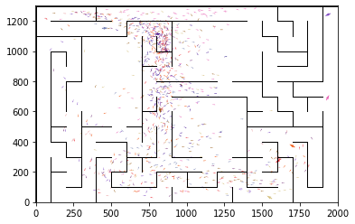

epoch 401 == proposed_mle: 21.01+-0.35/20.38+-0.24 --

epoch 402 == proposed_mle: 20.51+-0.34/20.47+-0.25 --

epoch 403 == proposed_mle: 21.20+-0.33/20.50+-0.25 --

epoch 404 == proposed_mle: 20.91+-0.41/20.37+-0.25 --

epoch 405 == proposed_mle: 21.05+-0.35/20.43+-0.24 --

epoch 406 == proposed_mle: 21.39+-0.37/20.54+-0.25 --

epoch 407 == proposed_mle: 21.06+-0.33/20.44+-0.25 --

epoch 408 == proposed_mle: 21.90+-0.38/20.54+-0.25 --

epoch 409 == proposed_mle: 21.00+-0.37/20.58+-0.24 --

epoch 410 == proposed_mle: 21.77+-0.30/20.79+-0.24 --

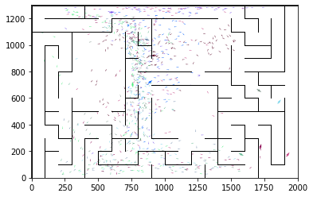

epoch 411 == proposed_mle: 21.51+-0.31/20.59+-0.23 --

epoch 412 == proposed_mle: 21.96+-0.35/20.55+-0.25 --

epoch 413 == proposed_mle: 20.96+-0.36/20.41+-0.26 --

epoch 414 == proposed_mle: 21.65+-0.33/20.34+-0.25 --

epoch 415 == proposed_mle: 21.55+-0.45/20.45+-0.25 --

epoch 416 == proposed_mle: 21.50+-0.36/20.34+-0.25 --

epoch 417 == proposed_mle: 21.59+-0.30/20.37+-0.25 --

epoch 418 >> proposed_mle: 21.21+-0.35/20.25+-0.24 --

epoch 419 == proposed_mle: 21.73+-0.32/20.39+-0.25 --

epoch 420 == proposed_mle: 21.37+-0.37/20.43+-0.23 --

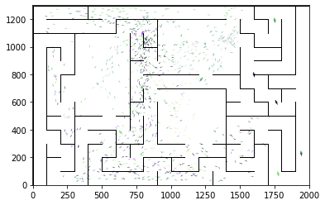

epoch 421 == proposed_mle: 21.61+-0.40/20.50+-0.24 --

epoch 422 == proposed_mle: 21.80+-0.43/20.48+-0.24 --

epoch 423 == proposed_mle: 21.95+-0.34/20.28+-0.25 --

epoch 424 == proposed_mle: 21.52+-0.37/20.35+-0.24 --

epoch 425 >> proposed_mle: 21.12+-0.39/20.16+-0.25 --

epoch 426 >> proposed_mle: 21.53+-0.35/20.07+-0.24 --

epoch 427 == proposed_mle: 21.33+-0.31/20.38+-0.24 --

epoch 428 == proposed_mle: 21.72+-0.35/20.45+-0.24 --

epoch 429 == proposed_mle: 21.84+-0.36/20.20+-0.23 --

epoch 430 == proposed_mle: 21.22+-0.41/20.44+-0.24 --

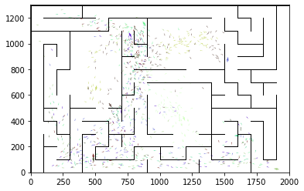

epoch 431 == proposed_mle: 21.87+-0.34/20.43+-0.23 --

epoch 432 == proposed_mle: 21.39+-0.41/20.39+-0.23 --

epoch 433 == proposed_mle: 21.17+-0.36/20.24+-0.24 --

epoch 434 == proposed_mle: 22.11+-0.38/20.38+-0.24 --

epoch 435 == proposed_mle: 21.13+-0.34/20.19+-0.23 --

epoch 436 == proposed_mle: 21.29+-0.36/20.23+-0.25 --

epoch 437 == proposed_mle: 21.31+-0.34/20.45+-0.23 --

epoch 438 == proposed_mle: 21.37+-0.37/20.33+-0.24 --

epoch 439 == proposed_mle: 21.50+-0.34/20.40+-0.25 --

epoch 440 == proposed_mle: 21.26+-0.34/20.24+-0.26 --

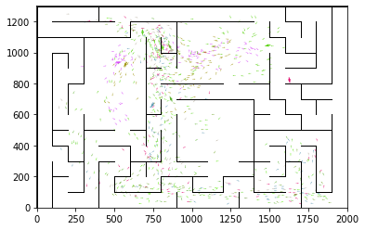

epoch 441 == proposed_mle: 21.99+-0.38/20.30+-0.25 --

epoch 442 == proposed_mle: 21.35+-0.35/20.44+-0.23 --

epoch 443 == proposed_mle: 21.40+-0.34/20.38+-0.23 --

epoch 444 == proposed_mle: 21.66+-0.33/20.39+-0.24 --

epoch 445 == proposed_mle: 20.67+-0.33/20.21+-0.23 --

epoch 446 == proposed_mle: 21.23+-0.35/20.62+-0.23 --

epoch 447 == proposed_mle: 21.18+-0.30/20.23+-0.25 --

epoch 448 >> proposed_mle: 21.44+-0.35/20.01+-0.24 --

epoch 449 == proposed_mle: 21.43+-0.32/20.06+-0.24 --

epoch 450 == proposed_mle: 20.86+-0.38/20.08+-0.24 --

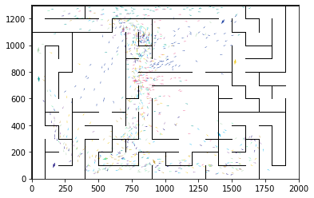

epoch 451 == proposed_mle: 21.14+-0.31/20.03+-0.24 --

epoch 452 == proposed_mle: 20.97+-0.28/20.03+-0.24 --

epoch 453 == proposed_mle: 20.63+-0.34/20.16+-0.23 --

epoch 454 == proposed_mle: 21.59+-0.40/20.37+-0.24 --

epoch 455 == proposed_mle: 21.24+-0.34/20.16+-0.25 --

epoch 456 == proposed_mle: 21.22+-0.39/20.13+-0.23 --

epoch 457 >> proposed_mle: 20.86+-0.34/19.92+-0.24 --

epoch 458 == proposed_mle: 20.33+-0.35/20.04+-0.24 --

epoch 459 == proposed_mle: 20.81+-0.37/19.94+-0.23 --

epoch 460 == proposed_mle: 21.38+-0.31/20.05+-0.25 --

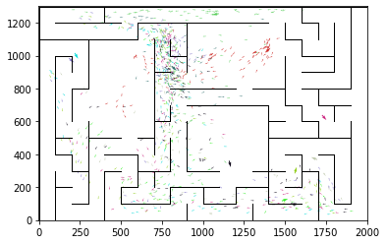

epoch 461 == proposed_mle: 20.81+-0.31/20.13+-0.25 --

epoch 462 == proposed_mle: 20.51+-0.36/20.15+-0.26 --

epoch 463 == proposed_mle: 20.83+-0.31/20.09+-0.25 --

epoch 464 == proposed_mle: 21.23+-0.27/19.98+-0.25 --

epoch 465 == proposed_mle: 21.12+-0.29/20.13+-0.23 --

epoch 466 == proposed_mle: 21.07+-0.30/20.38+-0.25 --

epoch 467 == proposed_mle: 20.59+-0.35/20.17+-0.25 --

epoch 468 == proposed_mle: 21.13+-0.35/20.04+-0.25 --

epoch 469 == proposed_mle: 21.28+-0.34/20.39+-0.24 --

epoch 470 == proposed_mle: 21.71+-0.38/20.13+-0.26 --

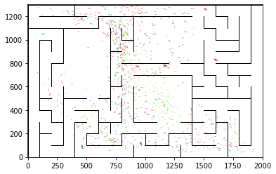

epoch 471 == proposed_mle: 20.91+-0.35/20.04+-0.24 --

epoch 472 == proposed_mle: 20.46+-0.29/20.12+-0.24 --

epoch 473 == proposed_mle: 20.84+-0.35/20.08+-0.24 --

epoch 474 == proposed_mle: 20.74+-0.35/20.09+-0.23 --

epoch 475 == proposed_mle: 21.34+-0.30/20.11+-0.23 --

epoch 476 >> proposed_mle: 21.04+-0.34/19.78+-0.24 --

epoch 477 == proposed_mle: 20.94+-0.34/19.95+-0.23 --

epoch 478 == proposed_mle: 20.91+-0.36/20.01+-0.23 --

epoch 479 == proposed_mle: 20.84+-0.33/19.95+-0.23 --

epoch 480 == proposed_mle: 21.15+-0.39/20.11+-0.25 --

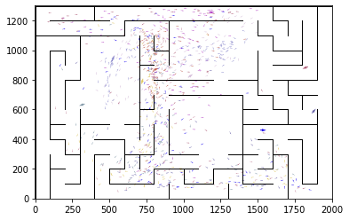

epoch 481 == proposed_mle: 21.41+-0.33/20.21+-0.25 --

epoch 482 == proposed_mle: 21.46+-0.40/20.20+-0.24 --

epoch 483 == proposed_mle: 20.89+-0.36/20.04+-0.22 --

epoch 484 == proposed_mle: 21.03+-0.35/19.83+-0.23 --

epoch 485 == proposed_mle: 21.16+-0.33/20.04+-0.24 --

epoch 486 == proposed_mle: 20.63+-0.35/19.81+-0.24 --

epoch 487 == proposed_mle: 21.40+-0.33/20.08+-0.23 --

epoch 488 == proposed_mle: 21.29+-0.42/20.16+-0.25 --

epoch 489 == proposed_mle: 20.84+-0.39/20.32+-0.24 --

epoch 490 == proposed_mle: 20.95+-0.36/19.92+-0.24 --

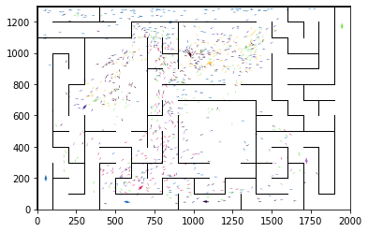

epoch 491 == proposed_mle: 20.52+-0.33/19.97+-0.23 --

epoch 492 == proposed_mle: 21.31+-0.38/19.95+-0.25 --

epoch 493 == proposed_mle: 20.88+-0.37/19.89+-0.25 --

epoch 494 >> proposed_mle: 20.31+-0.35/19.71+-0.23 --

epoch 495 == proposed_mle: 21.32+-0.36/20.00+-0.24 --

epoch 496 == proposed_mle: 21.37+-0.30/20.22+-0.24 --

epoch 497 == proposed_mle: 20.71+-0.37/19.83+-0.24 --

epoch 498 == proposed_mle: 21.05+-0.30/19.90+-0.23 --

epoch 499 == proposed_mle: 20.44+-0.36/19.84+-0.24 --

epoch 500 == proposed_mle: 21.79+-0.36/19.87+-0.24 --

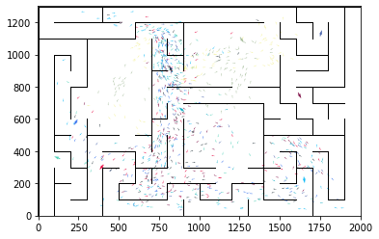

epoch 501 == proposed_mle: 20.57+-0.37/20.16+-0.24 --

epoch 502 == proposed_mle: 21.48+-0.37/20.05+-0.24 --

epoch 503 == proposed_mle: 21.17+-0.32/20.20+-0.23 --

epoch 504 == proposed_mle: 21.37+-0.38/20.05+-0.25 --

epoch 505 == proposed_mle: 20.77+-0.36/19.93+-0.26 --

epoch 506 == proposed_mle: 20.55+-0.30/19.86+-0.24 --

epoch 507 == proposed_mle: 21.16+-0.35/19.93+-0.26 --

epoch 508 >> proposed_mle: 20.47+-0.36/19.66+-0.24 --

epoch 509 == proposed_mle: 20.23+-0.35/19.81+-0.22 --

epoch 510 >> proposed_mle: 20.56+-0.32/19.61+-0.24 --

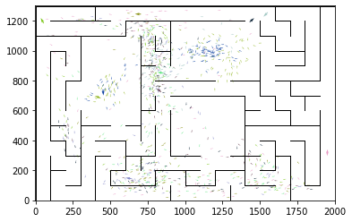

epoch 511 == proposed_mle: 20.64+-0.35/19.72+-0.24 --

epoch 512 >> proposed_mle: 20.54+-0.28/19.58+-0.25 --

epoch 513 == proposed_mle: 20.55+-0.34/19.80+-0.22 --

epoch 514 == proposed_mle: 20.54+-0.39/19.65+-0.24 --

epoch 515 == proposed_mle: 20.72+-0.34/19.82+-0.23 --

epoch 516 == proposed_mle: 20.84+-0.36/19.70+-0.24 --

epoch 517 == proposed_mle: 20.86+-0.33/19.73+-0.23 --

epoch 518 == proposed_mle: 20.75+-0.37/19.73+-0.26 --

epoch 519 == proposed_mle: 20.32+-0.30/19.69+-0.25 --

epoch 520 == proposed_mle: 20.27+-0.32/19.65+-0.25 --

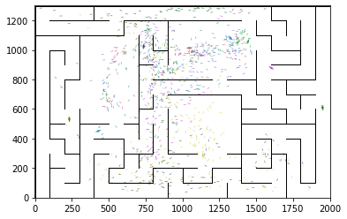

epoch 521 == proposed_mle: 20.55+-0.37/19.73+-0.26 --

epoch 522 == proposed_mle: 20.54+-0.34/19.59+-0.25 --

epoch 523 == proposed_mle: 20.98+-0.34/19.73+-0.23 --

epoch 524 == proposed_mle: 20.23+-0.39/19.67+-0.25 --

epoch 525 == proposed_mle: 20.62+-0.36/19.66+-0.25 --

epoch 526 >> proposed_mle: 20.69+-0.39/19.42+-0.24 --

epoch 527 == proposed_mle: 20.45+-0.36/19.74+-0.25 --

epoch 528 == proposed_mle: 20.93+-0.33/19.92+-0.23 --

epoch 529 == proposed_mle: 21.12+-0.30/19.73+-0.24 --

epoch 530 == proposed_mle: 20.95+-0.34/19.63+-0.23 --

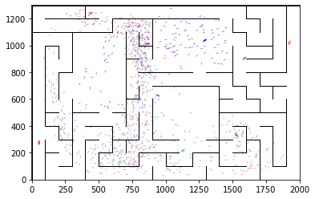

epoch 531 == proposed_mle: 20.90+-0.38/19.67+-0.24 --

epoch 532 == proposed_mle: 19.94+-0.30/19.56+-0.24 --

epoch 533 == proposed_mle: 19.97+-0.28/19.52+-0.24 --

epoch 534 == proposed_mle: 21.26+-0.35/20.02+-0.24 --

epoch 535 == proposed_mle: 20.72+-0.39/19.64+-0.26 --

epoch 536 == proposed_mle: 19.66+-0.33/19.52+-0.24 --

epoch 537 == proposed_mle: 20.23+-0.37/19.76+-0.24 --

epoch 538 == proposed_mle: 20.59+-0.33/19.75+-0.25 --

epoch 539 == proposed_mle: 20.85+-0.35/19.63+-0.24 --

epoch 540 == proposed_mle: 20.44+-0.29/19.64+-0.24 --

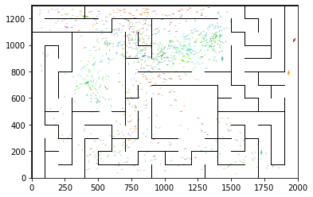

epoch 541 == proposed_mle: 20.93+-0.29/19.66+-0.24 --

epoch 542 == proposed_mle: 20.95+-0.31/19.78+-0.25 --

epoch 543 == proposed_mle: 20.29+-0.32/19.86+-0.24 --

epoch 544 == proposed_mle: 20.84+-0.31/19.81+-0.23 --

epoch 545 == proposed_mle: 20.20+-0.37/19.68+-0.23 --

epoch 546 == proposed_mle: 20.75+-0.33/19.67+-0.22 --

epoch 547 == proposed_mle: 20.26+-0.38/19.57+-0.24 --

epoch 548 == proposed_mle: 20.78+-0.31/19.70+-0.24 --

epoch 549 == proposed_mle: 21.11+-0.37/19.82+-0.25 --

epoch 550 == proposed_mle: 20.82+-0.31/19.65+-0.24 --

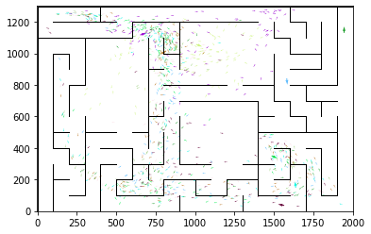

epoch 551 == proposed_mle: 20.25+-0.34/19.78+-0.25 --

epoch 552 == proposed_mle: 20.96+-0.37/19.61+-0.24 --

epoch 553 == proposed_mle: 20.87+-0.31/19.59+-0.24 --

epoch 554 == proposed_mle: 20.90+-0.38/20.04+-0.25 --

epoch 555 == proposed_mle: 20.45+-0.34/19.71+-0.24 --

epoch 556 == proposed_mle: 20.52+-0.30/20.14+-0.25 --

epoch 557 == proposed_mle: 20.57+-0.32/19.95+-0.25 --

epoch 558 == proposed_mle: 20.83+-0.38/19.95+-0.23 --

epoch 559 == proposed_mle: 20.44+-0.45/19.72+-0.26 --

epoch 560 == proposed_mle: 20.69+-0.38/19.51+-0.26 --

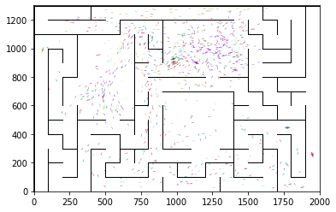

epoch 561 == proposed_mle: 20.80+-0.30/19.80+-0.26 --

epoch 562 == proposed_mle: 20.85+-0.32/20.02+-0.24 --

epoch 563 == proposed_mle: 20.47+-0.30/19.61+-0.25 --

epoch 564 == proposed_mle: 20.86+-0.32/19.79+-0.25 --

epoch 565 == proposed_mle: 20.41+-0.36/19.70+-0.25 --

epoch 566 == proposed_mle: 20.59+-0.35/19.96+-0.24 --

epoch 567 == proposed_mle: 21.09+-0.31/20.15+-0.25 --

epoch 568 == proposed_mle: 20.96+-0.37/20.00+-0.24 --

epoch 569 == proposed_mle: 21.10+-0.37/20.14+-0.24 --

epoch 570 == proposed_mle: 21.11+-0.34/20.23+-0.24 --

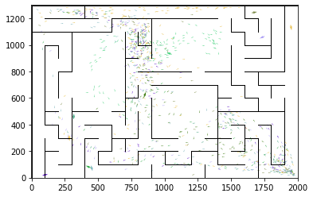

epoch 571 == proposed_mle: 20.93+-0.32/19.63+-0.25 --

epoch 572 == proposed_mle: 20.47+-0.38/19.96+-0.26 --

epoch 573 == proposed_mle: 21.32+-0.33/19.84+-0.23 --

epoch 574 == proposed_mle: 20.67+-0.32/19.71+-0.25 --

epoch 575 == proposed_mle: 20.40+-0.38/19.74+-0.24 --

epoch 576 == proposed_mle: 20.62+-0.32/19.82+-0.23 --

epoch 577 == proposed_mle: 21.86+-0.43/19.86+-0.27 --

epoch 578 == proposed_mle: 20.85+-0.31/20.07+-0.26 --

epoch 579 == proposed_mle: 21.05+-0.35/19.72+-0.26 --

epoch 580 == proposed_mle: 20.63+-0.31/19.76+-0.25 --

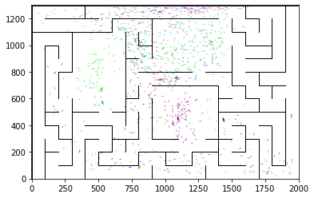

epoch 581 == proposed_mle: 20.86+-0.36/19.61+-0.26 --

epoch 582 == proposed_mle: 19.85+-0.35/19.51+-0.25 --

epoch 583 == proposed_mle: 20.43+-0.29/19.87+-0.24 --

epoch 584 == proposed_mle: 20.85+-0.30/19.81+-0.26 --

epoch 585 == proposed_mle: 20.53+-0.32/19.78+-0.25 --

epoch 586 == proposed_mle: 20.24+-0.33/19.65+-0.24 --

epoch 587 == proposed_mle: 20.70+-0.33/19.54+-0.26 --

epoch 588 == proposed_mle: 20.48+-0.40/19.42+-0.25 --

epoch 589 == proposed_mle: 20.01+-0.38/19.50+-0.25 --

epoch 590 == proposed_mle: 20.23+-0.31/19.58+-0.25 --

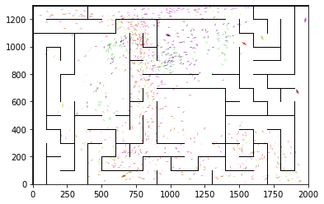

epoch 591 == proposed_mle: 19.77+-0.38/19.67+-0.26 --

epoch 592 >> proposed_mle: 20.20+-0.29/19.32+-0.25 --

epoch 593 >> proposed_mle: 20.03+-0.33/19.23+-0.25 --

epoch 594 == proposed_mle: 19.72+-0.39/19.32+-0.24 --

epoch 595 == proposed_mle: 19.98+-0.37/19.38+-0.23 --

epoch 596 == proposed_mle: 20.09+-0.31/19.54+-0.26 --

epoch 597 == proposed_mle: 19.85+-0.35/19.33+-0.25 --

epoch 598 == proposed_mle: 20.23+-0.45/19.53+-0.26 --

epoch 599 == proposed_mle: 20.39+-0.32/19.57+-0.25 --

epoch 600 == proposed_mle: 20.36+-0.32/19.47+-0.25 --

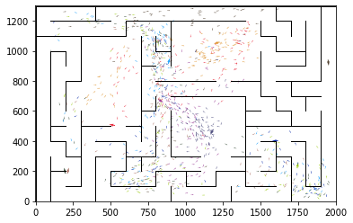

epoch 601 == proposed_mle: 20.25+-0.32/19.35+-0.26 --

epoch 602 == proposed_mle: 19.91+-0.35/19.49+-0.24 --

epoch 603 == proposed_mle: 20.60+-0.31/19.27+-0.25 --

epoch 604 == proposed_mle: 20.04+-0.33/19.28+-0.25 --

epoch 605 == proposed_mle: 20.41+-0.37/19.31+-0.26 --

epoch 606 >> proposed_mle: 20.10+-0.30/19.11+-0.25 --

epoch 607 == proposed_mle: 20.12+-0.32/19.21+-0.25 --

epoch 608 == proposed_mle: 20.21+-0.31/19.17+-0.25 --

epoch 609 == proposed_mle: 19.92+-0.39/19.48+-0.28 --

epoch 610 == proposed_mle: 20.35+-0.32/19.55+-0.24 --

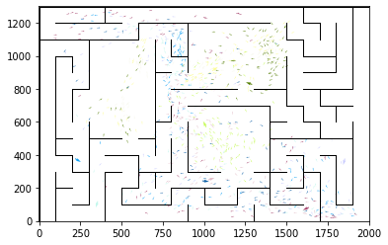

epoch 611 == proposed_mle: 20.19+-0.31/19.47+-0.26 --

epoch 612 == proposed_mle: 20.10+-0.37/19.48+-0.26 --

epoch 613 == proposed_mle: 20.01+-0.35/19.52+-0.24 --

epoch 614 == proposed_mle: 19.97+-0.31/19.47+-0.24 --

epoch 615 == proposed_mle: 20.27+-0.36/19.17+-0.24 --

epoch 616 == proposed_mle: 20.49+-0.37/19.40+-0.23 --

epoch 617 == proposed_mle: 19.91+-0.36/19.17+-0.24 --

epoch 618 == proposed_mle: 20.26+-0.29/19.23+-0.26 --

epoch 619 == proposed_mle: 19.91+-0.33/19.32+-0.25 --

epoch 620 == proposed_mle: 20.42+-0.30/19.15+-0.25 --

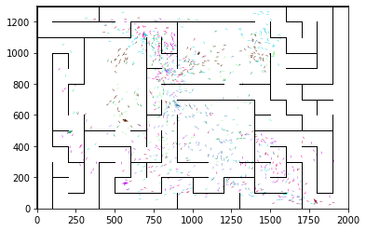

epoch 621 >> proposed_mle: 20.37+-0.28/18.94+-0.25 --

epoch 622 == proposed_mle: 20.49+-0.34/19.13+-0.24 --

epoch 623 == proposed_mle: 20.12+-0.34/19.18+-0.27 --

epoch 624 == proposed_mle: 19.90+-0.31/19.29+-0.24 --

epoch 625 == proposed_mle: 20.39+-0.31/19.51+-0.25 --

epoch 626 == proposed_mle: 20.40+-0.31/19.19+-0.24 --

epoch 627 == proposed_mle: 19.81+-0.35/19.25+-0.24 --

epoch 628 >> proposed_mle: 20.61+-0.36/18.93+-0.25 --

epoch 629 == proposed_mle: 20.87+-0.28/19.37+-0.25 --

epoch 630 == proposed_mle: 19.28+-0.25/19.22+-0.27 --

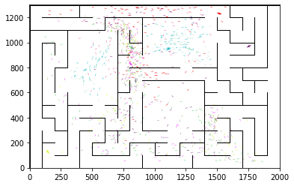

epoch 631 == proposed_mle: 20.31+-0.34/19.31+-0.25 --

epoch 632 == proposed_mle: 20.12+-0.39/19.04+-0.24 --

epoch 633 == proposed_mle: 19.96+-0.35/19.29+-0.26 --

epoch 634 == proposed_mle: 19.85+-0.37/19.09+-0.24 --

epoch 635 == proposed_mle: 19.43+-0.36/19.12+-0.25 --

epoch 636 >> proposed_mle: 19.89+-0.26/18.90+-0.25 --

epoch 637 == proposed_mle: 20.13+-0.35/19.19+-0.24 --

epoch 638 == proposed_mle: 19.98+-0.36/19.05+-0.25 --

epoch 639 == proposed_mle: 19.96+-0.38/18.99+-0.24 --

epoch 640 == proposed_mle: 19.65+-0.34/19.05+-0.23 --

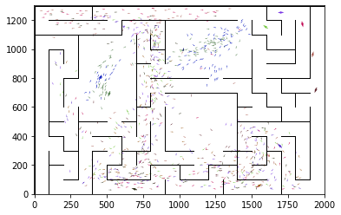

epoch 641 == proposed_mle: 19.76+-0.33/19.04+-0.23 --

epoch 642 == proposed_mle: 20.34+-0.35/19.13+-0.25 --

epoch 643 == proposed_mle: 19.60+-0.33/19.13+-0.26 --

epoch 644 == proposed_mle: 20.26+-0.29/19.20+-0.25 --

epoch 645 == proposed_mle: 20.72+-0.35/18.93+-0.25 --

epoch 646 == proposed_mle: 20.13+-0.33/19.34+-0.26 --

epoch 647 == proposed_mle: 19.80+-0.34/19.20+-0.25 --

epoch 648 == proposed_mle: 20.27+-0.32/19.08+-0.25 --

epoch 649 == proposed_mle: 19.75+-0.32/19.07+-0.25 --

epoch 650 == proposed_mle: 19.78+-0.34/19.13+-0.25 --

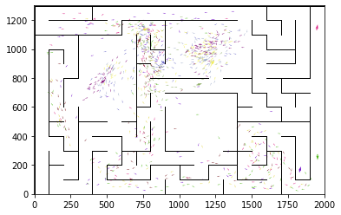

epoch 651 == proposed_mle: 19.95+-0.34/19.20+-0.24 --

epoch 652 == proposed_mle: 20.03+-0.33/19.34+-0.24 --

epoch 653 == proposed_mle: 20.21+-0.31/19.29+-0.25 --

epoch 654 == proposed_mle: 19.85+-0.36/18.95+-0.24 --

epoch 655 == proposed_mle: 19.99+-0.33/19.06+-0.24 --

epoch 656 == proposed_mle: 19.01+-0.34/19.35+-0.26 --

epoch 657 == proposed_mle: 20.93+-0.30/19.04+-0.22 --

epoch 658 == proposed_mle: 20.18+-0.38/18.93+-0.24 --

epoch 659 == proposed_mle: 19.79+-0.36/19.10+-0.25 --

epoch 660 == proposed_mle: 20.23+-0.33/18.99+-0.23 --

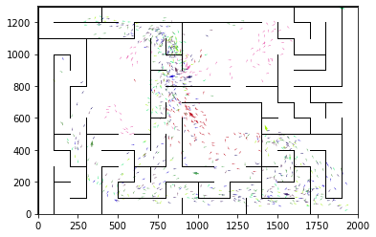

epoch 661 == proposed_mle: 19.78+-0.35/18.97+-0.24 --

epoch 662 == proposed_mle: 19.79+-0.28/19.08+-0.25 --

epoch 663 == proposed_mle: 19.98+-0.35/19.54+-0.24 --

epoch 664 == proposed_mle: 20.41+-0.37/19.24+-0.25 --

epoch 665 == proposed_mle: 19.86+-0.27/19.15+-0.25 --

epoch 666 == proposed_mle: 19.83+-0.34/18.95+-0.23 --

epoch 667 == proposed_mle: 19.34+-0.40/18.97+-0.25 --

epoch 668 == proposed_mle: 19.88+-0.31/19.02+-0.24 --

epoch 669 == proposed_mle: 19.64+-0.36/18.90+-0.23 --

epoch 670 >> proposed_mle: 20.08+-0.34/18.60+-0.24 --

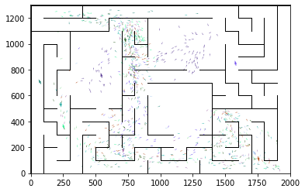

epoch 671 == proposed_mle: 19.41+-0.32/18.90+-0.24 --

epoch 672 == proposed_mle: 19.92+-0.36/18.91+-0.24 --

epoch 673 == proposed_mle: 19.71+-0.31/18.90+-0.24 --

epoch 674 == proposed_mle: 19.47+-0.41/19.14+-0.26 --

epoch 675 == proposed_mle: 20.24+-0.30/19.07+-0.24 --

epoch 676 == proposed_mle: 19.35+-0.35/18.90+-0.25 --

epoch 677 == proposed_mle: 20.42+-0.32/19.00+-0.25 --

epoch 678 == proposed_mle: 20.02+-0.36/19.16+-0.24 --

epoch 679 == proposed_mle: 19.67+-0.36/18.91+-0.23 --

epoch 680 == proposed_mle: 19.97+-0.30/18.89+-0.24 --

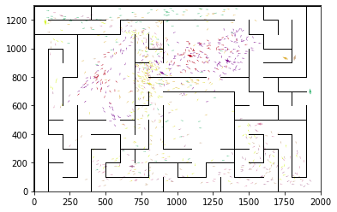

epoch 681 == proposed_mle: 19.74+-0.34/18.81+-0.23 --

epoch 682 == proposed_mle: 19.82+-0.35/18.79+-0.24 --

epoch 683 == proposed_mle: 20.18+-0.33/18.89+-0.23 --

epoch 684 == proposed_mle: 19.23+-0.38/18.74+-0.25 --

epoch 685 == proposed_mle: 19.22+-0.34/18.79+-0.23 --

epoch 686 == proposed_mle: 19.38+-0.30/18.80+-0.24 --

epoch 687 == proposed_mle: 19.61+-0.34/18.95+-0.24 --

epoch 688 == proposed_mle: 19.55+-0.32/19.08+-0.23 --

epoch 689 == proposed_mle: 19.94+-0.34/19.14+-0.24 --

epoch 690 == proposed_mle: 19.63+-0.41/19.28+-0.25 --

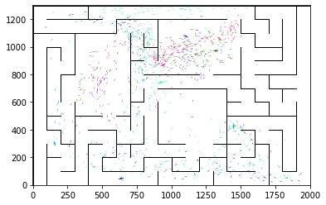

epoch 691 == proposed_mle: 19.49+-0.34/19.06+-0.24 --

epoch 692 == proposed_mle: 20.03+-0.34/18.82+-0.23 --

epoch 693 == proposed_mle: 19.88+-0.31/18.91+-0.22 --

epoch 694 == proposed_mle: 20.65+-0.42/18.70+-0.22 --

epoch 695 == proposed_mle: 19.52+-0.41/18.98+-0.23 --

epoch 696 == proposed_mle: 19.52+-0.34/18.82+-0.22 --

epoch 697 == proposed_mle: 19.49+-0.36/18.88+-0.23 --

epoch 698 == proposed_mle: 19.89+-0.32/19.08+-0.24 --

epoch 699 == proposed_mle: 20.31+-0.35/18.87+-0.25 --

epoch 700 == proposed_mle: 19.98+-0.32/18.74+-0.24 --

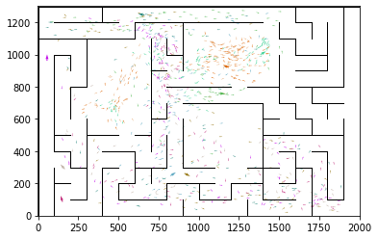

epoch 701 == proposed_mle: 20.21+-0.37/19.24+-0.26 --

epoch 702 == proposed_mle: 19.53+-0.35/18.62+-0.23 --

epoch 703 == proposed_mle: 19.79+-0.42/18.86+-0.23 --

epoch 704 == proposed_mle: 19.56+-0.31/18.89+-0.22 --

epoch 705 == proposed_mle: 20.06+-0.33/18.73+-0.24 --

epoch 706 == proposed_mle: 19.68+-0.35/18.89+-0.24 --

epoch 707 == proposed_mle: 19.08+-0.35/19.00+-0.24 --

epoch 708 == proposed_mle: 20.66+-0.36/18.84+-0.24 --

epoch 709 == proposed_mle: 19.60+-0.37/18.87+-0.25 --

epoch 710 == proposed_mle: 19.70+-0.32/18.96+-0.22 --

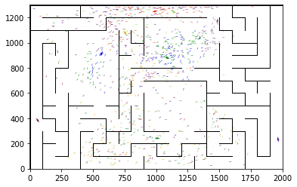

epoch 711 == proposed_mle: 19.77+-0.32/18.90+-0.25 --

epoch 712 == proposed_mle: 19.05+-0.33/18.92+-0.23 --

epoch 713 == proposed_mle: 20.09+-0.30/18.86+-0.23 --

epoch 714 == proposed_mle: 19.37+-0.36/18.84+-0.24 --

epoch 715 == proposed_mle: 19.71+-0.35/18.87+-0.25 --

epoch 716 == proposed_mle: 19.21+-0.41/18.78+-0.23 --

epoch 717 == proposed_mle: 19.53+-0.36/19.12+-0.25 --

epoch 718 == proposed_mle: 19.55+-0.40/18.79+-0.24 --

epoch 719 == proposed_mle: 19.42+-0.37/18.67+-0.24 --

epoch 720 == proposed_mle: 19.63+-0.38/18.93+-0.24 --

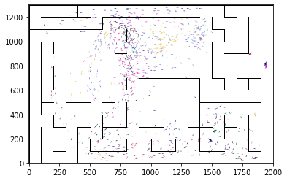

epoch 721 >> proposed_mle: 19.71+-0.40/18.58+-0.24 --

epoch 722 == proposed_mle: 20.03+-0.29/18.96+-0.23 --

epoch 723 == proposed_mle: 19.48+-0.33/19.17+-0.24 --

epoch 724 == proposed_mle: 20.41+-0.33/18.84+-0.26 --

epoch 725 == proposed_mle: 19.54+-0.34/18.64+-0.25 --

epoch 726 == proposed_mle: 19.65+-0.34/18.69+-0.26 --

epoch 727 == proposed_mle: 19.63+-0.29/18.83+-0.24 --

epoch 728 == proposed_mle: 19.68+-0.33/18.77+-0.25 --

epoch 729 == proposed_mle: 19.85+-0.34/18.72+-0.25 --

epoch 730 == proposed_mle: 19.99+-0.33/18.93+-0.23 --

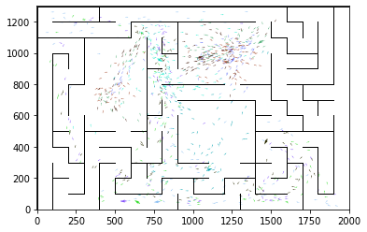

epoch 731 == proposed_mle: 19.25+-0.32/18.59+-0.25 --

epoch 732 == proposed_mle: 19.34+-0.39/18.59+-0.25 --

epoch 733 == proposed_mle: 19.98+-0.35/18.62+-0.25 --

epoch 734 == proposed_mle: 19.75+-0.33/18.68+-0.25 --

epoch 735 == proposed_mle: 19.61+-0.31/18.80+-0.23 --

epoch 736 == proposed_mle: 19.30+-0.33/18.77+-0.23 --

epoch 737 == proposed_mle: 19.93+-0.32/19.03+-0.22 --

epoch 738 == proposed_mle: 19.82+-0.34/18.71+-0.24 --

epoch 739 == proposed_mle: 19.62+-0.31/18.77+-0.25 --

epoch 740 == proposed_mle: 19.70+-0.33/18.67+-0.23 --

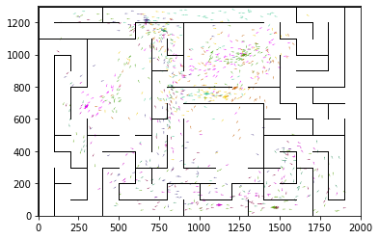

epoch 741 == proposed_mle: 19.69+-0.35/18.76+-0.23 --

epoch 742 == proposed_mle: 19.86+-0.38/18.62+-0.24 --

epoch 743 == proposed_mle: 19.45+-0.32/18.60+-0.24 --

epoch 744 == proposed_mle: 19.35+-0.33/18.61+-0.23 --

epoch 745 == proposed_mle: 19.66+-0.42/18.88+-0.26 --

epoch 746 == proposed_mle: 19.62+-0.39/18.68+-0.23 --

epoch 747 == proposed_mle: 20.11+-0.39/19.03+-0.24 --

epoch 748 == proposed_mle: 19.42+-0.29/18.61+-0.24 --

epoch 749 == proposed_mle: 19.92+-0.31/18.89+-0.25 --

epoch 750 == proposed_mle: 19.61+-0.36/18.74+-0.25 --

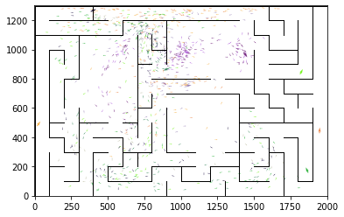

epoch 751 == proposed_mle: 19.54+-0.31/18.93+-0.24 --

epoch 752 == proposed_mle: 19.63+-0.33/18.77+-0.25 --

epoch 753 == proposed_mle: 20.11+-0.37/18.60+-0.26 --

epoch 754 == proposed_mle: 19.68+-0.36/18.96+-0.24 --

epoch 755 == proposed_mle: 20.00+-0.36/19.18+-0.23 --

epoch 756 == proposed_mle: 20.03+-0.30/18.79+-0.26 --

epoch 757 == proposed_mle: 19.67+-0.36/18.84+-0.25 --

epoch 758 >> proposed_mle: 19.65+-0.34/18.57+-0.24 --

epoch 759 == proposed_mle: 19.60+-0.37/18.65+-0.25 --

epoch 760 == proposed_mle: 19.93+-0.37/18.70+-0.26 --

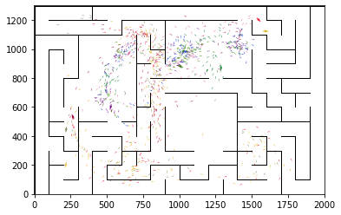

epoch 761 == proposed_mle: 19.30+-0.28/18.62+-0.24 --

epoch 762 == proposed_mle: 19.49+-0.35/18.68+-0.24 --

epoch 763 == proposed_mle: 19.38+-0.33/18.69+-0.24 --

epoch 764 == proposed_mle: 19.07+-0.40/18.68+-0.25 --

epoch 765 == proposed_mle: 19.59+-0.33/18.64+-0.25 --

epoch 766 == proposed_mle: 19.23+-0.33/18.73+-0.25 --

epoch 767 == proposed_mle: 19.44+-0.29/18.74+-0.25 --

epoch 768 == proposed_mle: 19.81+-0.36/18.88+-0.26 --

epoch 769 == proposed_mle: 19.40+-0.38/18.93+-0.24 --

epoch 770 == proposed_mle: 19.12+-0.32/18.85+-0.25 --

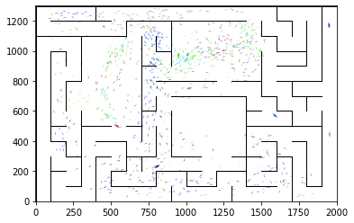

epoch 771 == proposed_mle: 19.46+-0.29/18.70+-0.25 --

epoch 772 == proposed_mle: 19.32+-0.32/18.62+-0.26 --

epoch 773 == proposed_mle: 19.35+-0.34/18.70+-0.24 --

epoch 774 >> proposed_mle: 18.88+-0.37/18.45+-0.23 --

epoch 775 == proposed_mle: 19.79+-0.38/18.66+-0.24 --

epoch 776 == proposed_mle: 19.30+-0.37/18.74+-0.26 --

epoch 777 == proposed_mle: 19.59+-0.31/18.79+-0.25 --

epoch 778 == proposed_mle: 19.19+-0.32/18.82+-0.23 --

epoch 779 == proposed_mle: 20.08+-0.31/18.65+-0.26 --

epoch 780 == proposed_mle: 19.09+-0.35/18.55+-0.24 --

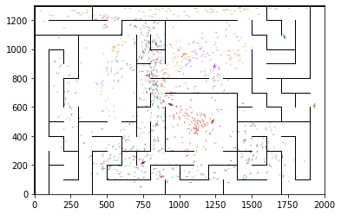

epoch 781 == proposed_mle: 20.10+-0.39/18.73+-0.27 --

epoch 782 == proposed_mle: 19.52+-0.34/18.61+-0.25 --

epoch 783 == proposed_mle: 18.98+-0.32/18.57+-0.25 --

epoch 784 == proposed_mle: 19.75+-0.31/18.60+-0.26 --

epoch 785 == proposed_mle: 20.04+-0.33/18.72+-0.25 --

epoch 786 == proposed_mle: 19.79+-0.31/18.77+-0.25 --

epoch 787 == proposed_mle: 19.96+-0.35/18.73+-0.22 --

epoch 788 == proposed_mle: 19.76+-0.37/18.66+-0.24 --

epoch 789 == proposed_mle: 19.87+-0.44/18.66+-0.26 --

epoch 790 == proposed_mle: 19.12+-0.34/18.75+-0.24 --

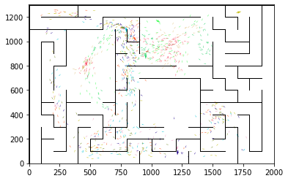

epoch 791 == proposed_mle: 19.70+-0.37/19.04+-0.24 --

epoch 792 == proposed_mle: 19.50+-0.27/18.67+-0.26 --

epoch 793 == proposed_mle: 19.83+-0.35/18.65+-0.26 --

epoch 794 == proposed_mle: 19.73+-0.34/18.51+-0.24 --

epoch 795 == proposed_mle: 19.50+-0.29/18.77+-0.25 --

epoch 796 == proposed_mle: 19.14+-0.33/18.59+-0.25 --

epoch 797 >> proposed_mle: 19.37+-0.34/18.43+-0.24 --

epoch 798 >> proposed_mle: 19.10+-0.37/18.39+-0.24 --

epoch 799 == proposed_mle: 19.95+-0.33/18.56+-0.23 --

epoch 800 == proposed_mle: 19.41+-0.37/18.59+-0.25 --

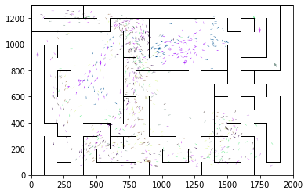

epoch 801 == proposed_mle: 19.34+-0.39/18.58+-0.25 --

epoch 802 == proposed_mle: 19.25+-0.33/18.40+-0.23 --

epoch 803 == proposed_mle: 20.01+-0.36/18.47+-0.24 --

epoch 804 == proposed_mle: 19.55+-0.30/18.52+-0.24 --

epoch 805 == proposed_mle: 19.29+-0.38/18.52+-0.24 --

epoch 806 == proposed_mle: 19.87+-0.38/18.47+-0.23 --

epoch 807 == proposed_mle: 19.80+-0.33/18.40+-0.26 --

epoch 808 == proposed_mle: 19.05+-0.32/18.57+-0.25 --

epoch 809 == proposed_mle: 19.04+-0.42/18.59+-0.26 --

epoch 810 == proposed_mle: 19.88+-0.38/18.65+-0.24 --

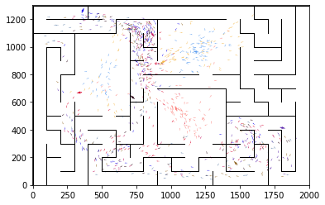

epoch 811 == proposed_mle: 19.15+-0.36/18.67+-0.26 --

epoch 812 == proposed_mle: 19.37+-0.38/18.39+-0.25 --

epoch 813 == proposed_mle: 19.31+-0.32/18.50+-0.24 --

epoch 814 == proposed_mle: 18.93+-0.40/18.90+-0.24 --

epoch 815 >> proposed_mle: 19.28+-0.35/18.28+-0.24 --

epoch 816 == proposed_mle: 19.44+-0.26/18.31+-0.25 --

epoch 817 == proposed_mle: 19.74+-0.39/18.42+-0.24 --

epoch 818 == proposed_mle: 19.30+-0.34/18.60+-0.23 --

epoch 819 == proposed_mle: 18.75+-0.37/18.46+-0.24 --

epoch 820 == proposed_mle: 18.92+-0.32/18.53+-0.25 --

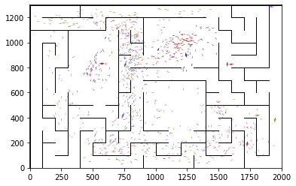

epoch 821 == proposed_mle: 19.11+-0.31/18.52+-0.23 --

epoch 822 == proposed_mle: 18.71+-0.34/18.29+-0.25 --

epoch 823 == proposed_mle: 18.89+-0.37/18.42+-0.25 --

epoch 824 == proposed_mle: 19.43+-0.34/18.65+-0.24 --

epoch 825 == proposed_mle: 19.29+-0.34/18.50+-0.24 --

epoch 826 == proposed_mle: 19.19+-0.38/18.56+-0.22 --

epoch 827 == proposed_mle: 19.09+-0.37/18.40+-0.25 --

epoch 828 == proposed_mle: 19.21+-0.33/18.56+-0.24 --

epoch 829 == proposed_mle: 19.58+-0.31/18.58+-0.25 --

epoch 830 == proposed_mle: 19.21+-0.31/18.56+-0.25 --

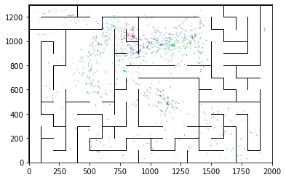

epoch 831 == proposed_mle: 18.98+-0.28/18.46+-0.23 --

epoch 832 == proposed_mle: 18.62+-0.32/18.73+-0.24 --

epoch 833 == proposed_mle: 20.09+-0.32/18.42+-0.23 --

epoch 834 == proposed_mle: 19.02+-0.38/18.60+-0.26 --

epoch 835 == proposed_mle: 19.22+-0.36/18.37+-0.26 --

epoch 836 == proposed_mle: 19.12+-0.39/19.20+-0.25 --

epoch 837 == proposed_mle: 19.79+-0.38/18.82+-0.25 --

epoch 838 == proposed_mle: 19.30+-0.33/18.82+-0.25 --

epoch 839 == proposed_mle: 19.64+-0.39/18.98+-0.26 --

epoch 840 == proposed_mle: 19.42+-0.32/18.64+-0.24 --

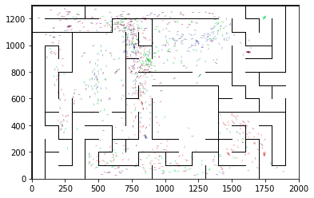

epoch 841 == proposed_mle: 19.98+-0.33/18.75+-0.24 --

epoch 842 == proposed_mle: 19.25+-0.37/18.51+-0.24 --

epoch 843 == proposed_mle: 19.01+-0.36/18.65+-0.25 --

epoch 844 == proposed_mle: 18.83+-0.34/18.68+-0.25 --

epoch 845 == proposed_mle: 19.36+-0.36/18.50+-0.25 --

epoch 846 == proposed_mle: 19.22+-0.32/18.30+-0.25 --

epoch 847 == proposed_mle: 18.97+-0.28/18.39+-0.25 --

epoch 848 == proposed_mle: 19.58+-0.34/18.62+-0.26 --

epoch 849 == proposed_mle: 19.33+-0.34/18.48+-0.23 --

epoch 850 == proposed_mle: 18.88+-0.33/18.34+-0.23 --

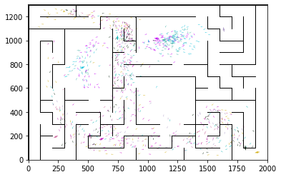

epoch 851 == proposed_mle: 19.06+-0.33/18.41+-0.25 --

epoch 852 == proposed_mle: 19.20+-0.32/18.44+-0.24 --

epoch 853 == proposed_mle: 18.71+-0.26/18.46+-0.25 --

epoch 854 == proposed_mle: 19.13+-0.34/18.39+-0.24 --

epoch 855 == proposed_mle: 19.28+-0.35/18.60+-0.25 --

epoch 856 == proposed_mle: 19.36+-0.38/18.59+-0.24 --

epoch 857 == proposed_mle: 19.94+-0.33/18.58+-0.24 --

epoch 858 == proposed_mle: 19.07+-0.38/18.48+-0.23 --

epoch 859 == proposed_mle: 19.59+-0.39/18.44+-0.26 --

epoch 860 == proposed_mle: 19.49+-0.35/18.53+-0.26 --

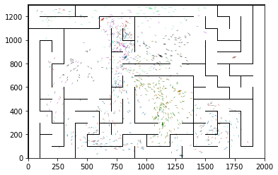

epoch 861 == proposed_mle: 19.45+-0.31/18.29+-0.26 --

epoch 862 == proposed_mle: 19.12+-0.40/18.36+-0.24 --

epoch 863 == proposed_mle: 18.53+-0.37/18.29+-0.25 --

epoch 864 == proposed_mle: 18.53+-0.27/18.52+-0.25 --

epoch 865 == proposed_mle: 19.24+-0.35/18.38+-0.24 --

epoch 866 == proposed_mle: 18.70+-0.28/18.52+-0.25 --

epoch 867 == proposed_mle: 18.71+-0.33/18.56+-0.25 --

epoch 868 == proposed_mle: 19.32+-0.35/18.38+-0.24 --

epoch 869 == proposed_mle: 19.03+-0.34/18.75+-0.24 --

epoch 870 == proposed_mle: 19.46+-0.36/18.55+-0.25 --

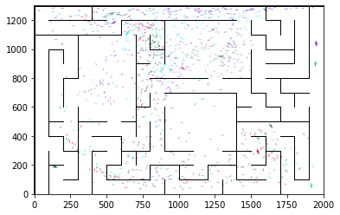

epoch 871 == proposed_mle: 19.54+-0.38/18.71+-0.26 --

epoch 872 == proposed_mle: 18.66+-0.37/18.37+-0.24 --

epoch 873 == proposed_mle: 18.96+-0.30/18.51+-0.24 --

epoch 874 == proposed_mle: 19.52+-0.38/18.44+-0.25 --

epoch 875 == proposed_mle: 19.11+-0.41/18.45+-0.26 --

epoch 876 == proposed_mle: 19.00+-0.34/18.58+-0.26 --

epoch 877 == proposed_mle: 19.44+-0.39/18.46+-0.25 --

epoch 878 == proposed_mle: 19.23+-0.35/18.45+-0.25 --

epoch 879 == proposed_mle: 18.91+-0.34/18.32+-0.24 --

epoch 880 == proposed_mle: 19.31+-0.30/18.41+-0.24 --

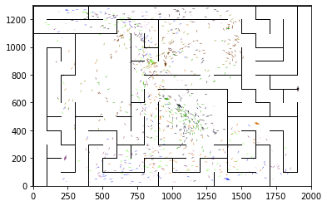

epoch 881 == proposed_mle: 19.39+-0.33/18.41+-0.23 --

epoch 882 >> proposed_mle: 19.12+-0.33/18.26+-0.23 --

epoch 883 == proposed_mle: 19.05+-0.35/18.31+-0.24 --

epoch 884 >> proposed_mle: 18.72+-0.32/18.26+-0.26 --

epoch 885 == proposed_mle: 18.40+-0.39/18.34+-0.24 --

epoch 886 >> proposed_mle: 19.15+-0.35/18.24+-0.24 --

epoch 887 >> proposed_mle: 18.58+-0.31/18.11+-0.23 --

epoch 888 == proposed_mle: 19.08+-0.24/18.20+-0.23 --

epoch 889 == proposed_mle: 19.38+-0.30/18.20+-0.23 --

epoch 890 == proposed_mle: 19.04+-0.39/18.54+-0.26 --

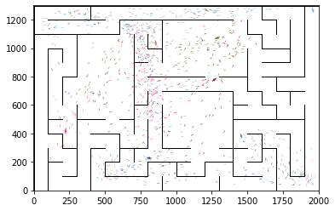

epoch 891 == proposed_mle: 19.74+-0.31/18.71+-0.26 --

epoch 892 == proposed_mle: 19.41+-0.37/18.51+-0.25 --

epoch 893 == proposed_mle: 19.16+-0.38/18.31+-0.25 --

epoch 894 == proposed_mle: 18.77+-0.30/18.27+-0.23 --

epoch 895 == proposed_mle: 19.41+-0.34/18.31+-0.24 --

epoch 896 == proposed_mle: 18.17+-0.30/18.31+-0.24 --

epoch 897 == proposed_mle: 18.56+-0.36/18.43+-0.25 --

epoch 898 == proposed_mle: 19.10+-0.40/18.38+-0.25 --

epoch 899 == proposed_mle: 19.25+-0.33/18.23+-0.25 --

epoch 900 == proposed_mle: 19.23+-0.32/18.20+-0.24 --

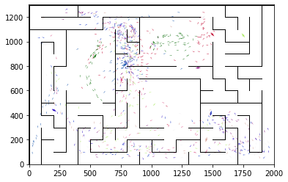

epoch 901 == proposed_mle: 18.74+-0.30/18.28+-0.24 --

epoch 902 == proposed_mle: 19.24+-0.29/18.41+-0.27 --

epoch 903 == proposed_mle: 19.18+-0.35/18.43+-0.22 --

epoch 904 == proposed_mle: 19.19+-0.32/18.55+-0.24 --

epoch 905 == proposed_mle: 19.43+-0.32/18.46+-0.24 --

epoch 906 == proposed_mle: 19.01+-0.31/18.30+-0.23 --

epoch 907 == proposed_mle: 18.59+-0.32/18.38+-0.24 --

epoch 908 == proposed_mle: 19.06+-0.29/18.31+-0.24 --

epoch 909 == proposed_mle: 19.45+-0.30/18.31+-0.25 --

epoch 910 == proposed_mle: 18.83+-0.30/18.24+-0.25 --

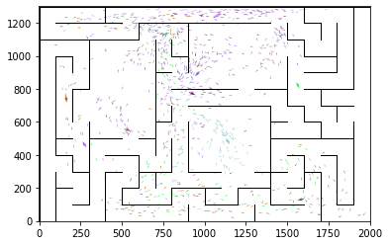

epoch 911 == proposed_mle: 18.94+-0.37/18.14+-0.24 --

epoch 912 == proposed_mle: 19.49+-0.34/18.58+-0.23 --

epoch 913 == proposed_mle: 19.22+-0.33/18.62+-0.24 --

epoch 914 == proposed_mle: 18.67+-0.37/18.35+-0.23 --

epoch 915 == proposed_mle: 19.45+-0.36/18.31+-0.22 --

epoch 916 == proposed_mle: 19.67+-0.39/18.31+-0.24 --

epoch 917 == proposed_mle: 19.19+-0.33/18.36+-0.22 --

epoch 918 == proposed_mle: 19.43+-0.34/18.71+-0.24 --

epoch 919 == proposed_mle: 19.35+-0.30/18.70+-0.23 --

epoch 920 == proposed_mle: 18.76+-0.36/18.21+-0.25 --

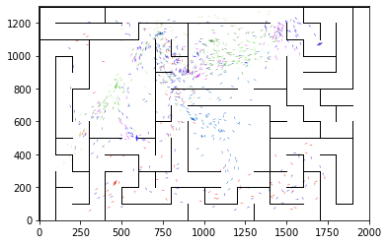

epoch 921 == proposed_mle: 18.57+-0.29/18.24+-0.24 --

epoch 922 == proposed_mle: 19.49+-0.35/18.39+-0.23 --

epoch 923 == proposed_mle: 18.83+-0.32/18.43+-0.23 --

epoch 924 == proposed_mle: 19.70+-0.35/18.37+-0.24 --

epoch 925 == proposed_mle: 19.19+-0.28/18.17+-0.24 --

epoch 926 == proposed_mle: 19.11+-0.43/18.15+-0.24 --

epoch 927 == proposed_mle: 19.21+-0.38/18.35+-0.23 --

epoch 928 == proposed_mle: 19.08+-0.35/18.53+-0.23 --

epoch 929 == proposed_mle: 19.43+-0.37/18.19+-0.23 --

epoch 930 >> proposed_mle: 18.81+-0.32/17.94+-0.23 --

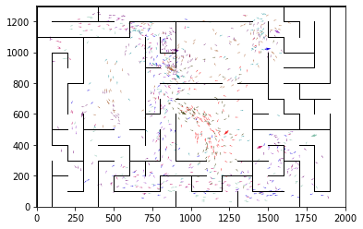

epoch 931 == proposed_mle: 19.27+-0.38/18.42+-0.23 --

epoch 932 == proposed_mle: 18.76+-0.30/18.10+-0.23 --

epoch 933 == proposed_mle: 19.15+-0.32/18.34+-0.25 --

epoch 934 == proposed_mle: 19.17+-0.31/18.21+-0.23 --

epoch 935 == proposed_mle: 19.23+-0.37/18.52+-0.23 --

epoch 936 == proposed_mle: 18.63+-0.35/18.23+-0.24 --

epoch 937 == proposed_mle: 19.02+-0.36/18.48+-0.24 --

epoch 938 == proposed_mle: 18.49+-0.29/18.29+-0.23 --

epoch 939 == proposed_mle: 19.03+-0.39/18.63+-0.24 --

epoch 940 == proposed_mle: 18.58+-0.36/18.32+-0.23 --

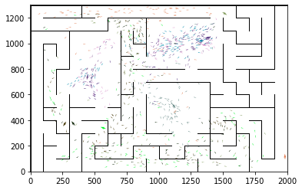

epoch 941 == proposed_mle: 18.71+-0.32/18.43+-0.25 --

epoch 942 == proposed_mle: 19.31+-0.37/18.20+-0.23 --

epoch 943 == proposed_mle: 18.93+-0.32/18.16+-0.23 --

epoch 944 == proposed_mle: 18.88+-0.31/18.37+-0.22 --

epoch 945 == proposed_mle: 18.88+-0.35/18.30+-0.24 --

epoch 946 == proposed_mle: 19.06+-0.38/18.44+-0.26 --

epoch 947 == proposed_mle: 18.97+-0.38/18.24+-0.24 --

epoch 948 == proposed_mle: 19.77+-0.30/18.14+-0.25 --

epoch 949 == proposed_mle: 19.36+-0.30/18.28+-0.24 --

epoch 950 == proposed_mle: 18.58+-0.34/18.36+-0.23 --

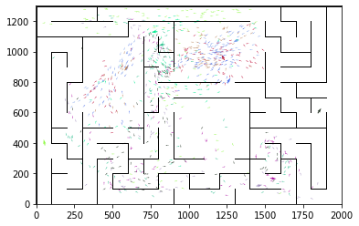

epoch 951 == proposed_mle: 19.61+-0.34/18.25+-0.24 --

epoch 952 == proposed_mle: 19.15+-0.31/18.15+-0.23 --

epoch 953 == proposed_mle: 19.29+-0.33/18.26+-0.23 --

epoch 954 == proposed_mle: 19.24+-0.31/18.23+-0.24 --

epoch 955 == proposed_mle: 18.91+-0.35/18.48+-0.25 --

epoch 956 == proposed_mle: 19.44+-0.29/18.48+-0.25 --

epoch 957 == proposed_mle: 18.69+-0.30/18.13+-0.23 --

epoch 958 == proposed_mle: 19.13+-0.38/18.12+-0.25 --

epoch 959 == proposed_mle: 18.34+-0.35/18.07+-0.25 --

epoch 960 == proposed_mle: 18.95+-0.34/18.10+-0.25 --

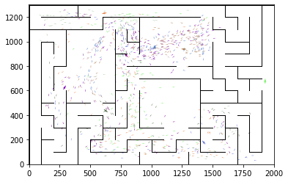

epoch 961 == proposed_mle: 18.64+-0.40/18.27+-0.26 --

epoch 962 == proposed_mle: 19.18+-0.34/18.42+-0.27 --

epoch 963 == proposed_mle: 18.84+-0.32/18.04+-0.25 --

epoch 964 == proposed_mle: 18.82+-0.28/18.26+-0.25 --

epoch 965 == proposed_mle: 18.94+-0.36/18.27+-0.25 --

epoch 966 == proposed_mle: 18.85+-0.30/18.26+-0.24 --

epoch 967 == proposed_mle: 19.28+-0.37/18.18+-0.24 --

epoch 968 == proposed_mle: 19.30+-0.34/18.38+-0.24 --

epoch 969 == proposed_mle: 19.13+-0.34/18.16+-0.26 --

epoch 970 == proposed_mle: 18.58+-0.31/18.42+-0.25 --

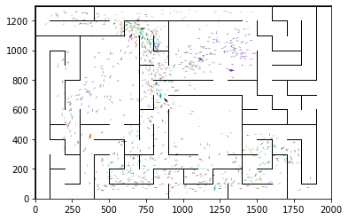

epoch 971 == proposed_mle: 18.23+-0.40/18.08+-0.24 --

epoch 972 == proposed_mle: 19.30+-0.37/18.23+-0.24 --

epoch 973 == proposed_mle: 19.57+-0.34/18.03+-0.23 --

epoch 974 == proposed_mle: 18.91+-0.38/18.33+-0.25 --

epoch 975 == proposed_mle: 19.39+-0.34/18.55+-0.27 --

epoch 976 == proposed_mle: 19.15+-0.42/18.02+-0.25 --

epoch 977 == proposed_mle: 18.92+-0.36/18.10+-0.24 --

epoch 978 >> proposed_mle: 19.41+-0.33/17.88+-0.24 --

epoch 979 == proposed_mle: 19.07+-0.33/18.18+-0.25 --

epoch 980 == proposed_mle: 18.50+-0.30/18.14+-0.23 --

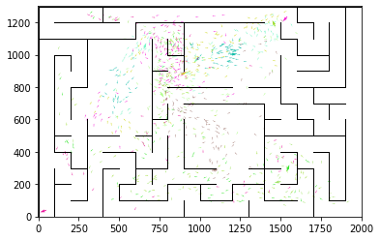

epoch 981 == proposed_mle: 19.03+-0.37/18.16+-0.24 --

epoch 982 == proposed_mle: 18.77+-0.33/18.09+-0.23 --

epoch 983 == proposed_mle: 19.07+-0.29/18.12+-0.26 --

epoch 984 == proposed_mle: 18.28+-0.36/18.15+-0.23 --

epoch 985 == proposed_mle: 19.36+-0.34/18.32+-0.25 --

epoch 986 == proposed_mle: 20.04+-0.36/18.01+-0.23 --

epoch 987 == proposed_mle: 19.05+-0.32/18.27+-0.22 --

epoch 988 == proposed_mle: 19.03+-0.31/18.08+-0.22 --

epoch 989 == proposed_mle: 18.33+-0.32/18.24+-0.25 --

epoch 990 == proposed_mle: 19.48+-0.33/18.19+-0.24 --

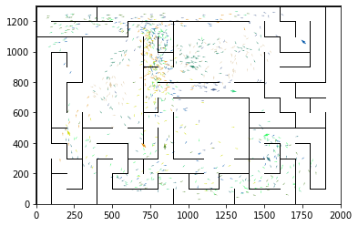

epoch 991 == proposed_mle: 19.60+-0.33/18.06+-0.25 --

epoch 992 == proposed_mle: 18.82+-0.34/18.24+-0.26 --

epoch 993 == proposed_mle: 19.36+-0.34/18.23+-0.26 --

epoch 994 == proposed_mle: 18.48+-0.35/18.41+-0.24 --

epoch 995 == proposed_mle: 19.50+-0.35/18.18+-0.24 --

epoch 996 == proposed_mle: 18.65+-0.35/18.32+-0.24 --

epoch 997 == proposed_mle: 19.38+-0.29/18.26+-0.23 --

epoch 998 == proposed_mle: 18.88+-0.33/18.08+-0.23 --

epoch 999 == proposed_mle: 18.45+-0.35/18.07+-0.24 --

epoch 1000 == proposed_mle: 19.11+-0.33/18.07+-0.24 --

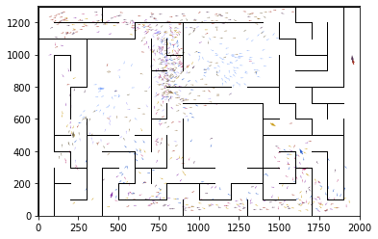

epoch 1001 == proposed_mle: 18.46+-0.36/18.10+-0.24 --

epoch 1002 == proposed_mle: 19.02+-0.33/18.07+-0.23 --

epoch 1003 >> proposed_mle: 19.05+-0.38/17.78+-0.23 --

epoch 1004 == proposed_mle: 18.39+-0.29/18.12+-0.23 --

epoch 1005 == proposed_mle: 18.79+-0.31/18.41+-0.26 --

epoch 1006 == proposed_mle: 19.28+-0.33/18.20+-0.24 --

epoch 1007 == proposed_mle: 19.03+-0.28/18.13+-0.24 --

epoch 1008 == proposed_mle: 18.66+-0.34/18.44+-0.25 --

epoch 1009 == proposed_mle: 19.41+-0.37/18.24+-0.26 --

epoch 1010 == proposed_mle: 18.83+-0.38/18.11+-0.25 --

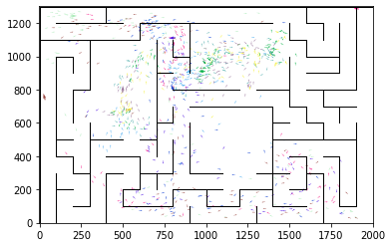

epoch 1011 == proposed_mle: 19.01+-0.35/18.05+-0.24 --

epoch 1012 == proposed_mle: 18.87+-0.38/18.22+-0.25 --

epoch 1013 == proposed_mle: 19.16+-0.35/17.88+-0.24 --

epoch 1014 == proposed_mle: 18.98+-0.33/17.98+-0.23 --

epoch 1015 == proposed_mle: 19.23+-0.35/18.25+-0.24 --

epoch 1016 == proposed_mle: 18.93+-0.38/17.95+-0.25 --

epoch 1017 == proposed_mle: 18.66+-0.41/18.33+-0.23 --

epoch 1018 == proposed_mle: 19.19+-0.35/18.23+-0.24 --

epoch 1019 == proposed_mle: 18.46+-0.38/18.19+-0.25 --

epoch 1020 == proposed_mle: 18.83+-0.41/18.20+-0.25 --

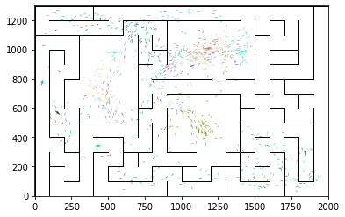

epoch 1021 == proposed_mle: 18.19+-0.28/18.26+-0.22 --

epoch 1022 == proposed_mle: 19.15+-0.33/18.02+-0.24 --

epoch 1023 == proposed_mle: 18.49+-0.29/18.12+-0.25 --

epoch 1024 == proposed_mle: 18.51+-0.34/17.87+-0.22 --

epoch 1025 == proposed_mle: 18.38+-0.36/17.84+-0.22 --

epoch 1026 == proposed_mle: 19.28+-0.34/18.01+-0.23 --

epoch 1027 == proposed_mle: 18.89+-0.37/17.96+-0.24 --

epoch 1028 == proposed_mle: 18.63+-0.38/18.26+-0.23 --

epoch 1029 == proposed_mle: 19.09+-0.35/18.39+-0.24 --

epoch 1030 == proposed_mle: 18.83+-0.39/18.27+-0.24 --

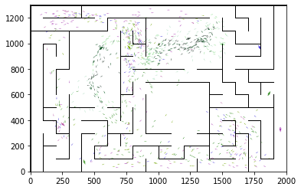

epoch 1031 == proposed_mle: 19.38+-0.39/18.20+-0.25 --

epoch 1032 == proposed_mle: 19.04+-0.39/18.18+-0.25 --

epoch 1033 == proposed_mle: 18.80+-0.32/18.44+-0.22 --

epoch 1034 == proposed_mle: 19.13+-0.32/17.98+-0.25 --

epoch 1035 == proposed_mle: 18.62+-0.39/18.22+-0.25 --

epoch 1036 == proposed_mle: 19.00+-0.35/18.14+-0.25 --

epoch 1037 == proposed_mle: 18.96+-0.30/18.10+-0.23 --

epoch 1038 == proposed_mle: 19.03+-0.28/18.18+-0.24 --

epoch 1039 == proposed_mle: 18.06+-0.32/17.79+-0.23 --

epoch 1040 == proposed_mle: 18.38+-0.40/17.93+-0.24 --

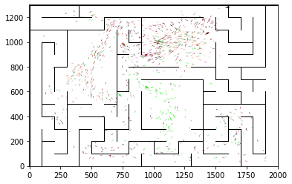

epoch 1041 == proposed_mle: 18.38+-0.27/17.84+-0.23 --

epoch 1042 == proposed_mle: 18.49+-0.34/17.92+-0.26 --

epoch 1043 == proposed_mle: 18.13+-0.30/18.07+-0.22 --

epoch 1044 == proposed_mle: 18.45+-0.34/18.07+-0.24 --

epoch 1045 == proposed_mle: 18.88+-0.36/18.04+-0.23 --

epoch 1046 == proposed_mle: 18.96+-0.39/17.88+-0.23 --

epoch 1047 == proposed_mle: 18.47+-0.35/17.96+-0.24 --

epoch 1048 == proposed_mle: 18.55+-0.38/18.03+-0.24 --

epoch 1049 == proposed_mle: 18.72+-0.40/18.14+-0.22 --

epoch 1050 == proposed_mle: 18.18+-0.34/18.14+-0.25 --

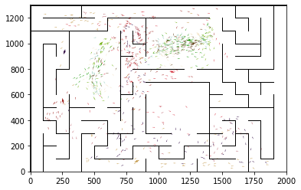

epoch 1051 == proposed_mle: 18.99+-0.37/18.13+-0.25 --

epoch 1052 == proposed_mle: 18.48+-0.39/18.34+-0.24 --

epoch 1053 == proposed_mle: 19.14+-0.33/18.16+-0.25 --

epoch 1054 == proposed_mle: 18.35+-0.44/18.29+-0.23 --

epoch 1055 == proposed_mle: 18.12+-0.31/17.90+-0.24 --

epoch 1056 == proposed_mle: 18.66+-0.36/17.99+-0.23 --

epoch 1057 == proposed_mle: 18.62+-0.33/18.18+-0.25 --

epoch 1058 == proposed_mle: 18.34+-0.36/17.80+-0.24 --

epoch 1059 == proposed_mle: 18.08+-0.34/17.97+-0.25 --

epoch 1060 == proposed_mle: 18.79+-0.30/18.24+-0.24 --

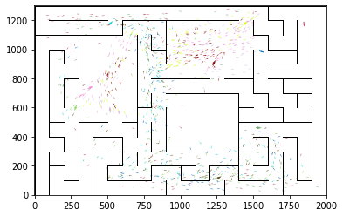

epoch 1061 == proposed_mle: 18.95+-0.33/18.23+-0.24 --

epoch 1062 == proposed_mle: 18.64+-0.30/18.09+-0.23 --

epoch 1063 == proposed_mle: 18.94+-0.41/17.97+-0.25 --

epoch 1064 == proposed_mle: 18.89+-0.30/18.15+-0.25 --

epoch 1065 == proposed_mle: 19.50+-0.35/18.14+-0.24 --

epoch 1066 == proposed_mle: 19.14+-0.31/18.44+-0.23 --

epoch 1067 == proposed_mle: 19.15+-0.28/18.16+-0.23 --

epoch 1068 == proposed_mle: 18.64+-0.31/17.86+-0.25 --

epoch 1069 == proposed_mle: 18.06+-0.37/17.91+-0.24 --

epoch 1070 == proposed_mle: 18.93+-0.33/18.20+-0.23 --

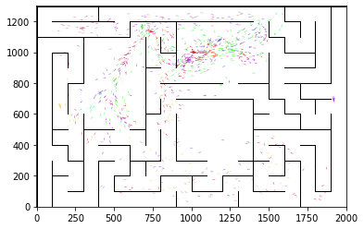

epoch 1071 == proposed_mle: 18.79+-0.33/18.07+-0.23 --

epoch 1072 == proposed_mle: 18.81+-0.35/17.90+-0.23 --

epoch 1073 == proposed_mle: 18.63+-0.40/18.22+-0.25 --

epoch 1074 == proposed_mle: 19.33+-0.36/17.85+-0.25 --

epoch 1075 == proposed_mle: 18.89+-0.37/17.88+-0.24 --

epoch 1076 == proposed_mle: 17.68+-0.38/17.89+-0.23 --

epoch 1077 >> proposed_mle: 18.05+-0.34/17.71+-0.25 --

epoch 1078 >> proposed_mle: 18.36+-0.32/17.69+-0.25 --

epoch 1079 == proposed_mle: 19.12+-0.38/18.05+-0.25 --

epoch 1080 >> proposed_mle: 19.05+-0.36/17.56+-0.23 --

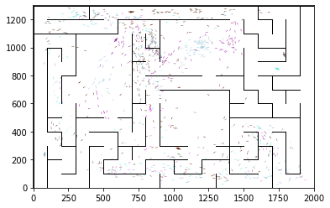

epoch 1081 == proposed_mle: 18.57+-0.36/17.66+-0.23 --

epoch 1082 == proposed_mle: 18.31+-0.34/18.02+-0.24 --

epoch 1083 == proposed_mle: 19.03+-0.34/17.85+-0.25 --

epoch 1084 == proposed_mle: 18.41+-0.37/17.92+-0.23 --

epoch 1085 == proposed_mle: 19.35+-0.36/17.81+-0.23 --

epoch 1086 == proposed_mle: 18.81+-0.33/18.00+-0.25 --

epoch 1087 == proposed_mle: 19.17+-0.37/17.90+-0.24 --

epoch 1088 == proposed_mle: 18.06+-0.38/17.83+-0.24 --

epoch 1089 == proposed_mle: 19.12+-0.33/17.95+-0.25 --

epoch 1090 == proposed_mle: 18.44+-0.31/17.88+-0.25 --

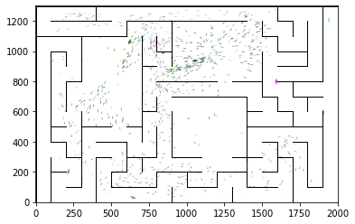

epoch 1091 == proposed_mle: 18.94+-0.33/18.00+-0.23 --

epoch 1092 == proposed_mle: 18.70+-0.31/17.80+-0.24 --

epoch 1093 == proposed_mle: 19.12+-0.36/17.94+-0.24 --

epoch 1094 == proposed_mle: 18.53+-0.35/17.74+-0.24 --

epoch 1095 == proposed_mle: 17.40+-0.35/17.90+-0.23 --

epoch 1096 == proposed_mle: 19.09+-0.32/18.10+-0.23 --

epoch 1097 == proposed_mle: 18.59+-0.40/17.80+-0.24 --

epoch 1098 == proposed_mle: 18.63+-0.40/17.75+-0.25 --

epoch 1099 == proposed_mle: 18.67+-0.33/17.82+-0.24 --

epoch 1100 == proposed_mle: 18.31+-0.32/17.77+-0.26 --

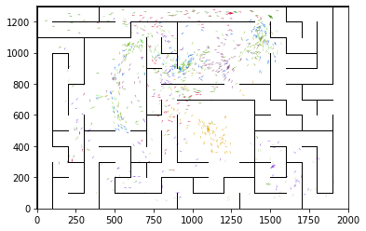

epoch 1101 == proposed_mle: 18.09+-0.33/17.91+-0.25 --

epoch 1102 == proposed_mle: 18.83+-0.37/17.87+-0.25 --

epoch 1103 == proposed_mle: 18.30+-0.30/17.69+-0.25 --

epoch 1104 == proposed_mle: 19.00+-0.32/17.99+-0.24 --

epoch 1105 == proposed_mle: 18.43+-0.32/17.77+-0.24 --

epoch 1106 >> proposed_mle: 18.49+-0.39/17.55+-0.26 --

epoch 1107 == proposed_mle: 18.65+-0.32/17.88+-0.25 --

epoch 1108 == proposed_mle: 17.64+-0.28/17.66+-0.24 --

epoch 1109 == proposed_mle: 18.65+-0.34/17.89+-0.25 --

epoch 1110 == proposed_mle: 18.22+-0.32/17.73+-0.23 --

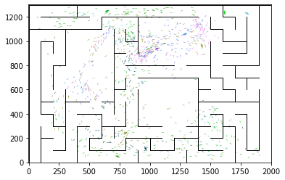

epoch 1111 == proposed_mle: 18.53+-0.40/17.66+-0.25 --

epoch 1112 == proposed_mle: 17.88+-0.36/17.88+-0.24 --

epoch 1113 == proposed_mle: 18.53+-0.35/17.87+-0.24 --

epoch 1114 == proposed_mle: 18.13+-0.29/17.77+-0.25 --

epoch 1115 == proposed_mle: 18.58+-0.28/17.90+-0.26 --

epoch 1116 == proposed_mle: 18.36+-0.32/17.69+-0.24 --

epoch 1117 == proposed_mle: 18.67+-0.31/17.61+-0.23 --

epoch 1118 == proposed_mle: 18.44+-0.38/17.90+-0.22 --

epoch 1119 == proposed_mle: 18.37+-0.37/17.79+-0.24 --

epoch 1120 == proposed_mle: 18.48+-0.30/17.86+-0.23 --

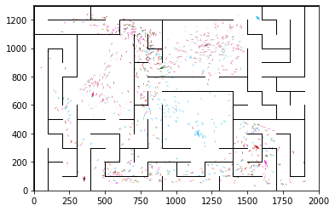

epoch 1121 == proposed_mle: 18.10+-0.35/17.71+-0.24 --

epoch 1122 == proposed_mle: 18.82+-0.35/17.61+-0.24 --

epoch 1123 == proposed_mle: 18.67+-0.32/17.74+-0.26 --

epoch 1124 == proposed_mle: 18.69+-0.33/17.76+-0.26 --

epoch 1125 == proposed_mle: 18.53+-0.29/17.65+-0.24 --

epoch 1126 == proposed_mle: 18.34+-0.33/17.87+-0.25 --

epoch 1127 == proposed_mle: 18.36+-0.36/17.94+-0.25 --

epoch 1128 == proposed_mle: 18.00+-0.35/17.70+-0.24 --

epoch 1129 == proposed_mle: 18.22+-0.33/17.67+-0.25 --

epoch 1130 == proposed_mle: 18.31+-0.30/17.95+-0.23 --

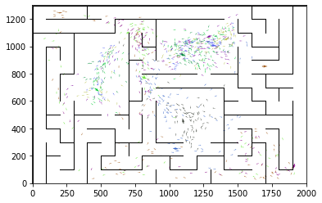

epoch 1131 == proposed_mle: 18.79+-0.35/17.65+-0.26 --

epoch 1132 == proposed_mle: 18.45+-0.32/17.76+-0.24 --

epoch 1133 == proposed_mle: 18.51+-0.33/17.65+-0.24 --

epoch 1134 == proposed_mle: 19.00+-0.33/17.76+-0.24 --

epoch 1135 == proposed_mle: 18.71+-0.35/17.77+-0.24 --

epoch 1136 == proposed_mle: 18.53+-0.35/17.93+-0.24 --

epoch 1137 == proposed_mle: 18.39+-0.37/17.89+-0.25 --

epoch 1138 == proposed_mle: 18.51+-0.29/17.91+-0.25 --

epoch 1139 == proposed_mle: 18.49+-0.35/17.73+-0.24 --

epoch 1140 == proposed_mle: 18.75+-0.40/17.90+-0.25 --

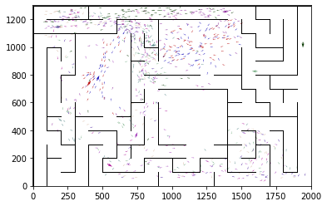

epoch 1141 == proposed_mle: 18.44+-0.30/17.93+-0.24 --

epoch 1142 >> proposed_mle: 18.05+-0.35/17.54+-0.26 --

epoch 1143 == proposed_mle: 18.49+-0.38/17.65+-0.23 --

epoch 1144 == proposed_mle: 18.92+-0.34/17.74+-0.25 --

epoch 1145 == proposed_mle: 18.92+-0.37/17.88+-0.25 --

epoch 1146 == proposed_mle: 18.81+-0.31/17.77+-0.25 --

epoch 1147 == proposed_mle: 18.58+-0.38/17.63+-0.24 --

epoch 1148 == proposed_mle: 17.89+-0.37/17.79+-0.24 --

epoch 1149 == proposed_mle: 18.92+-0.33/17.70+-0.23 --

epoch 1150 == proposed_mle: 17.99+-0.30/17.68+-0.24 --

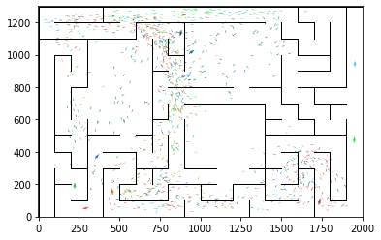

epoch 1151 == proposed_mle: 18.71+-0.33/17.66+-0.24 --

epoch 1152 == proposed_mle: 18.63+-0.35/17.80+-0.24 --

epoch 1153 == proposed_mle: 18.71+-0.35/17.79+-0.22 --

epoch 1154 == proposed_mle: 18.73+-0.38/17.84+-0.23 --

epoch 1155 == proposed_mle: 18.86+-0.38/17.70+-0.24 --

epoch 1156 == proposed_mle: 18.66+-0.34/17.70+-0.24 --

epoch 1157 == proposed_mle: 18.49+-0.31/17.70+-0.25 --

epoch 1158 == proposed_mle: 18.65+-0.32/17.60+-0.24 --

epoch 1159 == proposed_mle: 18.59+-0.27/17.59+-0.24 --

epoch 1160 == proposed_mle: 17.95+-0.33/17.75+-0.24 --

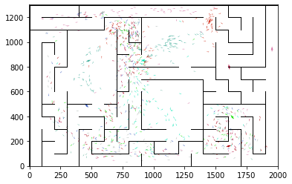

epoch 1161 == proposed_mle: 18.87+-0.42/17.84+-0.24 --

epoch 1162 == proposed_mle: 18.49+-0.40/17.81+-0.24 --

epoch 1163 == proposed_mle: 18.81+-0.41/17.75+-0.24 --

epoch 1164 == proposed_mle: 18.54+-0.32/17.71+-0.24 --

epoch 1165 == proposed_mle: 18.57+-0.36/17.80+-0.24 --

epoch 1166 == proposed_mle: 18.78+-0.34/17.93+-0.22 --

epoch 1167 == proposed_mle: 18.15+-0.34/17.69+-0.23 --

epoch 1168 == proposed_mle: 18.24+-0.33/17.69+-0.24 --

epoch 1169 == proposed_mle: 17.98+-0.33/17.61+-0.24 --

epoch 1170 == proposed_mle: 18.70+-0.35/17.70+-0.23 --

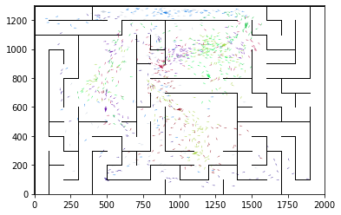

epoch 1171 == proposed_mle: 17.85+-0.35/17.88+-0.23 --

epoch 1172 == proposed_mle: 18.17+-0.35/18.02+-0.23 --

epoch 1173 == proposed_mle: 18.86+-0.35/17.71+-0.22 --

epoch 1174 == proposed_mle: 18.22+-0.35/17.88+-0.22 --

epoch 1175 == proposed_mle: 18.57+-0.36/17.67+-0.25 --

epoch 1176 == proposed_mle: 18.65+-0.32/17.74+-0.23 --

epoch 1177 >> proposed_mle: 18.25+-0.31/17.45+-0.23 --

epoch 1178 == proposed_mle: 18.36+-0.35/17.92+-0.23 --

epoch 1179 == proposed_mle: 18.94+-0.33/17.70+-0.23 --

epoch 1180 == proposed_mle: 18.85+-0.37/17.82+-0.24 --

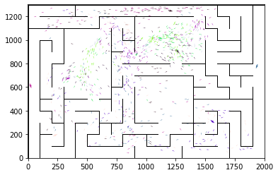

epoch 1181 == proposed_mle: 18.38+-0.35/17.64+-0.24 --

epoch 1182 == proposed_mle: 18.43+-0.33/17.75+-0.24 --

epoch 1183 == proposed_mle: 17.83+-0.33/17.68+-0.22 --

epoch 1184 == proposed_mle: 18.09+-0.34/17.65+-0.22 --

epoch 1185 == proposed_mle: 17.90+-0.30/17.86+-0.23 --

epoch 1186 == proposed_mle: 18.96+-0.37/18.01+-0.24 --

epoch 1187 == proposed_mle: 18.71+-0.32/17.97+-0.23 --

epoch 1188 == proposed_mle: 18.15+-0.35/17.72+-0.24 --

epoch 1189 >> proposed_mle: 18.74+-0.35/17.44+-0.23 --

epoch 1190 == proposed_mle: 18.79+-0.30/17.66+-0.23 --

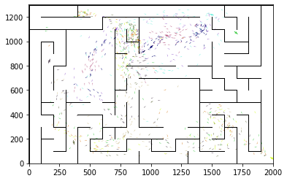

epoch 1191 == proposed_mle: 18.51+-0.29/17.90+-0.23 --

epoch 1192 == proposed_mle: 18.70+-0.41/17.55+-0.23 --

epoch 1193 == proposed_mle: 18.26+-0.33/17.50+-0.25 --

epoch 1194 == proposed_mle: 18.27+-0.32/17.56+-0.24 --

epoch 1195 == proposed_mle: 18.93+-0.33/17.52+-0.23 --

epoch 1196 == proposed_mle: 18.43+-0.30/17.45+-0.24 --

epoch 1197 == proposed_mle: 18.24+-0.36/17.47+-0.23 --

epoch 1198 == proposed_mle: 18.36+-0.30/17.81+-0.24 --

epoch 1199 == proposed_mle: 18.40+-0.30/17.67+-0.25 --

epoch 1200 == proposed_mle: 18.60+-0.36/17.69+-0.24 --

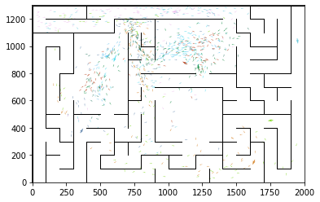

epoch 1201 == proposed_mle: 18.33+-0.31/17.58+-0.24 --

epoch 1202 == proposed_mle: 18.48+-0.36/17.57+-0.24 --

epoch 1203 == proposed_mle: 18.17+-0.34/17.56+-0.26 --

epoch 1204 == proposed_mle: 18.64+-0.42/17.66+-0.23 --

epoch 1205 == proposed_mle: 18.54+-0.39/17.54+-0.24 --

epoch 1206 == proposed_mle: 18.21+-0.27/17.76+-0.26 --

epoch 1207 == proposed_mle: 19.58+-0.44/17.81+-0.25 --

epoch 1208 == proposed_mle: 17.79+-0.33/17.59+-0.24 --

epoch 1209 == proposed_mle: 18.23+-0.36/17.51+-0.23 --

epoch 1210 == proposed_mle: 18.06+-0.37/17.53+-0.24 --

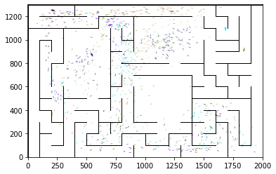

epoch 1211 == proposed_mle: 18.64+-0.38/17.76+-0.24 --

epoch 1212 == proposed_mle: 18.48+-0.32/17.79+-0.24 --

epoch 1213 == proposed_mle: 18.01+-0.33/17.93+-0.26 --

epoch 1214 == proposed_mle: 18.73+-0.37/17.87+-0.24 --

epoch 1215 == proposed_mle: 18.78+-0.34/17.86+-0.23 --

epoch 1216 == proposed_mle: 18.56+-0.39/17.79+-0.24 --

epoch 1217 == proposed_mle: 18.42+-0.35/17.65+-0.24 --

epoch 1218 == proposed_mle: 18.48+-0.35/17.74+-0.23 --

epoch 1219 == proposed_mle: 18.98+-0.34/17.74+-0.24 --

epoch 1220 == proposed_mle: 18.28+-0.29/17.74+-0.25 --

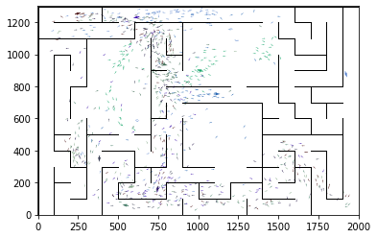

epoch 1221 == proposed_mle: 18.61+-0.40/17.76+-0.24 --

epoch 1222 == proposed_mle: 18.24+-0.31/17.57+-0.25 --

epoch 1223 == proposed_mle: 19.22+-0.39/17.57+-0.24 --

epoch 1224 == proposed_mle: 18.33+-0.29/17.75+-0.23 --

epoch 1225 == proposed_mle: 18.57+-0.30/17.58+-0.25 --

epoch 1226 == proposed_mle: 17.84+-0.31/17.57+-0.25 --

epoch 1227 == proposed_mle: 18.73+-0.29/17.59+-0.24 --

epoch 1228 == proposed_mle: 18.33+-0.30/17.60+-0.24 --

epoch 1229 == proposed_mle: 18.19+-0.38/17.55+-0.25 --

epoch 1230 == proposed_mle: 17.77+-0.35/17.68+-0.25 --

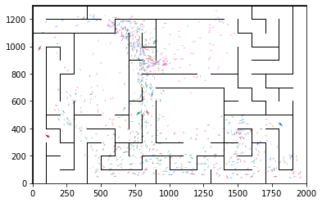

epoch 1231 == proposed_mle: 18.37+-0.31/17.76+-0.23 --

epoch 1232 == proposed_mle: 17.81+-0.32/17.52+-0.25 --

epoch 1233 == proposed_mle: 17.80+-0.31/17.67+-0.22 --

epoch 1234 == proposed_mle: 18.07+-0.33/17.77+-0.24 --

epoch 1235 == proposed_mle: 18.03+-0.34/17.58+-0.25 --

epoch 1236 == proposed_mle: 18.71+-0.36/17.54+-0.25 --

epoch 1237 == proposed_mle: 17.68+-0.30/17.54+-0.24 --

epoch 1238 == proposed_mle: 18.56+-0.34/17.49+-0.22 --

epoch 1239 == proposed_mle: 18.20+-0.29/17.61+-0.24 --

epoch 1240 == proposed_mle: 18.48+-0.33/17.56+-0.25 --

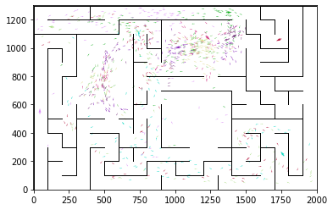

epoch 1241 == proposed_mle: 17.92+-0.33/17.62+-0.25 --

epoch 1242 == proposed_mle: 18.48+-0.36/17.57+-0.24 --

epoch 1243 == proposed_mle: 18.63+-0.33/17.51+-0.25 --

epoch 1244 == proposed_mle: 18.61+-0.38/17.63+-0.23 --

epoch 1245 == proposed_mle: 17.94+-0.32/17.73+-0.22 --

epoch 1246 == proposed_mle: 17.87+-0.30/17.52+-0.23 --

epoch 1247 == proposed_mle: 17.98+-0.32/17.62+-0.23 --

epoch 1248 == proposed_mle: 18.40+-0.38/17.55+-0.23 --

epoch 1249 >> proposed_mle: 18.21+-0.31/17.31+-0.22 --

epoch 1250 == proposed_mle: 17.71+-0.31/17.51+-0.24 --

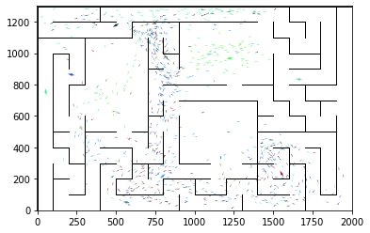

epoch 1251 == proposed_mle: 18.00+-0.36/17.43+-0.24 --

epoch 1252 == proposed_mle: 17.77+-0.31/17.43+-0.24 --

epoch 1253 == proposed_mle: 18.20+-0.35/17.44+-0.23 --

epoch 1254 == proposed_mle: 17.62+-0.33/17.46+-0.22 --

epoch 1255 == proposed_mle: 18.45+-0.36/17.37+-0.24 --

epoch 1256 == proposed_mle: 18.51+-0.32/17.63+-0.24 --

epoch 1257 == proposed_mle: 18.65+-0.29/17.60+-0.23 --

epoch 1258 == proposed_mle: 17.91+-0.30/17.46+-0.24 --

epoch 1259 == proposed_mle: 18.24+-0.31/17.68+-0.23 --

epoch 1260 == proposed_mle: 18.39+-0.28/17.60+-0.23 --

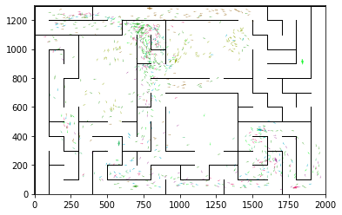

epoch 1261 == proposed_mle: 18.51+-0.28/17.41+-0.23 --

epoch 1262 == proposed_mle: 17.75+-0.33/17.55+-0.25 --

epoch 1263 == proposed_mle: 17.92+-0.35/17.58+-0.25 --

epoch 1264 == proposed_mle: 18.08+-0.34/17.50+-0.22 --

epoch 1265 == proposed_mle: 18.43+-0.37/17.57+-0.24 --

epoch 1266 == proposed_mle: 18.99+-0.26/17.64+-0.22 --

epoch 1267 == proposed_mle: 18.15+-0.31/17.90+-0.23 --

epoch 1268 == proposed_mle: 18.17+-0.30/17.63+-0.25 --

epoch 1269 == proposed_mle: 18.30+-0.36/17.49+-0.23 --

epoch 1270 == proposed_mle: 18.44+-0.35/17.43+-0.23 --

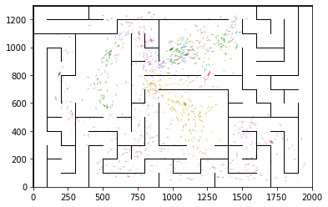

epoch 1271 == proposed_mle: 19.26+-0.36/17.62+-0.23 --

epoch 1272 == proposed_mle: 17.77+-0.36/17.71+-0.25 --

epoch 1273 == proposed_mle: 17.58+-0.30/17.64+-0.24 --

epoch 1274 == proposed_mle: 18.94+-0.33/17.86+-0.25 --

epoch 1275 == proposed_mle: 18.74+-0.40/17.81+-0.24 --

epoch 1276 == proposed_mle: 17.96+-0.34/17.64+-0.25 --

epoch 1277 == proposed_mle: 17.99+-0.33/17.85+-0.25 --

epoch 1278 == proposed_mle: 18.20+-0.37/17.58+-0.24 --

epoch 1279 == proposed_mle: 18.11+-0.32/17.37+-0.25 --

epoch 1280 == proposed_mle: 18.54+-0.36/17.73+-0.23 --

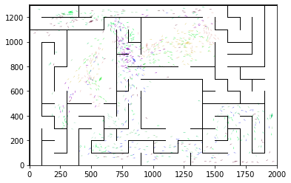

epoch 1281 == proposed_mle: 18.19+-0.30/17.78+-0.23 --

epoch 1282 == proposed_mle: 18.10+-0.35/17.76+-0.23 --

epoch 1283 == proposed_mle: 18.10+-0.39/17.71+-0.24 --

epoch 1284 == proposed_mle: 18.48+-0.36/17.55+-0.24 --

epoch 1285 == proposed_mle: 17.96+-0.29/17.53+-0.24 --

epoch 1286 == proposed_mle: 18.37+-0.30/17.58+-0.24 --

epoch 1287 == proposed_mle: 17.59+-0.28/17.72+-0.25 --

epoch 1288 == proposed_mle: 18.05+-0.28/17.55+-0.26 --

epoch 1289 == proposed_mle: 18.33+-0.36/17.45+-0.24 --

epoch 1290 == proposed_mle: 18.71+-0.36/17.57+-0.26 --

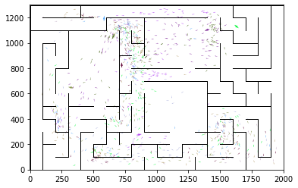

epoch 1291 == proposed_mle: 18.38+-0.34/17.56+-0.24 --

epoch 1292 == proposed_mle: 18.17+-0.36/17.76+-0.25 --

epoch 1293 == proposed_mle: 18.64+-0.32/17.69+-0.23 --

epoch 1294 == proposed_mle: 18.29+-0.35/17.43+-0.24 --

epoch 1295 == proposed_mle: 18.73+-0.33/17.43+-0.24 --

epoch 1296 == proposed_mle: 17.89+-0.35/17.70+-0.23 --

epoch 1297 == proposed_mle: 18.48+-0.41/17.47+-0.24 --

epoch 1298 == proposed_mle: 18.31+-0.34/17.60+-0.23 --

epoch 1299 == proposed_mle: 18.39+-0.30/17.54+-0.24 --

epoch 1300 == proposed_mle: 18.36+-0.32/17.59+-0.23 --

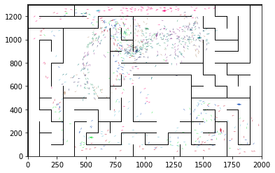

epoch 1301 == proposed_mle: 17.86+-0.40/17.44+-0.26 --

epoch 1302 == proposed_mle: 19.24+-0.38/17.43+-0.25 --

epoch 1303 == proposed_mle: 17.52+-0.31/17.39+-0.24 --

epoch 1304 == proposed_mle: 17.39+-0.30/17.39+-0.23 --

epoch 1305 == proposed_mle: 19.09+-0.37/17.33+-0.24 --

epoch 1306 == proposed_mle: 17.98+-0.35/17.47+-0.25 --

epoch 1307 == proposed_mle: 18.48+-0.32/17.52+-0.24 --

epoch 1308 == proposed_mle: 18.22+-0.26/17.34+-0.24 --

epoch 1309 >> proposed_mle: 17.83+-0.32/17.31+-0.24 --

epoch 1310 >> proposed_mle: 17.90+-0.32/17.22+-0.23 --

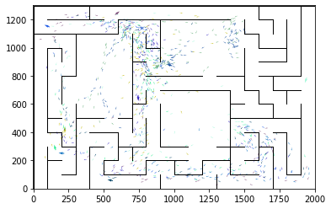

epoch 1311 == proposed_mle: 18.11+-0.33/17.38+-0.25 --

epoch 1312 == proposed_mle: 17.78+-0.35/17.28+-0.24 --

epoch 1313 == proposed_mle: 18.02+-0.33/17.42+-0.23 --

epoch 1314 == proposed_mle: 18.14+-0.31/17.31+-0.24 --

epoch 1315 == proposed_mle: 17.78+-0.35/17.34+-0.23 --

epoch 1316 == proposed_mle: 17.80+-0.35/17.41+-0.22 --

epoch 1317 == proposed_mle: 18.24+-0.31/17.41+-0.23 --

epoch 1318 >> proposed_mle: 18.68+-0.38/17.21+-0.22 --

epoch 1319 == proposed_mle: 18.10+-0.37/17.45+-0.23 --

epoch 1320 == proposed_mle: 18.17+-0.35/17.37+-0.25 --

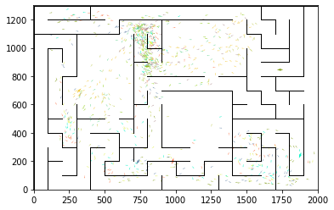

epoch 1321 == proposed_mle: 18.25+-0.34/17.43+-0.24 --

epoch 1322 >> proposed_mle: 17.53+-0.31/17.01+-0.23 --

epoch 1323 == proposed_mle: 18.49+-0.37/17.16+-0.23 --

epoch 1324 == proposed_mle: 17.96+-0.34/17.46+-0.24 --

epoch 1325 == proposed_mle: 17.91+-0.28/17.43+-0.24 --

epoch 1326 == proposed_mle: 18.35+-0.36/17.40+-0.22 --

epoch 1327 == proposed_mle: 17.98+-0.37/17.36+-0.22 --

epoch 1328 == proposed_mle: 18.29+-0.36/17.36+-0.23 --

epoch 1329 == proposed_mle: 18.27+-0.33/17.45+-0.22 --

epoch 1330 == proposed_mle: 17.88+-0.32/17.45+-0.23 --

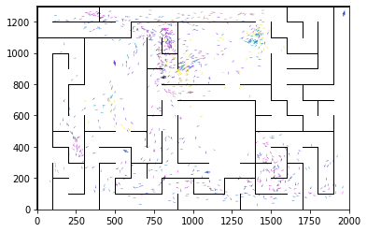

epoch 1331 == proposed_mle: 18.64+-0.31/17.34+-0.23 --

epoch 1332 == proposed_mle: 18.25+-0.30/17.56+-0.23 --

epoch 1333 == proposed_mle: 18.61+-0.35/17.29+-0.23 --

epoch 1334 == proposed_mle: 18.15+-0.33/17.34+-0.23 --

epoch 1335 == proposed_mle: 18.15+-0.41/17.11+-0.23 --

epoch 1336 == proposed_mle: 18.49+-0.34/17.41+-0.24 --

epoch 1337 == proposed_mle: 18.86+-0.35/17.27+-0.24 --

epoch 1338 == proposed_mle: 18.15+-0.33/17.38+-0.20 --

epoch 1339 == proposed_mle: 17.94+-0.40/17.08+-0.22 --

epoch 1340 == proposed_mle: 18.03+-0.35/17.40+-0.24 --

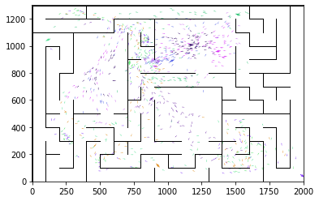

epoch 1341 == proposed_mle: 17.83+-0.31/17.28+-0.24 --

epoch 1342 == proposed_mle: 18.57+-0.39/17.19+-0.23 --

epoch 1343 == proposed_mle: 17.37+-0.31/17.34+-0.23 --

epoch 1344 == proposed_mle: 17.64+-0.32/17.29+-0.23 --

epoch 1345 == proposed_mle: 18.24+-0.28/17.09+-0.24 --

epoch 1346 == proposed_mle: 18.23+-0.35/17.20+-0.24 --

epoch 1347 == proposed_mle: 17.92+-0.31/17.14+-0.23 --

epoch 1348 == proposed_mle: 18.32+-0.31/17.10+-0.25 --

epoch 1349 == proposed_mle: 18.20+-0.31/17.39+-0.23 --

epoch 1350 == proposed_mle: 18.36+-0.35/17.44+-0.22 --

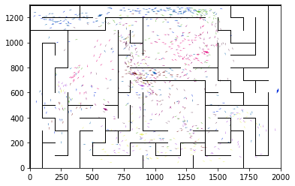

epoch 1351 == proposed_mle: 18.31+-0.30/17.30+-0.24 --

epoch 1352 == proposed_mle: 18.41+-0.32/17.50+-0.24 --

epoch 1353 == proposed_mle: 18.78+-0.37/17.42+-0.22 --

epoch 1354 == proposed_mle: 18.32+-0.34/17.45+-0.23 --

epoch 1355 == proposed_mle: 17.74+-0.33/17.68+-0.25 --

epoch 1356 == proposed_mle: 18.19+-0.36/17.27+-0.23 --

epoch 1357 == proposed_mle: 17.90+-0.37/17.55+-0.23 --

epoch 1358 == proposed_mle: 18.60+-0.35/17.36+-0.24 --

epoch 1359 == proposed_mle: 17.69+-0.35/17.14+-0.23 --

epoch 1360 == proposed_mle: 17.64+-0.30/17.28+-0.24 --

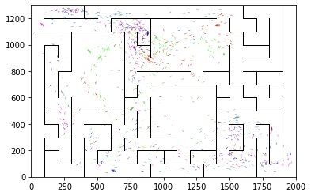

epoch 1361 == proposed_mle: 18.27+-0.42/17.28+-0.25 --

epoch 1362 == proposed_mle: 18.32+-0.31/17.13+-0.23 --

epoch 1363 == proposed_mle: 17.67+-0.34/17.35+-0.24 --

epoch 1364 == proposed_mle: 18.21+-0.32/17.38+-0.24 --

epoch 1365 == proposed_mle: 18.11+-0.38/17.40+-0.24 --

epoch 1366 == proposed_mle: 18.58+-0.30/17.13+-0.24 --

epoch 1367 >> proposed_mle: 17.38+-0.33/16.98+-0.23 --

epoch 1368 == proposed_mle: 17.84+-0.36/17.12+-0.24 --

epoch 1369 == proposed_mle: 18.08+-0.34/17.44+-0.25 --

epoch 1370 == proposed_mle: 17.34+-0.29/17.30+-0.25 --

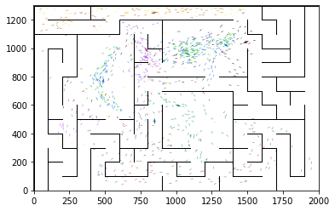

epoch 1371 == proposed_mle: 17.82+-0.33/17.37+-0.24 --

epoch 1372 == proposed_mle: 18.23+-0.33/17.43+-0.25 --

epoch 1373 == proposed_mle: 18.55+-0.36/17.42+-0.24 --

epoch 1374 == proposed_mle: 18.28+-0.34/17.51+-0.25 --

epoch 1375 == proposed_mle: 17.17+-0.28/17.11+-0.26 --

epoch 1376 == proposed_mle: 18.69+-0.29/17.18+-0.23 --

epoch 1377 == proposed_mle: 18.21+-0.36/17.48+-0.26 --

epoch 1378 == proposed_mle: 17.70+-0.41/17.45+-0.25 --

epoch 1379 == proposed_mle: 17.73+-0.32/17.50+-0.25 --

epoch 1380 == proposed_mle: 17.98+-0.38/17.46+-0.23 --

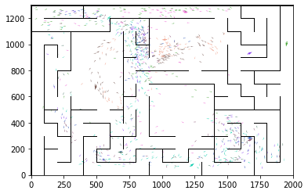

epoch 1381 == proposed_mle: 17.76+-0.33/17.12+-0.25 --

epoch 1382 == proposed_mle: 18.16+-0.35/17.39+-0.23 --

epoch 1383 == proposed_mle: 18.41+-0.36/17.40+-0.23 --

epoch 1384 == proposed_mle: 18.22+-0.34/17.11+-0.25 --

epoch 1385 == proposed_mle: 17.40+-0.40/17.14+-0.24 --

epoch 1386 == proposed_mle: 17.65+-0.35/17.14+-0.23 --

epoch 1387 == proposed_mle: 18.01+-0.34/17.12+-0.22 --

epoch 1388 == proposed_mle: 17.94+-0.29/17.29+-0.25 --

epoch 1389 == proposed_mle: 17.35+-0.37/17.25+-0.23 --

epoch 1390 == proposed_mle: 18.39+-0.32/17.16+-0.24 --

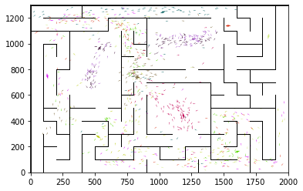

epoch 1391 == proposed_mle: 18.09+-0.26/17.06+-0.23 --

epoch 1392 == proposed_mle: 18.38+-0.35/17.10+-0.24 --

epoch 1393 == proposed_mle: 17.79+-0.31/17.08+-0.22 --

epoch 1394 == proposed_mle: 17.70+-0.33/16.99+-0.22 --

epoch 1395 == proposed_mle: 17.94+-0.34/17.13+-0.24 --

epoch 1396 == proposed_mle: 18.04+-0.36/17.26+-0.24 --

epoch 1397 == proposed_mle: 18.04+-0.37/17.22+-0.22 --

epoch 1398 == proposed_mle: 17.99+-0.34/17.13+-0.23 --

epoch 1399 == proposed_mle: 17.68+-0.37/17.22+-0.25 --

epoch 1400 == proposed_mle: 18.01+-0.35/16.99+-0.24 --

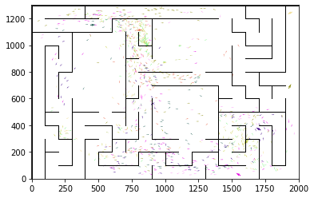

epoch 1401 == proposed_mle: 17.84+-0.34/17.16+-0.24 --

epoch 1402 == proposed_mle: 18.45+-0.29/17.14+-0.23 --

epoch 1403 == proposed_mle: 18.12+-0.32/17.39+-0.25 --

epoch 1404 == proposed_mle: 17.64+-0.34/17.14+-0.23 --

epoch 1405 == proposed_mle: 17.72+-0.29/17.04+-0.23 --

epoch 1406 >> proposed_mle: 17.56+-0.31/16.80+-0.22 --

epoch 1407 == proposed_mle: 17.68+-0.32/17.24+-0.23 --

epoch 1408 == proposed_mle: 17.97+-0.39/17.06+-0.23 --

epoch 1409 == proposed_mle: 18.17+-0.29/17.04+-0.24 --

epoch 1410 == proposed_mle: 17.42+-0.36/17.08+-0.24 --

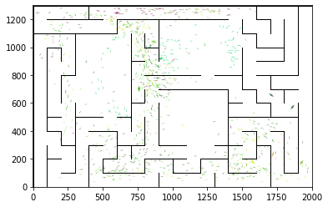

epoch 1411 == proposed_mle: 18.09+-0.33/17.33+-0.23 --

epoch 1412 == proposed_mle: 18.07+-0.35/17.45+-0.23 --

epoch 1413 == proposed_mle: 17.86+-0.30/17.24+-0.23 --

epoch 1414 == proposed_mle: 17.69+-0.38/17.03+-0.26 --

epoch 1415 == proposed_mle: 17.49+-0.31/17.16+-0.23 --

epoch 1416 == proposed_mle: 17.26+-0.32/17.03+-0.23 --

epoch 1417 == proposed_mle: 17.92+-0.34/17.06+-0.24 --

epoch 1418 == proposed_mle: 17.91+-0.40/17.05+-0.24 --

epoch 1419 == proposed_mle: 17.61+-0.34/17.35+-0.24 --

epoch 1420 == proposed_mle: 17.92+-0.30/17.20+-0.23 --

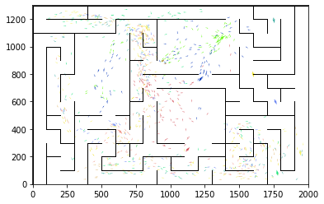

epoch 1421 == proposed_mle: 17.23+-0.38/16.97+-0.25 --

epoch 1422 == proposed_mle: 17.32+-0.34/17.05+-0.24 --

epoch 1423 == proposed_mle: 17.82+-0.29/16.89+-0.24 --

epoch 1424 == proposed_mle: 18.19+-0.34/16.94+-0.23 --

epoch 1425 == proposed_mle: 17.83+-0.28/17.00+-0.23 --

epoch 1426 == proposed_mle: 17.60+-0.41/17.28+-0.23 --

epoch 1427 == proposed_mle: 17.54+-0.31/16.94+-0.26 --

epoch 1428 == proposed_mle: 16.67+-0.35/17.17+-0.23 --

epoch 1429 == proposed_mle: 18.16+-0.34/16.88+-0.24 --

epoch 1430 == proposed_mle: 17.43+-0.33/17.25+-0.24 --

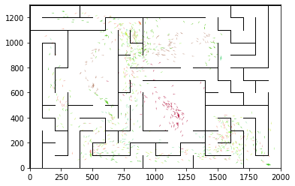

epoch 1431 == proposed_mle: 17.72+-0.32/16.86+-0.24 --

epoch 1432 == proposed_mle: 18.28+-0.34/17.18+-0.25 --

epoch 1433 == proposed_mle: 18.16+-0.32/17.06+-0.22 --

epoch 1434 == proposed_mle: 17.26+-0.37/17.11+-0.23 --

epoch 1435 == proposed_mle: 17.22+-0.31/17.06+-0.24 --

epoch 1436 == proposed_mle: 18.54+-0.28/17.02+-0.22 --

epoch 1437 == proposed_mle: 17.94+-0.33/17.26+-0.24 --

epoch 1438 == proposed_mle: 18.39+-0.31/17.29+-0.26 --

epoch 1439 == proposed_mle: 17.40+-0.34/16.92+-0.24 --

epoch 1440 == proposed_mle: 17.71+-0.32/17.39+-0.23 --

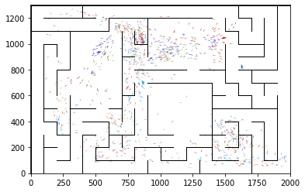

epoch 1441 == proposed_mle: 17.97+-0.37/17.12+-0.24 --

epoch 1442 == proposed_mle: 17.48+-0.39/17.35+-0.24 --

epoch 1443 == proposed_mle: 17.47+-0.30/16.93+-0.24 --

epoch 1444 == proposed_mle: 17.47+-0.37/16.99+-0.24 --

epoch 1445 == proposed_mle: 17.37+-0.30/17.00+-0.25 --

epoch 1446 == proposed_mle: 17.74+-0.36/17.09+-0.23 --

epoch 1447 == proposed_mle: 18.22+-0.37/16.89+-0.23 --

epoch 1448 >> proposed_mle: 17.66+-0.34/16.76+-0.25 --

epoch 1449 == proposed_mle: 17.86+-0.34/16.87+-0.23 --

epoch 1450 == proposed_mle: 18.07+-0.40/17.05+-0.24 --

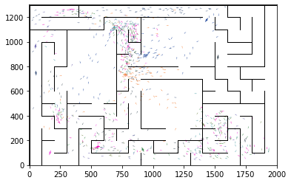

epoch 1451 == proposed_mle: 17.56+-0.33/16.91+-0.25 --

epoch 1452 == proposed_mle: 17.94+-0.28/16.94+-0.25 --

epoch 1453 == proposed_mle: 17.74+-0.35/17.08+-0.26 --

epoch 1454 == proposed_mle: 16.90+-0.29/16.95+-0.23 --

epoch 1455 == proposed_mle: 17.55+-0.32/16.97+-0.24 --

epoch 1456 == proposed_mle: 18.18+-0.37/17.09+-0.23 --

epoch 1457 == proposed_mle: 17.79+-0.34/16.79+-0.23 --

epoch 1458 == proposed_mle: 17.89+-0.34/16.90+-0.24 --

epoch 1459 == proposed_mle: 17.24+-0.32/16.97+-0.25 --

epoch 1460 == proposed_mle: 17.59+-0.34/16.98+-0.23 --

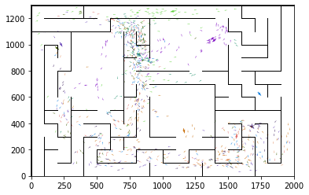

epoch 1461 == proposed_mle: 17.54+-0.29/17.02+-0.23 --

epoch 1462 == proposed_mle: 17.54+-0.35/16.97+-0.24 --

epoch 1463 == proposed_mle: 18.31+-0.33/17.04+-0.24 --

epoch 1464 == proposed_mle: 17.11+-0.36/17.06+-0.23 --

epoch 1465 == proposed_mle: 17.31+-0.34/17.09+-0.23 --

epoch 1466 == proposed_mle: 17.96+-0.31/17.05+-0.21 --

epoch 1467 == proposed_mle: 17.19+-0.34/16.97+-0.25 --

epoch 1468 == proposed_mle: 17.30+-0.34/17.14+-0.23 --

epoch 1469 == proposed_mle: 17.61+-0.34/17.02+-0.23 --

epoch 1470 == proposed_mle: 18.18+-0.38/16.82+-0.23 --

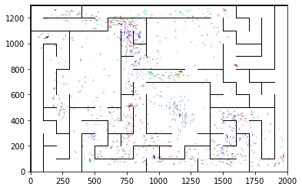

epoch 1471 == proposed_mle: 17.69+-0.35/17.02+-0.23 --

epoch 1472 == proposed_mle: 17.47+-0.32/16.92+-0.24 --

epoch 1473 == proposed_mle: 17.76+-0.34/16.96+-0.23 --

epoch 1474 >> proposed_mle: 17.63+-0.30/16.63+-0.24 --

epoch 1475 == proposed_mle: 17.55+-0.35/16.91+-0.23 --

epoch 1476 == proposed_mle: 18.26+-0.29/16.78+-0.24 --

epoch 1477 == proposed_mle: 17.97+-0.28/16.95+-0.24 --

epoch 1478 == proposed_mle: 17.04+-0.32/16.94+-0.24 --

epoch 1479 == proposed_mle: 17.91+-0.36/16.87+-0.24 --

epoch 1480 == proposed_mle: 17.46+-0.28/16.79+-0.24 --

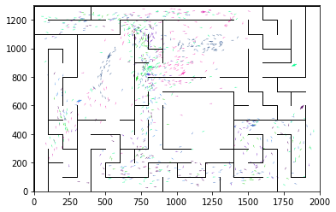

epoch 1481 == proposed_mle: 18.07+-0.29/17.06+-0.24 --

epoch 1482 == proposed_mle: 17.95+-0.35/16.97+-0.23 --

epoch 1483 == proposed_mle: 17.40+-0.31/17.06+-0.23 --

epoch 1484 == proposed_mle: 17.91+-0.39/17.02+-0.24 --

epoch 1485 == proposed_mle: 17.26+-0.30/16.80+-0.23 --

epoch 1486 == proposed_mle: 17.52+-0.30/16.92+-0.24 --

epoch 1487 == proposed_mle: 17.80+-0.35/17.04+-0.25 --

epoch 1488 == proposed_mle: 18.21+-0.37/16.86+-0.24 --

epoch 1489 == proposed_mle: 17.48+-0.37/16.76+-0.24 --

epoch 1490 == proposed_mle: 17.91+-0.43/16.77+-0.24 --

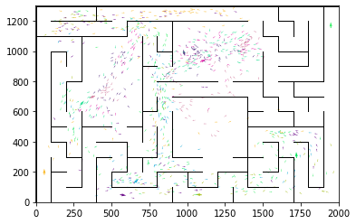

epoch 1491 == proposed_mle: 18.05+-0.39/16.90+-0.25 --

epoch 1492 == proposed_mle: 17.74+-0.31/16.81+-0.25 --

epoch 1493 == proposed_mle: 17.21+-0.32/16.84+-0.25 --

epoch 1494 == proposed_mle: 17.48+-0.32/16.76+-0.24 --

epoch 1495 == proposed_mle: 17.43+-0.31/16.81+-0.25 --

epoch 1496 == proposed_mle: 17.96+-0.26/16.86+-0.23 --

epoch 1497 == proposed_mle: 17.91+-0.37/16.74+-0.22 --

epoch 1498 == proposed_mle: 17.89+-0.33/16.82+-0.23 --

epoch 1499 == proposed_mle: 17.53+-0.39/16.82+-0.23 --

epoch 1500 == proposed_mle: 17.52+-0.35/16.98+-0.22 --

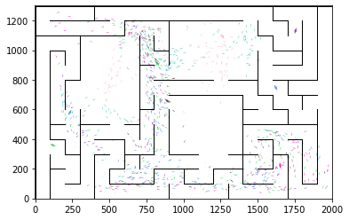

epoch 1501 == proposed_mle: 17.40+-0.31/17.03+-0.24 --

epoch 1502 == proposed_mle: 18.01+-0.39/16.76+-0.24 --

epoch 1503 == proposed_mle: 17.77+-0.27/17.01+-0.23 --

epoch 1504 == proposed_mle: 17.40+-0.28/17.01+-0.23 --

epoch 1505 == proposed_mle: 16.89+-0.35/17.15+-0.23 --

epoch 1506 == proposed_mle: 17.57+-0.31/17.01+-0.23 --

epoch 1507 == proposed_mle: 17.20+-0.37/16.97+-0.23 --

epoch 1508 == proposed_mle: 17.70+-0.35/16.76+-0.25 --

epoch 1509 == proposed_mle: 17.41+-0.42/16.79+-0.24 --

epoch 1510 == proposed_mle: 17.82+-0.37/16.86+-0.23 --

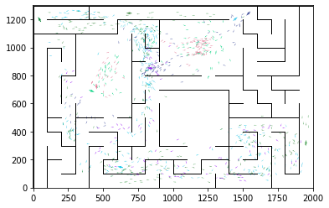

epoch 1511 >> proposed_mle: 18.29+-0.32/16.58+-0.25 --

epoch 1512 == proposed_mle: 17.62+-0.28/16.97+-0.25 --

epoch 1513 == proposed_mle: 17.48+-0.33/16.82+-0.24 --

epoch 1514 == proposed_mle: 17.25+-0.33/16.83+-0.25 --

epoch 1515 == proposed_mle: 17.41+-0.31/16.90+-0.24 --

epoch 1516 == proposed_mle: 17.40+-0.38/16.88+-0.24 --

epoch 1517 == proposed_mle: 17.96+-0.38/16.85+-0.26 --

epoch 1518 == proposed_mle: 18.20+-0.37/16.88+-0.24 --

epoch 1519 == proposed_mle: 18.14+-0.31/16.73+-0.24 --

epoch 1520 == proposed_mle: 18.02+-0.39/16.93+-0.25 --

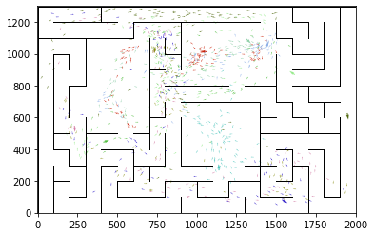

epoch 1521 == proposed_mle: 17.88+-0.35/16.86+-0.24 --

epoch 1522 == proposed_mle: 17.51+-0.33/16.78+-0.26 --

epoch 1523 == proposed_mle: 17.69+-0.36/16.79+-0.23 --

epoch 1524 == proposed_mle: 17.56+-0.33/16.87+-0.25 --

epoch 1525 == proposed_mle: 17.01+-0.27/16.73+-0.23 --

epoch 1526 == proposed_mle: 17.61+-0.32/16.72+-0.26 --

epoch 1527 == proposed_mle: 17.78+-0.35/16.76+-0.24 --

epoch 1528 >> proposed_mle: 17.45+-0.34/16.57+-0.24 --

epoch 1529 == proposed_mle: 16.96+-0.43/16.77+-0.25 --

epoch 1530 == proposed_mle: 17.83+-0.37/16.89+-0.25 --

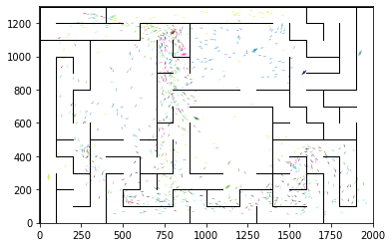

epoch 1531 == proposed_mle: 17.29+-0.37/16.57+-0.24 --

epoch 1532 == proposed_mle: 17.53+-0.31/16.94+-0.24 --

epoch 1533 >> proposed_mle: 17.56+-0.33/16.56+-0.23 --

epoch 1534 == proposed_mle: 16.82+-0.33/16.75+-0.24 --

epoch 1535 == proposed_mle: 17.74+-0.29/16.71+-0.24 --

epoch 1536 == proposed_mle: 17.55+-0.37/16.93+-0.26 --

epoch 1537 == proposed_mle: 17.32+-0.30/17.05+-0.23 --

epoch 1538 == proposed_mle: 17.89+-0.35/16.76+-0.24 --

epoch 1539 == proposed_mle: 17.20+-0.32/16.76+-0.25 --

epoch 1540 == proposed_mle: 17.19+-0.35/16.62+-0.23 --

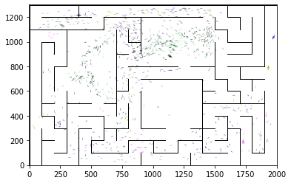

epoch 1541 == proposed_mle: 17.30+-0.39/16.95+-0.25 --

epoch 1542 == proposed_mle: 17.09+-0.31/16.63+-0.24 --

epoch 1543 == proposed_mle: 17.80+-0.31/16.75+-0.25 --

epoch 1544 == proposed_mle: 17.36+-0.30/16.83+-0.24 --

epoch 1545 == proposed_mle: 17.21+-0.32/16.66+-0.23 --

epoch 1546 == proposed_mle: 17.75+-0.30/16.77+-0.26 --

epoch 1547 == proposed_mle: 17.10+-0.25/16.72+-0.24 --

epoch 1548 == proposed_mle: 17.32+-0.32/16.96+-0.24 --

epoch 1549 == proposed_mle: 16.84+-0.38/16.81+-0.24 --

epoch 1550 == proposed_mle: 18.17+-0.32/16.84+-0.24 --

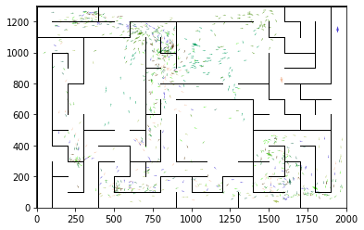

epoch 1551 == proposed_mle: 16.64+-0.36/16.73+-0.22 --

epoch 1552 == proposed_mle: 17.53+-0.39/16.91+-0.24 --

epoch 1553 == proposed_mle: 18.20+-0.33/16.84+-0.24 --

epoch 1554 == proposed_mle: 17.70+-0.36/16.97+-0.25 --

epoch 1555 == proposed_mle: 18.27+-0.38/16.65+-0.24 --

epoch 1556 == proposed_mle: 17.81+-0.31/16.65+-0.23 --

epoch 1557 == proposed_mle: 17.79+-0.35/16.88+-0.25 --

epoch 1558 == proposed_mle: 17.50+-0.33/16.86+-0.25 --

epoch 1559 == proposed_mle: 17.66+-0.33/16.95+-0.23 --

epoch 1560 == proposed_mle: 17.50+-0.37/16.99+-0.24 --

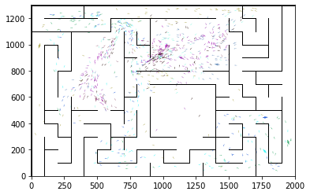

epoch 1561 == proposed_mle: 18.27+-0.33/16.64+-0.23 --

epoch 1562 == proposed_mle: 17.54+-0.28/16.82+-0.24 --

epoch 1563 == proposed_mle: 17.54+-0.33/16.79+-0.24 --

epoch 1564 == proposed_mle: 17.67+-0.33/16.66+-0.23 --

epoch 1565 == proposed_mle: 17.41+-0.33/16.67+-0.24 --

epoch 1566 == proposed_mle: 17.41+-0.38/16.61+-0.23 --

epoch 1567 == proposed_mle: 17.72+-0.38/16.59+-0.23 --

epoch 1568 == proposed_mle: 18.13+-0.29/16.64+-0.24 --

epoch 1569 == proposed_mle: 17.53+-0.34/16.75+-0.22 --

epoch 1570 == proposed_mle: 17.99+-0.29/16.82+-0.24 --

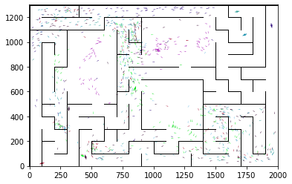

epoch 1571 == proposed_mle: 17.44+-0.41/16.83+-0.23 --

epoch 1572 == proposed_mle: 17.53+-0.28/16.63+-0.25 --

epoch 1573 == proposed_mle: 16.99+-0.32/16.63+-0.24 --

epoch 1574 >> proposed_mle: 17.38+-0.38/16.52+-0.25 --

epoch 1575 == proposed_mle: 17.49+-0.32/16.66+-0.23 --

epoch 1576 == proposed_mle: 17.25+-0.34/16.67+-0.22 --

epoch 1577 == proposed_mle: 17.45+-0.31/16.82+-0.24 --

epoch 1578 == proposed_mle: 16.94+-0.33/16.69+-0.23 --

epoch 1579 == proposed_mle: 17.43+-0.30/16.75+-0.25 --

epoch 1580 == proposed_mle: 17.10+-0.31/16.77+-0.26 --

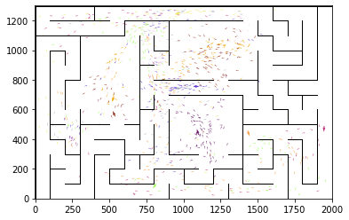

epoch 1581 == proposed_mle: 17.16+-0.27/16.58+-0.23 --

epoch 1582 == proposed_mle: 17.41+-0.30/16.57+-0.22 --

epoch 1583 == proposed_mle: 17.39+-0.33/16.85+-0.23 --

epoch 1584 == proposed_mle: 17.76+-0.32/16.74+-0.22 --

epoch 1585 == proposed_mle: 17.22+-0.32/16.87+-0.25 --

epoch 1586 == proposed_mle: 17.11+-0.30/16.66+-0.24 --

epoch 1587 == proposed_mle: 17.79+-0.36/16.56+-0.23 --

epoch 1588 == proposed_mle: 16.52+-0.35/16.72+-0.23 --

epoch 1589 == proposed_mle: 17.38+-0.30/16.74+-0.25 --

epoch 1590 == proposed_mle: 17.76+-0.26/16.62+-0.26 --

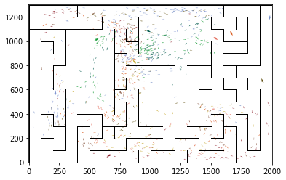

epoch 1591 == proposed_mle: 17.74+-0.37/16.79+-0.25 --

epoch 1592 == proposed_mle: 17.77+-0.36/16.73+-0.23 --

epoch 1593 == proposed_mle: 16.95+-0.31/16.74+-0.25 --

epoch 1594 == proposed_mle: 16.98+-0.28/16.64+-0.25 --

epoch 1595 == proposed_mle: 17.55+-0.33/16.61+-0.24 --

epoch 1596 == proposed_mle: 17.32+-0.37/16.79+-0.24 --

epoch 1597 == proposed_mle: 17.42+-0.34/16.72+-0.26 --

epoch 1598 == proposed_mle: 17.78+-0.29/16.81+-0.25 --

epoch 1599 == proposed_mle: 17.27+-0.38/16.79+-0.25 --

epoch 1600 == proposed_mle: 17.62+-0.34/16.55+-0.24 --

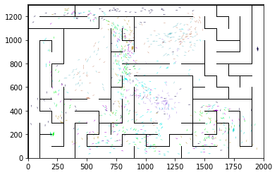

epoch 1601 >> proposed_mle: 17.41+-0.30/16.48+-0.24 --

epoch 1602 >> proposed_mle: 17.60+-0.39/16.45+-0.23 --

epoch 1603 == proposed_mle: 17.16+-0.32/16.75+-0.23 --

epoch 1604 == proposed_mle: 17.49+-0.38/16.76+-0.25 --

epoch 1605 == proposed_mle: 17.45+-0.33/16.67+-0.25 --

epoch 1606 == proposed_mle: 17.38+-0.32/16.79+-0.25 --

epoch 1607 == proposed_mle: 16.99+-0.34/16.72+-0.26 --

epoch 1608 == proposed_mle: 17.52+-0.38/16.73+-0.26 --

epoch 1609 == proposed_mle: 17.30+-0.37/16.74+-0.25 --

epoch 1610 == proposed_mle: 17.95+-0.30/16.83+-0.23 --

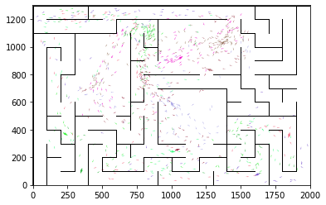

epoch 1611 == proposed_mle: 17.18+-0.36/16.60+-0.26 --

epoch 1612 == proposed_mle: 17.93+-0.32/16.76+-0.25 --

epoch 1613 == proposed_mle: 17.53+-0.35/16.62+-0.23 --

epoch 1614 == proposed_mle: 17.68+-0.33/16.61+-0.25 --

epoch 1615 == proposed_mle: 17.51+-0.39/16.58+-0.24 --

epoch 1616 >> proposed_mle: 17.86+-0.32/16.41+-0.25 --

epoch 1617 == proposed_mle: 17.77+-0.37/16.65+-0.25 --

epoch 1618 == proposed_mle: 17.00+-0.35/16.58+-0.25 --

epoch 1619 == proposed_mle: 17.09+-0.31/16.58+-0.25 --

epoch 1620 == proposed_mle: 17.34+-0.37/16.80+-0.25 --

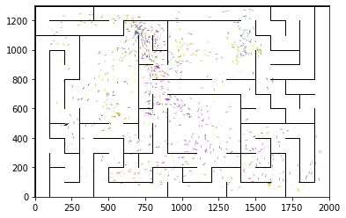

epoch 1621 == proposed_mle: 17.16+-0.30/16.63+-0.23 --

epoch 1622 == proposed_mle: 17.51+-0.32/16.54+-0.25 --

epoch 1623 == proposed_mle: 17.12+-0.27/16.61+-0.25 --

epoch 1624 >> proposed_mle: 17.56+-0.32/16.38+-0.23 --

epoch 1625 == proposed_mle: 17.25+-0.24/16.82+-0.26 --

epoch 1626 == proposed_mle: 17.56+-0.30/16.59+-0.24 --

epoch 1627 == proposed_mle: 17.70+-0.36/16.67+-0.25 --

epoch 1628 == proposed_mle: 17.44+-0.30/16.46+-0.24 --

epoch 1629 == proposed_mle: 17.48+-0.27/16.62+-0.24 --

epoch 1630 == proposed_mle: 17.68+-0.33/16.83+-0.25 --

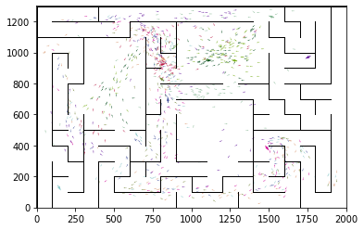

epoch 1631 == proposed_mle: 17.85+-0.29/16.59+-0.26 --

epoch 1632 == proposed_mle: 17.08+-0.27/16.75+-0.26 --

epoch 1633 == proposed_mle: 17.43+-0.34/16.49+-0.25 --

epoch 1634 == proposed_mle: 17.36+-0.29/16.55+-0.25 --

epoch 1635 == proposed_mle: 17.10+-0.39/16.83+-0.25 --

epoch 1636 == proposed_mle: 17.84+-0.33/16.48+-0.26 --

epoch 1637 == proposed_mle: 17.52+-0.28/16.48+-0.23 --

epoch 1638 == proposed_mle: 17.62+-0.37/16.62+-0.24 --

epoch 1639 == proposed_mle: 16.91+-0.37/16.48+-0.24 --

epoch 1640 == proposed_mle: 17.61+-0.32/16.47+-0.25 --

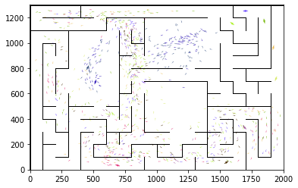

epoch 1641 == proposed_mle: 17.26+-0.34/16.73+-0.27 --

epoch 1642 == proposed_mle: 17.98+-0.39/16.47+-0.24 --

epoch 1643 == proposed_mle: 17.42+-0.37/16.66+-0.24 --

epoch 1644 >> proposed_mle: 17.19+-0.36/16.31+-0.24 --

epoch 1645 == proposed_mle: 17.46+-0.33/16.42+-0.22 --

epoch 1646 == proposed_mle: 16.92+-0.31/16.54+-0.26 --

epoch 1647 == proposed_mle: 17.00+-0.36/16.78+-0.23 --

epoch 1648 == proposed_mle: 17.26+-0.37/16.60+-0.23 --

epoch 1649 == proposed_mle: 17.65+-0.32/16.59+-0.25 --

epoch 1650 == proposed_mle: 17.78+-0.34/16.65+-0.25 --

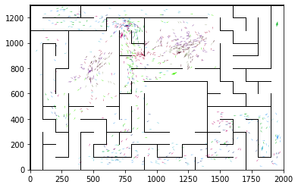

epoch 1651 == proposed_mle: 17.35+-0.34/16.67+-0.24 --

epoch 1652 == proposed_mle: 17.79+-0.31/16.55+-0.25 --

epoch 1653 == proposed_mle: 17.21+-0.34/16.52+-0.24 --

epoch 1654 == proposed_mle: 17.03+-0.38/16.63+-0.25 --

epoch 1655 == proposed_mle: 17.38+-0.32/16.61+-0.23 --

epoch 1656 == proposed_mle: 18.04+-0.32/16.65+-0.23 --

epoch 1657 == proposed_mle: 16.74+-0.38/16.50+-0.24 --

epoch 1658 == proposed_mle: 18.09+-0.29/16.52+-0.25 --

epoch 1659 == proposed_mle: 17.16+-0.38/16.50+-0.24 --

epoch 1660 == proposed_mle: 17.37+-0.37/16.45+-0.24 --

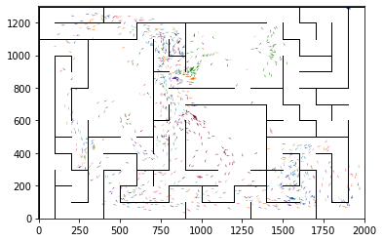

epoch 1661 == proposed_mle: 17.38+-0.34/16.50+-0.24 --

epoch 1662 == proposed_mle: 16.87+-0.36/16.50+-0.22 --

epoch 1663 == proposed_mle: 17.23+-0.32/16.49+-0.24 --

epoch 1664 == proposed_mle: 17.16+-0.26/16.38+-0.23 --

epoch 1665 == proposed_mle: 17.77+-0.35/16.50+-0.25 --

epoch 1666 >> proposed_mle: 17.12+-0.31/16.28+-0.23 --

epoch 1667 == proposed_mle: 17.03+-0.30/16.41+-0.23 --

epoch 1668 == proposed_mle: 17.19+-0.31/16.52+-0.24 --

epoch 1669 == proposed_mle: 17.53+-0.37/16.46+-0.24 --

epoch 1670 == proposed_mle: 16.75+-0.31/16.67+-0.25 --

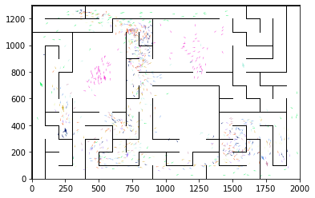

epoch 1671 == proposed_mle: 17.58+-0.30/16.43+-0.23 --

epoch 1672 == proposed_mle: 17.18+-0.32/16.48+-0.25 --

epoch 1673 == proposed_mle: 17.47+-0.29/16.48+-0.23 --

epoch 1674 == proposed_mle: 17.12+-0.35/16.62+-0.24 --

epoch 1675 == proposed_mle: 17.14+-0.33/16.52+-0.25 --

epoch 1676 == proposed_mle: 17.16+-0.32/16.48+-0.25 --

epoch 1677 == proposed_mle: 17.69+-0.29/16.37+-0.25 --

epoch 1678 == proposed_mle: 17.44+-0.30/16.37+-0.22 --

epoch 1679 == proposed_mle: 16.99+-0.36/16.29+-0.24 --

epoch 1680 == proposed_mle: 17.05+-0.31/16.41+-0.24 --

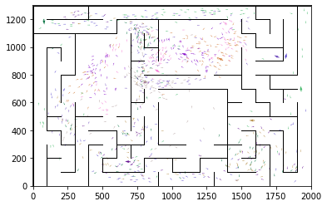

epoch 1681 >> proposed_mle: 16.71+-0.35/16.27+-0.22 --

epoch 1682 >> proposed_mle: 18.16+-0.39/16.24+-0.25 --

epoch 1683 >> proposed_mle: 16.97+-0.31/16.23+-0.22 --

epoch 1684 == proposed_mle: 17.65+-0.35/16.30+-0.23 --

epoch 1685 == proposed_mle: 17.37+-0.38/16.60+-0.25 --

epoch 1686 >> proposed_mle: 17.33+-0.32/16.20+-0.25 --

epoch 1687 == proposed_mle: 16.62+-0.30/16.32+-0.24 --

epoch 1688 >> proposed_mle: 17.65+-0.33/16.11+-0.25 --

epoch 1689 == proposed_mle: 17.28+-0.35/16.19+-0.22 --

epoch 1690 == proposed_mle: 17.27+-0.28/16.17+-0.24 --

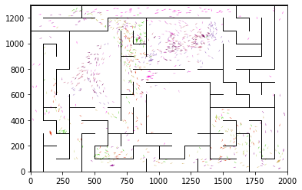

epoch 1691 == proposed_mle: 16.47+-0.40/16.25+-0.24 --

epoch 1692 >> proposed_mle: 17.12+-0.30/16.09+-0.23 --

epoch 1693 == proposed_mle: 17.57+-0.36/16.13+-0.26 --

epoch 1694 >> proposed_mle: 16.61+-0.33/16.08+-0.25 --

epoch 1695 == proposed_mle: 17.07+-0.36/16.17+-0.24 --

epoch 1696 == proposed_mle: 17.35+-0.28/16.31+-0.24 --

epoch 1697 == proposed_mle: 16.71+-0.30/16.30+-0.23 --

epoch 1698 >> proposed_mle: 16.53+-0.35/16.04+-0.24 --

epoch 1699 == proposed_mle: 16.71+-0.35/16.23+-0.25 --

epoch 1700 == proposed_mle: 17.04+-0.29/16.36+-0.26 --

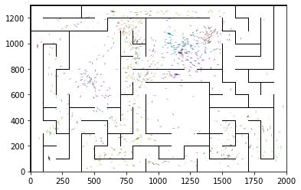

epoch 1701 == proposed_mle: 17.20+-0.34/16.05+-0.25 --

epoch 1702 >> proposed_mle: 17.03+-0.35/16.02+-0.23 --

epoch 1703 == proposed_mle: 16.54+-0.30/16.04+-0.26 --

epoch 1704 == proposed_mle: 17.50+-0.39/16.22+-0.24 --

epoch 1705 == proposed_mle: 16.78+-0.41/16.09+-0.25 --

epoch 1706 == proposed_mle: 16.17+-0.33/16.08+-0.24 --

epoch 1707 == proposed_mle: 16.91+-0.33/16.05+-0.23 --

epoch 1708 == proposed_mle: 16.84+-0.34/16.36+-0.25 --

epoch 1709 == proposed_mle: 16.88+-0.34/16.13+-0.24 --

epoch 1710 >> proposed_mle: 16.98+-0.29/15.98+-0.25 --

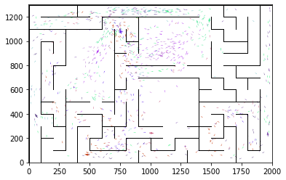

epoch 1711 == proposed_mle: 16.65+-0.32/16.09+-0.24 --

epoch 1712 == proposed_mle: 17.16+-0.40/16.15+-0.25 --

epoch 1713 == proposed_mle: 16.42+-0.27/16.09+-0.25 --

epoch 1714 >> proposed_mle: 17.55+-0.32/15.93+-0.24 --

epoch 1715 == proposed_mle: 16.86+-0.32/16.02+-0.23 --

epoch 1716 == proposed_mle: 16.50+-0.35/16.02+-0.22 --

epoch 1717 == proposed_mle: 17.20+-0.30/16.03+-0.24 --

epoch 1718 == proposed_mle: 17.08+-0.32/16.01+-0.26 --

epoch 1719 == proposed_mle: 16.58+-0.31/16.12+-0.25 --

epoch 1720 == proposed_mle: 16.92+-0.30/15.98+-0.25 --

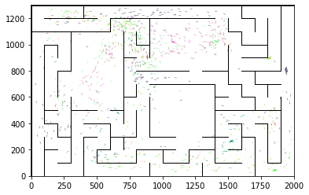

epoch 1721 == proposed_mle: 17.37+-0.32/16.16+-0.26 --

epoch 1722 == proposed_mle: 16.93+-0.30/15.94+-0.25 --

epoch 1723 == proposed_mle: 17.16+-0.27/16.05+-0.23 --

epoch 1724 == proposed_mle: 17.13+-0.28/16.23+-0.26 --

epoch 1725 == proposed_mle: 17.02+-0.35/16.02+-0.25 --

epoch 1726 == proposed_mle: 17.23+-0.32/15.95+-0.24 --

epoch 1727 >> proposed_mle: 16.47+-0.30/15.86+-0.25 --

epoch 1728 == proposed_mle: 16.79+-0.39/15.99+-0.24 --

epoch 1729 == proposed_mle: 16.59+-0.31/15.98+-0.23 --

epoch 1730 == proposed_mle: 17.41+-0.35/16.08+-0.23 --

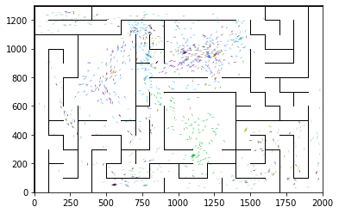

epoch 1731 >> proposed_mle: 17.17+-0.37/15.75+-0.24 --

epoch 1732 == proposed_mle: 16.18+-0.30/15.91+-0.23 --

epoch 1733 == proposed_mle: 16.72+-0.38/16.15+-0.23 --

epoch 1734 == proposed_mle: 16.73+-0.36/15.75+-0.25 --

epoch 1735 == proposed_mle: 16.26+-0.34/16.23+-0.23 --

epoch 1736 == proposed_mle: 16.84+-0.29/16.15+-0.23 --

epoch 1737 == proposed_mle: 16.80+-0.34/16.26+-0.22 --

epoch 1738 == proposed_mle: 16.58+-0.26/16.08+-0.22 --

epoch 1739 == proposed_mle: 17.54+-0.32/15.94+-0.24 --

epoch 1740 == proposed_mle: 16.18+-0.36/16.00+-0.24 --

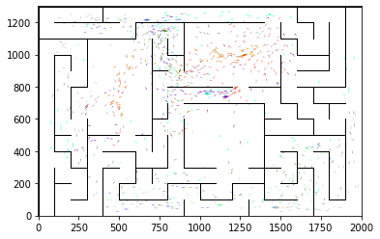

epoch 1741 == proposed_mle: 17.01+-0.27/16.07+-0.23 --

epoch 1742 == proposed_mle: 16.73+-0.28/15.87+-0.23 --

epoch 1743 == proposed_mle: 16.64+-0.35/15.91+-0.23 --

epoch 1744 == proposed_mle: 16.19+-0.34/16.07+-0.23 --

epoch 1745 == proposed_mle: 16.89+-0.36/16.01+-0.23 --

epoch 1746 == proposed_mle: 16.89+-0.33/16.04+-0.24 --

epoch 1747 == proposed_mle: 16.93+-0.37/16.00+-0.25 --

epoch 1748 == proposed_mle: 16.54+-0.31/16.11+-0.23 --

epoch 1749 == proposed_mle: 16.73+-0.35/15.96+-0.24 --

epoch 1750 == proposed_mle: 17.15+-0.39/16.08+-0.25 --

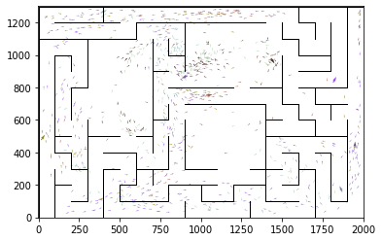

epoch 1751 == proposed_mle: 17.03+-0.32/16.26+-0.25 --

epoch 1752 == proposed_mle: 16.53+-0.30/15.91+-0.24 --

epoch 1753 == proposed_mle: 17.14+-0.30/16.20+-0.23 --

epoch 1754 == proposed_mle: 17.49+-0.38/16.06+-0.24 --

epoch 1755 == proposed_mle: 15.98+-0.37/16.13+-0.23 --

epoch 1756 == proposed_mle: 16.61+-0.34/16.07+-0.23 --

epoch 1757 == proposed_mle: 17.34+-0.35/15.81+-0.23 --

epoch 1758 == proposed_mle: 16.73+-0.35/15.81+-0.23 --

epoch 1759 == proposed_mle: 16.27+-0.32/15.93+-0.25 --

epoch 1760 == proposed_mle: 16.65+-0.37/15.88+-0.26 --

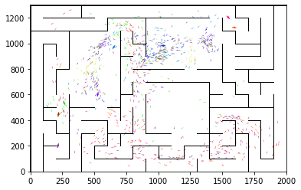

epoch 1761 == proposed_mle: 16.76+-0.31/16.08+-0.24 --

epoch 1762 == proposed_mle: 16.73+-0.28/15.93+-0.25 --

epoch 1763 == proposed_mle: 16.91+-0.27/15.76+-0.23 --

epoch 1764 == proposed_mle: 16.61+-0.28/16.00+-0.24 --

epoch 1765 == proposed_mle: 17.04+-0.29/15.98+-0.26 --

epoch 1766 == proposed_mle: 16.36+-0.27/15.98+-0.24 --

epoch 1767 == proposed_mle: 16.74+-0.27/16.04+-0.23 --

epoch 1768 == proposed_mle: 16.26+-0.35/15.99+-0.23 --

epoch 1769 == proposed_mle: 16.37+-0.30/15.97+-0.26 --

epoch 1770 == proposed_mle: 17.06+-0.30/15.95+-0.24 --

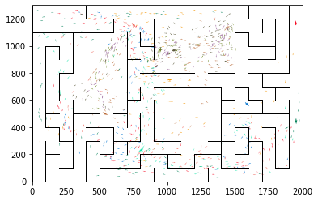

epoch 1771 == proposed_mle: 16.74+-0.34/15.93+-0.24 --

epoch 1772 >> proposed_mle: 16.49+-0.39/15.74+-0.22 --

epoch 1773 == proposed_mle: 16.89+-0.36/15.77+-0.25 --

epoch 1774 == proposed_mle: 16.71+-0.32/15.81+-0.22 --

epoch 1775 == proposed_mle: 16.57+-0.30/15.80+-0.23 --

epoch 1776 == proposed_mle: 16.92+-0.31/15.79+-0.24 --

epoch 1777 >> proposed_mle: 16.46+-0.28/15.71+-0.24 --

epoch 1778 == proposed_mle: 16.69+-0.31/15.85+-0.23 --

epoch 1779 >> proposed_mle: 16.98+-0.35/15.66+-0.23 --

epoch 1780 == proposed_mle: 16.18+-0.35/16.16+-0.24 --

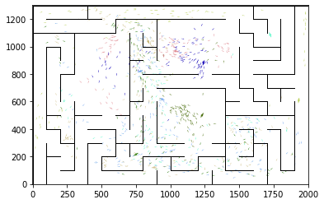

epoch 1781 == proposed_mle: 16.29+-0.35/16.01+-0.24 --

epoch 1782 == proposed_mle: 17.11+-0.35/15.87+-0.22 --

epoch 1783 == proposed_mle: 16.67+-0.36/15.72+-0.24 --

epoch 1784 == proposed_mle: 17.09+-0.34/16.10+-0.25 --

epoch 1785 == proposed_mle: 16.66+-0.31/15.86+-0.23 --

epoch 1786 == proposed_mle: 17.00+-0.32/16.04+-0.25 --

epoch 1787 == proposed_mle: 16.19+-0.27/16.18+-0.24 --

epoch 1788 == proposed_mle: 16.47+-0.31/15.87+-0.24 --

epoch 1789 == proposed_mle: 17.15+-0.34/15.99+-0.24 --

epoch 1790 == proposed_mle: 15.90+-0.26/15.99+-0.25 --

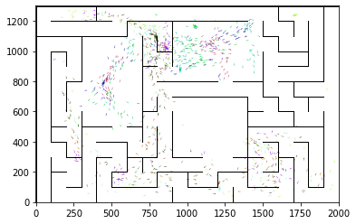

epoch 1791 == proposed_mle: 16.31+-0.28/15.84+-0.25 --

epoch 1792 == proposed_mle: 16.77+-0.28/15.80+-0.24 --

epoch 1793 == proposed_mle: 16.09+-0.35/15.81+-0.22 --

epoch 1794 == proposed_mle: 16.10+-0.33/15.77+-0.23 --

epoch 1795 == proposed_mle: 16.98+-0.38/15.72+-0.23 --

epoch 1796 == proposed_mle: 16.40+-0.34/15.75+-0.22 --

epoch 1797 == proposed_mle: 16.70+-0.33/15.89+-0.23 --

epoch 1798 >> proposed_mle: 16.82+-0.30/15.62+-0.23 --

epoch 1799 == proposed_mle: 16.40+-0.34/15.82+-0.24 --

epoch 1800 == proposed_mle: 16.61+-0.40/15.67+-0.23 --

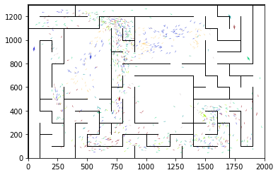

epoch 1801 == proposed_mle: 16.59+-0.31/15.77+-0.25 --

epoch 1802 == proposed_mle: 16.92+-0.35/15.68+-0.23 --

epoch 1803 == proposed_mle: 16.00+-0.27/15.97+-0.24 --

epoch 1804 >> proposed_mle: 16.34+-0.32/15.56+-0.22 --

epoch 1805 == proposed_mle: 16.82+-0.33/15.73+-0.23 --

epoch 1806 == proposed_mle: 16.30+-0.35/15.78+-0.24 --

epoch 1807 == proposed_mle: 16.53+-0.34/15.63+-0.24 --

epoch 1808 >> proposed_mle: 16.53+-0.33/15.55+-0.26 --

epoch 1809 == proposed_mle: 16.17+-0.32/16.00+-0.26 --

epoch 1810 == proposed_mle: 17.04+-0.37/15.94+-0.22 --

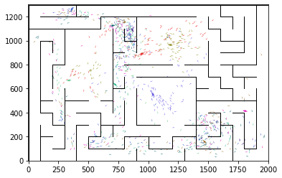

epoch 1811 == proposed_mle: 17.30+-0.39/15.81+-0.24 --

epoch 1812 == proposed_mle: 16.68+-0.31/15.75+-0.24 --

epoch 1813 == proposed_mle: 16.41+-0.34/15.73+-0.26 --

epoch 1814 == proposed_mle: 16.46+-0.34/15.97+-0.24 --

epoch 1815 == proposed_mle: 16.85+-0.28/15.67+-0.23 --

epoch 1816 == proposed_mle: 16.25+-0.36/16.00+-0.25 --

epoch 1817 == proposed_mle: 16.87+-0.36/15.72+-0.24 --

epoch 1818 == proposed_mle: 16.58+-0.36/15.99+-0.23 --

epoch 1819 == proposed_mle: 16.59+-0.34/15.88+-0.24 --

epoch 1820 == proposed_mle: 16.04+-0.33/15.87+-0.22 --

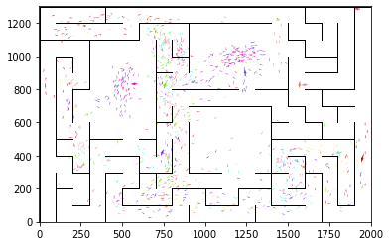

epoch 1821 == proposed_mle: 15.96+-0.32/15.85+-0.23 --

epoch 1822 == proposed_mle: 17.03+-0.29/16.00+-0.25 --

epoch 1823 == proposed_mle: 16.24+-0.42/15.83+-0.24 --

epoch 1824 == proposed_mle: 16.57+-0.30/15.77+-0.23 --

epoch 1825 == proposed_mle: 16.23+-0.30/16.14+-0.24 --

epoch 1826 == proposed_mle: 16.35+-0.29/15.68+-0.24 --

epoch 1827 == proposed_mle: 16.21+-0.34/15.71+-0.25 --

epoch 1828 == proposed_mle: 16.25+-0.32/15.91+-0.23 --

epoch 1829 >> proposed_mle: 16.45+-0.36/15.54+-0.24 --

epoch 1830 == proposed_mle: 16.46+-0.34/15.88+-0.25 --

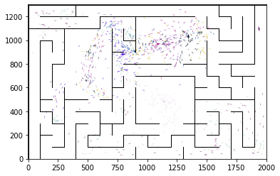

epoch 1831 == proposed_mle: 16.65+-0.30/15.81+-0.22 --

epoch 1832 == proposed_mle: 16.19+-0.33/15.90+-0.24 --

epoch 1833 == proposed_mle: 16.91+-0.32/15.89+-0.24 --

epoch 1834 == proposed_mle: 16.15+-0.28/16.13+-0.25 --

epoch 1835 == proposed_mle: 16.39+-0.28/16.04+-0.23 --

epoch 1836 == proposed_mle: 16.63+-0.29/15.69+-0.23 --

epoch 1837 == proposed_mle: 17.01+-0.34/15.85+-0.22 --

epoch 1838 == proposed_mle: 16.81+-0.34/15.76+-0.23 --

epoch 1839 == proposed_mle: 16.67+-0.36/15.75+-0.24 --

epoch 1840 == proposed_mle: 16.40+-0.34/15.95+-0.22 --

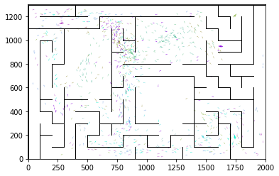

epoch 1841 == proposed_mle: 16.49+-0.27/16.00+-0.23 --

epoch 1842 == proposed_mle: 16.63+-0.40/15.67+-0.23 --

epoch 1843 == proposed_mle: 16.68+-0.31/15.55+-0.22 --

epoch 1844 == proposed_mle: 16.83+-0.37/15.82+-0.22 --

epoch 1845 == proposed_mle: 17.16+-0.27/16.35+-0.24 --

epoch 1846 == proposed_mle: 16.99+-0.33/16.09+-0.24 --

epoch 1847 == proposed_mle: 16.94+-0.35/16.22+-0.24 --

epoch 1848 == proposed_mle: 17.09+-0.37/15.97+-0.22 --

epoch 1849 == proposed_mle: 17.65+-0.37/16.00+-0.24 --

epoch 1850 == proposed_mle: 16.94+-0.32/15.94+-0.25 --

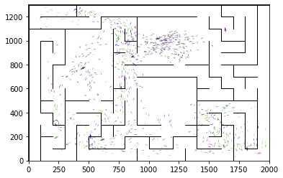

epoch 1851 == proposed_mle: 16.80+-0.34/16.03+-0.24 --

epoch 1852 == proposed_mle: 17.10+-0.33/15.92+-0.24 --

epoch 1853 == proposed_mle: 16.95+-0.32/16.07+-0.24 --

epoch 1854 == proposed_mle: 16.53+-0.38/15.78+-0.25 --

epoch 1855 == proposed_mle: 16.01+-0.34/15.95+-0.24 --

epoch 1856 == proposed_mle: 16.38+-0.31/16.06+-0.23 --

epoch 1857 == proposed_mle: 16.63+-0.31/15.79+-0.22 --

epoch 1858 == proposed_mle: 16.77+-0.28/15.86+-0.23 --

epoch 1859 == proposed_mle: 16.80+-0.29/15.82+-0.23 --

epoch 1860 == proposed_mle: 16.41+-0.32/15.82+-0.24 --

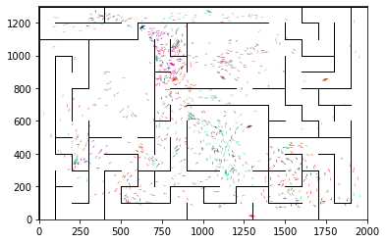

epoch 1861 == proposed_mle: 16.51+-0.35/15.61+-0.22 --

epoch 1862 == proposed_mle: 16.55+-0.34/15.87+-0.23 --

epoch 1863 == proposed_mle: 16.91+-0.28/15.73+-0.23 --

epoch 1864 == proposed_mle: 16.64+-0.34/15.93+-0.24 --

epoch 1865 == proposed_mle: 16.50+-0.28/15.79+-0.22 --

epoch 1866 == proposed_mle: 16.82+-0.34/15.79+-0.23 --

epoch 1867 == proposed_mle: 16.20+-0.29/15.91+-0.23 --

epoch 1868 == proposed_mle: 16.74+-0.37/15.81+-0.23 --

epoch 1869 == proposed_mle: 16.83+-0.35/15.60+-0.23 --

epoch 1870 == proposed_mle: 16.74+-0.39/15.79+-0.25 --

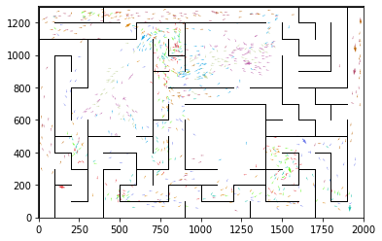

epoch 1871 == proposed_mle: 16.57+-0.30/15.65+-0.21 --

epoch 1872 == proposed_mle: 16.38+-0.30/15.64+-0.23 --

epoch 1873 == proposed_mle: 16.05+-0.32/15.69+-0.24 --

epoch 1874 == proposed_mle: 16.57+-0.39/15.91+-0.24 --

epoch 1875 == proposed_mle: 16.94+-0.35/15.66+-0.22 --

epoch 1876 == proposed_mle: 16.54+-0.29/15.62+-0.23 --

epoch 1877 == proposed_mle: 16.36+-0.29/15.78+-0.24 --

epoch 1878 == proposed_mle: 16.77+-0.34/15.71+-0.21 --

epoch 1879 >> proposed_mle: 15.89+-0.33/15.47+-0.23 --

epoch 1880 == proposed_mle: 15.86+-0.33/15.73+-0.23 --

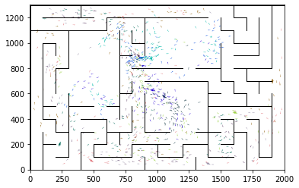

epoch 1881 == proposed_mle: 16.19+-0.30/15.89+-0.24 --

epoch 1882 == proposed_mle: 16.14+-0.33/15.76+-0.23 --

epoch 1883 == proposed_mle: 16.55+-0.33/15.82+-0.24 --

epoch 1884 == proposed_mle: 16.21+-0.31/15.53+-0.23 --

epoch 1885 == proposed_mle: 16.12+-0.37/15.68+-0.23 --

epoch 1886 == proposed_mle: 16.08+-0.30/15.78+-0.21 --

epoch 1887 == proposed_mle: 16.73+-0.37/15.91+-0.24 --

epoch 1888 == proposed_mle: 16.59+-0.33/15.69+-0.24 --

epoch 1889 == proposed_mle: 16.77+-0.34/15.84+-0.25 --

epoch 1890 == proposed_mle: 16.14+-0.36/15.77+-0.22 --

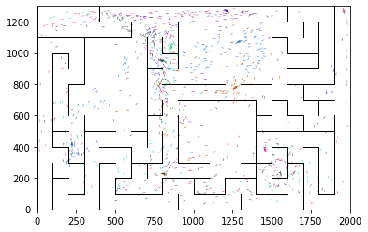

epoch 1891 == proposed_mle: 16.30+-0.31/15.87+-0.23 --

epoch 1892 == proposed_mle: 16.61+-0.32/15.59+-0.23 --

epoch 1893 == proposed_mle: 16.27+-0.38/15.59+-0.23 --

epoch 1894 == proposed_mle: 16.40+-0.34/15.81+-0.24 --

epoch 1895 == proposed_mle: 16.23+-0.30/16.02+-0.22 --

epoch 1896 == proposed_mle: 16.58+-0.30/15.83+-0.24 --

epoch 1897 == proposed_mle: 16.54+-0.34/15.85+-0.25 --

epoch 1898 == proposed_mle: 16.33+-0.33/15.85+-0.24 --

epoch 1899 == proposed_mle: 16.73+-0.34/15.80+-0.23 --

epoch 1900 == proposed_mle: 16.51+-0.33/15.82+-0.23 --

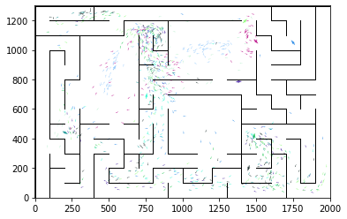

epoch 1901 == proposed_mle: 16.81+-0.31/15.66+-0.25 --

epoch 1902 == proposed_mle: 16.55+-0.32/15.83+-0.24 --

epoch 1903 == proposed_mle: 16.31+-0.29/15.80+-0.22 --

epoch 1904 == proposed_mle: 16.61+-0.36/15.70+-0.23 --

epoch 1905 == proposed_mle: 16.71+-0.31/15.81+-0.23 --

epoch 1906 == proposed_mle: 16.41+-0.34/15.96+-0.26 --

epoch 1907 == proposed_mle: 17.08+-0.35/15.50+-0.24 --

epoch 1908 == proposed_mle: 16.96+-0.37/15.77+-0.24 --

epoch 1909 == proposed_mle: 16.92+-0.32/15.84+-0.25 --

epoch 1910 >> proposed_mle: 16.38+-0.27/15.44+-0.24 --

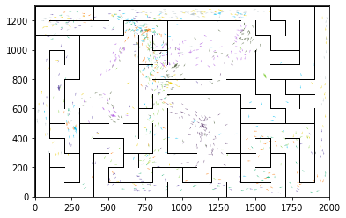

epoch 1911 == proposed_mle: 16.08+-0.33/15.68+-0.24 --

epoch 1912 == proposed_mle: 16.87+-0.33/15.58+-0.23 --

epoch 1913 == proposed_mle: 16.65+-0.32/16.04+-0.23 --

epoch 1914 == proposed_mle: 16.85+-0.33/15.71+-0.24 --

epoch 1915 == proposed_mle: 15.98+-0.32/15.64+-0.22 --

epoch 1916 == proposed_mle: 16.46+-0.37/15.76+-0.24 --

epoch 1917 == proposed_mle: 16.31+-0.34/15.80+-0.23 --

epoch 1918 == proposed_mle: 16.07+-0.30/15.79+-0.26 --

epoch 1919 == proposed_mle: 16.60+-0.24/15.69+-0.23 --

epoch 1920 == proposed_mle: 16.82+-0.37/15.92+-0.23 --

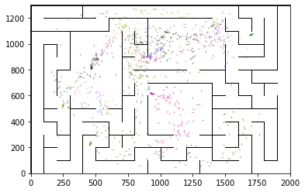

epoch 1921 == proposed_mle: 16.82+-0.32/15.55+-0.23 --

epoch 1922 == proposed_mle: 16.15+-0.35/15.67+-0.23 --

epoch 1923 == proposed_mle: 16.70+-0.26/15.74+-0.24 --

epoch 1924 == proposed_mle: 16.91+-0.27/15.79+-0.24 --

epoch 1925 == proposed_mle: 16.54+-0.33/15.75+-0.25 --

epoch 1926 == proposed_mle: 16.99+-0.32/15.69+-0.24 --

epoch 1927 == proposed_mle: 15.94+-0.32/15.59+-0.24 --

epoch 1928 == proposed_mle: 16.67+-0.30/15.64+-0.25 --

epoch 1929 == proposed_mle: 16.35+-0.29/15.58+-0.24 --

epoch 1930 == proposed_mle: 15.93+-0.38/15.62+-0.23 --

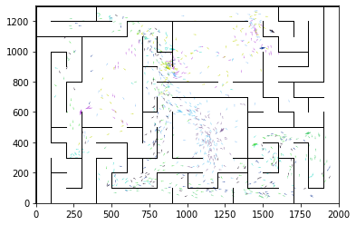

epoch 1931 == proposed_mle: 16.47+-0.36/15.59+-0.24 --

epoch 1932 == proposed_mle: 16.80+-0.30/15.90+-0.25 --

epoch 1933 == proposed_mle: 16.50+-0.35/15.74+-0.23 --

epoch 1934 == proposed_mle: 16.18+-0.36/15.65+-0.25 --

epoch 1935 == proposed_mle: 16.77+-0.30/15.58+-0.24 --

epoch 1936 == proposed_mle: 15.96+-0.32/15.66+-0.25 --

epoch 1937 == proposed_mle: 16.25+-0.32/15.82+-0.24 --

epoch 1938 == proposed_mle: 16.29+-0.37/15.57+-0.22 --

epoch 1939 == proposed_mle: 16.37+-0.31/15.67+-0.23 --

epoch 1940 == proposed_mle: 16.38+-0.31/15.99+-0.25 --

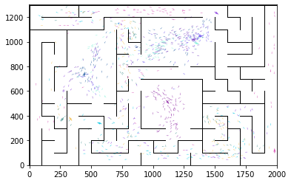

epoch 1941 == proposed_mle: 16.25+-0.25/15.80+-0.24 --

epoch 1942 == proposed_mle: 16.48+-0.28/15.71+-0.25 --

epoch 1943 == proposed_mle: 16.82+-0.35/15.63+-0.24 --

epoch 1944 == proposed_mle: 16.29+-0.33/16.02+-0.26 --

epoch 1945 == proposed_mle: 16.69+-0.31/15.76+-0.25 --

epoch 1946 == proposed_mle: 17.07+-0.33/15.78+-0.24 --

epoch 1947 == proposed_mle: 16.59+-0.36/15.90+-0.24 --

epoch 1948 == proposed_mle: 16.62+-0.30/15.84+-0.26 --

epoch 1949 == proposed_mle: 16.39+-0.37/15.60+-0.25 --

epoch 1950 == proposed_mle: 15.81+-0.38/15.55+-0.22 --

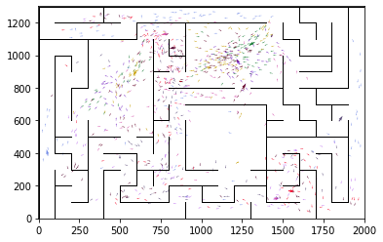

epoch 1951 == proposed_mle: 17.06+-0.30/15.53+-0.25 --

epoch 1952 == proposed_mle: 15.58+-0.21/15.58+-0.24 --

epoch 1953 == proposed_mle: 16.61+-0.37/15.69+-0.25 --

epoch 1954 == proposed_mle: 17.33+-0.37/15.60+-0.25 --

epoch 1955 == proposed_mle: 15.93+-0.32/15.57+-0.23 --

epoch 1956 == proposed_mle: 16.24+-0.37/15.68+-0.24 --

epoch 1957 == proposed_mle: 16.61+-0.32/15.82+-0.23 --

epoch 1958 == proposed_mle: 16.86+-0.35/15.64+-0.23 --

epoch 1959 == proposed_mle: 16.44+-0.29/15.73+-0.23 --

epoch 1960 == proposed_mle: 16.59+-0.34/15.73+-0.23 --

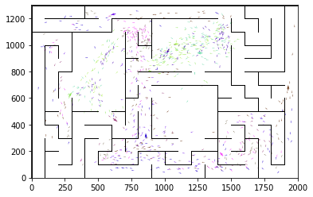

epoch 1961 == proposed_mle: 16.56+-0.35/15.78+-0.23 --

epoch 1962 == proposed_mle: 16.42+-0.31/15.88+-0.23 --

epoch 1963 == proposed_mle: 16.12+-0.32/16.00+-0.23 --

epoch 1964 == proposed_mle: 16.16+-0.33/15.71+-0.24 --

epoch 1965 == proposed_mle: 16.95+-0.35/15.48+-0.24 --

epoch 1966 == proposed_mle: 17.11+-0.30/15.77+-0.24 --

epoch 1967 == proposed_mle: 16.14+-0.35/15.80+-0.23 --

epoch 1968 == proposed_mle: 16.22+-0.32/15.93+-0.22 --

epoch 1969 == proposed_mle: 16.57+-0.32/15.81+-0.23 --

epoch 1970 == proposed_mle: 16.16+-0.30/15.88+-0.25 --

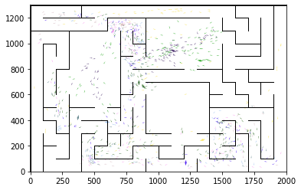

epoch 1971 == proposed_mle: 16.47+-0.31/15.75+-0.23 --

epoch 1972 == proposed_mle: 16.76+-0.37/15.75+-0.23 --

epoch 1973 == proposed_mle: 16.03+-0.29/15.77+-0.25 --

epoch 1974 == proposed_mle: 16.20+-0.31/15.70+-0.23 --

epoch 1975 == proposed_mle: 15.87+-0.29/15.77+-0.23 --

epoch 1976 == proposed_mle: 16.84+-0.33/15.60+-0.23 --

epoch 1977 == proposed_mle: 16.49+-0.34/15.66+-0.23 --

epoch 1978 == proposed_mle: 16.68+-0.32/16.02+-0.23 --

epoch 1979 == proposed_mle: 16.61+-0.40/15.70+-0.24 --

epoch 1980 == proposed_mle: 16.60+-0.36/15.55+-0.22 --

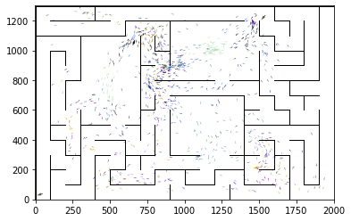

epoch 1981 == proposed_mle: 16.28+-0.37/15.54+-0.23 --

epoch 1982 == proposed_mle: 15.95+-0.33/15.70+-0.23 --

epoch 1983 == proposed_mle: 16.07+-0.31/15.60+-0.24 --

epoch 1984 == proposed_mle: 16.73+-0.35/15.64+-0.23 --

epoch 1985 == proposed_mle: 16.34+-0.33/15.70+-0.25 --

epoch 1986 == proposed_mle: 15.86+-0.34/15.56+-0.23 --

epoch 1987 == proposed_mle: 16.01+-0.33/15.56+-0.22 --

epoch 1988 == proposed_mle: 16.08+-0.29/15.74+-0.24 --

epoch 1989 == proposed_mle: 15.95+-0.33/15.71+-0.23 --

epoch 1990 >> proposed_mle: 16.45+-0.31/15.43+-0.22 --

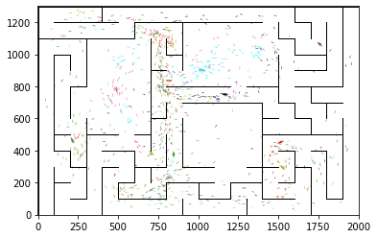

epoch 1991 == proposed_mle: 16.43+-0.34/15.54+-0.23 --

epoch 1992 == proposed_mle: 16.42+-0.35/15.64+-0.25 --

epoch 1993 == proposed_mle: 15.99+-0.29/15.55+-0.23 --

epoch 1994 == proposed_mle: 15.61+-0.31/15.55+-0.22 --

epoch 1995 == proposed_mle: 16.24+-0.37/15.62+-0.23 --

epoch 1996 == proposed_mle: 16.62+-0.37/15.72+-0.22 --

epoch 1997 == proposed_mle: 17.25+-0.34/15.61+-0.23 --

epoch 1998 == proposed_mle: 16.46+-0.35/15.48+-0.24 --

epoch 1999 == proposed_mle: 16.09+-0.30/15.59+-0.22 --

epoch 2000 == proposed_mle: 16.95+-0.33/15.50+-0.23 --

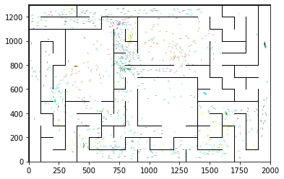

epoch 2001 == proposed_mle: 16.53+-0.30/15.63+-0.23 --

epoch 2002 == proposed_mle: 16.37+-0.33/15.52+-0.22 --

epoch 2003 == proposed_mle: 16.91+-0.36/15.67+-0.22 --

epoch 2004 == proposed_mle: 16.49+-0.32/15.64+-0.23 --

epoch 2005 == proposed_mle: 16.58+-0.35/15.55+-0.23 --

epoch 2006 == proposed_mle: 16.55+-0.36/15.49+-0.22 --

epoch 2007 == proposed_mle: 16.53+-0.30/15.64+-0.23 --

epoch 2008 == proposed_mle: 15.70+-0.30/15.73+-0.22 --

epoch 2009 == proposed_mle: 16.53+-0.30/15.52+-0.21 --

epoch 2010 >> proposed_mle: 16.62+-0.38/15.41+-0.23 --

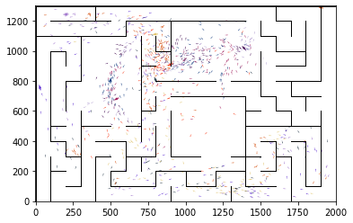

epoch 2011 == proposed_mle: 16.11+-0.35/15.66+-0.23 --

epoch 2012 == proposed_mle: 16.63+-0.31/15.51+-0.23 --

epoch 2013 >> proposed_mle: 15.66+-0.32/15.41+-0.22 --

epoch 2014 == proposed_mle: 15.59+-0.36/15.62+-0.23 --

epoch 2015 == proposed_mle: 16.52+-0.28/15.81+-0.22 --

epoch 2016 == proposed_mle: 16.42+-0.30/15.50+-0.23 --

epoch 2017 == proposed_mle: 16.53+-0.34/15.62+-0.24 --

epoch 2018 == proposed_mle: 16.66+-0.33/15.67+-0.23 --

epoch 2019 == proposed_mle: 15.59+-0.33/15.59+-0.22 --

epoch 2020 == proposed_mle: 15.95+-0.31/15.53+-0.23 --

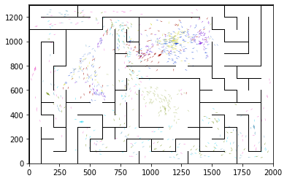

epoch 2021 == proposed_mle: 16.00+-0.29/15.93+-0.23 --

epoch 2022 == proposed_mle: 16.53+-0.27/15.76+-0.22 --

epoch 2023 == proposed_mle: 15.86+-0.32/15.49+-0.23 --

epoch 2024 == proposed_mle: 15.74+-0.31/15.59+-0.22 --

epoch 2025 == proposed_mle: 16.04+-0.29/15.48+-0.24 --

epoch 2026 == proposed_mle: 16.31+-0.29/15.72+-0.24 --

epoch 2027 == proposed_mle: 15.98+-0.30/15.60+-0.21 --

epoch 2028 == proposed_mle: 15.84+-0.38/15.58+-0.24 --

epoch 2029 == proposed_mle: 15.96+-0.32/15.76+-0.23 --

epoch 2030 == proposed_mle: 16.09+-0.30/15.60+-0.23 --

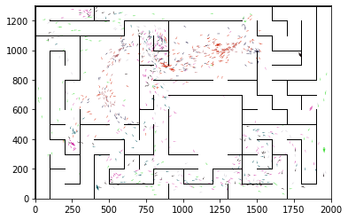

epoch 2031 == proposed_mle: 16.59+-0.31/15.49+-0.23 --

epoch 2032 == proposed_mle: 16.13+-0.36/15.70+-0.25 --

epoch 2033 == proposed_mle: 16.48+-0.31/15.48+-0.22 --

epoch 2034 == proposed_mle: 16.08+-0.36/15.56+-0.24 --

epoch 2035 == proposed_mle: 15.82+-0.30/15.51+-0.24 --

epoch 2036 == proposed_mle: 15.74+-0.28/15.59+-0.22 --

epoch 2037 == proposed_mle: 15.87+-0.32/15.57+-0.22 --

epoch 2038 == proposed_mle: 15.74+-0.30/15.56+-0.23 --

epoch 2039 == proposed_mle: 16.91+-0.34/15.60+-0.23 --

epoch 2040 == proposed_mle: 16.20+-0.35/15.51+-0.22 --

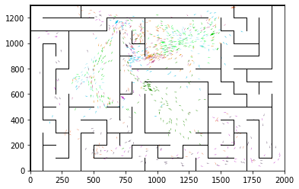

epoch 2041 >> proposed_mle: 16.08+-0.31/15.37+-0.23 --

epoch 2042 == proposed_mle: 16.77+-0.39/15.41+-0.24 --

epoch 2043 == proposed_mle: 16.17+-0.35/15.52+-0.25 --

epoch 2044 == proposed_mle: 16.13+-0.32/15.51+-0.22 --

epoch 2045 == proposed_mle: 16.29+-0.34/15.62+-0.24 --

epoch 2046 == proposed_mle: 16.10+-0.33/15.79+-0.24 --

epoch 2047 == proposed_mle: 16.71+-0.33/15.84+-0.23 --

epoch 2048 == proposed_mle: 15.75+-0.30/15.80+-0.23 --

epoch 2049 == proposed_mle: 16.25+-0.31/15.79+-0.23 --

epoch 2050 == proposed_mle: 16.31+-0.32/15.53+-0.21 --

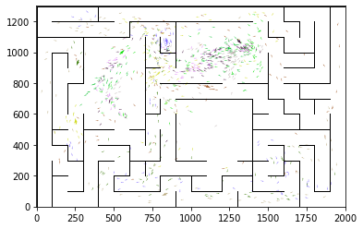

epoch 2051 == proposed_mle: 16.14+-0.30/15.61+-0.22 --

epoch 2052 == proposed_mle: 15.96+-0.31/15.88+-0.23 --

epoch 2053 == proposed_mle: 16.05+-0.31/15.89+-0.23 --

epoch 2054 == proposed_mle: 16.30+-0.34/15.53+-0.21 --

epoch 2055 == proposed_mle: 16.01+-0.24/15.67+-0.22 --

epoch 2056 == proposed_mle: 16.36+-0.37/15.58+-0.24 --

epoch 2057 == proposed_mle: 16.33+-0.30/15.65+-0.23 --

epoch 2058 == proposed_mle: 16.37+-0.28/15.77+-0.23 --

epoch 2059 == proposed_mle: 16.86+-0.35/15.66+-0.22 --

epoch 2060 == proposed_mle: 16.47+-0.32/15.57+-0.24 --

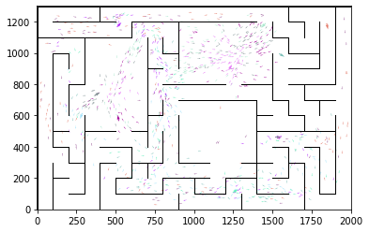

epoch 2061 == proposed_mle: 15.84+-0.39/15.52+-0.25 --

epoch 2062 == proposed_mle: 16.31+-0.35/15.68+-0.23 --

epoch 2063 == proposed_mle: 16.31+-0.35/15.72+-0.24 --

epoch 2064 == proposed_mle: 16.35+-0.31/15.47+-0.25 --

epoch 2065 == proposed_mle: 16.52+-0.32/15.81+-0.24 --

epoch 2066 == proposed_mle: 16.58+-0.35/15.57+-0.24 --

epoch 2067 == proposed_mle: 16.58+-0.30/15.72+-0.22 --

epoch 2068 == proposed_mle: 16.58+-0.32/15.52+-0.24 --

epoch 2069 == proposed_mle: 16.28+-0.30/15.72+-0.22 --

epoch 2070 == proposed_mle: 16.34+-0.27/15.47+-0.23 --

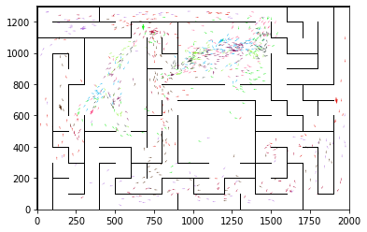

epoch 2071 == proposed_mle: 16.39+-0.31/15.62+-0.23 --

epoch 2072 == proposed_mle: 16.85+-0.32/15.55+-0.22 --

epoch 2073 == proposed_mle: 16.65+-0.30/15.63+-0.22 --

epoch 2074 == proposed_mle: 15.74+-0.30/15.45+-0.24 --

epoch 2075 == proposed_mle: 16.01+-0.36/15.72+-0.23 --

epoch 2076 == proposed_mle: 15.75+-0.31/15.38+-0.23 --

epoch 2077 == proposed_mle: 15.94+-0.34/15.56+-0.25 --

epoch 2078 == proposed_mle: 16.17+-0.30/15.65+-0.22 --

epoch 2079 == proposed_mle: 17.09+-0.25/15.72+-0.24 --

epoch 2080 == proposed_mle: 16.83+-0.38/15.76+-0.22 --

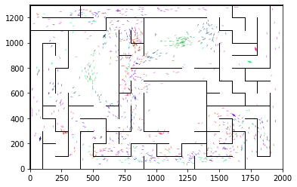

epoch 2081 == proposed_mle: 16.52+-0.34/15.73+-0.23 --

epoch 2082 == proposed_mle: 16.46+-0.31/15.84+-0.24 --

epoch 2083 == proposed_mle: 15.77+-0.31/15.78+-0.23 --

epoch 2084 == proposed_mle: 16.45+-0.28/15.53+-0.22 --

epoch 2085 == proposed_mle: 16.08+-0.29/15.57+-0.23 --

epoch 2086 == proposed_mle: 17.14+-0.33/15.52+-0.22 --

epoch 2087 == proposed_mle: 15.96+-0.33/15.61+-0.22 --

epoch 2088 == proposed_mle: 16.39+-0.30/15.48+-0.21 --

epoch 2089 == proposed_mle: 15.79+-0.27/15.71+-0.24 --

epoch 2090 == proposed_mle: 16.51+-0.26/15.44+-0.23 --

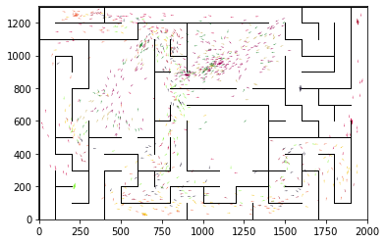

epoch 2091 == proposed_mle: 16.26+-0.28/15.67+-0.23 --

epoch 2092 == proposed_mle: 16.71+-0.28/15.67+-0.23 --

epoch 2093 == proposed_mle: 16.07+-0.32/15.60+-0.25 --

epoch 2094 == proposed_mle: 16.00+-0.31/15.74+-0.22 --

epoch 2095 == proposed_mle: 16.45+-0.33/15.73+-0.23 --

epoch 2096 == proposed_mle: 16.18+-0.36/15.59+-0.24 --

epoch 2097 == proposed_mle: 16.11+-0.31/15.39+-0.24 --

epoch 2098 == proposed_mle: 16.37+-0.32/15.45+-0.23 --

epoch 2099 == proposed_mle: 16.45+-0.35/15.40+-0.22 --

epoch 2100 == proposed_mle: 16.75+-0.32/15.69+-0.24 --

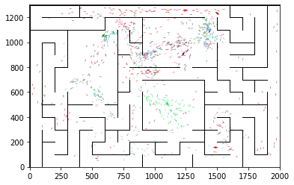

epoch 2101 == proposed_mle: 16.91+-0.34/16.02+-0.23 --

epoch 2102 == proposed_mle: 16.25+-0.34/15.73+-0.23 --

epoch 2103 == proposed_mle: 16.29+-0.34/15.70+-0.24 --

epoch 2104 == proposed_mle: 16.28+-0.35/15.87+-0.24 --

epoch 2105 == proposed_mle: 16.26+-0.35/15.60+-0.23 --

epoch 2106 == proposed_mle: 16.04+-0.31/15.45+-0.24 --

epoch 2107 == proposed_mle: 16.52+-0.33/15.40+-0.23 --

epoch 2108 == proposed_mle: 16.25+-0.37/15.65+-0.22 --

epoch 2109 == proposed_mle: 16.24+-0.30/15.53+-0.24 --

epoch 2110 == proposed_mle: 16.22+-0.29/15.73+-0.25 --

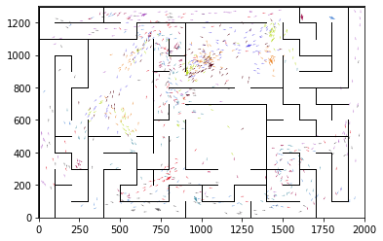

epoch 2111 == proposed_mle: 16.23+-0.32/15.50+-0.24 --

epoch 2112 == proposed_mle: 16.82+-0.32/15.57+-0.23 --

epoch 2113 == proposed_mle: 15.76+-0.35/15.65+-0.25 --

epoch 2114 == proposed_mle: 16.29+-0.33/15.66+-0.24 --

epoch 2115 == proposed_mle: 15.76+-0.28/15.51+-0.22 --

epoch 2116 == proposed_mle: 16.80+-0.35/15.76+-0.25 --

epoch 2117 == proposed_mle: 16.64+-0.37/15.45+-0.23 --

epoch 2118 == proposed_mle: 15.89+-0.30/15.60+-0.24 --

epoch 2119 == proposed_mle: 15.96+-0.29/15.45+-0.23 --

epoch 2120 == proposed_mle: 16.05+-0.30/15.65+-0.22 --

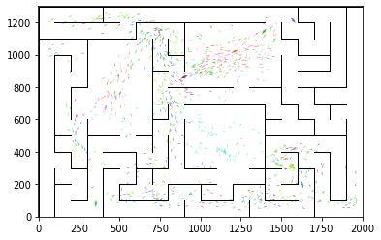

epoch 2121 == proposed_mle: 16.28+-0.33/15.85+-0.23 --

epoch 2122 == proposed_mle: 16.25+-0.30/15.87+-0.23 --

epoch 2123 == proposed_mle: 16.58+-0.36/15.76+-0.24 --

epoch 2124 == proposed_mle: 16.12+-0.30/15.72+-0.24 --

epoch 2125 == proposed_mle: 16.58+-0.31/15.81+-0.24 --

epoch 2126 == proposed_mle: 16.48+-0.29/15.71+-0.23 --

epoch 2127 == proposed_mle: 16.78+-0.31/15.74+-0.23 --

epoch 2128 == proposed_mle: 16.52+-0.33/15.47+-0.23 --

epoch 2129 == proposed_mle: 16.01+-0.29/15.83+-0.22 --

epoch 2130 == proposed_mle: 16.14+-0.31/15.63+-0.22 --

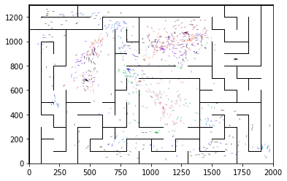

epoch 2131 == proposed_mle: 16.49+-0.31/15.69+-0.22 --

epoch 2132 == proposed_mle: 16.14+-0.33/15.60+-0.23 --

epoch 2133 == proposed_mle: 16.39+-0.37/15.56+-0.23 --

epoch 2134 == proposed_mle: 16.65+-0.35/15.67+-0.24 --

epoch 2135 == proposed_mle: 16.40+-0.29/15.40+-0.23 --

epoch 2136 == proposed_mle: 16.48+-0.38/15.48+-0.23 --

epoch 2137 == proposed_mle: 16.30+-0.28/15.59+-0.23 --

epoch 2138 == proposed_mle: 16.47+-0.35/15.66+-0.23 --

epoch 2139 == proposed_mle: 16.21+-0.34/15.70+-0.23 --

epoch 2140 == proposed_mle: 15.81+-0.31/15.52+-0.23 --

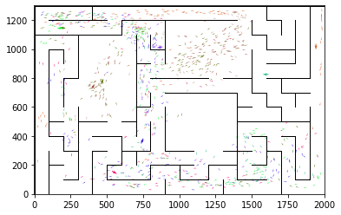

epoch 2141 == proposed_mle: 15.99+-0.27/15.54+-0.23 --

epoch 2142 == proposed_mle: 16.70+-0.28/15.72+-0.23 --

epoch 2143 == proposed_mle: 16.83+-0.30/15.63+-0.24 --

epoch 2144 == proposed_mle: 16.19+-0.35/15.46+-0.24 --

epoch 2145 == proposed_mle: 16.58+-0.32/15.48+-0.23 --

epoch 2146 == proposed_mle: 16.26+-0.33/15.67+-0.23 --

epoch 2147 == proposed_mle: 15.74+-0.33/15.40+-0.23 --

epoch 2148 == proposed_mle: 16.17+-0.29/15.50+-0.23 --

epoch 2149 == proposed_mle: 16.04+-0.31/15.51+-0.23 --

epoch 2150 == proposed_mle: 16.40+-0.34/15.39+-0.24 --

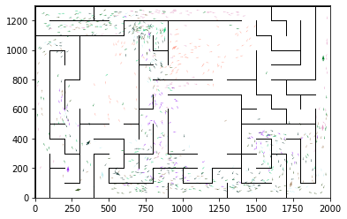

epoch 2151 == proposed_mle: 16.49+-0.33/15.55+-0.24 --

epoch 2152 >> proposed_mle: 16.59+-0.40/15.30+-0.23 --

epoch 2153 >> proposed_mle: 16.46+-0.38/15.19+-0.22 --

epoch 2154 == proposed_mle: 15.89+-0.31/15.49+-0.22 --

epoch 2155 == proposed_mle: 16.49+-0.32/15.44+-0.23 --

epoch 2156 == proposed_mle: 16.03+-0.32/15.20+-0.24 --

epoch 2157 == proposed_mle: 15.54+-0.31/15.29+-0.23 --

epoch 2158 == proposed_mle: 16.12+-0.29/15.42+-0.23 --

epoch 2159 == proposed_mle: 15.81+-0.30/15.26+-0.23 --

epoch 2160 == proposed_mle: 16.16+-0.37/15.37+-0.22 --

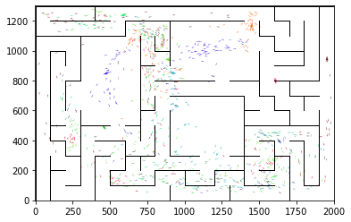

epoch 2161 == proposed_mle: 15.65+-0.28/15.34+-0.22 --

epoch 2162 == proposed_mle: 16.13+-0.35/15.52+-0.25 --

epoch 2163 >> proposed_mle: 16.06+-0.36/15.10+-0.23 --

epoch 2164 == proposed_mle: 16.17+-0.27/15.73+-0.24 --

epoch 2165 == proposed_mle: 16.53+-0.38/15.38+-0.22 --

epoch 2166 == proposed_mle: 16.66+-0.32/15.39+-0.24 --

epoch 2167 == proposed_mle: 16.16+-0.37/15.36+-0.24 --

epoch 2168 == proposed_mle: 16.46+-0.31/15.42+-0.22 --

epoch 2169 == proposed_mle: 16.35+-0.35/15.18+-0.22 --

epoch 2170 == proposed_mle: 16.23+-0.34/15.49+-0.22 --

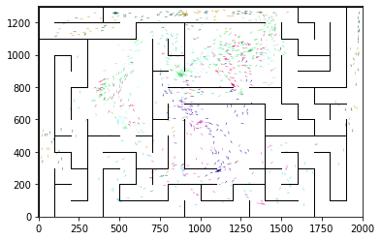

epoch 2171 == proposed_mle: 15.85+-0.25/15.34+-0.25 --

epoch 2172 >> proposed_mle: 15.72+-0.36/15.10+-0.21 --

epoch 2173 == proposed_mle: 16.18+-0.31/15.80+-0.23 --

epoch 2174 == proposed_mle: 16.46+-0.28/15.31+-0.23 --

epoch 2175 == proposed_mle: 16.33+-0.32/15.49+-0.24 --

epoch 2176 == proposed_mle: 15.94+-0.30/15.45+-0.22 --

epoch 2177 == proposed_mle: 16.06+-0.35/15.35+-0.23 --

epoch 2178 == proposed_mle: 16.01+-0.33/15.37+-0.25 --

epoch 2179 == proposed_mle: 15.97+-0.31/15.44+-0.22 --

epoch 2180 == proposed_mle: 16.12+-0.33/15.35+-0.23 --

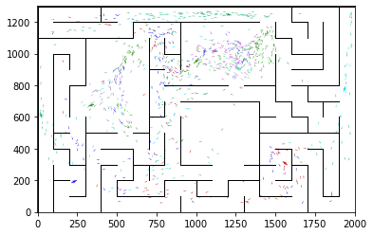

epoch 2181 == proposed_mle: 15.97+-0.35/15.34+-0.23 --

epoch 2182 == proposed_mle: 16.41+-0.36/15.43+-0.24 --

epoch 2183 == proposed_mle: 16.97+-0.39/15.36+-0.24 --

epoch 2184 == proposed_mle: 16.43+-0.38/15.38+-0.24 --

epoch 2185 == proposed_mle: 16.39+-0.38/15.35+-0.24 --

epoch 2186 == proposed_mle: 16.69+-0.35/15.17+-0.23 --

epoch 2187 == proposed_mle: 16.69+-0.31/15.26+-0.25 --

epoch 2188 == proposed_mle: 16.66+-0.33/15.31+-0.22 --

epoch 2189 == proposed_mle: 16.40+-0.31/15.48+-0.24 --

epoch 2190 == proposed_mle: 17.01+-0.33/15.22+-0.23 --

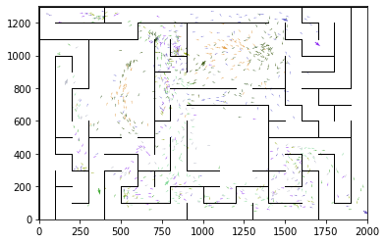

epoch 2191 == proposed_mle: 15.66+-0.27/15.56+-0.23 --

epoch 2192 == proposed_mle: 16.17+-0.36/15.23+-0.23 --

epoch 2193 == proposed_mle: 16.32+-0.35/15.47+-0.24 --

epoch 2194 == proposed_mle: 16.13+-0.29/15.35+-0.23 --

epoch 2195 == proposed_mle: 16.60+-0.38/15.35+-0.21 --

epoch 2196 == proposed_mle: 16.54+-0.37/15.25+-0.23 --

epoch 2197 == proposed_mle: 15.98+-0.35/15.46+-0.25 --

epoch 2198 == proposed_mle: 16.18+-0.34/15.53+-0.21 --

epoch 2199 == proposed_mle: 16.40+-0.32/15.35+-0.25 --

epoch 2200 == proposed_mle: 16.31+-0.32/15.29+-0.22 --

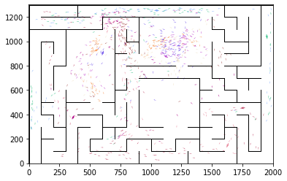

epoch 2201 == proposed_mle: 15.64+-0.34/15.67+-0.26 --

epoch 2202 == proposed_mle: 16.16+-0.28/15.43+-0.23 --

epoch 2203 == proposed_mle: 15.79+-0.40/15.62+-0.23 --

epoch 2204 == proposed_mle: 15.63+-0.31/15.59+-0.25 --

epoch 2205 == proposed_mle: 16.38+-0.34/15.48+-0.25 --

epoch 2206 == proposed_mle: 16.56+-0.36/15.44+-0.24 --

epoch 2207 == proposed_mle: 16.18+-0.30/15.42+-0.24 --

epoch 2208 == proposed_mle: 16.22+-0.36/15.36+-0.23 --

epoch 2209 == proposed_mle: 16.61+-0.32/15.40+-0.23 --

epoch 2210 == proposed_mle: 16.65+-0.31/15.25+-0.22 --

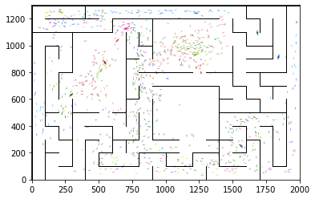

epoch 2211 == proposed_mle: 16.50+-0.33/15.58+-0.24 --

epoch 2212 == proposed_mle: 16.40+-0.28/15.60+-0.24 --

epoch 2213 == proposed_mle: 16.65+-0.29/15.47+-0.23 --

epoch 2214 == proposed_mle: 15.41+-0.33/15.31+-0.24 --

epoch 2215 == proposed_mle: 16.68+-0.35/15.39+-0.24 --

epoch 2216 == proposed_mle: 16.51+-0.33/15.63+-0.24 --

epoch 2217 == proposed_mle: 15.91+-0.28/15.51+-0.24 --

epoch 2218 == proposed_mle: 15.35+-0.29/15.45+-0.23 --

epoch 2219 == proposed_mle: 15.83+-0.33/15.32+-0.22 --

epoch 2220 == proposed_mle: 15.83+-0.31/15.37+-0.21 --

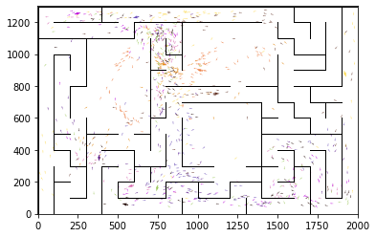

epoch 2221 == proposed_mle: 16.10+-0.34/15.36+-0.24 --

epoch 2222 == proposed_mle: 15.85+-0.29/15.36+-0.23 --

epoch 2223 == proposed_mle: 15.81+-0.29/15.40+-0.24 --

epoch 2224 == proposed_mle: 16.22+-0.34/15.19+-0.24 --

epoch 2225 == proposed_mle: 16.34+-0.33/15.51+-0.25 --

epoch 2226 == proposed_mle: 16.24+-0.33/15.38+-0.23 --

epoch 2227 == proposed_mle: 15.78+-0.30/15.37+-0.23 --

epoch 2228 == proposed_mle: 16.16+-0.32/15.22+-0.24 --

epoch 2229 == proposed_mle: 15.72+-0.37/15.37+-0.23 --

epoch 2230 == proposed_mle: 16.25+-0.31/15.33+-0.24 --

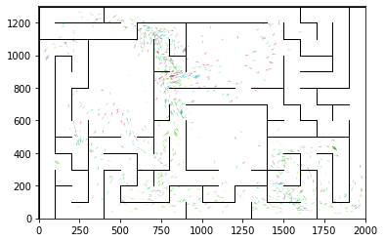

epoch 2231 == proposed_mle: 15.64+-0.28/15.44+-0.23 --

epoch 2232 == proposed_mle: 16.47+-0.31/15.33+-0.24 --

epoch 2233 == proposed_mle: 15.64+-0.31/15.25+-0.23 --

epoch 2234 == proposed_mle: 16.15+-0.34/15.48+-0.25 --

epoch 2235 == proposed_mle: 16.55+-0.33/15.40+-0.21 --

epoch 2236 >> proposed_mle: 16.00+-0.36/15.08+-0.22 --

epoch 2237 == proposed_mle: 15.93+-0.32/15.20+-0.24 --

epoch 2238 == proposed_mle: 15.95+-0.33/15.33+-0.24 --

epoch 2239 == proposed_mle: 15.79+-0.29/15.38+-0.23 --

epoch 2240 == proposed_mle: 16.34+-0.32/15.67+-0.23 --

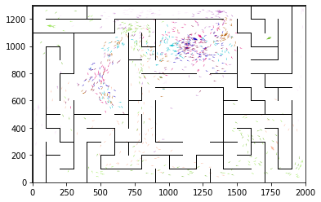

epoch 2241 == proposed_mle: 16.23+-0.33/15.54+-0.24 --

epoch 2242 == proposed_mle: 16.38+-0.35/15.55+-0.25 --

epoch 2243 == proposed_mle: 16.31+-0.35/15.35+-0.23 --

epoch 2244 == proposed_mle: 15.67+-0.34/15.55+-0.23 --

epoch 2245 == proposed_mle: 16.07+-0.28/15.30+-0.25 --

epoch 2246 == proposed_mle: 15.77+-0.34/15.31+-0.25 --

epoch 2247 == proposed_mle: 15.72+-0.29/15.40+-0.23 --

epoch 2248 == proposed_mle: 15.77+-0.32/15.44+-0.26 --

epoch 2249 == proposed_mle: 16.57+-0.30/15.69+-0.23 --

epoch 2250 == proposed_mle: 16.35+-0.32/15.32+-0.23 --

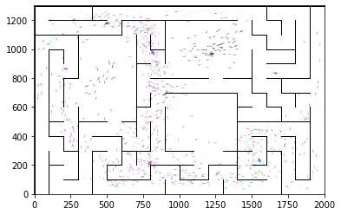

epoch 2251 == proposed_mle: 16.23+-0.30/15.25+-0.23 --

epoch 2252 == proposed_mle: 15.92+-0.30/15.32+-0.23 --

epoch 2253 == proposed_mle: 15.86+-0.30/15.34+-0.24 --

epoch 2254 == proposed_mle: 15.82+-0.28/15.21+-0.23 --

epoch 2255 == proposed_mle: 16.41+-0.34/15.35+-0.22 --

epoch 2256 == proposed_mle: 16.06+-0.36/15.17+-0.23 --

epoch 2257 == proposed_mle: 15.96+-0.32/15.47+-0.23 --

epoch 2258 == proposed_mle: 16.47+-0.34/15.13+-0.23 --

epoch 2259 == proposed_mle: 16.01+-0.32/15.45+-0.24 --

epoch 2260 == proposed_mle: 16.23+-0.33/15.41+-0.21 --

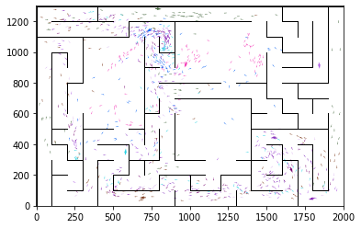

epoch 2261 == proposed_mle: 15.79+-0.31/15.48+-0.23 --

epoch 2262 == proposed_mle: 15.60+-0.30/15.40+-0.24 --

epoch 2263 == proposed_mle: 16.33+-0.32/15.27+-0.23 --

epoch 2264 == proposed_mle: 16.14+-0.33/15.32+-0.24 --

epoch 2265 == proposed_mle: 16.15+-0.33/15.27+-0.24 --

epoch 2266 == proposed_mle: 15.92+-0.38/15.46+-0.24 --

epoch 2267 == proposed_mle: 16.42+-0.35/15.61+-0.25 --

epoch 2268 == proposed_mle: 16.24+-0.31/15.38+-0.24 --

epoch 2269 == proposed_mle: 16.51+-0.27/15.18+-0.24 --

epoch 2270 == proposed_mle: 16.34+-0.27/15.61+-0.24 --

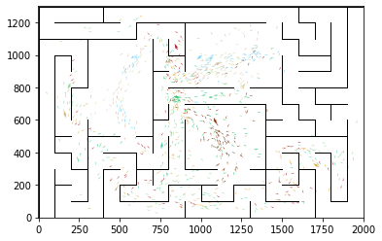

epoch 2271 == proposed_mle: 16.29+-0.31/15.41+-0.23 --

epoch 2272 == proposed_mle: 16.26+-0.33/15.49+-0.24 --

epoch 2273 == proposed_mle: 15.48+-0.35/15.23+-0.25 --

epoch 2274 == proposed_mle: 16.05+-0.28/15.35+-0.25 --

epoch 2275 == proposed_mle: 15.83+-0.30/15.39+-0.23 --

epoch 2276 == proposed_mle: 16.10+-0.36/15.39+-0.24 --

epoch 2277 == proposed_mle: 16.24+-0.37/15.21+-0.23 --

epoch 2278 == proposed_mle: 16.23+-0.35/15.46+-0.23 --

epoch 2279 == proposed_mle: 16.51+-0.38/15.41+-0.23 --

epoch 2280 == proposed_mle: 16.27+-0.38/15.51+-0.23 --

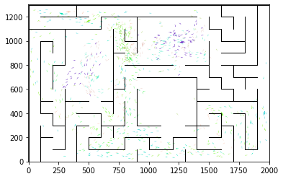

epoch 2281 == proposed_mle: 16.90+-0.32/15.56+-0.25 --

epoch 2282 == proposed_mle: 15.91+-0.29/15.17+-0.24 --

epoch 2283 == proposed_mle: 16.45+-0.37/15.36+-0.23 --

epoch 2284 == proposed_mle: 16.65+-0.35/15.40+-0.24 --

epoch 2285 == proposed_mle: 16.02+-0.31/15.47+-0.24 --

epoch 2286 == proposed_mle: 16.17+-0.27/15.50+-0.25 --

epoch 2287 == proposed_mle: 16.36+-0.35/15.36+-0.23 --

epoch 2288 == proposed_mle: 15.96+-0.28/15.51+-0.24 --

epoch 2289 == proposed_mle: 15.87+-0.36/15.49+-0.23 --

epoch 2290 == proposed_mle: 16.25+-0.31/15.62+-0.22 --

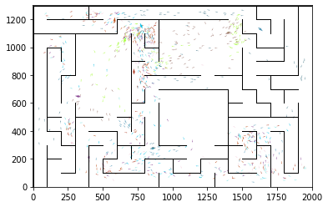

epoch 2291 == proposed_mle: 15.82+-0.35/15.38+-0.25 --

epoch 2292 == proposed_mle: 15.91+-0.30/15.48+-0.25 --

epoch 2293 == proposed_mle: 15.69+-0.27/15.45+-0.24 --

epoch 2294 == proposed_mle: 16.08+-0.31/15.33+-0.23 --

epoch 2295 == proposed_mle: 16.04+-0.37/15.28+-0.24 --

epoch 2296 == proposed_mle: 16.42+-0.33/15.37+-0.23 --

epoch 2297 == proposed_mle: 15.91+-0.37/15.41+-0.24 --

epoch 2298 == proposed_mle: 16.31+-0.32/15.45+-0.22 --

epoch 2299 == proposed_mle: 16.39+-0.35/15.36+-0.24 --

epoch 2300 == proposed_mle: 15.83+-0.34/15.25+-0.23 --

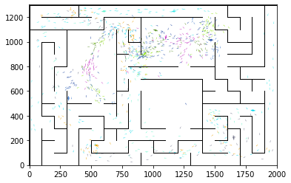

epoch 2301 == proposed_mle: 16.28+-0.35/15.34+-0.24 --

epoch 2302 == proposed_mle: 15.60+-0.31/15.47+-0.23 --

epoch 2303 == proposed_mle: 15.96+-0.29/15.38+-0.23 --

epoch 2304 == proposed_mle: 15.90+-0.30/15.39+-0.24 --

epoch 2305 == proposed_mle: 16.42+-0.35/15.30+-0.23 --

epoch 2306 == proposed_mle: 15.87+-0.36/15.44+-0.26 --

epoch 2307 == proposed_mle: 16.28+-0.34/15.35+-0.24 --

epoch 2308 == proposed_mle: 16.16+-0.30/15.20+-0.23 --

epoch 2309 == proposed_mle: 16.05+-0.37/15.26+-0.23 --

epoch 2310 == proposed_mle: 16.44+-0.35/15.52+-0.24 --

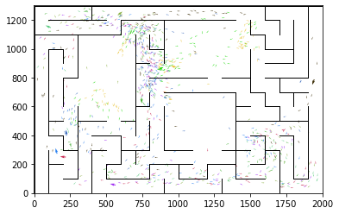

epoch 2311 == proposed_mle: 16.09+-0.28/15.35+-0.22 --

epoch 2312 == proposed_mle: 15.89+-0.29/15.44+-0.22 --

epoch 2313 == proposed_mle: 16.04+-0.32/15.15+-0.22 --

epoch 2314 == proposed_mle: 16.42+-0.33/15.26+-0.24 --

epoch 2315 == proposed_mle: 16.19+-0.33/15.31+-0.23 --

epoch 2316 == proposed_mle: 15.55+-0.36/15.20+-0.23 --

epoch 2317 == proposed_mle: 16.06+-0.36/15.17+-0.22 --

epoch 2318 == proposed_mle: 16.28+-0.36/15.30+-0.23 --

epoch 2319 == proposed_mle: 15.76+-0.39/15.31+-0.23 --

epoch 2320 == proposed_mle: 15.76+-0.35/15.14+-0.23 --

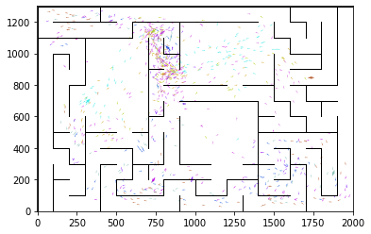

epoch 2321 == proposed_mle: 15.99+-0.29/15.30+-0.24 --

epoch 2322 == proposed_mle: 15.99+-0.33/15.38+-0.23 --

epoch 2323 == proposed_mle: 16.00+-0.31/15.16+-0.24 --

epoch 2324 == proposed_mle: 15.59+-0.35/15.26+-0.23 --

epoch 2325 == proposed_mle: 15.63+-0.35/15.10+-0.23 --

epoch 2326 == proposed_mle: 16.15+-0.34/15.34+-0.22 --

epoch 2327 == proposed_mle: 16.23+-0.31/15.26+-0.25 --

epoch 2328 == proposed_mle: 15.89+-0.28/15.42+-0.24 --

epoch 2329 == proposed_mle: 16.29+-0.31/15.10+-0.24 --

epoch 2330 == proposed_mle: 16.50+-0.35/15.51+-0.24 --

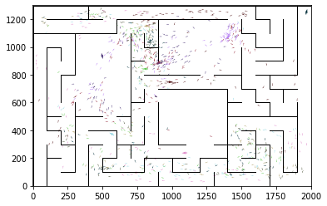

epoch 2331 == proposed_mle: 15.82+-0.36/15.22+-0.23 --

epoch 2332 == proposed_mle: 16.18+-0.33/15.37+-0.24 --

epoch 2333 == proposed_mle: 16.18+-0.32/15.27+-0.22 --

epoch 2334 == proposed_mle: 15.67+-0.30/15.20+-0.23 --

epoch 2335 == proposed_mle: 16.04+-0.35/15.34+-0.24 --

epoch 2336 == proposed_mle: 16.40+-0.30/15.20+-0.22 --

epoch 2337 == proposed_mle: 15.93+-0.33/15.15+-0.22 --

epoch 2338 == proposed_mle: 15.80+-0.33/15.27+-0.23 --

epoch 2339 == proposed_mle: 15.94+-0.33/15.13+-0.22 --

epoch 2340 == proposed_mle: 16.51+-0.35/15.38+-0.23 --

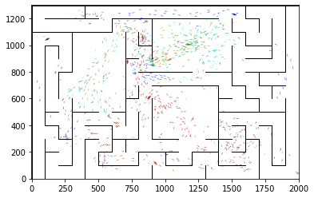

epoch 2341 == proposed_mle: 16.05+-0.29/15.31+-0.23 --

epoch 2342 == proposed_mle: 16.08+-0.26/15.13+-0.23 --

epoch 2343 == proposed_mle: 15.76+-0.32/15.27+-0.22 --

epoch 2344 == proposed_mle: 16.28+-0.38/15.16+-0.22 --

epoch 2345 == proposed_mle: 15.85+-0.35/15.29+-0.23 --

epoch 2346 == proposed_mle: 16.03+-0.29/15.17+-0.24 --

epoch 2347 == proposed_mle: 15.89+-0.33/15.38+-0.23 --

epoch 2348 == proposed_mle: 15.50+-0.34/15.32+-0.21 --

epoch 2349 == proposed_mle: 15.67+-0.30/15.40+-0.22 --

epoch 2350 == proposed_mle: 15.52+-0.29/15.57+-0.22 --

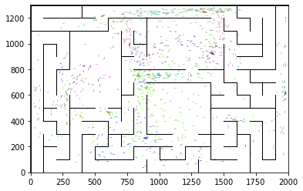

epoch 2351 == proposed_mle: 15.96+-0.31/15.44+-0.24 --

epoch 2352 == proposed_mle: 16.46+-0.31/15.54+-0.22 --

epoch 2353 == proposed_mle: 17.14+-0.34/15.52+-0.23 --

epoch 2354 == proposed_mle: 15.93+-0.30/15.37+-0.24 --

epoch 2355 == proposed_mle: 15.92+-0.32/15.28+-0.24 --

epoch 2356 == proposed_mle: 15.85+-0.26/15.34+-0.22 --

epoch 2357 >> proposed_mle: 16.55+-0.31/15.04+-0.23 --

epoch 2358 == proposed_mle: 16.18+-0.30/15.18+-0.24 --

epoch 2359 == proposed_mle: 16.16+-0.31/15.15+-0.23 --

epoch 2360 == proposed_mle: 16.09+-0.36/15.16+-0.23 --

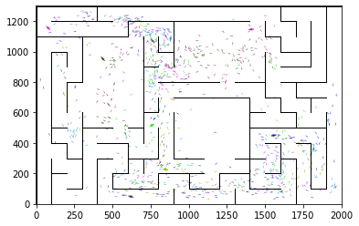

epoch 2361 == proposed_mle: 16.49+-0.28/15.25+-0.24 --

epoch 2362 == proposed_mle: 15.94+-0.37/15.35+-0.25 --

epoch 2363 == proposed_mle: 16.06+-0.33/15.27+-0.25 --

epoch 2364 == proposed_mle: 15.69+-0.31/15.31+-0.25 --

epoch 2365 == proposed_mle: 16.13+-0.35/15.22+-0.23 --

epoch 2366 == proposed_mle: 16.05+-0.29/15.41+-0.22 --

epoch 2367 == proposed_mle: 16.14+-0.40/15.36+-0.23 --

epoch 2368 == proposed_mle: 15.91+-0.39/15.42+-0.23 --

epoch 2369 == proposed_mle: 15.91+-0.27/15.21+-0.23 --

epoch 2370 >> proposed_mle: 15.56+-0.30/14.91+-0.23 --

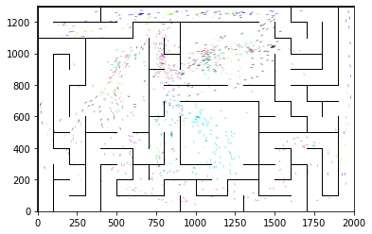

epoch 2371 == proposed_mle: 16.11+-0.30/15.13+-0.25 --

epoch 2372 == proposed_mle: 15.75+-0.33/15.24+-0.24 --

epoch 2373 == proposed_mle: 16.24+-0.28/15.35+-0.23 --

epoch 2374 == proposed_mle: 16.07+-0.30/15.10+-0.23 --

epoch 2375 >> proposed_mle: 16.22+-0.31/14.80+-0.23 --

epoch 2376 == proposed_mle: 15.48+-0.35/14.99+-0.23 --

epoch 2377 == proposed_mle: 15.96+-0.31/15.07+-0.22 --

epoch 2378 == proposed_mle: 16.09+-0.35/15.07+-0.22 --

epoch 2379 == proposed_mle: 15.61+-0.29/15.21+-0.23 --

epoch 2380 == proposed_mle: 15.92+-0.33/15.42+-0.23 --

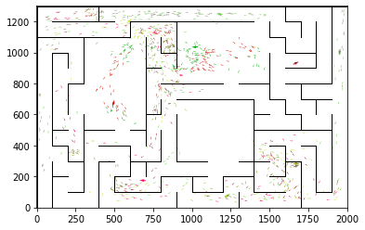

epoch 2381 == proposed_mle: 15.78+-0.31/15.20+-0.21 --

epoch 2382 == proposed_mle: 15.97+-0.31/15.34+-0.21 --

epoch 2383 == proposed_mle: 16.10+-0.28/15.31+-0.24 --

epoch 2384 == proposed_mle: 16.02+-0.29/15.26+-0.23 --

epoch 2385 == proposed_mle: 15.73+-0.35/15.29+-0.21 --

epoch 2386 == proposed_mle: 16.33+-0.34/15.25+-0.22 --

epoch 2387 == proposed_mle: 15.91+-0.31/15.50+-0.23 --

epoch 2388 == proposed_mle: 16.15+-0.30/15.19+-0.25 --

epoch 2389 == proposed_mle: 16.20+-0.25/15.17+-0.23 --

epoch 2390 == proposed_mle: 15.43+-0.33/15.07+-0.22 --

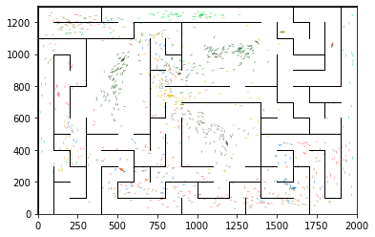

epoch 2391 == proposed_mle: 16.24+-0.27/15.44+-0.23 --

epoch 2392 == proposed_mle: 15.66+-0.35/15.44+-0.23 --

epoch 2393 == proposed_mle: 16.24+-0.37/15.12+-0.24 --

epoch 2394 == proposed_mle: 15.26+-0.30/15.08+-0.24 --

epoch 2395 == proposed_mle: 15.83+-0.34/15.36+-0.24 --

epoch 2396 == proposed_mle: 15.91+-0.36/15.31+-0.23 --

epoch 2397 == proposed_mle: 15.25+-0.33/15.18+-0.22 --

epoch 2398 == proposed_mle: 16.22+-0.39/15.25+-0.23 --

epoch 2399 == proposed_mle: 15.49+-0.29/14.96+-0.24 --

epoch 2400 == proposed_mle: 16.29+-0.32/15.38+-0.22 --

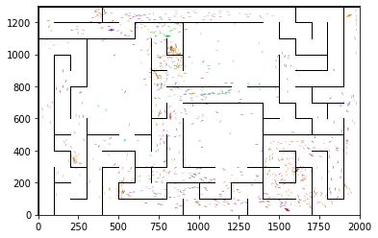

epoch 2401 == proposed_mle: 15.98+-0.26/15.27+-0.23 --

epoch 2402 == proposed_mle: 15.46+-0.31/14.81+-0.24 --

epoch 2403 == proposed_mle: 15.82+-0.31/15.15+-0.22 --

epoch 2404 == proposed_mle: 15.69+-0.32/14.93+-0.21 --

epoch 2405 == proposed_mle: 15.98+-0.30/15.45+-0.25 --

epoch 2406 == proposed_mle: 16.15+-0.34/15.10+-0.23 --

epoch 2407 == proposed_mle: 16.38+-0.30/15.18+-0.23 --

epoch 2408 == proposed_mle: 16.42+-0.28/15.12+-0.23 --

epoch 2409 == proposed_mle: 15.65+-0.38/15.32+-0.22 --

epoch 2410 == proposed_mle: 15.78+-0.33/15.36+-0.22 --

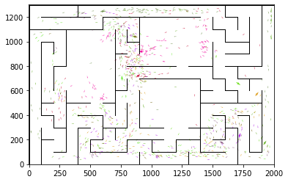

epoch 2411 == proposed_mle: 15.89+-0.31/15.33+-0.23 --

epoch 2412 == proposed_mle: 16.01+-0.28/15.08+-0.22 --

epoch 2413 == proposed_mle: 16.10+-0.35/15.07+-0.22 --

epoch 2414 == proposed_mle: 16.33+-0.31/14.85+-0.22 --

epoch 2415 == proposed_mle: 15.80+-0.34/15.03+-0.24 --

epoch 2416 == proposed_mle: 15.79+-0.24/15.16+-0.23 --

epoch 2417 == proposed_mle: 15.49+-0.35/15.31+-0.24 --

epoch 2418 == proposed_mle: 15.93+-0.35/15.11+-0.21 --

epoch 2419 == proposed_mle: 15.97+-0.35/15.10+-0.21 --

epoch 2420 == proposed_mle: 15.89+-0.31/15.46+-0.22 --

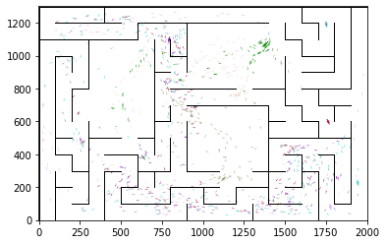

epoch 2421 == proposed_mle: 16.00+-0.33/15.19+-0.22 --

epoch 2422 == proposed_mle: 14.97+-0.27/15.06+-0.22 --

epoch 2423 == proposed_mle: 15.94+-0.29/15.16+-0.23 --

epoch 2424 == proposed_mle: 15.76+-0.31/14.99+-0.21 --

epoch 2425 == proposed_mle: 15.96+-0.36/14.94+-0.22 --

epoch 2426 == proposed_mle: 15.58+-0.30/15.01+-0.20 --

epoch 2427 == proposed_mle: 15.46+-0.29/15.07+-0.21 --

epoch 2428 == proposed_mle: 15.92+-0.34/15.19+-0.22 --

epoch 2429 == proposed_mle: 16.40+-0.34/15.04+-0.23 --

epoch 2430 == proposed_mle: 15.45+-0.32/14.85+-0.23 --

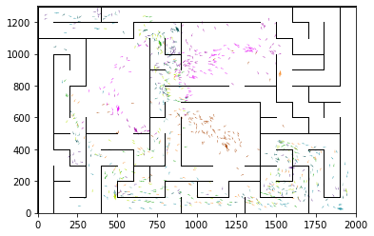

epoch 2431 == proposed_mle: 15.77+-0.40/15.14+-0.23 --

epoch 2432 == proposed_mle: 15.75+-0.31/15.02+-0.24 --

epoch 2433 == proposed_mle: 15.62+-0.30/15.09+-0.24 --

epoch 2434 == proposed_mle: 15.90+-0.28/15.29+-0.23 --

epoch 2435 == proposed_mle: 15.42+-0.32/15.15+-0.23 --

epoch 2436 == proposed_mle: 16.24+-0.36/15.38+-0.23 --

epoch 2437 == proposed_mle: 16.08+-0.31/15.27+-0.22 --

epoch 2438 == proposed_mle: 15.75+-0.28/15.08+-0.21 --

epoch 2439 == proposed_mle: 15.77+-0.31/15.41+-0.23 --

epoch 2440 == proposed_mle: 15.55+-0.35/15.21+-0.22 --

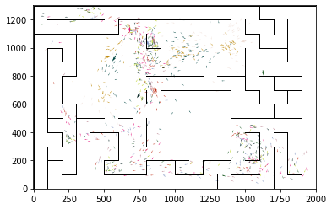

epoch 2441 == proposed_mle: 16.01+-0.34/15.29+-0.23 --

epoch 2442 == proposed_mle: 16.23+-0.26/15.28+-0.22 --

epoch 2443 == proposed_mle: 15.43+-0.28/15.07+-0.22 --

epoch 2444 == proposed_mle: 15.73+-0.31/15.04+-0.22 --

epoch 2445 == proposed_mle: 15.66+-0.29/15.11+-0.23 --

epoch 2446 == proposed_mle: 16.44+-0.34/15.28+-0.22 --

epoch 2447 == proposed_mle: 15.62+-0.35/14.91+-0.21 --

epoch 2448 == proposed_mle: 16.02+-0.28/15.19+-0.23 --

epoch 2449 == proposed_mle: 16.08+-0.31/15.16+-0.23 --

epoch 2450 == proposed_mle: 15.92+-0.33/15.09+-0.23 --

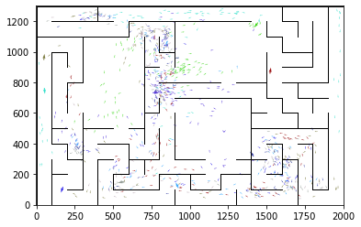

epoch 2451 == proposed_mle: 15.81+-0.35/15.13+-0.24 --

epoch 2452 == proposed_mle: 15.92+-0.35/15.26+-0.22 --

epoch 2453 == proposed_mle: 16.06+-0.36/15.24+-0.22 --

epoch 2454 == proposed_mle: 16.39+-0.29/15.08+-0.21 --

epoch 2455 == proposed_mle: 15.81+-0.37/15.20+-0.21 --

epoch 2456 == proposed_mle: 15.61+-0.34/15.28+-0.22 --

epoch 2457 == proposed_mle: 15.71+-0.32/15.01+-0.23 --

epoch 2458 == proposed_mle: 16.41+-0.33/15.06+-0.23 --

epoch 2459 == proposed_mle: 15.99+-0.34/15.24+-0.23 --

epoch 2460 == proposed_mle: 16.07+-0.36/15.17+-0.22 --

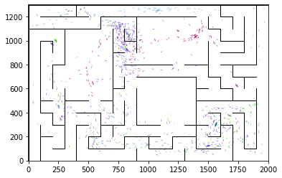

epoch 2461 == proposed_mle: 16.68+-0.30/14.95+-0.23 --

epoch 2462 == proposed_mle: 15.91+-0.32/15.19+-0.21 --

epoch 2463 == proposed_mle: 15.58+-0.30/15.11+-0.23 --

epoch 2464 == proposed_mle: 15.98+-0.39/15.13+-0.21 --

epoch 2465 == proposed_mle: 16.20+-0.29/15.01+-0.22 --

epoch 2466 == proposed_mle: 15.67+-0.35/15.06+-0.22 --

epoch 2467 == proposed_mle: 15.76+-0.29/15.04+-0.21 --

epoch 2468 == proposed_mle: 15.76+-0.31/14.95+-0.23 --

epoch 2469 == proposed_mle: 15.90+-0.31/14.96+-0.22 --

epoch 2470 == proposed_mle: 16.06+-0.35/14.94+-0.22 --

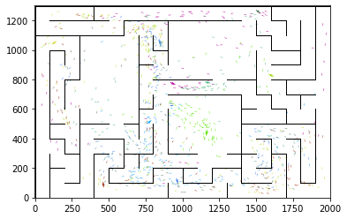

epoch 2471 == proposed_mle: 15.64+-0.31/15.15+-0.21 --

epoch 2472 == proposed_mle: 15.95+-0.31/15.23+-0.23 --

epoch 2473 == proposed_mle: 15.19+-0.31/15.01+-0.23 --

epoch 2474 == proposed_mle: 15.31+-0.33/14.93+-0.21 --

epoch 2475 == proposed_mle: 15.87+-0.30/15.13+-0.23 --

epoch 2476 == proposed_mle: 15.89+-0.29/15.33+-0.23 --

epoch 2477 == proposed_mle: 15.94+-0.35/15.14+-0.21 --

epoch 2478 == proposed_mle: 15.33+-0.30/15.18+-0.23 --

epoch 2479 == proposed_mle: 15.90+-0.36/15.02+-0.24 --

epoch 2480 == proposed_mle: 15.85+-0.29/15.21+-0.24 --

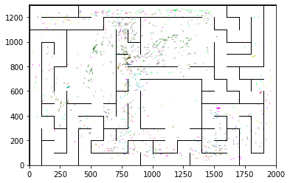

epoch 2481 == proposed_mle: 16.27+-0.29/15.27+-0.24 --

epoch 2482 == proposed_mle: 15.23+-0.34/14.93+-0.24 --

epoch 2483 == proposed_mle: 15.36+-0.34/15.04+-0.24 --

epoch 2484 == proposed_mle: 15.38+-0.33/15.36+-0.24 --

epoch 2485 == proposed_mle: 16.17+-0.34/15.13+-0.23 --

epoch 2486 == proposed_mle: 15.49+-0.32/15.27+-0.24 --

epoch 2487 == proposed_mle: 16.41+-0.34/15.51+-0.23 --

epoch 2488 == proposed_mle: 15.97+-0.33/15.38+-0.24 --

epoch 2489 == proposed_mle: 15.89+-0.33/15.08+-0.23 --

epoch 2490 == proposed_mle: 16.14+-0.32/14.99+-0.23 --

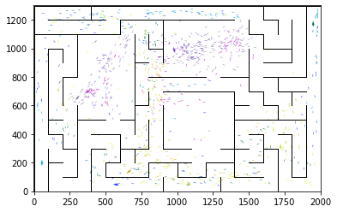

epoch 2491 == proposed_mle: 16.28+-0.36/15.25+-0.23 --

epoch 2492 == proposed_mle: 15.50+-0.25/15.04+-0.21 --

epoch 2493 == proposed_mle: 16.44+-0.28/15.31+-0.23 --

epoch 2494 == proposed_mle: 15.59+-0.27/15.16+-0.23 --

epoch 2495 == proposed_mle: 15.98+-0.32/15.03+-0.22 --

epoch 2496 == proposed_mle: 16.04+-0.31/15.06+-0.23 --

epoch 2497 == proposed_mle: 15.64+-0.33/15.01+-0.21 --

epoch 2498 == proposed_mle: 15.37+-0.36/15.18+-0.23 --

epoch 2499 == proposed_mle: 16.10+-0.37/14.96+-0.21 --

epoch 2500 == proposed_mle: 15.67+-0.37/14.86+-0.22 --

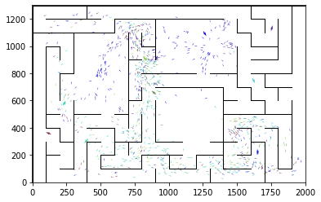

epoch 2501 == proposed_mle: 15.72+-0.34/15.02+-0.21 --

epoch 2502 == proposed_mle: 15.87+-0.31/15.07+-0.22 --

epoch 2503 == proposed_mle: 16.02+-0.31/15.03+-0.23 --

epoch 2504 == proposed_mle: 15.77+-0.31/15.16+-0.23 --

epoch 2505 == proposed_mle: 15.86+-0.34/15.14+-0.24 --

epoch 2506 == proposed_mle: 15.51+-0.31/15.09+-0.23 --

epoch 2507 == proposed_mle: 16.00+-0.35/15.18+-0.23 --

epoch 2508 == proposed_mle: 16.41+-0.31/15.05+-0.22 --

epoch 2509 == proposed_mle: 15.83+-0.38/15.12+-0.23 --

epoch 2510 == proposed_mle: 15.75+-0.27/14.98+-0.23 --

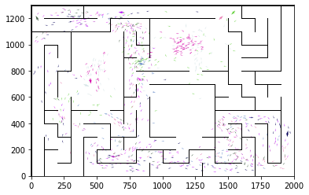

epoch 2511 == proposed_mle: 15.90+-0.30/15.03+-0.23 --

epoch 2512 == proposed_mle: 15.98+-0.29/15.03+-0.22 --

epoch 2513 >> proposed_mle: 16.20+-0.32/14.72+-0.22 --

epoch 2514 == proposed_mle: 15.75+-0.29/14.93+-0.23 --

epoch 2515 == proposed_mle: 16.12+-0.31/14.84+-0.22 --

epoch 2516 == proposed_mle: 15.69+-0.33/15.02+-0.21 --

epoch 2517 == proposed_mle: 15.47+-0.36/14.97+-0.24 --

epoch 2518 == proposed_mle: 15.63+-0.30/14.80+-0.22 --

epoch 2519 == proposed_mle: 15.44+-0.31/15.07+-0.22 --

epoch 2520 == proposed_mle: 15.88+-0.32/15.00+-0.24 --

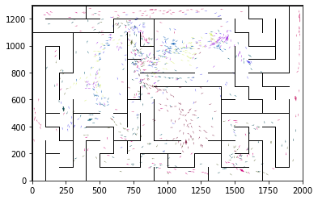

epoch 2521 == proposed_mle: 16.18+-0.26/15.05+-0.21 --

epoch 2522 == proposed_mle: 16.04+-0.30/15.05+-0.22 --

epoch 2523 == proposed_mle: 16.03+-0.29/15.19+-0.24 --

epoch 2524 == proposed_mle: 16.28+-0.35/14.91+-0.21 --

epoch 2525 == proposed_mle: 16.06+-0.33/15.07+-0.24 --

epoch 2526 == proposed_mle: 16.37+-0.31/15.11+-0.23 --

epoch 2527 == proposed_mle: 15.82+-0.40/14.94+-0.24 --

epoch 2528 == proposed_mle: 15.59+-0.33/14.95+-0.23 --

epoch 2529 == proposed_mle: 15.64+-0.33/15.03+-0.24 --

epoch 2530 == proposed_mle: 15.57+-0.31/15.25+-0.22 --

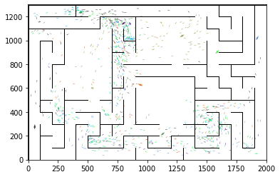

epoch 2531 == proposed_mle: 15.84+-0.39/14.82+-0.23 --

epoch 2532 == proposed_mle: 15.53+-0.30/15.03+-0.24 --

epoch 2533 == proposed_mle: 16.01+-0.32/15.03+-0.23 --

epoch 2534 == proposed_mle: 16.58+-0.35/15.00+-0.24 --

epoch 2535 == proposed_mle: 15.57+-0.32/14.81+-0.23 --

epoch 2536 == proposed_mle: 16.05+-0.29/14.95+-0.22 --

epoch 2537 == proposed_mle: 15.63+-0.30/15.04+-0.22 --

epoch 2538 == proposed_mle: 15.92+-0.32/15.19+-0.23 --

epoch 2539 == proposed_mle: 15.58+-0.36/14.98+-0.23 --

epoch 2540 == proposed_mle: 16.53+-0.31/15.24+-0.23 --

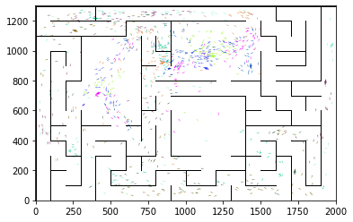

epoch 2541 == proposed_mle: 16.31+-0.35/15.22+-0.24 --

epoch 2542 == proposed_mle: 15.99+-0.24/14.93+-0.23 --

epoch 2543 == proposed_mle: 15.75+-0.33/14.90+-0.25 --

epoch 2544 == proposed_mle: 14.96+-0.32/14.83+-0.23 --

epoch 2545 == proposed_mle: 15.36+-0.32/15.11+-0.23 --

epoch 2546 == proposed_mle: 16.69+-0.37/15.26+-0.23 --

epoch 2547 == proposed_mle: 15.85+-0.30/15.14+-0.24 --

epoch 2548 == proposed_mle: 16.18+-0.34/15.03+-0.22 --

epoch 2549 == proposed_mle: 15.82+-0.37/15.16+-0.22 --

epoch 2550 == proposed_mle: 16.08+-0.33/14.94+-0.23 --

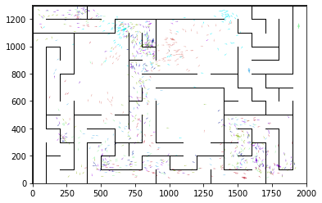

epoch 2551 == proposed_mle: 15.76+-0.33/14.97+-0.23 --

epoch 2552 == proposed_mle: 15.59+-0.31/15.02+-0.22 --

epoch 2553 == proposed_mle: 16.12+-0.29/15.04+-0.22 --

epoch 2554 == proposed_mle: 15.97+-0.33/14.97+-0.24 --

epoch 2555 == proposed_mle: 15.95+-0.37/15.07+-0.22 --

epoch 2556 == proposed_mle: 16.63+-0.33/15.01+-0.22 --

epoch 2557 == proposed_mle: 15.80+-0.33/14.96+-0.22 --

epoch 2558 == proposed_mle: 15.75+-0.34/14.93+-0.21 --

epoch 2559 == proposed_mle: 15.77+-0.28/14.96+-0.22 --

epoch 2560 == proposed_mle: 16.17+-0.34/15.19+-0.24 --

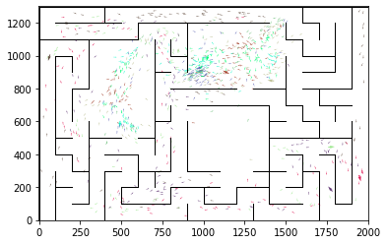

epoch 2561 == proposed_mle: 15.92+-0.32/15.06+-0.22 --

epoch 2562 == proposed_mle: 15.52+-0.27/14.83+-0.23 --

epoch 2563 == proposed_mle: 15.99+-0.29/15.23+-0.23 --

epoch 2564 == proposed_mle: 15.48+-0.31/15.11+-0.24 --

epoch 2565 == proposed_mle: 15.39+-0.37/15.09+-0.21 --

epoch 2566 == proposed_mle: 15.75+-0.32/14.89+-0.22 --

epoch 2567 == proposed_mle: 15.79+-0.32/15.05+-0.24 --

epoch 2568 == proposed_mle: 16.07+-0.40/15.22+-0.24 --

epoch 2569 == proposed_mle: 15.82+-0.33/14.95+-0.22 --

epoch 2570 == proposed_mle: 15.85+-0.34/15.23+-0.22 --

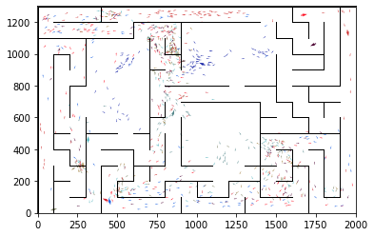

epoch 2571 == proposed_mle: 15.44+-0.32/14.99+-0.20 --

epoch 2572 == proposed_mle: 15.28+-0.25/15.17+-0.24 --

epoch 2573 == proposed_mle: 16.31+-0.28/14.91+-0.23 --

epoch 2574 == proposed_mle: 15.46+-0.32/15.03+-0.22 --

epoch 2575 == proposed_mle: 15.81+-0.36/15.33+-0.23 --

epoch 2576 == proposed_mle: 15.63+-0.32/14.92+-0.22 --

epoch 2577 == proposed_mle: 15.59+-0.36/14.78+-0.23 --

epoch 2578 == proposed_mle: 15.56+-0.28/15.19+-0.24 --

epoch 2579 == proposed_mle: 15.58+-0.35/14.83+-0.23 --

epoch 2580 == proposed_mle: 15.52+-0.30/15.06+-0.22 --

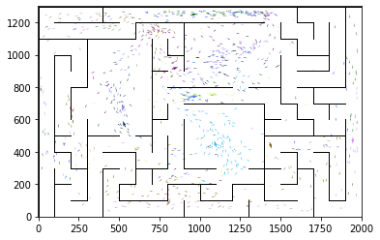

epoch 2581 == proposed_mle: 16.12+-0.30/15.06+-0.23 --

epoch 2582 == proposed_mle: 15.83+-0.41/15.11+-0.24 --

epoch 2583 == proposed_mle: 16.15+-0.32/15.31+-0.23 --

epoch 2584 == proposed_mle: 15.80+-0.34/15.48+-0.25 --

epoch 2585 == proposed_mle: 16.31+-0.38/15.32+-0.24 --

epoch 2586 == proposed_mle: 16.06+-0.29/15.11+-0.21 --

epoch 2587 == proposed_mle: 15.84+-0.32/15.03+-0.22 --

epoch 2588 == proposed_mle: 15.95+-0.31/15.15+-0.23 --

epoch 2589 == proposed_mle: 15.21+-0.34/15.04+-0.22 --

epoch 2590 == proposed_mle: 15.80+-0.34/15.10+-0.21 --

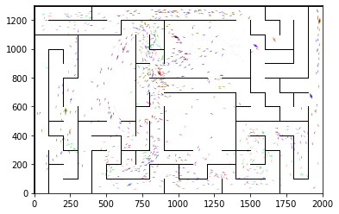

epoch 2591 == proposed_mle: 16.01+-0.35/15.13+-0.22 --

epoch 2592 == proposed_mle: 15.55+-0.33/14.91+-0.23 --

epoch 2593 == proposed_mle: 15.35+-0.33/15.20+-0.23 --

epoch 2594 == proposed_mle: 15.62+-0.29/15.09+-0.21 --

epoch 2595 == proposed_mle: 16.15+-0.29/15.02+-0.23 --

epoch 2596 == proposed_mle: 15.59+-0.27/15.17+-0.23 --

epoch 2597 == proposed_mle: 15.93+-0.34/14.97+-0.21 --

epoch 2598 == proposed_mle: 15.57+-0.31/15.01+-0.22 --

epoch 2599 == proposed_mle: 16.01+-0.37/15.09+-0.23 --

epoch 2600 == proposed_mle: 16.08+-0.31/14.89+-0.21 --

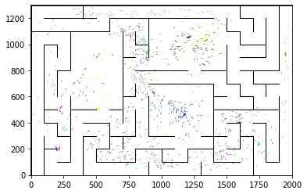

epoch 2601 == proposed_mle: 15.55+-0.32/15.05+-0.23 --

epoch 2602 == proposed_mle: 16.07+-0.26/14.96+-0.22 --

epoch 2603 == proposed_mle: 15.81+-0.30/14.99+-0.23 --

epoch 2604 == proposed_mle: 15.85+-0.32/15.09+-0.21 --

epoch 2605 == proposed_mle: 15.81+-0.32/14.88+-0.24 --

epoch 2606 == proposed_mle: 15.66+-0.29/14.97+-0.22 --

epoch 2607 == proposed_mle: 15.35+-0.36/14.88+-0.22 --

epoch 2608 == proposed_mle: 15.27+-0.36/15.14+-0.22 --

epoch 2609 == proposed_mle: 15.40+-0.32/14.99+-0.23 --

epoch 2610 == proposed_mle: 15.74+-0.32/15.02+-0.23 --

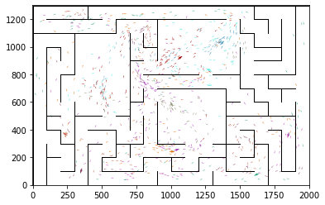

epoch 2611 == proposed_mle: 15.80+-0.29/14.78+-0.21 --

epoch 2612 == proposed_mle: 16.16+-0.32/14.97+-0.21 --

epoch 2613 == proposed_mle: 16.10+-0.30/15.25+-0.22 --

epoch 2614 == proposed_mle: 15.34+-0.38/14.82+-0.24 --

epoch 2615 == proposed_mle: 16.12+-0.28/15.09+-0.24 --

epoch 2616 == proposed_mle: 16.00+-0.32/14.92+-0.22 --

epoch 2617 == proposed_mle: 16.18+-0.32/14.94+-0.23 --

epoch 2618 == proposed_mle: 15.56+-0.22/14.96+-0.22 --

epoch 2619 == proposed_mle: 15.71+-0.26/14.90+-0.22 --

epoch 2620 == proposed_mle: 15.98+-0.32/15.16+-0.22 --

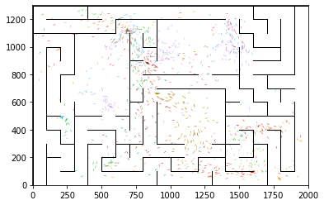

epoch 2621 == proposed_mle: 15.27+-0.37/15.05+-0.24 --

epoch 2622 == proposed_mle: 15.50+-0.33/14.97+-0.22 --

epoch 2623 == proposed_mle: 15.80+-0.42/15.11+-0.22 --

epoch 2624 == proposed_mle: 15.82+-0.29/15.19+-0.24 --

epoch 2625 == proposed_mle: 15.97+-0.28/15.13+-0.24 --

epoch 2626 == proposed_mle: 15.52+-0.29/15.00+-0.23 --

epoch 2627 == proposed_mle: 15.10+-0.38/15.12+-0.24 --

epoch 2628 == proposed_mle: 15.79+-0.31/14.95+-0.23 --

epoch 2629 == proposed_mle: 15.94+-0.29/15.05+-0.24 --

epoch 2630 == proposed_mle: 16.18+-0.32/14.85+-0.25 --

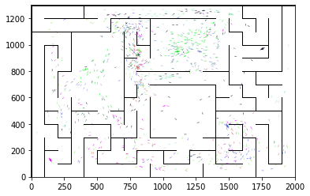

epoch 2631 == proposed_mle: 15.87+-0.31/15.00+-0.22 --

epoch 2632 == proposed_mle: 15.55+-0.26/14.98+-0.24 --

epoch 2633 == proposed_mle: 15.57+-0.26/14.78+-0.22 --

epoch 2634 == proposed_mle: 15.56+-0.38/15.06+-0.24 --

epoch 2635 == proposed_mle: 16.01+-0.29/14.95+-0.22 --

epoch 2636 == proposed_mle: 15.43+-0.33/14.84+-0.24 --

epoch 2637 == proposed_mle: 15.56+-0.31/14.97+-0.26 --

epoch 2638 == proposed_mle: 16.49+-0.33/15.05+-0.23 --

epoch 2639 == proposed_mle: 15.96+-0.32/14.85+-0.24 --

epoch 2640 == proposed_mle: 15.34+-0.32/15.05+-0.23 --

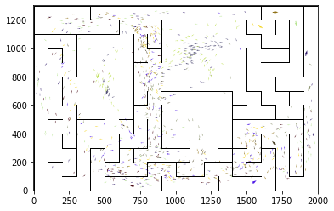

epoch 2641 == proposed_mle: 15.78+-0.30/14.86+-0.24 --

epoch 2642 == proposed_mle: 15.33+-0.29/15.09+-0.23 --

epoch 2643 == proposed_mle: 15.44+-0.34/15.00+-0.23 --

epoch 2644 == proposed_mle: 15.52+-0.34/15.02+-0.24 --

epoch 2645 == proposed_mle: 15.70+-0.35/15.14+-0.23 --

epoch 2646 == proposed_mle: 15.85+-0.36/15.01+-0.24 --

epoch 2647 == proposed_mle: 15.54+-0.33/14.96+-0.23 --

epoch 2648 == proposed_mle: 15.41+-0.30/14.93+-0.22 --

epoch 2649 == proposed_mle: 15.82+-0.34/15.05+-0.22 --

epoch 2650 == proposed_mle: 15.44+-0.31/14.97+-0.22 --

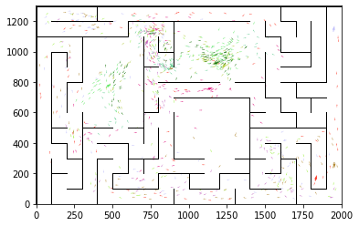

epoch 2651 == proposed_mle: 15.75+-0.27/14.95+-0.24 --

epoch 2652 == proposed_mle: 16.28+-0.33/15.08+-0.22 --

epoch 2653 == proposed_mle: 15.71+-0.27/15.05+-0.22 --

epoch 2654 == proposed_mle: 15.63+-0.31/15.21+-0.24 --

epoch 2655 == proposed_mle: 15.60+-0.29/14.88+-0.24 --

epoch 2656 == proposed_mle: 15.50+-0.31/14.80+-0.22 --

epoch 2657 == proposed_mle: 15.74+-0.25/14.83+-0.23 --

epoch 2658 == proposed_mle: 15.89+-0.36/15.08+-0.23 --

epoch 2659 == proposed_mle: 15.54+-0.34/14.82+-0.23 --

epoch 2660 == proposed_mle: 15.95+-0.31/14.81+-0.24 --

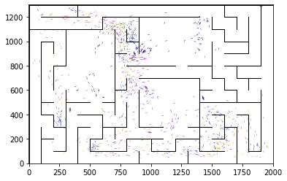

epoch 2661 == proposed_mle: 15.41+-0.33/14.90+-0.24 --

epoch 2662 == proposed_mle: 15.63+-0.38/14.93+-0.23 --

epoch 2663 == proposed_mle: 15.28+-0.29/14.84+-0.21 --

epoch 2664 == proposed_mle: 15.89+-0.31/14.82+-0.22 --

epoch 2665 == proposed_mle: 15.57+-0.28/14.88+-0.23 --

epoch 2666 == proposed_mle: 16.13+-0.38/14.80+-0.22 --

epoch 2667 == proposed_mle: 15.24+-0.33/14.98+-0.24 --

epoch 2668 == proposed_mle: 15.54+-0.32/14.97+-0.23 --

epoch 2669 == proposed_mle: 15.55+-0.31/15.05+-0.24 --

epoch 2670 == proposed_mle: 15.46+-0.35/15.05+-0.22 --

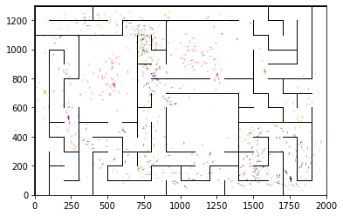

epoch 2671 == proposed_mle: 15.60+-0.38/15.16+-0.22 --

epoch 2672 == proposed_mle: 15.49+-0.33/15.05+-0.22 --

epoch 2673 == proposed_mle: 16.08+-0.39/14.79+-0.22 --

epoch 2674 == proposed_mle: 15.89+-0.31/14.82+-0.24 --

epoch 2675 == proposed_mle: 15.75+-0.31/15.14+-0.23 --

epoch 2676 == proposed_mle: 15.70+-0.34/15.03+-0.23 --

epoch 2677 == proposed_mle: 15.70+-0.26/15.52+-0.24 --

epoch 2678 == proposed_mle: 15.71+-0.34/15.14+-0.23 --

epoch 2679 == proposed_mle: 15.55+-0.36/15.36+-0.24 --

epoch 2680 == proposed_mle: 16.38+-0.34/15.28+-0.24 --

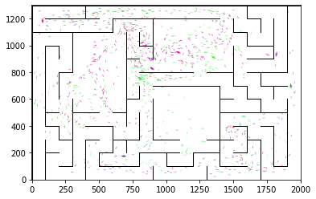

epoch 2681 == proposed_mle: 15.75+-0.34/15.20+-0.25 --

epoch 2682 == proposed_mle: 16.19+-0.37/14.99+-0.23 --

epoch 2683 == proposed_mle: 15.75+-0.31/15.11+-0.23 --

epoch 2684 == proposed_mle: 15.70+-0.30/15.08+-0.23 --

epoch 2685 == proposed_mle: 15.79+-0.33/14.96+-0.22 --

epoch 2686 == proposed_mle: 15.80+-0.36/14.97+-0.24 --

epoch 2687 == proposed_mle: 15.40+-0.31/15.10+-0.23 --

epoch 2688 == proposed_mle: 15.13+-0.29/14.80+-0.23 --

epoch 2689 == proposed_mle: 15.52+-0.34/14.90+-0.23 --

epoch 2690 == proposed_mle: 15.78+-0.34/14.93+-0.23 --

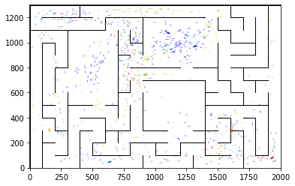

epoch 2691 == proposed_mle: 15.51+-0.36/14.83+-0.24 --

epoch 2692 == proposed_mle: 15.81+-0.31/14.72+-0.22 --

epoch 2693 >> proposed_mle: 15.89+-0.29/14.67+-0.20 --

epoch 2694 == proposed_mle: 15.32+-0.32/14.81+-0.24 --

epoch 2695 == proposed_mle: 15.69+-0.30/14.73+-0.23 --

epoch 2696 == proposed_mle: 16.07+-0.43/14.96+-0.24 --

epoch 2697 == proposed_mle: 15.31+-0.32/14.73+-0.24 --

epoch 2698 == proposed_mle: 15.51+-0.34/14.88+-0.24 --

epoch 2699 == proposed_mle: 15.73+-0.35/15.13+-0.25 --

epoch 2700 == proposed_mle: 15.30+-0.32/15.06+-0.22 --

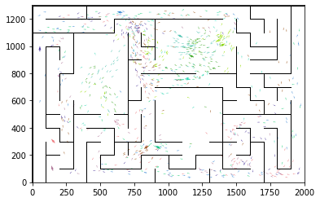

epoch 2701 == proposed_mle: 15.53+-0.34/14.84+-0.22 --

epoch 2702 == proposed_mle: 16.09+-0.35/15.10+-0.23 --

epoch 2703 == proposed_mle: 15.45+-0.29/14.98+-0.22 --

epoch 2704 == proposed_mle: 15.37+-0.26/14.83+-0.24 --

epoch 2705 == proposed_mle: 15.44+-0.31/14.77+-0.22 --

epoch 2706 == proposed_mle: 15.69+-0.35/15.03+-0.20 --

epoch 2707 == proposed_mle: 15.68+-0.26/15.12+-0.24 --

epoch 2708 == proposed_mle: 15.61+-0.33/15.03+-0.25 --

epoch 2709 == proposed_mle: 15.85+-0.37/14.78+-0.24 --

epoch 2710 == proposed_mle: 15.43+-0.33/14.89+-0.22 --

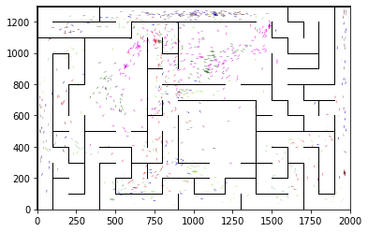

epoch 2711 == proposed_mle: 15.89+-0.31/14.86+-0.22 --

epoch 2712 == proposed_mle: 15.94+-0.25/14.83+-0.22 --

epoch 2713 == proposed_mle: 15.63+-0.34/14.71+-0.24 --

epoch 2714 >> proposed_mle: 15.89+-0.32/14.62+-0.23 --

epoch 2715 == proposed_mle: 15.68+-0.31/15.04+-0.23 --

epoch 2716 == proposed_mle: 15.67+-0.29/14.97+-0.23 --

epoch 2717 == proposed_mle: 15.19+-0.33/14.92+-0.23 --

epoch 2718 == proposed_mle: 15.03+-0.28/14.84+-0.22 --

epoch 2719 == proposed_mle: 15.86+-0.31/14.77+-0.23 --

epoch 2720 == proposed_mle: 15.29+-0.36/14.76+-0.24 --

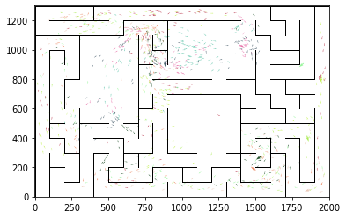

epoch 2721 == proposed_mle: 15.37+-0.35/14.77+-0.23 --

epoch 2722 == proposed_mle: 15.81+-0.39/14.91+-0.22 --

epoch 2723 == proposed_mle: 15.36+-0.29/14.92+-0.24 --

epoch 2724 == proposed_mle: 14.99+-0.31/14.79+-0.23 --

epoch 2725 == proposed_mle: 15.26+-0.32/14.72+-0.23 --

epoch 2726 == proposed_mle: 15.80+-0.38/14.80+-0.22 --

epoch 2727 == proposed_mle: 14.85+-0.33/14.85+-0.23 --

epoch 2728 == proposed_mle: 15.02+-0.33/14.86+-0.23 --

epoch 2729 == proposed_mle: 15.46+-0.29/14.86+-0.24 --

epoch 2730 == proposed_mle: 15.36+-0.23/14.82+-0.21 --

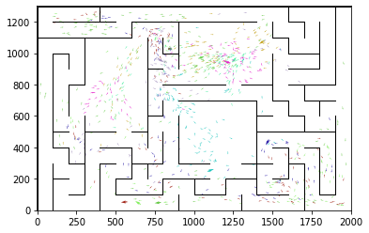

epoch 2731 == proposed_mle: 15.93+-0.33/15.08+-0.25 --

epoch 2732 == proposed_mle: 15.66+-0.24/14.98+-0.21 --

epoch 2733 == proposed_mle: 15.55+-0.38/14.98+-0.24 --

epoch 2734 == proposed_mle: 15.66+-0.33/14.85+-0.24 --

epoch 2735 == proposed_mle: 15.48+-0.30/15.02+-0.22 --

epoch 2736 == proposed_mle: 15.83+-0.31/14.90+-0.22 --

epoch 2737 == proposed_mle: 15.96+-0.32/14.85+-0.23 --

epoch 2738 == proposed_mle: 15.87+-0.25/14.69+-0.24 --

epoch 2739 == proposed_mle: 16.41+-0.38/14.99+-0.23 --

epoch 2740 == proposed_mle: 16.16+-0.33/15.07+-0.23 --

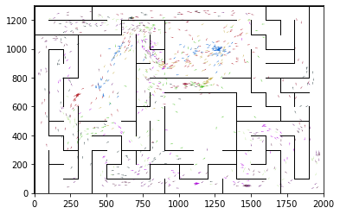

epoch 2741 == proposed_mle: 15.80+-0.28/14.84+-0.23 --

epoch 2742 == proposed_mle: 15.88+-0.33/14.97+-0.24 --

epoch 2743 == proposed_mle: 15.47+-0.30/14.81+-0.22 --

epoch 2744 == proposed_mle: 16.05+-0.35/14.92+-0.24 --

epoch 2745 == proposed_mle: 15.53+-0.29/14.98+-0.25 --

epoch 2746 == proposed_mle: 15.49+-0.28/15.01+-0.21 --

epoch 2747 == proposed_mle: 15.72+-0.29/14.79+-0.23 --

epoch 2748 == proposed_mle: 16.29+-0.39/14.78+-0.23 --

epoch 2749 == proposed_mle: 15.34+-0.35/14.82+-0.21 --

epoch 2750 == proposed_mle: 15.92+-0.34/14.75+-0.23 --

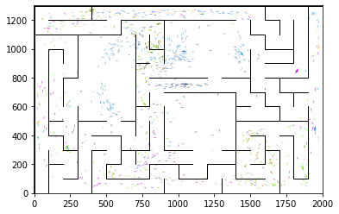

epoch 2751 >> proposed_mle: 14.62+-0.35/14.54+-0.23 --

epoch 2752 == proposed_mle: 15.11+-0.30/14.82+-0.24 --

epoch 2753 == proposed_mle: 15.70+-0.32/14.72+-0.23 --

epoch 2754 == proposed_mle: 15.71+-0.33/14.58+-0.22 --

epoch 2755 == proposed_mle: 15.64+-0.23/14.75+-0.23 --

epoch 2756 == proposed_mle: 15.67+-0.34/15.11+-0.22 --

epoch 2757 == proposed_mle: 16.05+-0.32/15.25+-0.24 --

epoch 2758 == proposed_mle: 15.12+-0.28/14.96+-0.23 --

epoch 2759 == proposed_mle: 15.58+-0.36/14.83+-0.24 --

epoch 2760 == proposed_mle: 15.79+-0.36/15.05+-0.21 --

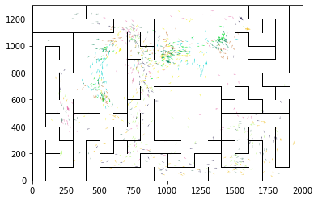

epoch 2761 == proposed_mle: 15.43+-0.36/14.73+-0.23 --

epoch 2762 == proposed_mle: 15.87+-0.37/14.90+-0.21 --

epoch 2763 == proposed_mle: 15.07+-0.28/14.72+-0.22 --

epoch 2764 == proposed_mle: 16.06+-0.31/14.89+-0.22 --

epoch 2765 == proposed_mle: 15.71+-0.28/14.88+-0.22 --

epoch 2766 == proposed_mle: 15.69+-0.38/14.91+-0.22 --

epoch 2767 == proposed_mle: 15.73+-0.30/14.78+-0.22 --

epoch 2768 == proposed_mle: 15.48+-0.28/14.68+-0.22 --

epoch 2769 == proposed_mle: 15.79+-0.29/14.87+-0.22 --

epoch 2770 == proposed_mle: 15.77+-0.39/14.88+-0.23 --

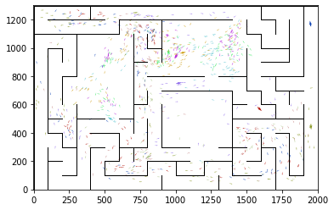

epoch 2771 == proposed_mle: 15.75+-0.39/14.61+-0.22 --

epoch 2772 == proposed_mle: 15.89+-0.37/14.88+-0.24 --

epoch 2773 == proposed_mle: 15.89+-0.28/14.83+-0.21 --

epoch 2774 == proposed_mle: 15.55+-0.34/14.90+-0.23 --

epoch 2775 == proposed_mle: 15.34+-0.36/14.78+-0.22 --

epoch 2776 == proposed_mle: 15.13+-0.36/14.73+-0.24 --

epoch 2777 == proposed_mle: 15.26+-0.30/14.56+-0.21 --

epoch 2778 == proposed_mle: 15.64+-0.32/14.65+-0.23 --

epoch 2779 == proposed_mle: 14.94+-0.32/14.85+-0.21 --

epoch 2780 == proposed_mle: 15.48+-0.32/14.83+-0.23 --

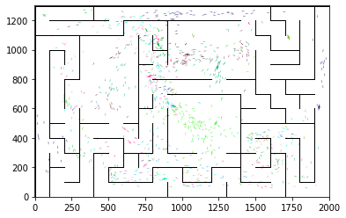

epoch 2781 == proposed_mle: 15.23+-0.30/14.89+-0.22 --

epoch 2782 == proposed_mle: 16.25+-0.36/14.92+-0.23 --

epoch 2783 == proposed_mle: 15.37+-0.28/14.89+-0.23 --

epoch 2784 == proposed_mle: 15.12+-0.31/14.65+-0.22 --

epoch 2785 >> proposed_mle: 15.59+-0.34/14.47+-0.23 --

epoch 2786 == proposed_mle: 15.17+-0.27/14.76+-0.23 --

epoch 2787 == proposed_mle: 15.73+-0.31/14.86+-0.23 --

epoch 2788 == proposed_mle: 15.13+-0.32/14.79+-0.26 --

epoch 2789 == proposed_mle: 15.45+-0.29/14.65+-0.23 --

epoch 2790 == proposed_mle: 15.83+-0.32/14.99+-0.24 --

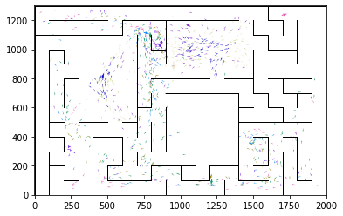

epoch 2791 == proposed_mle: 15.28+-0.30/15.10+-0.23 --

epoch 2792 == proposed_mle: 15.77+-0.36/14.77+-0.21 --

epoch 2793 == proposed_mle: 15.49+-0.29/15.01+-0.22 --

epoch 2794 == proposed_mle: 15.28+-0.39/14.61+-0.22 --

epoch 2795 >> proposed_mle: 14.97+-0.23/14.44+-0.23 --

epoch 2796 == proposed_mle: 15.68+-0.30/14.97+-0.22 --

epoch 2797 == proposed_mle: 15.19+-0.38/14.75+-0.23 --

epoch 2798 == proposed_mle: 15.93+-0.35/14.78+-0.23 --

epoch 2799 == proposed_mle: 15.09+-0.35/14.78+-0.23 --

epoch 2800 == proposed_mle: 15.70+-0.29/14.68+-0.20 --

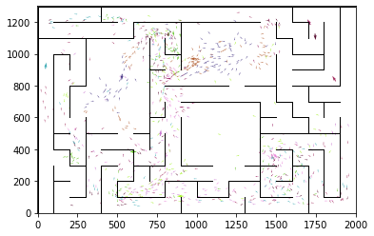

epoch 2801 == proposed_mle: 15.20+-0.36/14.81+-0.23 --

epoch 2802 == proposed_mle: 16.44+-0.28/14.82+-0.23 --

epoch 2803 == proposed_mle: 15.77+-0.32/14.89+-0.23 --

epoch 2804 == proposed_mle: 15.92+-0.30/14.67+-0.22 --

epoch 2805 == proposed_mle: 15.94+-0.35/14.85+-0.25 --

epoch 2806 == proposed_mle: 15.56+-0.30/14.83+-0.23 --

epoch 2807 == proposed_mle: 15.33+-0.34/14.83+-0.24 --

epoch 2808 == proposed_mle: 15.61+-0.36/14.66+-0.24 --

epoch 2809 == proposed_mle: 14.91+-0.32/14.85+-0.24 --

epoch 2810 == proposed_mle: 15.50+-0.32/14.74+-0.22 --

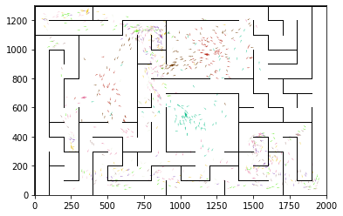

epoch 2811 == proposed_mle: 15.60+-0.28/14.98+-0.22 --

epoch 2812 == proposed_mle: 15.52+-0.36/14.90+-0.23 --

epoch 2813 == proposed_mle: 15.13+-0.31/14.82+-0.24 --

epoch 2814 == proposed_mle: 15.91+-0.36/14.91+-0.21 --

epoch 2815 == proposed_mle: 15.69+-0.32/15.22+-0.23 --

epoch 2816 == proposed_mle: 15.51+-0.31/14.99+-0.24 --

epoch 2817 == proposed_mle: 15.73+-0.31/15.22+-0.24 --

epoch 2818 == proposed_mle: 15.34+-0.26/15.01+-0.23 --

epoch 2819 == proposed_mle: 15.93+-0.32/14.99+-0.25 --

epoch 2820 == proposed_mle: 15.91+-0.32/14.72+-0.23 --

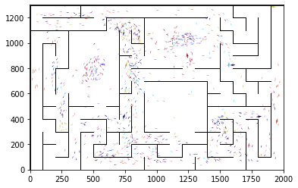

epoch 2821 == proposed_mle: 15.19+-0.31/14.90+-0.24 --

epoch 2822 == proposed_mle: 15.63+-0.31/14.96+-0.23 --

epoch 2823 == proposed_mle: 16.16+-0.32/14.91+-0.24 --

epoch 2824 == proposed_mle: 15.47+-0.34/14.90+-0.24 --

epoch 2825 == proposed_mle: 15.39+-0.31/14.85+-0.24 --

epoch 2826 == proposed_mle: 15.10+-0.33/14.93+-0.24 --

epoch 2827 == proposed_mle: 15.61+-0.30/14.75+-0.23 --

epoch 2828 == proposed_mle: 15.65+-0.37/14.88+-0.22 --

epoch 2829 == proposed_mle: 15.07+-0.36/14.96+-0.22 --

epoch 2830 == proposed_mle: 16.17+-0.33/15.02+-0.23 --

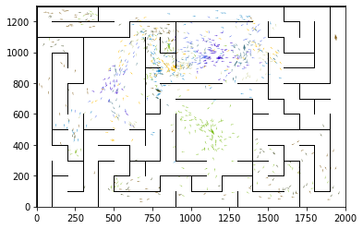

epoch 2831 == proposed_mle: 15.79+-0.33/15.11+-0.23 --

epoch 2832 == proposed_mle: 15.82+-0.34/14.85+-0.23 --

epoch 2833 == proposed_mle: 15.60+-0.34/14.84+-0.23 --

epoch 2834 == proposed_mle: 15.45+-0.31/14.77+-0.23 --

epoch 2835 == proposed_mle: 14.99+-0.32/14.79+-0.22 --

epoch 2836 == proposed_mle: 15.91+-0.40/14.71+-0.22 --

epoch 2837 == proposed_mle: 15.28+-0.29/14.96+-0.24 --

epoch 2838 == proposed_mle: 16.15+-0.27/14.79+-0.22 --

epoch 2839 == proposed_mle: 15.50+-0.31/15.02+-0.22 --

epoch 2840 == proposed_mle: 15.43+-0.38/14.99+-0.23 --

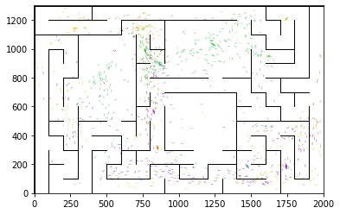

epoch 2841 == proposed_mle: 15.64+-0.34/14.92+-0.23 --

epoch 2842 == proposed_mle: 15.87+-0.30/14.85+-0.22 --

epoch 2843 == proposed_mle: 15.90+-0.34/15.34+-0.22 --

epoch 2844 == proposed_mle: 15.38+-0.31/14.75+-0.22 --

epoch 2845 == proposed_mle: 15.28+-0.33/14.93+-0.23 --

epoch 2846 == proposed_mle: 15.34+-0.36/15.01+-0.24 --

epoch 2847 == proposed_mle: 15.91+-0.30/14.65+-0.24 --

epoch 2848 == proposed_mle: 15.25+-0.31/14.90+-0.22 --

epoch 2849 == proposed_mle: 15.94+-0.36/14.90+-0.23 --

epoch 2850 == proposed_mle: 15.62+-0.28/14.86+-0.22 --

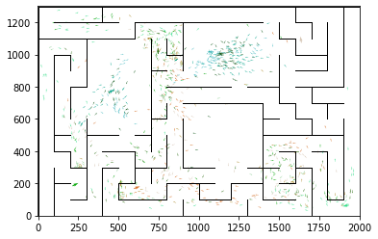

epoch 2851 == proposed_mle: 15.67+-0.31/14.88+-0.21 --

epoch 2852 == proposed_mle: 15.84+-0.28/14.74+-0.24 --

epoch 2853 == proposed_mle: 15.83+-0.29/15.02+-0.24 --

epoch 2854 == proposed_mle: 15.09+-0.36/14.52+-0.22 --

epoch 2855 == proposed_mle: 16.16+-0.29/14.98+-0.22 --

epoch 2856 == proposed_mle: 15.30+-0.29/14.79+-0.23 --

epoch 2857 == proposed_mle: 15.15+-0.34/14.78+-0.22 --

epoch 2858 == proposed_mle: 15.14+-0.28/14.90+-0.22 --

epoch 2859 == proposed_mle: 15.24+-0.31/15.02+-0.22 --

epoch 2860 == proposed_mle: 15.75+-0.35/14.90+-0.21 --

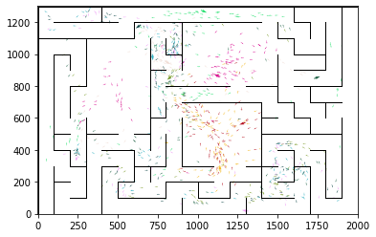

epoch 2861 == proposed_mle: 15.51+-0.35/14.71+-0.24 --

epoch 2862 == proposed_mle: 15.50+-0.26/14.68+-0.20 --

epoch 2863 == proposed_mle: 14.69+-0.32/14.72+-0.22 --

epoch 2864 == proposed_mle: 15.47+-0.31/14.86+-0.22 --

epoch 2865 == proposed_mle: 14.82+-0.32/14.57+-0.22 --

epoch 2866 == proposed_mle: 15.13+-0.34/14.56+-0.21 --

epoch 2867 == proposed_mle: 14.73+-0.33/14.60+-0.22 --

epoch 2868 == proposed_mle: 15.57+-0.31/14.76+-0.22 --

epoch 2869 == proposed_mle: 15.64+-0.31/14.69+-0.23 --

epoch 2870 == proposed_mle: 15.10+-0.40/14.72+-0.23 --

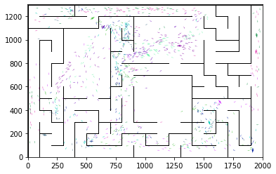

epoch 2871 == proposed_mle: 15.52+-0.32/14.76+-0.22 --

epoch 2872 == proposed_mle: 15.89+-0.33/14.77+-0.22 --

epoch 2873 == proposed_mle: 15.65+-0.37/14.66+-0.23 --

epoch 2874 == proposed_mle: 15.16+-0.32/14.74+-0.22 --

epoch 2875 == proposed_mle: 15.00+-0.31/14.78+-0.22 --

epoch 2876 == proposed_mle: 15.49+-0.38/14.62+-0.22 --

epoch 2877 >> proposed_mle: 15.38+-0.30/14.44+-0.23 --

epoch 2878 == proposed_mle: 15.57+-0.37/14.86+-0.22 --

epoch 2879 == proposed_mle: 15.12+-0.34/14.69+-0.23 --

epoch 2880 == proposed_mle: 15.74+-0.33/14.90+-0.23 --

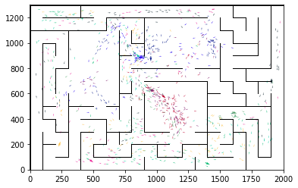

epoch 2881 == proposed_mle: 15.50+-0.33/14.69+-0.23 --

epoch 2882 == proposed_mle: 15.31+-0.34/14.69+-0.23 --

epoch 2883 == proposed_mle: 15.38+-0.32/14.74+-0.23 --

epoch 2884 == proposed_mle: 15.58+-0.33/14.58+-0.22 --

epoch 2885 == proposed_mle: 15.32+-0.31/14.83+-0.22 --

epoch 2886 == proposed_mle: 15.62+-0.31/14.87+-0.23 --

epoch 2887 == proposed_mle: 15.49+-0.32/14.69+-0.22 --

epoch 2888 == proposed_mle: 15.37+-0.31/14.84+-0.22 --

epoch 2889 == proposed_mle: 15.28+-0.35/14.58+-0.23 --

epoch 2890 == proposed_mle: 15.33+-0.31/14.65+-0.23 --

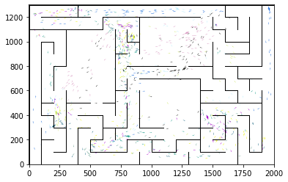

epoch 2891 == proposed_mle: 15.21+-0.31/14.59+-0.23 --

epoch 2892 == proposed_mle: 15.36+-0.32/14.78+-0.23 --

epoch 2893 == proposed_mle: 14.79+-0.33/14.56+-0.22 --

epoch 2894 == proposed_mle: 15.10+-0.38/14.66+-0.21 --

epoch 2895 == proposed_mle: 15.62+-0.27/14.71+-0.22 --

epoch 2896 == proposed_mle: 15.73+-0.36/14.78+-0.21 --

epoch 2897 == proposed_mle: 15.11+-0.30/14.72+-0.22 --

epoch 2898 == proposed_mle: 15.22+-0.30/14.60+-0.25 --

epoch 2899 == proposed_mle: 15.42+-0.31/14.53+-0.24 --

epoch 2900 == proposed_mle: 15.58+-0.39/14.62+-0.22 --

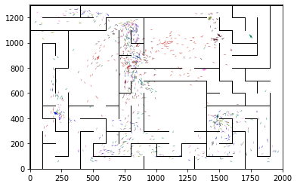

epoch 2901 == proposed_mle: 15.56+-0.34/14.93+-0.22 --

epoch 2902 == proposed_mle: 15.28+-0.29/14.60+-0.22 --

epoch 2903 == proposed_mle: 15.32+-0.29/14.74+-0.23 --

epoch 2904 == proposed_mle: 15.85+-0.34/14.86+-0.22 --

epoch 2905 == proposed_mle: 15.31+-0.31/14.59+-0.22 --

epoch 2906 == proposed_mle: 15.56+-0.28/14.73+-0.22 --

epoch 2907 == proposed_mle: 15.18+-0.30/14.77+-0.22 --

epoch 2908 == proposed_mle: 15.30+-0.33/14.67+-0.23 --

epoch 2909 == proposed_mle: 16.31+-0.28/14.85+-0.23 --

epoch 2910 == proposed_mle: 15.37+-0.26/14.82+-0.23 --

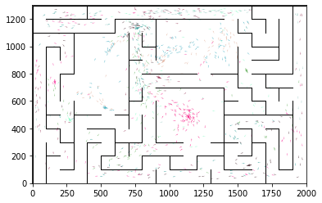

epoch 2911 == proposed_mle: 15.28+-0.29/14.82+-0.21 --

epoch 2912 == proposed_mle: 15.20+-0.33/14.74+-0.24 --

epoch 2913 == proposed_mle: 14.82+-0.28/14.91+-0.23 --

epoch 2914 == proposed_mle: 15.51+-0.28/14.70+-0.22 --

epoch 2915 == proposed_mle: 15.32+-0.32/14.73+-0.23 --

epoch 2916 == proposed_mle: 15.22+-0.34/14.94+-0.24 --

epoch 2917 == proposed_mle: 15.24+-0.24/14.82+-0.23 --

epoch 2918 == proposed_mle: 16.31+-0.28/15.05+-0.25 --

epoch 2919 == proposed_mle: 16.08+-0.32/15.03+-0.23 --

epoch 2920 == proposed_mle: 15.36+-0.27/15.09+-0.24 --

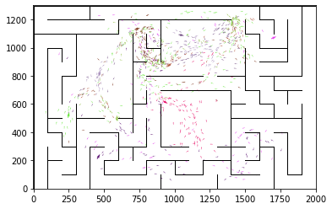

epoch 2921 == proposed_mle: 16.09+-0.35/15.06+-0.23 --

epoch 2922 == proposed_mle: 15.65+-0.39/15.00+-0.23 --

epoch 2923 == proposed_mle: 15.00+-0.28/14.87+-0.23 --

epoch 2924 == proposed_mle: 15.78+-0.30/15.05+-0.24 --

epoch 2925 == proposed_mle: 15.19+-0.34/14.95+-0.24 --

epoch 2926 == proposed_mle: 15.91+-0.26/14.93+-0.25 --

epoch 2927 == proposed_mle: 15.78+-0.27/14.78+-0.24 --

epoch 2928 == proposed_mle: 15.74+-0.29/14.75+-0.22 --

epoch 2929 == proposed_mle: 15.24+-0.33/14.67+-0.24 --

epoch 2930 == proposed_mle: 15.48+-0.30/14.87+-0.24 --

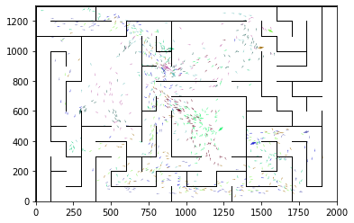

epoch 2931 == proposed_mle: 15.38+-0.28/14.84+-0.21 --

epoch 2932 == proposed_mle: 15.21+-0.30/14.89+-0.23 --

epoch 2933 == proposed_mle: 15.45+-0.37/14.74+-0.23 --

epoch 2934 == proposed_mle: 15.10+-0.34/14.70+-0.22 --

epoch 2935 == proposed_mle: 15.32+-0.27/14.71+-0.22 --

epoch 2936 == proposed_mle: 15.84+-0.32/14.85+-0.21 --

epoch 2937 == proposed_mle: 15.53+-0.32/14.65+-0.24 --

epoch 2938 == proposed_mle: 15.37+-0.32/14.86+-0.24 --

epoch 2939 == proposed_mle: 14.88+-0.28/14.87+-0.24 --

epoch 2940 == proposed_mle: 15.99+-0.31/14.87+-0.23 --

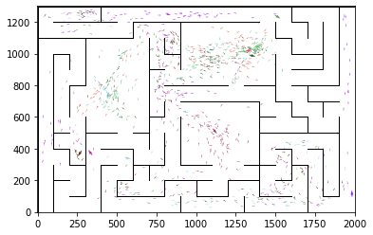

epoch 2941 == proposed_mle: 15.80+-0.27/14.63+-0.22 --

epoch 2942 == proposed_mle: 14.76+-0.33/14.76+-0.23 --

epoch 2943 == proposed_mle: 15.64+-0.31/14.60+-0.22 --

epoch 2944 == proposed_mle: 15.04+-0.26/14.77+-0.22 --

epoch 2945 == proposed_mle: 15.69+-0.33/14.70+-0.22 --

epoch 2946 == proposed_mle: 14.89+-0.33/14.73+-0.22 --

epoch 2947 == proposed_mle: 15.57+-0.27/14.86+-0.22 --

epoch 2948 == proposed_mle: 15.75+-0.39/14.75+-0.22 --

epoch 2949 == proposed_mle: 15.35+-0.34/14.73+-0.25 --

epoch 2950 == proposed_mle: 15.07+-0.28/14.60+-0.20 --

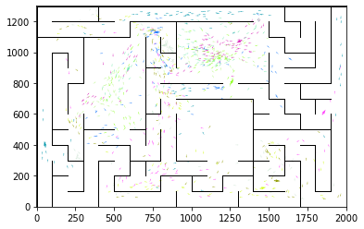

epoch 2951 == proposed_mle: 15.08+-0.36/14.93+-0.23 --

epoch 2952 == proposed_mle: 15.70+-0.34/14.71+-0.22 --

epoch 2953 == proposed_mle: 15.39+-0.30/14.93+-0.23 --

epoch 2954 == proposed_mle: 15.22+-0.28/14.84+-0.23 --

epoch 2955 == proposed_mle: 16.42+-0.33/14.84+-0.24 --

epoch 2956 == proposed_mle: 15.52+-0.36/14.77+-0.21 --

epoch 2957 == proposed_mle: 15.15+-0.32/14.64+-0.22 --

epoch 2958 == proposed_mle: 15.32+-0.33/14.82+-0.23 --

epoch 2959 == proposed_mle: 15.43+-0.33/14.71+-0.23 --

epoch 2960 == proposed_mle: 14.80+-0.33/14.87+-0.23 --

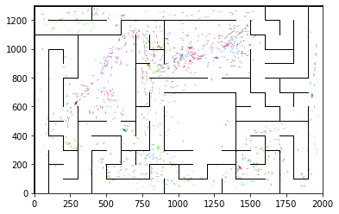

epoch 2961 == proposed_mle: 15.58+-0.36/14.87+-0.23 --

epoch 2962 == proposed_mle: 15.27+-0.31/14.82+-0.22 --

epoch 2963 == proposed_mle: 15.41+-0.34/14.77+-0.24 --

epoch 2964 == proposed_mle: 15.60+-0.32/14.87+-0.23 --

epoch 2965 == proposed_mle: 15.39+-0.29/14.56+-0.23 --

epoch 2966 == proposed_mle: 15.91+-0.39/14.85+-0.23 --

epoch 2967 == proposed_mle: 15.70+-0.30/14.85+-0.24 --

epoch 2968 == proposed_mle: 15.43+-0.32/15.11+-0.23 --

epoch 2969 == proposed_mle: 15.40+-0.38/15.04+-0.23 --

epoch 2970 == proposed_mle: 14.58+-0.33/14.57+-0.24 --

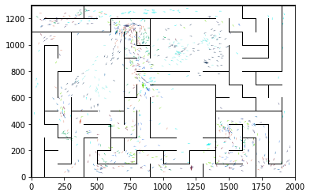

epoch 2971 == proposed_mle: 15.04+-0.33/14.98+-0.24 --

epoch 2972 == proposed_mle: 15.34+-0.30/14.62+-0.25 --

epoch 2973 == proposed_mle: 15.85+-0.27/14.63+-0.23 --

epoch 2974 == proposed_mle: 15.00+-0.30/14.76+-0.22 --

epoch 2975 == proposed_mle: 15.18+-0.25/14.67+-0.23 --

epoch 2976 == proposed_mle: 15.24+-0.31/14.48+-0.21 --

epoch 2977 >> proposed_mle: 15.52+-0.38/14.41+-0.23 --

epoch 2978 == proposed_mle: 15.00+-0.33/14.64+-0.23 --

epoch 2979 == proposed_mle: 15.57+-0.34/14.56+-0.22 --

epoch 2980 == proposed_mle: 15.40+-0.24/14.62+-0.23 --

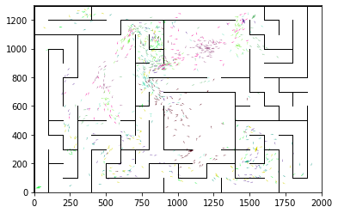

epoch 2981 == proposed_mle: 15.38+-0.37/14.43+-0.23 --

epoch 2982 == proposed_mle: 15.01+-0.31/14.69+-0.22 --

epoch 2983 == proposed_mle: 15.44+-0.30/14.45+-0.22 --

epoch 2984 == proposed_mle: 15.44+-0.29/14.52+-0.23 --

epoch 2985 == proposed_mle: 15.21+-0.34/14.44+-0.22 --

epoch 2986 == proposed_mle: 14.52+-0.32/14.82+-0.22 --

epoch 2987 == proposed_mle: 15.37+-0.35/14.95+-0.23 --

epoch 2988 == proposed_mle: 15.61+-0.31/14.68+-0.22 --

epoch 2989 == proposed_mle: 15.52+-0.32/14.56+-0.23 --

epoch 2990 == proposed_mle: 15.31+-0.38/14.61+-0.23 --

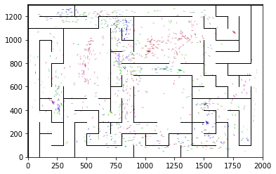

epoch 2991 == proposed_mle: 15.57+-0.31/14.66+-0.23 --

epoch 2992 == proposed_mle: 15.44+-0.33/14.78+-0.20 --

epoch 2993 == proposed_mle: 15.37+-0.31/14.67+-0.24 --

epoch 2994 == proposed_mle: 15.67+-0.30/14.76+-0.21 --

epoch 2995 == proposed_mle: 15.49+-0.35/14.61+-0.22 --

epoch 2996 == proposed_mle: 15.41+-0.31/14.56+-0.23 --

epoch 2997 == proposed_mle: 15.61+-0.31/14.76+-0.24 --

epoch 2998 == proposed_mle: 15.44+-0.36/14.69+-0.22 --

epoch 2999 == proposed_mle: 15.53+-0.31/14.71+-0.24 --

epoch 3000 == proposed_mle: 15.54+-0.37/14.48+-0.24 --

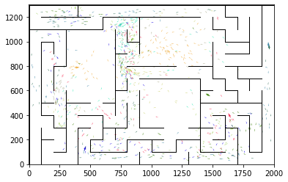

epoch 3001 == proposed_mle: 15.26+-0.29/14.61+-0.22 --

epoch 3002 == proposed_mle: 15.36+-0.29/14.52+-0.23 --

epoch 3003 == proposed_mle: 15.34+-0.30/14.45+-0.23 --

epoch 3004 == proposed_mle: 15.02+-0.28/14.57+-0.23 --

epoch 3005 == proposed_mle: 15.52+-0.31/14.73+-0.23 --

epoch 3006 == proposed_mle: 15.00+-0.34/14.72+-0.22 --

epoch 3007 == proposed_mle: 15.31+-0.31/14.66+-0.22 --

epoch 3008 == proposed_mle: 15.53+-0.31/14.71+-0.22 --

epoch 3009 == proposed_mle: 14.49+-0.33/14.53+-0.22 --

epoch 3010 == proposed_mle: 14.78+-0.35/14.61+-0.21 --

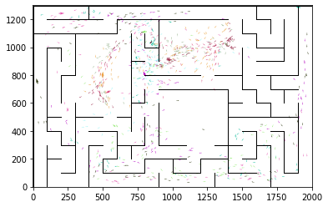

epoch 3011 == proposed_mle: 15.36+-0.37/14.72+-0.23 --

epoch 3012 == proposed_mle: 15.38+-0.29/14.71+-0.24 --

epoch 3013 == proposed_mle: 15.74+-0.27/14.53+-0.23 --

epoch 3014 == proposed_mle: 15.66+-0.30/14.60+-0.23 --

epoch 3015 == proposed_mle: 15.71+-0.32/14.77+-0.23 --

epoch 3016 == proposed_mle: 15.78+-0.33/14.63+-0.24 --

epoch 3017 == proposed_mle: 15.48+-0.36/14.64+-0.22 --

epoch 3018 == proposed_mle: 15.54+-0.31/14.59+-0.24 --

epoch 3019 == proposed_mle: 15.82+-0.28/14.72+-0.22 --

epoch 3020 == proposed_mle: 15.21+-0.34/14.55+-0.22 --

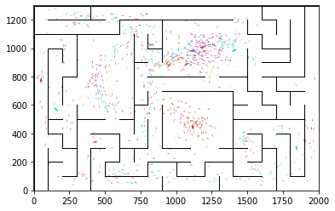

epoch 3021 == proposed_mle: 14.90+-0.34/14.55+-0.23 --

epoch 3022 == proposed_mle: 15.59+-0.34/14.82+-0.23 --

epoch 3023 == proposed_mle: 14.98+-0.36/14.57+-0.23 --

epoch 3024 == proposed_mle: 14.83+-0.29/14.52+-0.22 --

epoch 3025 == proposed_mle: 15.54+-0.40/14.60+-0.22 --

epoch 3026 == proposed_mle: 15.23+-0.33/14.56+-0.24 --

epoch 3027 == proposed_mle: 15.46+-0.33/14.58+-0.24 --

epoch 3028 == proposed_mle: 15.00+-0.29/14.62+-0.23 --

epoch 3029 == proposed_mle: 15.74+-0.31/14.70+-0.22 --

epoch 3030 == proposed_mle: 15.33+-0.30/14.53+-0.23 --

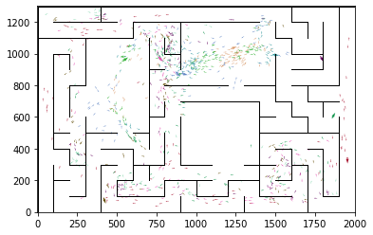

epoch 3031 == proposed_mle: 15.44+-0.38/14.63+-0.25 --

epoch 3032 == proposed_mle: 15.77+-0.26/14.53+-0.23 --

epoch 3033 == proposed_mle: 14.81+-0.30/14.50+-0.23 --

epoch 3034 == proposed_mle: 15.04+-0.34/14.66+-0.22 --

epoch 3035 == proposed_mle: 15.81+-0.25/14.78+-0.23 --

epoch 3036 == proposed_mle: 15.43+-0.33/14.65+-0.24 --

epoch 3037 == proposed_mle: 15.41+-0.32/14.63+-0.23 --

epoch 3038 == proposed_mle: 15.20+-0.35/14.54+-0.25 --

epoch 3039 == proposed_mle: 15.12+-0.35/14.57+-0.22 --

epoch 3040 == proposed_mle: 15.67+-0.40/14.67+-0.23 --

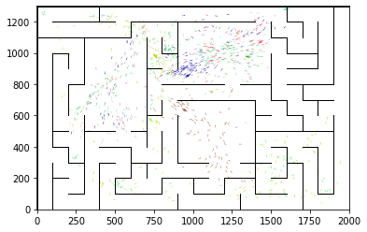

epoch 3041 >> proposed_mle: 15.65+-0.28/14.38+-0.22 --

epoch 3042 == proposed_mle: 15.25+-0.30/14.57+-0.22 --

epoch 3043 == proposed_mle: 15.07+-0.32/14.56+-0.22 --

epoch 3044 == proposed_mle: 15.38+-0.34/14.51+-0.24 --

epoch 3045 == proposed_mle: 15.57+-0.36/14.51+-0.21 --

epoch 3046 == proposed_mle: 15.21+-0.29/14.64+-0.23 --

epoch 3047 == proposed_mle: 15.47+-0.33/14.62+-0.22 --

epoch 3048 == proposed_mle: 15.91+-0.32/14.70+-0.23 --

epoch 3049 == proposed_mle: 15.71+-0.29/14.47+-0.22 --

epoch 3050 == proposed_mle: 15.43+-0.33/14.64+-0.23 --

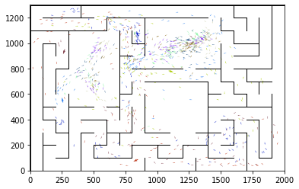

epoch 3051 == proposed_mle: 15.24+-0.29/14.45+-0.20 --

epoch 3052 == proposed_mle: 15.12+-0.33/14.46+-0.22 --

epoch 3053 == proposed_mle: 15.11+-0.34/14.45+-0.23 --

epoch 3054 == proposed_mle: 15.41+-0.36/14.61+-0.21 --

epoch 3055 == proposed_mle: 15.12+-0.32/14.76+-0.22 --

epoch 3056 == proposed_mle: 14.77+-0.35/14.70+-0.23 --

epoch 3057 == proposed_mle: 15.26+-0.31/14.49+-0.23 --

epoch 3058 == proposed_mle: 15.65+-0.33/14.47+-0.23 --

epoch 3059 >> proposed_mle: 14.86+-0.35/14.37+-0.22 --

epoch 3060 == proposed_mle: 14.91+-0.33/14.64+-0.22 --

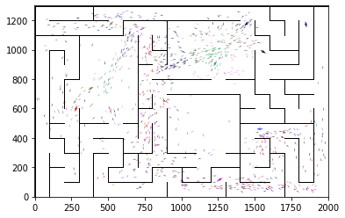

epoch 3061 == proposed_mle: 15.01+-0.34/14.67+-0.22 --

epoch 3062 == proposed_mle: 15.09+-0.32/14.54+-0.22 --

epoch 3063 == proposed_mle: 15.49+-0.30/14.63+-0.22 --

epoch 3064 == proposed_mle: 15.62+-0.34/14.58+-0.23 --

epoch 3065 >> proposed_mle: 14.91+-0.34/14.30+-0.23 --

epoch 3066 == proposed_mle: 14.90+-0.35/14.68+-0.22 --

epoch 3067 == proposed_mle: 14.76+-0.27/14.56+-0.23 --

epoch 3068 == proposed_mle: 15.46+-0.35/14.50+-0.22 --

epoch 3069 == proposed_mle: 14.97+-0.33/14.64+-0.22 --

epoch 3070 == proposed_mle: 15.65+-0.34/14.49+-0.23 --

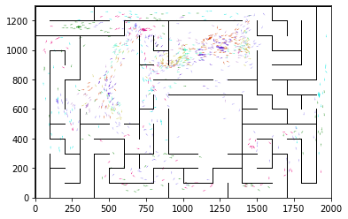

epoch 3071 == proposed_mle: 15.10+-0.28/14.61+-0.22 --

epoch 3072 == proposed_mle: 15.45+-0.32/14.63+-0.24 --

epoch 3073 == proposed_mle: 15.32+-0.27/14.63+-0.23 --

epoch 3074 == proposed_mle: 15.43+-0.36/14.71+-0.22 --

epoch 3075 == proposed_mle: 15.22+-0.28/14.49+-0.24 --

epoch 3076 == proposed_mle: 15.76+-0.31/14.52+-0.23 --

epoch 3077 == proposed_mle: 15.36+-0.30/14.60+-0.22 --

epoch 3078 == proposed_mle: 15.36+-0.30/14.40+-0.22 --

epoch 3079 == proposed_mle: 15.34+-0.30/14.86+-0.23 --

epoch 3080 == proposed_mle: 15.10+-0.37/14.73+-0.21 --

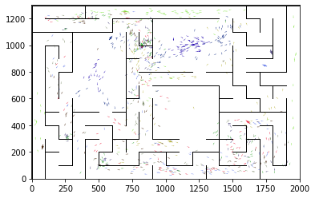

epoch 3081 == proposed_mle: 15.08+-0.26/14.59+-0.22 --

epoch 3082 == proposed_mle: 15.53+-0.28/14.81+-0.21 --

epoch 3083 == proposed_mle: 15.55+-0.30/14.82+-0.22 --

epoch 3084 == proposed_mle: 15.21+-0.31/14.62+-0.23 --

epoch 3085 == proposed_mle: 14.86+-0.28/14.59+-0.22 --

epoch 3086 == proposed_mle: 15.43+-0.24/14.61+-0.23 --

epoch 3087 == proposed_mle: 15.69+-0.29/14.65+-0.22 --

epoch 3088 == proposed_mle: 15.71+-0.33/14.49+-0.24 --

epoch 3089 == proposed_mle: 15.24+-0.31/14.57+-0.22 --

epoch 3090 == proposed_mle: 15.22+-0.41/14.57+-0.23 --

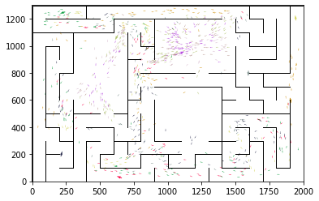

epoch 3091 == proposed_mle: 15.56+-0.28/14.54+-0.25 --

epoch 3092 == proposed_mle: 15.18+-0.28/14.48+-0.21 --

epoch 3093 == proposed_mle: 15.51+-0.28/14.36+-0.22 --

epoch 3094 == proposed_mle: 15.48+-0.31/14.63+-0.23 --

epoch 3095 == proposed_mle: 14.95+-0.35/14.49+-0.23 --

epoch 3096 == proposed_mle: 15.14+-0.30/14.43+-0.23 --

epoch 3097 == proposed_mle: 15.52+-0.28/14.61+-0.23 --

epoch 3098 == proposed_mle: 15.29+-0.32/14.43+-0.22 --

epoch 3099 == proposed_mle: 15.58+-0.34/14.47+-0.24 --

epoch 3100 == proposed_mle: 15.71+-0.32/14.60+-0.23 --

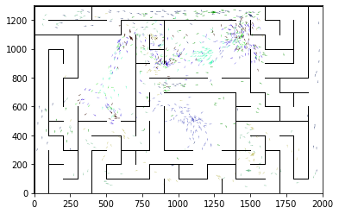

epoch 3101 == proposed_mle: 15.36+-0.28/14.42+-0.22 --

epoch 3102 == proposed_mle: 15.34+-0.30/14.47+-0.24 --

epoch 3103 == proposed_mle: 15.18+-0.27/14.54+-0.23 --

epoch 3104 == proposed_mle: 15.50+-0.33/14.64+-0.24 --

epoch 3105 == proposed_mle: 15.43+-0.35/14.61+-0.25 --

epoch 3106 == proposed_mle: 15.92+-0.30/14.64+-0.24 --

epoch 3107 == proposed_mle: 14.84+-0.29/14.63+-0.23 --

epoch 3108 == proposed_mle: 14.86+-0.25/14.60+-0.22 --

epoch 3109 == proposed_mle: 15.33+-0.31/14.64+-0.23 --

epoch 3110 == proposed_mle: 15.07+-0.35/14.49+-0.23 --

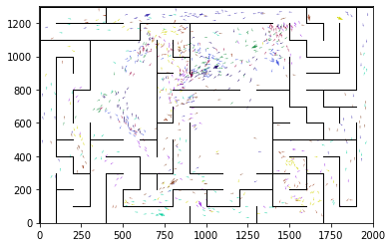

epoch 3111 == proposed_mle: 15.48+-0.36/14.75+-0.22 --

epoch 3112 == proposed_mle: 15.12+-0.34/14.82+-0.22 --

epoch 3113 == proposed_mle: 15.40+-0.32/14.54+-0.22 --

epoch 3114 == proposed_mle: 15.04+-0.27/14.65+-0.22 --

epoch 3115 == proposed_mle: 15.16+-0.31/14.41+-0.22 --

epoch 3116 == proposed_mle: 16.01+-0.28/14.64+-0.22 --

epoch 3117 == proposed_mle: 15.00+-0.34/14.44+-0.24 --

epoch 3118 == proposed_mle: 15.18+-0.31/14.53+-0.22 --

epoch 3119 == proposed_mle: 15.03+-0.30/14.53+-0.24 --

epoch 3120 == proposed_mle: 15.99+-0.33/14.80+-0.24 --

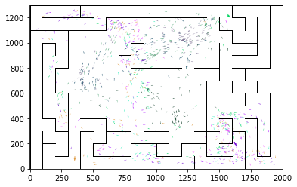

epoch 3121 == proposed_mle: 15.50+-0.33/14.50+-0.24 --

epoch 3122 == proposed_mle: 15.39+-0.35/14.79+-0.23 --

epoch 3123 == proposed_mle: 15.64+-0.32/14.76+-0.23 --

epoch 3124 == proposed_mle: 15.06+-0.32/14.83+-0.25 --

epoch 3125 == proposed_mle: 15.14+-0.34/14.50+-0.24 --

epoch 3126 == proposed_mle: 14.93+-0.29/14.48+-0.22 --

epoch 3127 == proposed_mle: 15.58+-0.26/14.35+-0.23 --

epoch 3128 == proposed_mle: 15.13+-0.32/14.43+-0.22 --

epoch 3129 == proposed_mle: 15.22+-0.27/14.55+-0.23 --

epoch 3130 == proposed_mle: 15.05+-0.25/14.49+-0.22 --

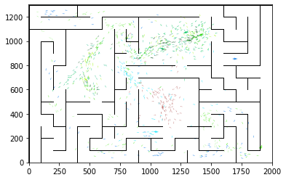

epoch 3131 == proposed_mle: 15.08+-0.26/14.40+-0.21 --

epoch 3132 == proposed_mle: 15.29+-0.34/14.48+-0.23 --

epoch 3133 == proposed_mle: 14.91+-0.33/14.59+-0.24 --

epoch 3134 == proposed_mle: 14.92+-0.34/14.55+-0.21 --

epoch 3135 == proposed_mle: 15.32+-0.33/14.47+-0.23 --

epoch 3136 == proposed_mle: 15.99+-0.31/14.54+-0.23 --

epoch 3137 == proposed_mle: 15.84+-0.30/14.71+-0.24 --

epoch 3138 == proposed_mle: 15.90+-0.27/14.71+-0.22 --

epoch 3139 == proposed_mle: 15.52+-0.34/14.61+-0.24 --

epoch 3140 == proposed_mle: 15.69+-0.35/14.78+-0.24 --

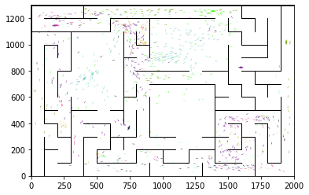

epoch 3141 == proposed_mle: 14.93+-0.33/14.60+-0.21 --

epoch 3142 == proposed_mle: 15.54+-0.29/14.52+-0.22 --

epoch 3143 == proposed_mle: 14.97+-0.36/14.64+-0.24 --

epoch 3144 == proposed_mle: 15.40+-0.29/14.42+-0.22 --

epoch 3145 == proposed_mle: 15.25+-0.33/14.49+-0.22 --

epoch 3146 == proposed_mle: 15.82+-0.30/14.55+-0.23 --

epoch 3147 == proposed_mle: 15.54+-0.37/14.54+-0.23 --

epoch 3148 == proposed_mle: 15.66+-0.35/14.56+-0.22 --

epoch 3149 == proposed_mle: 14.64+-0.32/14.47+-0.21 --

epoch 3150 == proposed_mle: 15.20+-0.31/14.67+-0.22 --

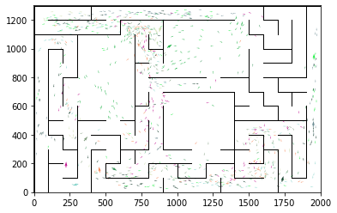

epoch 3151 == proposed_mle: 15.30+-0.30/14.69+-0.23 --

epoch 3152 == proposed_mle: 15.36+-0.32/14.75+-0.24 --

epoch 3153 == proposed_mle: 15.88+-0.33/14.83+-0.21 --

epoch 3154 == proposed_mle: 15.18+-0.28/14.67+-0.23 --

epoch 3155 == proposed_mle: 15.87+-0.30/14.62+-0.23 --

epoch 3156 == proposed_mle: 15.20+-0.38/14.54+-0.21 --

epoch 3157 == proposed_mle: 14.45+-0.29/14.63+-0.21 --

epoch 3158 == proposed_mle: 14.99+-0.37/14.51+-0.23 --

epoch 3159 == proposed_mle: 15.25+-0.35/14.41+-0.23 --

epoch 3160 == proposed_mle: 15.08+-0.29/14.40+-0.22 --

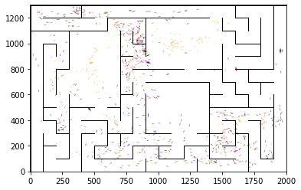

epoch 3161 == proposed_mle: 15.09+-0.29/14.57+-0.23 --

epoch 3162 == proposed_mle: 14.77+-0.32/14.55+-0.24 --

epoch 3163 == proposed_mle: 15.68+-0.37/14.59+-0.23 --

epoch 3164 == proposed_mle: 15.32+-0.32/14.64+-0.23 --

epoch 3165 == proposed_mle: 15.64+-0.29/14.70+-0.23 --

epoch 3166 == proposed_mle: 15.21+-0.39/14.51+-0.22 --

epoch 3167 == proposed_mle: 15.37+-0.31/14.59+-0.21 --

epoch 3168 == proposed_mle: 15.32+-0.29/14.74+-0.23 --

epoch 3169 == proposed_mle: 15.10+-0.31/14.56+-0.23 --

epoch 3170 == proposed_mle: 14.73+-0.38/14.62+-0.23 --

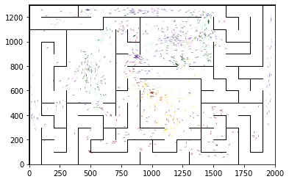

epoch 3171 == proposed_mle: 15.10+-0.31/14.66+-0.22 --

epoch 3172 == proposed_mle: 15.02+-0.31/14.39+-0.21 --

epoch 3173 == proposed_mle: 15.54+-0.35/14.52+-0.22 --

epoch 3174 == proposed_mle: 14.70+-0.28/14.43+-0.22 --

epoch 3175 == proposed_mle: 14.99+-0.35/14.51+-0.23 --

epoch 3176 == proposed_mle: 14.64+-0.25/14.36+-0.22 --

epoch 3177 == proposed_mle: 15.08+-0.31/14.49+-0.23 --

epoch 3178 == proposed_mle: 14.92+-0.34/14.38+-0.22 --

epoch 3179 >> proposed_mle: 15.02+-0.28/14.26+-0.22 --

epoch 3180 == proposed_mle: 14.66+-0.30/14.46+-0.22 --

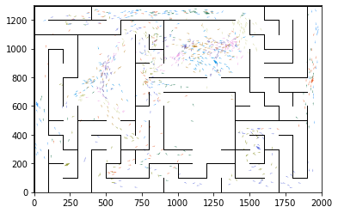

epoch 3181 == proposed_mle: 14.99+-0.31/14.51+-0.23 --

epoch 3182 == proposed_mle: 15.24+-0.28/14.31+-0.22 --

epoch 3183 == proposed_mle: 14.90+-0.36/14.40+-0.22 --

epoch 3184 == proposed_mle: 15.35+-0.29/14.49+-0.23 --

epoch 3185 == proposed_mle: 15.44+-0.31/14.36+-0.22 --

epoch 3186 == proposed_mle: 14.71+-0.25/14.31+-0.23 --

epoch 3187 == proposed_mle: 15.33+-0.37/14.31+-0.22 --

epoch 3188 == proposed_mle: 14.88+-0.37/14.50+-0.22 --

epoch 3189 == proposed_mle: 14.82+-0.26/14.37+-0.23 --

epoch 3190 == proposed_mle: 15.88+-0.28/14.41+-0.21 --

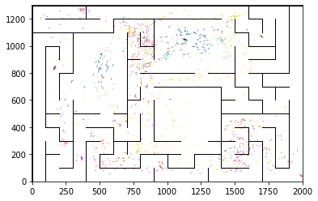

epoch 3191 == proposed_mle: 14.63+-0.29/14.55+-0.22 --

epoch 3192 == proposed_mle: 15.70+-0.34/14.56+-0.21 --

epoch 3193 == proposed_mle: 15.37+-0.34/14.47+-0.21 --

epoch 3194 == proposed_mle: 15.29+-0.31/14.78+-0.24 --

epoch 3195 == proposed_mle: 15.30+-0.31/14.57+-0.23 --

epoch 3196 == proposed_mle: 14.94+-0.30/14.42+-0.22 --

epoch 3197 == proposed_mle: 15.20+-0.27/14.42+-0.23 --

epoch 3198 == proposed_mle: 14.85+-0.35/14.61+-0.23 --

epoch 3199 == proposed_mle: 15.91+-0.32/14.63+-0.21 --

epoch 3200 == proposed_mle: 15.76+-0.28/14.61+-0.23 --

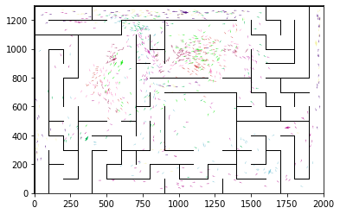

epoch 3201 == proposed_mle: 15.00+-0.34/14.60+-0.22 --

epoch 3202 == proposed_mle: 15.02+-0.34/14.61+-0.22 --

epoch 3203 == proposed_mle: 15.55+-0.36/14.70+-0.22 --

epoch 3204 == proposed_mle: 15.40+-0.38/14.47+-0.22 --

epoch 3205 == proposed_mle: 14.91+-0.30/14.37+-0.22 --

epoch 3206 == proposed_mle: 14.97+-0.33/14.57+-0.22 --

epoch 3207 == proposed_mle: 15.30+-0.29/14.49+-0.23 --

epoch 3208 == proposed_mle: 15.91+-0.30/14.43+-0.22 --

epoch 3209 == proposed_mle: 15.40+-0.38/14.63+-0.23 --

epoch 3210 == proposed_mle: 15.23+-0.27/14.45+-0.23 --

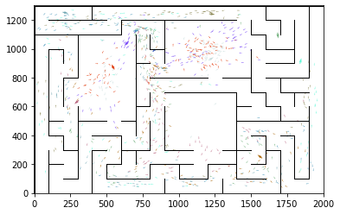

epoch 3211 == proposed_mle: 14.91+-0.36/14.64+-0.23 --

epoch 3212 == proposed_mle: 14.96+-0.32/14.36+-0.23 --

epoch 3213 == proposed_mle: 15.16+-0.29/14.66+-0.22 --

epoch 3214 == proposed_mle: 15.26+-0.34/14.58+-0.23 --

epoch 3215 == proposed_mle: 15.38+-0.35/14.44+-0.20 --

epoch 3216 == proposed_mle: 14.72+-0.32/14.51+-0.22 --

epoch 3217 >> proposed_mle: 15.05+-0.31/14.25+-0.23 --

epoch 3218 == proposed_mle: 14.72+-0.31/14.42+-0.22 --

epoch 3219 == proposed_mle: 15.22+-0.28/14.54+-0.23 --

epoch 3220 == proposed_mle: 15.31+-0.34/14.55+-0.23 --

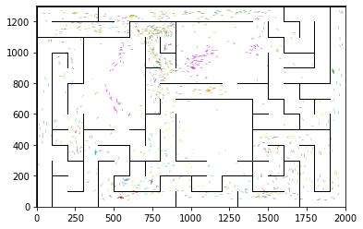

epoch 3221 == proposed_mle: 15.70+-0.25/14.48+-0.22 --

epoch 3222 == proposed_mle: 14.37+-0.26/14.49+-0.22 --

epoch 3223 == proposed_mle: 15.70+-0.26/14.45+-0.21 --

epoch 3224 == proposed_mle: 15.31+-0.31/14.36+-0.22 --

epoch 3225 == proposed_mle: 14.39+-0.31/14.35+-0.23 --

epoch 3226 == proposed_mle: 15.29+-0.31/14.39+-0.23 --

epoch 3227 == proposed_mle: 15.88+-0.30/14.52+-0.22 --

epoch 3228 == proposed_mle: 14.84+-0.31/14.39+-0.21 --

epoch 3229 == proposed_mle: 14.90+-0.33/14.56+-0.22 --

epoch 3230 == proposed_mle: 15.38+-0.34/14.38+-0.22 --

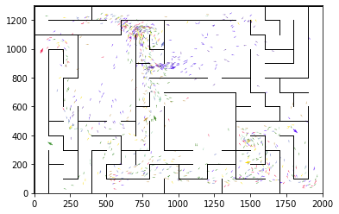

epoch 3231 == proposed_mle: 14.82+-0.32/14.26+-0.22 --

epoch 3232 == proposed_mle: 15.19+-0.24/14.42+-0.21 --

epoch 3233 == proposed_mle: 15.19+-0.32/14.26+-0.22 --

epoch 3234 == proposed_mle: 15.24+-0.40/14.45+-0.22 --

epoch 3235 == proposed_mle: 15.34+-0.30/14.55+-0.24 --

epoch 3236 == proposed_mle: 14.80+-0.35/14.51+-0.22 --

epoch 3237 == proposed_mle: 15.34+-0.30/14.45+-0.22 --

epoch 3238 == proposed_mle: 15.22+-0.37/14.36+-0.23 --

epoch 3239 == proposed_mle: 15.27+-0.31/14.37+-0.21 --

epoch 3240 == proposed_mle: 14.92+-0.28/14.25+-0.20 --

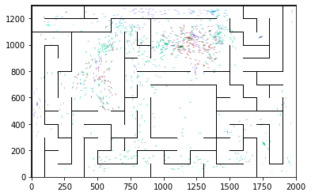

epoch 3241 == proposed_mle: 15.13+-0.25/14.39+-0.24 --

epoch 3242 >> proposed_mle: 15.09+-0.27/14.25+-0.23 --

epoch 3243 == proposed_mle: 14.97+-0.25/14.36+-0.22 --

epoch 3244 == proposed_mle: 14.96+-0.31/14.51+-0.25 --

epoch 3245 == proposed_mle: 15.35+-0.34/14.46+-0.23 --

epoch 3246 == proposed_mle: 15.05+-0.24/14.37+-0.23 --

epoch 3247 == proposed_mle: 15.16+-0.32/14.55+-0.21 --

epoch 3248 == proposed_mle: 15.01+-0.35/14.57+-0.21 --

epoch 3249 == proposed_mle: 15.30+-0.41/14.52+-0.23 --

epoch 3250 == proposed_mle: 15.47+-0.37/14.49+-0.21 --

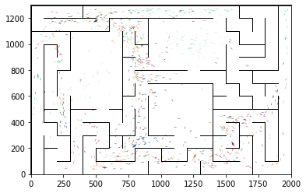

epoch 3251 == proposed_mle: 14.89+-0.39/14.31+-0.22 --

epoch 3252 == proposed_mle: 14.98+-0.32/14.71+-0.23 --

epoch 3253 == proposed_mle: 15.11+-0.27/14.71+-0.23 --

epoch 3254 == proposed_mle: 15.22+-0.35/14.46+-0.22 --

epoch 3255 == proposed_mle: 15.35+-0.35/14.57+-0.23 --

epoch 3256 == proposed_mle: 15.42+-0.32/14.36+-0.23 --

epoch 3257 >> proposed_mle: 15.00+-0.37/14.24+-0.23 --

epoch 3258 == proposed_mle: 15.16+-0.33/14.59+-0.22 --

epoch 3259 == proposed_mle: 15.09+-0.30/14.40+-0.22 --

epoch 3260 >> proposed_mle: 15.01+-0.34/14.21+-0.21 --

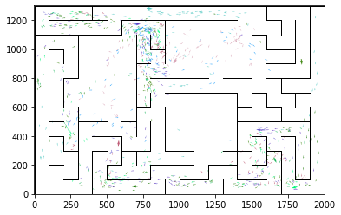

epoch 3261 == proposed_mle: 14.98+-0.43/14.34+-0.23 --

epoch 3262 == proposed_mle: 15.02+-0.33/14.49+-0.23 --

epoch 3263 == proposed_mle: 15.19+-0.35/14.37+-0.20 --

epoch 3264 == proposed_mle: 15.25+-0.32/14.36+-0.21 --

epoch 3265 == proposed_mle: 15.23+-0.32/14.24+-0.24 --

epoch 3266 == proposed_mle: 14.87+-0.33/14.35+-0.23 --

epoch 3267 == proposed_mle: 15.33+-0.37/14.44+-0.23 --

epoch 3268 == proposed_mle: 14.65+-0.33/14.40+-0.23 --

epoch 3269 == proposed_mle: 15.21+-0.32/14.44+-0.22 --

epoch 3270 == proposed_mle: 15.47+-0.30/14.36+-0.23 --

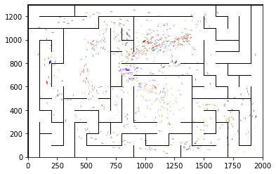

epoch 3271 == proposed_mle: 14.82+-0.36/14.48+-0.24 --

epoch 3272 == proposed_mle: 15.38+-0.32/14.49+-0.23 --

epoch 3273 == proposed_mle: 14.64+-0.30/14.38+-0.23 --

epoch 3274 == proposed_mle: 15.35+-0.32/14.75+-0.23 --

epoch 3275 == proposed_mle: 15.71+-0.31/14.39+-0.22 --

epoch 3276 == proposed_mle: 14.83+-0.29/14.30+-0.22 --

epoch 3277 == proposed_mle: 14.94+-0.24/14.43+-0.23 --

epoch 3278 == proposed_mle: 15.21+-0.39/14.51+-0.21 --

epoch 3279 == proposed_mle: 15.71+-0.34/14.50+-0.22 --

epoch 3280 == proposed_mle: 15.05+-0.28/14.58+-0.24 --

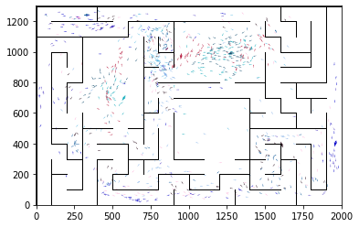

epoch 3281 == proposed_mle: 15.11+-0.33/14.35+-0.22 --

epoch 3282 == proposed_mle: 15.44+-0.28/14.42+-0.24 --

epoch 3283 == proposed_mle: 14.90+-0.30/14.32+-0.23 --

epoch 3284 == proposed_mle: 15.58+-0.37/14.45+-0.23 --

epoch 3285 == proposed_mle: 15.08+-0.29/14.37+-0.23 --

epoch 3286 == proposed_mle: 15.52+-0.37/14.30+-0.21 --

epoch 3287 == proposed_mle: 14.66+-0.31/14.28+-0.22 --

epoch 3288 == proposed_mle: 16.02+-0.34/14.45+-0.24 --

epoch 3289 == proposed_mle: 15.53+-0.32/14.49+-0.22 --

epoch 3290 == proposed_mle: 14.98+-0.29/14.42+-0.24 --

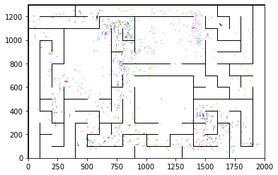

epoch 3291 == proposed_mle: 15.54+-0.30/14.56+-0.22 --

epoch 3292 == proposed_mle: 15.76+-0.27/14.43+-0.21 --

epoch 3293 == proposed_mle: 15.39+-0.34/14.25+-0.21 --

epoch 3294 == proposed_mle: 15.25+-0.29/14.36+-0.22 --

epoch 3295 == proposed_mle: 15.04+-0.29/14.29+-0.20 --

epoch 3296 == proposed_mle: 15.32+-0.28/14.51+-0.24 --

epoch 3297 == proposed_mle: 15.37+-0.30/14.46+-0.23 --

epoch 3298 == proposed_mle: 14.61+-0.32/14.41+-0.21 --

epoch 3299 == proposed_mle: 15.32+-0.36/14.36+-0.21 --

epoch 3300 >> proposed_mle: 14.50+-0.31/14.21+-0.21 --

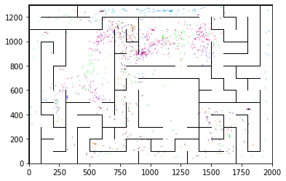

epoch 3301 == proposed_mle: 15.40+-0.34/14.48+-0.23 --

epoch 3302 == proposed_mle: 14.71+-0.29/14.35+-0.24 --

epoch 3303 == proposed_mle: 14.95+-0.32/14.40+-0.23 --

epoch 3304 == proposed_mle: 15.38+-0.28/14.34+-0.23 --

epoch 3305 == proposed_mle: 14.90+-0.30/14.27+-0.22 --

epoch 3306 == proposed_mle: 14.82+-0.28/14.31+-0.22 --

epoch 3307 == proposed_mle: 15.40+-0.34/14.28+-0.22 --

epoch 3308 == proposed_mle: 14.95+-0.26/14.39+-0.23 --

epoch 3309 == proposed_mle: 14.70+-0.28/14.24+-0.24 --

epoch 3310 == proposed_mle: 15.22+-0.26/14.30+-0.22 --

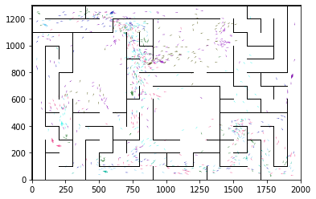

epoch 3311 == proposed_mle: 14.59+-0.26/14.42+-0.23 --

epoch 3312 == proposed_mle: 15.36+-0.35/14.41+-0.24 --

epoch 3313 == proposed_mle: 15.01+-0.27/14.39+-0.21 --

epoch 3314 == proposed_mle: 15.16+-0.31/14.30+-0.22 --

epoch 3315 == proposed_mle: 15.66+-0.36/14.25+-0.23 --

epoch 3316 == proposed_mle: 15.52+-0.33/14.61+-0.23 --

epoch 3317 == proposed_mle: 14.78+-0.28/14.27+-0.24 --

epoch 3318 == proposed_mle: 14.96+-0.26/14.40+-0.23 --

epoch 3319 == proposed_mle: 15.78+-0.34/14.36+-0.22 --

epoch 3320 == proposed_mle: 14.95+-0.28/14.40+-0.22 --

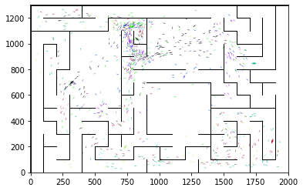

epoch 3321 == proposed_mle: 15.35+-0.36/14.45+-0.21 --

epoch 3322 == proposed_mle: 14.90+-0.31/14.54+-0.22 --

epoch 3323 == proposed_mle: 14.89+-0.30/14.37+-0.24 --

epoch 3324 == proposed_mle: 15.18+-0.30/14.49+-0.20 --

epoch 3325 == proposed_mle: 14.87+-0.30/14.29+-0.23 --

epoch 3326 == proposed_mle: 15.06+-0.35/14.59+-0.22 --

epoch 3327 == proposed_mle: 15.77+-0.36/14.49+-0.23 --

epoch 3328 == proposed_mle: 15.48+-0.30/14.34+-0.23 --

epoch 3329 == proposed_mle: 15.13+-0.30/14.54+-0.24 --

epoch 3330 == proposed_mle: 15.32+-0.34/14.55+-0.22 --

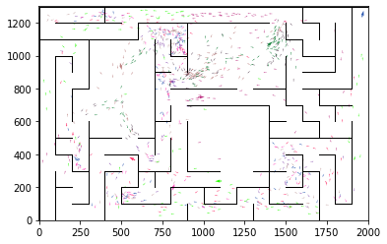

epoch 3331 == proposed_mle: 15.57+-0.33/14.41+-0.21 --

epoch 3332 == proposed_mle: 15.25+-0.29/14.26+-0.22 --

epoch 3333 == proposed_mle: 15.74+-0.31/14.48+-0.24 --

epoch 3334 == proposed_mle: 15.10+-0.33/14.38+-0.23 --

epoch 3335 == proposed_mle: 15.81+-0.34/14.44+-0.23 --

epoch 3336 == proposed_mle: 15.38+-0.27/14.21+-0.24 --

epoch 3337 >> proposed_mle: 14.82+-0.27/14.17+-0.25 --

epoch 3338 == proposed_mle: 15.42+-0.29/14.27+-0.21 --

epoch 3339 >> proposed_mle: 14.80+-0.36/14.12+-0.22 --

epoch 3340 == proposed_mle: 14.64+-0.30/14.42+-0.22 --

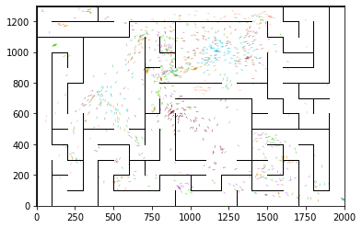

epoch 3341 == proposed_mle: 15.57+-0.37/14.39+-0.22 --

epoch 3342 == proposed_mle: 15.50+-0.37/14.49+-0.23 --

epoch 3343 == proposed_mle: 15.77+-0.38/14.39+-0.23 --

epoch 3344 == proposed_mle: 15.39+-0.25/14.47+-0.22 --

epoch 3345 == proposed_mle: 14.90+-0.31/14.37+-0.21 --

epoch 3346 == proposed_mle: 15.63+-0.28/14.39+-0.22 --

epoch 3347 == proposed_mle: 14.69+-0.34/14.35+-0.21 --

epoch 3348 == proposed_mle: 15.39+-0.33/14.27+-0.23 --

epoch 3349 == proposed_mle: 15.58+-0.30/14.40+-0.25 --

epoch 3350 == proposed_mle: 14.84+-0.31/14.31+-0.23 --

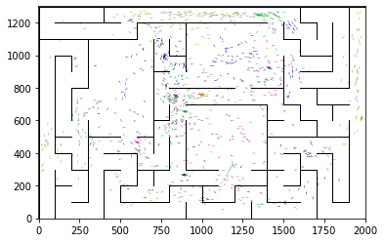

epoch 3351 == proposed_mle: 14.81+-0.28/14.37+-0.22 --

epoch 3352 == proposed_mle: 14.93+-0.33/14.27+-0.22 --

epoch 3353 == proposed_mle: 15.29+-0.32/14.36+-0.23 --

epoch 3354 == proposed_mle: 15.19+-0.30/14.54+-0.23 --

epoch 3355 == proposed_mle: 15.60+-0.31/14.51+-0.23 --

epoch 3356 == proposed_mle: 14.90+-0.25/14.34+-0.21 --

epoch 3357 == proposed_mle: 15.28+-0.27/14.40+-0.24 --

epoch 3358 == proposed_mle: 15.16+-0.30/14.55+-0.22 --

epoch 3359 == proposed_mle: 15.10+-0.36/14.40+-0.23 --

epoch 3360 == proposed_mle: 14.94+-0.30/14.44+-0.21 --

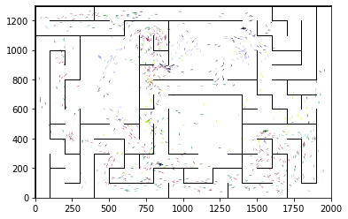

epoch 3361 == proposed_mle: 15.36+-0.29/14.35+-0.21 --

epoch 3362 == proposed_mle: 15.13+-0.30/14.57+-0.22 --

epoch 3363 == proposed_mle: 14.68+-0.30/14.45+-0.22 --

epoch 3364 == proposed_mle: 15.22+-0.26/14.31+-0.22 --

epoch 3365 == proposed_mle: 14.54+-0.32/14.50+-0.22 --

epoch 3366 == proposed_mle: 15.10+-0.31/14.40+-0.21 --

epoch 3367 == proposed_mle: 14.36+-0.31/14.29+-0.22 --

epoch 3368 == proposed_mle: 15.73+-0.31/14.75+-0.22 --

epoch 3369 == proposed_mle: 15.33+-0.31/14.59+-0.21 --

epoch 3370 == proposed_mle: 15.00+-0.32/14.46+-0.22 --

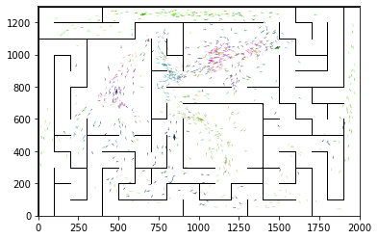

epoch 3371 == proposed_mle: 15.25+-0.31/14.50+-0.23 --

epoch 3372 == proposed_mle: 15.27+-0.33/14.54+-0.21 --

epoch 3373 == proposed_mle: 14.85+-0.33/14.53+-0.24 --

epoch 3374 == proposed_mle: 15.40+-0.35/14.65+-0.23 --

epoch 3375 == proposed_mle: 15.43+-0.34/14.67+-0.23 --

epoch 3376 == proposed_mle: 15.28+-0.44/14.34+-0.23 --

epoch 3377 == proposed_mle: 15.13+-0.34/14.66+-0.24 --

epoch 3378 == proposed_mle: 15.15+-0.31/14.44+-0.22 --

epoch 3379 == proposed_mle: 15.36+-0.29/14.61+-0.23 --

epoch 3380 == proposed_mle: 14.54+-0.29/14.47+-0.23 --

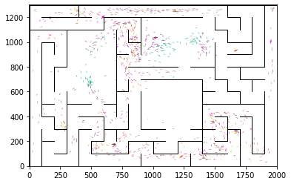

epoch 3381 == proposed_mle: 14.59+-0.31/14.61+-0.23 --

epoch 3382 == proposed_mle: 15.40+-0.32/14.22+-0.22 --

epoch 3383 == proposed_mle: 15.19+-0.30/14.14+-0.21 --

epoch 3384 == proposed_mle: 15.20+-0.30/14.38+-0.21 --

epoch 3385 == proposed_mle: 15.00+-0.28/14.41+-0.23 --

epoch 3386 == proposed_mle: 15.32+-0.27/14.37+-0.21 --

epoch 3387 == proposed_mle: 14.81+-0.30/14.41+-0.23 --

epoch 3388 == proposed_mle: 15.01+-0.32/14.25+-0.22 --

epoch 3389 == proposed_mle: 14.82+-0.36/14.44+-0.23 --

epoch 3390 == proposed_mle: 15.21+-0.36/14.44+-0.21 --

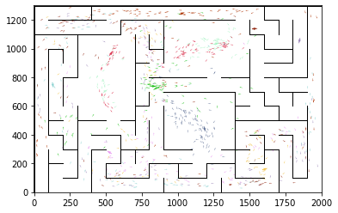

epoch 3391 == proposed_mle: 15.37+-0.36/14.43+-0.24 --

epoch 3392 == proposed_mle: 15.02+-0.34/14.43+-0.22 --

epoch 3393 == proposed_mle: 15.10+-0.29/14.33+-0.21 --

epoch 3394 == proposed_mle: 14.54+-0.28/14.43+-0.23 --

epoch 3395 == proposed_mle: 14.88+-0.29/14.55+-0.22 --

epoch 3396 == proposed_mle: 15.40+-0.33/14.32+-0.23 --

epoch 3397 == proposed_mle: 14.96+-0.28/14.29+-0.23 --

epoch 3398 == proposed_mle: 14.74+-0.31/14.29+-0.20 --

epoch 3399 == proposed_mle: 15.09+-0.37/14.31+-0.22 --

epoch 3400 == proposed_mle: 15.03+-0.31/14.25+-0.24 --

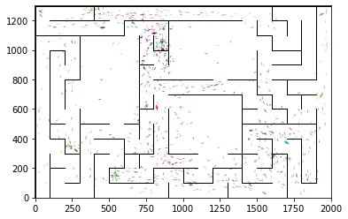

epoch 3401 == proposed_mle: 14.35+-0.26/14.18+-0.23 --

epoch 3402 == proposed_mle: 15.10+-0.32/14.12+-0.23 --

epoch 3403 == proposed_mle: 15.09+-0.33/14.35+-0.21 --

epoch 3404 == proposed_mle: 15.41+-0.28/14.24+-0.23 --

epoch 3405 == proposed_mle: 15.14+-0.33/14.49+-0.21 --

epoch 3406 == proposed_mle: 15.07+-0.29/14.56+-0.23 --

epoch 3407 == proposed_mle: 14.72+-0.26/14.33+-0.23 --

epoch 3408 == proposed_mle: 15.11+-0.28/14.31+-0.22 --

epoch 3409 == proposed_mle: 15.07+-0.28/14.37+-0.22 --

epoch 3410 == proposed_mle: 15.36+-0.29/14.58+-0.22 --

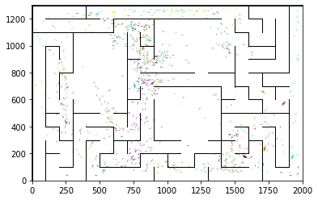

epoch 3411 == proposed_mle: 15.31+-0.31/14.40+-0.20 --

epoch 3412 == proposed_mle: 15.09+-0.34/14.33+-0.21 --

epoch 3413 == proposed_mle: 14.86+-0.31/14.24+-0.22 --

epoch 3414 == proposed_mle: 14.64+-0.31/14.28+-0.22 --

epoch 3415 == proposed_mle: 15.17+-0.35/14.18+-0.22 --

epoch 3416 == proposed_mle: 14.85+-0.34/14.26+-0.22 --

epoch 3417 == proposed_mle: 14.66+-0.31/14.19+-0.22 --

epoch 3418 == proposed_mle: 15.54+-0.30/14.38+-0.23 --

epoch 3419 == proposed_mle: 14.79+-0.32/14.23+-0.22 --

epoch 3420 == proposed_mle: 14.88+-0.28/14.38+-0.22 --

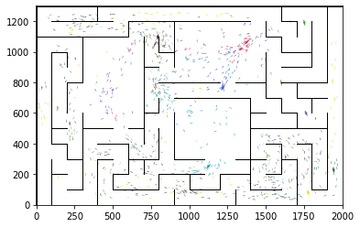

epoch 3421 == proposed_mle: 15.15+-0.35/14.28+-0.23 --

epoch 3422 == proposed_mle: 14.51+-0.30/14.37+-0.22 --

epoch 3423 == proposed_mle: 14.75+-0.33/14.24+-0.23 --

epoch 3424 == proposed_mle: 14.72+-0.34/14.36+-0.23 --

epoch 3425 == proposed_mle: 15.24+-0.26/14.41+-0.24 --

epoch 3426 == proposed_mle: 14.91+-0.34/14.41+-0.21 --

epoch 3427 == proposed_mle: 15.41+-0.32/14.27+-0.23 --

epoch 3428 == proposed_mle: 14.91+-0.29/14.57+-0.22 --

epoch 3429 == proposed_mle: 14.83+-0.29/14.31+-0.22 --

epoch 3430 == proposed_mle: 15.28+-0.29/14.33+-0.22 --

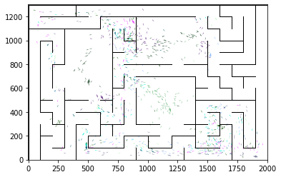

epoch 3431 == proposed_mle: 14.76+-0.38/14.27+-0.21 --

epoch 3432 == proposed_mle: 15.22+-0.34/14.35+-0.24 --

epoch 3433 == proposed_mle: 15.10+-0.34/14.61+-0.23 --

epoch 3434 == proposed_mle: 15.78+-0.32/14.48+-0.22 --

epoch 3435 == proposed_mle: 14.80+-0.27/14.37+-0.22 --

epoch 3436 == proposed_mle: 15.03+-0.32/14.36+-0.21 --

epoch 3437 == proposed_mle: 15.24+-0.29/14.39+-0.23 --

epoch 3438 == proposed_mle: 15.07+-0.25/14.25+-0.22 --

epoch 3439 == proposed_mle: 14.92+-0.34/14.18+-0.24 --

epoch 3440 >> proposed_mle: 15.05+-0.32/14.00+-0.22 --

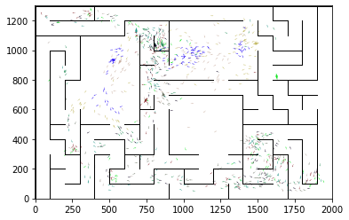

epoch 3441 == proposed_mle: 14.53+-0.36/14.26+-0.20 --

epoch 3442 == proposed_mle: 15.04+-0.36/14.42+-0.23 --

epoch 3443 == proposed_mle: 14.81+-0.30/14.46+-0.24 --

epoch 3444 == proposed_mle: 14.53+-0.38/14.29+-0.22 --

epoch 3445 == proposed_mle: 15.06+-0.29/14.33+-0.22 --

epoch 3446 == proposed_mle: 15.02+-0.28/14.18+-0.23 --

epoch 3447 == proposed_mle: 14.85+-0.35/14.37+-0.23 --

epoch 3448 == proposed_mle: 14.54+-0.35/14.32+-0.24 --

epoch 3449 == proposed_mle: 15.58+-0.30/14.27+-0.22 --

epoch 3450 == proposed_mle: 15.31+-0.32/14.20+-0.23 --

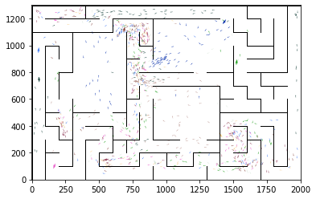

epoch 3451 == proposed_mle: 15.08+-0.33/14.35+-0.23 --

epoch 3452 == proposed_mle: 15.00+-0.28/14.22+-0.21 --

epoch 3453 == proposed_mle: 15.29+-0.28/14.37+-0.23 --

epoch 3454 == proposed_mle: 15.08+-0.31/14.53+-0.22 --

epoch 3455 == proposed_mle: 15.07+-0.30/14.49+-0.23 --

epoch 3456 == proposed_mle: 14.72+-0.33/14.37+-0.21 --

epoch 3457 == proposed_mle: 15.29+-0.32/14.40+-0.23 --

epoch 3458 == proposed_mle: 15.09+-0.27/14.12+-0.22 --

epoch 3459 == proposed_mle: 14.78+-0.26/14.29+-0.23 --

epoch 3460 == proposed_mle: 15.01+-0.27/14.27+-0.23 --

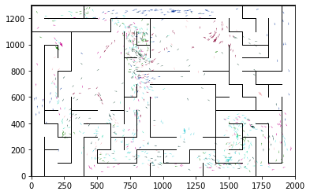

epoch 3461 == proposed_mle: 15.17+-0.30/14.42+-0.24 --

epoch 3462 == proposed_mle: 14.74+-0.30/14.26+-0.23 --

epoch 3463 == proposed_mle: 15.09+-0.31/14.48+-0.23 --

epoch 3464 == proposed_mle: 14.97+-0.33/14.28+-0.21 --

epoch 3465 == proposed_mle: 14.50+-0.33/14.29+-0.23 --

epoch 3466 == proposed_mle: 15.28+-0.31/14.41+-0.22 --

epoch 3467 == proposed_mle: 14.50+-0.30/14.31+-0.23 --

epoch 3468 == proposed_mle: 15.04+-0.35/14.31+-0.23 --

epoch 3469 == proposed_mle: 14.62+-0.27/14.30+-0.23 --

epoch 3470 == proposed_mle: 14.71+-0.31/14.36+-0.22 --

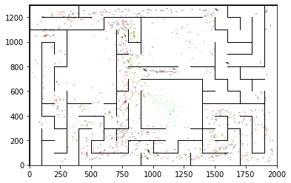

epoch 3471 == proposed_mle: 14.91+-0.32/14.25+-0.22 --

epoch 3472 == proposed_mle: 14.80+-0.33/14.42+-0.22 --

epoch 3473 == proposed_mle: 15.38+-0.30/14.15+-0.24 --

epoch 3474 == proposed_mle: 14.74+-0.28/14.40+-0.22 --

epoch 3475 == proposed_mle: 14.56+-0.27/14.38+-0.22 --

epoch 3476 == proposed_mle: 14.26+-0.24/14.37+-0.23 --

epoch 3477 == proposed_mle: 15.65+-0.32/14.45+-0.22 --

epoch 3478 == proposed_mle: 15.00+-0.31/14.41+-0.24 --

epoch 3479 == proposed_mle: 14.78+-0.31/14.21+-0.23 --

epoch 3480 == proposed_mle: 15.25+-0.34/14.27+-0.23 --

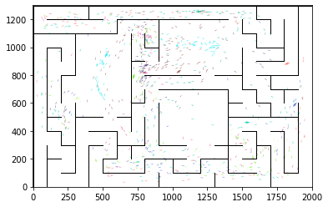

epoch 3481 == proposed_mle: 14.46+-0.31/14.31+-0.22 --

epoch 3482 == proposed_mle: 15.04+-0.32/14.42+-0.22 --

epoch 3483 == proposed_mle: 15.64+-0.31/14.21+-0.23 --

epoch 3484 == proposed_mle: 15.09+-0.32/14.39+-0.23 --

epoch 3485 == proposed_mle: 14.96+-0.33/14.15+-0.23 --

epoch 3486 == proposed_mle: 15.07+-0.29/14.38+-0.21 --

epoch 3487 == proposed_mle: 14.90+-0.28/14.42+-0.21 --

epoch 3488 == proposed_mle: 15.36+-0.41/14.18+-0.22 --

epoch 3489 == proposed_mle: 15.00+-0.28/14.47+-0.22 --

epoch 3490 == proposed_mle: 15.48+-0.33/14.17+-0.21 --

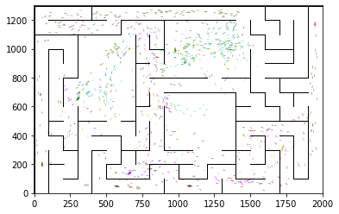

epoch 3491 == proposed_mle: 14.86+-0.32/14.21+-0.21 --

epoch 3492 == proposed_mle: 14.94+-0.29/14.28+-0.22 --

epoch 3493 == proposed_mle: 14.95+-0.32/14.21+-0.22 --

epoch 3494 == proposed_mle: 14.69+-0.33/14.18+-0.22 --

epoch 3495 == proposed_mle: 14.81+-0.32/14.24+-0.23 --

epoch 3496 == proposed_mle: 15.18+-0.33/14.22+-0.22 --

epoch 3497 == proposed_mle: 15.14+-0.36/14.16+-0.23 --

epoch 3498 == proposed_mle: 14.41+-0.35/14.10+-0.22 --

epoch 3499 == proposed_mle: 15.15+-0.33/14.28+-0.23 --

epoch 3500 == proposed_mle: 14.61+-0.34/14.24+-0.23 --

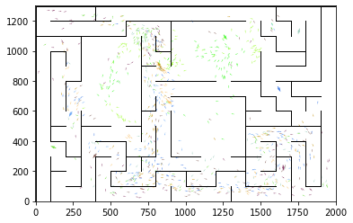

epoch 3501 == proposed_mle: 15.28+-0.31/14.21+-0.23 --

epoch 3502 == proposed_mle: 15.27+-0.28/14.28+-0.21 --

epoch 3503 == proposed_mle: 14.65+-0.35/14.03+-0.22 --

epoch 3504 == proposed_mle: 15.11+-0.29/14.33+-0.23 --

epoch 3505 == proposed_mle: 15.13+-0.29/14.24+-0.23 --

epoch 3506 == proposed_mle: 15.02+-0.35/14.33+-0.23 --

epoch 3507 == proposed_mle: 14.78+-0.32/14.16+-0.22 --

epoch 3508 == proposed_mle: 14.99+-0.27/14.13+-0.23 --

epoch 3509 == proposed_mle: 14.79+-0.33/14.27+-0.22 --

epoch 3510 == proposed_mle: 15.22+-0.33/14.26+-0.22 --

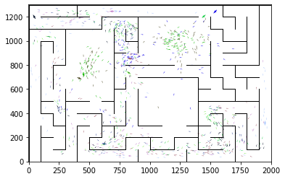

epoch 3511 == proposed_mle: 15.17+-0.35/14.17+-0.22 --

epoch 3512 == proposed_mle: 15.23+-0.29/14.35+-0.23 --

epoch 3513 == proposed_mle: 14.46+-0.33/14.29+-0.22 --

epoch 3514 == proposed_mle: 15.37+-0.36/14.34+-0.21 --

epoch 3515 == proposed_mle: 14.95+-0.28/14.28+-0.23 --

epoch 3516 == proposed_mle: 14.74+-0.32/14.20+-0.19 --

epoch 3517 == proposed_mle: 14.90+-0.31/14.22+-0.21 --

epoch 3518 == proposed_mle: 14.93+-0.33/14.25+-0.24 --

epoch 3519 == proposed_mle: 14.74+-0.30/14.28+-0.22 --

epoch 3520 == proposed_mle: 15.49+-0.37/14.40+-0.22 --

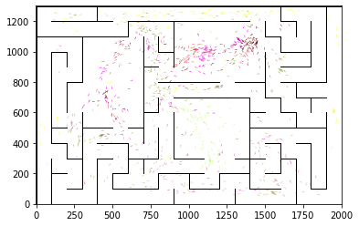

epoch 3521 == proposed_mle: 14.74+-0.32/14.38+-0.22 --

epoch 3522 == proposed_mle: 14.98+-0.28/14.56+-0.22 --

epoch 3523 == proposed_mle: 15.18+-0.28/14.45+-0.23 --

epoch 3524 == proposed_mle: 15.13+-0.33/14.39+-0.23 --

epoch 3525 == proposed_mle: 14.78+-0.29/14.59+-0.24 --

epoch 3526 == proposed_mle: 15.25+-0.30/14.33+-0.20 --

epoch 3527 == proposed_mle: 15.30+-0.32/14.44+-0.24 --

epoch 3528 == proposed_mle: 14.87+-0.34/14.47+-0.23 --

epoch 3529 == proposed_mle: 15.02+-0.31/14.21+-0.21 --

epoch 3530 == proposed_mle: 15.05+-0.33/14.16+-0.22 --

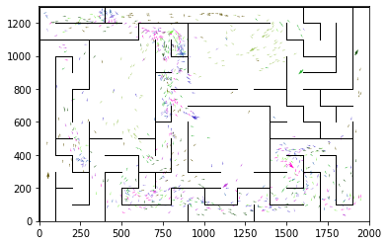

epoch 3531 == proposed_mle: 15.12+-0.34/14.42+-0.24 --

epoch 3532 == proposed_mle: 14.88+-0.30/14.13+-0.22 --

epoch 3533 == proposed_mle: 15.54+-0.28/14.28+-0.22 --

epoch 3534 == proposed_mle: 15.16+-0.33/14.27+-0.21 --

epoch 3535 == proposed_mle: 15.73+-0.36/14.44+-0.20 --

epoch 3536 == proposed_mle: 14.97+-0.30/14.06+-0.20 --

epoch 3537 == proposed_mle: 14.53+-0.34/14.06+-0.19 --

epoch 3538 == proposed_mle: 14.62+-0.35/14.43+-0.22 --

epoch 3539 == proposed_mle: 14.69+-0.33/14.39+-0.21 --

epoch 3540 == proposed_mle: 15.14+-0.28/14.45+-0.22 --

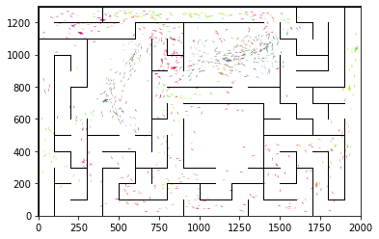

epoch 3541 == proposed_mle: 14.96+-0.30/14.26+-0.22 --

epoch 3542 == proposed_mle: 15.33+-0.32/14.54+-0.23 --

epoch 3543 == proposed_mle: 15.28+-0.31/14.23+-0.21 --

epoch 3544 == proposed_mle: 14.68+-0.34/14.38+-0.22 --

epoch 3545 == proposed_mle: 15.32+-0.33/14.30+-0.23 --

epoch 3546 == proposed_mle: 15.17+-0.31/14.41+-0.23 --

epoch 3547 == proposed_mle: 14.66+-0.33/14.43+-0.22 --

epoch 3548 == proposed_mle: 15.57+-0.36/14.48+-0.24 --

epoch 3549 == proposed_mle: 14.95+-0.30/14.35+-0.24 --

epoch 3550 == proposed_mle: 14.77+-0.28/14.51+-0.21 --

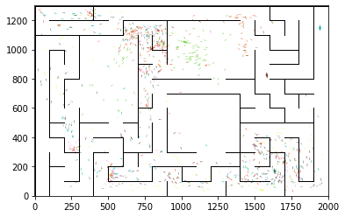

epoch 3551 == proposed_mle: 14.95+-0.34/14.36+-0.21 --

epoch 3552 == proposed_mle: 15.10+-0.31/14.51+-0.23 --

epoch 3553 == proposed_mle: 15.04+-0.40/14.49+-0.23 --

epoch 3554 == proposed_mle: 15.43+-0.30/14.24+-0.23 --

epoch 3555 == proposed_mle: 15.12+-0.30/14.41+-0.22 --

epoch 3556 == proposed_mle: 14.86+-0.31/14.42+-0.21 --

epoch 3557 == proposed_mle: 14.82+-0.29/14.34+-0.21 --

epoch 3558 == proposed_mle: 15.40+-0.33/14.36+-0.21 --

epoch 3559 == proposed_mle: 15.80+-0.29/14.44+-0.24 --

epoch 3560 == proposed_mle: 15.12+-0.32/14.11+-0.21 --

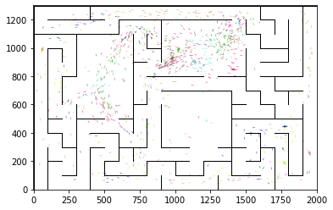

epoch 3561 == proposed_mle: 15.05+-0.29/14.21+-0.23 --

epoch 3562 == proposed_mle: 15.04+-0.29/14.07+-0.22 --

epoch 3563 == proposed_mle: 15.43+-0.28/14.17+-0.21 --

epoch 3564 == proposed_mle: 15.02+-0.30/14.32+-0.24 --

epoch 3565 == proposed_mle: 15.33+-0.30/14.22+-0.22 --

epoch 3566 == proposed_mle: 14.91+-0.37/14.06+-0.22 --

epoch 3567 == proposed_mle: 14.76+-0.27/14.28+-0.22 --

epoch 3568 == proposed_mle: 15.03+-0.28/14.35+-0.21 --

epoch 3569 == proposed_mle: 14.60+-0.27/14.26+-0.21 --

epoch 3570 == proposed_mle: 14.85+-0.34/14.23+-0.23 --

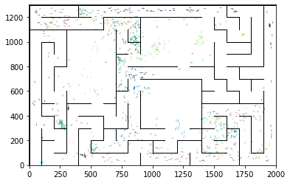

epoch 3571 == proposed_mle: 15.09+-0.31/14.30+-0.21 --

epoch 3572 == proposed_mle: 15.45+-0.35/14.36+-0.22 --

epoch 3573 == proposed_mle: 15.72+-0.30/14.23+-0.21 --

epoch 3574 == proposed_mle: 15.22+-0.31/14.34+-0.21 --

epoch 3575 == proposed_mle: 14.90+-0.29/14.06+-0.21 --

epoch 3576 == proposed_mle: 14.69+-0.32/14.28+-0.23 --

epoch 3577 == proposed_mle: 15.02+-0.29/14.17+-0.22 --

epoch 3578 == proposed_mle: 15.21+-0.28/14.31+-0.21 --

epoch 3579 == proposed_mle: 15.27+-0.30/14.14+-0.22 --

epoch 3580 == proposed_mle: 15.01+-0.33/14.34+-0.22 --

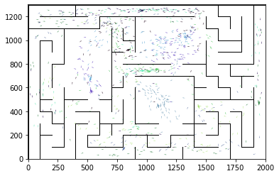

epoch 3581 == proposed_mle: 15.45+-0.33/14.16+-0.22 --

epoch 3582 == proposed_mle: 14.68+-0.39/14.14+-0.22 --

epoch 3583 == proposed_mle: 15.41+-0.31/14.29+-0.24 --

epoch 3584 == proposed_mle: 14.76+-0.31/14.26+-0.21 --

epoch 3585 == proposed_mle: 14.94+-0.26/14.45+-0.21 --

epoch 3586 == proposed_mle: 15.25+-0.34/14.27+-0.21 --

epoch 3587 == proposed_mle: 14.91+-0.28/14.09+-0.21 --

epoch 3588 == proposed_mle: 14.86+-0.30/14.20+-0.22 --

epoch 3589 == proposed_mle: 14.54+-0.32/14.14+-0.22 --

epoch 3590 == proposed_mle: 14.93+-0.31/14.22+-0.22 --

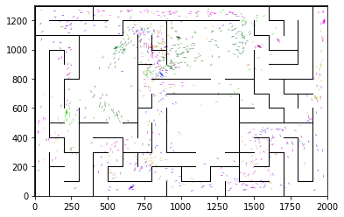

epoch 3591 == proposed_mle: 15.35+-0.31/14.34+-0.21 --

epoch 3592 == proposed_mle: 15.08+-0.30/14.31+-0.22 --

epoch 3593 == proposed_mle: 14.94+-0.29/14.24+-0.21 --

epoch 3594 == proposed_mle: 14.97+-0.27/14.06+-0.22 --

epoch 3595 == proposed_mle: 15.00+-0.32/14.26+-0.22 --

epoch 3596 == proposed_mle: 15.23+-0.35/14.16+-0.25 --

epoch 3597 == proposed_mle: 14.76+-0.27/14.27+-0.21 --

epoch 3598 == proposed_mle: 15.12+-0.35/14.31+-0.21 --

epoch 3599 == proposed_mle: 14.67+-0.27/14.30+-0.22 --

epoch 3600 == proposed_mle: 15.01+-0.26/14.23+-0.21 --

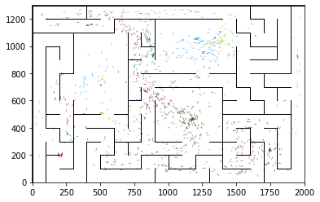

epoch 3601 == proposed_mle: 15.81+-0.36/14.11+-0.22 --

epoch 3602 == proposed_mle: 14.59+-0.32/14.32+-0.23 --

epoch 3603 == proposed_mle: 14.92+-0.26/14.21+-0.24 --

epoch 3604 == proposed_mle: 15.38+-0.32/14.15+-0.21 --

epoch 3605 == proposed_mle: 14.71+-0.34/14.16+-0.23 --

epoch 3606 == proposed_mle: 14.89+-0.34/14.26+-0.21 --

epoch 3607 == proposed_mle: 14.99+-0.30/14.23+-0.23 --

epoch 3608 == proposed_mle: 14.77+-0.27/14.28+-0.23 --

epoch 3609 == proposed_mle: 15.05+-0.31/14.19+-0.23 --

epoch 3610 == proposed_mle: 14.65+-0.32/14.27+-0.22 --

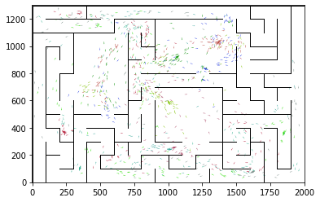

epoch 3611 == proposed_mle: 15.48+-0.28/14.26+-0.22 --

epoch 3612 == proposed_mle: 15.33+-0.25/14.25+-0.23 --

epoch 3613 == proposed_mle: 14.34+-0.28/14.24+-0.24 --

epoch 3614 == proposed_mle: 14.86+-0.25/14.22+-0.21 --

epoch 3615 >> proposed_mle: 15.17+-0.28/13.98+-0.22 --

epoch 3616 == proposed_mle: 14.57+-0.35/14.39+-0.26 --

epoch 3617 == proposed_mle: 15.39+-0.26/14.41+-0.21 --

epoch 3618 == proposed_mle: 14.76+-0.38/14.47+-0.23 --

epoch 3619 == proposed_mle: 15.13+-0.32/14.17+-0.22 --

epoch 3620 == proposed_mle: 14.35+-0.34/14.16+-0.23 --

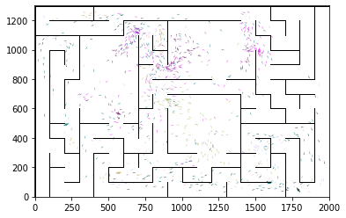

epoch 3621 == proposed_mle: 14.58+-0.30/14.34+-0.22 --

epoch 3622 == proposed_mle: 14.61+-0.26/14.48+-0.23 --

epoch 3623 == proposed_mle: 14.88+-0.35/14.18+-0.24 --

epoch 3624 == proposed_mle: 14.73+-0.25/14.29+-0.24 --

epoch 3625 == proposed_mle: 14.73+-0.34/14.31+-0.24 --

epoch 3626 == proposed_mle: 15.07+-0.32/14.09+-0.21 --

epoch 3627 == proposed_mle: 14.93+-0.34/14.23+-0.23 --

epoch 3628 == proposed_mle: 14.89+-0.27/14.27+-0.23 --

epoch 3629 == proposed_mle: 14.34+-0.36/14.23+-0.22 --

epoch 3630 >> proposed_mle: 15.17+-0.33/13.97+-0.21 --

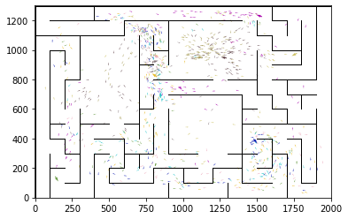

epoch 3631 == proposed_mle: 14.76+-0.35/14.27+-0.21 --

epoch 3632 == proposed_mle: 14.59+-0.34/14.27+-0.22 --

epoch 3633 == proposed_mle: 14.81+-0.33/14.19+-0.23 --

epoch 3634 == proposed_mle: 15.12+-0.37/14.26+-0.21 --

epoch 3635 == proposed_mle: 14.86+-0.28/14.32+-0.23 --

epoch 3636 == proposed_mle: 15.22+-0.29/14.33+-0.23 --

epoch 3637 == proposed_mle: 14.78+-0.31/14.46+-0.24 --

epoch 3638 == proposed_mle: 15.20+-0.26/14.29+-0.25 --

epoch 3639 == proposed_mle: 14.73+-0.25/14.31+-0.23 --

epoch 3640 == proposed_mle: 14.23+-0.29/14.43+-0.24 --

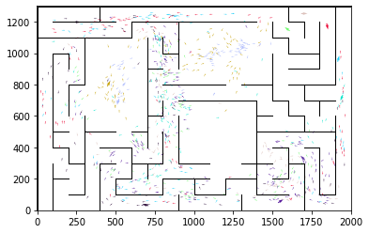

epoch 3641 == proposed_mle: 14.66+-0.33/14.25+-0.21 --

epoch 3642 == proposed_mle: 15.27+-0.32/14.28+-0.23 --

epoch 3643 == proposed_mle: 15.21+-0.27/14.31+-0.23 --

epoch 3644 == proposed_mle: 15.05+-0.34/14.39+-0.23 --

epoch 3645 == proposed_mle: 15.21+-0.33/14.35+-0.22 --

epoch 3646 == proposed_mle: 15.00+-0.29/14.12+-0.21 --

epoch 3647 == proposed_mle: 15.04+-0.32/14.32+-0.21 --

epoch 3648 >> proposed_mle: 15.03+-0.32/13.96+-0.22 --

epoch 3649 == proposed_mle: 15.18+-0.30/14.24+-0.24 --

epoch 3650 == proposed_mle: 14.95+-0.33/14.24+-0.22 --

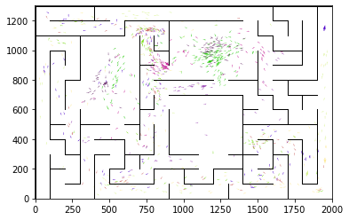

epoch 3651 == proposed_mle: 15.01+-0.33/14.22+-0.19 --

epoch 3652 == proposed_mle: 14.57+-0.31/14.19+-0.21 --

epoch 3653 == proposed_mle: 15.44+-0.27/14.53+-0.23 --

epoch 3654 == proposed_mle: 15.03+-0.35/14.55+-0.22 --

epoch 3655 == proposed_mle: 15.03+-0.35/14.32+-0.23 --

epoch 3656 == proposed_mle: 15.48+-0.29/14.39+-0.21 --

epoch 3657 == proposed_mle: 15.57+-0.31/14.16+-0.22 --

epoch 3658 == proposed_mle: 14.61+-0.31/14.18+-0.21 --

epoch 3659 == proposed_mle: 14.49+-0.26/14.18+-0.24 --

epoch 3660 == proposed_mle: 14.80+-0.34/14.31+-0.21 --

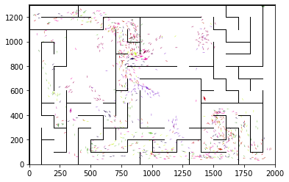

epoch 3661 == proposed_mle: 14.78+-0.31/14.44+-0.21 --

epoch 3662 == proposed_mle: 14.91+-0.28/14.48+-0.24 --

epoch 3663 == proposed_mle: 14.94+-0.27/14.25+-0.22 --

epoch 3664 == proposed_mle: 15.09+-0.32/14.32+-0.23 --

epoch 3665 == proposed_mle: 14.72+-0.30/14.32+-0.23 --

epoch 3666 == proposed_mle: 14.58+-0.29/14.15+-0.21 --

epoch 3667 == proposed_mle: 15.01+-0.25/14.21+-0.21 --

epoch 3668 == proposed_mle: 14.92+-0.25/14.12+-0.21 --

epoch 3669 == proposed_mle: 14.89+-0.30/14.22+-0.22 --

epoch 3670 == proposed_mle: 15.13+-0.30/14.36+-0.23 --

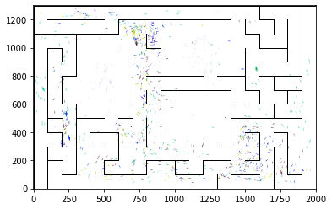

epoch 3671 == proposed_mle: 14.91+-0.29/14.34+-0.23 --

epoch 3672 == proposed_mle: 15.38+-0.34/14.23+-0.22 --

epoch 3673 == proposed_mle: 15.40+-0.33/14.21+-0.22 --

epoch 3674 == proposed_mle: 14.63+-0.35/14.25+-0.22 --

epoch 3675 == proposed_mle: 14.23+-0.32/14.26+-0.23 --

epoch 3676 == proposed_mle: 14.83+-0.28/14.30+-0.22 --

epoch 3677 == proposed_mle: 14.90+-0.34/13.98+-0.22 --

epoch 3678 == proposed_mle: 14.96+-0.32/14.11+-0.21 --

epoch 3679 == proposed_mle: 14.95+-0.32/14.17+-0.24 --

epoch 3680 == proposed_mle: 15.30+-0.31/14.36+-0.24 --

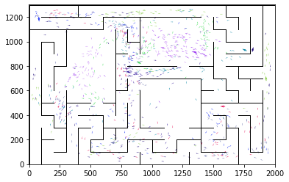

epoch 3681 == proposed_mle: 15.38+-0.32/14.51+-0.23 --

epoch 3682 == proposed_mle: 15.53+-0.30/14.44+-0.22 --

epoch 3683 == proposed_mle: 14.69+-0.32/13.96+-0.22 --

epoch 3684 == proposed_mle: 15.29+-0.29/14.08+-0.22 --

epoch 3685 == proposed_mle: 14.99+-0.32/14.33+-0.23 --

epoch 3686 == proposed_mle: 14.92+-0.38/13.99+-0.21 --

epoch 3687 == proposed_mle: 14.47+-0.32/14.27+-0.23 --

epoch 3688 == proposed_mle: 14.85+-0.36/14.22+-0.22 --

epoch 3689 == proposed_mle: 14.76+-0.29/13.98+-0.24 --

epoch 3690 == proposed_mle: 14.86+-0.35/14.10+-0.21 --

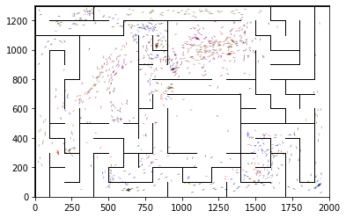

epoch 3691 == proposed_mle: 14.90+-0.30/14.09+-0.23 --

epoch 3692 == proposed_mle: 15.27+-0.32/14.07+-0.23 --

epoch 3693 == proposed_mle: 15.08+-0.27/14.33+-0.22 --

epoch 3694 == proposed_mle: 15.06+-0.35/14.04+-0.23 --

epoch 3695 == proposed_mle: 15.11+-0.31/14.11+-0.24 --

epoch 3696 >> proposed_mle: 15.09+-0.35/13.93+-0.22 --

epoch 3697 == proposed_mle: 15.16+-0.28/14.16+-0.22 --

epoch 3698 == proposed_mle: 14.84+-0.30/14.16+-0.22 --

epoch 3699 == proposed_mle: 14.39+-0.34/14.08+-0.21 --

epoch 3700 == proposed_mle: 14.97+-0.34/14.30+-0.24 --

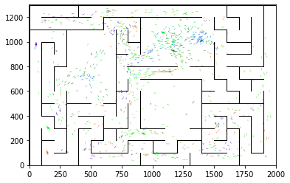

epoch 3701 == proposed_mle: 15.09+-0.34/14.07+-0.22 --

epoch 3702 == proposed_mle: 14.54+-0.30/14.13+-0.22 --

epoch 3703 == proposed_mle: 15.02+-0.29/14.10+-0.23 --

epoch 3704 == proposed_mle: 14.70+-0.30/14.15+-0.23 --

epoch 3705 == proposed_mle: 14.66+-0.33/14.07+-0.20 --

epoch 3706 == proposed_mle: 15.19+-0.32/14.09+-0.23 --

epoch 3707 == proposed_mle: 15.59+-0.39/14.29+-0.23 --

epoch 3708 == proposed_mle: 15.14+-0.32/14.32+-0.21 --

epoch 3709 == proposed_mle: 15.11+-0.29/13.96+-0.22 --

epoch 3710 == proposed_mle: 14.47+-0.26/14.00+-0.22 --

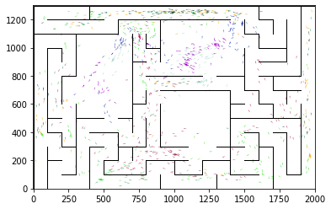

epoch 3711 == proposed_mle: 14.78+-0.30/14.34+-0.23 --

epoch 3712 == proposed_mle: 14.20+-0.29/14.27+-0.23 --

epoch 3713 == proposed_mle: 15.15+-0.28/14.10+-0.23 --

epoch 3714 == proposed_mle: 14.58+-0.28/14.13+-0.23 --

epoch 3715 == proposed_mle: 14.99+-0.32/14.02+-0.22 --

epoch 3716 == proposed_mle: 14.60+-0.34/14.03+-0.22 --

epoch 3717 == proposed_mle: 15.06+-0.38/14.16+-0.23 --

epoch 3718 == proposed_mle: 14.95+-0.27/14.24+-0.21 --

epoch 3719 == proposed_mle: 14.91+-0.31/14.21+-0.24 --

epoch 3720 == proposed_mle: 14.93+-0.34/14.09+-0.23 --

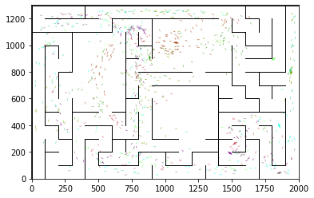

epoch 3721 == proposed_mle: 13.95+-0.30/14.01+-0.22 --

epoch 3722 == proposed_mle: 14.99+-0.32/14.10+-0.22 --

epoch 3723 == proposed_mle: 14.10+-0.31/13.96+-0.22 --

epoch 3724 == proposed_mle: 14.74+-0.42/14.23+-0.24 --

epoch 3725 == proposed_mle: 14.72+-0.36/14.31+-0.23 --

epoch 3726 == proposed_mle: 14.45+-0.37/14.19+-0.23 --

epoch 3727 == proposed_mle: 14.98+-0.32/14.04+-0.22 --

epoch 3728 == proposed_mle: 15.01+-0.31/14.21+-0.22 --

epoch 3729 == proposed_mle: 15.15+-0.28/14.16+-0.23 --

epoch 3730 == proposed_mle: 14.60+-0.30/14.10+-0.24 --

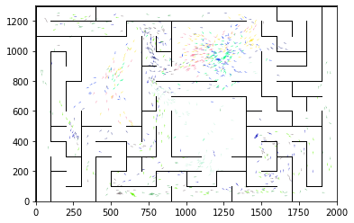

epoch 3731 == proposed_mle: 14.58+-0.31/14.26+-0.23 --

epoch 3732 == proposed_mle: 15.49+-0.34/13.97+-0.21 --

epoch 3733 == proposed_mle: 15.28+-0.36/14.05+-0.22 --

epoch 3734 == proposed_mle: 14.74+-0.41/14.09+-0.22 --

epoch 3735 == proposed_mle: 14.80+-0.34/14.00+-0.20 --

epoch 3736 == proposed_mle: 14.53+-0.27/14.01+-0.22 --

epoch 3737 == proposed_mle: 14.52+-0.29/14.00+-0.25 --

epoch 3738 == proposed_mle: 14.63+-0.33/14.31+-0.22 --

epoch 3739 == proposed_mle: 14.65+-0.34/14.13+-0.23 --

epoch 3740 == proposed_mle: 14.98+-0.34/13.99+-0.22 --

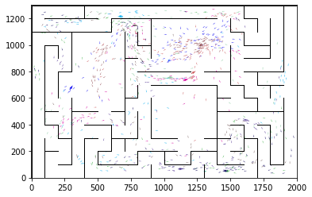

epoch 3741 == proposed_mle: 14.69+-0.31/14.24+-0.21 --

epoch 3742 == proposed_mle: 15.25+-0.35/14.25+-0.24 --

epoch 3743 == proposed_mle: 14.91+-0.29/13.96+-0.22 --

epoch 3744 == proposed_mle: 14.56+-0.31/14.13+-0.21 --

epoch 3745 == proposed_mle: 14.28+-0.31/14.10+-0.23 --

epoch 3746 == proposed_mle: 14.83+-0.34/14.21+-0.24 --

epoch 3747 == proposed_mle: 14.87+-0.38/14.07+-0.23 --

epoch 3748 == proposed_mle: 15.20+-0.35/14.11+-0.22 --

epoch 3749 == proposed_mle: 14.50+-0.29/14.07+-0.23 --

epoch 3750 == proposed_mle: 14.77+-0.34/14.18+-0.21 --

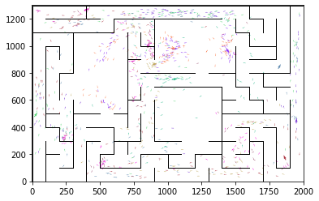

epoch 3751 == proposed_mle: 15.44+-0.32/14.04+-0.22 --

epoch 3752 == proposed_mle: 14.41+-0.38/14.12+-0.22 --

epoch 3753 == proposed_mle: 15.29+-0.37/14.04+-0.22 --

epoch 3754 == proposed_mle: 14.48+-0.29/14.19+-0.22 --

epoch 3755 == proposed_mle: 14.75+-0.29/14.03+-0.21 --

epoch 3756 == proposed_mle: 14.07+-0.34/14.01+-0.23 --

epoch 3757 == proposed_mle: 14.78+-0.23/14.04+-0.22 --

epoch 3758 == proposed_mle: 14.56+-0.29/14.11+-0.22 --

epoch 3759 >> proposed_mle: 14.40+-0.30/13.79+-0.23 --

epoch 3760 == proposed_mle: 14.76+-0.33/14.06+-0.23 --

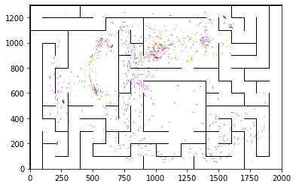

epoch 3761 == proposed_mle: 14.59+-0.33/14.07+-0.22 --

epoch 3762 == proposed_mle: 15.14+-0.33/14.26+-0.22 --

epoch 3763 == proposed_mle: 14.65+-0.27/13.95+-0.21 --

epoch 3764 == proposed_mle: 14.42+-0.29/14.18+-0.22 --

epoch 3765 == proposed_mle: 14.35+-0.31/14.20+-0.22 --

epoch 3766 == proposed_mle: 14.31+-0.29/13.97+-0.23 --

epoch 3767 == proposed_mle: 14.41+-0.31/14.08+-0.22 --

epoch 3768 == proposed_mle: 14.91+-0.29/13.97+-0.21 --

epoch 3769 == proposed_mle: 15.26+-0.35/13.94+-0.23 --

epoch 3770 == proposed_mle: 14.77+-0.28/13.92+-0.23 --

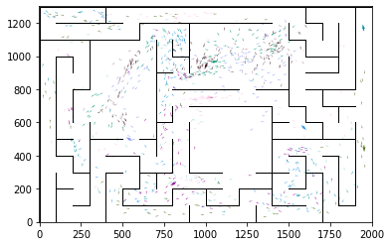

epoch 3771 == proposed_mle: 15.03+-0.36/14.02+-0.21 --

epoch 3772 == proposed_mle: 14.33+-0.37/13.95+-0.24 --

epoch 3773 == proposed_mle: 15.31+-0.33/14.13+-0.22 --

epoch 3774 == proposed_mle: 14.25+-0.32/14.25+-0.23 --

epoch 3775 == proposed_mle: 15.05+-0.33/14.06+-0.22 --

epoch 3776 == proposed_mle: 15.37+-0.30/14.15+-0.22 --

epoch 3777 == proposed_mle: 14.77+-0.27/13.94+-0.20 --

epoch 3778 == proposed_mle: 14.89+-0.32/13.80+-0.21 --

epoch 3779 == proposed_mle: 14.74+-0.32/14.03+-0.22 --

epoch 3780 == proposed_mle: 15.24+-0.39/14.02+-0.22 --

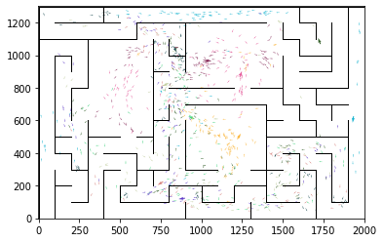

epoch 3781 == proposed_mle: 14.68+-0.34/14.08+-0.23 --

epoch 3782 == proposed_mle: 14.86+-0.33/14.02+-0.22 --

epoch 3783 == proposed_mle: 14.85+-0.27/14.16+-0.22 --

epoch 3784 == proposed_mle: 14.74+-0.31/14.06+-0.23 --

epoch 3785 == proposed_mle: 14.55+-0.32/13.93+-0.21 --

epoch 3786 == proposed_mle: 14.95+-0.33/14.02+-0.22 --

epoch 3787 == proposed_mle: 14.74+-0.29/14.04+-0.21 --

epoch 3788 == proposed_mle: 14.81+-0.34/14.31+-0.24 --

epoch 3789 == proposed_mle: 14.96+-0.30/13.90+-0.23 --

epoch 3790 == proposed_mle: 14.83+-0.38/14.08+-0.24 --

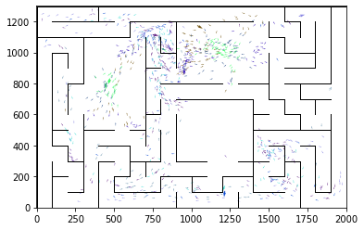

epoch 3791 == proposed_mle: 14.28+-0.29/14.20+-0.22 --

epoch 3792 == proposed_mle: 14.63+-0.34/13.92+-0.21 --

epoch 3793 == proposed_mle: 14.92+-0.29/14.05+-0.20 --

epoch 3794 == proposed_mle: 15.33+-0.32/13.91+-0.20 --

epoch 3795 == proposed_mle: 14.76+-0.31/14.05+-0.20 --

epoch 3796 == proposed_mle: 14.54+-0.31/14.13+-0.21 --

epoch 3797 == proposed_mle: 14.16+-0.35/13.87+-0.22 --

epoch 3798 == proposed_mle: 14.50+-0.31/13.93+-0.22 --

epoch 3799 == proposed_mle: 14.84+-0.27/14.12+-0.21 --

epoch 3800 == proposed_mle: 14.68+-0.33/13.95+-0.22 --

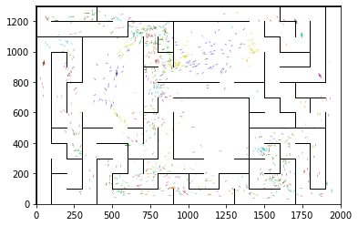

epoch 3801 == proposed_mle: 15.05+-0.29/14.21+-0.22 --

epoch 3802 == proposed_mle: 15.17+-0.29/14.11+-0.25 --

epoch 3803 == proposed_mle: 14.40+-0.31/13.85+-0.23 --

epoch 3804 == proposed_mle: 14.73+-0.29/14.00+-0.22 --

epoch 3805 == proposed_mle: 14.91+-0.29/14.14+-0.21 --

epoch 3806 == proposed_mle: 14.39+-0.32/14.13+-0.22 --

epoch 3807 == proposed_mle: 14.63+-0.29/14.14+-0.22 --

epoch 3808 == proposed_mle: 14.50+-0.27/13.88+-0.21 --

epoch 3809 == proposed_mle: 14.59+-0.33/13.92+-0.22 --

epoch 3810 == proposed_mle: 14.81+-0.28/13.90+-0.21 --

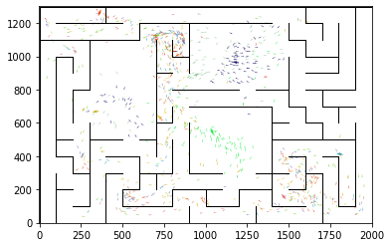

epoch 3811 == proposed_mle: 14.38+-0.32/14.10+-0.22 --

epoch 3812 == proposed_mle: 14.90+-0.36/13.92+-0.22 --

epoch 3813 == proposed_mle: 14.59+-0.29/13.96+-0.22 --

epoch 3814 == proposed_mle: 14.28+-0.31/13.99+-0.23 --

epoch 3815 == proposed_mle: 14.48+-0.27/13.89+-0.22 --

epoch 3816 == proposed_mle: 15.49+-0.31/14.08+-0.22 --

epoch 3817 == proposed_mle: 14.46+-0.28/13.96+-0.23 --

epoch 3818 == proposed_mle: 14.94+-0.22/14.21+-0.21 --

epoch 3819 == proposed_mle: 14.40+-0.31/14.05+-0.22 --

epoch 3820 == proposed_mle: 14.83+-0.31/14.24+-0.23 --

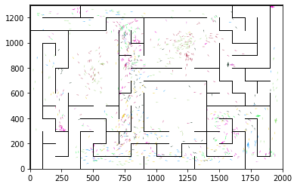

epoch 3821 == proposed_mle: 14.40+-0.30/14.16+-0.21 --

epoch 3822 == proposed_mle: 15.04+-0.33/13.92+-0.21 --

epoch 3823 == proposed_mle: 14.59+-0.27/14.14+-0.22 --

epoch 3824 == proposed_mle: 14.64+-0.28/14.19+-0.22 --

epoch 3825 == proposed_mle: 14.36+-0.31/13.99+-0.21 --

epoch 3826 == proposed_mle: 14.71+-0.34/14.11+-0.22 --

epoch 3827 == proposed_mle: 14.64+-0.35/13.99+-0.22 --

epoch 3828 == proposed_mle: 14.83+-0.34/13.96+-0.22 --

epoch 3829 == proposed_mle: 14.99+-0.33/13.91+-0.23 --

epoch 3830 == proposed_mle: 14.32+-0.30/14.14+-0.24 --

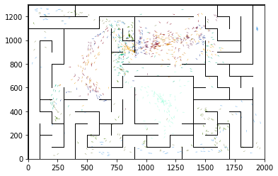

epoch 3831 == proposed_mle: 14.96+-0.37/14.05+-0.20 --

epoch 3832 == proposed_mle: 14.34+-0.32/14.20+-0.22 --

epoch 3833 == proposed_mle: 14.15+-0.31/13.85+-0.22 --

epoch 3834 == proposed_mle: 14.81+-0.34/13.99+-0.20 --

epoch 3835 == proposed_mle: 14.60+-0.26/14.00+-0.22 --

epoch 3836 == proposed_mle: 14.17+-0.34/14.10+-0.23 --

epoch 3837 == proposed_mle: 14.83+-0.27/14.11+-0.22 --

epoch 3838 == proposed_mle: 14.40+-0.33/13.93+-0.23 --

epoch 3839 == proposed_mle: 14.61+-0.34/14.16+-0.22 --

epoch 3840 == proposed_mle: 14.87+-0.34/14.06+-0.21 --

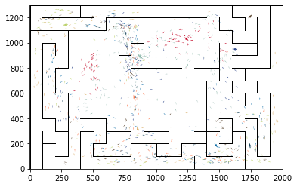

epoch 3841 == proposed_mle: 15.25+-0.31/14.07+-0.21 --

epoch 3842 == proposed_mle: 14.90+-0.29/14.01+-0.22 --

epoch 3843 == proposed_mle: 14.44+-0.31/14.15+-0.23 --

epoch 3844 == proposed_mle: 14.91+-0.34/14.28+-0.22 --

epoch 3845 == proposed_mle: 14.87+-0.34/13.87+-0.21 --

epoch 3846 == proposed_mle: 15.00+-0.29/13.99+-0.21 --

epoch 3847 == proposed_mle: 14.73+-0.30/14.05+-0.20 --

epoch 3848 == proposed_mle: 14.67+-0.31/13.94+-0.22 --

epoch 3849 == proposed_mle: 14.60+-0.35/14.08+-0.22 --

epoch 3850 == proposed_mle: 14.47+-0.29/14.03+-0.22 --

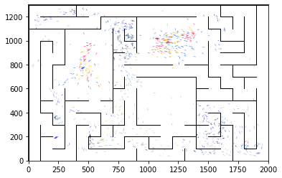

epoch 3851 == proposed_mle: 14.07+-0.27/14.09+-0.20 --

epoch 3852 == proposed_mle: 14.76+-0.28/13.79+-0.22 --

epoch 3853 == proposed_mle: 14.74+-0.29/14.15+-0.22 --

epoch 3854 == proposed_mle: 13.97+-0.35/14.12+-0.23 --

epoch 3855 == proposed_mle: 14.65+-0.33/14.12+-0.22 --

epoch 3856 == proposed_mle: 14.68+-0.31/14.19+-0.21 --

epoch 3857 == proposed_mle: 14.84+-0.30/13.93+-0.22 --

epoch 3858 == proposed_mle: 14.78+-0.36/14.18+-0.22 --

epoch 3859 == proposed_mle: 13.90+-0.28/14.20+-0.22 --

epoch 3860 == proposed_mle: 15.32+-0.33/14.11+-0.22 --

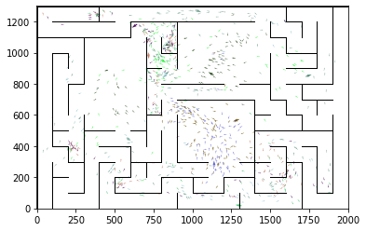

epoch 3861 == proposed_mle: 14.72+-0.33/14.27+-0.23 --

epoch 3862 == proposed_mle: 15.06+-0.33/14.04+-0.23 --

epoch 3863 == proposed_mle: 15.05+-0.31/13.88+-0.23 --

epoch 3864 == proposed_mle: 14.82+-0.30/13.96+-0.21 --

epoch 3865 == proposed_mle: 14.92+-0.28/14.16+-0.21 --

epoch 3866 == proposed_mle: 14.65+-0.32/13.95+-0.24 --

epoch 3867 == proposed_mle: 14.34+-0.34/14.22+-0.23 --

epoch 3868 == proposed_mle: 14.66+-0.30/13.92+-0.23 --

epoch 3869 == proposed_mle: 14.93+-0.37/14.09+-0.23 --

epoch 3870 == proposed_mle: 14.36+-0.28/13.91+-0.22 --

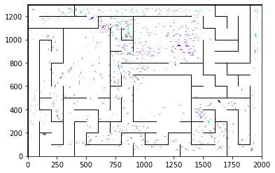

epoch 3871 == proposed_mle: 14.81+-0.32/13.95+-0.21 --

epoch 3872 == proposed_mle: 14.01+-0.35/14.01+-0.21 --

epoch 3873 == proposed_mle: 14.91+-0.29/14.04+-0.21 --

epoch 3874 == proposed_mle: 14.87+-0.30/14.09+-0.21 --

epoch 3875 == proposed_mle: 14.58+-0.30/14.31+-0.22 --

epoch 3876 == proposed_mle: 14.88+-0.32/14.14+-0.22 --

epoch 3877 == proposed_mle: 14.89+-0.31/14.02+-0.22 --

epoch 3878 == proposed_mle: 14.91+-0.31/14.19+-0.23 --

epoch 3879 == proposed_mle: 15.35+-0.34/14.28+-0.24 --

epoch 3880 == proposed_mle: 14.84+-0.30/13.95+-0.21 --

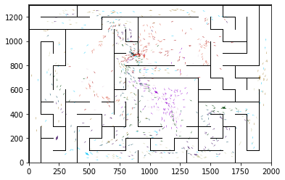

epoch 3881 == proposed_mle: 15.45+-0.30/14.05+-0.21 --

epoch 3882 == proposed_mle: 15.05+-0.31/14.14+-0.22 --

epoch 3883 == proposed_mle: 15.34+-0.35/14.07+-0.21 --

epoch 3884 == proposed_mle: 15.05+-0.32/14.06+-0.20 --

epoch 3885 == proposed_mle: 14.71+-0.29/14.03+-0.21 --

epoch 3886 >> proposed_mle: 15.04+-0.36/13.77+-0.20 --

epoch 3887 == proposed_mle: 14.43+-0.23/13.97+-0.21 --

epoch 3888 == proposed_mle: 14.94+-0.30/13.87+-0.21 --

epoch 3889 == proposed_mle: 14.77+-0.30/13.88+-0.22 --

epoch 3890 == proposed_mle: 15.52+-0.33/13.85+-0.22 --

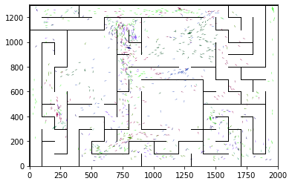

epoch 3891 == proposed_mle: 14.92+-0.31/13.83+-0.21 --

epoch 3892 == proposed_mle: 15.34+-0.35/14.04+-0.23 --

epoch 3893 == proposed_mle: 15.07+-0.29/14.24+-0.23 --

epoch 3894 == proposed_mle: 15.04+-0.37/14.12+-0.22 --

epoch 3895 == proposed_mle: 14.15+-0.29/14.10+-0.24 --

epoch 3896 == proposed_mle: 15.07+-0.31/13.93+-0.22 --

epoch 3897 == proposed_mle: 14.87+-0.28/13.94+-0.23 --

epoch 3898 == proposed_mle: 14.94+-0.29/13.97+-0.23 --

epoch 3899 == proposed_mle: 14.70+-0.28/14.01+-0.21 --

epoch 3900 == proposed_mle: 14.36+-0.31/14.03+-0.23 --

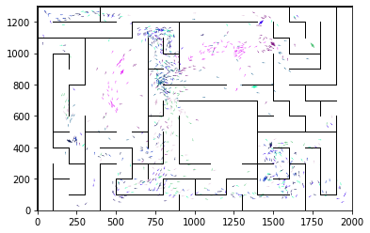

epoch 3901 == proposed_mle: 14.55+-0.27/14.11+-0.24 --

epoch 3902 == proposed_mle: 14.70+-0.36/14.01+-0.22 --

epoch 3903 == proposed_mle: 14.79+-0.32/14.10+-0.21 --

epoch 3904 == proposed_mle: 14.97+-0.36/14.06+-0.22 --

epoch 3905 == proposed_mle: 14.92+-0.32/13.98+-0.22 --

epoch 3906 == proposed_mle: 14.61+-0.31/14.12+-0.22 --

epoch 3907 == proposed_mle: 14.64+-0.33/14.32+-0.22 --

epoch 3908 == proposed_mle: 15.01+-0.25/14.06+-0.22 --

epoch 3909 == proposed_mle: 14.88+-0.34/14.17+-0.23 --

epoch 3910 == proposed_mle: 14.86+-0.32/14.06+-0.21 --

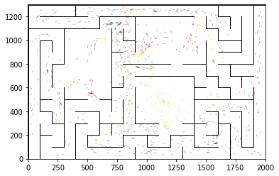

epoch 3911 == proposed_mle: 14.42+-0.28/13.88+-0.21 --

epoch 3912 == proposed_mle: 14.88+-0.29/13.87+-0.21 --

epoch 3913 == proposed_mle: 15.00+-0.31/14.00+-0.23 --

epoch 3914 == proposed_mle: 14.54+-0.31/14.04+-0.21 --

epoch 3915 == proposed_mle: 15.13+-0.33/13.84+-0.23 --

epoch 3916 == proposed_mle: 15.04+-0.32/14.03+-0.20 --

epoch 3917 == proposed_mle: 14.90+-0.36/13.94+-0.21 --

epoch 3918 == proposed_mle: 14.36+-0.32/13.95+-0.23 --

epoch 3919 == proposed_mle: 14.99+-0.28/13.87+-0.24 --

epoch 3920 == proposed_mle: 15.23+-0.36/14.09+-0.24 --

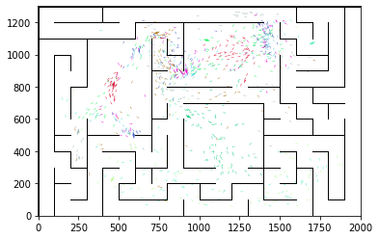

epoch 3921 == proposed_mle: 14.69+-0.25/14.05+-0.21 --

epoch 3922 == proposed_mle: 14.33+-0.30/13.90+-0.23 --

epoch 3923 == proposed_mle: 14.32+-0.27/14.10+-0.22 --

epoch 3924 == proposed_mle: 14.79+-0.32/13.88+-0.21 --

epoch 3925 == proposed_mle: 14.66+-0.29/14.02+-0.23 --

epoch 3926 == proposed_mle: 14.62+-0.27/14.00+-0.22 --

epoch 3927 == proposed_mle: 14.49+-0.33/13.93+-0.23 --

epoch 3928 == proposed_mle: 14.49+-0.31/14.14+-0.22 --

epoch 3929 == proposed_mle: 14.90+-0.31/13.82+-0.22 --

epoch 3930 == proposed_mle: 14.94+-0.32/14.05+-0.21 --

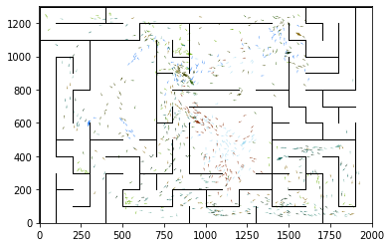

epoch 3931 == proposed_mle: 13.93+-0.27/13.94+-0.22 --

epoch 3932 == proposed_mle: 14.24+-0.32/13.81+-0.21 --

epoch 3933 == proposed_mle: 14.76+-0.36/14.00+-0.22 --

epoch 3934 >> proposed_mle: 14.63+-0.33/13.68+-0.21 --

epoch 3935 == proposed_mle: 14.07+-0.35/13.78+-0.21 --

epoch 3936 == proposed_mle: 14.61+-0.32/13.94+-0.23 --

epoch 3937 == proposed_mle: 14.29+-0.29/14.31+-0.21 --

epoch 3938 == proposed_mle: 15.03+-0.25/14.03+-0.23 --

epoch 3939 == proposed_mle: 14.29+-0.30/14.23+-0.23 --

epoch 3940 == proposed_mle: 15.14+-0.38/13.74+-0.21 --

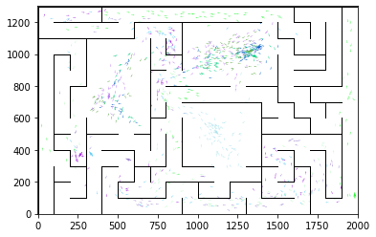

epoch 3941 == proposed_mle: 14.33+-0.29/14.12+-0.23 --

epoch 3942 == proposed_mle: 15.09+-0.36/14.08+-0.23 --

epoch 3943 == proposed_mle: 14.63+-0.31/14.01+-0.22 --

epoch 3944 == proposed_mle: 15.01+-0.36/13.87+-0.21 --

epoch 3945 == proposed_mle: 15.35+-0.33/13.88+-0.22 --

epoch 3946 == proposed_mle: 15.33+-0.32/14.06+-0.23 --

epoch 3947 == proposed_mle: 14.71+-0.27/13.91+-0.24 --

epoch 3948 == proposed_mle: 14.69+-0.35/13.93+-0.22 --

epoch 3949 == proposed_mle: 14.82+-0.34/13.83+-0.22 --

epoch 3950 == proposed_mle: 14.80+-0.28/13.91+-0.23 --

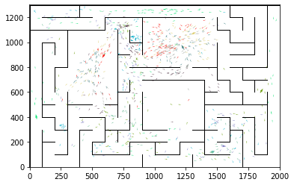

epoch 3951 == proposed_mle: 14.40+-0.24/14.06+-0.20 --

epoch 3952 == proposed_mle: 14.33+-0.28/13.94+-0.22 --

epoch 3953 == proposed_mle: 14.68+-0.29/14.10+-0.24 --

epoch 3954 == proposed_mle: 14.81+-0.39/13.91+-0.21 --

epoch 3955 == proposed_mle: 14.51+-0.32/13.81+-0.24 --

epoch 3956 == proposed_mle: 14.19+-0.29/14.00+-0.24 --

epoch 3957 == proposed_mle: 14.91+-0.34/13.81+-0.21 --

epoch 3958 == proposed_mle: 14.90+-0.35/13.75+-0.24 --

epoch 3959 >> proposed_mle: 14.42+-0.32/13.64+-0.23 --

epoch 3960 == proposed_mle: 14.85+-0.27/14.00+-0.22 --

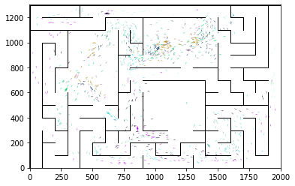

epoch 3961 == proposed_mle: 14.95+-0.30/13.94+-0.23 --

epoch 3962 == proposed_mle: 14.79+-0.35/14.04+-0.23 --

epoch 3963 == proposed_mle: 14.78+-0.30/13.99+-0.23 --

epoch 3964 == proposed_mle: 14.65+-0.31/13.89+-0.23 --

epoch 3965 == proposed_mle: 14.92+-0.36/13.92+-0.22 --

epoch 3966 == proposed_mle: 14.58+-0.33/14.02+-0.23 --

epoch 3967 == proposed_mle: 14.74+-0.26/13.99+-0.21 --

epoch 3968 == proposed_mle: 15.26+-0.33/14.08+-0.23 --

epoch 3969 == proposed_mle: 14.40+-0.28/13.93+-0.24 --

epoch 3970 == proposed_mle: 14.52+-0.31/13.98+-0.22 --

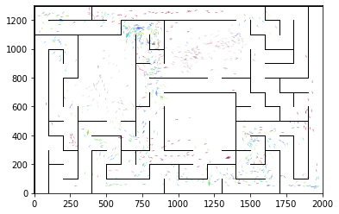

epoch 3971 == proposed_mle: 14.75+-0.34/14.03+-0.23 --

epoch 3972 == proposed_mle: 14.43+-0.31/13.74+-0.23 --

epoch 3973 == proposed_mle: 14.77+-0.34/13.84+-0.22 --

epoch 3974 == proposed_mle: 14.94+-0.28/13.92+-0.24 --

epoch 3975 == proposed_mle: 14.53+-0.31/14.01+-0.21 --

epoch 3976 == proposed_mle: 14.22+-0.35/13.98+-0.23 --

epoch 3977 == proposed_mle: 14.65+-0.34/13.98+-0.22 --

epoch 3978 == proposed_mle: 13.83+-0.27/14.05+-0.23 --

epoch 3979 == proposed_mle: 14.57+-0.31/14.03+-0.23 --

epoch 3980 == proposed_mle: 14.96+-0.27/13.91+-0.22 --

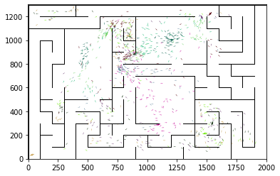

epoch 3981 == proposed_mle: 14.89+-0.28/13.87+-0.24 --

epoch 3982 == proposed_mle: 14.77+-0.30/13.99+-0.22 --

epoch 3983 == proposed_mle: 15.37+-0.34/14.18+-0.23 --

epoch 3984 == proposed_mle: 14.63+-0.38/13.83+-0.20 --

epoch 3985 == proposed_mle: 14.50+-0.31/13.84+-0.23 --

epoch 3986 == proposed_mle: 14.62+-0.32/13.87+-0.23 --

epoch 3987 == proposed_mle: 13.95+-0.28/14.00+-0.23 --

epoch 3988 == proposed_mle: 15.37+-0.35/13.89+-0.21 --

epoch 3989 == proposed_mle: 14.52+-0.33/14.14+-0.21 --

epoch 3990 == proposed_mle: 14.87+-0.25/14.09+-0.21 --

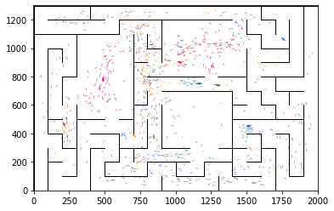

epoch 3991 == proposed_mle: 14.64+-0.31/14.13+-0.22 --

epoch 3992 == proposed_mle: 14.56+-0.34/14.15+-0.22 --

epoch 3993 == proposed_mle: 14.61+-0.29/14.06+-0.22 --

epoch 3994 == proposed_mle: 14.90+-0.30/14.02+-0.22 --

epoch 3995 == proposed_mle: 14.68+-0.30/14.03+-0.22 --

epoch 3996 == proposed_mle: 14.95+-0.25/14.01+-0.22 --

epoch 3997 == proposed_mle: 14.20+-0.35/13.99+-0.23 --

epoch 3998 == proposed_mle: 14.75+-0.35/14.18+-0.24 --

epoch 3999 == proposed_mle: 14.37+-0.26/14.02+-0.24 --

epoch 4000 == proposed_mle: 14.57+-0.29/14.10+-0.23 --

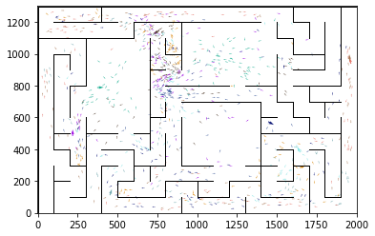

epoch 4001 == proposed_mle: 14.32+-0.32/13.99+-0.22 --

epoch 4002 == proposed_mle: 14.95+-0.24/14.07+-0.24 --

epoch 4003 == proposed_mle: 14.89+-0.34/13.90+-0.22 --

epoch 4004 == proposed_mle: 15.23+-0.35/14.08+-0.23 --

epoch 4005 == proposed_mle: 14.72+-0.29/14.12+-0.23 --

epoch 4006 == proposed_mle: 14.76+-0.28/13.99+-0.22 --

epoch 4007 == proposed_mle: 15.07+-0.36/14.35+-0.24 --

epoch 4008 == proposed_mle: 14.64+-0.32/14.15+-0.22 --

epoch 4009 == proposed_mle: 14.76+-0.33/14.09+-0.22 --

epoch 4010 == proposed_mle: 14.86+-0.38/13.97+-0.21 --

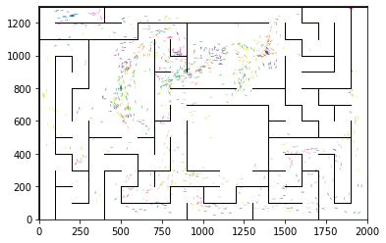

epoch 4011 == proposed_mle: 14.80+-0.27/14.19+-0.21 --

epoch 4012 == proposed_mle: 14.76+-0.37/13.98+-0.22 --

epoch 4013 == proposed_mle: 14.83+-0.34/14.24+-0.24 --

epoch 4014 == proposed_mle: 14.93+-0.33/14.26+-0.23 --

epoch 4015 == proposed_mle: 14.74+-0.28/14.23+-0.22 --

epoch 4016 == proposed_mle: 14.58+-0.34/14.11+-0.22 --

epoch 4017 == proposed_mle: 14.71+-0.29/13.86+-0.23 --

epoch 4018 == proposed_mle: 14.37+-0.30/13.77+-0.22 --

epoch 4019 == proposed_mle: 13.96+-0.33/13.96+-0.21 --

epoch 4020 == proposed_mle: 14.94+-0.36/13.79+-0.22 --

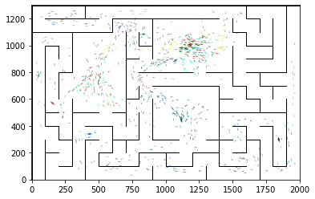

epoch 4021 == proposed_mle: 14.75+-0.28/13.80+-0.20 --

epoch 4022 == proposed_mle: 14.97+-0.40/14.02+-0.23 --

epoch 4023 == proposed_mle: 14.73+-0.30/13.93+-0.25 --

epoch 4024 == proposed_mle: 14.85+-0.27/13.90+-0.22 --

epoch 4025 == proposed_mle: 14.12+-0.36/13.96+-0.22 --

epoch 4026 == proposed_mle: 14.61+-0.31/14.02+-0.22 --

epoch 4027 == proposed_mle: 14.71+-0.34/14.07+-0.21 --

epoch 4028 == proposed_mle: 14.20+-0.34/13.99+-0.22 --

epoch 4029 == proposed_mle: 14.34+-0.33/14.04+-0.23 --

epoch 4030 == proposed_mle: 15.12+-0.29/14.13+-0.21 --

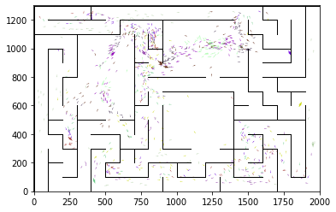

epoch 4031 == proposed_mle: 14.78+-0.37/14.07+-0.23 --

epoch 4032 == proposed_mle: 14.23+-0.27/13.73+-0.22 --

epoch 4033 == proposed_mle: 14.98+-0.28/13.82+-0.19 --

epoch 4034 == proposed_mle: 14.52+-0.31/13.87+-0.21 --

epoch 4035 == proposed_mle: 14.50+-0.32/13.98+-0.22 --

epoch 4036 == proposed_mle: 15.29+-0.33/13.97+-0.21 --

epoch 4037 == proposed_mle: 14.81+-0.33/13.98+-0.21 --

epoch 4038 == proposed_mle: 15.27+-0.36/14.00+-0.24 --

epoch 4039 == proposed_mle: 14.52+-0.33/14.01+-0.22 --

epoch 4040 == proposed_mle: 15.41+-0.35/14.04+-0.22 --

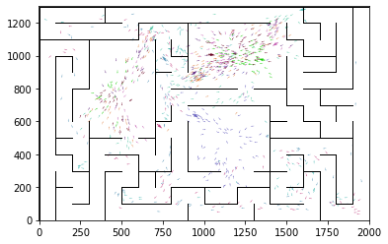

epoch 4041 == proposed_mle: 14.33+-0.25/13.84+-0.23 --

epoch 4042 == proposed_mle: 14.51+-0.34/14.05+-0.22 --

epoch 4043 == proposed_mle: 14.70+-0.31/14.16+-0.21 --

epoch 4044 == proposed_mle: 15.12+-0.30/14.14+-0.22 --

epoch 4045 == proposed_mle: 14.41+-0.22/14.26+-0.22 --

epoch 4046 == proposed_mle: 14.78+-0.28/13.98+-0.21 --

epoch 4047 == proposed_mle: 14.73+-0.34/14.04+-0.22 --

epoch 4048 == proposed_mle: 15.07+-0.32/14.33+-0.24 --

epoch 4049 == proposed_mle: 14.53+-0.30/14.13+-0.22 --

epoch 4050 == proposed_mle: 14.12+-0.31/14.12+-0.22 --

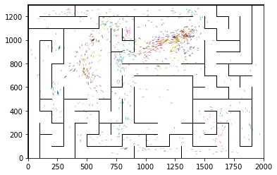

epoch 4051 == proposed_mle: 14.72+-0.31/14.21+-0.22 --

epoch 4052 == proposed_mle: 15.10+-0.27/14.04+-0.23 --

epoch 4053 == proposed_mle: 14.81+-0.26/14.09+-0.20 --

epoch 4054 == proposed_mle: 14.84+-0.36/13.94+-0.21 --

epoch 4055 == proposed_mle: 14.72+-0.38/14.07+-0.23 --

epoch 4056 == proposed_mle: 14.47+-0.31/13.64+-0.24 --

epoch 4057 == proposed_mle: 15.50+-0.28/13.86+-0.23 --

epoch 4058 == proposed_mle: 15.09+-0.31/13.90+-0.24 --

epoch 4059 == proposed_mle: 14.80+-0.30/13.87+-0.21 --

epoch 4060 == proposed_mle: 15.06+-0.31/14.03+-0.22 --

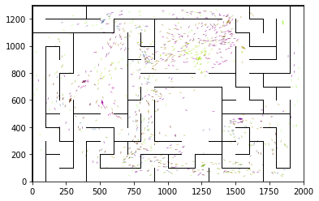

epoch 4061 == proposed_mle: 14.38+-0.31/13.86+-0.21 --

epoch 4062 == proposed_mle: 15.02+-0.32/13.96+-0.22 --

epoch 4063 == proposed_mle: 14.50+-0.34/13.89+-0.22 --

epoch 4064 == proposed_mle: 14.42+-0.26/13.87+-0.22 --

epoch 4065 == proposed_mle: 14.87+-0.30/14.06+-0.23 --

epoch 4066 == proposed_mle: 14.99+-0.32/14.00+-0.21 --

epoch 4067 == proposed_mle: 14.48+-0.36/13.86+-0.20 --

epoch 4068 == proposed_mle: 14.10+-0.32/13.98+-0.24 --

epoch 4069 == proposed_mle: 14.85+-0.31/14.06+-0.22 --

epoch 4070 == proposed_mle: 14.97+-0.41/14.13+-0.22 --

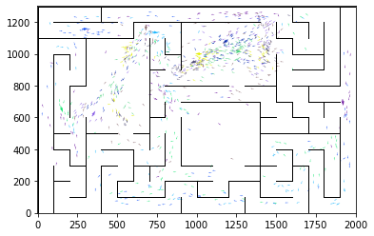

epoch 4071 == proposed_mle: 14.77+-0.34/13.75+-0.22 --

epoch 4072 == proposed_mle: 14.38+-0.32/13.88+-0.23 --

epoch 4073 == proposed_mle: 14.51+-0.25/14.19+-0.22 --

epoch 4074 == proposed_mle: 14.64+-0.29/13.85+-0.22 --

epoch 4075 == proposed_mle: 14.63+-0.36/14.05+-0.22 --

epoch 4076 == proposed_mle: 14.38+-0.31/13.70+-0.23 --

epoch 4077 == proposed_mle: 15.01+-0.28/13.95+-0.22 --

epoch 4078 == proposed_mle: 14.43+-0.35/13.86+-0.21 --

epoch 4079 == proposed_mle: 15.17+-0.30/13.77+-0.21 --

epoch 4080 == proposed_mle: 14.35+-0.32/13.78+-0.21 --

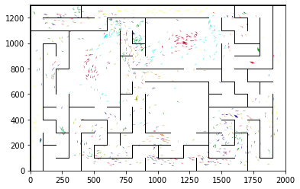

epoch 4081 >> proposed_mle: 14.60+-0.23/13.42+-0.19 --

epoch 4082 == proposed_mle: 14.72+-0.29/13.85+-0.23 --

epoch 4083 == proposed_mle: 14.40+-0.28/13.73+-0.20 --

epoch 4084 == proposed_mle: 14.82+-0.31/14.01+-0.23 --

epoch 4085 == proposed_mle: 14.29+-0.27/13.85+-0.21 --

epoch 4086 == proposed_mle: 14.66+-0.25/13.94+-0.22 --

epoch 4087 == proposed_mle: 14.62+-0.36/13.90+-0.22 --

epoch 4088 == proposed_mle: 14.54+-0.28/13.87+-0.24 --

epoch 4089 == proposed_mle: 14.45+-0.32/13.96+-0.23 --

epoch 4090 == proposed_mle: 14.11+-0.25/13.87+-0.21 --

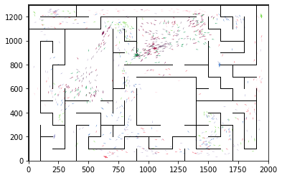

epoch 4091 == proposed_mle: 14.72+-0.29/13.80+-0.23 --

epoch 4092 == proposed_mle: 14.33+-0.29/13.78+-0.22 --

epoch 4093 == proposed_mle: 14.05+-0.28/13.79+-0.21 --

epoch 4094 == proposed_mle: 14.48+-0.28/13.70+-0.21 --

epoch 4095 == proposed_mle: 14.65+-0.34/14.01+-0.23 --

epoch 4096 == proposed_mle: 14.13+-0.32/13.68+-0.20 --

epoch 4097 == proposed_mle: 14.93+-0.30/13.58+-0.22 --

epoch 4098 == proposed_mle: 14.50+-0.33/13.73+-0.21 --

epoch 4099 == proposed_mle: 14.50+-0.30/13.73+-0.20 --

epoch 4100 == proposed_mle: 14.37+-0.36/13.76+-0.22 --

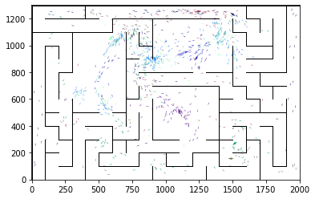

epoch 4101 == proposed_mle: 15.26+-0.26/13.78+-0.22 --

epoch 4102 == proposed_mle: 14.60+-0.28/13.80+-0.23 --

epoch 4103 == proposed_mle: 14.39+-0.32/13.74+-0.21 --

epoch 4104 == proposed_mle: 14.42+-0.30/13.96+-0.24 --

epoch 4105 == proposed_mle: 15.08+-0.34/13.92+-0.22 --

epoch 4106 == proposed_mle: 14.56+-0.38/13.97+-0.22 --

epoch 4107 == proposed_mle: 14.07+-0.36/13.82+-0.22 --

epoch 4108 == proposed_mle: 14.85+-0.30/13.76+-0.21 --

epoch 4109 == proposed_mle: 15.31+-0.37/13.79+-0.24 --

epoch 4110 == proposed_mle: 14.71+-0.34/13.69+-0.22 --

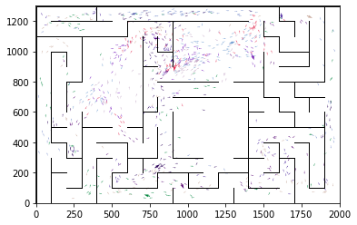

epoch 4111 == proposed_mle: 15.04+-0.36/14.04+-0.22 --

epoch 4112 == proposed_mle: 14.60+-0.27/13.86+-0.23 --

epoch 4113 == proposed_mle: 14.41+-0.28/13.80+-0.23 --

epoch 4114 == proposed_mle: 14.43+-0.28/13.56+-0.22 --

epoch 4115 == proposed_mle: 14.80+-0.36/13.78+-0.22 --

epoch 4116 == proposed_mle: 14.77+-0.32/13.94+-0.21 --

epoch 4117 == proposed_mle: 14.37+-0.30/13.84+-0.22 --

epoch 4118 == proposed_mle: 14.77+-0.30/13.61+-0.21 --

epoch 4119 == proposed_mle: 14.34+-0.29/13.67+-0.21 --

epoch 4120 == proposed_mle: 14.41+-0.30/13.93+-0.22 --

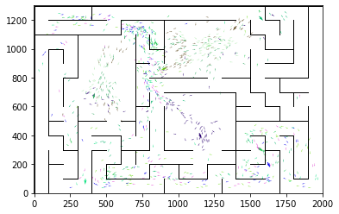

epoch 4121 == proposed_mle: 14.26+-0.30/13.80+-0.20 --

epoch 4122 == proposed_mle: 14.71+-0.32/13.78+-0.20 --

epoch 4123 == proposed_mle: 14.64+-0.33/13.73+-0.22 --

epoch 4124 == proposed_mle: 14.30+-0.26/13.75+-0.20 --

epoch 4125 == proposed_mle: 14.45+-0.28/13.93+-0.21 --

epoch 4126 == proposed_mle: 14.15+-0.29/13.90+-0.20 --

epoch 4127 == proposed_mle: 14.77+-0.29/13.91+-0.22 --

epoch 4128 == proposed_mle: 14.99+-0.34/13.97+-0.23 --

epoch 4129 == proposed_mle: 14.81+-0.25/14.00+-0.20 --

epoch 4130 == proposed_mle: 14.52+-0.29/14.22+-0.22 --

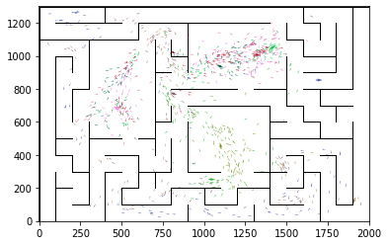

epoch 4131 == proposed_mle: 14.22+-0.34/13.94+-0.21 --

epoch 4132 == proposed_mle: 14.53+-0.27/13.58+-0.22 --

epoch 4133 == proposed_mle: 14.76+-0.33/14.11+-0.22 --

epoch 4134 == proposed_mle: 14.96+-0.34/13.96+-0.22 --

epoch 4135 == proposed_mle: 14.38+-0.36/13.83+-0.22 --

epoch 4136 == proposed_mle: 15.00+-0.36/14.05+-0.22 --

epoch 4137 == proposed_mle: 14.32+-0.31/13.93+-0.23 --

epoch 4138 == proposed_mle: 14.79+-0.29/13.90+-0.21 --

epoch 4139 == proposed_mle: 15.07+-0.34/13.87+-0.23 --

epoch 4140 == proposed_mle: 14.49+-0.32/13.90+-0.20 --

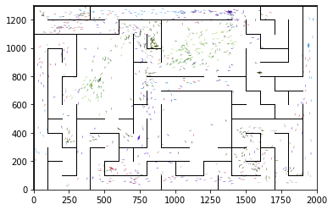

epoch 4141 == proposed_mle: 14.73+-0.30/14.03+-0.22 --

epoch 4142 == proposed_mle: 14.56+-0.32/13.89+-0.24 --

epoch 4143 == proposed_mle: 13.93+-0.30/14.16+-0.22 --

epoch 4144 == proposed_mle: 14.30+-0.26/14.11+-0.24 --

epoch 4145 == proposed_mle: 15.15+-0.30/14.02+-0.22 --

epoch 4146 == proposed_mle: 14.52+-0.28/13.93+-0.22 --

epoch 4147 == proposed_mle: 14.10+-0.29/13.82+-0.22 --

epoch 4148 == proposed_mle: 15.00+-0.34/13.99+-0.22 --

epoch 4149 == proposed_mle: 14.22+-0.29/13.91+-0.21 --

epoch 4150 == proposed_mle: 14.07+-0.38/13.93+-0.22 --

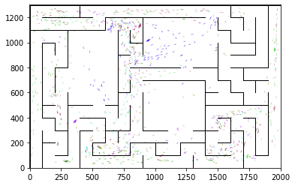

epoch 4151 == proposed_mle: 14.64+-0.35/13.80+-0.22 --

epoch 4152 == proposed_mle: 14.78+-0.29/13.77+-0.20 --

epoch 4153 == proposed_mle: 14.63+-0.27/13.72+-0.23 --

epoch 4154 == proposed_mle: 13.81+-0.26/13.70+-0.21 --

epoch 4155 == proposed_mle: 14.48+-0.32/13.66+-0.22 --

epoch 4156 == proposed_mle: 14.36+-0.30/13.61+-0.21 --

epoch 4157 == proposed_mle: 14.59+-0.30/13.70+-0.21 --

epoch 4158 == proposed_mle: 14.78+-0.32/13.76+-0.22 --

epoch 4159 == proposed_mle: 14.81+-0.28/13.59+-0.21 --

epoch 4160 == proposed_mle: 14.78+-0.33/13.69+-0.21 --

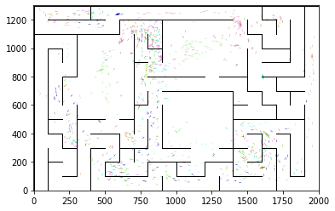

epoch 4161 == proposed_mle: 15.00+-0.32/13.95+-0.22 --

epoch 4162 == proposed_mle: 13.61+-0.28/13.88+-0.22 --

epoch 4163 == proposed_mle: 14.83+-0.32/13.75+-0.22 --

epoch 4164 == proposed_mle: 14.74+-0.29/13.80+-0.21 --

epoch 4165 == proposed_mle: 14.26+-0.31/14.04+-0.21 --

epoch 4166 == proposed_mle: 14.61+-0.30/14.00+-0.23 --

epoch 4167 == proposed_mle: 14.48+-0.27/13.90+-0.23 --

epoch 4168 == proposed_mle: 14.52+-0.31/13.92+-0.21 --

epoch 4169 == proposed_mle: 14.14+-0.31/14.01+-0.23 --

epoch 4170 == proposed_mle: 14.10+-0.33/13.76+-0.23 --

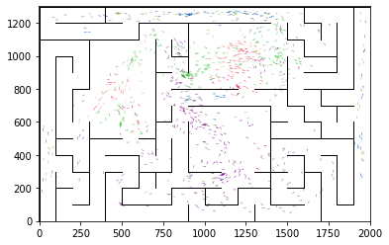

epoch 4171 == proposed_mle: 14.38+-0.33/13.83+-0.22 --

epoch 4172 == proposed_mle: 14.80+-0.29/13.85+-0.21 --

epoch 4173 == proposed_mle: 15.01+-0.29/13.83+-0.23 --

epoch 4174 == proposed_mle: 14.60+-0.34/13.89+-0.21 --

epoch 4175 == proposed_mle: 14.12+-0.31/13.90+-0.22 --

epoch 4176 == proposed_mle: 14.42+-0.33/13.76+-0.21 --

epoch 4177 == proposed_mle: 13.80+-0.28/13.78+-0.22 --

epoch 4178 == proposed_mle: 14.51+-0.31/13.68+-0.23 --

epoch 4179 == proposed_mle: 14.23+-0.28/14.15+-0.23 --

epoch 4180 == proposed_mle: 14.70+-0.27/14.03+-0.21 --

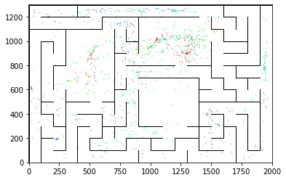

epoch 4181 == proposed_mle: 14.16+-0.33/13.79+-0.21 --

epoch 4182 == proposed_mle: 14.58+-0.30/13.83+-0.22 --

epoch 4183 == proposed_mle: 14.82+-0.34/13.86+-0.21 --

epoch 4184 == proposed_mle: 14.62+-0.29/13.73+-0.22 --

epoch 4185 == proposed_mle: 14.97+-0.29/13.82+-0.22 --

epoch 4186 == proposed_mle: 14.62+-0.28/13.99+-0.21 --

epoch 4187 == proposed_mle: 14.60+-0.31/13.75+-0.21 --

epoch 4188 == proposed_mle: 14.55+-0.37/13.89+-0.20 --

epoch 4189 == proposed_mle: 14.86+-0.29/13.80+-0.22 --

epoch 4190 == proposed_mle: 14.51+-0.29/14.09+-0.23 --

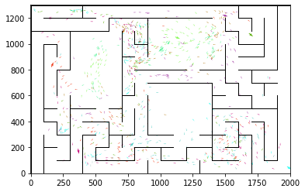

epoch 4191 == proposed_mle: 14.61+-0.34/13.88+-0.23 --

epoch 4192 == proposed_mle: 14.88+-0.34/13.78+-0.22 --

epoch 4193 == proposed_mle: 14.59+-0.24/13.83+-0.21 --

epoch 4194 == proposed_mle: 14.83+-0.34/13.77+-0.21 --

epoch 4195 == proposed_mle: 14.63+-0.26/13.74+-0.21 --

epoch 4196 == proposed_mle: 14.44+-0.29/13.91+-0.23 --

epoch 4197 == proposed_mle: 14.96+-0.34/13.50+-0.22 --

epoch 4198 == proposed_mle: 14.86+-0.29/13.61+-0.22 --

epoch 4199 == proposed_mle: 14.11+-0.30/13.89+-0.22 --

epoch 4200 == proposed_mle: 14.37+-0.26/13.60+-0.20 --

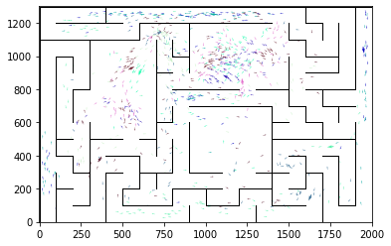

epoch 4201 == proposed_mle: 14.45+-0.29/13.83+-0.21 --

epoch 4202 == proposed_mle: 14.37+-0.32/13.81+-0.22 --

epoch 4203 == proposed_mle: 14.24+-0.38/13.71+-0.20 --

epoch 4204 == proposed_mle: 14.06+-0.32/13.86+-0.21 --

epoch 4205 == proposed_mle: 14.16+-0.33/13.93+-0.22 --

epoch 4206 == proposed_mle: 14.24+-0.29/13.82+-0.21 --

epoch 4207 == proposed_mle: 14.84+-0.33/13.95+-0.21 --

epoch 4208 == proposed_mle: 14.41+-0.26/13.60+-0.21 --

epoch 4209 == proposed_mle: 14.70+-0.30/13.59+-0.23 --

epoch 4210 == proposed_mle: 14.77+-0.27/13.72+-0.23 --

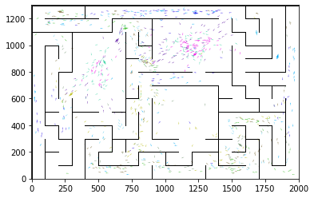

epoch 4211 == proposed_mle: 14.01+-0.26/13.51+-0.20 --

epoch 4212 == proposed_mle: 14.59+-0.32/13.68+-0.21 --

epoch 4213 == proposed_mle: 15.15+-0.36/13.63+-0.21 --

epoch 4214 == proposed_mle: 15.18+-0.33/13.61+-0.20 --

epoch 4215 == proposed_mle: 14.33+-0.28/13.92+-0.22 --

epoch 4216 == proposed_mle: 14.54+-0.34/13.85+-0.23 --

epoch 4217 == proposed_mle: 14.62+-0.29/13.88+-0.21 --

epoch 4218 == proposed_mle: 14.33+-0.29/13.73+-0.20 --

epoch 4219 == proposed_mle: 14.86+-0.32/13.87+-0.22 --

epoch 4220 == proposed_mle: 14.17+-0.32/13.67+-0.21 --

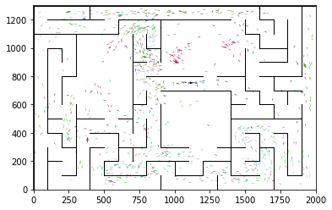

epoch 4221 == proposed_mle: 14.40+-0.28/13.82+-0.21 --

epoch 4222 == proposed_mle: 14.41+-0.39/13.59+-0.19 --

epoch 4223 == proposed_mle: 14.34+-0.28/13.70+-0.23 --

epoch 4224 == proposed_mle: 14.84+-0.31/13.58+-0.21 --

epoch 4225 == proposed_mle: 14.60+-0.28/13.79+-0.20 --

epoch 4226 == proposed_mle: 14.03+-0.31/13.77+-0.21 --

epoch 4227 == proposed_mle: 14.51+-0.32/13.73+-0.22 --

epoch 4228 == proposed_mle: 14.35+-0.32/13.71+-0.22 --

epoch 4229 == proposed_mle: 15.06+-0.31/13.90+-0.20 --

epoch 4230 == proposed_mle: 14.19+-0.33/13.64+-0.21 --

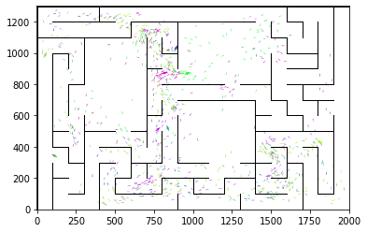

epoch 4231 == proposed_mle: 14.25+-0.29/13.85+-0.20 --

epoch 4232 == proposed_mle: 14.46+-0.31/13.79+-0.22 --

epoch 4233 == proposed_mle: 13.63+-0.32/13.88+-0.20 --

epoch 4234 == proposed_mle: 14.44+-0.29/13.80+-0.20 --

epoch 4235 == proposed_mle: 14.79+-0.36/13.93+-0.23 --

epoch 4236 == proposed_mle: 14.92+-0.32/13.83+-0.21 --

epoch 4237 == proposed_mle: 13.81+-0.28/13.87+-0.20 --

epoch 4238 == proposed_mle: 14.54+-0.31/13.72+-0.21 --

epoch 4239 == proposed_mle: 14.00+-0.34/13.89+-0.23 --

epoch 4240 == proposed_mle: 14.27+-0.36/13.94+-0.23 --

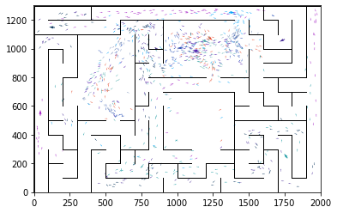

epoch 4241 == proposed_mle: 14.15+-0.33/13.80+-0.22 --

epoch 4242 == proposed_mle: 14.57+-0.30/13.74+-0.19 --

epoch 4243 == proposed_mle: 13.95+-0.29/13.75+-0.21 --

epoch 4244 == proposed_mle: 14.67+-0.30/13.57+-0.21 --

epoch 4245 == proposed_mle: 14.47+-0.33/13.78+-0.22 --

epoch 4246 == proposed_mle: 14.96+-0.38/13.52+-0.22 --

epoch 4247 == proposed_mle: 13.87+-0.30/13.73+-0.22 --

epoch 4248 == proposed_mle: 14.25+-0.29/13.73+-0.23 --

epoch 4249 == proposed_mle: 14.23+-0.28/13.72+-0.21 --

epoch 4250 == proposed_mle: 13.67+-0.32/13.84+-0.23 --

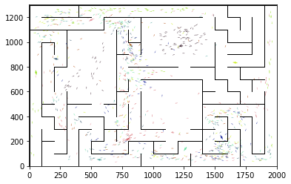

epoch 4251 == proposed_mle: 14.78+-0.28/13.74+-0.21 --

epoch 4252 == proposed_mle: 14.71+-0.32/13.78+-0.23 --

epoch 4253 == proposed_mle: 14.56+-0.26/13.88+-0.23 --

epoch 4254 == proposed_mle: 14.68+-0.29/13.80+-0.22 --

epoch 4255 == proposed_mle: 14.16+-0.26/13.62+-0.21 --

epoch 4256 == proposed_mle: 14.76+-0.35/13.80+-0.22 --

epoch 4257 == proposed_mle: 14.19+-0.28/13.91+-0.23 --

epoch 4258 == proposed_mle: 14.39+-0.24/13.62+-0.22 --

epoch 4259 == proposed_mle: 14.57+-0.31/13.65+-0.23 --

epoch 4260 == proposed_mle: 14.69+-0.25/13.65+-0.21 --

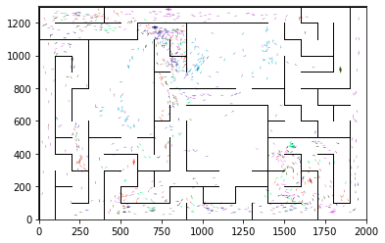

epoch 4261 == proposed_mle: 14.48+-0.35/13.55+-0.21 --

epoch 4262 == proposed_mle: 14.02+-0.30/13.67+-0.22 --

epoch 4263 == proposed_mle: 14.40+-0.35/13.68+-0.20 --

epoch 4264 == proposed_mle: 14.67+-0.27/13.75+-0.21 --

epoch 4265 == proposed_mle: 14.89+-0.35/14.05+-0.22 --

epoch 4266 == proposed_mle: 14.17+-0.25/13.69+-0.22 --

epoch 4267 == proposed_mle: 14.66+-0.32/13.80+-0.22 --

epoch 4268 == proposed_mle: 14.13+-0.31/13.74+-0.22 --

epoch 4269 == proposed_mle: 14.50+-0.23/13.87+-0.21 --

epoch 4270 == proposed_mle: 14.69+-0.33/13.71+-0.22 --

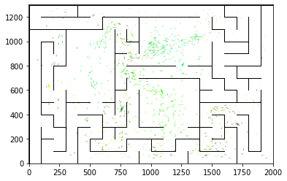

epoch 4271 == proposed_mle: 14.85+-0.28/13.79+-0.21 --

epoch 4272 == proposed_mle: 14.17+-0.32/13.83+-0.21 --

epoch 4273 == proposed_mle: 14.45+-0.36/13.86+-0.21 --

epoch 4274 == proposed_mle: 15.04+-0.32/13.86+-0.22 --

epoch 4275 == proposed_mle: 14.48+-0.29/13.72+-0.22 --

epoch 4276 == proposed_mle: 14.42+-0.30/13.60+-0.19 --

epoch 4277 == proposed_mle: 14.65+-0.31/13.67+-0.22 --

epoch 4278 == proposed_mle: 14.37+-0.31/13.90+-0.20 --

epoch 4279 == proposed_mle: 14.48+-0.34/13.68+-0.22 --

epoch 4280 == proposed_mle: 13.76+-0.36/13.70+-0.22 --

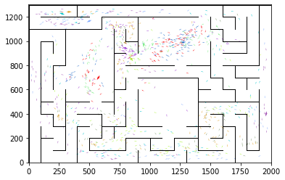

INFO:tensorflow:Restoring parameters from ../models/tmp/best_validation

INFO:tensorflow:Restoring parameters from ../models/tmp/best_validation

epoch 0 >> mse_last: 28.13+-2.31 -- mle: 8.65+-0.15 --

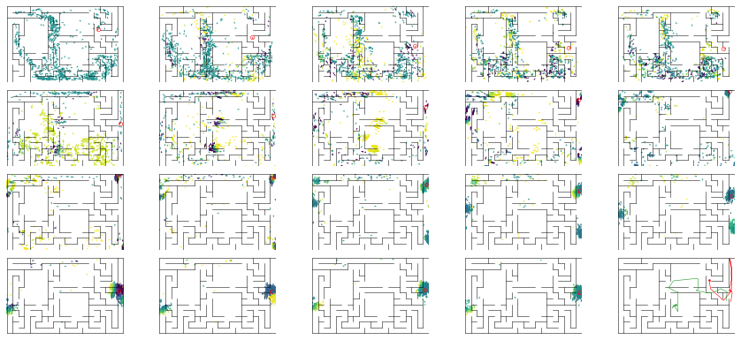

epoch 1 >> mse_last: 33.33+-3.41/26.18+-1.94 -- mle: 8.99+-0.22/8.03+-0.15 --

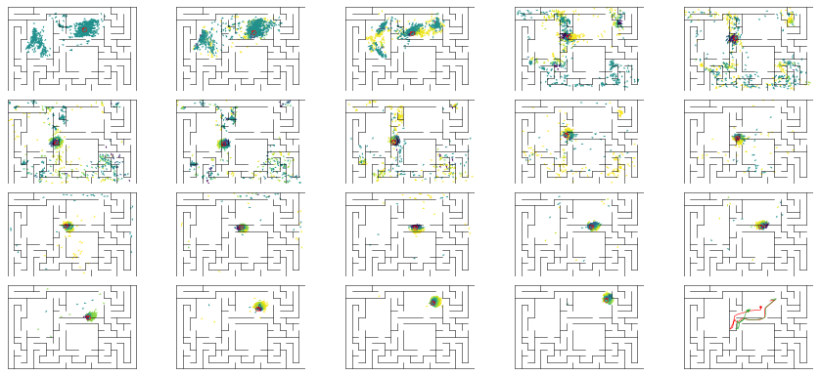

epoch 2 == mse_last: 35.42+-4.08/31.75+-2.62 -- mle: 9.06+-0.26/8.14+-0.18 --

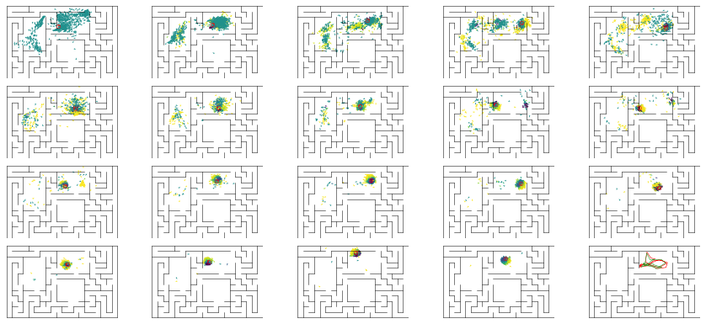

epoch 3 == mse_last: 22.26+-2.89/31.39+-2.18 -- mle: 8.56+-0.23/8.14+-0.16 --

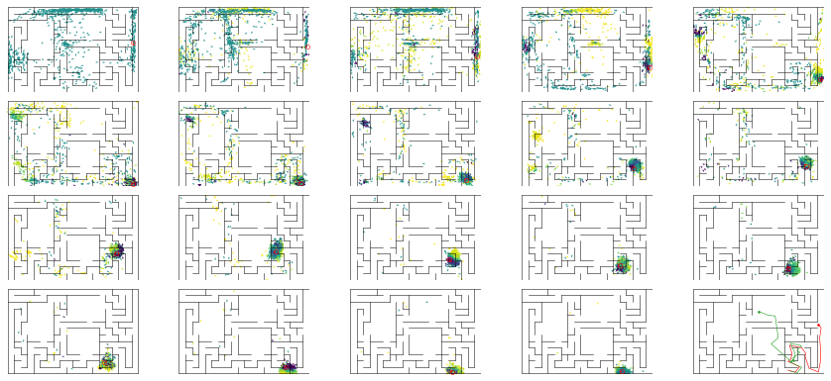

epoch 4 == mse_last: 27.16+-3.03/26.18+-2.01 -- mle: 8.39+-0.27/8.01+-0.17 --

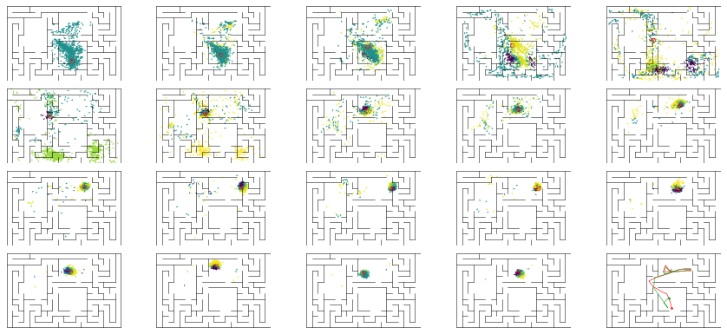

epoch 5 == mse_last: 27.24+-3.04/30.07+-2.28 -- mle: 8.63+-0.24/7.72+-0.15 --

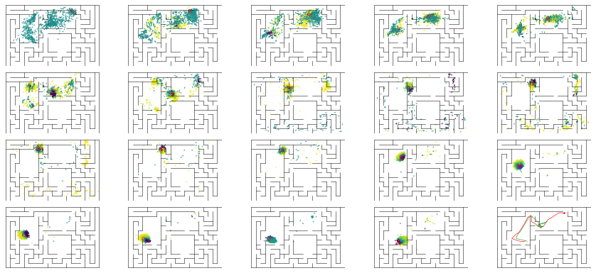

epoch 6 == mse_last: 32.52+-3.82/29.31+-2.21 -- mle: 8.76+-0.23/7.85+-0.17 --

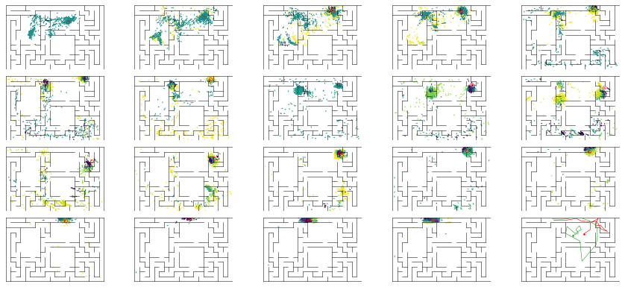

epoch 7 >> mse_last: 24.55+-2.88/25.14+-2.00 -- mle: 8.42+-0.24/7.54+-0.16 --

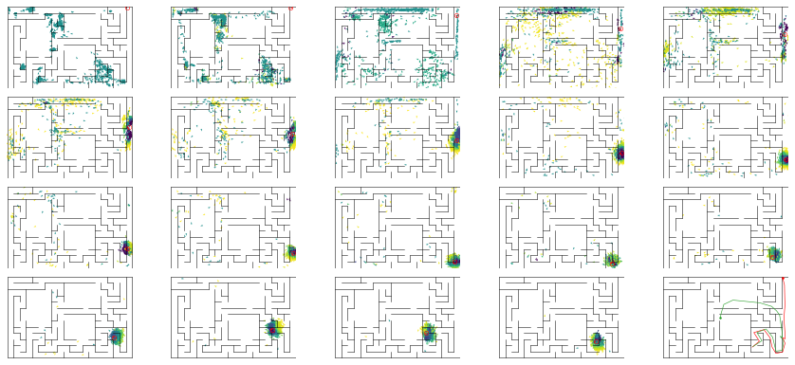

epoch 8 == mse_last: 21.90+-1.91/30.61+-2.15 -- mle: 8.33+-0.24/7.73+-0.16 --

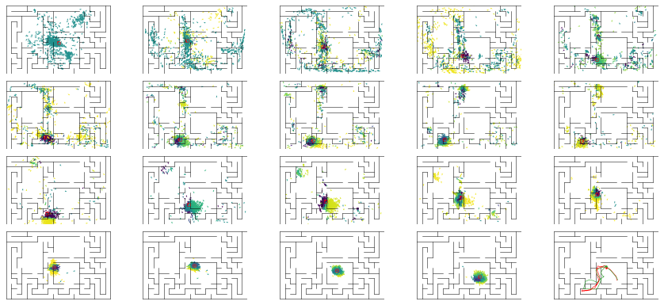

epoch 9 == mse_last: 32.19+-3.26/29.72+-2.34 -- mle: 8.63+-0.24/7.52+-0.17 --

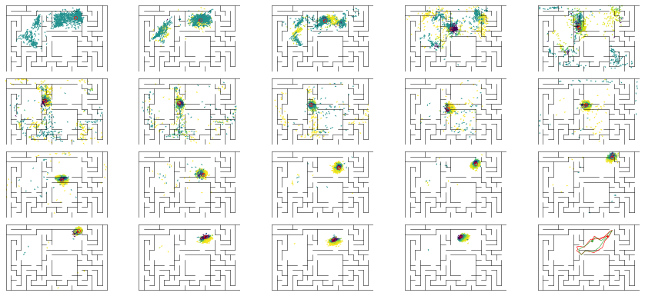

epoch 10 == mse_last: 29.08+-2.84/27.58+-2.16 -- mle: 8.57+-0.26/7.70+-0.16 --

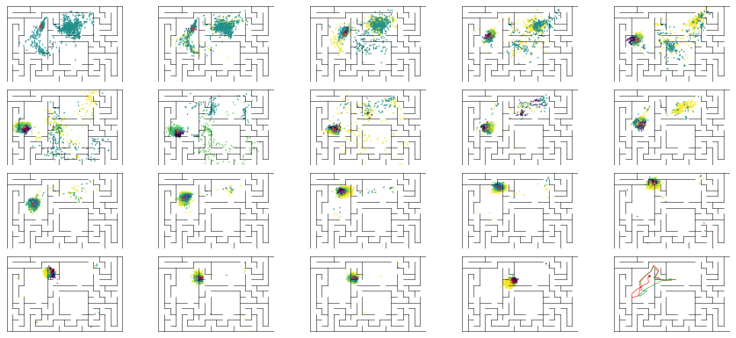

epoch 11 == mse_last: 27.10+-3.16/30.53+-2.46 -- mle: 8.40+-0.24/7.66+-0.15 --

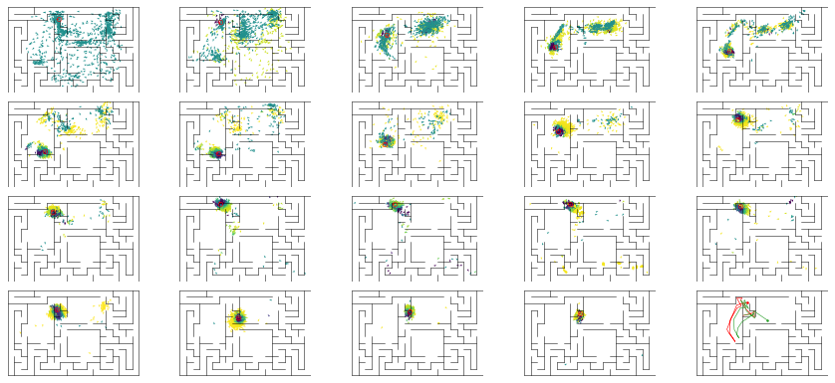

epoch 12 == mse_last: 26.91+-2.26/30.13+-2.25 -- mle: 8.47+-0.21/7.67+-0.15 --

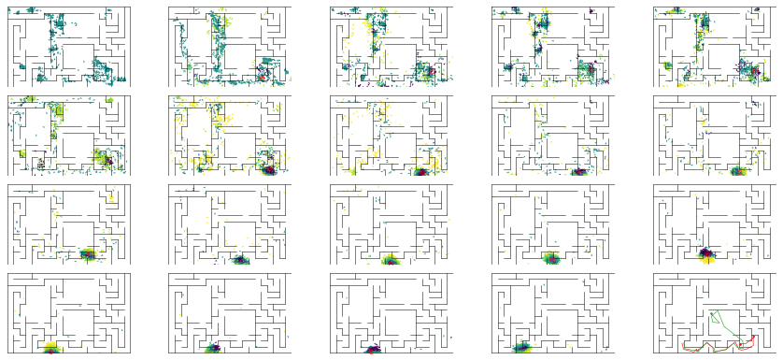

epoch 13 == mse_last: 30.95+-3.22/26.67+-1.77 -- mle: 8.53+-0.21/7.76+-0.17 --

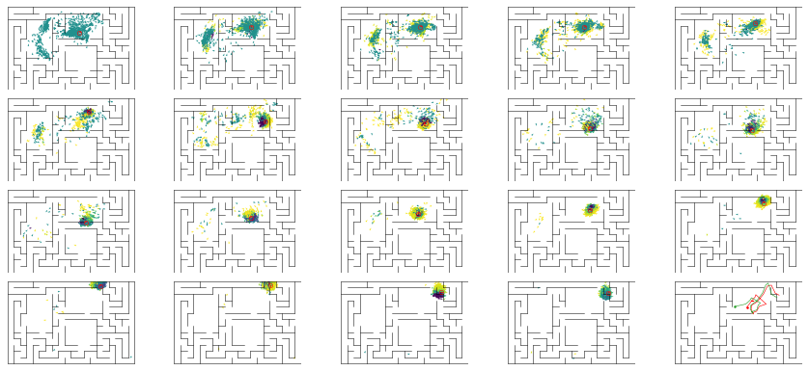

epoch 14 == mse_last: 27.49+-2.66/26.77+-2.30 -- mle: 8.30+-0.24/7.37+-0.14 --

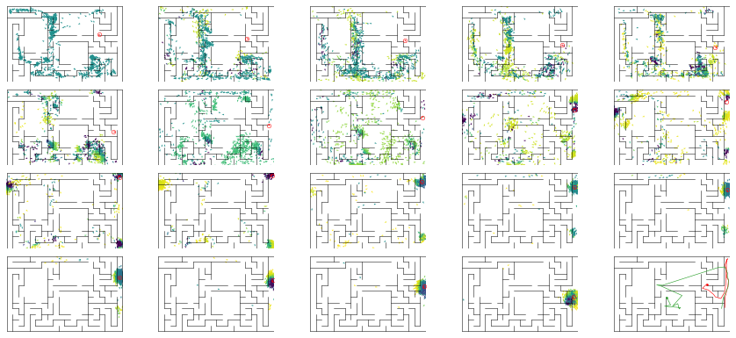

epoch 15 >> mse_last: 24.57+-2.90/24.86+-2.01 -- mle: 8.36+-0.24/7.50+-0.15 --

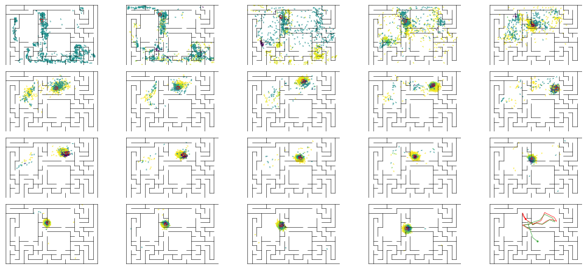

epoch 16 == mse_last: 29.72+-3.02/28.35+-2.02 -- mle: 8.06+-0.24/7.95+-0.17 --

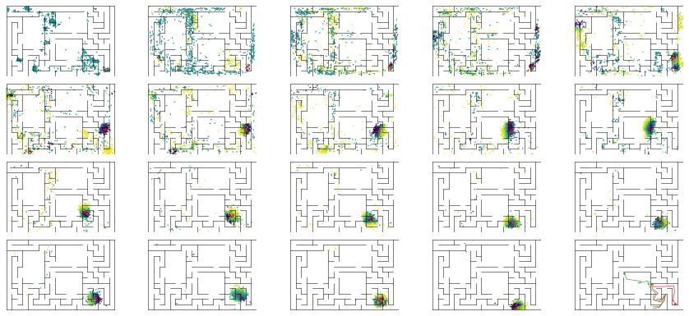

epoch 17 == mse_last: 24.70+-2.43/26.08+-2.08 -- mle: 8.02+-0.20/7.38+-0.15 --

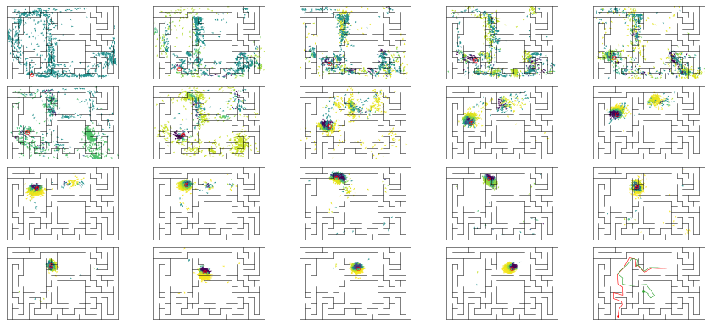

epoch 18 == mse_last: 22.56+-2.41/25.25+-2.06 -- mle: 7.95+-0.20/7.42+-0.16 --

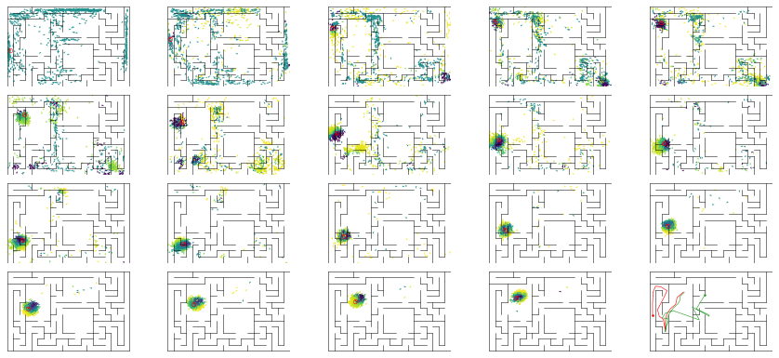

epoch 19 == mse_last: 27.17+-3.20/29.89+-2.23 -- mle: 8.23+-0.25/7.48+-0.15 --

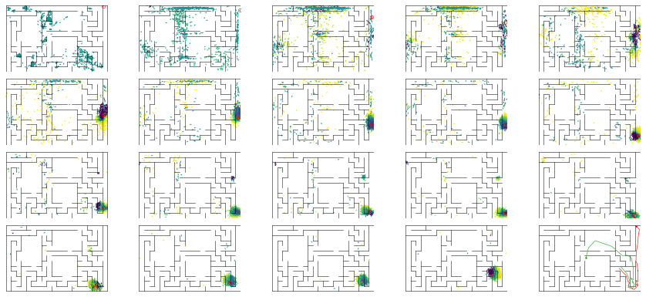

epoch 20 == mse_last: 27.42+-3.00/29.45+-2.13 -- mle: 7.90+-0.25/7.39+-0.14 --

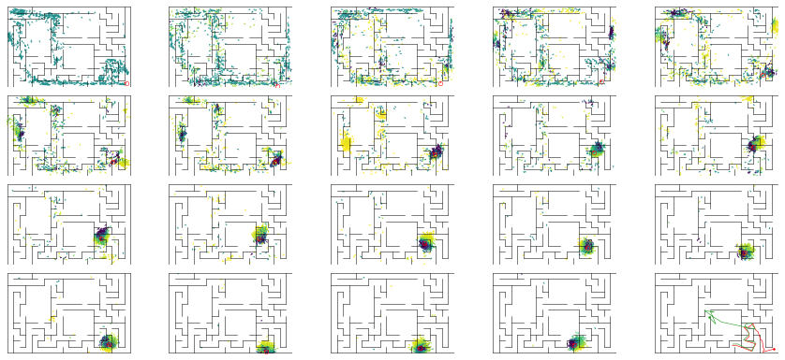

epoch 21 >> mse_last: 30.01+-2.73/22.76+-1.80 -- mle: 8.42+-0.23/7.16+-0.15 --

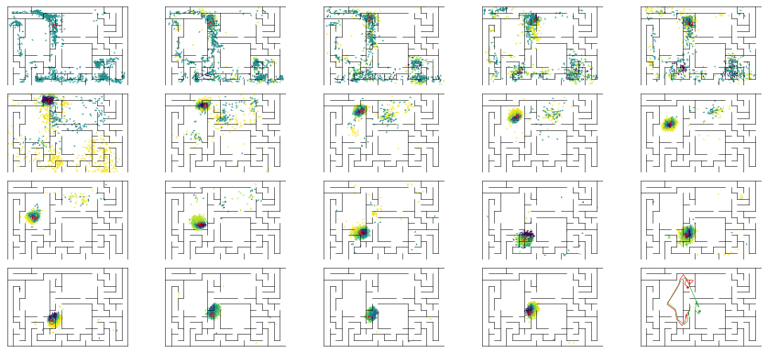

epoch 22 == mse_last: 28.48+-3.27/24.87+-2.05 -- mle: 8.20+-0.23/7.13+-0.15 --

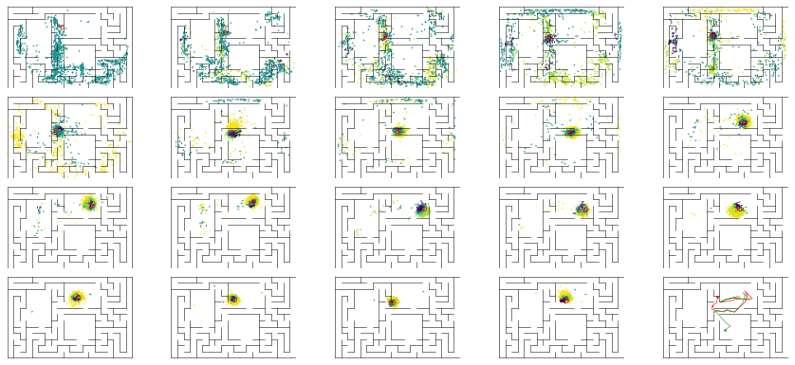

epoch 23 == mse_last: 23.56+-2.56/24.24+-1.97 -- mle: 7.93+-0.23/7.09+-0.15 --

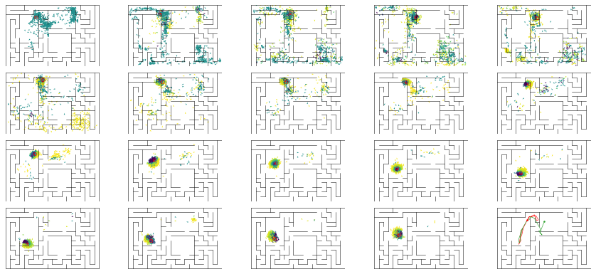

epoch 24 == mse_last: 28.59+-3.17/32.12+-2.21 -- mle: 8.14+-0.21/7.59+-0.17 --

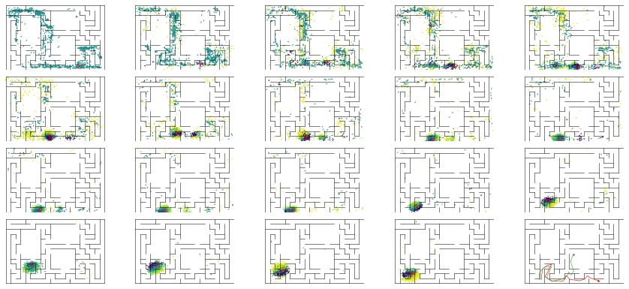

epoch 25 == mse_last: 28.52+-3.23/24.35+-1.97 -- mle: 8.09+-0.22/7.20+-0.14 --

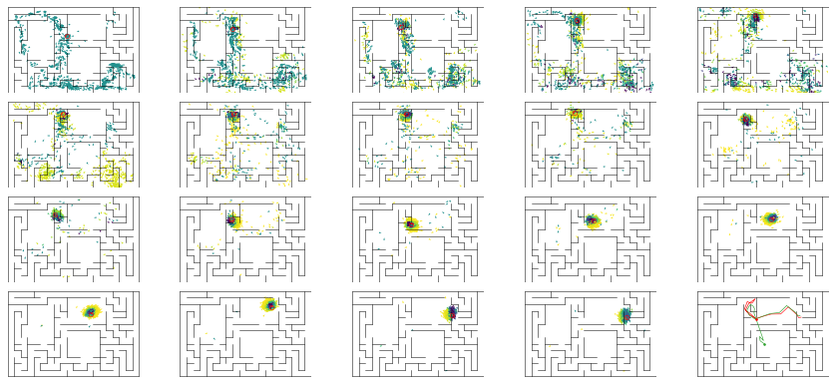

epoch 26 == mse_last: 26.24+-2.86/23.50+-2.28 -- mle: 8.18+-0.25/7.19+-0.15 --

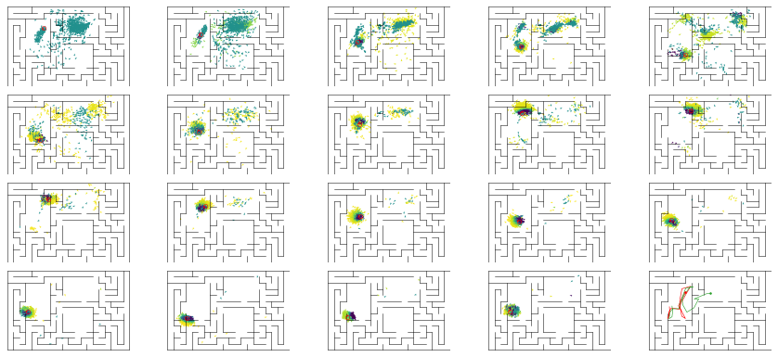

epoch 27 == mse_last: 24.19+-2.68/24.83+-2.06 -- mle: 8.08+-0.22/7.22+-0.15 --

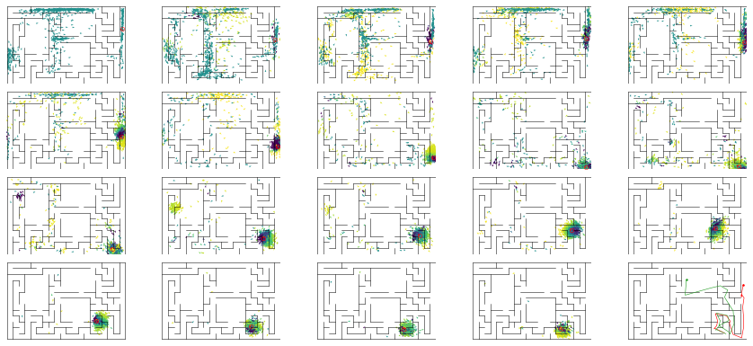

epoch 28 == mse_last: 25.03+-2.68/37.54+-2.21 -- mle: 8.03+-0.23/7.84+-0.17 --

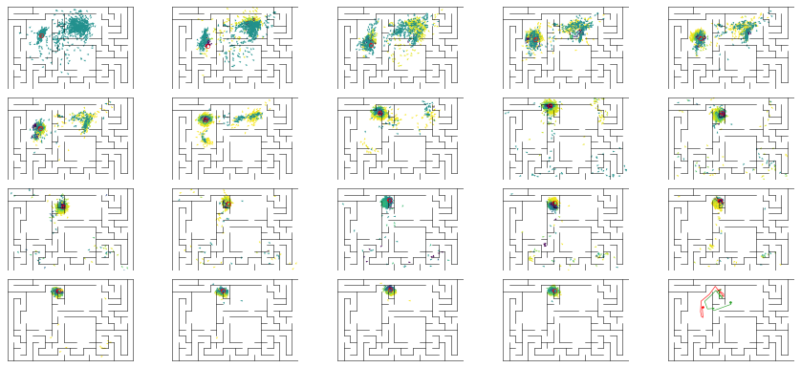

epoch 29 == mse_last: 28.48+-3.29/26.60+-2.27 -- mle: 8.11+-0.25/7.58+-0.16 --

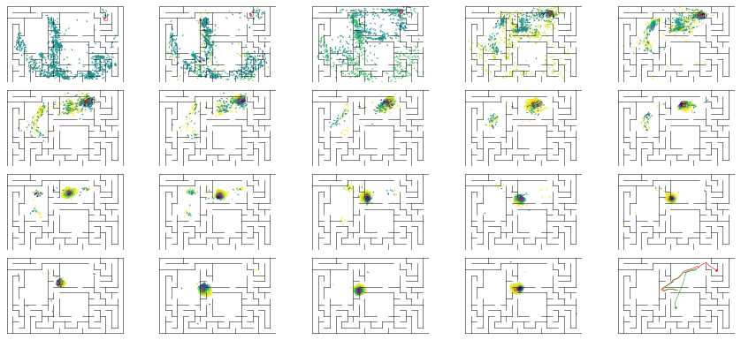

epoch 30 == mse_last: 30.03+-2.92/24.42+-2.14 -- mle: 8.15+-0.20/7.30+-0.15 --

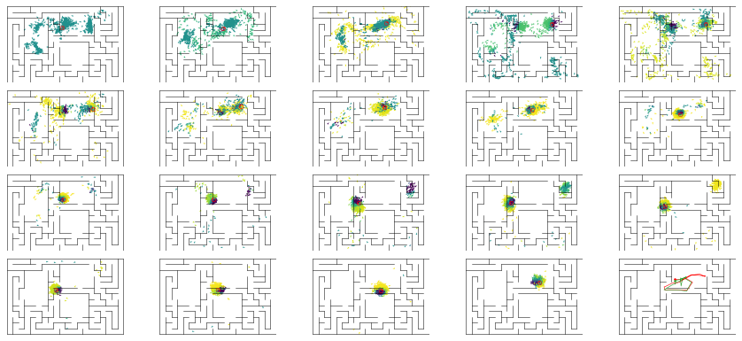

epoch 31 == mse_last: 24.61+-2.38/27.44+-2.05 -- mle: 7.94+-0.20/7.46+-0.16 --

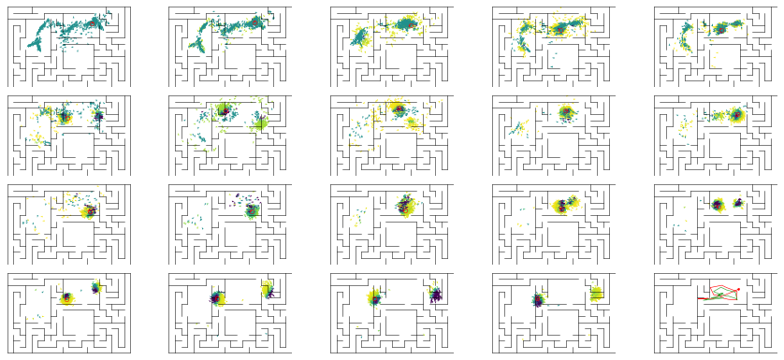

epoch 32 == mse_last: 23.19+-2.68/24.50+-2.00 -- mle: 7.95+-0.23/7.35+-0.16 --

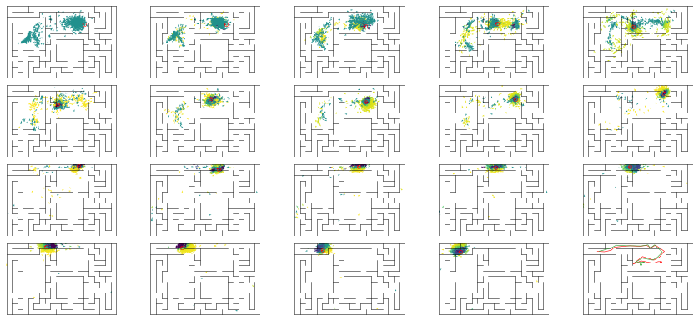

epoch 33 == mse_last: 28.84+-3.01/23.50+-1.86 -- mle: 8.21+-0.24/7.33+-0.16 --

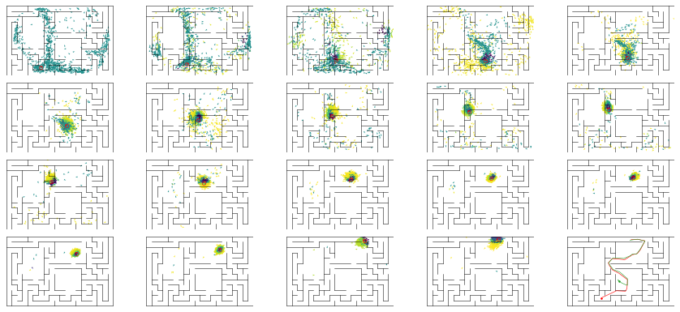

epoch 34 == mse_last: 20.58+-2.63/24.44+-2.17 -- mle: 7.87+-0.21/7.18+-0.14 --

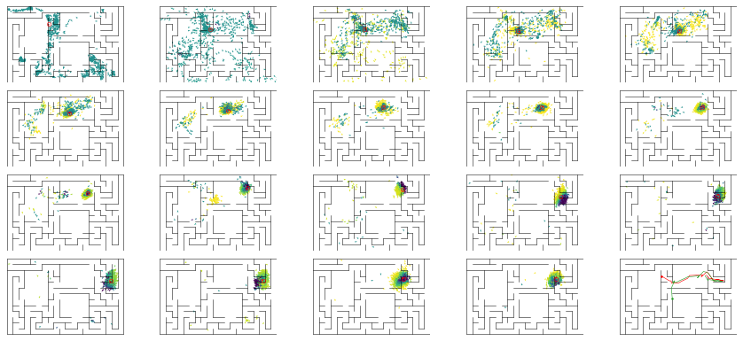

epoch 35 == mse_last: 31.34+-2.81/25.91+-2.14 -- mle: 7.88+-0.22/7.31+-0.15 --

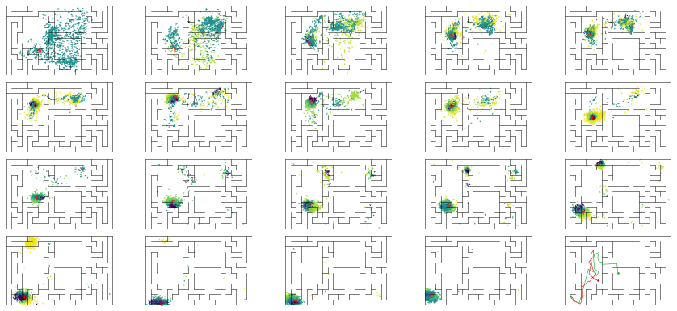

epoch 36 == mse_last: 27.42+-3.17/28.73+-2.15 -- mle: 8.15+-0.25/7.46+-0.15 --

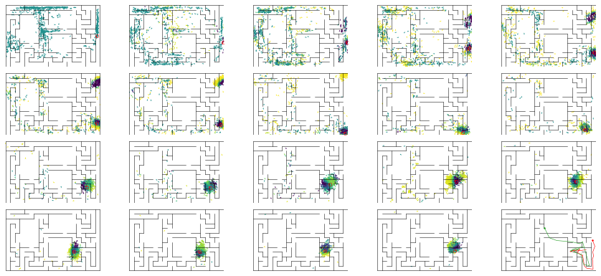

epoch 37 >> mse_last: 23.82+-2.67/21.59+-1.66 -- mle: 7.78+-0.19/7.12+-0.15 --

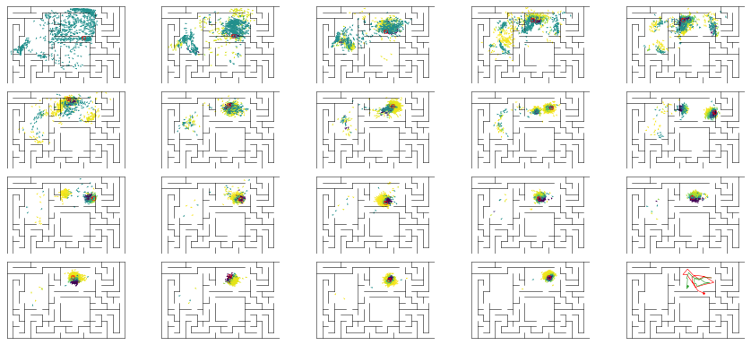

epoch 38 == mse_last: 20.03+-2.25/29.04+-2.22 -- mle: 7.89+-0.22/7.30+-0.16 --

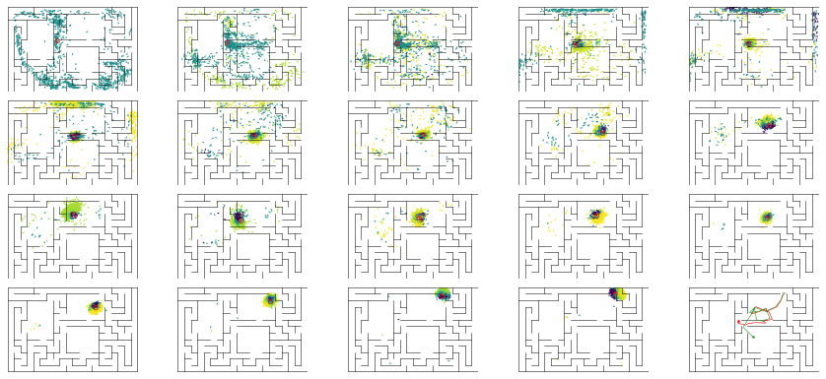

epoch 39 == mse_last: 24.51+-1.99/25.71+-2.17 -- mle: 8.23+-0.22/7.38+-0.15 --

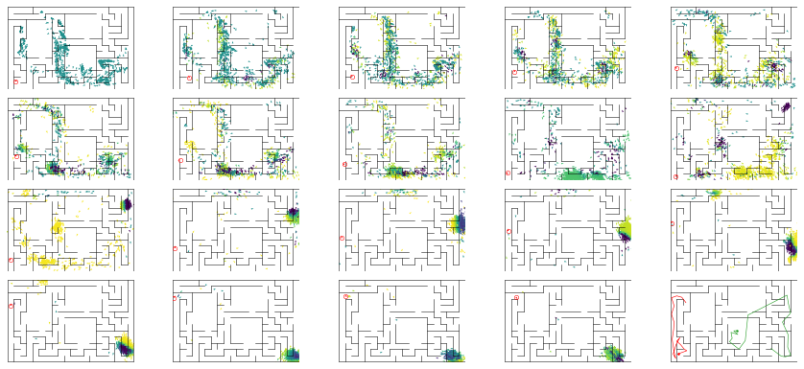

epoch 40 == mse_last: 28.80+-2.83/26.63+-2.12 -- mle: 8.06+-0.19/7.18+-0.15 --

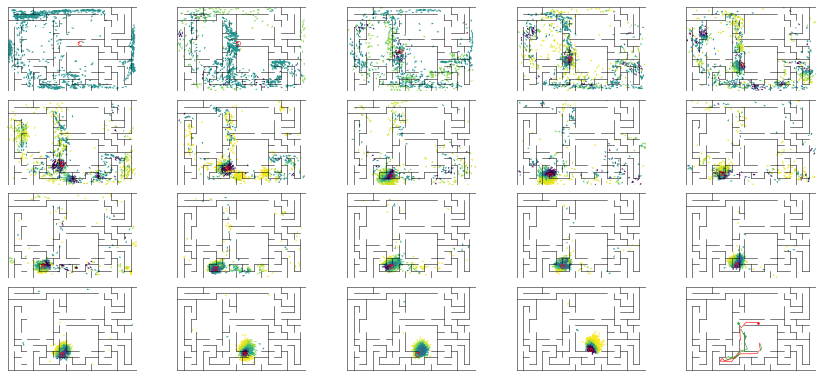

epoch 41 == mse_last: 25.58+-2.61/29.79+-2.21 -- mle: 8.01+-0.23/7.39+-0.15 --

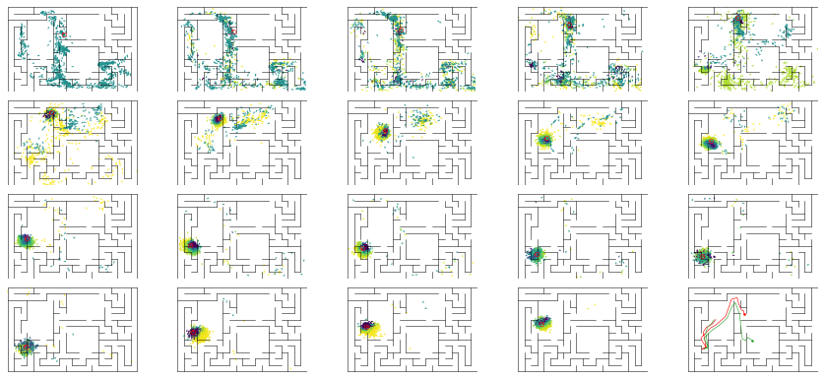

epoch 42 == mse_last: 24.23+-2.46/24.59+-2.10 -- mle: 8.07+-0.24/7.38+-0.16 --

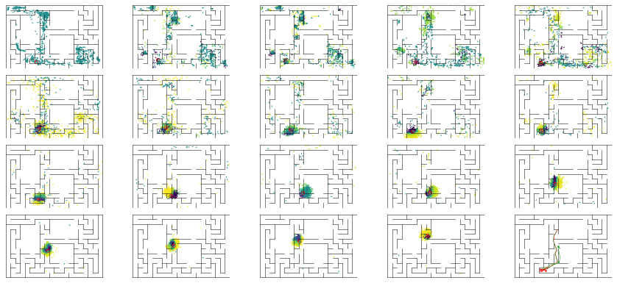

epoch 43 == mse_last: 26.08+-2.66/29.33+-2.05 -- mle: 8.30+-0.20/7.58+-0.15 --

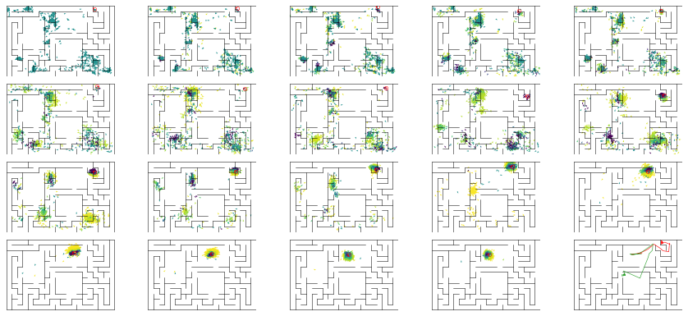

epoch 44 == mse_last: 26.03+-2.53/32.76+-2.54 -- mle: 8.13+-0.22/7.68+-0.16 --

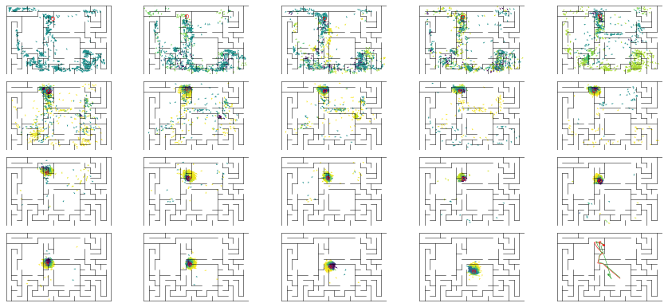

epoch 45 == mse_last: 29.72+-2.60/29.74+-2.10 -- mle: 8.33+-0.23/7.62+-0.15 --

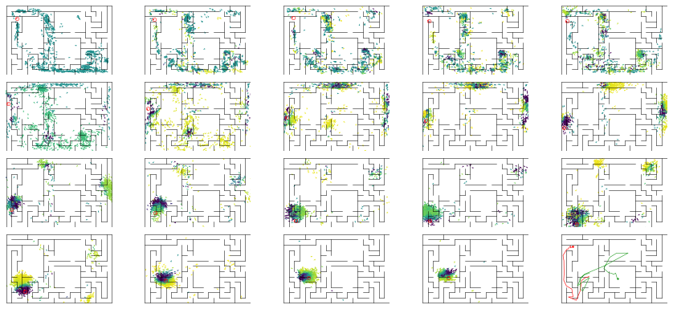

epoch 46 == mse_last: 38.09+-3.78/58.73+-3.10 -- mle: 9.06+-0.26/8.94+-0.19 --

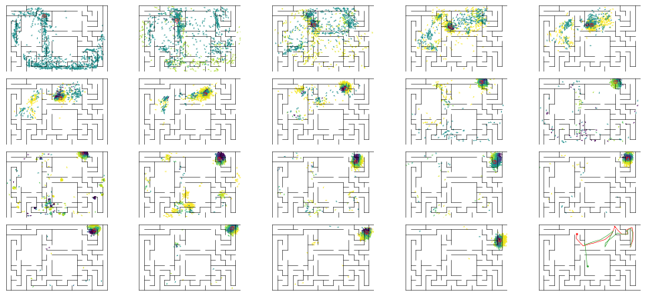

epoch 47 == mse_last: 30.52+-3.01/28.99+-2.07 -- mle: 8.38+-0.22/7.51+-0.16 --

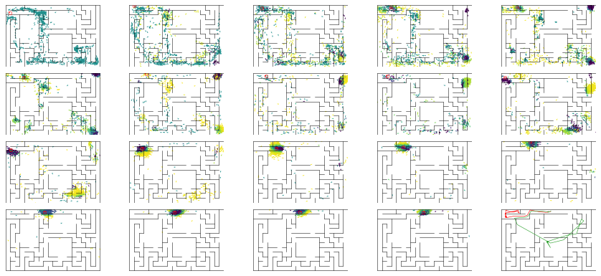

epoch 48 == mse_last: 24.22+-2.41/29.74+-2.08 -- mle: 8.57+-0.23/7.64+-0.15 --

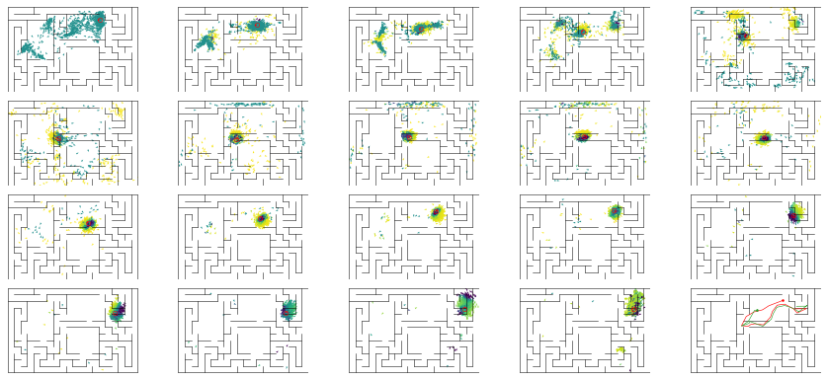

epoch 49 == mse_last: 24.68+-2.70/23.32+-1.92 -- mle: 8.51+-0.24/7.23+-0.14 --

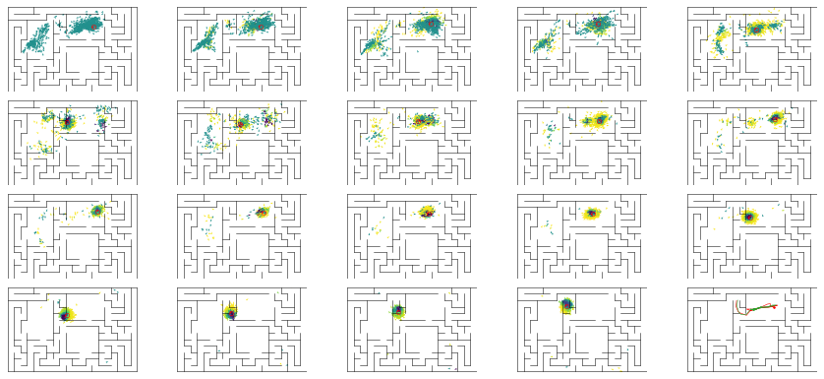

epoch 50 == mse_last: 35.27+-2.88/28.61+-1.97 -- mle: 9.01+-0.24/7.63+-0.16 --

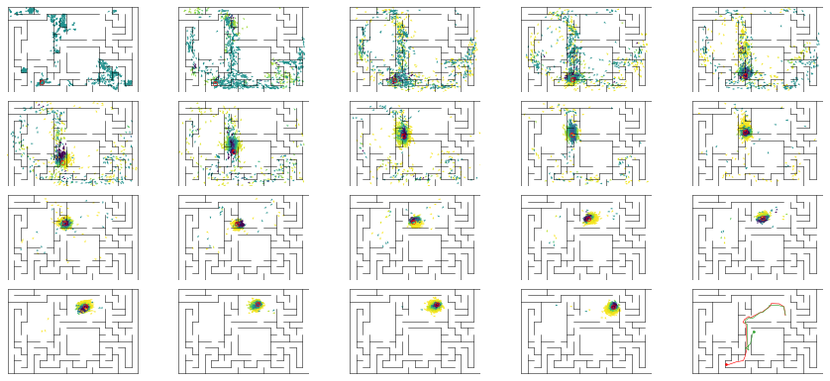

epoch 51 == mse_last: 29.79+-2.85/24.95+-1.88 -- mle: 8.20+-0.23/7.39+-0.15 --

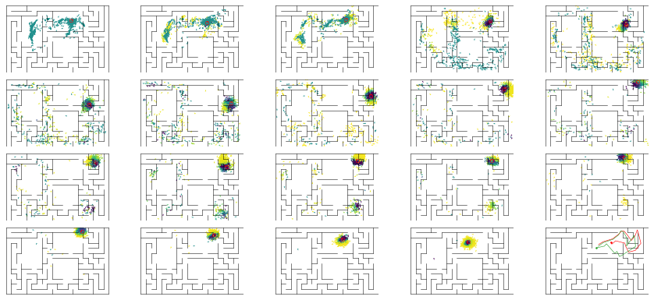

epoch 52 == mse_last: 29.31+-3.35/28.87+-2.33 -- mle: 8.14+-0.24/7.42+-0.17 --

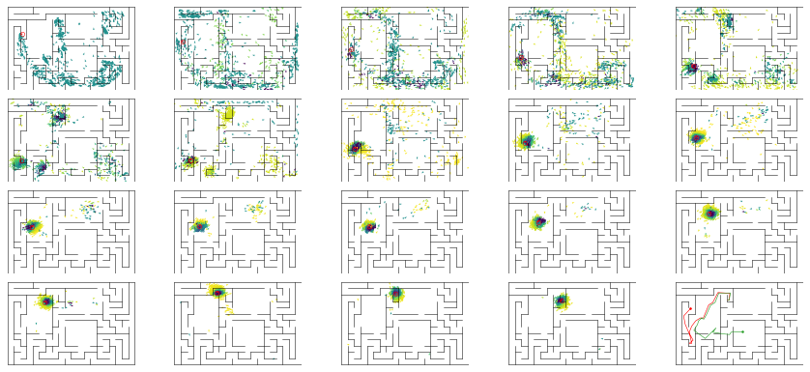

epoch 53 == mse_last: 32.26+-3.24/23.20+-1.77 -- mle: 8.35+-0.22/7.26+-0.13 --

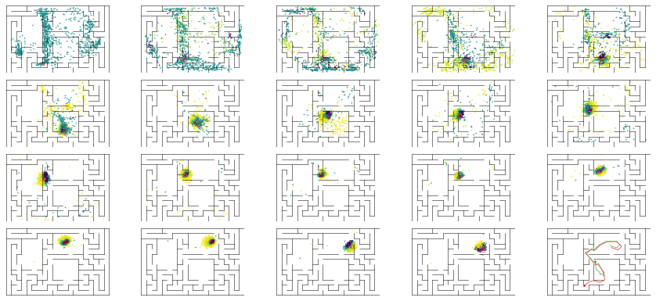

epoch 54 == mse_last: 25.87+-2.85/24.49+-1.97 -- mle: 8.09+-0.18/7.22+-0.15 --

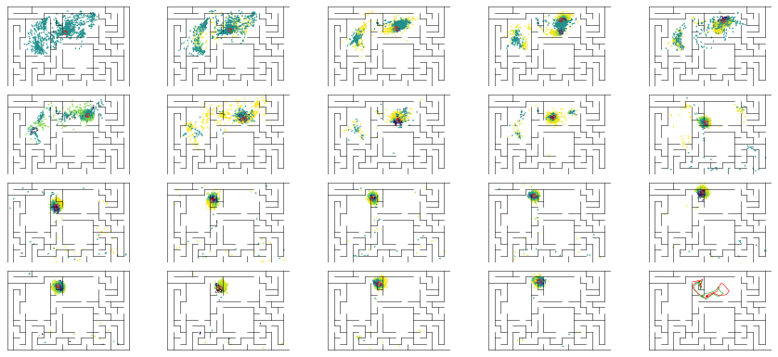

epoch 55 == mse_last: 24.09+-2.49/28.12+-2.26 -- mle: 8.10+-0.24/7.43+-0.16 --

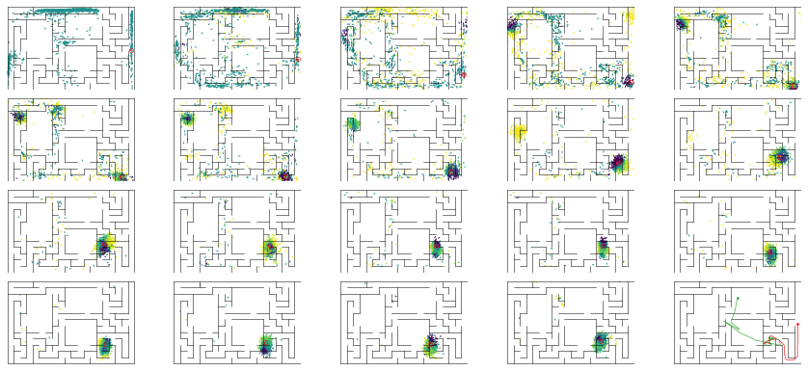

epoch 56 == mse_last: 23.89+-2.72/26.85+-1.92 -- mle: 7.88+-0.22/7.35+-0.15 --

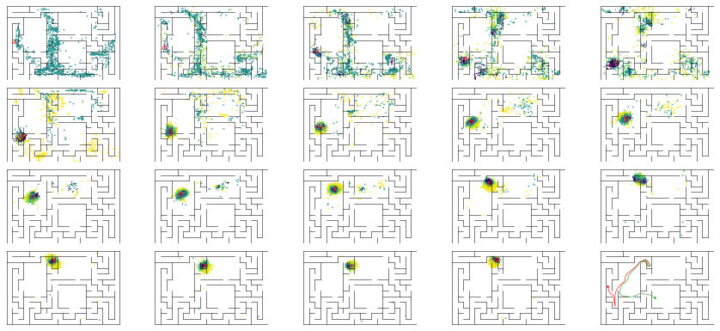

epoch 57 == mse_last: 28.54+-3.23/25.77+-2.14 -- mle: 8.21+-0.24/7.28+-0.15 --

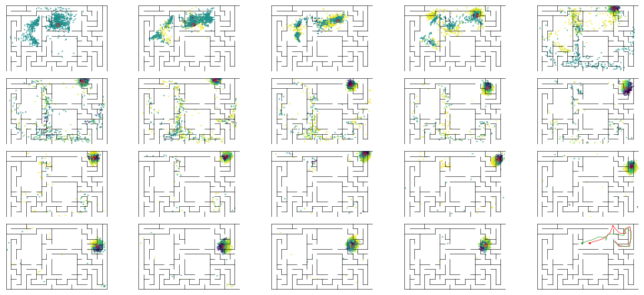

epoch 58 == mse_last: 25.75+-2.80/24.75+-2.18 -- mle: 8.16+-0.21/7.26+-0.15 --

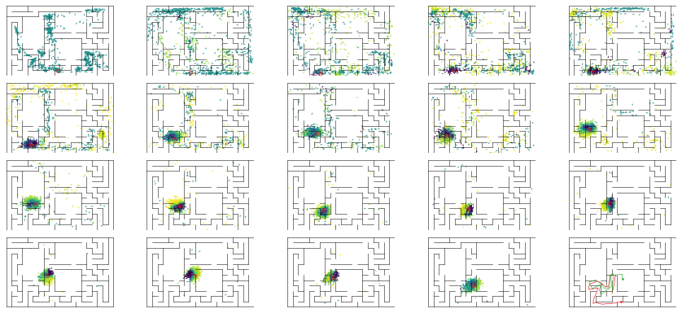

epoch 59 == mse_last: 27.24+-3.12/24.46+-1.84 -- mle: 8.17+-0.24/7.16+-0.14 --

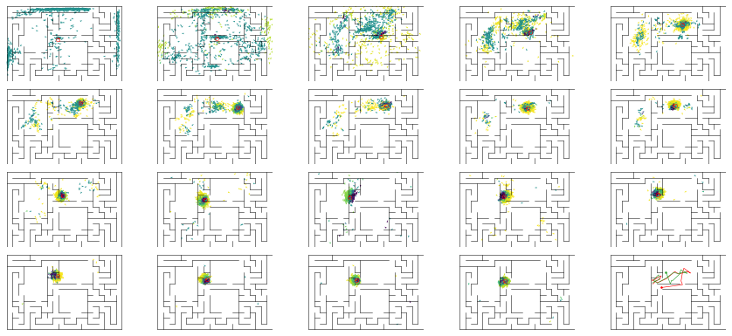

epoch 60 == mse_last: 25.68+-2.39/25.78+-2.15 -- mle: 8.19+-0.22/7.33+-0.15 --

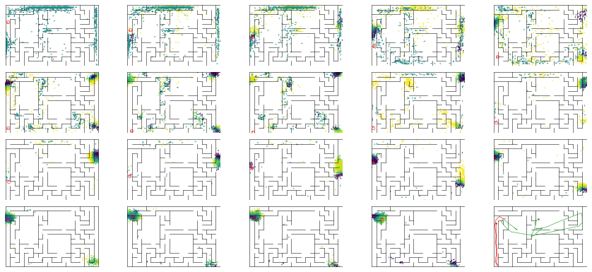

epoch 61 == mse_last: 23.07+-2.28/24.62+-2.06 -- mle: 8.12+-0.25/7.23+-0.16 --

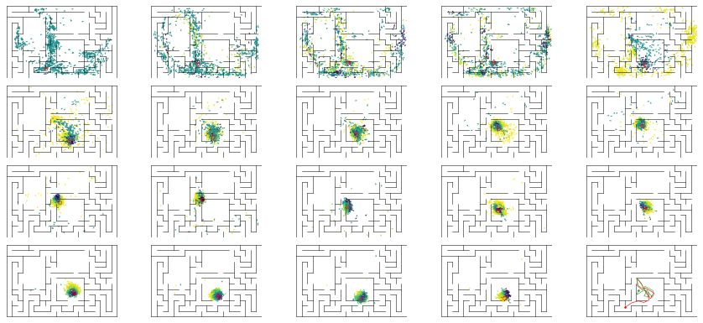

epoch 62 == mse_last: 22.64+-2.64/25.59+-1.98 -- mle: 7.66+-0.21/7.18+-0.16 --

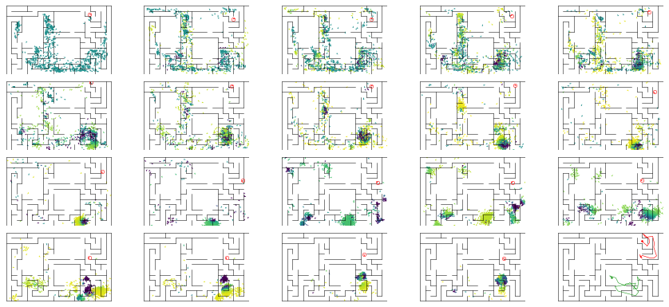

epoch 63 == mse_last: 26.63+-2.44/29.21+-2.57 -- mle: 8.22+-0.20/7.24+-0.15 --

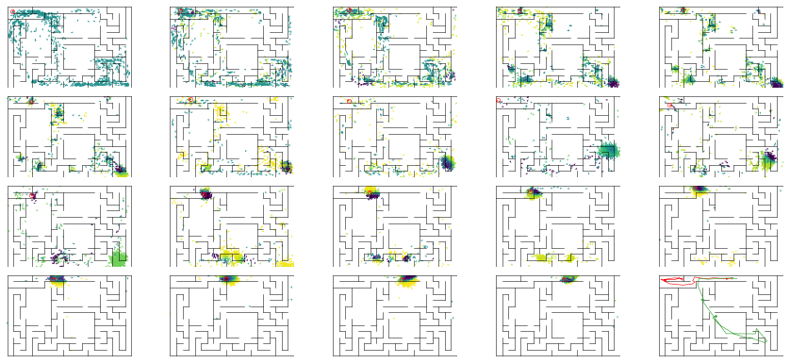

epoch 64 == mse_last: 36.47+-3.34/24.72+-2.07 -- mle: 8.65+-0.25/7.27+-0.16 --

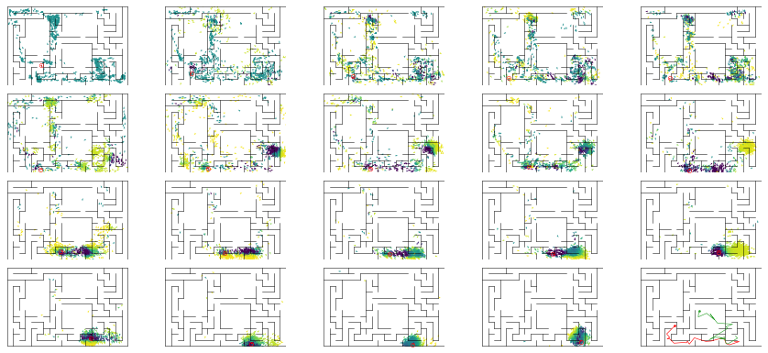

epoch 65 == mse_last: 23.15+-1.85/23.51+-1.85 -- mle: 8.18+-0.21/7.22+-0.14 --

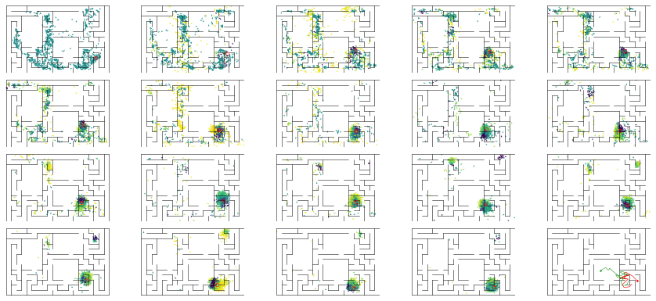

epoch 66 == mse_last: 28.24+-2.91/23.48+-1.89 -- mle: 8.41+-0.23/7.29+-0.16 --

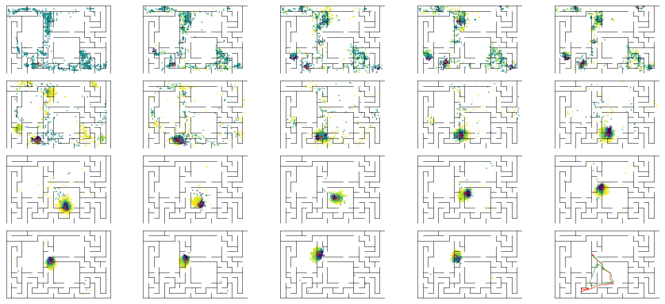

epoch 67 >> mse_last: 25.32+-2.70/21.20+-1.76 -- mle: 8.04+-0.20/6.98+-0.15 --

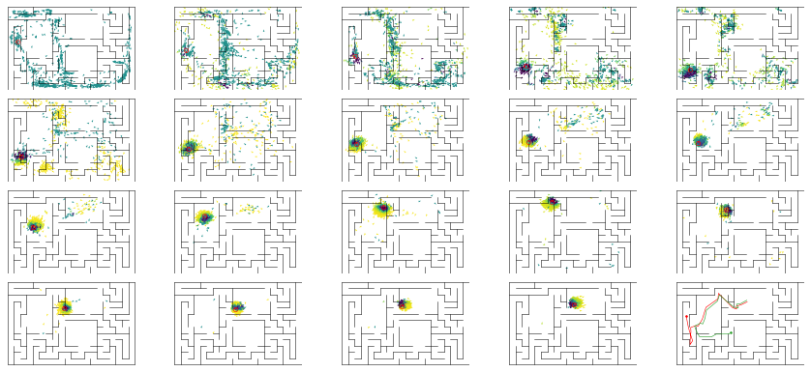

epoch 68 == mse_last: 30.87+-3.51/25.63+-2.08 -- mle: 8.38+-0.23/7.01+-0.15 --

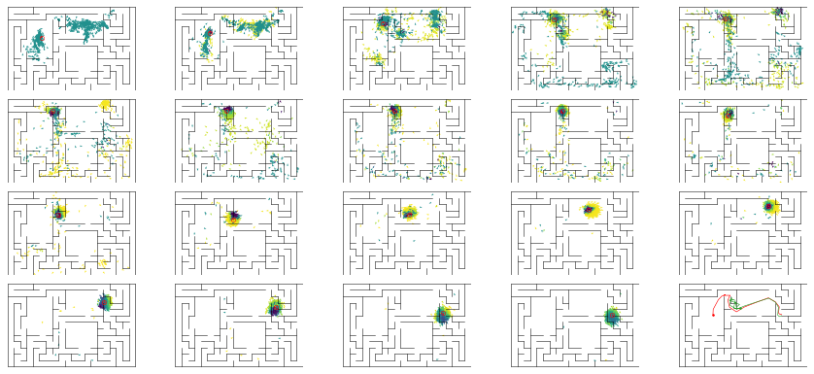

epoch 69 == mse_last: 21.85+-2.36/28.44+-2.38 -- mle: 7.58+-0.19/7.20+-0.14 --

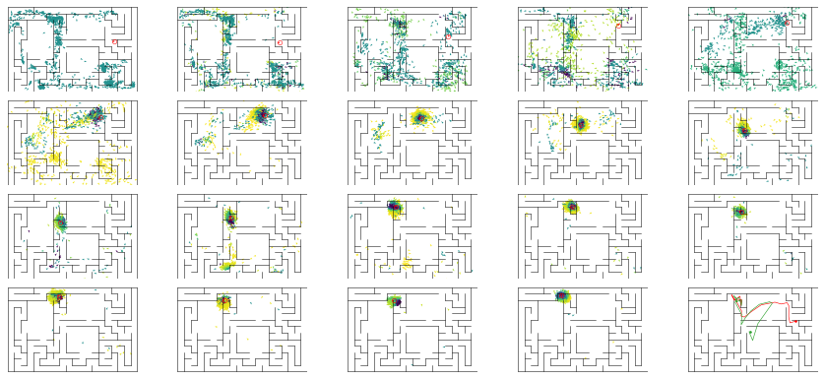

epoch 70 == mse_last: 24.17+-2.83/24.63+-2.21 -- mle: 7.95+-0.23/7.00+-0.15 --

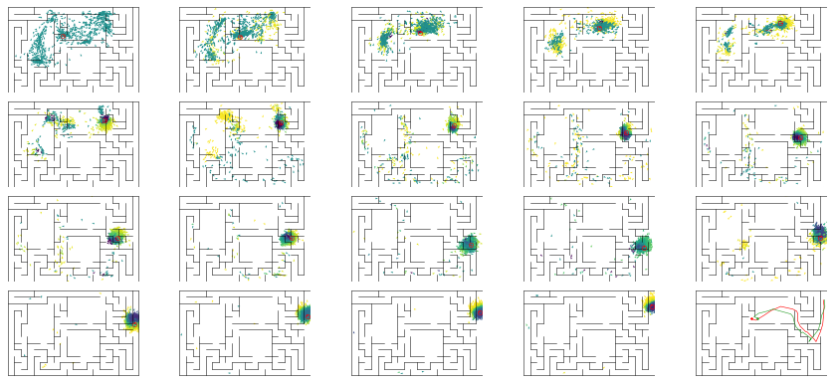

epoch 71 >> mse_last: 27.81+-3.21/18.85+-1.81 -- mle: 8.09+-0.25/6.93+-0.14 --

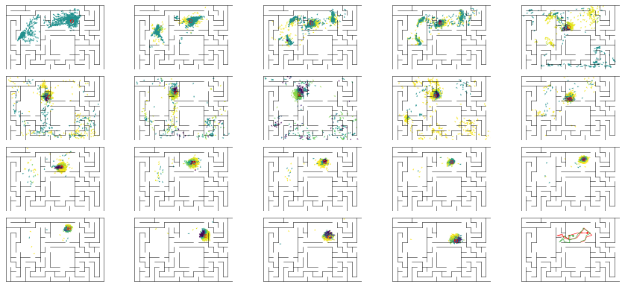

epoch 72 == mse_last: 30.39+-3.62/26.33+-1.98 -- mle: 8.10+-0.21/7.32+-0.14 --

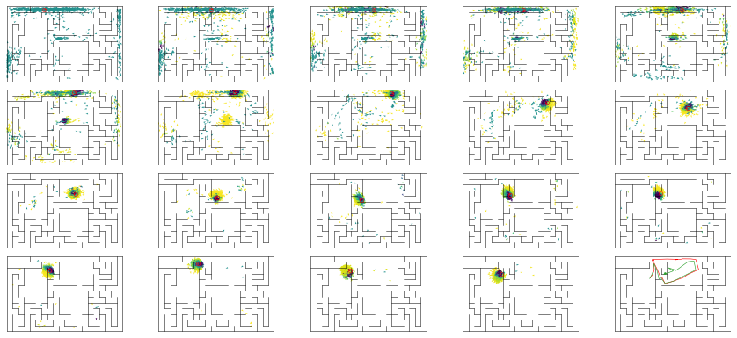

epoch 73 == mse_last: 29.31+-3.14/25.95+-2.00 -- mle: 7.82+-0.23/7.22+-0.15 --

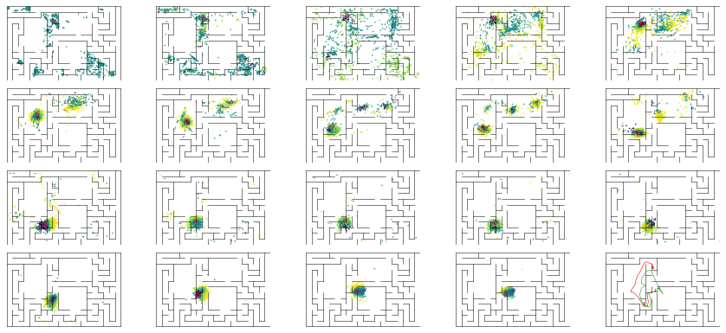

epoch 74 == mse_last: 24.05+-2.86/23.83+-1.90 -- mle: 7.81+-0.21/7.35+-0.16 --

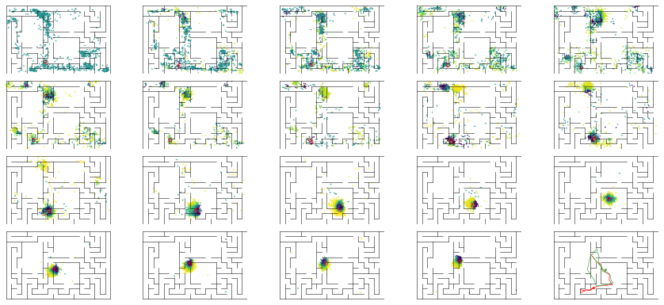

epoch 75 == mse_last: 30.12+-3.22/22.22+-1.89 -- mle: 8.25+-0.22/6.98+-0.14 --

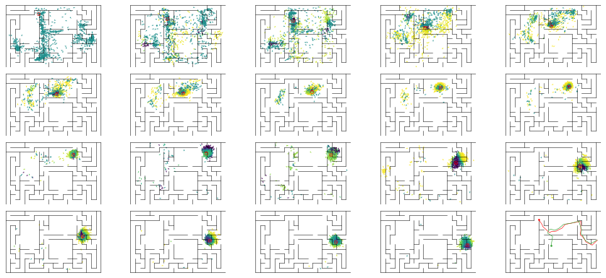

epoch 76 == mse_last: 20.82+-2.52/23.82+-1.70 -- mle: 7.65+-0.22/7.06+-0.14 --

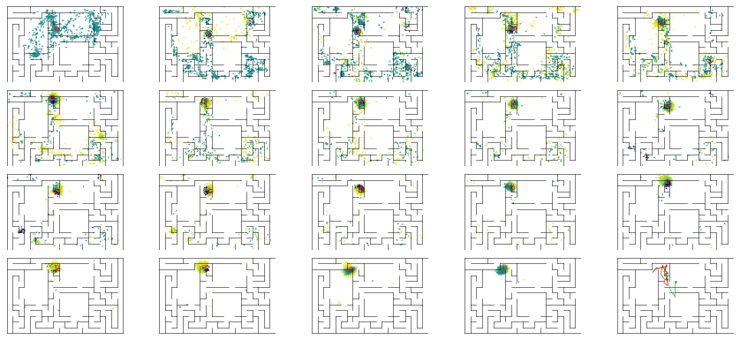

epoch 77 == mse_last: 21.88+-2.44/25.89+-2.19 -- mle: 7.72+-0.19/7.13+-0.17 --

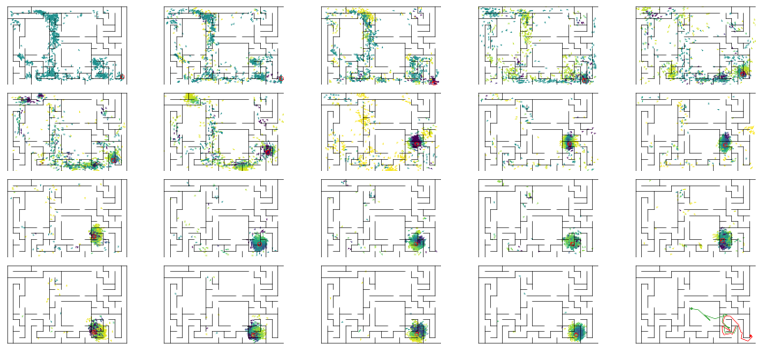

epoch 78 == mse_last: 23.00+-2.68/27.32+-2.23 -- mle: 7.65+-0.21/7.04+-0.15 --

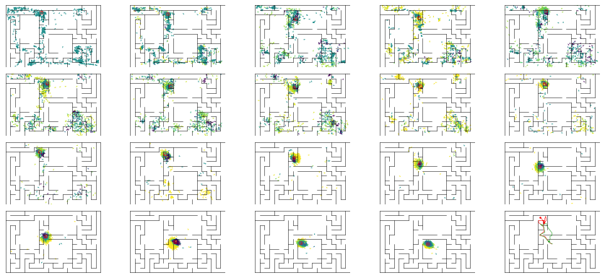

epoch 79 == mse_last: 22.32+-2.93/25.25+-1.97 -- mle: 7.70+-0.24/7.09+-0.15 --

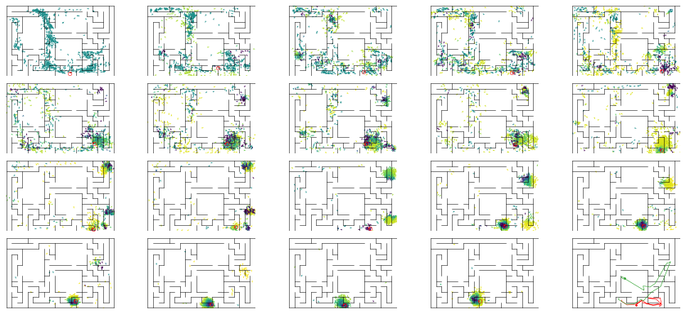

epoch 80 == mse_last: 25.76+-2.51/26.93+-2.04 -- mle: 7.74+-0.21/7.40+-0.15 --

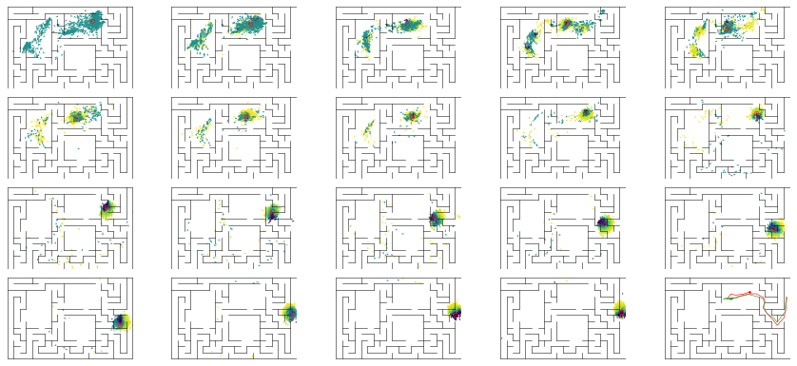

epoch 81 == mse_last: 27.52+-2.59/31.50+-2.22 -- mle: 8.31+-0.20/7.27+-0.16 --

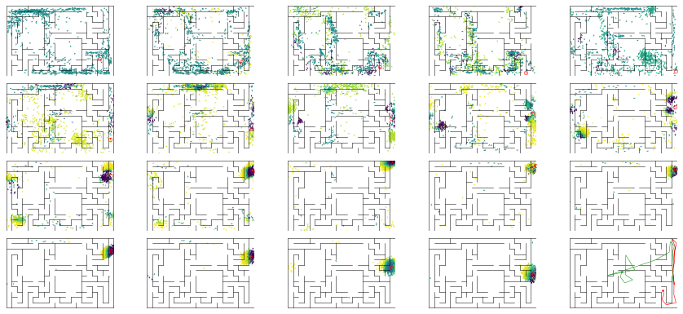

epoch 82 == mse_last: 20.14+-2.36/29.30+-2.20 -- mle: 7.76+-0.25/7.16+-0.14 --

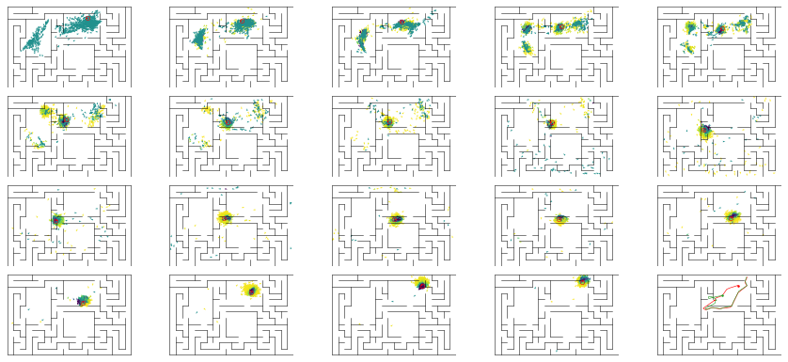

epoch 83 == mse_last: 23.27+-2.75/24.28+-2.00 -- mle: 7.69+-0.20/7.11+-0.15 --

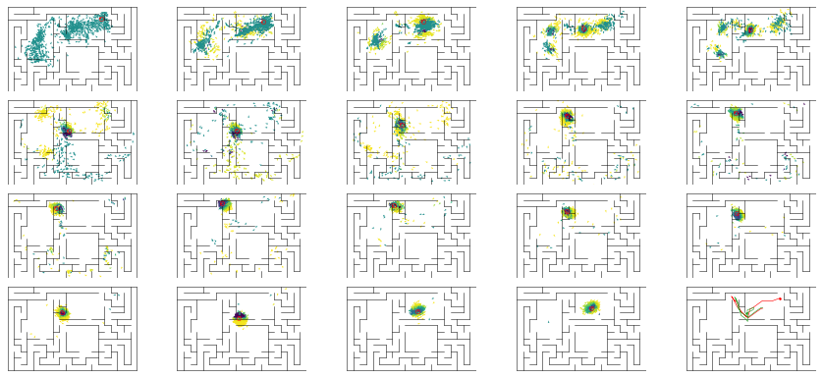

epoch 84 == mse_last: 28.18+-2.72/27.23+-2.06 -- mle: 7.47+-0.21/7.18+-0.15 --

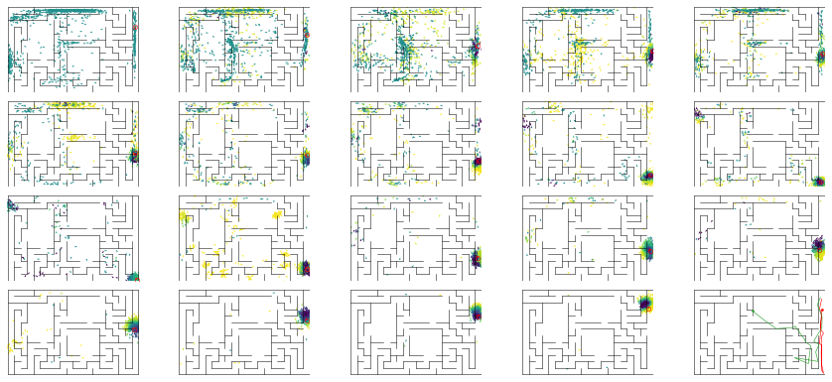

epoch 85 == mse_last: 31.06+-2.97/40.50+-2.36 -- mle: 8.21+-0.22/7.64+-0.16 --

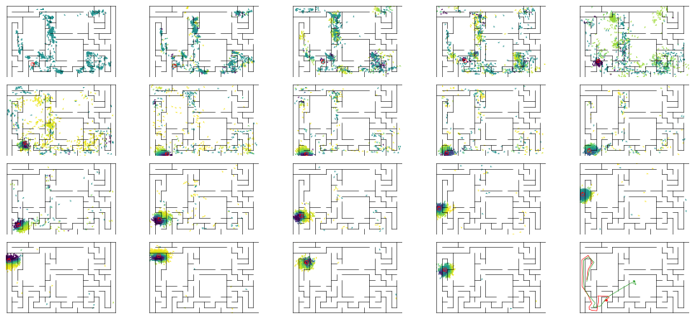

epoch 86 == mse_last: 34.09+-3.34/26.45+-2.08 -- mle: 8.43+-0.24/7.31+-0.14 --

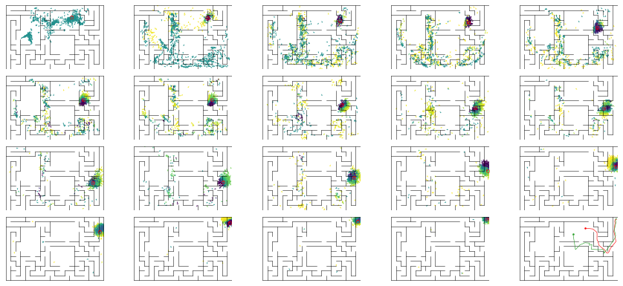

epoch 87 == mse_last: 22.73+-2.58/21.35+-1.72 -- mle: 7.79+-0.20/7.01+-0.15 --

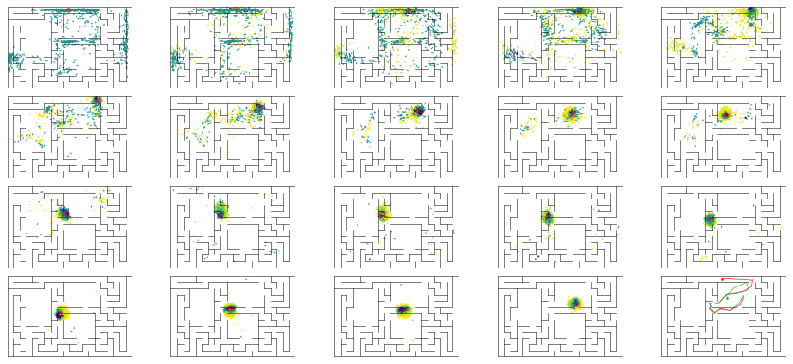

epoch 88 == mse_last: 21.31+-2.58/25.09+-2.30 -- mle: 7.53+-0.20/6.93+-0.14 --

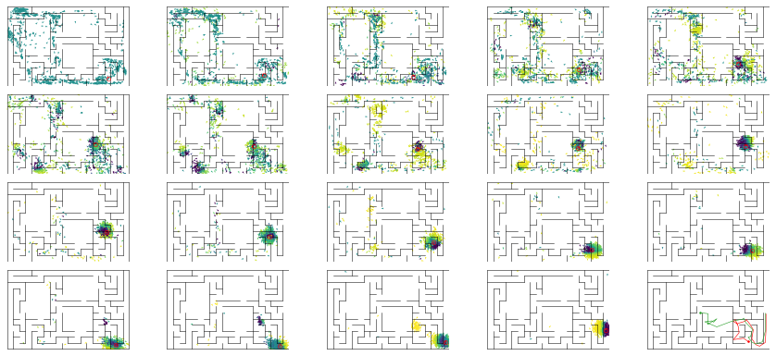

epoch 89 == mse_last: 27.20+-2.76/29.28+-2.16 -- mle: 7.86+-0.21/7.09+-0.16 --

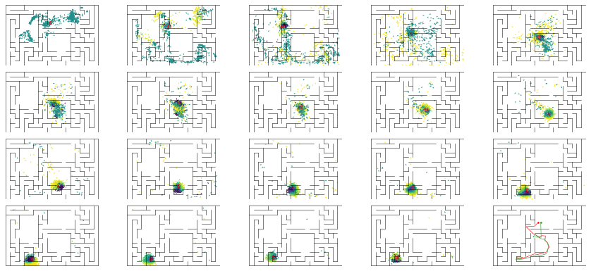

epoch 90 == mse_last: 28.52+-2.76/25.46+-2.03 -- mle: 7.86+-0.22/7.36+-0.17 --

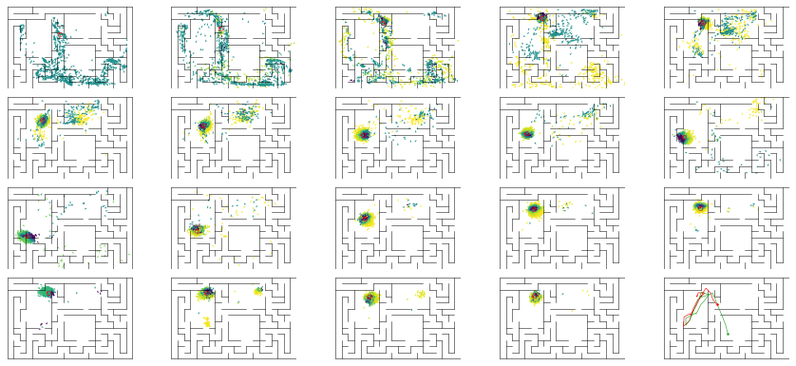

epoch 91 == mse_last: 24.06+-2.24/24.47+-2.45 -- mle: 8.07+-0.25/7.11+-0.15 --

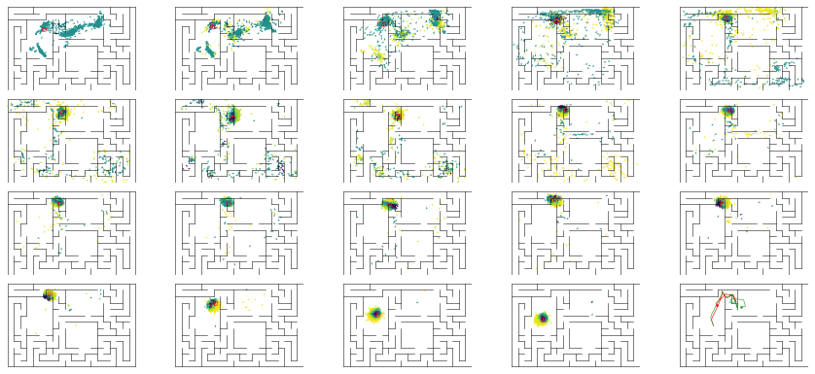

epoch 92 == mse_last: 23.12+-2.09/34.50+-2.46 -- mle: 7.90+-0.22/7.65+-0.17 --

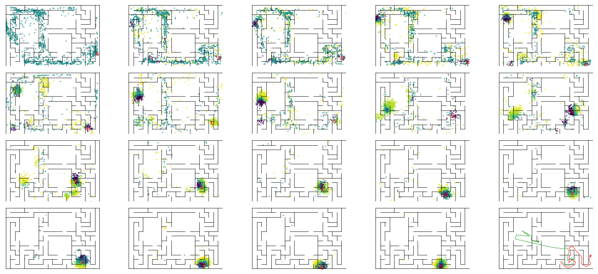

epoch 93 == mse_last: 27.46+-2.92/26.63+-2.44 -- mle: 8.08+-0.21/7.09+-0.16 --

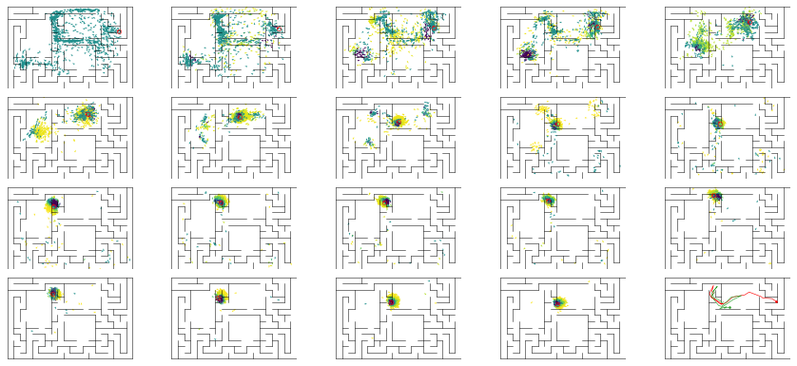

epoch 94 == mse_last: 20.28+-2.65/23.26+-1.92 -- mle: 7.30+-0.20/7.17+-0.16 --

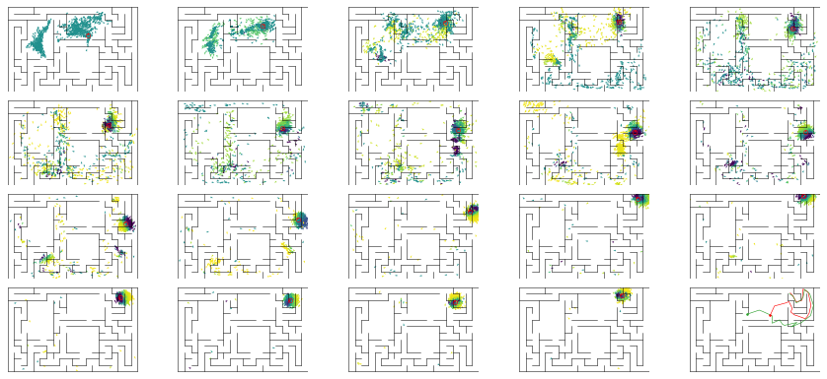

epoch 95 == mse_last: 24.03+-2.55/27.44+-2.36 -- mle: 7.67+-0.21/7.08+-0.15 --

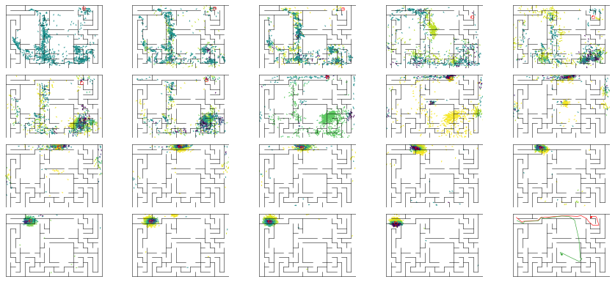

epoch 96 == mse_last: 27.03+-2.74/42.88+-2.68 -- mle: 7.93+-0.19/7.70+-0.16 --

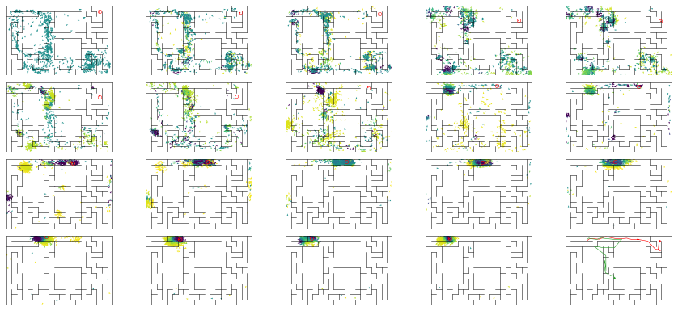

epoch 97 == mse_last: 27.57+-3.00/22.37+-1.96 -- mle: 7.97+-0.18/6.87+-0.14 --

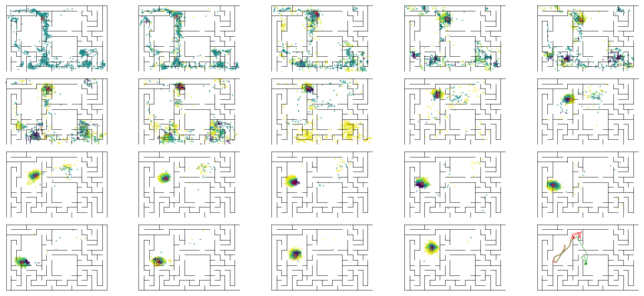

epoch 98 == mse_last: 25.26+-2.67/27.43+-2.01 -- mle: 8.10+-0.18/7.12+-0.14 --

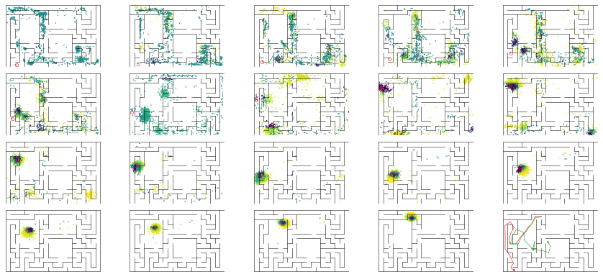

epoch 99 == mse_last: 21.67+-2.54/29.34+-2.43 -- mle: 7.52+-0.21/7.30+-0.16 --

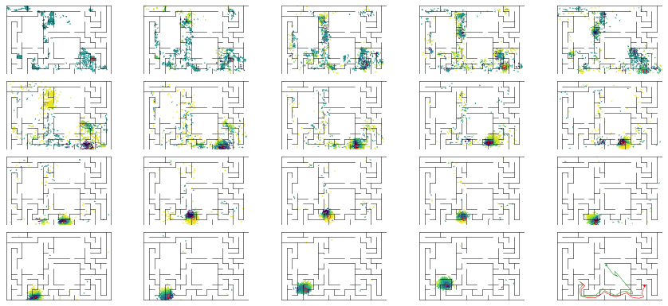

epoch 100 == mse_last: 20.42+-2.53/25.18+-1.78 -- mle: 7.51+-0.22/7.03+-0.15 --

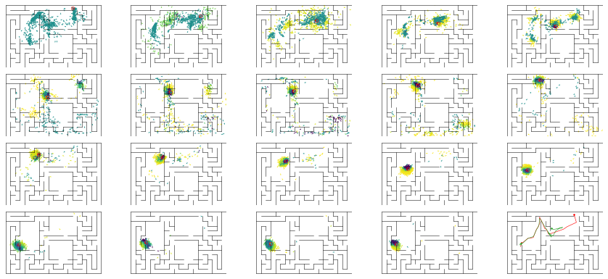

epoch 101 == mse_last: 18.71+-2.20/26.18+-2.11 -- mle: 7.68+-0.20/7.08+-0.16 --

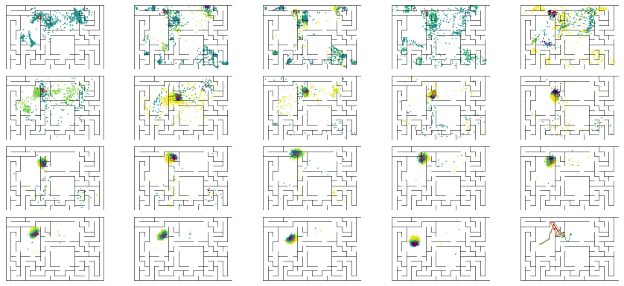

epoch 102 == mse_last: 22.19+-2.25/24.00+-2.10 -- mle: 7.74+-0.25/6.87+-0.14 --

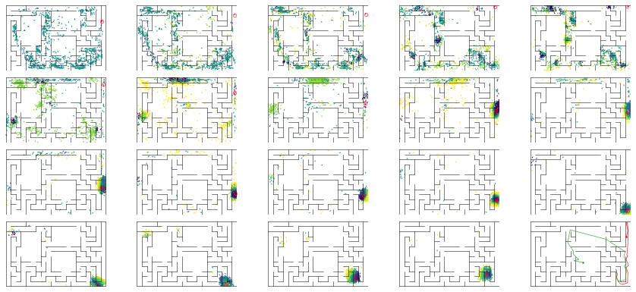

epoch 103 == mse_last: 26.15+-2.51/25.01+-1.97 -- mle: 7.96+-0.17/7.13+-0.15 --

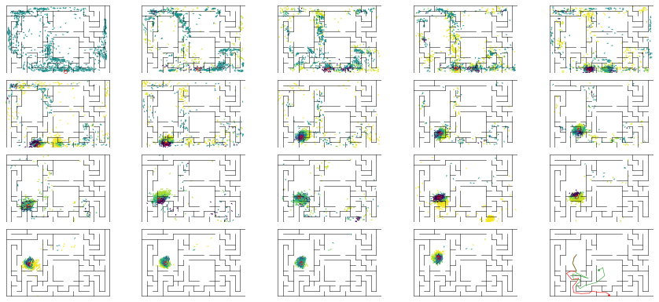

epoch 104 == mse_last: 28.25+-2.40/26.98+-1.90 -- mle: 8.10+-0.20/7.38+-0.17 --

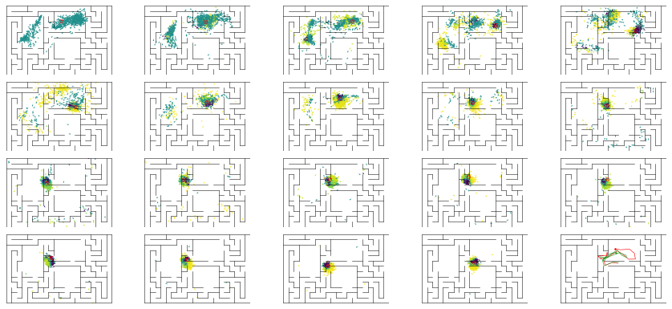

epoch 105 == mse_last: 25.45+-3.14/21.19+-1.87 -- mle: 8.20+-0.27/6.99+-0.14 --

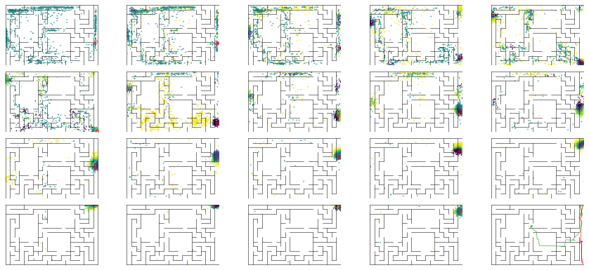

epoch 106 == mse_last: 28.41+-3.48/24.98+-2.07 -- mle: 8.26+-0.26/7.15+-0.14 --

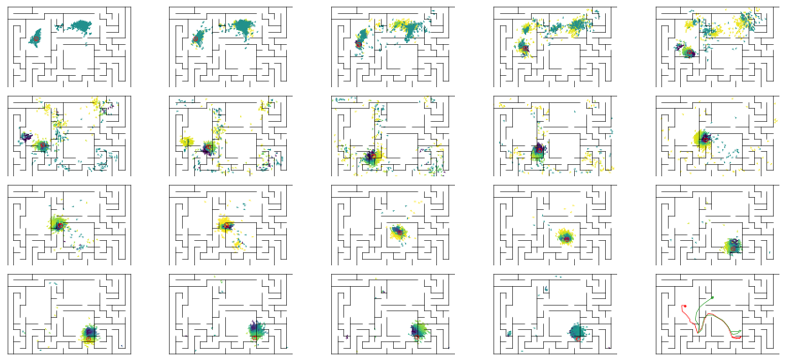

epoch 107 == mse_last: 23.76+-2.63/22.72+-2.18 -- mle: 7.78+-0.20/6.91+-0.15 --

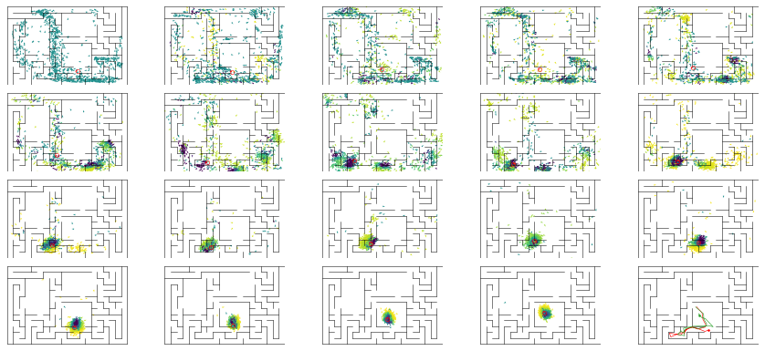

epoch 108 == mse_last: 23.94+-2.27/23.09+-1.80 -- mle: 7.94+-0.21/7.17+-0.14 --

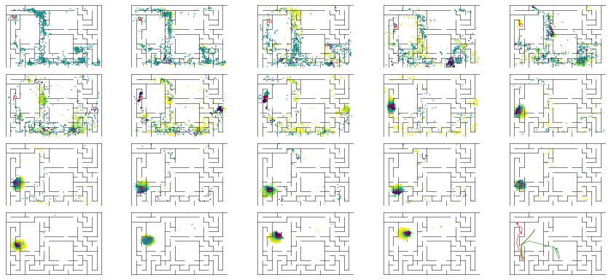

epoch 109 == mse_last: 27.74+-3.19/27.06+-2.26 -- mle: 8.03+-0.24/7.11+-0.16 --

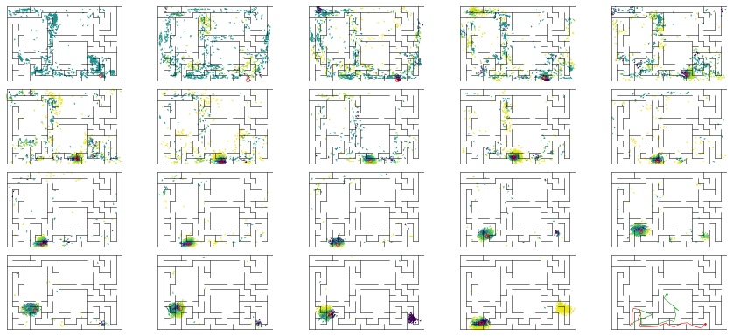

epoch 110 == mse_last: 27.45+-2.60/29.57+-2.04 -- mle: 8.48+-0.23/7.22+-0.16 --

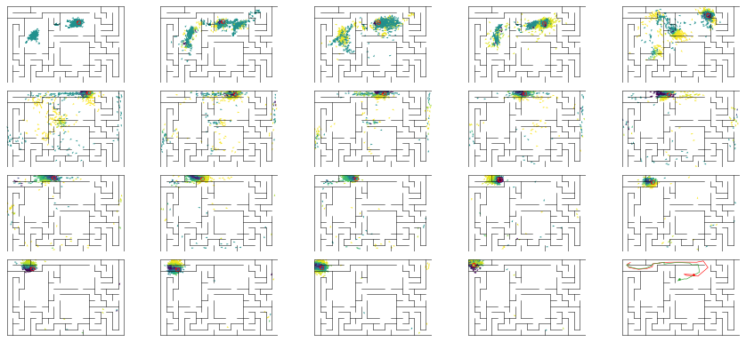

epoch 111 == mse_last: 21.54+-2.40/26.45+-2.24 -- mle: 7.75+-0.22/7.02+-0.15 --

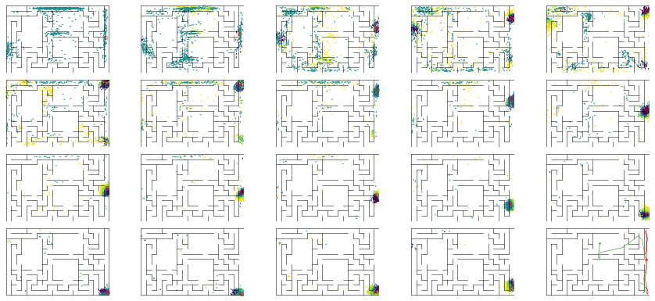

epoch 112 == mse_last: 20.93+-2.71/24.13+-1.97 -- mle: 7.64+-0.27/6.92+-0.15 --

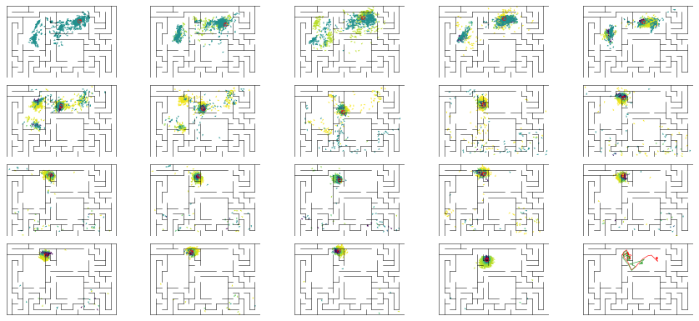

epoch 113 == mse_last: 29.11+-2.54/22.12+-1.73 -- mle: 7.80+-0.22/6.91+-0.14 --

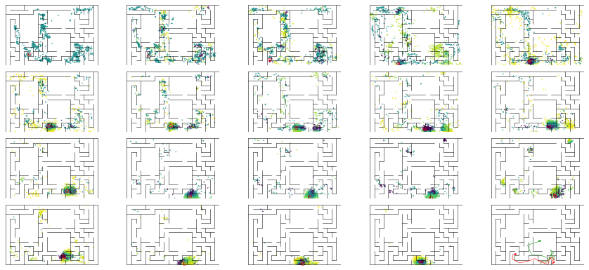

epoch 114 == mse_last: 25.83+-3.08/29.06+-2.30 -- mle: 7.92+-0.24/7.07+-0.15 --

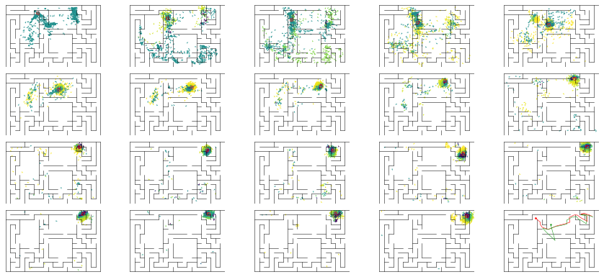

epoch 115 == mse_last: 29.95+-2.91/25.79+-1.88 -- mle: 8.14+-0.23/7.12+-0.14 --

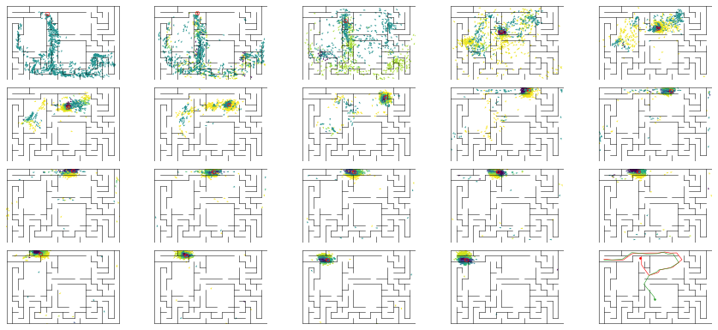

epoch 116 == mse_last: 29.37+-2.77/25.69+-2.16 -- mle: 7.77+-0.19/7.18+-0.15 --

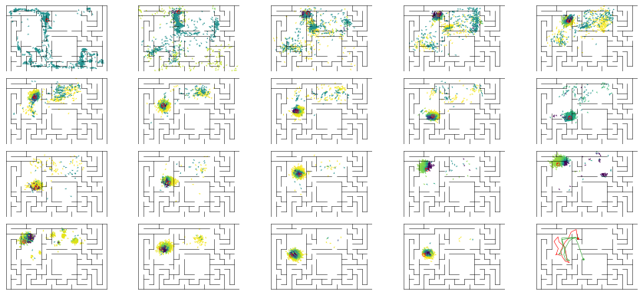

epoch 117 == mse_last: 26.34+-2.71/24.63+-1.93 -- mle: 7.97+-0.22/7.12+-0.16 --

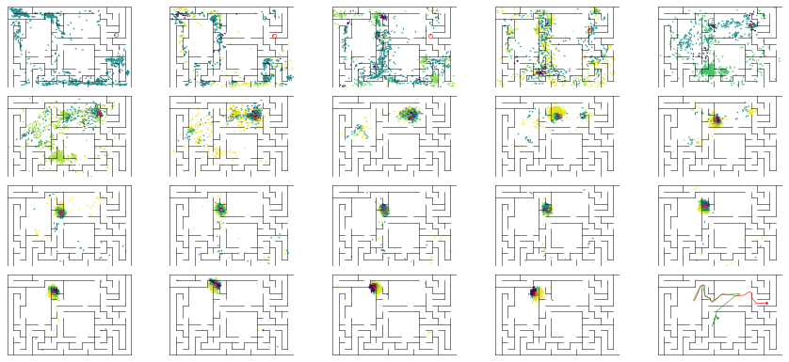

epoch 118 == mse_last: 22.82+-3.14/22.91+-1.80 -- mle: 7.27+-0.24/6.97+-0.16 --

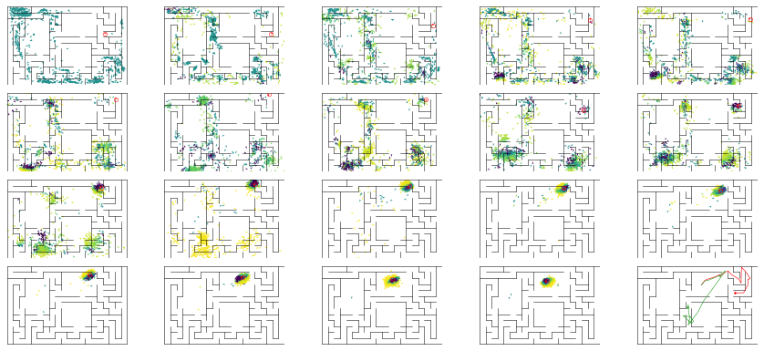

epoch 119 == mse_last: 22.30+-2.26/26.27+-2.09 -- mle: 7.84+-0.20/7.07+-0.15 --

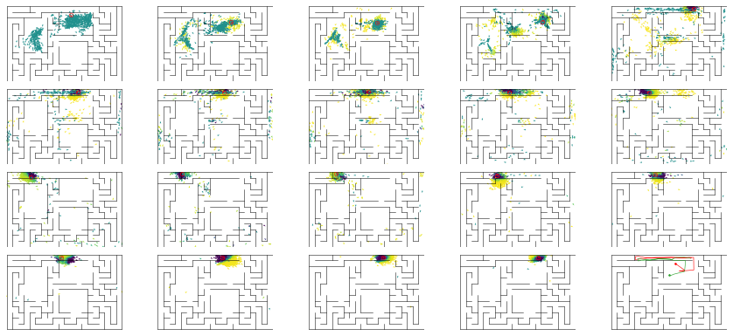

epoch 120 == mse_last: 25.32+-2.75/26.15+-2.04 -- mle: 7.75+-0.22/7.12+-0.15 --

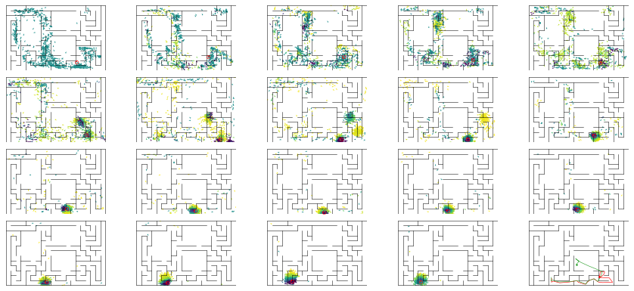

epoch 121 == mse_last: 25.12+-2.61/25.53+-1.97 -- mle: 7.86+-0.21/7.02+-0.14 --

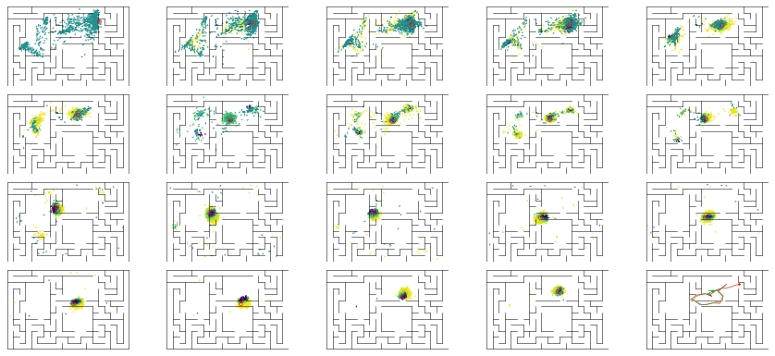

epoch 122 == mse_last: 23.86+-2.33/24.12+-1.98 -- mle: 7.70+-0.21/6.97+-0.15 --

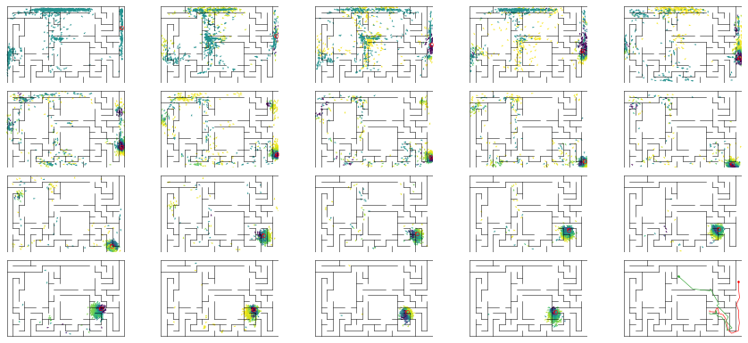

epoch 123 == mse_last: 23.78+-2.81/22.12+-2.08 -- mle: 7.54+-0.21/6.76+-0.15 --

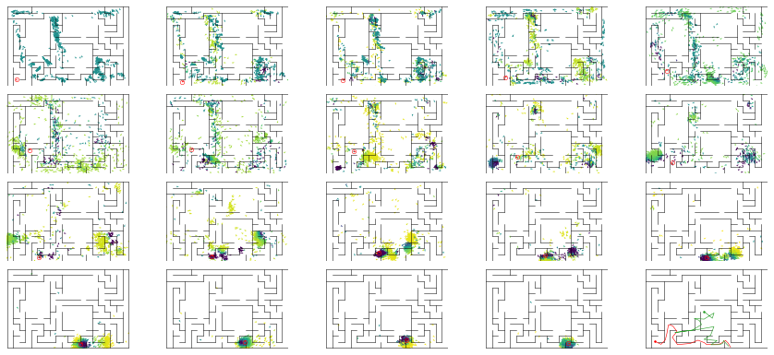

epoch 124 == mse_last: 23.12+-2.31/24.28+-2.00 -- mle: 7.59+-0.22/6.90+-0.15 --

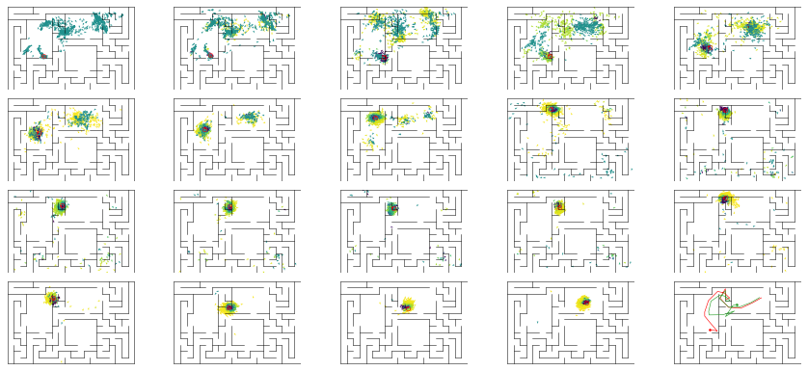

epoch 125 == mse_last: 21.09+-2.07/25.80+-1.96 -- mle: 7.48+-0.23/6.98+-0.14 --

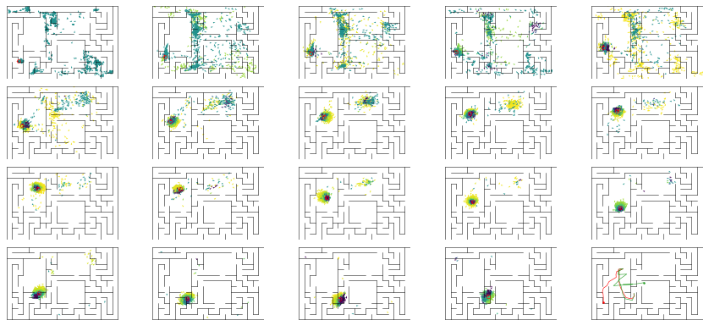

epoch 126 == mse_last: 25.73+-2.94/26.19+-1.99 -- mle: 8.19+-0.21/7.19+-0.15 --

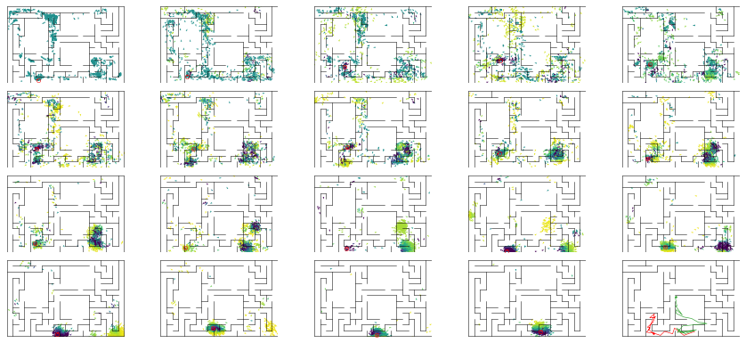

epoch 127 == mse_last: 26.25+-2.45/26.09+-2.27 -- mle: 7.95+-0.19/7.08+-0.15 --

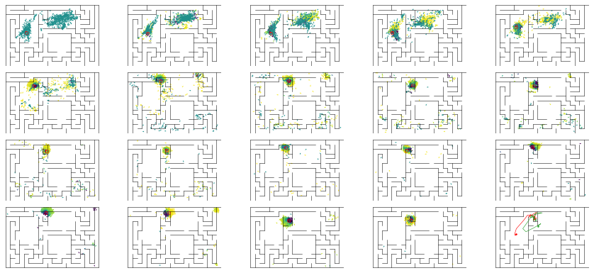

epoch 128 == mse_last: 26.43+-2.95/25.09+-2.06 -- mle: 7.99+-0.26/7.02+-0.15 --

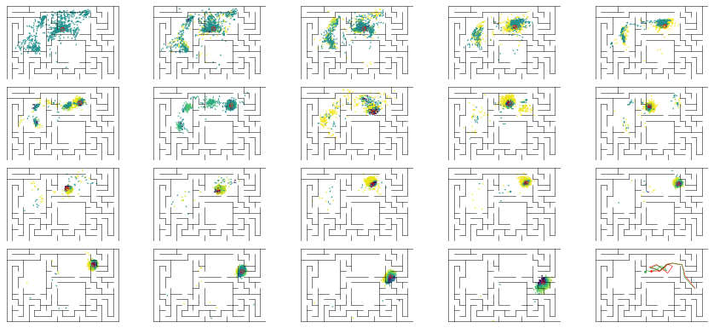

epoch 129 == mse_last: 26.67+-2.71/23.29+-1.78 -- mle: 7.73+-0.22/7.01+-0.13 --

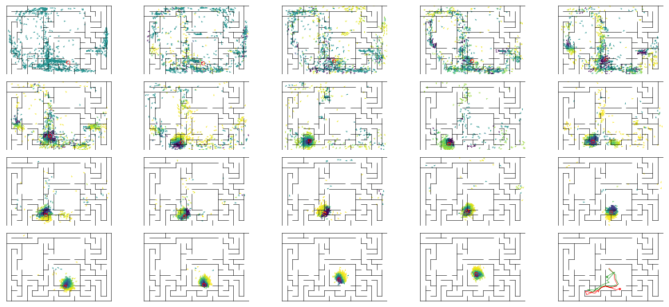

epoch 130 == mse_last: 23.69+-2.67/26.16+-2.44 -- mle: 7.79+-0.23/7.36+-0.16 --

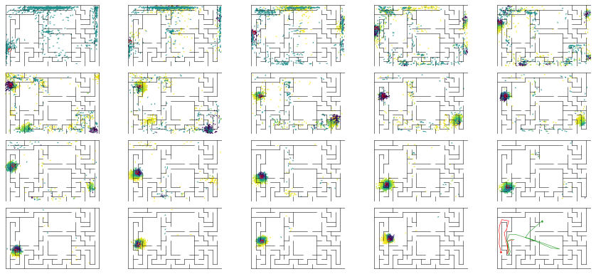

epoch 131 == mse_last: 21.30+-2.86/24.32+-2.21 -- mle: 7.63+-0.22/6.99+-0.15 --

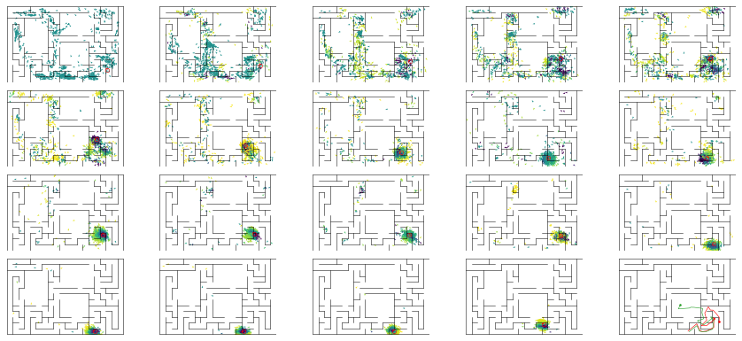

epoch 132 == mse_last: 21.43+-2.71/30.76+-2.11 -- mle: 7.88+-0.20/7.51+-0.17 --

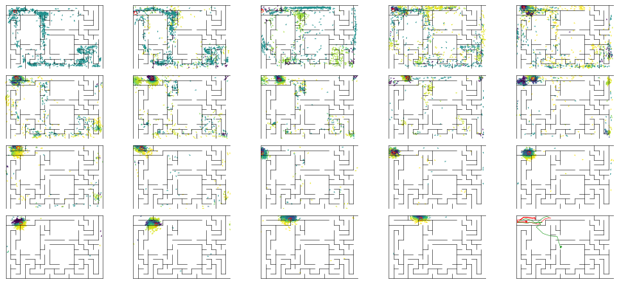

epoch 133 == mse_last: 33.17+-3.12/25.40+-2.19 -- mle: 8.57+-0.25/7.04+-0.15 --

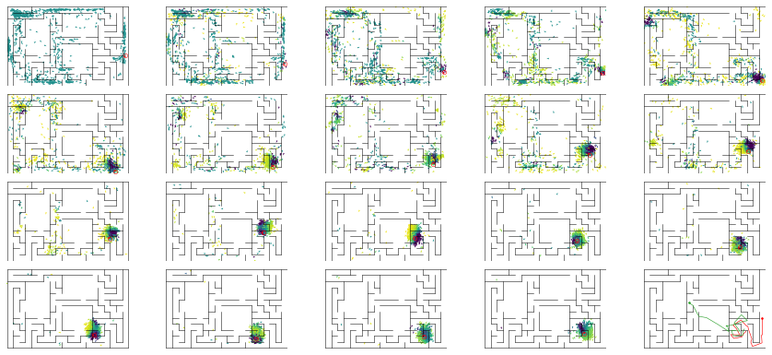

epoch 134 == mse_last: 34.17+-4.03/25.82+-2.02 -- mle: 8.30+-0.23/7.21+-0.15 --

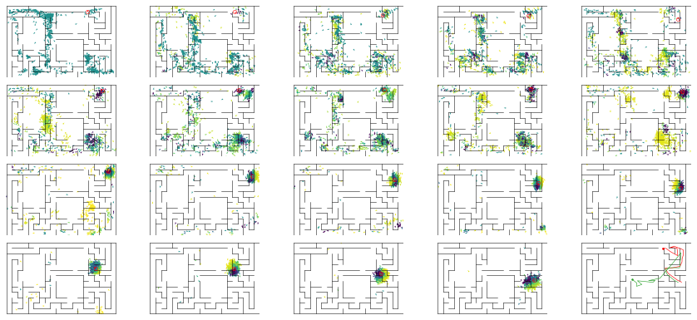

epoch 135 == mse_last: 28.44+-2.71/27.94+-2.17 -- mle: 7.80+-0.23/7.17+-0.15 --

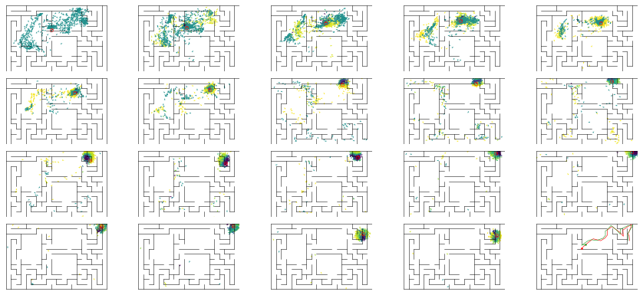

epoch 136 == mse_last: 30.32+-3.05/22.97+-2.08 -- mle: 8.22+-0.24/7.06+-0.15 --

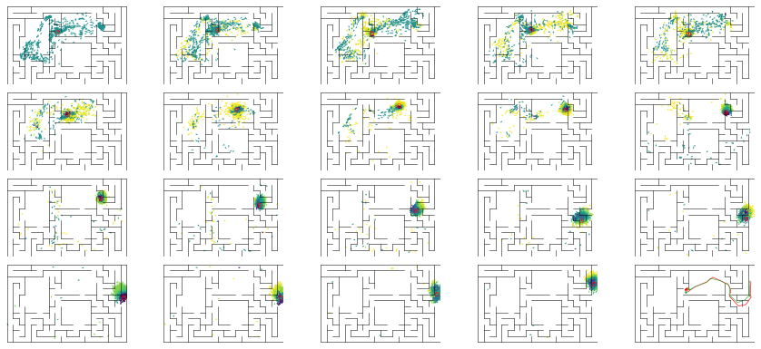

epoch 137 == mse_last: 30.08+-3.16/23.42+-2.41 -- mle: 8.11+-0.20/6.95+-0.15 --

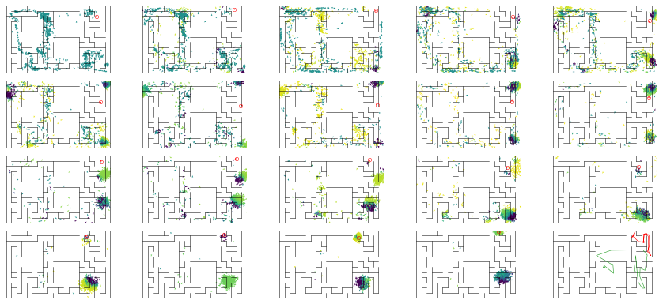

epoch 138 == mse_last: 27.10+-2.41/23.09+-2.01 -- mle: 7.87+-0.19/6.94+-0.14 --

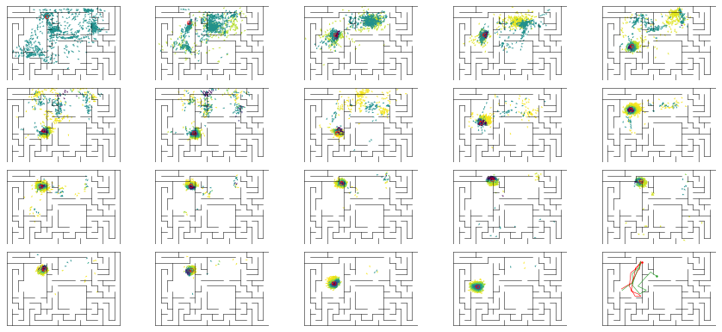

epoch 139 == mse_last: 20.59+-2.28/26.65+-1.78 -- mle: 7.55+-0.24/7.07+-0.14 --

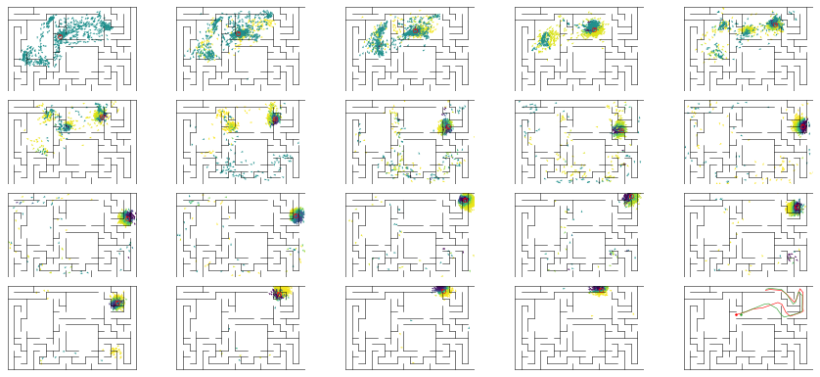

epoch 140 == mse_last: 23.07+-2.63/22.04+-1.74 -- mle: 7.91+-0.22/6.86+-0.14 --

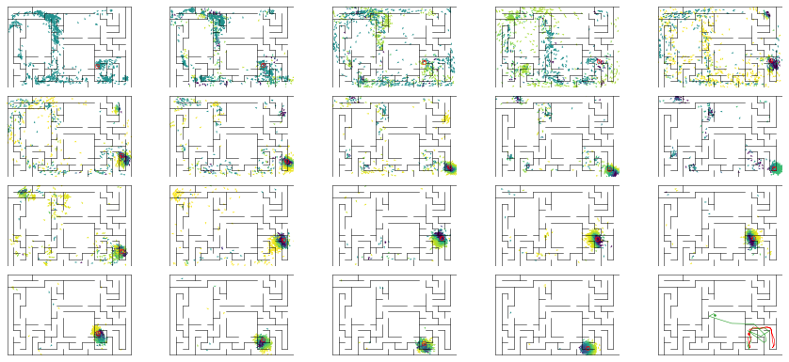

epoch 141 == mse_last: 23.55+-2.58/22.60+-2.13 -- mle: 7.67+-0.23/6.78+-0.16 --

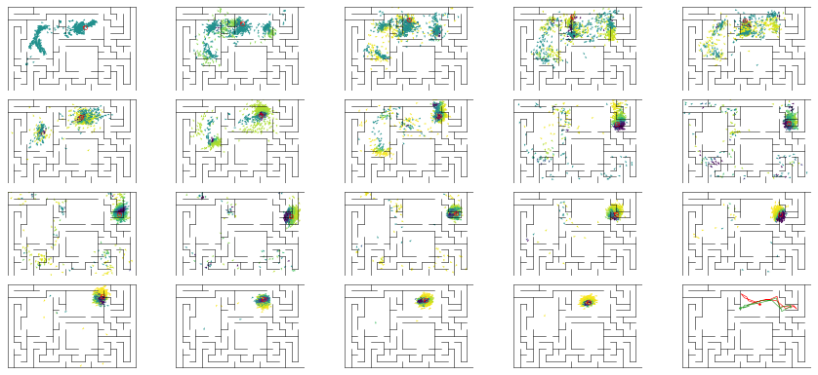

epoch 142 == mse_last: 20.13+-2.47/27.83+-2.21 -- mle: 7.54+-0.23/7.28+-0.16 --

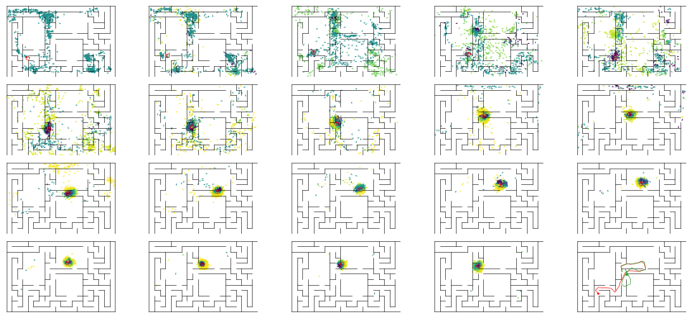

epoch 143 == mse_last: 22.89+-2.32/22.43+-2.21 -- mle: 7.48+-0.19/6.95+-0.16 --

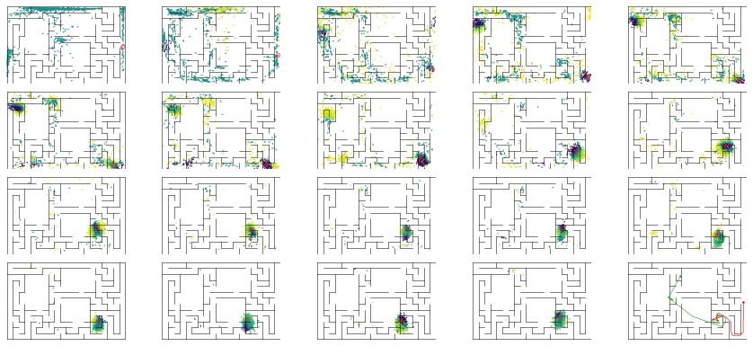

epoch 144 == mse_last: 21.86+-2.10/25.32+-2.08 -- mle: 7.68+-0.18/7.10+-0.15 --

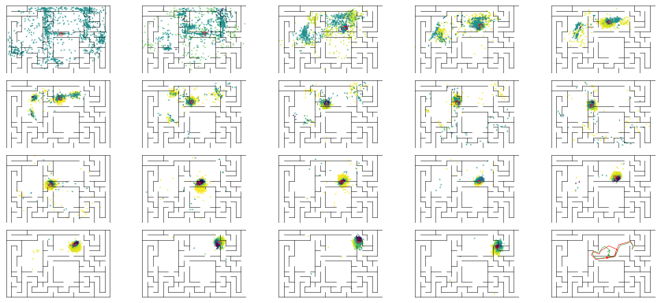

epoch 145 == mse_last: 24.00+-2.72/28.94+-2.10 -- mle: 7.83+-0.22/7.37+-0.16 --

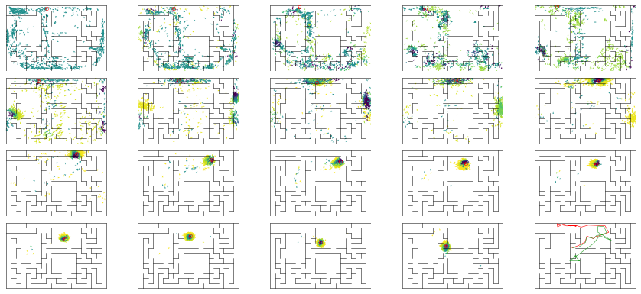

epoch 146 == mse_last: 30.07+-3.29/25.86+-2.10 -- mle: 8.21+-0.27/7.08+-0.16 --

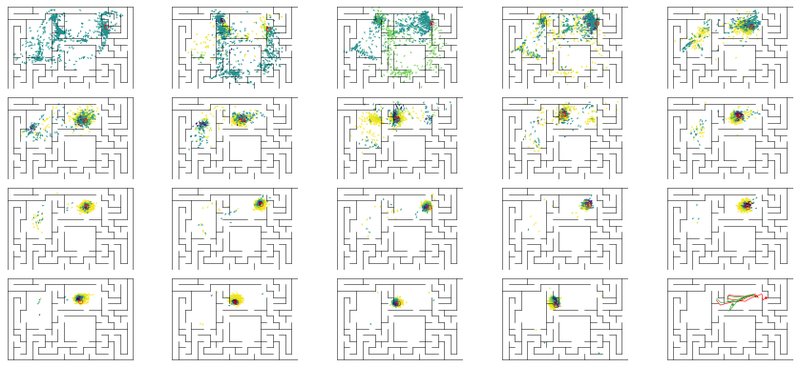

epoch 147 == mse_last: 17.84+-2.45/30.58+-2.10 -- mle: 7.32+-0.21/7.38+-0.17 --

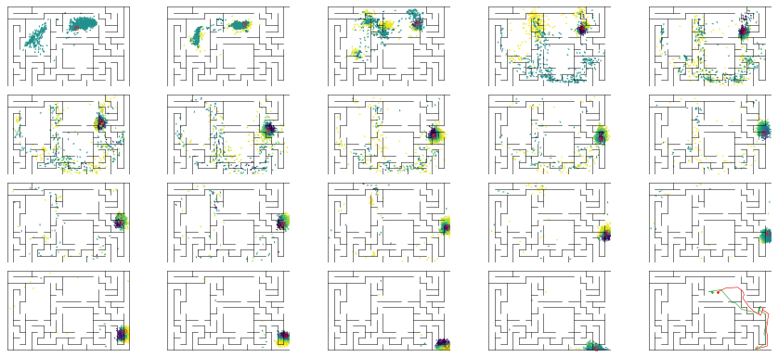

epoch 148 == mse_last: 25.63+-2.47/23.48+-2.01 -- mle: 7.69+-0.22/7.03+-0.15 --

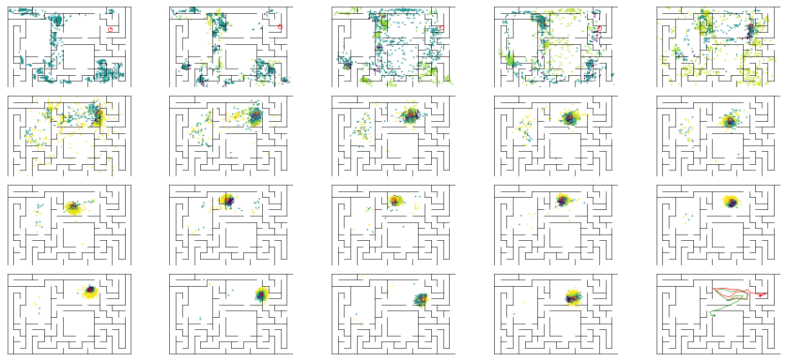

epoch 149 == mse_last: 23.10+-2.99/25.60+-2.09 -- mle: 7.87+-0.28/7.01+-0.15 --

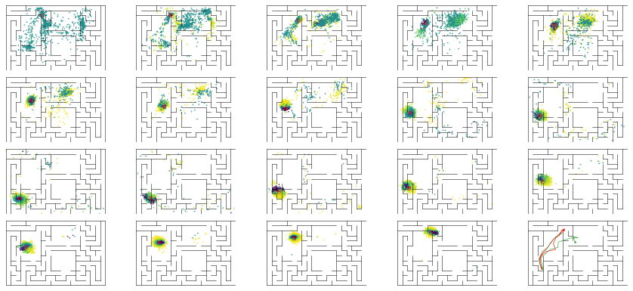

epoch 150 == mse_last: 19.81+-2.55/25.09+-1.96 -- mle: 7.58+-0.22/7.09+-0.16 --

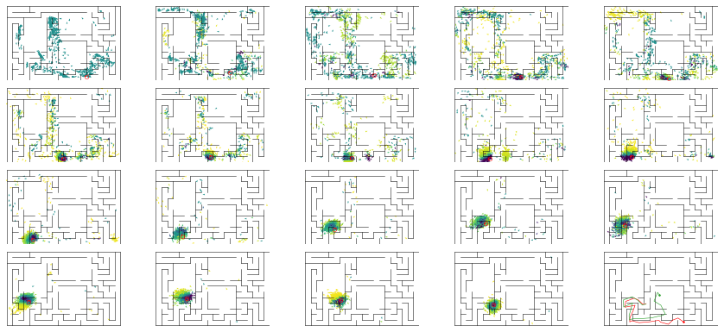

epoch 151 == mse_last: 25.77+-3.22/28.92+-2.25 -- mle: 7.98+-0.24/7.07+-0.15 --

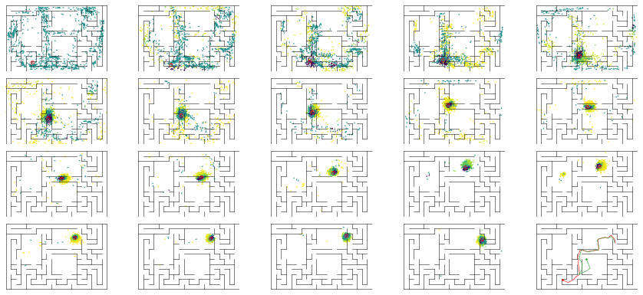

epoch 152 == mse_last: 25.29+-3.12/26.70+-2.14 -- mle: 7.57+-0.21/7.05+-0.14 --

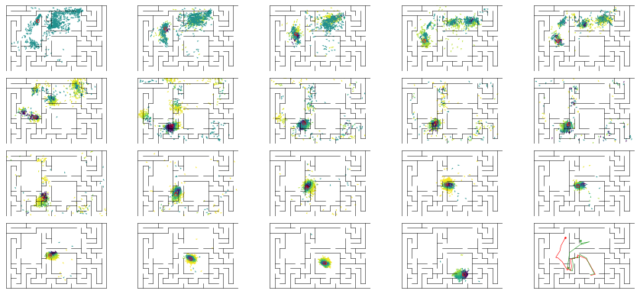

epoch 153 == mse_last: 31.55+-3.24/24.02+-1.70 -- mle: 8.14+-0.21/6.94+-0.14 --

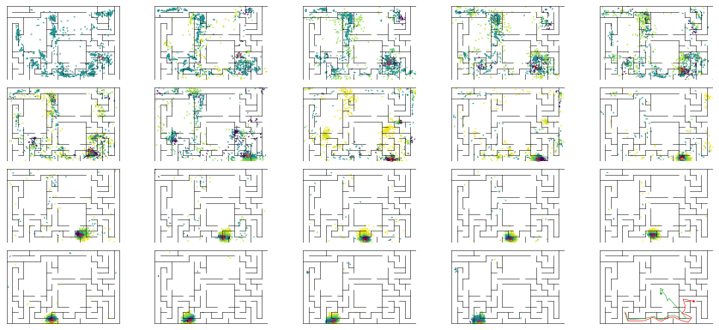

epoch 154 == mse_last: 24.64+-3.04/25.29+-2.29 -- mle: 7.79+-0.23/7.08+-0.15 --

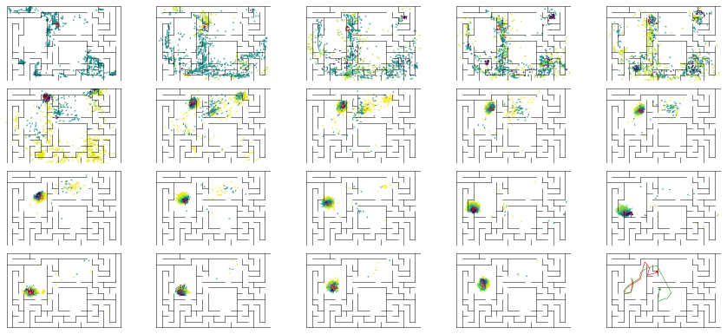

epoch 155 == mse_last: 25.15+-2.81/27.78+-2.48 -- mle: 7.54+-0.23/6.93+-0.14 --

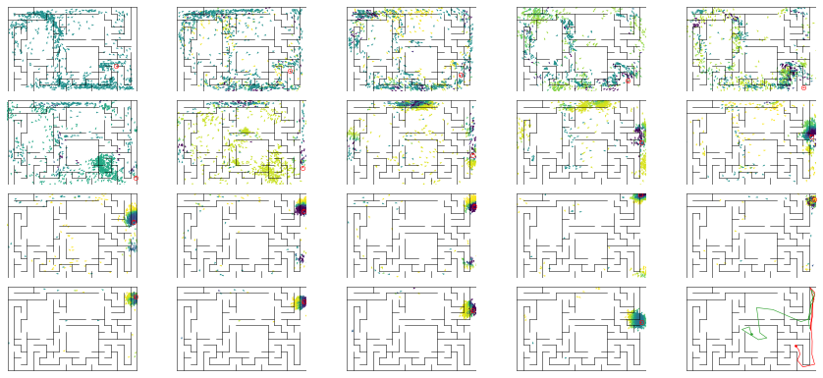

epoch 156 == mse_last: 26.89+-2.66/26.72+-2.22 -- mle: 7.71+-0.21/6.97+-0.15 --

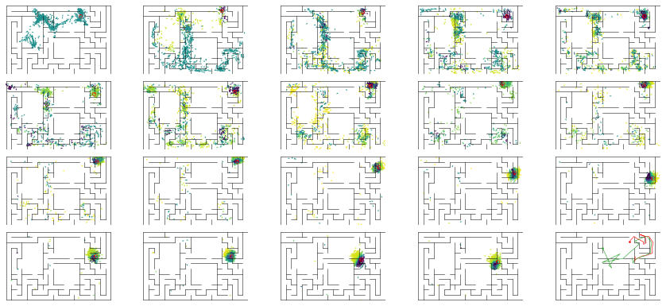

epoch 157 == mse_last: 22.25+-2.52/23.76+-2.21 -- mle: 7.41+-0.19/6.85+-0.16 --

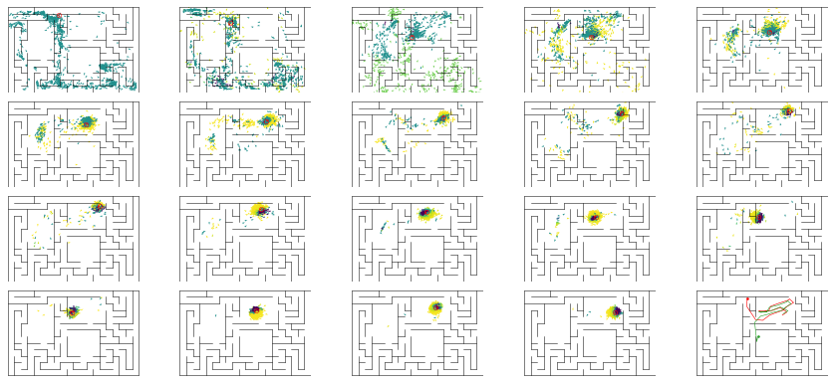

epoch 158 == mse_last: 27.65+-2.68/29.14+-2.21 -- mle: 8.00+-0.23/7.36+-0.15 --

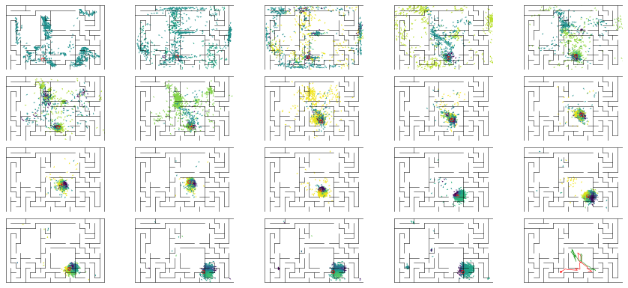

epoch 159 == mse_last: 22.55+-2.64/26.76+-2.09 -- mle: 7.60+-0.20/7.19+-0.15 --

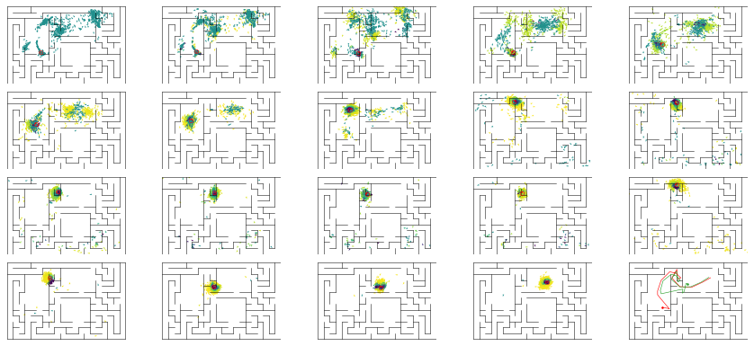

epoch 160 == mse_last: 24.01+-2.60/22.20+-1.96 -- mle: 7.59+-0.23/6.92+-0.15 --

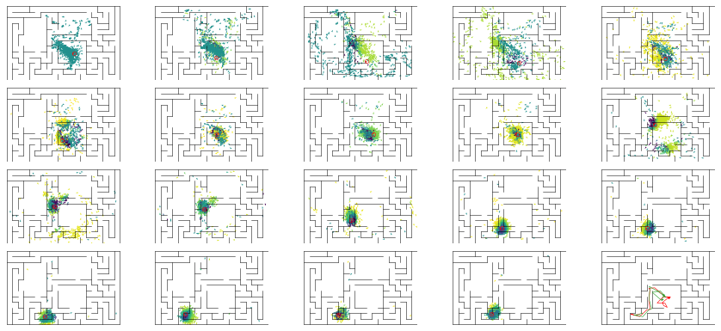

epoch 161 == mse_last: 30.83+-2.97/24.67+-2.29 -- mle: 7.89+-0.22/7.08+-0.14 --

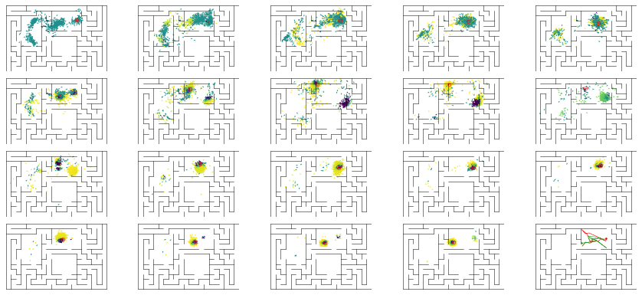

epoch 162 == mse_last: 25.15+-2.55/23.97+-2.03 -- mle: 7.80+-0.23/7.14+-0.15 --

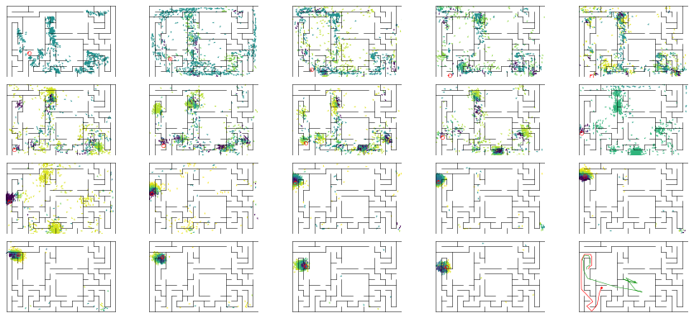

epoch 163 == mse_last: 24.01+-3.14/23.00+-2.10 -- mle: 7.78+-0.25/6.99+-0.16 --

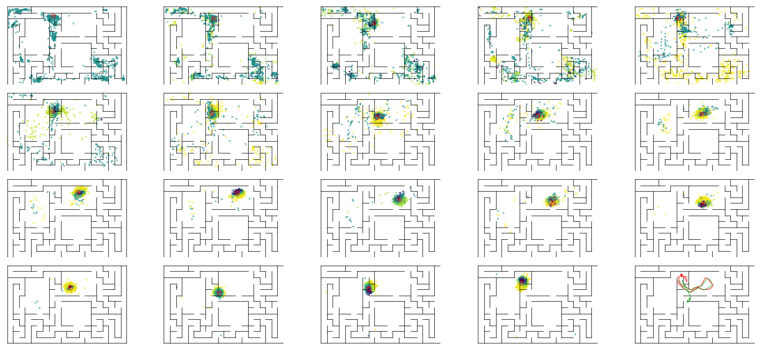

epoch 164 == mse_last: 31.54+-3.47/24.36+-1.91 -- mle: 8.29+-0.22/6.93+-0.15 --

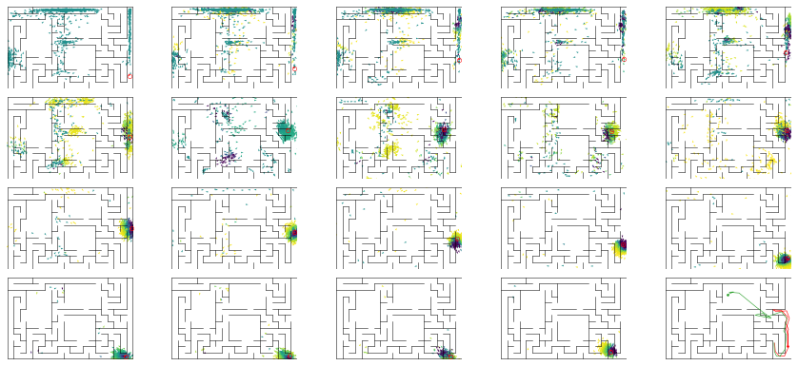

epoch 165 == mse_last: 22.47+-2.57/22.12+-1.89 -- mle: 7.61+-0.24/6.82+-0.15 --

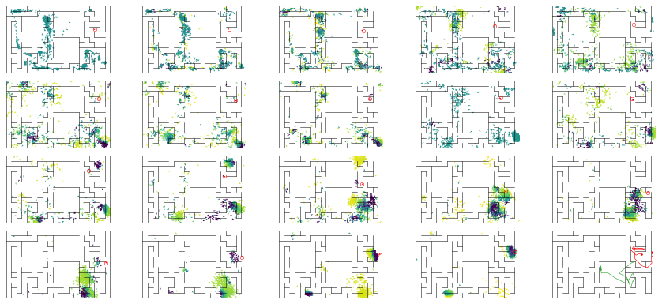

epoch 166 == mse_last: 21.95+-2.89/27.27+-2.05 -- mle: 7.48+-0.21/7.11+-0.15 --

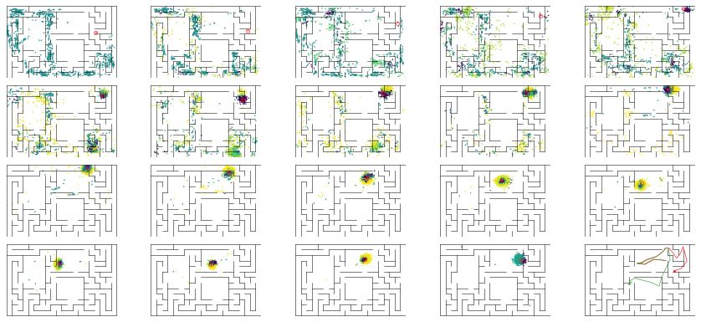

epoch 167 == mse_last: 22.38+-2.58/24.42+-1.83 -- mle: 7.75+-0.23/6.98+-0.14 --

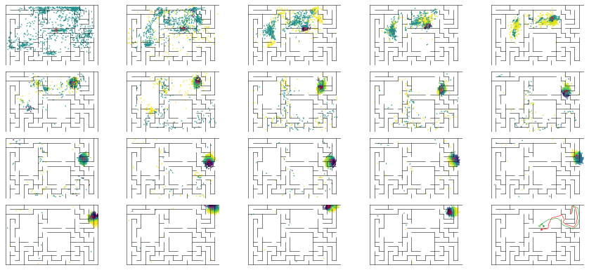

epoch 168 == mse_last: 22.64+-2.33/23.45+-1.79 -- mle: 7.79+-0.21/7.04+-0.16 --

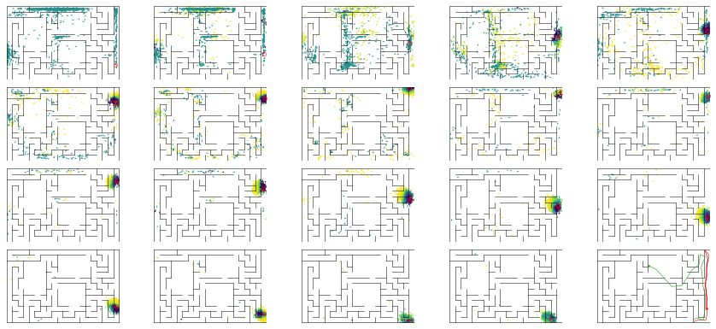

epoch 169 == mse_last: 26.08+-2.50/30.63+-2.31 -- mle: 7.65+-0.22/7.18+-0.15 --

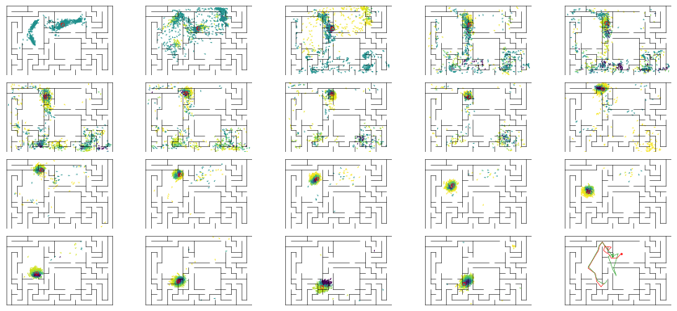

epoch 170 == mse_last: 27.93+-2.67/23.50+-1.78 -- mle: 8.01+-0.23/7.10+-0.15 --

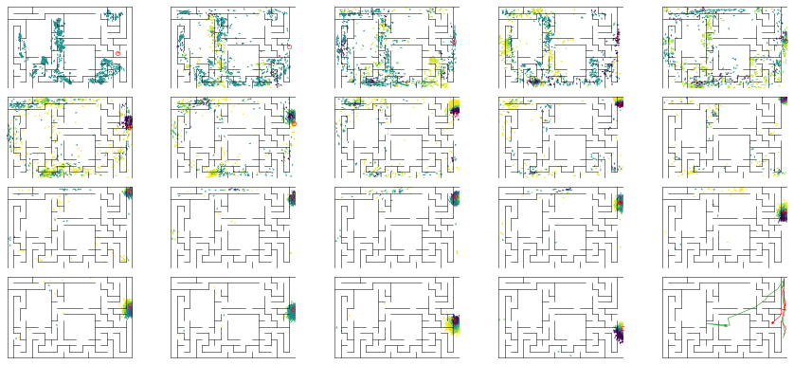

epoch 171 == mse_last: 21.32+-2.66/24.92+-2.09 -- mle: 7.75+-0.22/6.82+-0.14 --

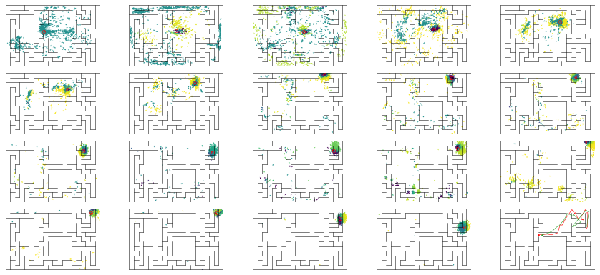

epoch 172 == mse_last: 25.76+-3.19/24.83+-1.96 -- mle: 7.79+-0.26/7.21+-0.15 --

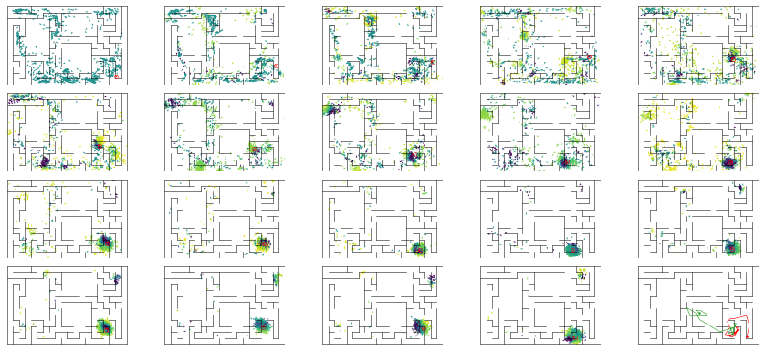

epoch 173 == mse_last: 24.48+-2.70/24.09+-1.83 -- mle: 7.74+-0.21/7.17+-0.14 --

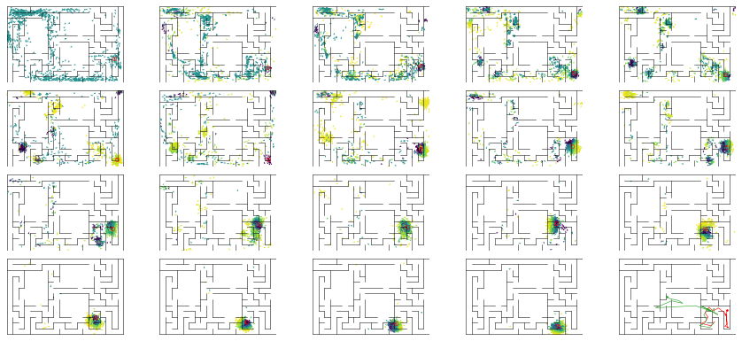

epoch 174 == mse_last: 23.95+-2.81/25.06+-2.08 -- mle: 7.72+-0.21/6.91+-0.15 --

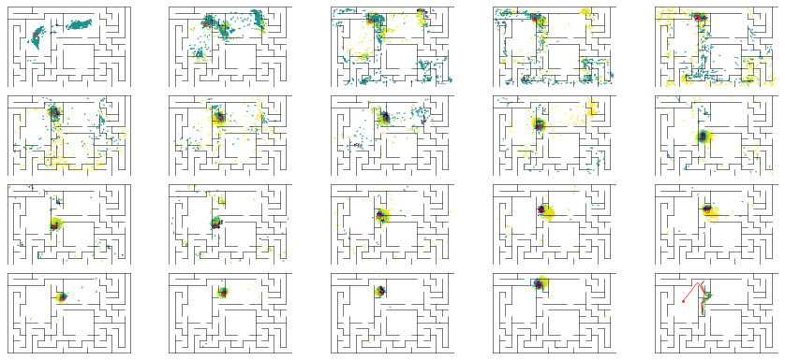

epoch 175 == mse_last: 26.99+-2.59/23.13+-1.78 -- mle: 7.73+-0.22/7.11+-0.15 --

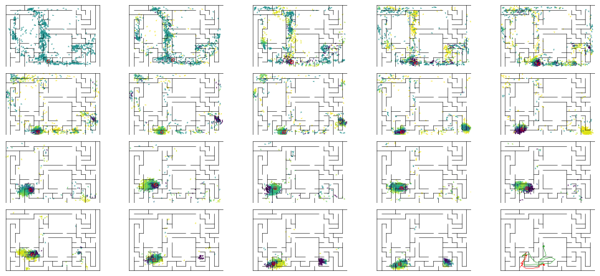

epoch 176 == mse_last: 23.92+-3.16/25.42+-2.19 -- mle: 7.83+-0.24/7.17+-0.16 --

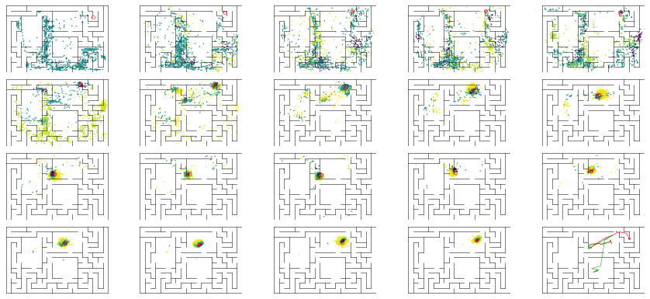

epoch 177 == mse_last: 21.84+-2.34/24.72+-1.97 -- mle: 7.23+-0.24/7.02+-0.16 --

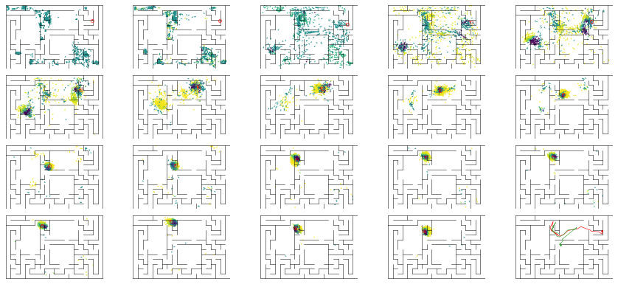

epoch 178 == mse_last: 20.57+-2.28/29.63+-2.10 -- mle: 7.51+-0.20/7.34+-0.15 --

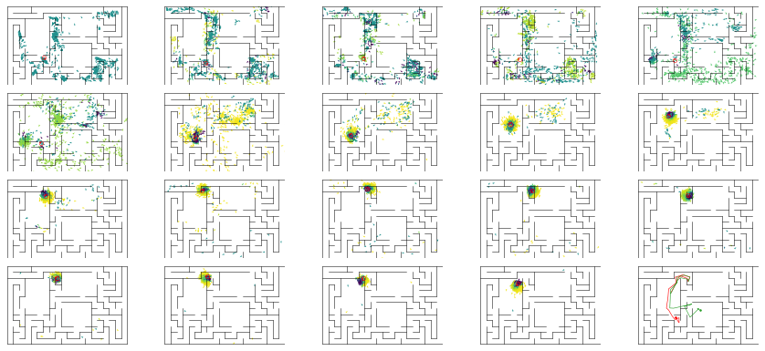

epoch 179 == mse_last: 25.72+-2.53/22.94+-1.89 -- mle: 7.66+-0.21/6.99+-0.15 --

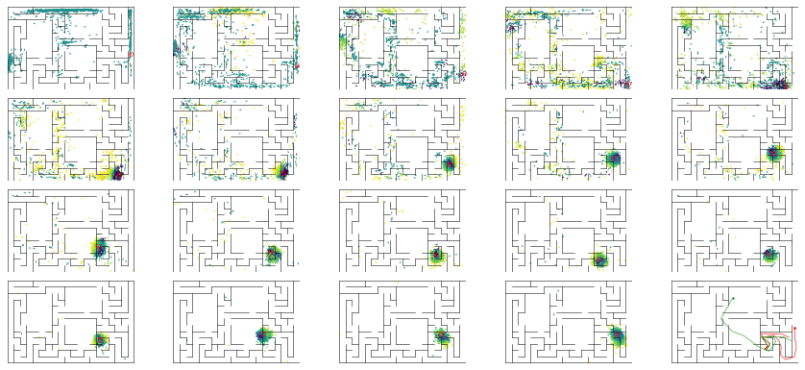

epoch 180 == mse_last: 23.31+-2.66/45.68+-2.54 -- mle: 7.64+-0.24/7.71+-0.15 --

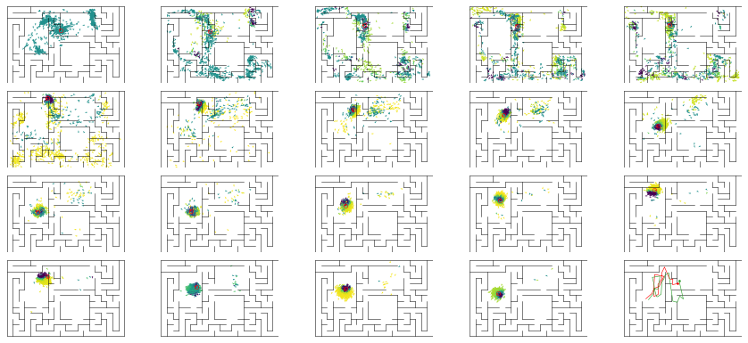

epoch 181 == mse_last: 28.20+-2.88/25.07+-2.13 -- mle: 8.23+-0.26/6.90+-0.14 --

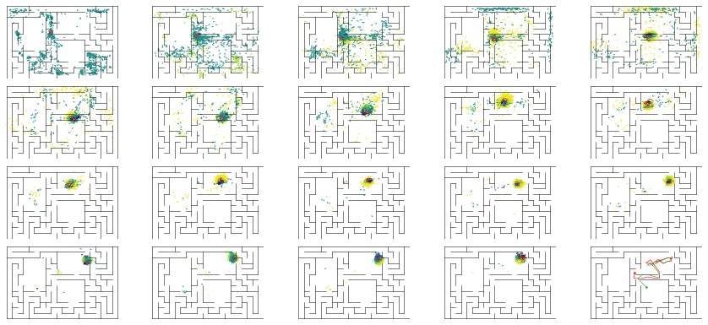

epoch 182 == mse_last: 23.60+-2.73/24.60+-1.92 -- mle: 7.70+-0.25/7.06+-0.16 --

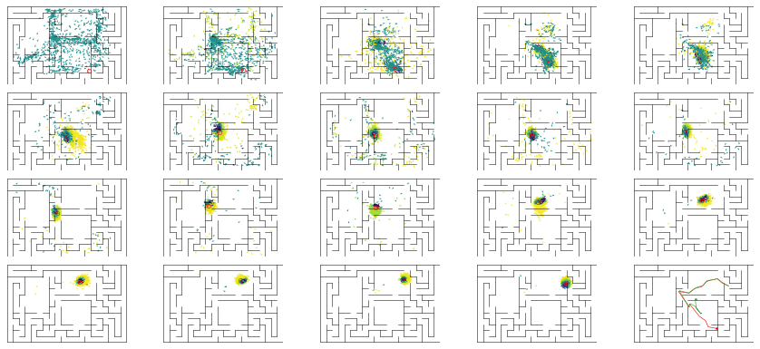

epoch 183 == mse_last: 30.21+-2.84/28.37+-2.40 -- mle: 7.87+-0.20/7.13+-0.15 --

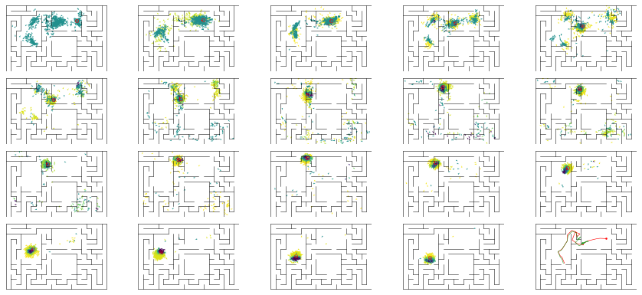

epoch 184 == mse_last: 27.12+-2.56/25.05+-1.97 -- mle: 7.97+-0.20/7.02+-0.16 --

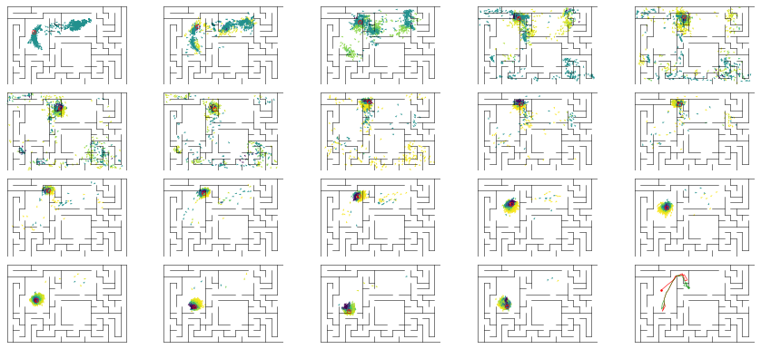

epoch 185 == mse_last: 24.15+-2.77/22.68+-1.82 -- mle: 7.90+-0.21/6.95+-0.17 --

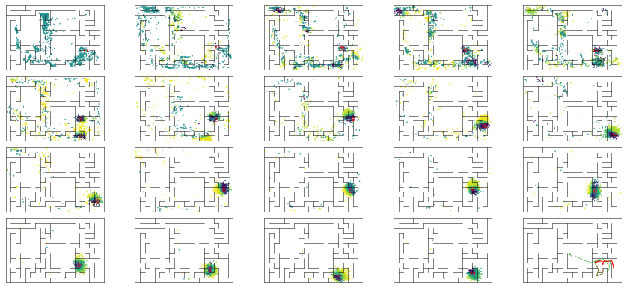

epoch 186 == mse_last: 27.66+-2.46/24.89+-1.90 -- mle: 8.14+-0.21/7.14+-0.17 --

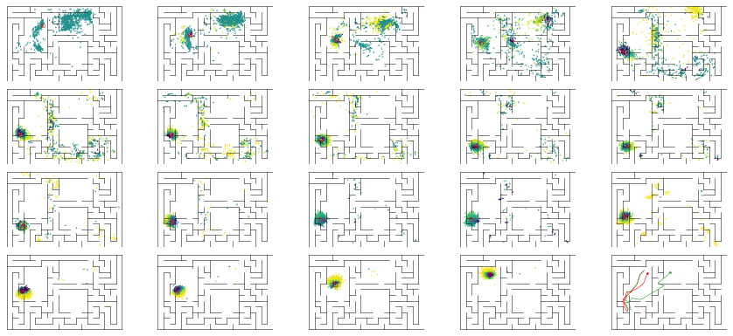

epoch 187 == mse_last: 24.03+-2.78/27.60+-2.12 -- mle: 7.74+-0.22/7.31+-0.15 --

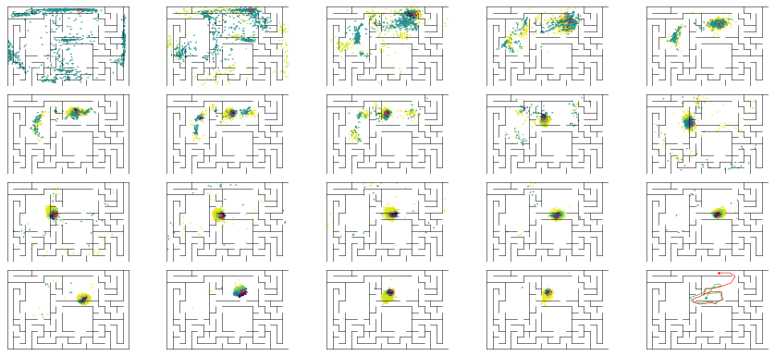

epoch 188 == mse_last: 31.88+-3.28/29.05+-2.23 -- mle: 8.41+-0.29/7.64+-0.15 --

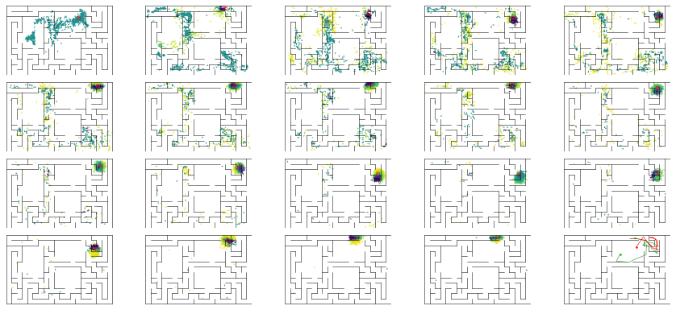

epoch 189 == mse_last: 31.86+-3.16/30.53+-2.42 -- mle: 8.43+-0.25/7.45+-0.14 --

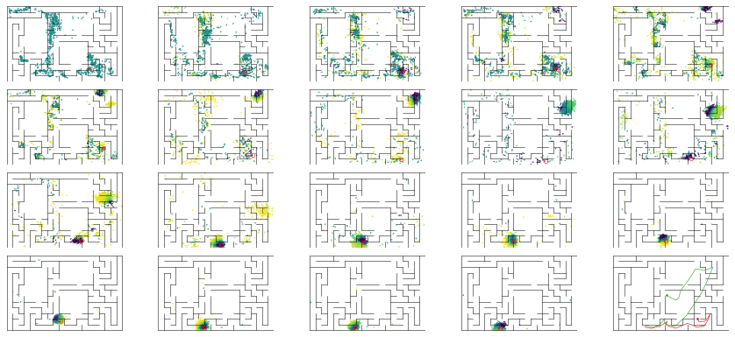

epoch 190 == mse_last: 35.61+-3.09/24.16+-1.83 -- mle: 8.20+-0.23/7.12+-0.15 --

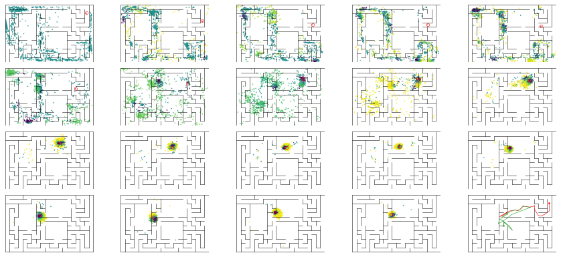

epoch 191 == mse_last: 21.93+-2.25/22.90+-1.98 -- mle: 7.52+-0.19/7.14+-0.15 --

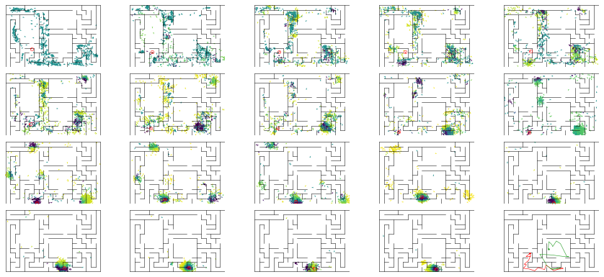

epoch 192 == mse_last: 28.68+-2.72/29.12+-2.03 -- mle: 7.94+-0.19/7.35+-0.16 --

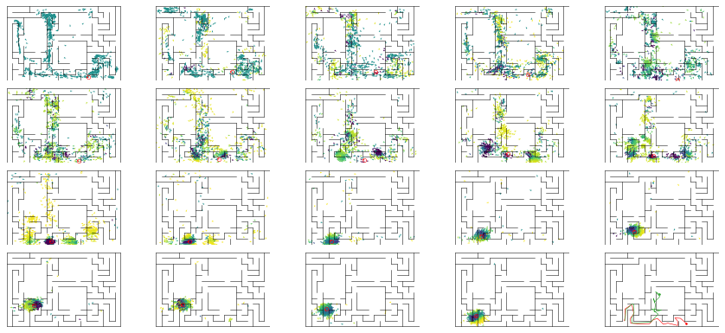

epoch 193 == mse_last: 24.05+-2.22/31.62+-2.34 -- mle: 8.03+-0.20/7.21+-0.16 --

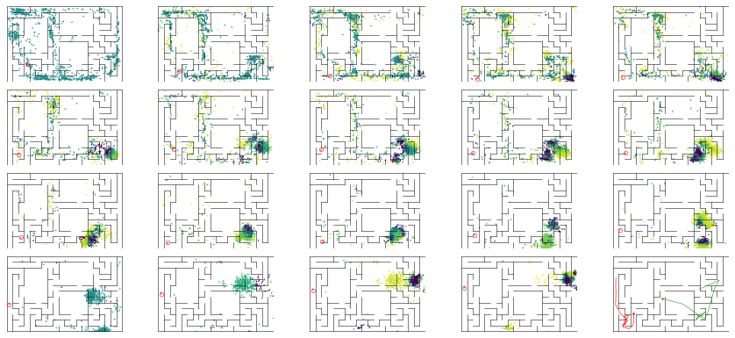

epoch 194 == mse_last: 23.75+-2.62/23.34+-2.02 -- mle: 7.53+-0.21/6.90+-0.15 --

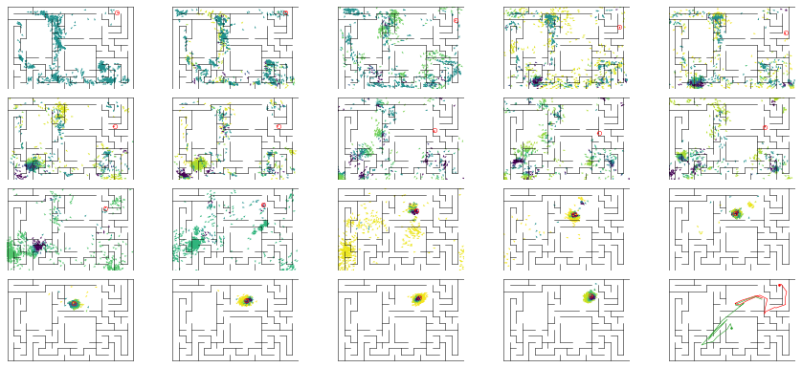

epoch 195 == mse_last: 22.71+-2.37/23.48+-1.73 -- mle: 7.56+-0.22/6.93+-0.14 --

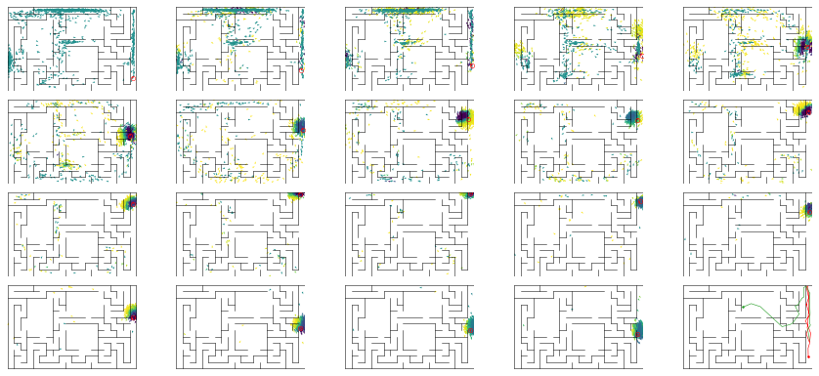

epoch 196 == mse_last: 25.39+-2.67/24.59+-2.02 -- mle: 7.85+-0.22/7.04+-0.15 --

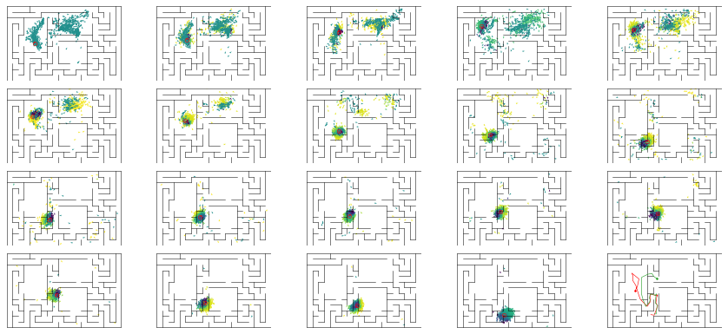

epoch 197 == mse_last: 27.28+-2.69/24.80+-1.88 -- mle: 8.35+-0.23/7.07+-0.14 --

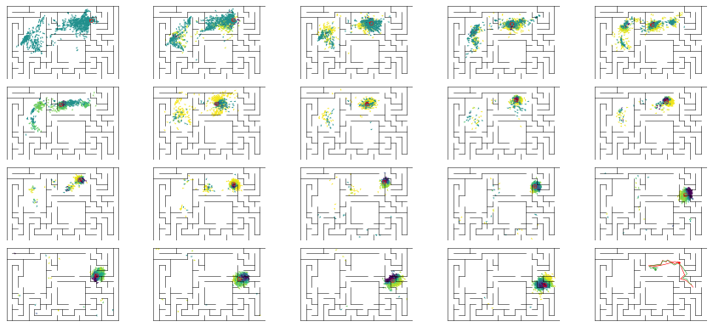

epoch 198 == mse_last: 22.38+-2.73/23.01+-1.81 -- mle: 7.37+-0.21/6.91+-0.14 --

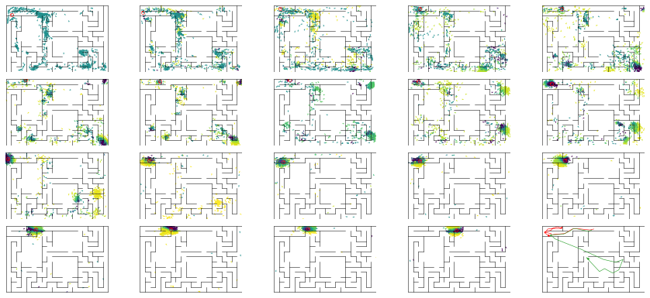

epoch 199 == mse_last: 28.49+-3.13/23.47+-2.01 -- mle: 8.03+-0.27/6.95+-0.17 --

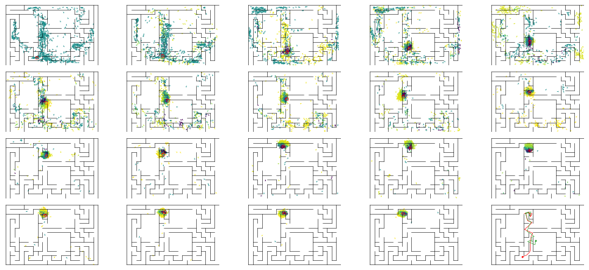

epoch 200 == mse_last: 28.19+-3.31/22.08+-1.91 -- mle: 7.94+-0.25/6.85+-0.15 --

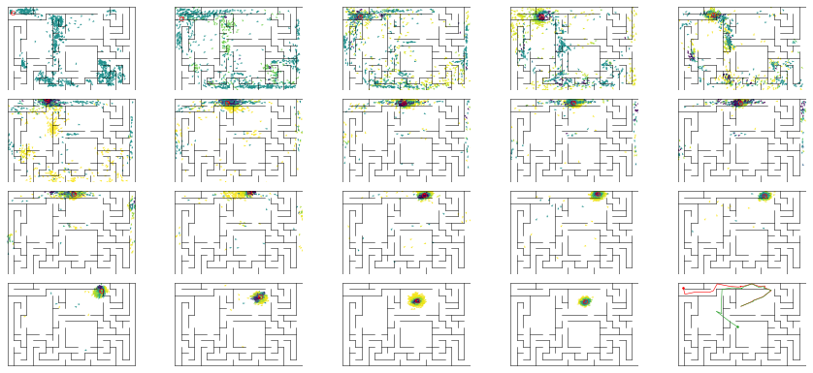

epoch 201 == mse_last: 18.07+-2.00/21.82+-1.93 -- mle: 7.53+-0.20/6.89+-0.14 --

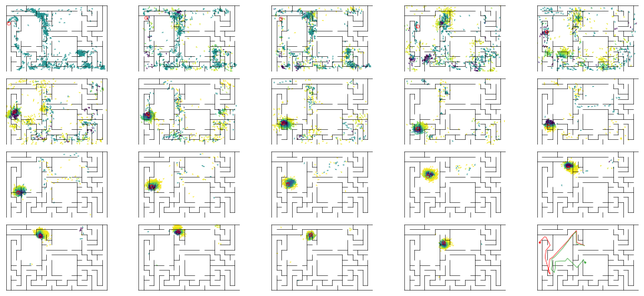

epoch 202 == mse_last: 17.78+-2.14/23.48+-2.09 -- mle: 7.36+-0.20/6.84+-0.14 --

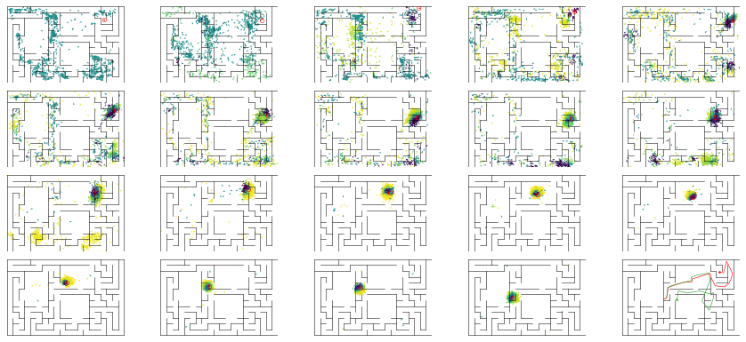

epoch 203 == mse_last: 26.83+-3.03/27.36+-2.11 -- mle: 7.75+-0.23/7.14+-0.17 --

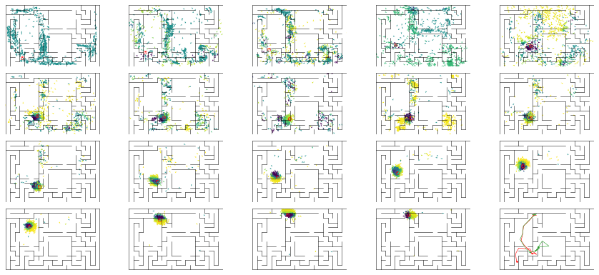

epoch 204 == mse_last: 23.63+-2.72/22.92+-2.03 -- mle: 7.60+-0.22/6.98+-0.16 --

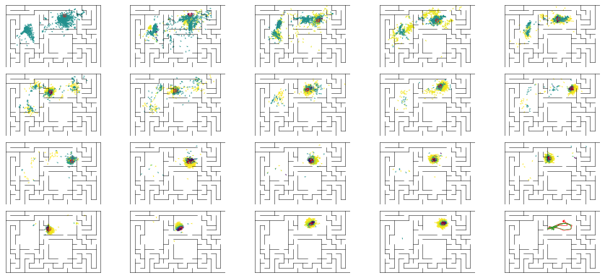

epoch 205 == mse_last: 23.92+-2.83/23.40+-1.92 -- mle: 7.79+-0.23/6.91+-0.13 --

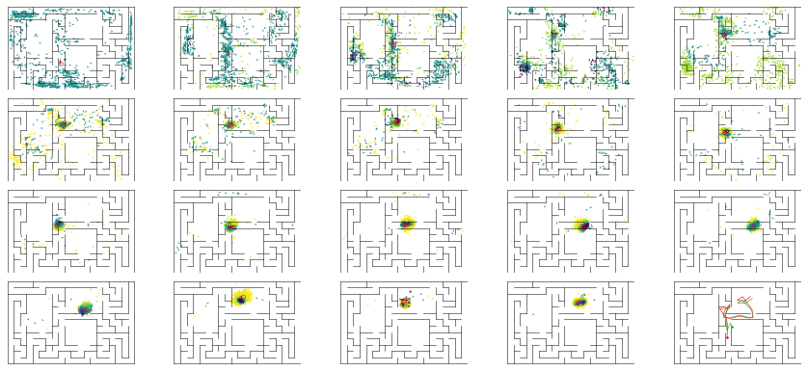

epoch 206 == mse_last: 19.29+-1.75/23.57+-1.99 -- mle: 7.46+-0.22/7.04+-0.15 --

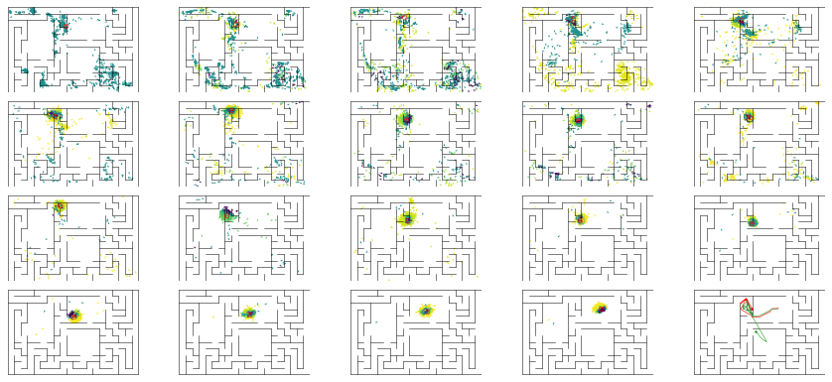

epoch 207 == mse_last: 20.89+-2.41/28.22+-2.07 -- mle: 7.39+-0.20/7.01+-0.16 --

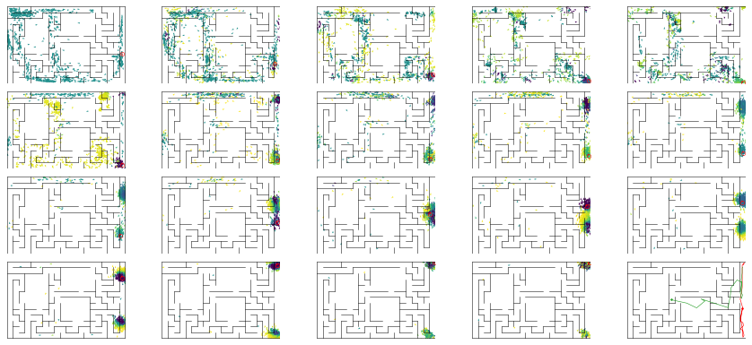

epoch 208 == mse_last: 21.41+-2.72/23.66+-1.98 -- mle: 7.82+-0.23/6.88+-0.15 --

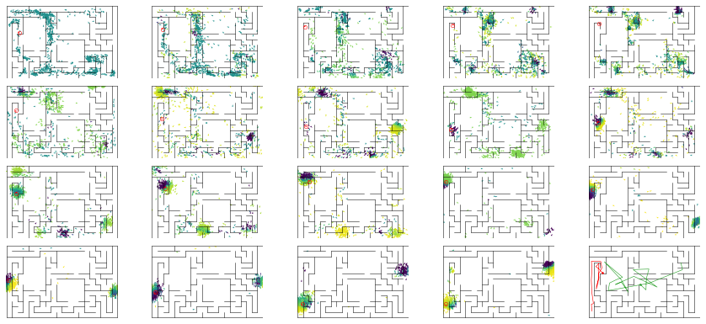

epoch 209 == mse_last: 25.05+-2.75/25.29+-2.16 -- mle: 7.74+-0.22/7.04+-0.16 --

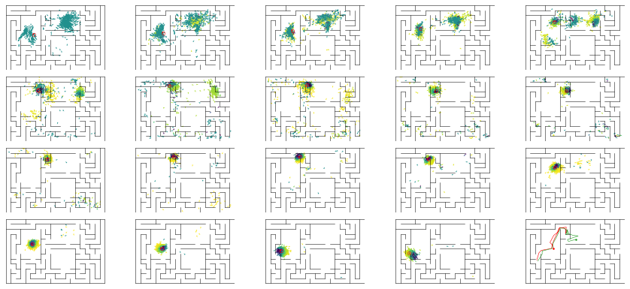

epoch 210 == mse_last: 23.12+-2.75/21.48+-1.89 -- mle: 7.34+-0.21/6.67+-0.14 --

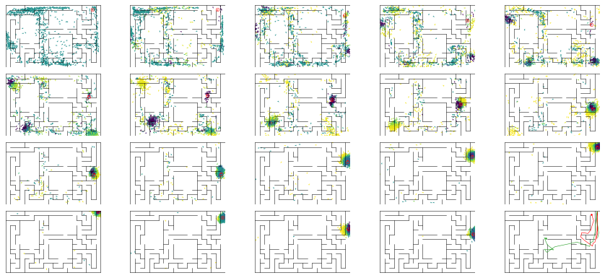

epoch 211 == mse_last: 21.60+-2.39/23.82+-2.06 -- mle: 7.90+-0.24/6.82+-0.15 --

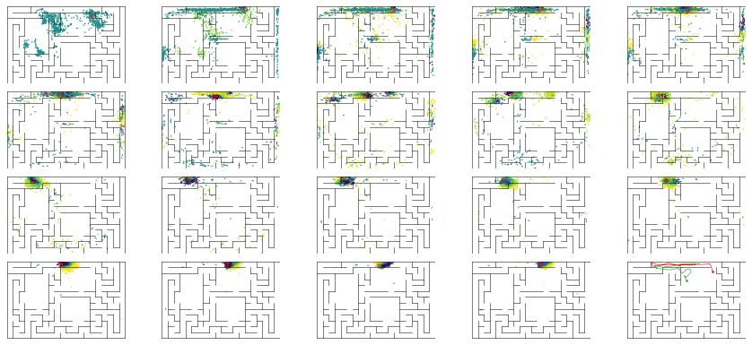

epoch 212 == mse_last: 23.37+-2.64/22.09+-1.86 -- mle: 7.60+-0.22/6.76+-0.14 --

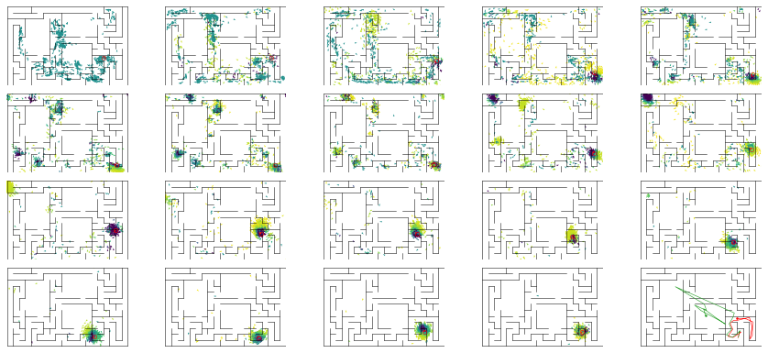

epoch 213 == mse_last: 22.14+-2.25/22.24+-1.81 -- mle: 7.55+-0.18/7.06+-0.15 --

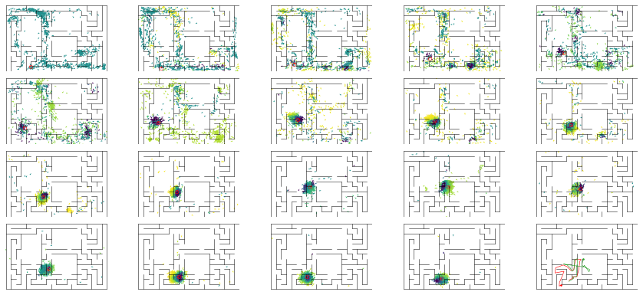

epoch 214 == mse_last: 28.41+-2.78/22.40+-1.84 -- mle: 7.79+-0.25/6.87+-0.15 --

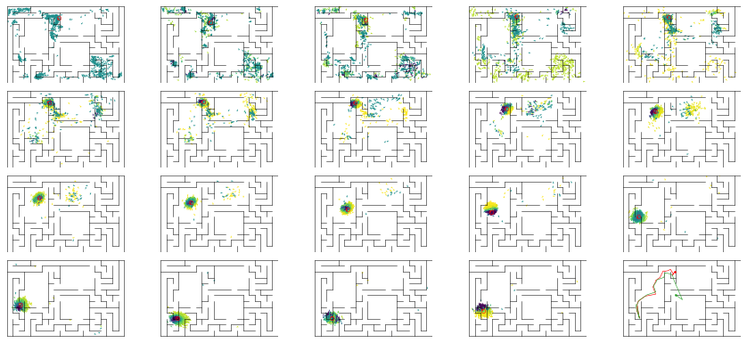

epoch 215 == mse_last: 25.02+-2.19/27.91+-2.11 -- mle: 7.64+-0.18/7.09+-0.15 --

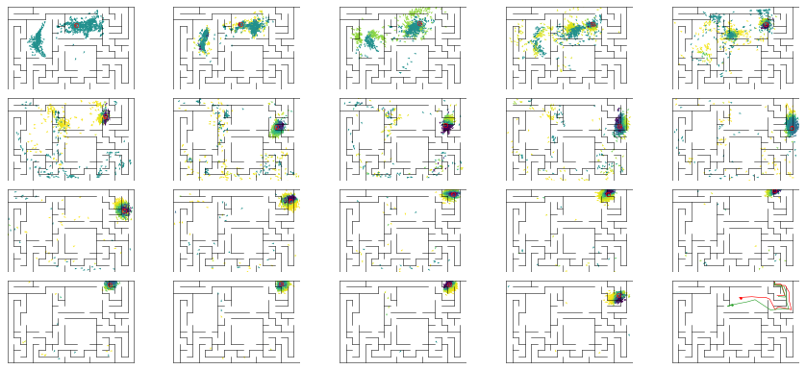

epoch 216 == mse_last: 26.17+-2.60/23.71+-1.99 -- mle: 8.02+-0.24/6.96+-0.15 --

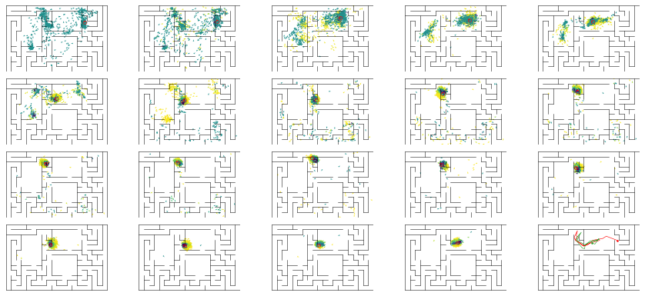

epoch 217 == mse_last: 22.32+-2.43/24.58+-2.17 -- mle: 7.85+-0.22/7.01+-0.14 --

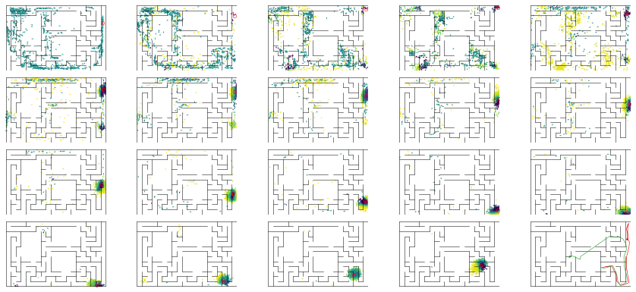

epoch 218 == mse_last: 22.35+-2.92/22.54+-2.01 -- mle: 7.61+-0.21/6.93+-0.16 --

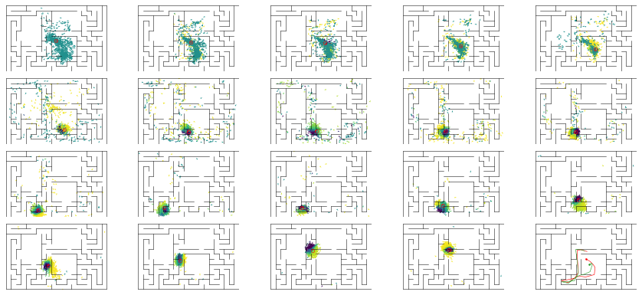

epoch 219 == mse_last: 24.58+-2.61/26.02+-1.77 -- mle: 7.72+-0.23/7.17+-0.15 --

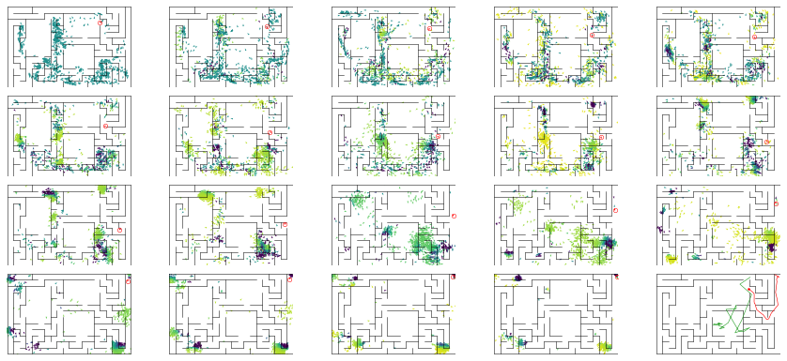

epoch 220 == mse_last: 25.25+-2.75/24.00+-2.14 -- mle: 7.70+-0.21/6.87+-0.15 --

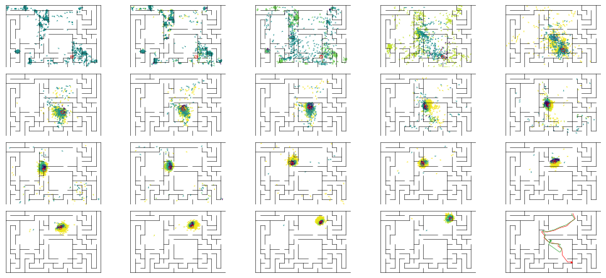

epoch 221 == mse_last: 22.41+-2.46/22.73+-1.92 -- mle: 7.63+-0.22/6.82+-0.16 --

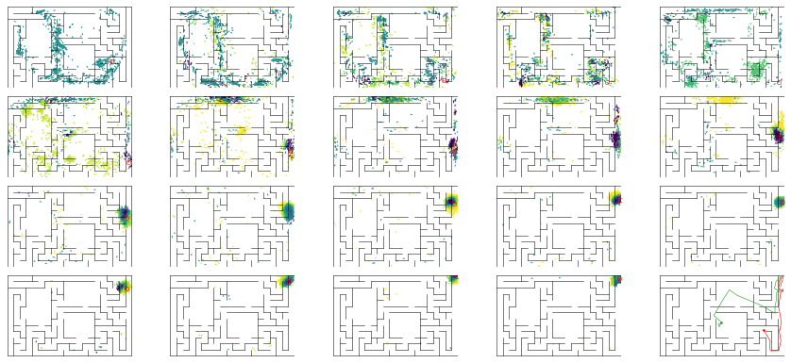

epoch 222 == mse_last: 27.70+-3.10/22.46+-1.77 -- mle: 8.01+-0.20/7.08+-0.15 --

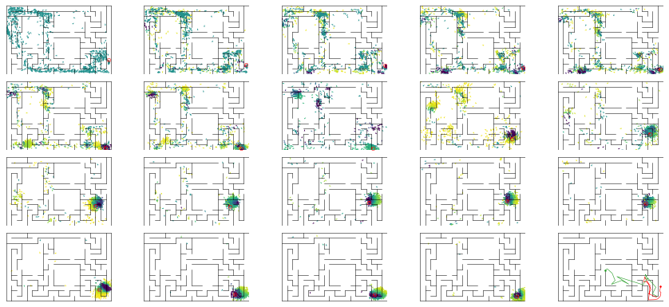

epoch 223 == mse_last: 27.22+-2.75/30.52+-2.38 -- mle: 7.74+-0.22/7.24+-0.16 --

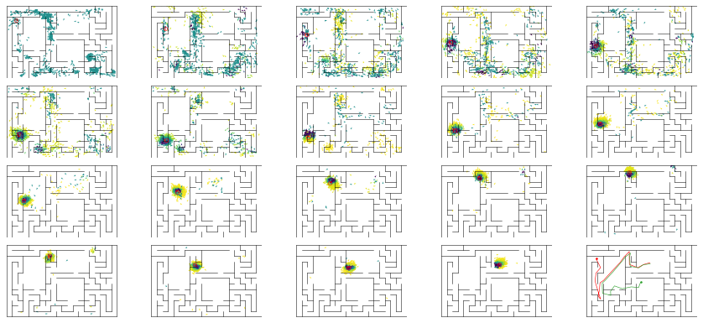

epoch 224 == mse_last: 29.13+-2.68/24.84+-2.20 -- mle: 8.05+-0.23/6.86+-0.15 --

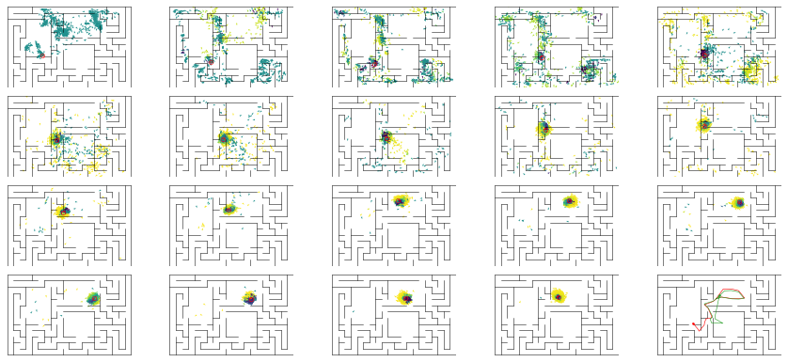

epoch 225 == mse_last: 21.71+-2.25/25.94+-1.89 -- mle: 7.65+-0.19/7.04+-0.14 --

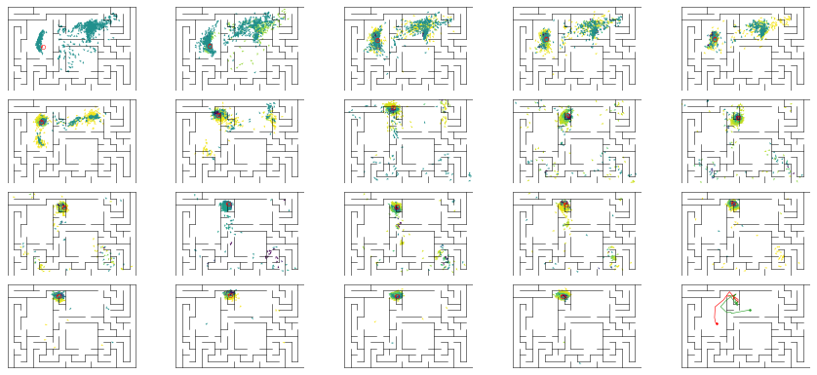

epoch 226 == mse_last: 25.63+-2.64/22.74+-1.85 -- mle: 7.78+-0.24/6.76+-0.14 --

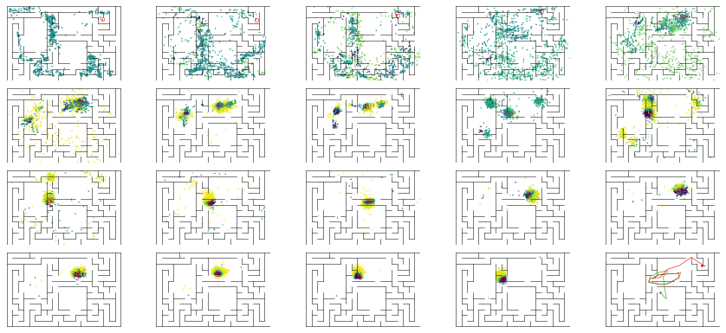

epoch 227 == mse_last: 20.37+-2.32/26.72+-1.98 -- mle: 7.33+-0.20/7.16+-0.16 --

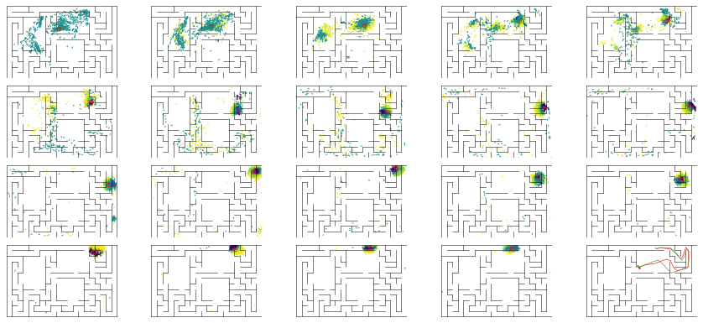

epoch 228 == mse_last: 25.39+-2.49/22.69+-2.07 -- mle: 7.63+-0.23/6.78+-0.16 --

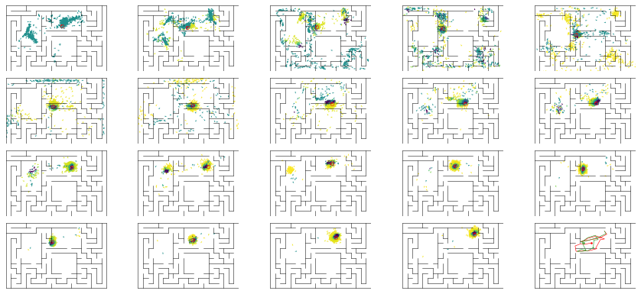

epoch 229 == mse_last: 30.05+-3.13/26.16+-2.29 -- mle: 7.52+-0.21/6.99+-0.16 --

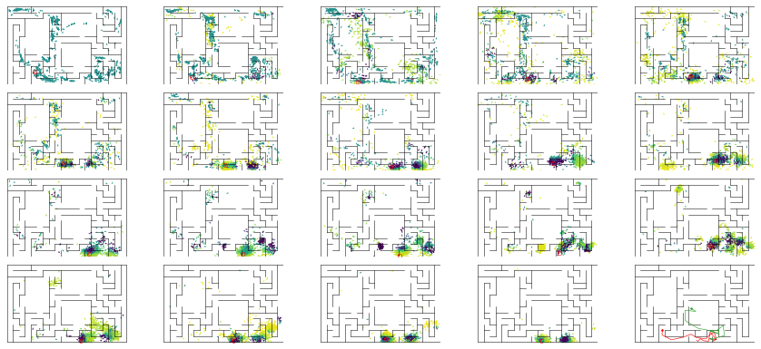

epoch 230 == mse_last: 23.75+-3.05/22.58+-1.95 -- mle: 7.51+-0.22/6.89+-0.14 --

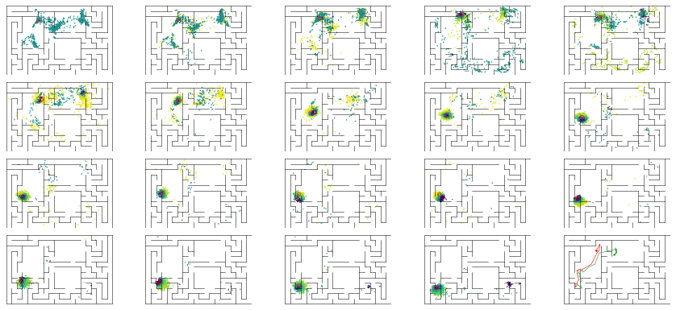

epoch 231 == mse_last: 22.75+-2.42/24.43+-2.25 -- mle: 7.36+-0.25/6.94+-0.15 --

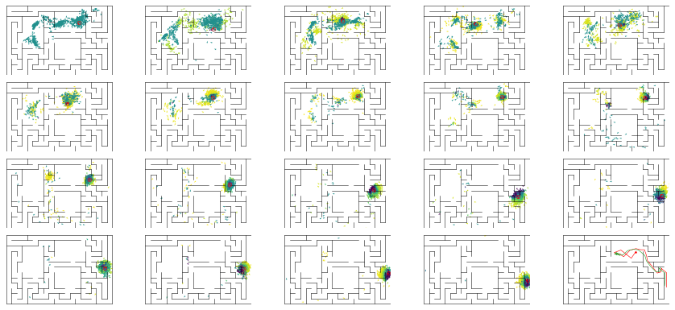

epoch 232 == mse_last: 21.32+-2.08/26.58+-2.23 -- mle: 7.67+-0.19/7.09+-0.15 --

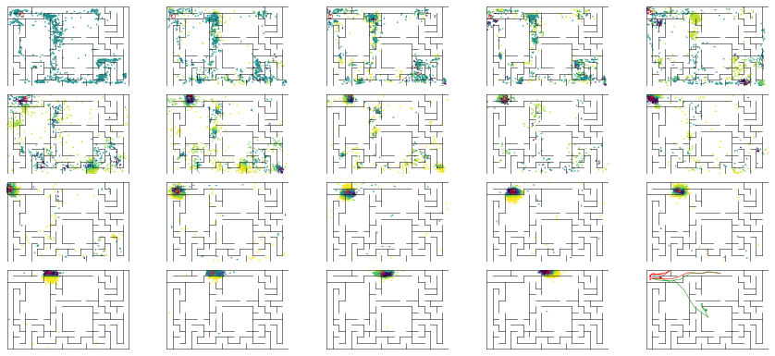

epoch 233 == mse_last: 26.38+-2.66/26.62+-2.11 -- mle: 7.70+-0.22/7.19+-0.17 --

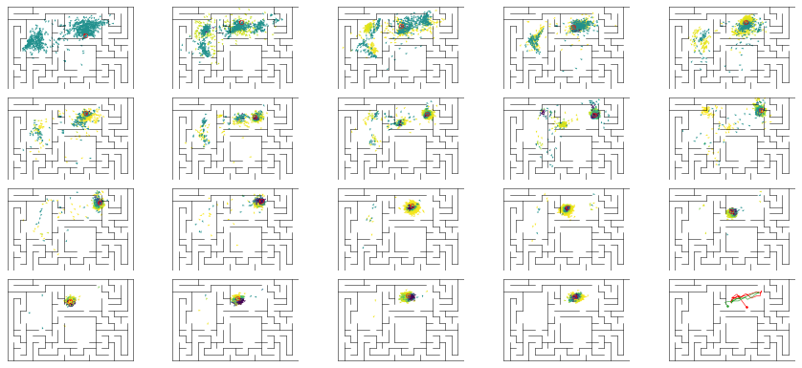

epoch 234 == mse_last: 25.66+-2.77/25.21+-2.03 -- mle: 7.78+-0.23/6.91+-0.14 --

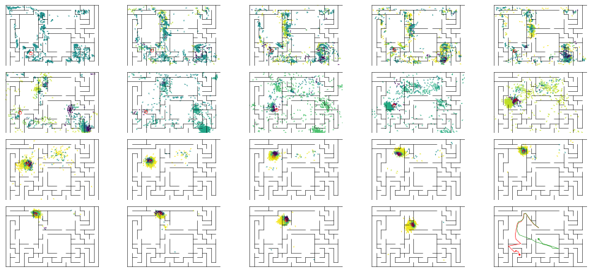

epoch 235 == mse_last: 23.45+-2.18/27.03+-2.12 -- mle: 7.69+-0.21/7.10+-0.16 --

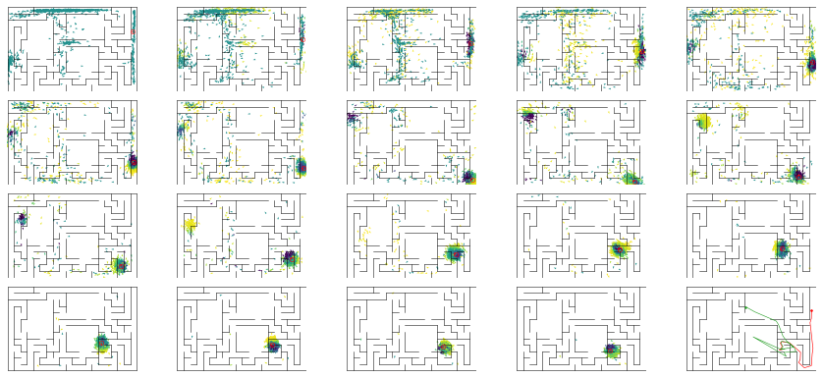

epoch 236 == mse_last: 25.37+-2.75/24.62+-1.80 -- mle: 7.93+-0.25/7.21+-0.16 --

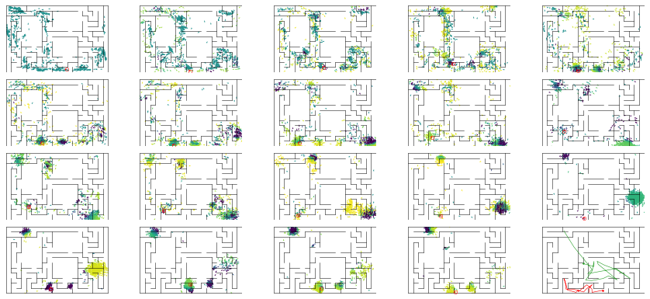

epoch 237 == mse_last: 24.79+-2.56/22.06+-1.73 -- mle: 8.31+-0.26/6.84+-0.15 --

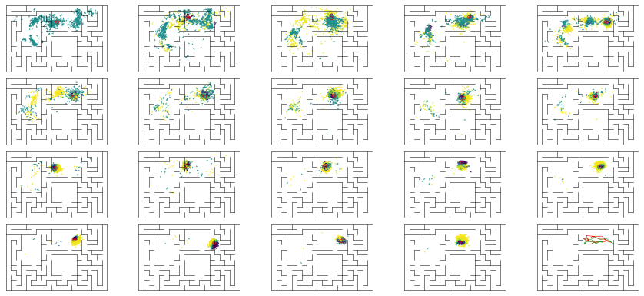

epoch 238 == mse_last: 23.25+-2.31/22.59+-1.96 -- mle: 7.67+-0.18/6.89+-0.14 --

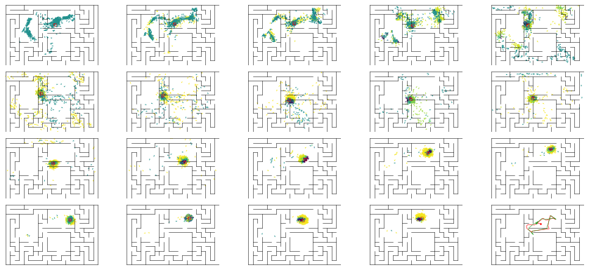

epoch 239 == mse_last: 24.12+-2.27/26.69+-1.95 -- mle: 7.72+-0.19/7.06+-0.16 --

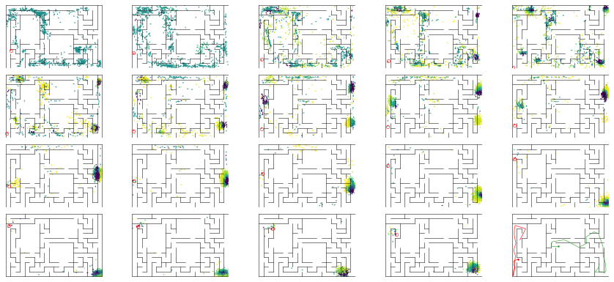

epoch 240 == mse_last: 24.76+-2.94/22.79+-1.91 -- mle: 7.62+-0.20/6.83+-0.15 --

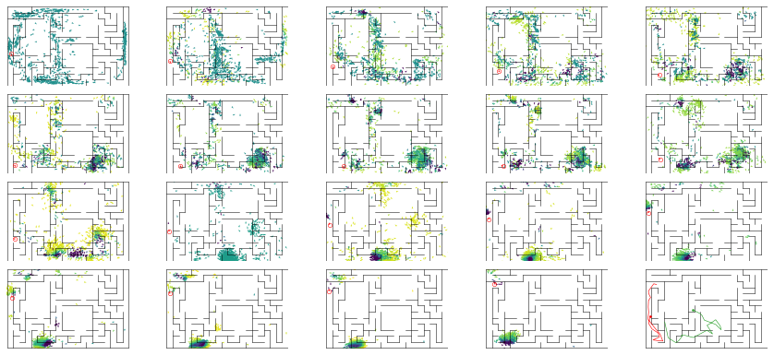

epoch 241 == mse_last: 26.98+-2.48/21.79+-1.88 -- mle: 7.96+-0.21/6.89+-0.15 --

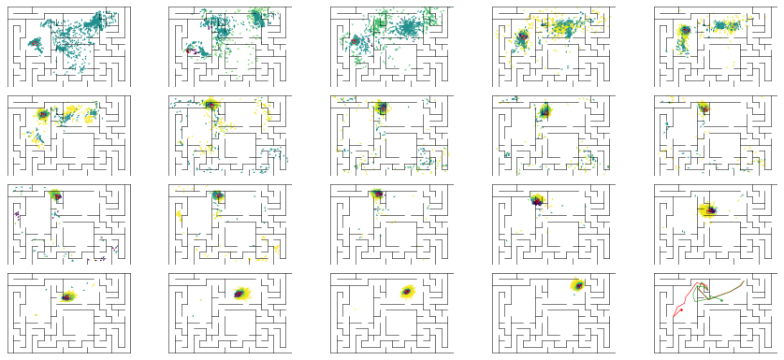

epoch 242 == mse_last: 24.12+-2.11/22.22+-1.80 -- mle: 7.70+-0.22/6.99+-0.15 --

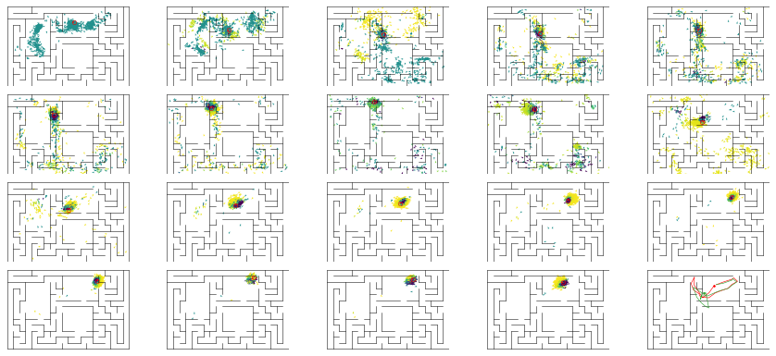

epoch 243 == mse_last: 23.59+-2.75/24.22+-1.87 -- mle: 7.61+-0.24/6.90+-0.15 --

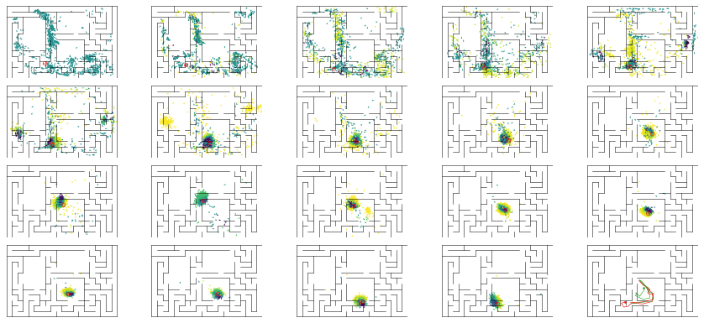

epoch 244 == mse_last: 22.63+-2.79/24.38+-2.24 -- mle: 7.63+-0.18/6.77+-0.16 --

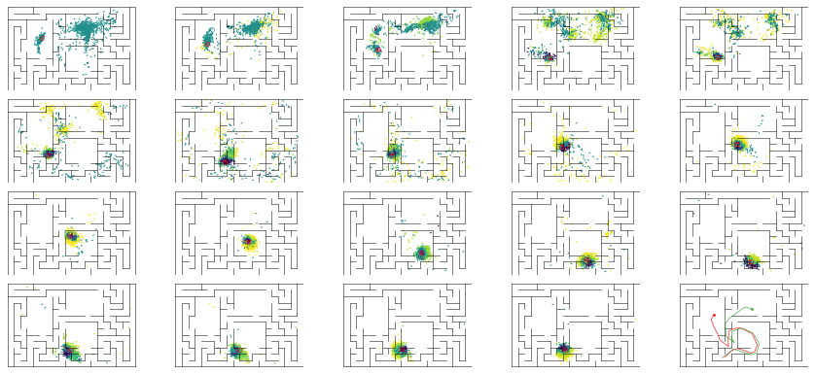

epoch 245 == mse_last: 24.41+-2.88/25.20+-1.95 -- mle: 7.80+-0.22/6.99+-0.14 --

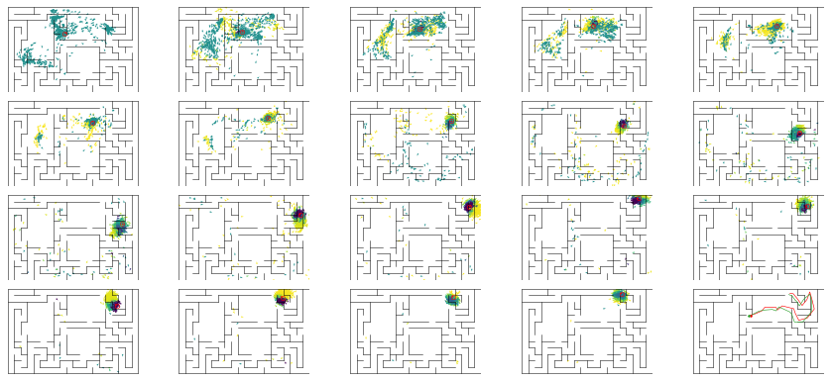

epoch 246 == mse_last: 20.91+-2.45/21.73+-1.83 -- mle: 7.47+-0.18/6.71+-0.15 --

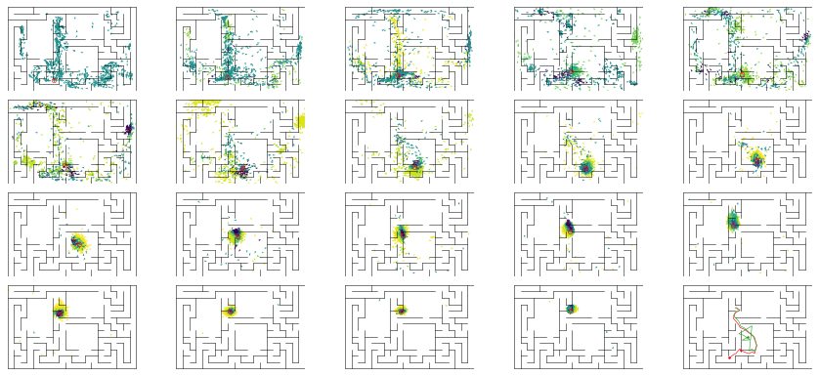

epoch 247 == mse_last: 21.56+-1.85/27.95+-2.00 -- mle: 7.59+-0.19/7.05+-0.16 --

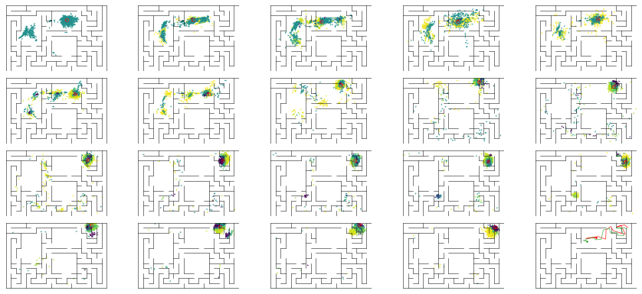

epoch 248 == mse_last: 23.64+-2.77/23.23+-2.08 -- mle: 7.32+-0.21/6.86+-0.16 --

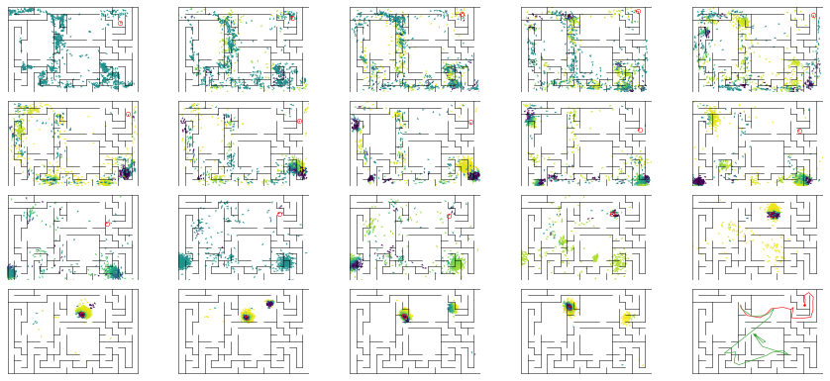

epoch 249 == mse_last: 25.63+-2.71/26.62+-2.02 -- mle: 7.46+-0.19/7.00+-0.14 --

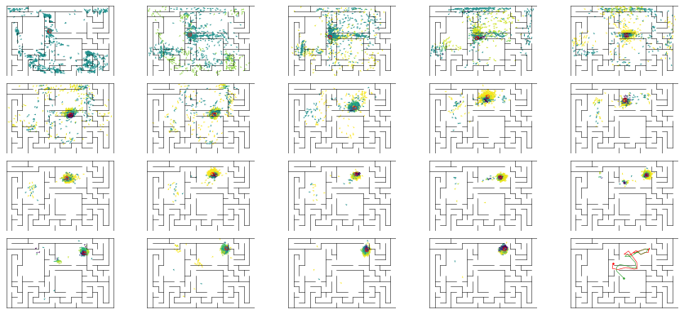

epoch 250 == mse_last: 23.90+-2.64/24.76+-1.89 -- mle: 7.82+-0.24/7.12+-0.16 --

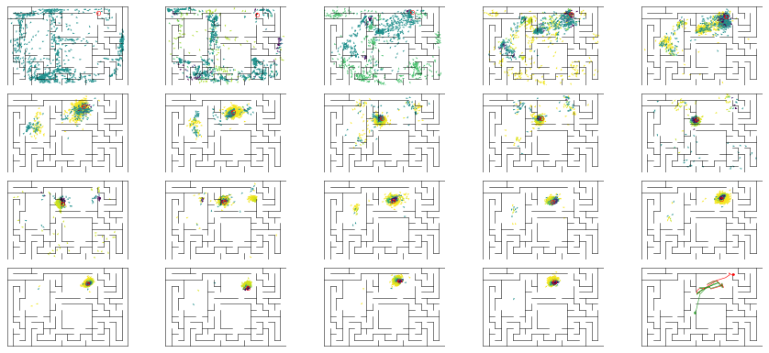

epoch 251 == mse_last: 25.73+-2.97/21.20+-2.04 -- mle: 7.52+-0.21/6.80+-0.15 --

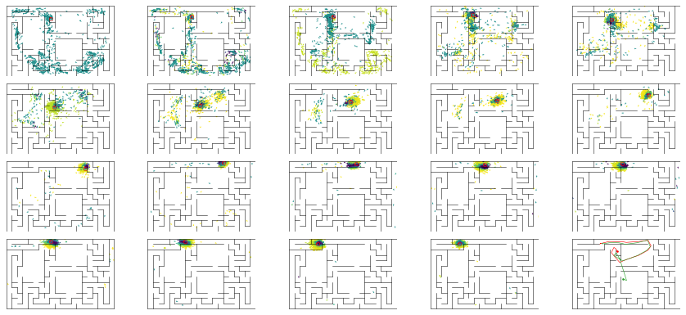

epoch 252 == mse_last: 20.42+-2.37/20.78+-1.73 -- mle: 7.69+-0.21/6.76+-0.14 --

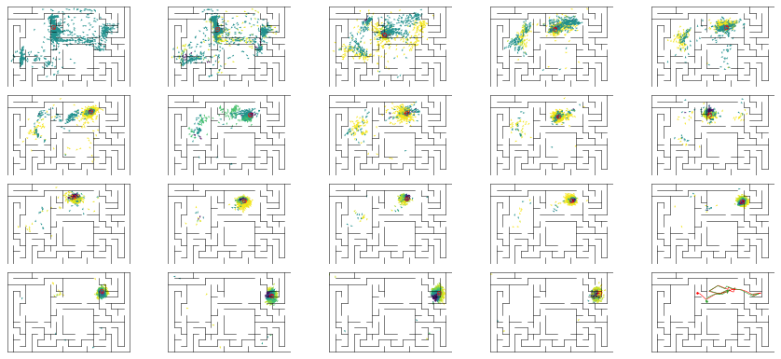

epoch 253 == mse_last: 23.46+-2.70/22.38+-1.89 -- mle: 7.45+-0.20/6.79+-0.15 --

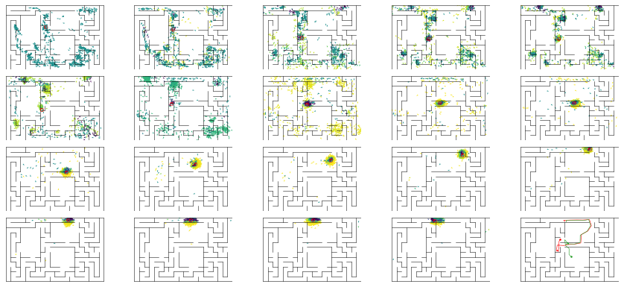

epoch 254 == mse_last: 19.33+-2.01/25.12+-1.95 -- mle: 7.62+-0.21/7.04+-0.14 --

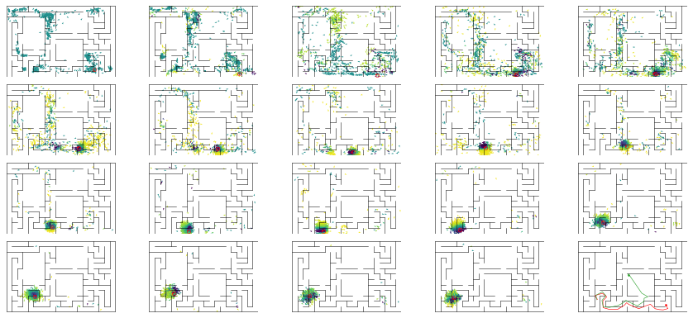

epoch 255 == mse_last: 21.60+-2.61/24.59+-2.15 -- mle: 7.47+-0.21/7.07+-0.14 --

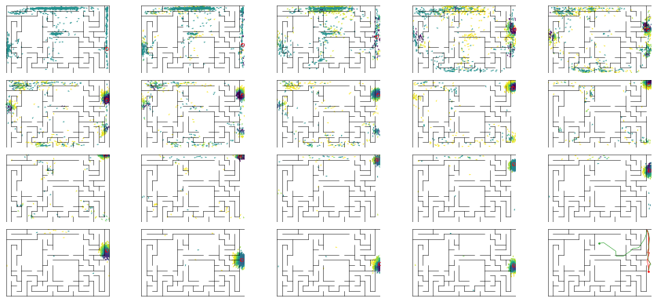

epoch 256 == mse_last: 25.46+-2.72/21.83+-1.86 -- mle: 7.75+-0.20/6.90+-0.16 --

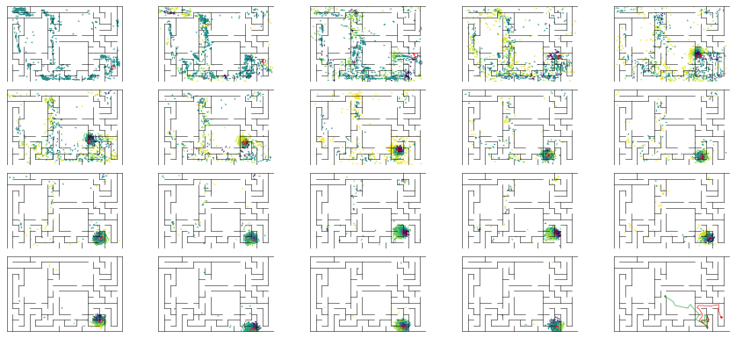

epoch 257 == mse_last: 19.23+-2.45/23.37+-2.23 -- mle: 7.61+-0.23/6.85+-0.16 --

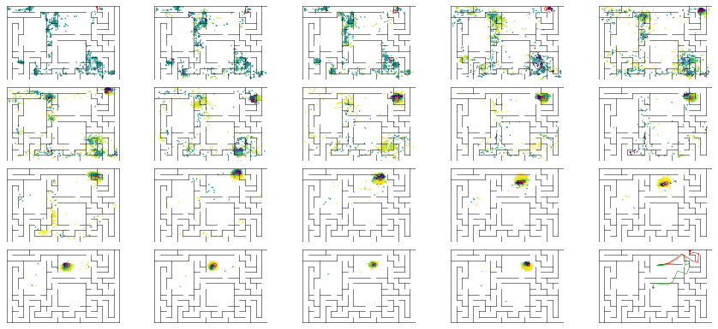

epoch 258 == mse_last: 21.26+-2.32/26.06+-2.25 -- mle: 7.34+-0.22/7.07+-0.16 --

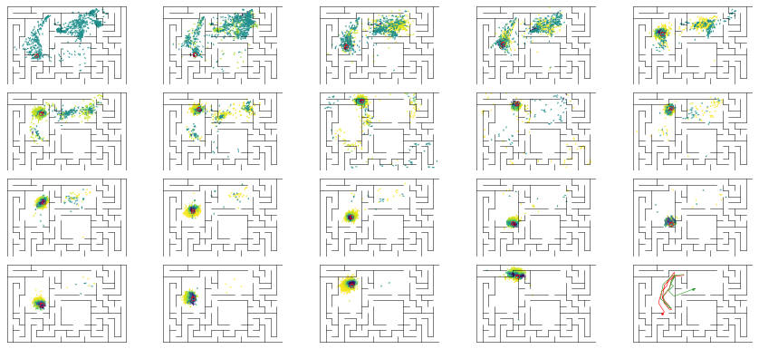

epoch 259 == mse_last: 21.58+-2.23/27.64+-2.07 -- mle: 7.60+-0.20/7.14+-0.16 --

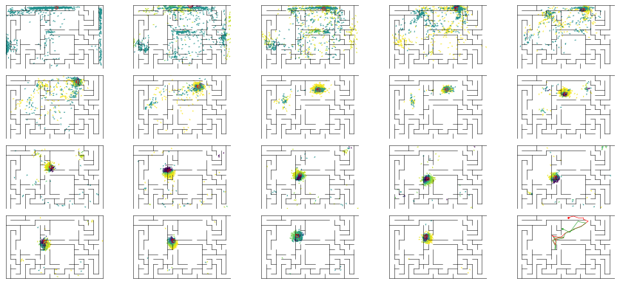

epoch 260 == mse_last: 26.33+-3.20/23.53+-1.88 -- mle: 8.09+-0.27/6.91+-0.16 --

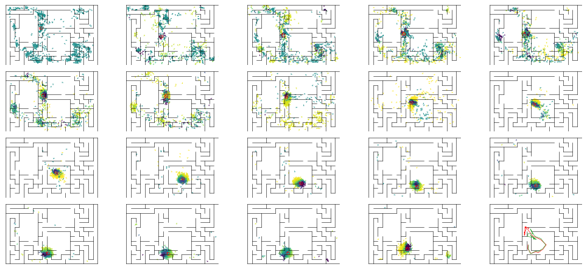

epoch 261 == mse_last: 22.62+-2.71/24.69+-2.13 -- mle: 7.55+-0.27/6.98+-0.16 --

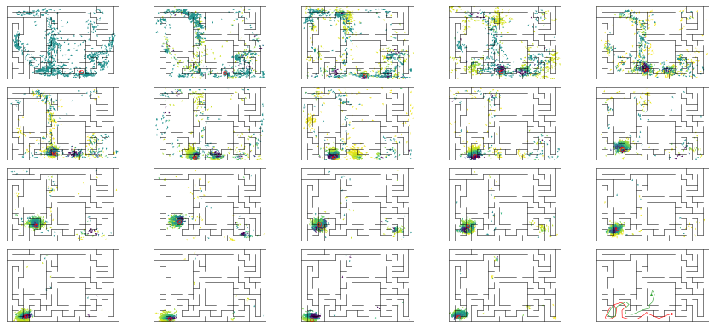

epoch 262 == mse_last: 28.79+-3.00/27.65+-2.04 -- mle: 7.76+-0.20/7.06+-0.16 --

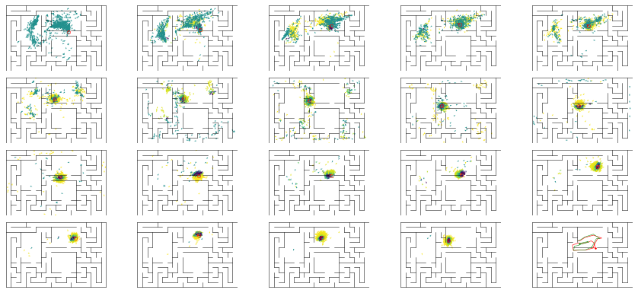

epoch 263 == mse_last: 24.97+-2.71/24.10+-2.02 -- mle: 7.76+-0.18/6.75+-0.16 --

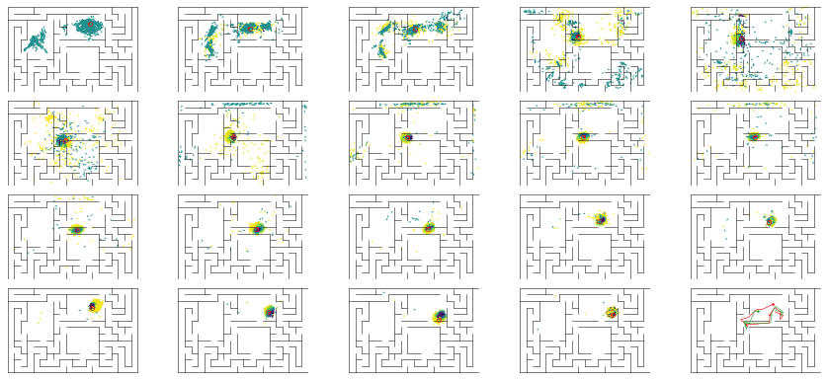

epoch 264 == mse_last: 20.14+-2.33/27.70+-2.20 -- mle: 7.52+-0.23/7.11+-0.16 --

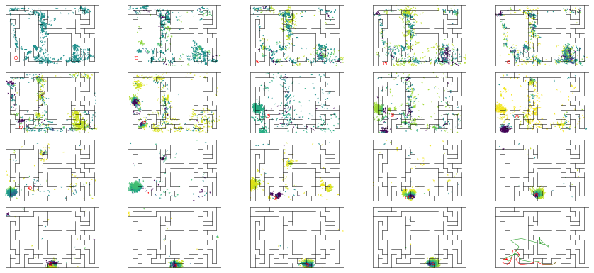

epoch 265 == mse_last: 23.50+-2.85/25.23+-1.93 -- mle: 7.66+-0.24/6.77+-0.15 --

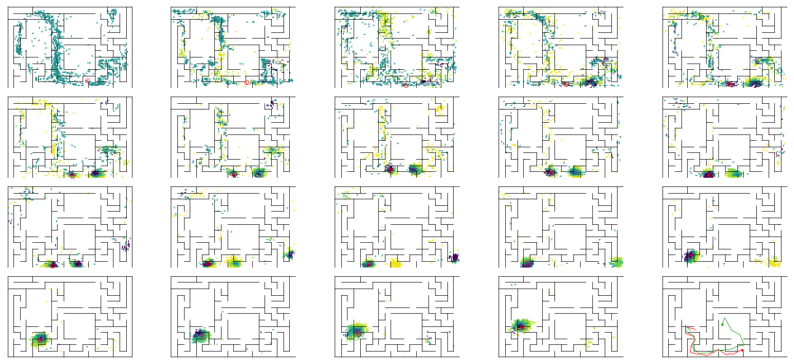

epoch 266 == mse_last: 23.08+-3.00/28.33+-2.12 -- mle: 7.39+-0.20/6.95+-0.16 --

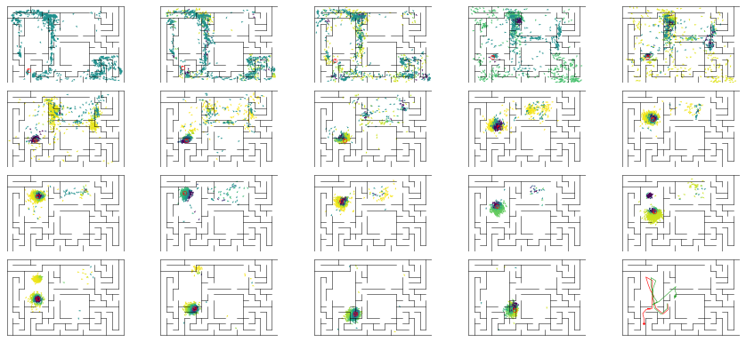

epoch 267 == mse_last: 20.97+-2.75/22.15+-1.75 -- mle: 7.33+-0.23/6.75+-0.13 --

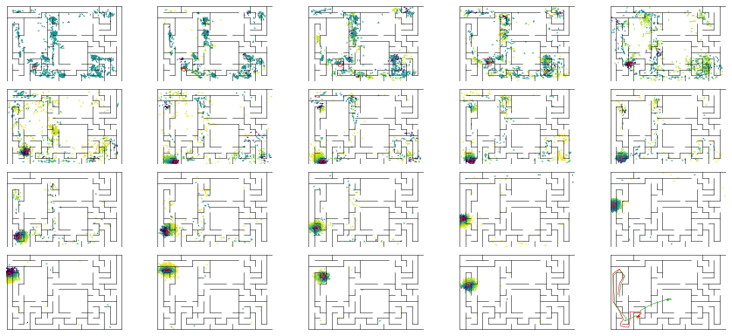

epoch 268 == mse_last: 24.47+-3.06/27.63+-2.17 -- mle: 7.49+-0.22/7.25+-0.16 --

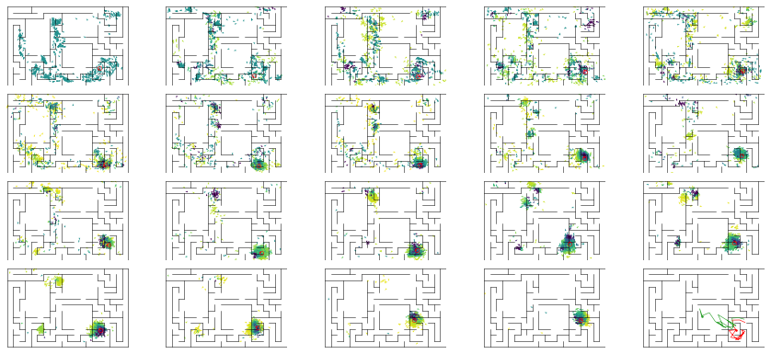

epoch 269 == mse_last: 27.14+-3.23/29.43+-2.07 -- mle: 7.82+-0.22/7.14+-0.16 --

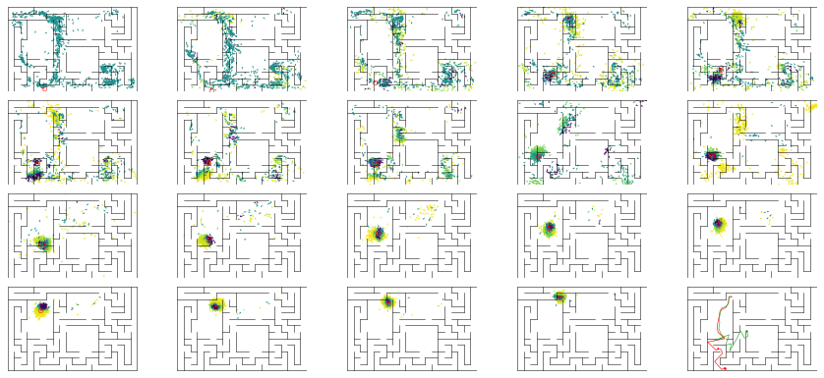

epoch 270 == mse_last: 21.92+-2.23/27.63+-2.23 -- mle: 7.46+-0.21/7.23+-0.16 --

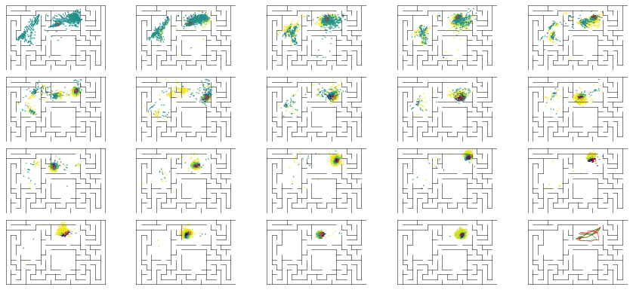

INFO:tensorflow:Restoring parameters from ../models/tmp/best_validation

INFO:tensorflow:Restoring parameters from ../models/tmp/best_validation

noisyfying data ...

WARNING:tensorflow:Large dropout rate: 0.85 (>0.5). In TensorFlow 2.x, dropout() uses dropout rate instead of keep_prob. Please ensure that this is intended.

WARNING:tensorflow:Large dropout rate: 0.85 (>0.5). In TensorFlow 2.x, dropout() uses dropout rate instead of keep_prob. Please ensure that this is intended.

WARNING:tensorflow:Large dropout rate: 0.85 (>0.5). In TensorFlow 2.x, dropout() uses dropout rate instead of keep_prob. Please ensure that this is intended.

WARNING:tensorflow:Large dropout rate: 0.85 (>0.5). In TensorFlow 2.x, dropout() uses dropout rate instead of keep_prob. Please ensure that this is intended.

Loading these modules: {'particle_proposer', 'obs_like_estimator', 'encoder', 'mo_noise_generator'}

../models/tmp best_validation

'../models/tmp' 'best_validation'

INFO:tensorflow:Restoring parameters from ../models/tmp/best_validation

INFO:tensorflow:Restoring parameters from ../models/tmp/best_validation

Loaded the following variables:

encoder/convnet/conv_2d_0/w:0

encoder/convnet/conv_2d_0/b:0

encoder/convnet/conv_2d_1/w:0

encoder/convnet/conv_2d_1/b:0

encoder/convnet/conv_2d_2/w:0

encoder/convnet/conv_2d_2/b:0

encoder/linear/w:0

encoder/linear/b:0

particle_proposer/linear/w:0

particle_proposer/linear/b:0

particle_proposer/linear_1/w:0

particle_proposer/linear_1/b:0

particle_proposer/linear_2/w:0

particle_proposer/linear_2/b:0

particle_proposer/linear_3/w:0

particle_proposer/linear_3/b:0

particle_proposer/linear_4/w:0

particle_proposer/linear_4/b:0

mo_noise_generator/linear_0/w:0

mo_noise_generator/linear_0/b:0

mo_noise_generator/linear_1/w:0

mo_noise_generator/linear_1/b:0

mo_noise_generator/linear_2/w:0

mo_noise_generator/linear_2/b:0

obs_like_estimator/linear/w:0

obs_like_estimator/linear/b:0

obs_like_estimator/linear_1/w:0

obs_like_estimator/linear_1/b:0

obs_like_estimator/linear_2/w:0

obs_like_estimator/linear_2/b:0